AGGREGATION PHEROMONE OF Cyrtogenius luteus, AN INVASIVE BARK BEETLE IN SOUTHERN SOUTH AMERICA

G. ZINOLA¹, M.A. AMORÓS¹, C. ROSSINI¹, G. SEOANE², G. MARTÍNEZ CROSA³, A. GONZÁLEZ^{1,*}
¹ Chemical Ecology Laboratory, Department of Organic Chemistry & Department of Biosciences, Faculty of Chemistry, Universidad de la República, Montevideo, Uruguay
² Organic Synthesis Laboratory, Department of Organic Chemistry, Faculty of Chemistry, Universidad de la República, Montevideo, Uruguay
³ Instituto Nacional de Investigación Agropecuaria (INIA). Sistema Agrícola-Ganadero, Colonia, Uruguay

* agonzal@fq.edu.uy
Supplementary information

Fig. S1 Kaplan–Meier survival curves with 95% confidence intervals showing the survival probability over time for Cyrtogenius luteus adults exposed to cold conditions (4 °C ± 1 °C) prior to and during shipping. Sample size was N = 100 individuals per sex. Differences between sex-specific survival curves were assessed using the log-rank (Mantel–Cox) test. The table below the plot indicates the number of individuals at risk at selected time points for each sex.
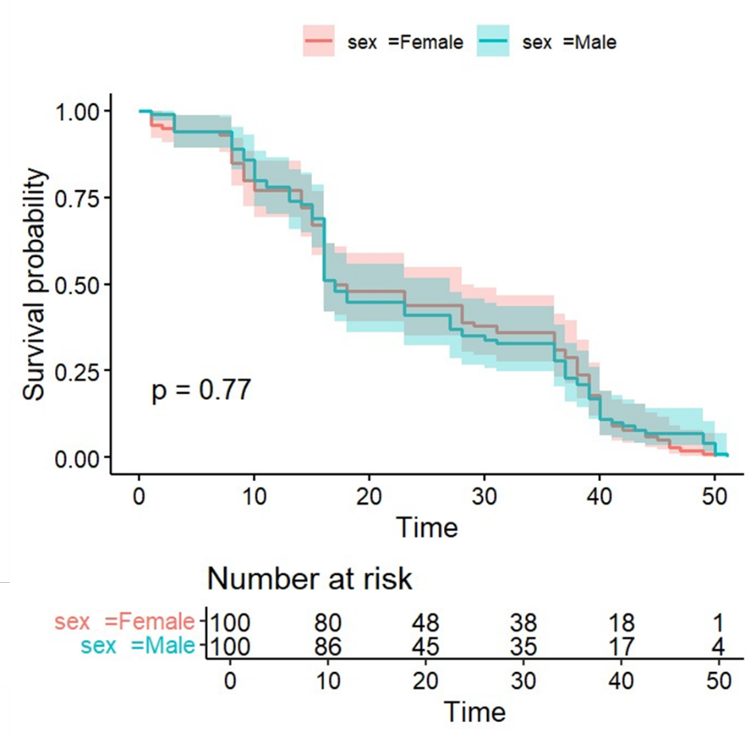

Fig. S2 Field test site within a commercial P. taeda forested area in Tacuarembó, Uruguay (planted in 2004). Markers indicate the location of twenty cross-vane traps arranged in a 4 treatments x 5 blocks experimental design. Traps within a block were spaced at least 50 m apart. Treatment positions within a block were randomly assigned (1- unbaited control; 2 - turpentine and ethanol; 3 - turpentine, ethanol and pheromone; 4 - ethanol and pheromone.
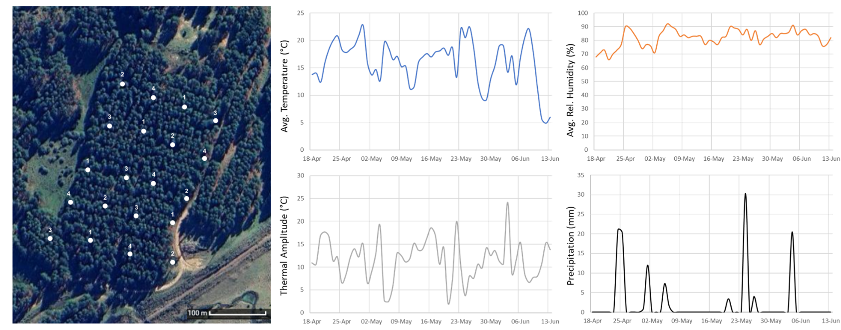
Fig. S3 Weight loss of rubber septa loaded with 50 mg of p-mentha-1,8-dien-4-ol in 200 μl dichloromethane (blue trace). Septa loaded with solvent (200 μl, black trace) were used as control for solvent evaporation. Dotted lines show approximate weight loss of 50% after 14 days, the period in which septa were replaced in the field trial. Weight data show averages of 3 replicates and were corrected for septa weight.
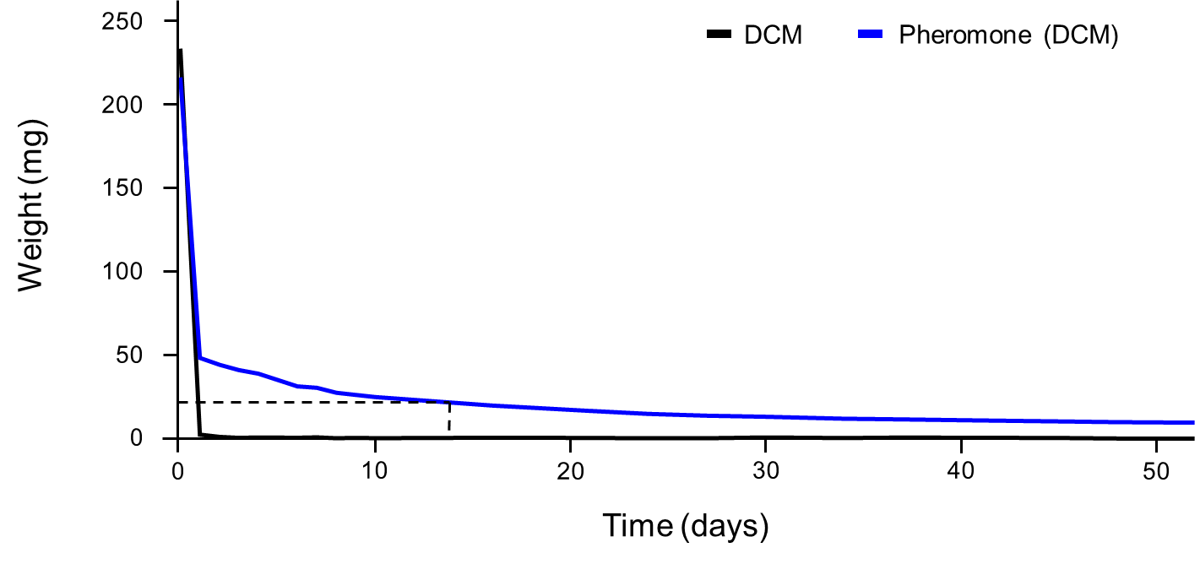

Fig. S4 Weekly C. luteus adult captures per trap for unbaited control traps and traps baited with turpentine/ethanol, turpentine/ethanol/pheromone or ethanol/pheromone. Data are shown as boxplots with black points indicating individual trap captures (n = 5 traps per treatment).
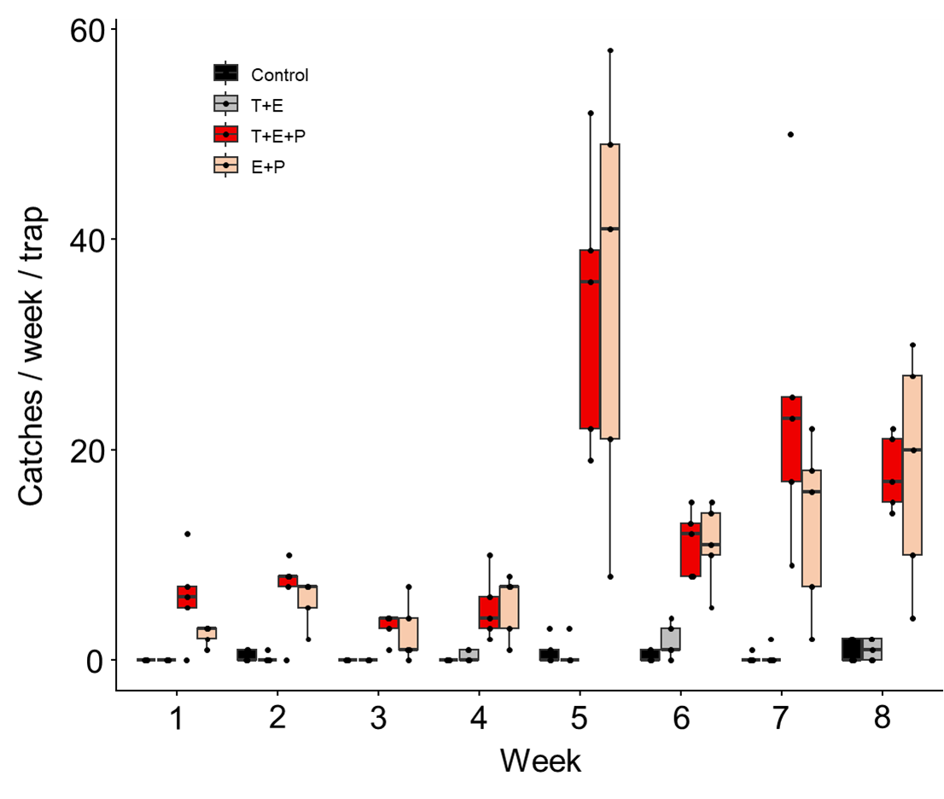

Fig. S5a-d Mono and bidimensional NMR spectra of synthetic p-mentha-1,8-dien-4-ol (BrukerAvance DPX-400 instrument, in CDCl₃).
