Supplementary Table 1. Pain characteristics at baseline and average daily physical activity over 14 days adjusted for age and sex
 | TAC (x1000) |  |  | ASTP |  |  | Active time (mins)
 | $$β$$ | Robust SE | p-value | $$β$$ | Robust SE | p-value | $$β$$ | Robust SE | p-value
BPI pain severity | -77.01 | 44.69 | 0.097 | 0.59 | 0.47 | 0.220 | -11.67 | 8.17 | 0.165
BPI pain interference | 20.00 | 48.89 | 0.686 | -0.10 | 0.47 | 0.832 | 4.99 | 8.04 | 0.540
Pain presence at each location
Shoulder pain | 383.53 | 184.82 | 0.048 | -1.99 | 1.80 | 0.279 | 63.80 | 32.55 | 0.061
Elbow pain | 657.97 | 176.78 | 0.001 | -5.14 | 1.39 | 0.001 | 110.69 | 28.45 | <0.001
Wrist/hand/finger pain | -116.33 | 187.30 | 0.540 | 0.56 | 1.55 | 0.721 | -20.14 | 35.59 | 0.576
Back pain | -388.91 | 168.41 | 0.029 | 5.38 | 1.27 | <0.001 | -74.54 | 28.90 | 0.016
Hip pain | -152.26 | 183.59 | 0.415 | 1.84 | 1.51 | 0.233 | -33.88 | 33.41 | 0.320
Knee pain | 163.59 | 171.30 | 0.348 | -1.87 | 1.51 | 0.225 | 42.53 | 30.17 | 0.171
Ankle/foot/toe pain | 282.26 | 194.79 | 0.159 | -2.47 | 1.92 | 0.211 | 58.98 | 30.55 | 0.065
Pain severity at each location
Shoulder pain | 52.23 | 34.08 | 0.137 | -0.15 | 0.41 | 0.708 | 8.15 | 6.53 | 0.223
Elbow pain | 224.59 | 55.02 | <0.001 | -1.74 | 0.52 | 0.002 | 39.25 | 8.62 | <0.001
Wrist/hand/finger pain | 4.20 | 39.77 | 0.917 | -0.17 | 0.33 | 0.617 | -1.18 | 7.19 | 0.871
Back pain | -60.42 | 24.38 | 0.020 | 0.95 | 0.20 | <0.001 | -10.87 | 4.23 | 0.016
Hip pain | -25.49 | 28.35 | 0.377 | 0.32 | 0.24 | 0.190 | -5.67 | 5.19 | 0.284
Knee pain | 9.17 | 32.67 | 0.781 | -0.06 | 0.30 | 0.831 | 3.17 | 5.61 | 0.576
Ankle/foot/toe pain | 42.23 | 45.81 | 0.365 | -0.28 | 0.46 | 0.547 | 9.30 | 7.19 | 0.207
Pain laterality at each location
Shoulder pain
No | ref | ref | ref | ref | ref | ref | ref | ref | ref
Unilateral | 484.38 | 187.81 | 0.016 | -2.78 | 1.72 | 0.119 | 86.68 | 30.90 | 0.010
Bilateral | 113.89 | 313.20 | 0.719 | 0.14 | 3.74 | 0.970 | 2.61 | 49.55 | 0.959
Elbow pain
No | ref | ref | ref | ref | ref | ref | ref | ref | ref
Unilateral | 747.78 | 202.72 | 0.001 | -6.28 | 1.33 | <0.001 | 115.92 | 35.09 | 0.003
Bilateral | 338.53 | 176.36 | 0.066 | -1.10 | 1.41 | 0.443 | 92.07 | 30.32 | 0.006
Wrist/hand/finger pain
No | ref | ref | ref | ref | ref | ref | ref | ref | ref
Unilateral | -170.88 | 202.19 | 0.406 | 1.91 | 2.12 | 0.378 | -29.26 | 36.56 | 0.431
Bilateral | -77.03 | 210.64 | 0.718 | -0.41 | 1.58 | 0.797 | -13.57 | 40.68 | 0.741
Hip pain
No | ref | ref | ref | ref | ref | ref | ref | ref | ref
Unilateral | -157.43 | 191.46 | 0.419 | 1.73 | 1.58 | 0.285 | -36.64 | 35.69 | 0.315
Bilateral | -135.51 | 313.22 | 0.669 | 2.21 | 2.82 | 0.441 | -24.96 | 51.27 | 0.631
Knee pain
No | ref | ref | ref | ref | ref | ref | ref | ref | ref
Unilateral | 215.45 | 255.08 | 0.406 | -2.18 | 2.66 | 0.420 | 46.59 | 44.05 | 0.300
Bilateral | 143.52 | 200.92 | 0.482 | -1.75 | 1.69 | 0.310 | 40.96 | 35.94 | 0.265
Ankle/foot/toe pain
No | ref | ref | ref | ref | ref | ref | ref | ref | ref
Unilateral | 516.15 | 294.72 | 0.092 | -3.76 | 2.87 | 0.203 | 64.11 | 52.67 | 0.235
Bilateral | 174.37 | 234.32 | 0.464 | -1.87 | 2.43 | 0.449 | 56.62 | 37.74 | 0.146
Note. *P-values were based on heteroskedasticity-robust (Huber–White) standard errors (SEs). Conventional ordinary least squares SEs yielded similar conclusions. Linear regression models were adjusted for age and sex. TAC=total activity counts. ASTP=active-to-sedentary transition probability. BPI=Brief Pain Inventory.

Supplementary Figure 1
A. Changes of pain characteristics across day of the week
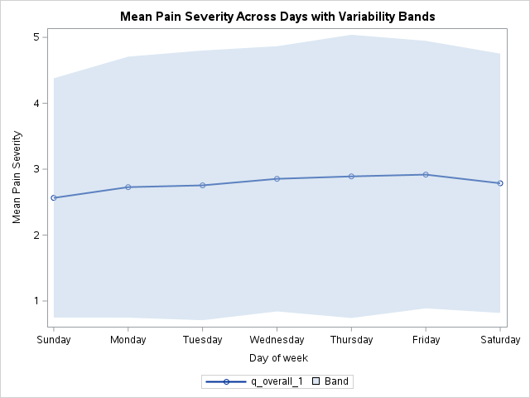

B. Changes of physical activity counts across day of the week
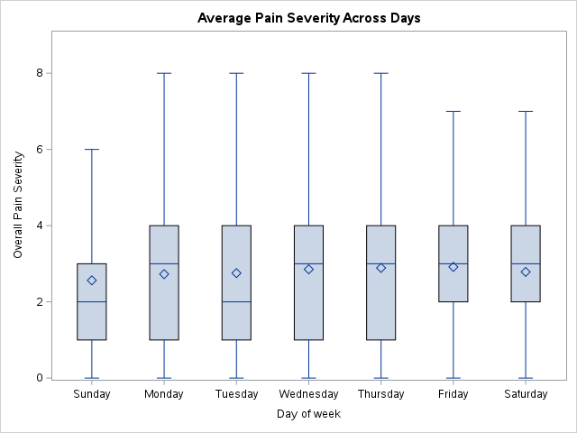

Supplementary Figure 2
A. Changes of overall pain severity by four time points across day of the week
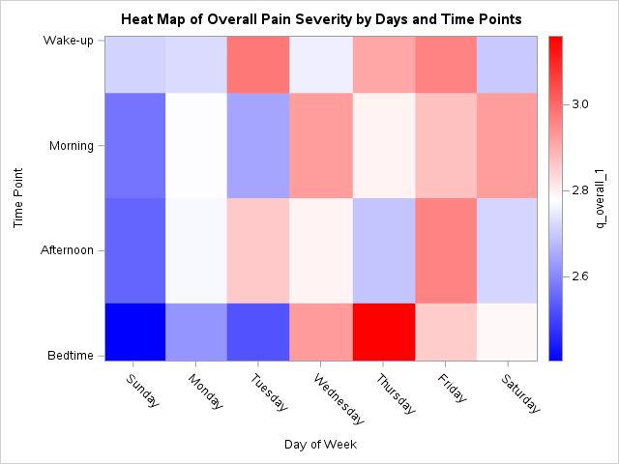

B. Changes of physical activity by four time points across day of the week
