6. Supplementary
Table S1. Standardized mean differences of baseline variables before and after propensity score matching
Variable | Upstaging (matched), mean/prop | Non-upstaging (matched), mean/prop | SMD
Age, years | 49.9 | 54.5 | 0.449
BMI | 22.6 | 23.2 | 0.146
Parity | 0.85 | 0.77 | 0.192
Palpable | 0.65 | 0.62 | 0.080
Side (Right) | 0.42 | 0.54 | 0.232
Max SMD |  |  | 0.449
All covariates balanced (SMD < 0.1) |  |  | No
SMD indicates absolute standardized mean difference. An SMD < 0.1 is commonly considered indicative of adequate covariate balance.

Figure S1. Covariate balance before and after propensity score matching
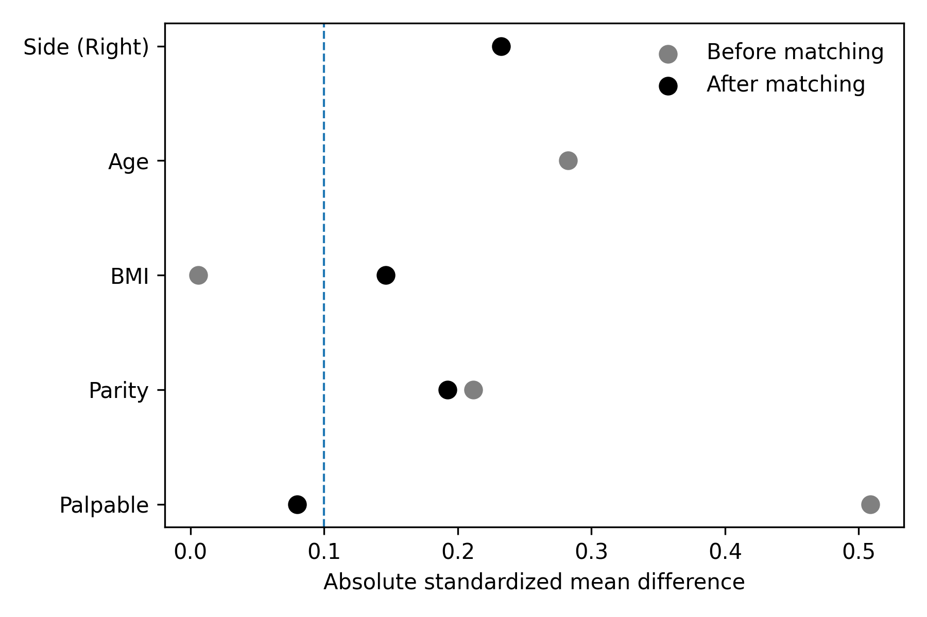
Standardized mean differences (SMDs) of baseline clinical variables before and after propensity score matching between the upstaging and non-upstaging groups. The dashed vertical line indicates the commonly accepted threshold for adequate balance (SMD = 0.1). Despite matching, several variables did not achieve sufficient balance, reflecting limited overlap between the two cohorts. Therefore, propensity score matching was not used as the primary analytical strategy.

Table S2. Complete results of late fusion analyses combining clinical variables and imaging-based models for DCIS upstaging prediction.
ID | Model group | Features included | AUC | ACC | ΔAUC vs Clinical | ΔAUC vs Best single-source
C1 | Clinical only | Clinical variables | 0.453 | 0.543 | 0.000 | -0.380
S* | Best single-source (MG_tumor) | MG_tumor | 0.833 | 0.800 | 0.380 | 0.000
MG1 | MG tumor core | MG tumor | 0.833 | 0.800 | 0.380 | 0.000
MG2 | MG peritumoral short | MG peri 2 mm | 0.628 | 0.743 | 0.175 | -0.205
MG3 | MG peritumoral mid | MG peri 5 mm | 0.739 | 0.743 | 0.286 | -0.094
MG4 | MG peritumoral long | MG peri 10 mm | 0.761 | 0.714 | 0.308 | -0.073
US1 | US tumor core | US tumor | 0.675 | 0.743 | 0.222 | -0.158
US2 | US peritumoral short | US peri 2 mm | 0.551 | 0.629 | 0.098 | -0.282
US3 | US peritumoral mid | US peri 5 mm | 0.543 | 0.629 | 0.090 | -0.291
US4 | US peritumoral long | US peri 10 mm | 0.688 | 0.686 | 0.235 | -0.145
US5 | US posterior near | US post 5 mm | 0.739 | 0.743 | 0.286 | -0.094
US6 | US posterior mid | US post 10 mm | 0.603 | 0.743 | 0.150 | -0.231
US7 | US posterior deep | US post 20 mm | 0.611 | 0.743 | 0.158 | -0.222
MGF1 | MG tumor + peri10 | MG tumor + peri10 | 0.821 | 0.771 | 0.368 | -0.013
MGF2 | MG tumor + peri5 | MG tumor + peri5 | 0.812 | 0.771 | 0.359 | -0.021
MGF3 | MG tumor + peri2 | MG tumor + peri2 | 0.829 | 0.829 | 0.376 | -0.004
MGF4 | MG peri5 + peri10 | MG peri5 + peri10 | 0.761 | 0.743 | 0.308 | -0.073
USF1 | US tumor + peri10 | US tumor + peri10 | 0.671 | 0.714 | 0.218 | -0.162
USF2 | US tumor + post5 | US tumor + post5 | 0.752 | 0.743 | 0.299 | -0.081
USF3 | US tumor + post10 | US tumor + post10 | 0.628 | 0.543 | 0.175 | -0.205
USF4 | US peri10 + post5 | US peri10 + post5 | 0.684 | 0.714 | 0.231 | -0.150
CMG1 | Clinical + MG tumor | Clin + MG tumor | 0.833 | 0.829 | 0.380 | 0.000
CMG2 | Clinical + MG peri10 | Clin + MG peri10 | 0.769 | 0.743 | 0.316 | -0.064
CMG3 | Clinical + MG peri5 | Clin + MG peri5 | 0.688 | 0.714 | 0.235 | -0.145
CMG4 | Clinical + MG tumor + peri10 | Clin + MG tumor + peri10 | 0.821 | 0.800 | 0.368 | -0.013
CUS1 | Clinical + US tumor | Clin + US tumor | 0.453 | 0.543 | 0.000 | -0.380
CUS2 | Clinical + US peri10 | Clin + US peri10 | 0.564 | 0.714 | 0.111 | -0.269
CUS3 | Clinical + US post5 | Clin + US post5 | 0.453 | 0.543 | 0.000 | -0.380
CUS4 | Clinical + US tumor + post5 | Clin + US tumor + post5 | 0.453 | 0.543 | 0.000 | -0.380
IM1 | MG tumor + US tumor | MG tumor + US tumor | 0.833 | 0.800 | 0.380 | 0.000
IM2 | MG tumor + US post5 | MG tumor + US post5 | 0.829 | 0.829 | 0.376 | -0.004
IM3 | MG peri10 + US post5 | MG peri10 + US post5 | 0.761 | 0.714 | 0.308 | -0.073
IM4 | MG peri5 + US post5 | MG peri5 + US post5 | 0.744 | 0.714 | 0.291 | -0.090
IM5 | MG tumor + peri10 + US post5 | MG tumor + peri10 + US post5 | 0.816 | 0.771 | 0.363 | -0.017
IM6 | MG tumor + US tumor + post5 | MG tumor + US tumor + post5 | 0.833 | 0.800 | 0.380 | 0.000
IM7 | MG peri10 + US peri10 | MG peri10 + US peri10 | 0.756 | 0.714 | 0.303 | -0.077
IM8 | MG tumor + US peri10 | MG tumor + US peri10 | 0.786 | 0.743 | 0.333 | -0.047
FULL1 | Clin + MG tumor + US tumor | Clin + MG tumor + US tumor | 0.833 | 0.829 | 0.380 | 0.000
FULL2 | Clin + MG tumor + US post5 | Clin + MG tumor + US post5 | 0.829 | 0.829 | 0.376 | -0.004
FULL3 | Clin + MG peri10 + US post5 | Clin + MG peri10 + US post5 | 0.765 | 0.714 | 0.312 | -0.068
FULL4 | Clin + MG tumor + peri10 + US post5 | Clin + MG tumor + peri10 + US post5 | 0.821 | 0.800 | 0.368 | -0.013
FULL5 | Clin + MG tumor + US tumor + post5 | Clin + MG tumor + US tumor + post5 | 0.833 | 0.829 | 0.380 | 0.000
FULL6 | Clin + MG peri10 + US tumor | Clin + MG peri10 + US tumor | 0.765 | 0.714 | 0.312 | -0.068
FULL7 | Clin + MG tumor + US peri10 | Clin + MG tumor + US peri10 | 0.791 | 0.743 | 0.338 | -0.043
FULL8 | Clin + MG tumor + peri10 + US tumor + post5 | Clin + MG tumor + peri10 + US tumor + post5 | 0.816 | 0.800 | 0.363 | -0.017
Comprehensive performance comparison of clinical, imaging, and fusion models for DCIS upstaging prediction. Predictive performance is reported as area under the receiver operating characteristic curve (AUC) and accuracy (ACC). ΔAUC indicates the absolute difference in AUC relative to the clinical-only baseline or the best single-source imaging model.

Table S3. Performance comparison of prior DCIS upstaging prediction models
Study (Year) | Cohort (N; upstaging %) | Endpoint definition | Modality | Feature type | Model | Validation | AUC | ACC
Lee et al. (2022) | 346; 43.3% | Histologic upgrade of DCIS | DCE-MRI | Radiomics | LR/SVM/RF + clinical fusion | internal split | 0.85 | 0.80
Miceli et al. (2023) | 68; 38.0% | Upgrade / invasive component | Ufast DCE-MRI | Ultrafast kinetics | logistic regression (kinetic parameters) | cross-validation | 0.87 | NR
Huang et al. (2025) | 87; 23.0% | Upstaging to invasive | MRI | Radiomics | radiomics nomogram | train/test split | 0.81 | 0.76
Alaeikhanehshir et al., (2024) | 161; 25.5% | High-risk DCIS / invasive-related risk | MG | Deep learning | clinical-imaging nomogram | train/val/test | 0.74 | 0.71
Zhang et al., (2025) | 464; 20.7% | Upstaging predictors/nomogram | US/clinical | Clinical + imaging | ROI-specific CNN + LR fusion | training + validation cohort | 0.83 | NR
Present study | 178; 27% | Biopsy DCIS → surgical invasive | MG/Clinical | Deep learning + fusion | LR fusion | fixed matched split + paired bootstrap | 0.833 | 0.829
Published studies differ in cohort composition, endpoint definition, imaging modality, and validation strategy; therefore, performance metrics are not directly comparable.
AUC = area under the receiver operating characteristic curve; ACC = accuracy; NR = not reported.

