Supplementary
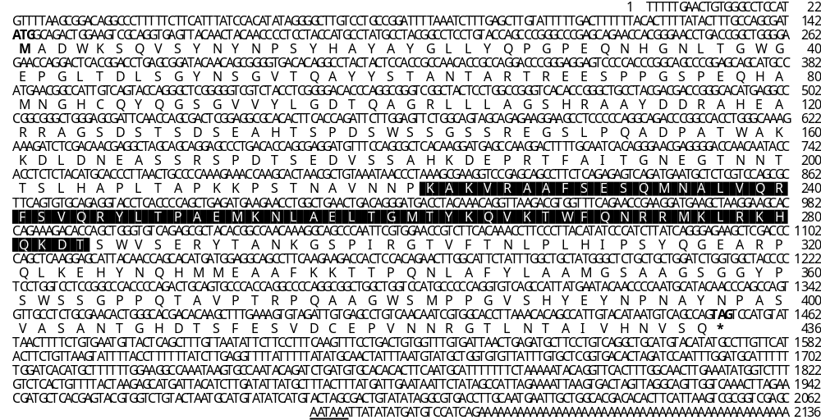
Fig. S1 Nucleotide sequence of sequence structural organization of Cv-Nanog.
Note: The homeobox domain (HOX) is shaded in black background. The start and stop codons are in boldface. The deduced amino acid sequences are shown underneath the CDS using single letter codes. Non-consensus polyadenylation signal (AATAAA) is underlined.
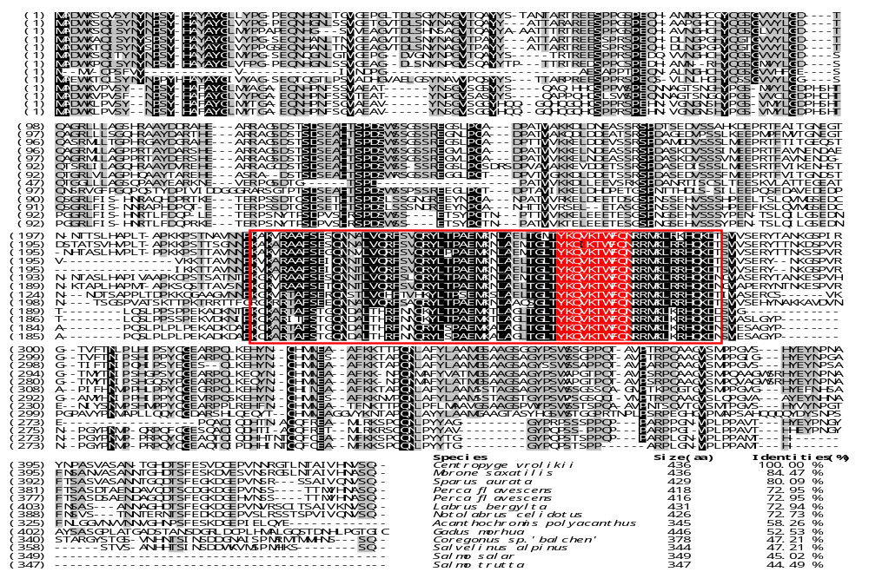
Fig. S2 Multiple sequence alignment of Cv-Nanog.
Note: Multiple alignment of full-length between Cv-Nanogand other species counterparts. The conserved homeodomain sequence is denoted within a red box, ans the conservative motif, YKQVKTWFQN, is shaded in red background.

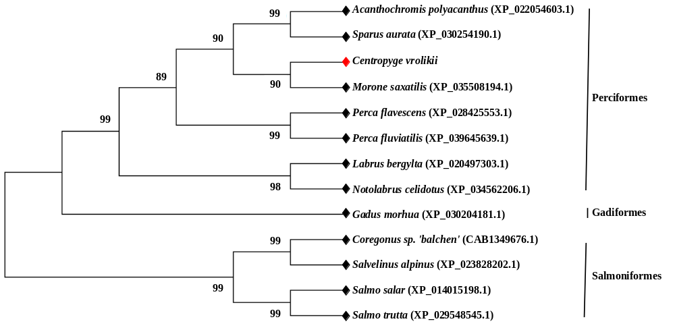
Fig. S3 Phylogenetic analysis of Cv-Nanog.
Note: The evolutionary relationship with other Nanog protein counterparts were verified by using MEGA 7.0 program by the bootstrap method of neighbor-joining (NJ) with 1,000 replicates. The bootstrap values are mentioned next to the branches. Accession numbers of each protein sequence are specified in parenthesis.
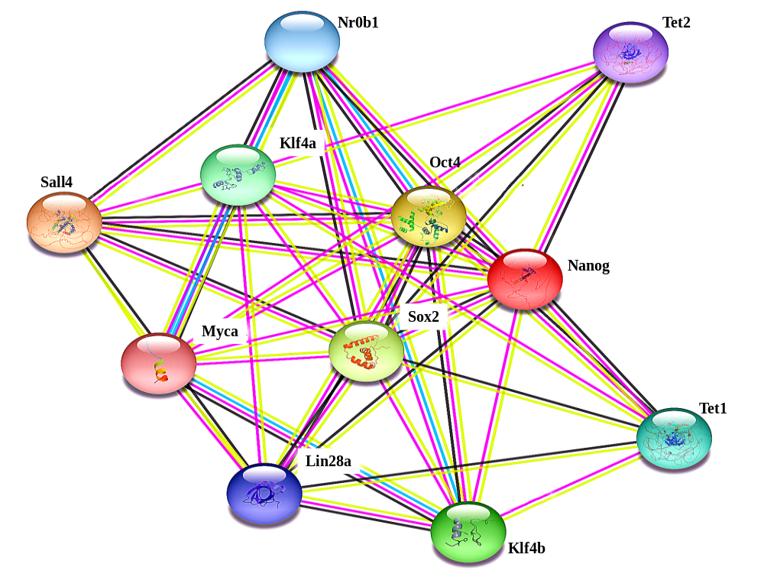
Fig. S4 Interaction network between Nanog and other factors/proteins involved in the pluripotency, as predicted by STRING.

Table S1 Primers used for various PCR amplifications and mRNA expression analysis of Nanog of Centropyge vrolikii.
Analysis methods | Primer Name | Primer Sequences (F or inner: 5’ to 3’) | Primer Sequences (R or outer: 5’ to 3’) | Accession
Partial CDS analysis | P-Nanog-F / -R | CTGACACCAGCGAGGATGTT | GGTCTTCTTGAAGGCTGCCT | /
RACE-PCR | UPM-long | CTAATACGACTCACTATAGGGCAAGCAGTGGTATCAACGCAGAGT |  | /
 | UPM-short | CTAATACGACTCACTATAGGGC |  | /
 | NUP | AAGCAGTGGTATCAACGCAGAGT |  | /
 | 5’-RACE-inner1 / -outer1 | TCCCTGTGATTGCAAAAGTC | CGAGAGCATTCATCTGACTC | /
 | 5’-RACE-inner2 / -outer2 | TCCGCTCAGGTCCGTGAGTC | TCACCCCGCTGTTGTATCC | /
 | 3’-RACE-inner1 / -outer1 | ATCAGGGAGAAGCTCGA | GTGTGCAGAGGTACCTCA | /
 | 3’-RACE-inner2 / -outer2 | GTGTTATTTGTGCTCGGTG | TGCATGTACATATGCCT | /
Full CDS analysis | F-Nanog-F / -R | ATGGCAGACTGGAAGTCGCA | CTACTGGCTGACATTATGTA | /
Positive clone selection | M13-47-F / M13-48-R | TGTAAAACGACGGCCAGT | CAGGAAACAGCTATGACC | /
 | T7-F / SP6-R | TAATACGACTCACTATAGGG | ATTTAGGTGACACTATAGAA | /
ISH probe | I-Nanog-F / R | AACAATCGTGGCACCTTA | TGTCACCGAGCACAAATA | /
Overexpression | O-Nanog-F1 / -R1 | ATGGCAGACTGGAAGTCGC | CTGGCTGTGGTTATGCACT | /
 | O-Nanog-F2 (KpnI) | aattctgcagtcgacGGTACCATGGCAGACTGGAAGTCGCA |  | /
 | O-Nanog-R2 (BamHI) | atggtggcgaccggtGGATCCCTGGCTGACATTATGTACAATGGC |  | /
Semi-RT-PCR | SRT-Nanog-F / -R | AACCCTAAAGCGAAGGTCCG | CTTGAAGGCTGCCTCCATCA | /
qRT-PCR | qRT-Nanog-F / -R | GATACAACAGCGGGGTGACA | GCTTGGTTTCTTTGGGGCAG | /
 | qRT-Oct4-F / -R | CTCTGCCCTGGAGTCCTACT | CTAACCAGTCCAGGGTGCAG | KF246681.1
 | qRT-cMyc-F / -R | CCGATCAGCTGGAGATGGTC | ACGGATGGATCGATGCACTC | KJ588782.1
 | qRT-Sox2-F / -R | GGTGGCTACGGTATGATGCA | CATGTCCCTCAGATCTCCGC | KF246679.1
 | qRT-Klf4-F / -R | TCCCCAGACCATCCTCTGAG | GCTTTGAGGTGGGAGCTCTT | XM_010742687.1
 | qRT-Lin28a-F / -R | TGCAAGTGGTTCAACATGCG | GCCCTCCACAGTTGTAGCAT | XM_010731616.3
 | qRT-Sf-1-F / -R | GTCCTCCAGCAGCTTCACAT | CTTCAAGGAGCTCAGGGTGG | XM_027287908.1
 | qRT-Cyp19a-F / -R | TGCACCGGACAGAGTTCTTC | GCAAACCGAGAACTGGGAGA | FJ800566.1
 | qRT-Foxl2-F / -R | CCAAATGAAACGTGAACACA | TGGCCCCAACATGAATATAG | XM_010731397.3
 | qRT-Dmrt1-F / -R | GGAGGAACACAAGGCTGACA | TGTCCACATCCACACTGAGC | XM_027278091.1
 | qRT-Sox9-F / -R | ATCTTACCCTCTCCCCTCCC | GTGAAGGTATGCTGGGTCCA | MH996432.1
 | qRT-Amh-F / -R | GACTGTGTGTTTGGCTGCAG | GTGCACTTGGTGGAGGAAGA | XM_027289871.1
 | qRT-Sox3-F / -R | GGCAACCCAAACACTGGTAT | GTCATCACCGGTGTCCTTCT | KJ588786.1
 | qRT-Rps29-F / -R | TCACCCCAGAAAATTCGGACAGG | GTATTTACGGATCAGACCGTGTC | XM_039782493.1

Table S2 Post-translation modified glycation and phosphorylation sites in Cv-Nanog protein.

Glycation |  |  |  | Phosphorylation
N-Gly |  |  |  | Serine |  |  |  |  |  |  | Threonine |  |  |  |  | Tyrosine
Pos | Sequence | NGlyc result |  | Pos | Score | Pos | Score | Pos | Score |  | Pos | Score | Pos | Score |  | Pos | Score | Pos | Score
31 | NMSN | ++ |  | 6 | 0.594 | 141 | 0.781 | 285 | 0.971 |  | 37 | 0.614 | 215 | 0.477 |  | 10 | 0.716 | 113 | 0.406
96 | NLTE | + |  | 9 | 0.682 | 142 | 0.608 | 288 | 0.893 |  | 45 | 0.533 | 248 | 0.935 |  | 12 | 0.397 | 246 | 0.498
176 | NKTQ | - |  | 15 | 0.438 | 144 | 0.993 | 297 | 0.983 |  | 55 | 0.455 | 259 | 0.438 |  | 16 | 0.898 | 263 | 0.468
260 | NGTV | ++ |  | 48 | 0.817 | 145 | 0.969 | 313 | 0.477 |  | 61 | 0.465 | 262 | 0.869 |  | 19 | 0.397 | 291 | 0.796
330 | NFSR | - |  | 52 | 0.475 | 149 | 0.968 | 352 | 0.475 |  | 64 | 0.743 | 268 | 0.687 |  | 21 | 0.399 | 314 | 0.413
369 | NLTS | ++ |  | 60 | 0.903 | 168 | 0.622 | 356 | 0.667 |  | 67 | 0.701 | 284 | 0.706 |  | 25 | 0.421 | 326 | 0.424
 |  |  |  | 71 | 0.997 | 169 | 0.979 | 361 | 0.956 |  | 98 | 0.457 | 292 | 0.444 |  | 50 | 0.405 | 346 | 0.377
 |  |  |  | 75 | 0.995 | 171 | 0.984 | 363 | 0.545 |  | 128 | 0.632 | 302 | 0.711 |  | 58 | 0.428 | 359 | 0.487
 |  |  |  | 90 | 0.511 | 175 | 0.971 | 364 | 0.522 |  | 135 | 0.513 | 305 | 0.459 |  | 59 | 0.449 | 389 | 0.563
 |  |  |  | 108 | 0.569 | 179 | 0.884 | 381 | 0.498 |  | 157 | 0.575 | 338 | 0.675 |  | 87 | 0.443 | 391 | 0.397
 |  |  |  | 125 | 0.991 | 180 | 0.911 | 387 | 0.823 |  | 174 | 0.963 | 339 | 0.519 |  | 94 | 0.388 | 396 | 0.479
 |  |  |  | 127 | 0.998 | 202 | 0.586 | 400 | 0.511 |  | 188 | 0.468 | 369 | 0.952
 |  |  |  | 129 | 0.996 | 214 | 0.510 | 403 | 0.461 |  | 192 | 0.581 | 373 | 0.537
 |  |  |  | 131 | 0.909 | 230 | 0.454 | 411 | 0.975 |  | 197 | 0.44 | 406 | 0.748
 |  |  |  | 136 | 0.823 | 232 | 0.605 | 414 | 0.827 |  | 200 | 0.443 | 410 | 0.947
 |  |  |  | 139 | 0.984 | 242 | 0.774 | 435 | 0.610 |  | 201 | 0.511 | 425 | 0.589
 |  |  |  |  |  |  |  |  |  |  | 208 | 0.906 | 428 | 0.681

Table S3 Protein-protein interacting networks as determined by STRING.
Coexpression
Textmining
Experiments
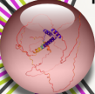
Nanog homeobox (436 AA): Ovary-expressed homeobox protein.
Score

Predicted Functional Partners:

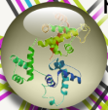 | Oct4 | POU domain, class 5, transcription factor 1; Involved in early development of embryos, especially in the process of gastrulation. Seems to be required to maintain the cells in a highly undifferentiated satte. May play an important role in establishing and specifying rhombomeric segments. | 0.999
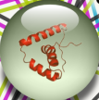 | Sox2 | Transcription factor Sox-2; Transcriptional activator. May function as a switch in neuronal development (By similarity). Downstream SRRT target that mediates the promotion of neural stem cell self-renewal. | 0.992
 | cMyc | Transcription factor that binds DNA in a non-specific manner. Activates the transcription of growth-related genes. | 0.938
 | Lin28a | Protein lin-28 homolog A; RNA-binding protein that inhibits processing of pre-let- 7 miRNAs and regulates translation of mRNAs. | 0.948
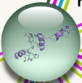 | Klf4a | Kruppel-like factor 4a. | 0.975
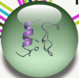 | Klf4b | Kruppel-like factor 4b. | 0.979
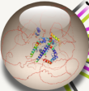 | Sall4 | Spalt-like transcription factor 4; Sal-like 4 (Drosophila). | 0.999
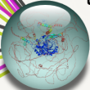 | Tet1 | Tet methylcytosine dioxygenase 1. | 0.950
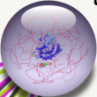 | Tet2 | Tet methylcytosine dioxygenase 2. | 0.943
 | Nr0b1 | Nuclear receptor subfamily 0, group B, member 1. | 0.949

Table S4 Abbreviations list of the manuscripts

Abbreviations | Full name
C. vrolikii | Centropyge vrolikii
Cv-Nanog | Nanog gene of C. vrolikii
qRT-PCR | Quantitative RT-PCR
OSKM | Oct4, Sox2, Klf4 and cMyc
iPSCs | Induced pluripotent stem cells
ESCs | Embryonic stem cells
SCs | Stem cells
LIF | Leukemia Inhibitory Factor
HD | Homeodomain
WR | Tryptophan rich domain
GSCs | Germ stem cell
DEGs | Differential expression genes
O_{Ⅱ} | The ovary at the perinucleolus stage
O_{T} | The ovotestis in the hermaphroditic period
O_{Ⅳ} | The ovary at the yolk vesicle stage
T | Testis
PFA | Paraformaldehyde
H.E | Hematoxylin-Eosin
DIG | The digoxigenin
WISH | In situ hybridization of whole mount samples
FBS | Fetal bovine serum
EGF | Epidermal Growth Factor
HGF | Hepatocyte Growth Factor
β-FGF | Fibroblast Growth Factor
CMC | Carboxy Methyl Cellulose
N-AG | N-acetyl-D-(+)-glucosamine
2-Me | 2-Mercaptoethanol
UTR | Untranslated Region
FSH | Follicle-Stimulating Hormone
OC_{Ⅱ} | The oocytes at stage Ⅱ
OC_{Ⅲ} | The oocytes at stage Ⅲ
OC_{Ⅳ} | The oocytes at stage Ⅳ
OW | The ovarian wall
OL | The oolemma
CT | The connective tissue
Y | The yolks
NB | The nutrient body
SG | The spermatogonia
SS | The secondary spermatocyte
S | The mature sperm
n | The nucleus

