A pilot scale-up study to evaluate the role of storage conditions on functional stability of PCL/hAM composite membrane as a wound dressing: An in vivo assessment
Supplementary Data:
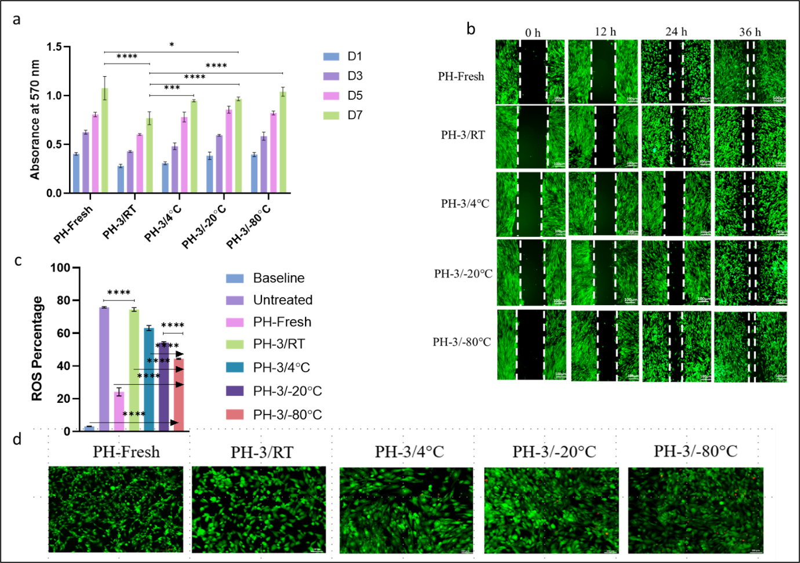
Fig S1. Effect of 3-month storage at different temperatures on PH composite membrane a: Quantitative analysis of proliferation via MTT assay
b: Representative fluorescence images of scratch wound healing assay depicting cell migration over time, c: Quantitative estimation of ROS, d: Live/dead staining images indicating cell viability
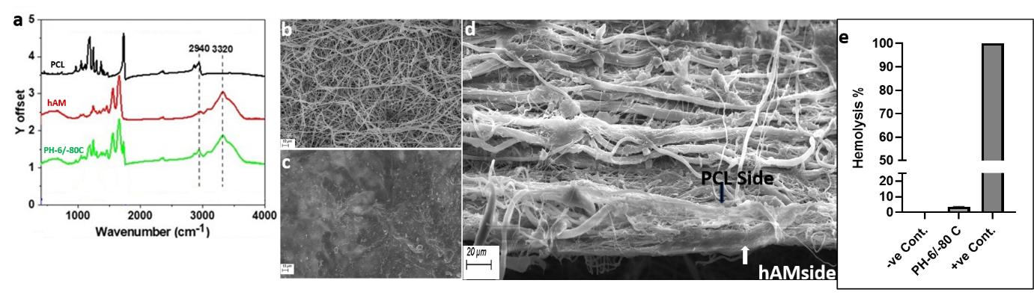
Figure S2: PH-6/-80 C membrane structural and functional stability assessment a) FTIR assessment of the PH composite membrane stored for 6 months at -80 °C to check the presence of functional groups, b) SEM image of PCL side of the membrane, c) SEM image of hAM side, d) SEM image of bi-layer integration showing intact bi-layer membrane even after storage, e) hemocompatibility of the membrane even after 6 months storage at -80 °C

