Supporting Information
Supporting Figures
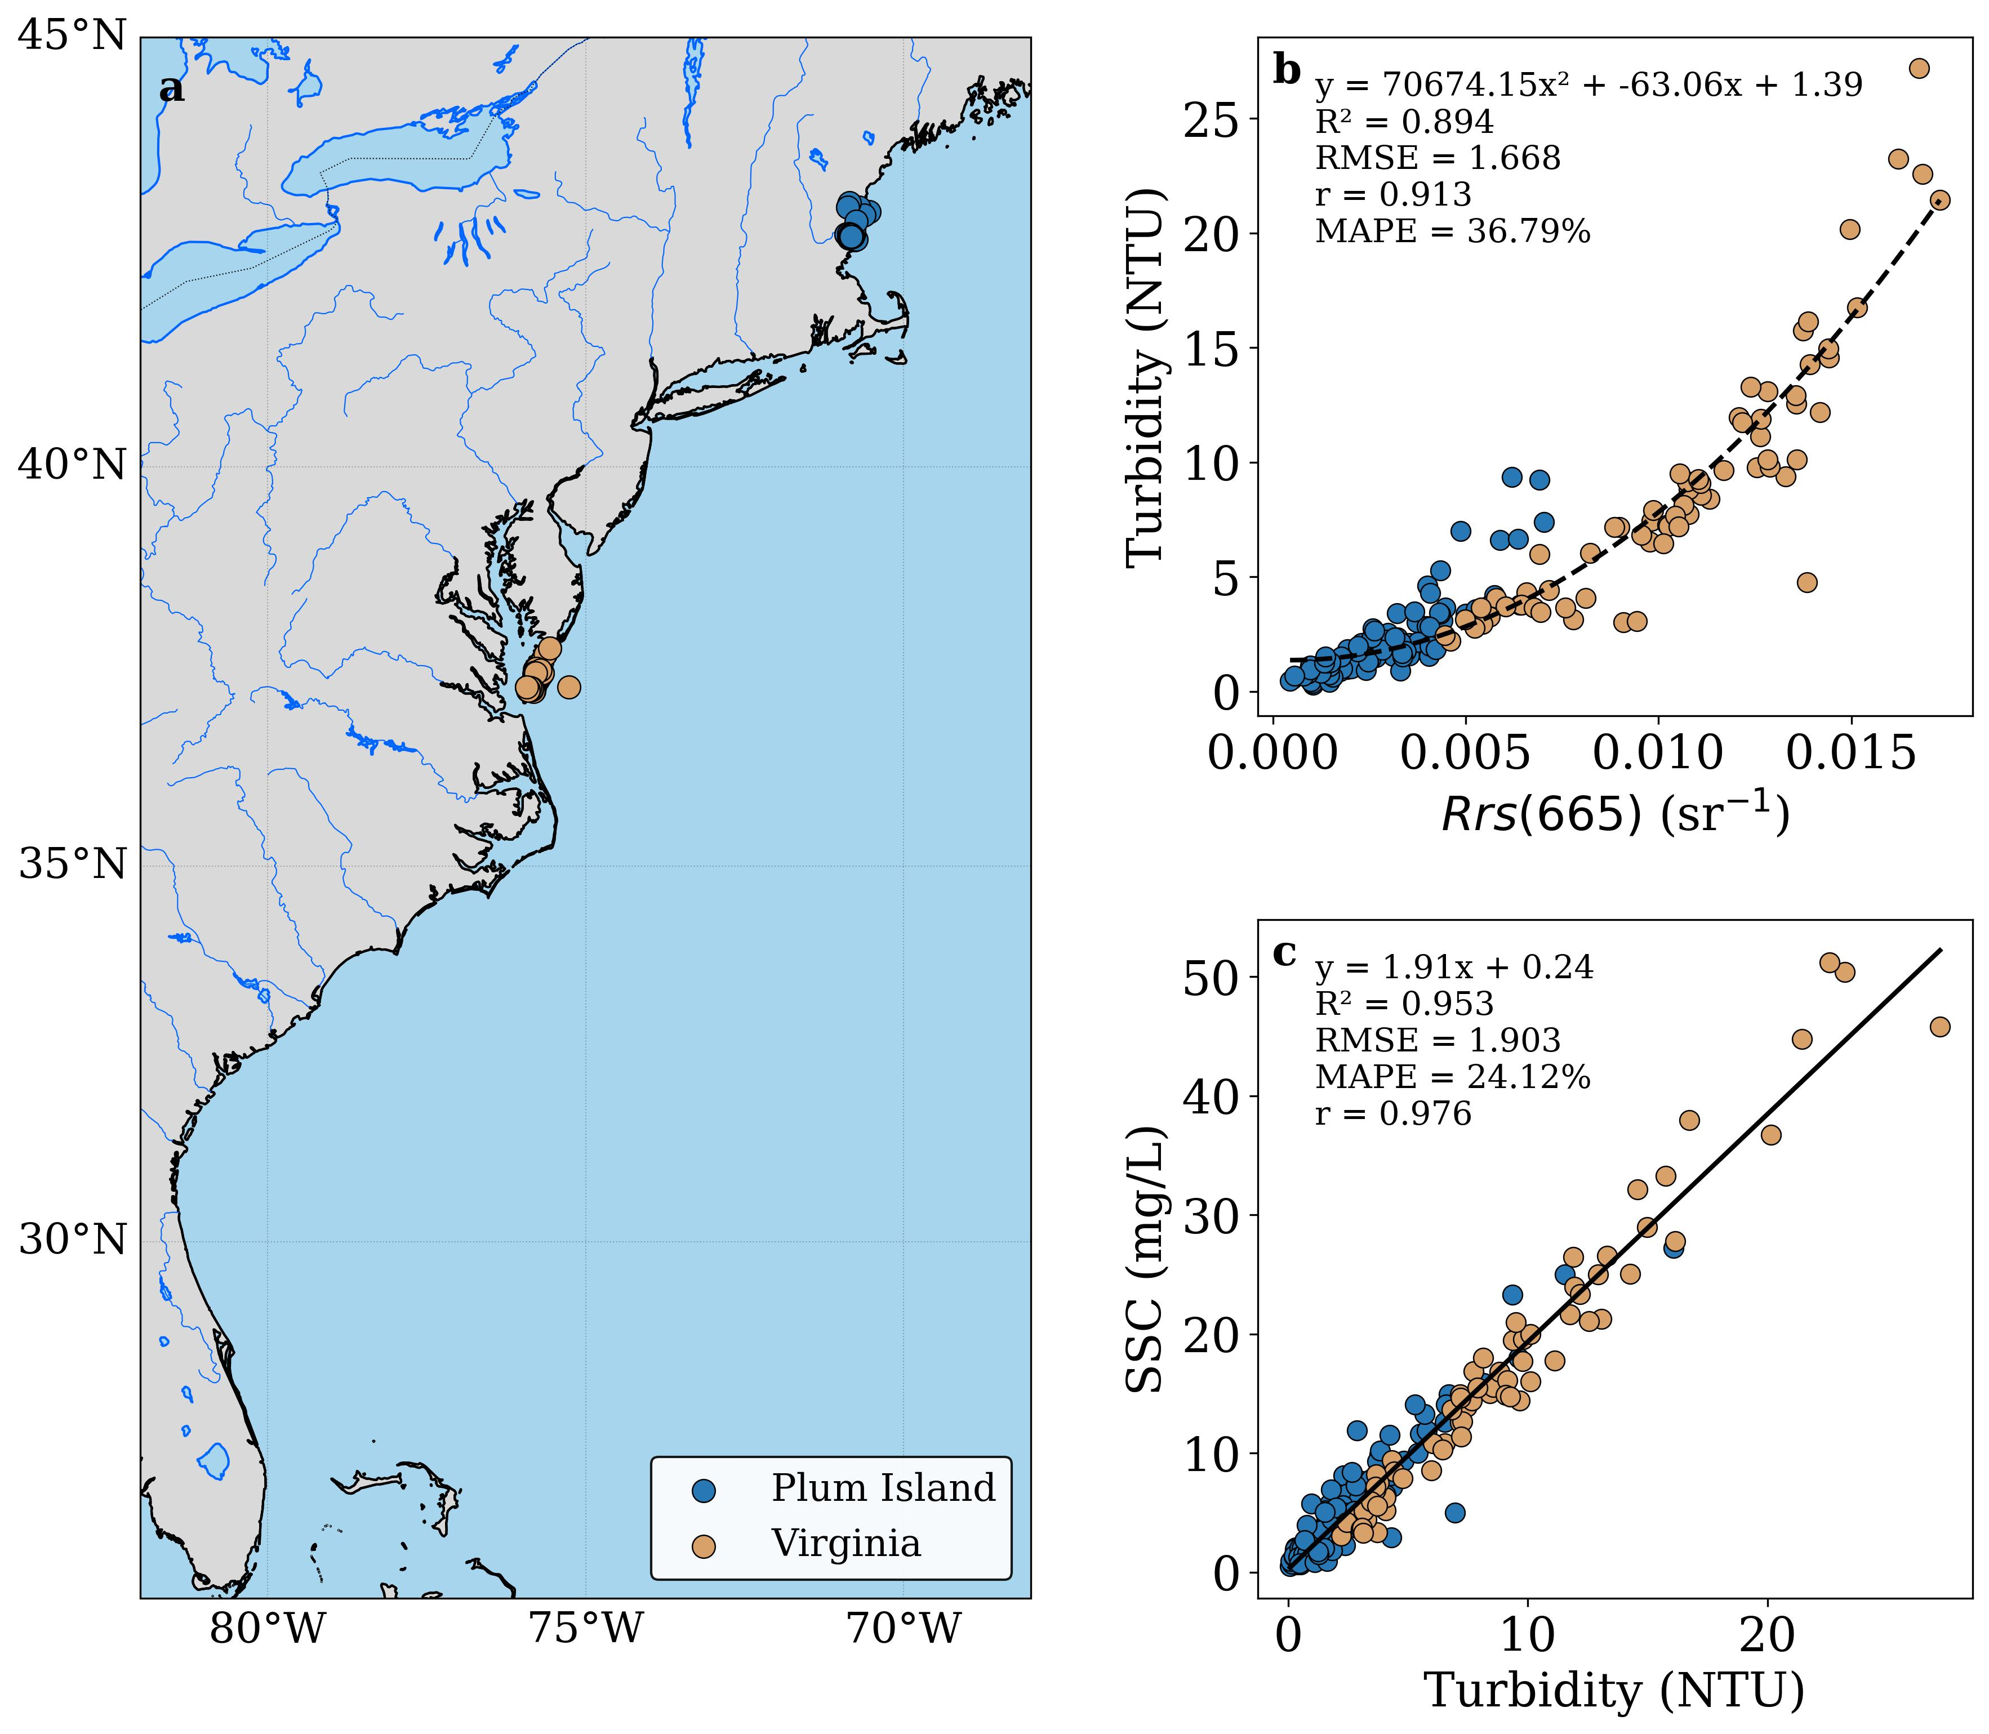
Figure S1 | Regional SSC retrieval framework using in situ measurements from Plum Island Ecosystems (PIE) and the Virginia Coast Reserve (VCR). (a) Map of sampling stations along the U.S. East Coast. (b) Relationship between in situ remote-sensing reflectance at 665 nm and turbidity. (c) Relationship between turbidity and SSC.

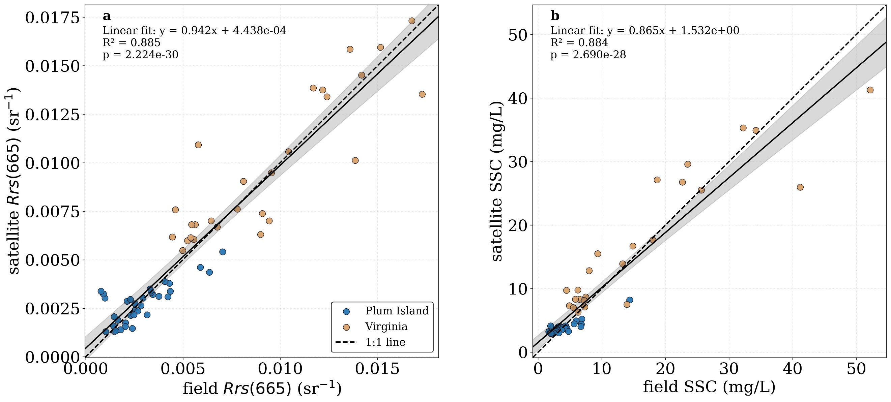
Figure S2 | Validation of satellite-derived products against in situ measurements. (a) Comparison between Landsat red-band reflectance and spectrally matched in situ reflectance. (b) Comparison between satellite-estimated SSC and field-measured SSC. Points are colored by sampling region. The solid black line shows the fitted regression, the gray band indicates the 95% confidence interval of the mean prediction, and the dashed line is the 1:1 reference.
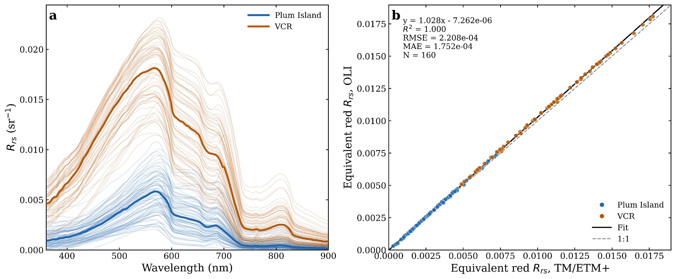
Figure S3 | Landsat red-band consistency across in situ hyperspectral spectra. (a) Measured hyperspectral remote-sensing reflectance spectra ($R_{rs}$) from the two study areas, Plum Island and the Virginia Coast Reserve (VCR), with individual samples shown as thin lines and group median spectra overlaid as thick lines. This panel shows the spectral shape and magnitude of the field observations used for sensor-response convolution. (b) Scatter comparison between TM/ETM+-equivalent red-band reflectance and OLI-equivalent red-band reflectance derived by convolving the measured hyperspectral spectra with the official Landsat spectral response functions. Points are colored by study area; the dashed line indicates the 1:1 relationship and the solid line shows the linear fit. The close agreement indicates that differences in red-band reflectance attributable solely to the Landsat sensor spectral response are small across the sampled optical conditions.
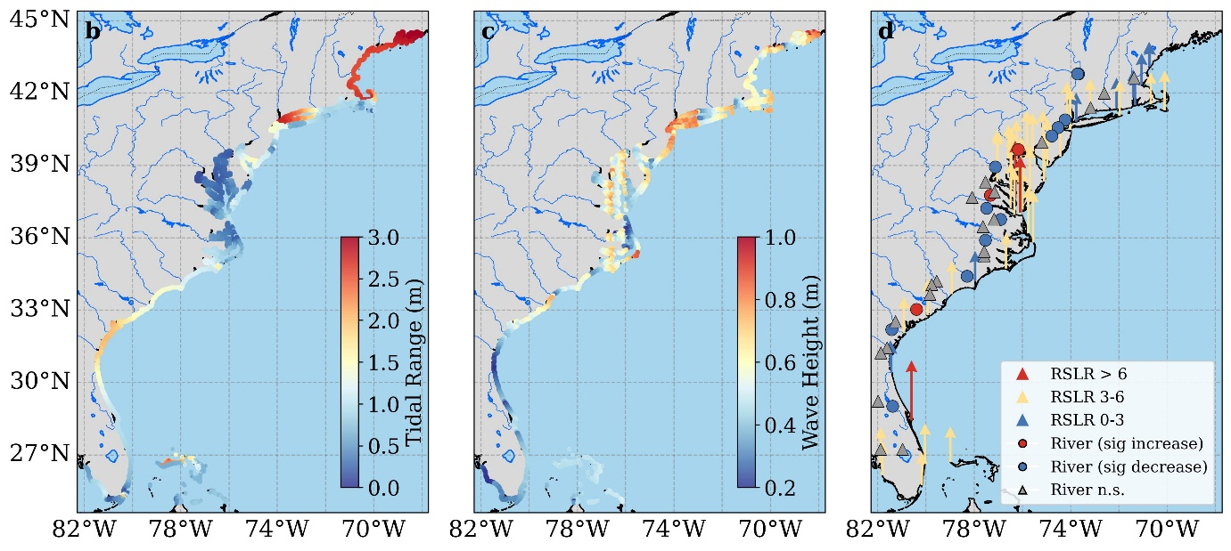
Figure S4 | Spatial patterns of the main forcing variables along the U.S. East Coast. (a) Mean tidal range. (b) Mean significant wave height. (c) Relative sea-level-rise rates and riverine sediment signals. Upward arrows indicate positive sea-level-rise rates, and river markers denote significant increases, significant decreases, or non-significant trends.

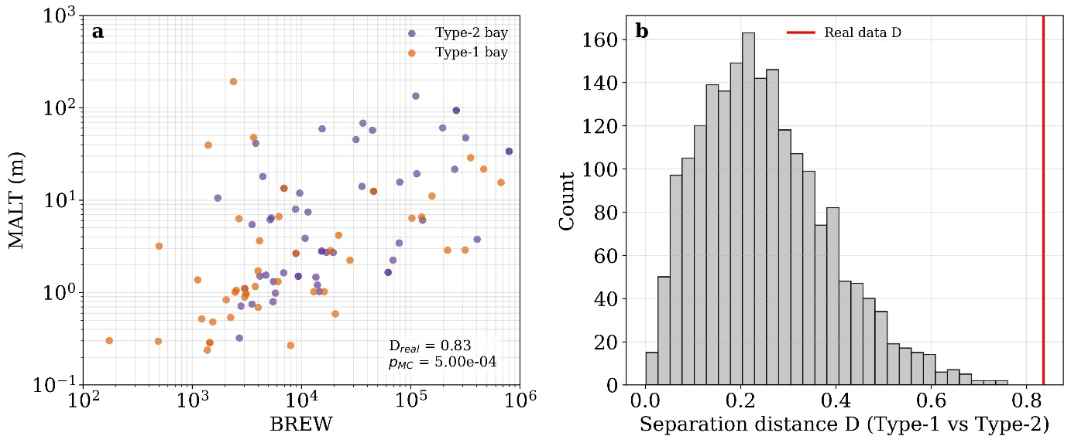
Figure S5 | Monte Carlo validation of the BREW-MALT separation between bay response modes. (a) Distribution of Type-1 and Type-2 bays in BREW-MALT space. The observed centroid separation between the two groups is labeled. (b) Null distribution of centroid separation from 2,000 random permutations of bay attributes. The vertical red line marks the observed value, showing that the empirical separation is stronger than expected by chance.

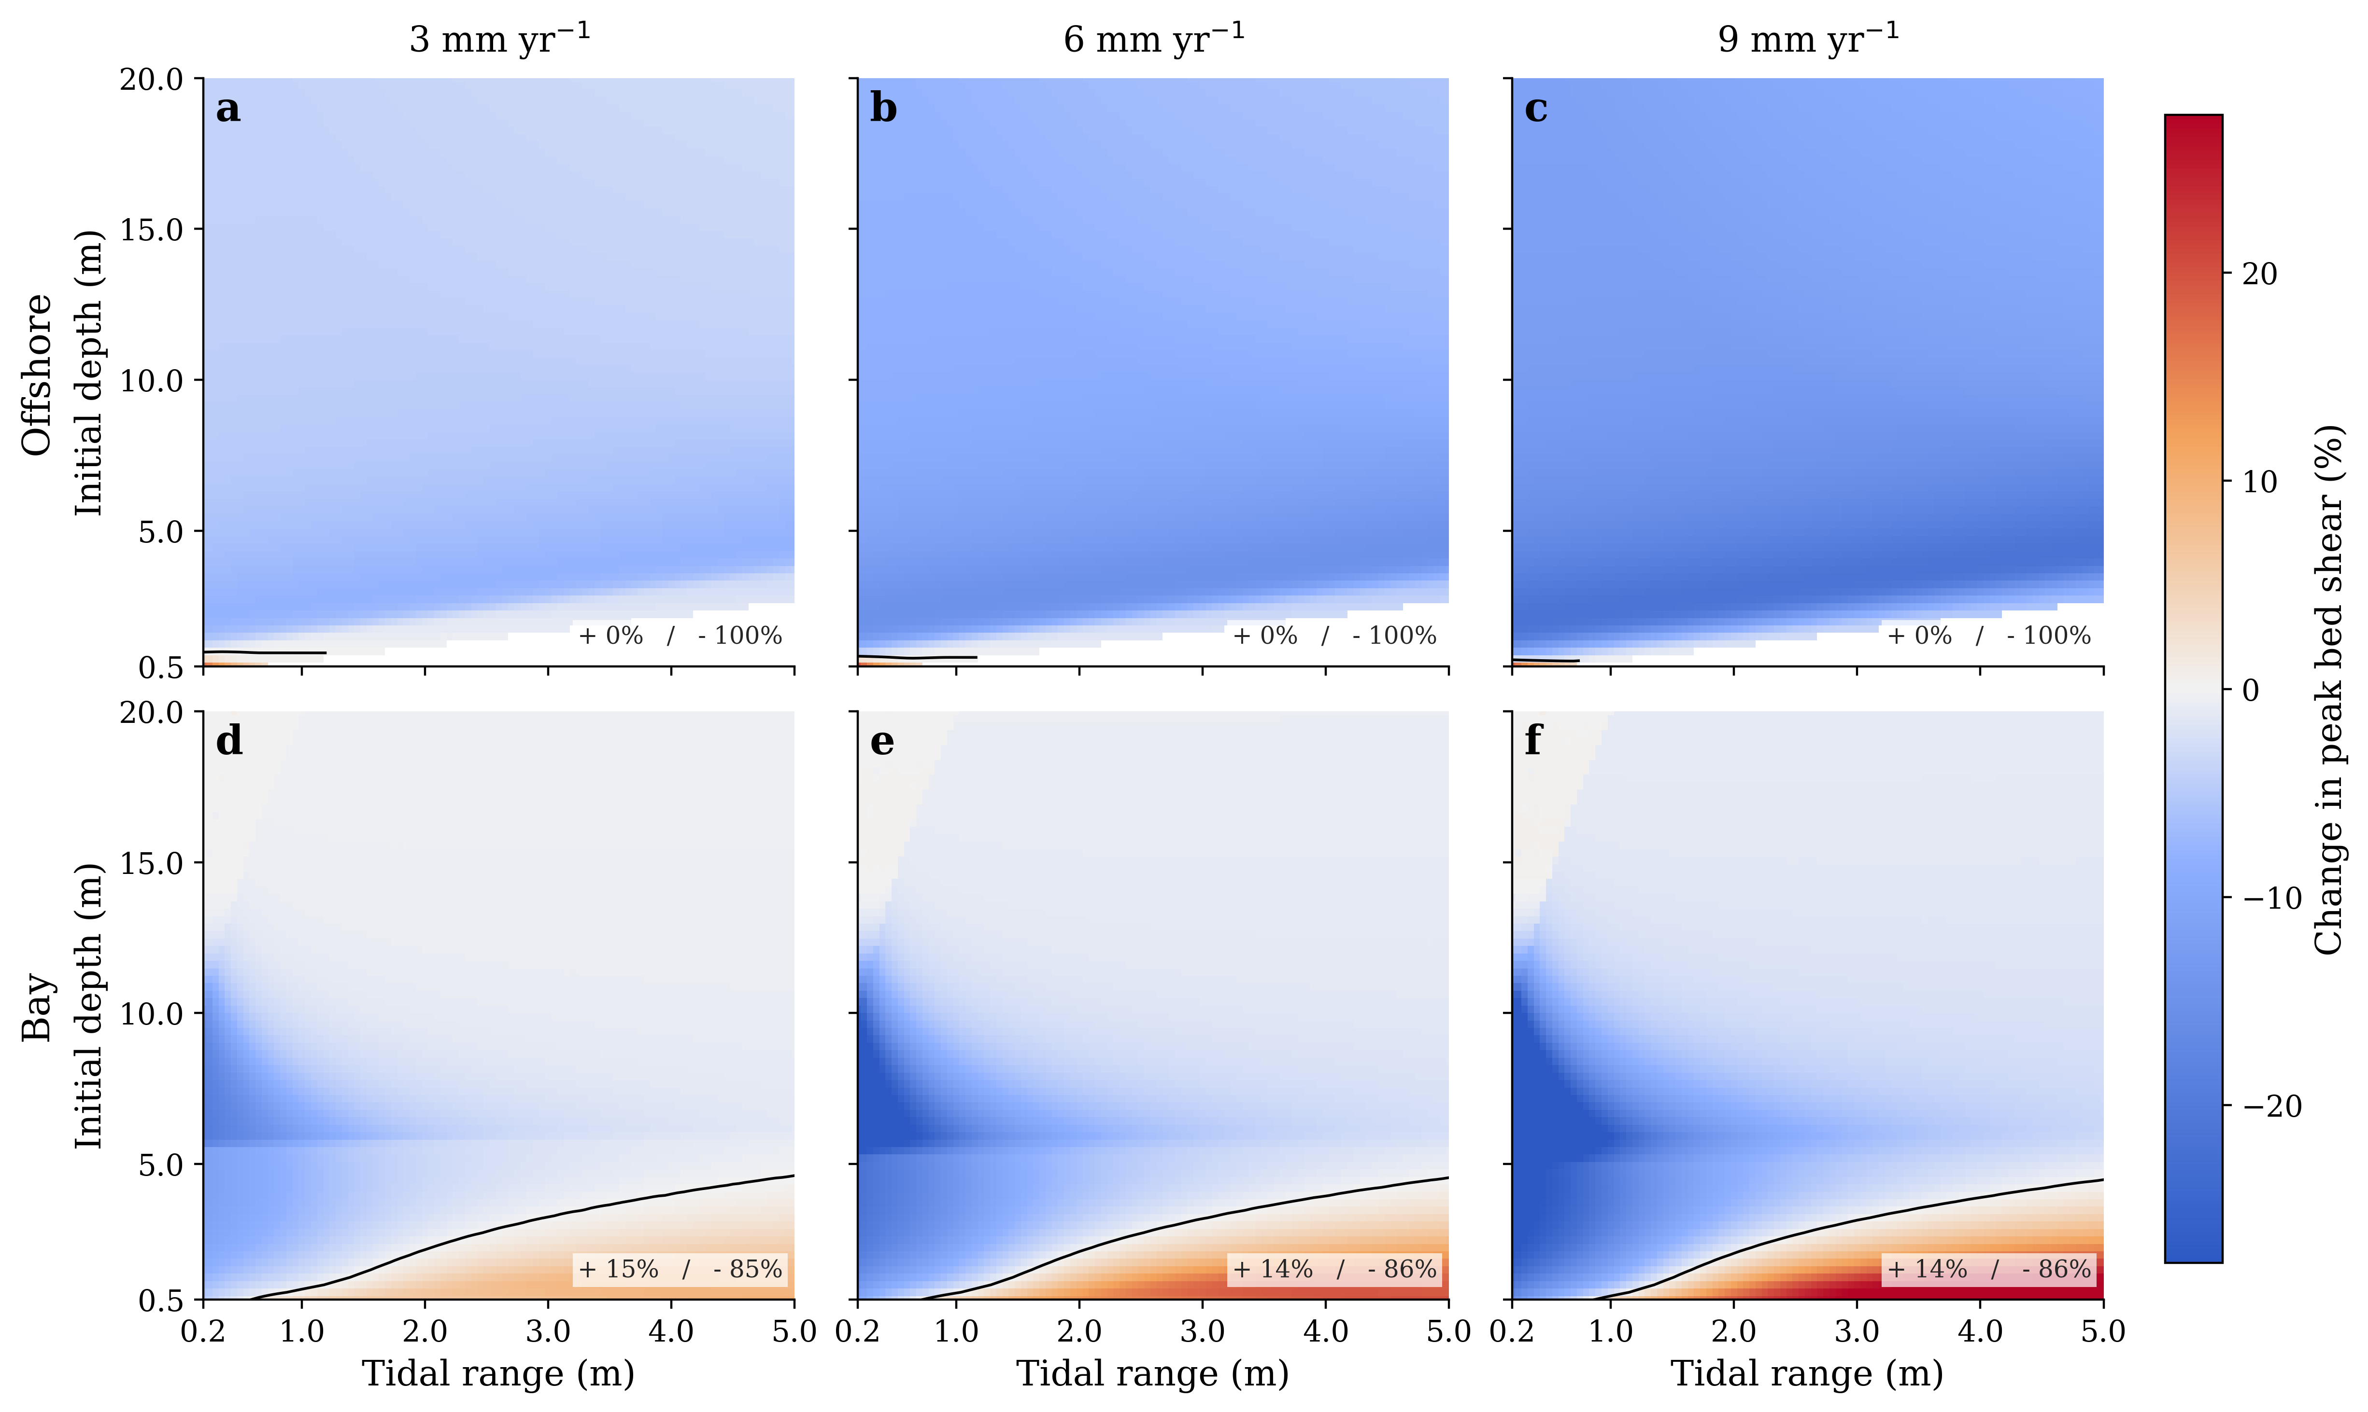
Figure S6 | Sea-level rise drives systematically different peak bed-shear responses offshore and inside bays across the depth–tidal-range space. Response surfaces show the percentage change in peak bed shear relative to the no-sea-level-rise baseline, plotted as a function of initial water depth and tidal range for offshore settings (top row) and bays (bottom row). Columns correspond to sea-level-rise rates of 3, 6, and 9 mm yr⁻¹. Warm colors indicate an increase in peak bed shear, whereas cool colors indicate a decrease. Black curves mark the zero-response boundary separating positive and negative sensitivity domains. Across the parameter space, offshore responses are more uniformly negative, consistent with shear reduction under deepening water, whereas bay responses remain more heterogeneous, indicating that sea-level rise in embayments can either weaken or enhance peak bed shear depending on the initial hydro-geomorphic setting.
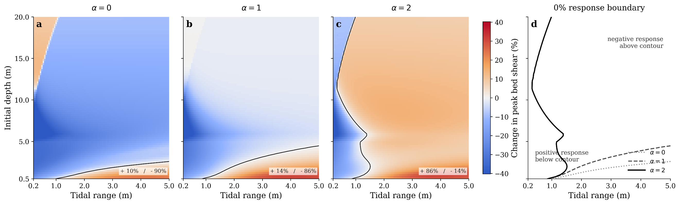
Figure S7 | Response surfaces and zero-response boundaries used to diagnose how geometry feedback alters the bay shear response to sea-level rise across depth–tidal-range space. (a–c) Response surfaces show the percentage change in peak bed shear in bays at a sea-level-rise rate of 9 mm/yr for three geometry-feedback scenarios parameterized by $α=0$, 1, and 2. Axes show initial water depth and tidal range; warm colors indicate increasing peak bed shear and cool colors indicate decreasing peak bed shear. Black curves denote the zero-response boundary. Here, $α=0$represents a laterally confined basin with negligible expansion of flooded area as depth increases, $α=1$represents an intermediate case with moderate depth-dependent storage growth, and $α=2$represents a low-relief system in which rising water levels inundate broad adjacent surfaces and generate strong geometric feedback. (d) Overlay of the zero-response boundaries for the three $α$ scenarios.
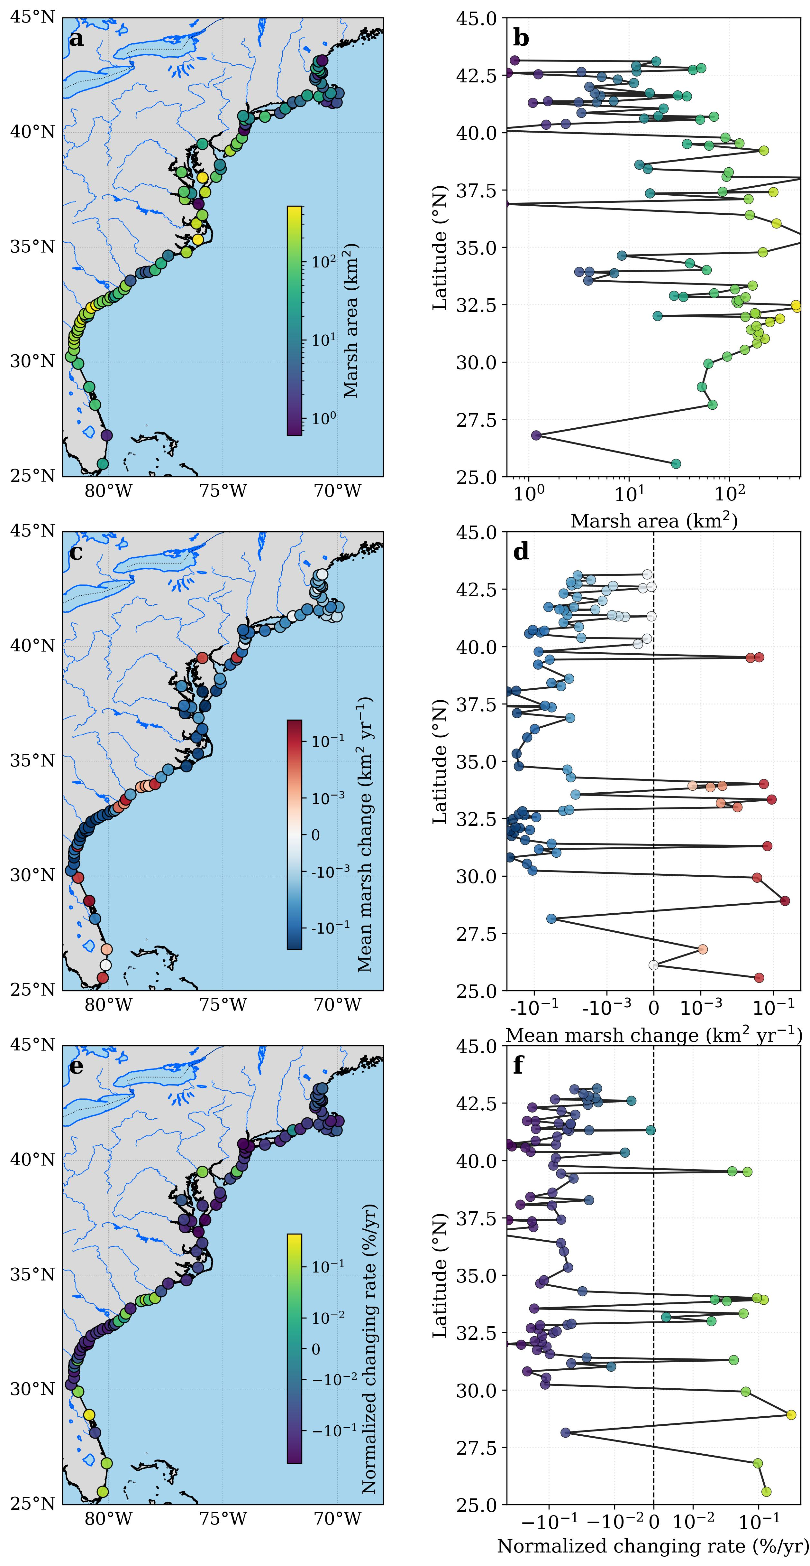
Figure S8 | Salt-marsh extent and change across U.S. East Coast embayments. (a,b) Spatial and latitudinal patterns of marsh area. (c,d) Spatial and latitudinal patterns of marsh area change rate. (e,f) Spatial and latitudinal patterns of normalized marsh change rate.

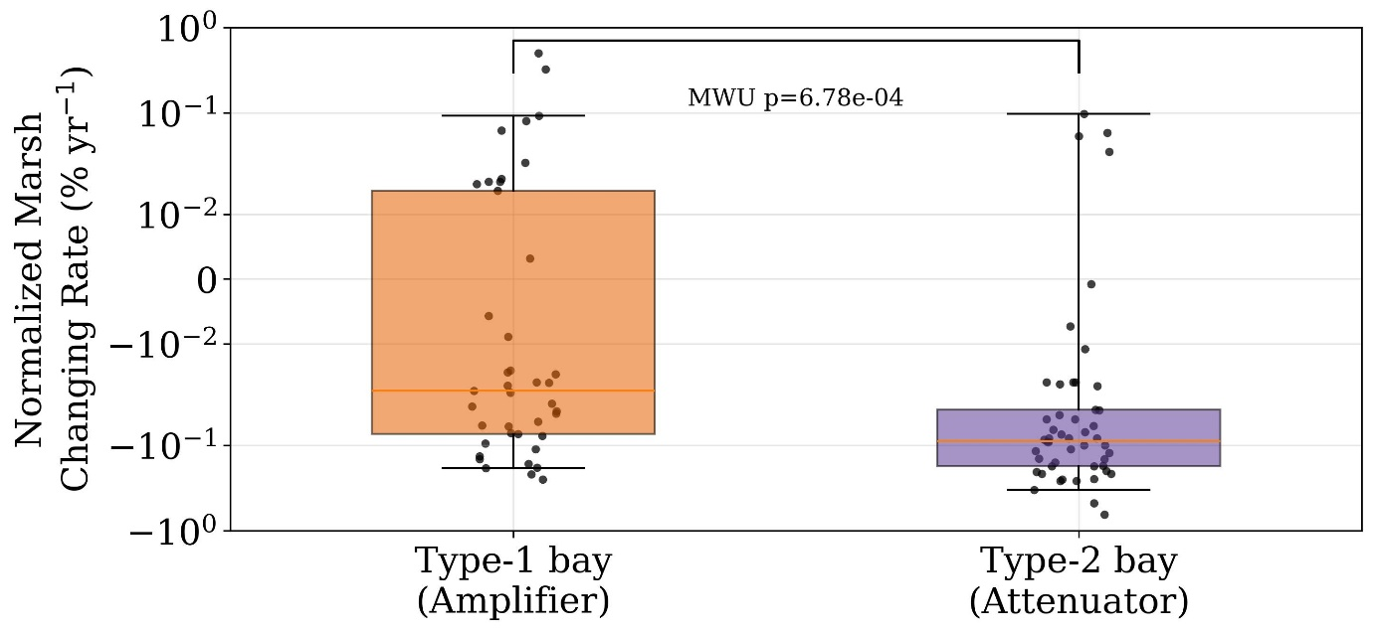
Figure S9 | Normalized marsh change rates in the two bay response modes. Boxplots compare Type-1 and Type-2 bays. The central line marks the median, boxes indicate the interquartile range, and significance is evaluated with a Mann-Whitney U test.

Supporting Text
Text S1 hydrodynamic framework for sea-level-rise sensitivity of peak bed shear in offshore waters and coastal bays
This note documents the reduced-order model structure, governing equations, parameter choices, numerical procedure, and interpretation used to support the theoretical sensitivity analysis of sea-level-rise (SLR) effects on bottom shear stress.^{13,20} The framework is diagnostic rather than predictive of suspended sediment concentration (SSC) itself, and isolates how deepening, wave limitation, inlet friction, and basin geometry alter the capacity of a system to mobilize sediment from the bed across a two-dimensional parameter space of initial water depth and tidal range.
Governing framework
The parameter space is defined by initial mean water depth $h_{0}$ and tidal range $R$. The external tide is prescribed as a semidiurnal oscillation with period $T$ and angular frequency
$$σ=\frac{2π}{T}.$$
The ocean-side water level is
$$η_{o}\left(t\right)=\frac{R}{2}sin\left(σt\right),$$
so that
$$\frac{dη_{o}}{dt}=\frac{Rσ}{2}cos\left(σt\right).$$
For a prescribed sea-level-rise increment $SLR$, the instantaneous water depth is written as
$$h\left(t\right)=h_{0}+SLR+η\left(t\right),$$
where $η\left(t\right)$ is either the imposed offshore elevation $η_{o}\left(t\right)$ or, in the bay branch, the prognostic interior elevation $η_{b}\left(t\right)$. A grid cell is retained only if the minimum depth over the analyzed tidal cycle remains larger than the dry-cell cutoff $h_{min}$. The principal diagnostic is the peak combined bed shear over one saved tidal cycle,
$$τ_{peak}=\max_{t}\left[τ_{max}\left(t\right)\right].$$
Wave module
Wave-bottom coupling is evaluated with linear wave theory. For a wave period $T_{p}$, the angular frequency is
$$ω=\frac{2π}{T_{p}},$$
and the wavenumber $k$ satisfies the dispersion relation
$$ω^{2}=gktanh\left(kh\right).$$
The near-bed orbital velocity amplitude is then
$$U_{w}=\frac{πH_{s}}{T_{p}sinh\left(kh\right)}.$$
Wave friction is represented with a rough-turbulent Soulsby-style parameterization.²⁰ Defining the orbital excursion amplitude
$$A=\frac{U_{w}T_{p}}{2π}, r=\frac{A}{k_{s,w}},$$
the wave friction factor is
$$f_{w}=\left\{\begin{matrix}0.30, & r≤1.57, \\ 0.00251exp\left(5.21 r^{-0.19}\right), & r>1.57,\end{matrix}\right.$$
clipped in the implementation to ${10}^{-4}≤f_{w}≤0.30$. The wave-induced bed shear stress is
$$τ_{w}=\frac{1}{2}ρf_{w}U_{w}^{2}.$$
In both offshore and bay settings, wave height is limited by depth-induced breaking. The breaking-limited height is
$$H_{break}=γh,$$
and the effective significant wave height is smoothed as
$$H_{s,eff}=H_{break}tanh\left(\frac{H_{s,raw}}{H_{break}}\right).$$
This form prevents unphysical growth of wave height in shallow water while avoiding a discontinuous hard cutoff.
Current module
Depth-averaged current drag is represented with a quadratic law based on a log-profile closure,
$$C_{D}={\left[\frac{κ}{ln\left(30h/k_{s,c}\right)-1}\right]}^{2},$$
where $κ$ is the von Karman constant and $k_{s,c}$ is the current roughness height. The current-only bed shear stress is
$$τ_{c}=ρC_{D}U_{c}^{2}.$$
Wave-current interaction is then represented with a Soulsby-type combination.²⁰ If $ϕ$ is the angle between current and wave directions, then
$$τ_{m}=τ_{c}\left[1+1.2{\left(\frac{τ_{w}}{τ_{c}+τ_{w}}\right)}^{3.2}\right],$$
and the instantaneous maximum combined stress is
$$τ_{max}={\left[{\left(τ_{m}+τ_{w}\left|cosϕ\right|\right)}^{2}+{\left(τ_{w}sinϕ\right)}^{2}\right]}^{1/2}.$$
In the implementation, if $τ_{c}$ is numerically negligible, the model sets $τ_{max}=τ_{w}$.
Offshore and bay branches
The two branches share the same stress formulation but differ in how wave and current forcing are obtained.
Offshore branch
The offshore branch is deliberately simple. Tidal current amplitude is prescribed rather than solved prognostically, and scales linearly with tidal range:
$$U_{a,off}=U_{ref}\frac{R}{R_{ref}}.$$
Because the code computes the current from the normalized stage rate, the offshore velocity is equivalently
$$U_{c,off}\left(t\right)=U_{a,off}\frac{dη_{o}/dt}{Rσ/2}=U_{a,off}cos\left(σt\right).$$
Offshore waves are prescribed with incident height $H_{s,inc}$ and period $T_{p,inc}$, then reduced by the breaking limiter above,
$$H_{s,raw}=H_{s,inc}, T_{p}=T_{p,inc}.$$
This branch therefore isolates the first-order effect of deepening on wave-bottom coupling and current drag without introducing channelized geometry or restricted exchange.
Bay branch
The bay branch is a friction-limited, single-inlet, single-basin box model. Its purpose is to capture the minimal additional physics required for semi-enclosed systems: restricted exchange, storage effects, and geometric feedback.
The basin-storage term is written in terms of basin area divided by inlet width,
$$\left(\frac{A}{B}\right)\left(h_{b}\right)=\left(\frac{A_{0}}{B}\right){\left(\frac{h_{b}}{h_{0}}\right)}^{α},$$
where $A_{0}/B$ is a reference storage scale, $h_{b}$ is the instantaneous bay depth, and $α$ controls the strength of geometric expansion with depth. This formulation is not intended to reproduce site-specific hypsometry, but to span a controlled range of geometric feedbacks from confined to laterally expansive basins. Here, $α$ parameterizes how strongly basin storage expands as water depth increases under sea-level rise. When $α=0$, the effective basin area-to-inlet-width ratio is depth-independent, representing a confined basin with little additional inundation of adjacent flats or marsh platforms. When $α=1$, storage increases approximately linearly with depth, representing an intermediate case in which rising water levels produce moderate lateral expansion of the flooded area. When $α=2$, storage increases super linearly with depth, representing a low-relief system in which small increases in water level inundate broad surrounding surfaces, such as tidal flats or marsh margins, and therefore generate strong geometric feedback on basin hydrodynamics. This is the key parameter linking the reduced-order model to accommodation-space feedback.
Let $U$ be the inlet current and $h_{in}$ the representative inlet depth. Continuity gives
$$\frac{dη_{b}}{dt}=\frac{Q}{A_{basin}}=\frac{Bh_{in}U}{A_{basin}}=\frac{h_{in}U}{A/B}.$$
The model uses the mean of ocean-side and basin-side depths as the representative inlet depth,
$$h_{in}=\frac{h_{o}+h_{b}}{2}.$$
The inlet current is computed from a Bernoulli-style head-loss closure. Defining the instantaneous head difference as
$$Δη=η_{o}-η_{b},$$
the current speed is
$$U=sgn\left(Δη\right){\left(\frac{2g\left|Δη\right|}{K_{total}}\right)}^{1/2},$$
with total loss coefficient
$$K_{total}=K_{minor}+C_{D,in}\frac{L_{in}}{h_{in}}.$$
Here $L_{in}$ is inlet length, $K_{minor}$ is a bulk minor-loss coefficient, and
$$C_{D,in}={\left[\frac{κ}{ln\left(30h_{in}/k_{s,c}\right)-1}\right]}^{2}.$$
The prognostic bay water level is then advanced explicitly through time using the continuity equation above. This structure prevents the unrealistically large shallow-water currents that can arise when continuity alone is forced through a very shallow inlet.
Wind waves inside the bay are generated rather than prescribed. The implementation uses the finite-depth, finite-fetch Young–Verhagen formulation.²⁷ With wind speed $U_{10}$ and fetch $F$,
$$δ=\frac{gh}{U_{10}^{2}}, X=\frac{gF}{U_{10}^{2}},$$
$$A_{1}=0.493 δ^{0.75}, B_{1}=0.00313 X^{0.57},$$
$$A_{2}=0.331 δ^{1.01}, B_{2}=0.0005215 X^{0.73}.$$
The non-dimensional energy and frequency variables are
$$\tilde{E}=0.00364{\left[tanh\left(A_{1}\right)tanh\left(\frac{B_{1}}{tanh\left(A_{1}\right)}\right)\right]}^{1.74},$$
$$\tilde{ν}=0.133{\left[tanh\left(A_{2}\right)tanh\left(\frac{B_{2}}{tanh\left(A_{2}\right)}\right)\right]}^{-0.37}.$$
These are converted to dimensional wave properties as
$$E=\tilde{E}\frac{U_{10}^{4}}{g^{2}}, H_{s,raw}=4\sqrt{E}, T_{p}=\frac{U_{10}}{g\tilde{ν}},$$
after which the same depth-limited breaking correction and wave-stress calculation are applied.
Numerical implementation and parameter choices
The model is evaluated on a rectangular parameter grid rather than at a specific field site. Initial depth spans $0.5$–$20.0 m$ using 80 evenly spaced values, and tidal range spans $0.2$–$5.0 m$ using 97 evenly spaced values. Main SLR experiments use rates of $3$, $6$, and $9 mm yr^{-1}$ over a 100-year horizon, corresponding to total deepening increments of $0.3$, $0.6$, and $0.9 m$. Bay-geometry sensitivity is evaluated at $9 mm yr^{-1}$ with $α=0$, 1, and 2.
Shared constants are fixed at $ρ=1025 kg m^{-3}$, $g=9.81 m s^{-2}$, $κ=0.40$, $T=12.42 h$, $ϕ=0^{∘}$, $k_{s,c}=0.02 m$, $k_{s,w}=0.02 m$, and $h_{min}=0.15 m$. Each saved tide cycle is resolved with $N_{t}=361$ time steps.
Offshore forcing uses $H_{s,inc}=1.0 m$, $T_{p,inc}=6.0 s$, $U_{ref}=0.20 m s^{-1}$, $R_{ref}=2.0 m$, and a common breaking index of $γ=0.78$. Bay forcing uses $U_{10}=10.0 m s^{-1}$, $F=10,000 m$, $\left(A_{0}/B\right)=50,000 m$, $L_{in}=4000 m$, $K_{minor}=3.0$, the same $γ=0.78$, and a default geometry exponent $α=1$ unless otherwise stated.
The bay model is spun up for eight full tidal cycles, and diagnostics are taken from the final cycle. This removes initialization transients in $η_{b}\left(t\right)$ and ensures that the reported stresses reflect the periodic solution of the reduced system.
The principal mapped response quantity is the percent change in peak bed shear relative to the baseline state,
$$Δτ_{peak}\left(\%\right)=100×\frac{τ_{peak}^{future}-τ_{peak}^{baseline}}{τ_{peak}^{baseline}}.$$
Contours of $Δτ_{peak}=0$ therefore mark the transition between parameter combinations for which SLR strengthens near-bed mobility and those for which it weakens it.
Interpretation for SSC trends
The theoretical model is not an SSC model and should not be interpreted as predicting concentration trends directly. A positive response in $Δτ_{peak}$ means only that the capacity for bed remobilization has increased. Long-term SSC must still satisfy a broader suspended-sediment mass balance. In a reduced form,
$$\frac{dM_{sus}}{dt}=F_{offshore}+E_{internal}-D_{settling/assimilation}-F_{export},$$
with concentration approximately given by
$$C≈\frac{M_{sus}}{V},$$
where $M_{sus}$ is suspended sediment mass and $V$ is water volume. Offshore SSC decline can therefore remain the dominant background forcing even when SLR increases local bed-shear sensitivity within a bay.
In that framework, SLR modifies bay SSC by changing wave-current shear, effective fetch, and accommodation space. Internal resuspension therefore acts mainly as partial compensation rather than a guaranteed source of net concentration increase. High-BREW and/or high-MALT systems are thus expected to show slower SSC decline than adjacent offshore waters; if that buffering co-occurs with faster marsh retreat, the most consistent interpretation is remobilization of internal geomorphic capital.

