Additional file 1: Supplementary Material
Contents: S1 Supplementary methods; S2 Supplementary figure (S1); S3 Supplementary tables (S1-S3); S4 STROBE/RECORD reporting checklist.
S1. Supplementary Methods
S1.1 Variable derivation
Exposure. The three-level digital-integration variable was derived from two NHATS technology-module items: whether the participant went online and whether the participant had an internet-based telehealth visit with a medical provider. Telehealth users reported an internet-based telehealth visit; connected non-users went online but reported no such visit; and completely disconnected participants reported not going online. The gating skip for the telehealth item among offline participants was coded as consistent with offline status. Refused and “don’t know” responses were coded as missing and handled using multiple imputation.
High cardiovascular risk. High cardiovascular risk was defined as a reported diagnosis of heart disease, hypertension, or diabetes in the chronic-condition module, using carry-forward coding in which a previously reported diagnosis was counted as present. The established cardiovascular disease covariate, defined as prior myocardial infarction, heart disease, or stroke, was constructed using data up to and including the entry round.
Outcomes. Death was ascertained from round 14 tracker case-status codes. Transition to nursing home or residential care was ascertained from the residential-status variable; participants already in residential care at entry were excluded from this risk set. The composite endpoint was death or transition to residential care.
Geriatric-vulnerability covariates (M4). The M4 block added the following covariates: assistance with activities of daily living, counted from 0 to ≥2 across eating, bathing, toileting, and dressing; frequency of going outside, used as a proxy for homebound status; a positive depression screen, defined as a Patient Health Questionnaire-2 score ≥3; self-rated memory; and household income tertile. All covariates were measured at the entry round; participants with missing values for a given item were retained using an explicit missing category.
S1.2 Statistical models
The primary model was a survey-weighted discrete-time survival model with a complementary log-log link, fitted to a stacked person-period dataset that pooled the three entry cohorts and included entry-cohort fixed effects and cluster-robust variance estimation at the participant level. As a consistency check, each entry cohort was estimated separately using its corresponding NHATS survey design, and the estimates were combined using an inverse-variance random-effects meta-analysis. The following robustness analyses were conducted and are reported in the main text (Table 4) and below: (1) multiple imputation by chained equations with 10 imputations for covariate missingness; (2) cause-specific and Fine–Gray subdistribution models for transition to residential care, with death treated as the competing event; (3) exclusion of first-interval events; (4) restriction to self-respondents; and (5) characterization of loss to follow-up by exposure group using extreme-scenario bounds. A time-varying exposure analysis was considered but not adopted as the primary analysis because updating connectivity during follow-up could reintroduce susceptibility to reverse causation; connectivity was therefore fixed at the entry-round value.
S2. Supplementary Figure
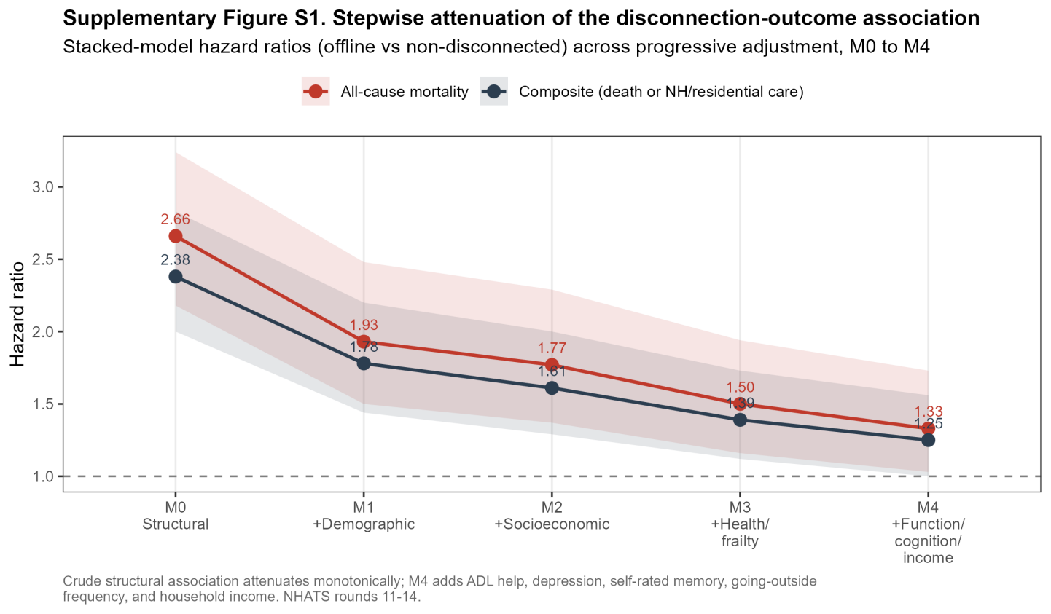

Supplementary Figure S1. Stepwise attenuation of the stacked-model hazard ratio for offline versus non-disconnected status across progressive confounder adjustment (M0 structural terms only to M4 full geriatric-vulnerability model), for all-cause mortality and the composite end point.
S3. Supplementary Tables
Supplementary Table S1. Fully adjusted (M3) hazard ratios for the additional contrast of complete disconnection versus connected non-users (reference).
Outcome and model | Stacked (primary) | R11 | R12 | R13 | Meta-analytic (I-squared)
Composite end point (M3) | 1.38 (1.09-1.75) | 1.37 (1.03-1.82) | 1.43 (0.97-2.10) | 1.36 (0.92-2.00) | 1.38 (1.14-1.68); 0%
All-cause mortality (M3) | 1.49 (1.13-1.96) | 1.33 (0.92-1.93) | 1.97 (1.26-3.08) | 1.17 (0.78-1.77) | 1.42 (1.13-1.80); 34%
Note. Hazard ratios (95% CI). Reference category is connected non-users. Models adjusted as in main-text Table 3 (M3).
Supplementary Table S2. Secondary contrast between telehealth users and connected non-users by adjustment model, showing similar risk among connected adults.
Adjustment model | Composite - stacked | Composite - meta (I-squared) | Mortality - stacked | Mortality - meta (I-squared)
M0 (structural terms only) | 0.88 (0.70-1.10) | 0.88 (0.74-1.05); 55% | 0.89 (0.68-1.17) | 0.89 (0.73-1.09); 42%
M1 (+demographic) | 0.98 (0.78-1.23) | 1.00 (0.85-1.18); 64% | 0.98 (0.75-1.29) | 1.00 (0.82-1.21); 49%
M2 (+socioeconomic) | 1.02 (0.81-1.28) | 1.03 (0.87-1.22); 64% | 1.01 (0.77-1.34) | 1.04 (0.85-1.27); 54%
M3 (+health/frailty) | 0.99 (0.79-1.24) | 1.00 (0.85-1.18); 61% | 0.99 (0.75-1.30) | 1.00 (0.82-1.22); 52%
M4 (+geriatric vulnerability) | 1.03 (0.82-1.29) | 1.05 (0.89-1.25); 55% | 1.02 (0.78-1.34) | 1.02 (0.84-1.24); 61%
Note. Hazard ratios (95% CI). The near-1.0 stacked estimates show no evidence of materially different risk that telehealth adoption, conditional on being online, is not associated with the hard outcomes. The per-cohort meta-analytic estimates are heterogeneous (I-squared up to 64%); the single stacked estimate is the more stable summary.
Supplementary Table S3. Survey-weighted loss to follow-up by digital-integration group.
Exposure group | Weighted loss to follow-up
Connected non-user | 11.3%
Telehealth user | 11.8%
Completely disconnected | 14.0%
Note. Loss to follow-up = no composite event and last observation before round 14. Under extreme-scenario bounding (offline losses recoded as event-free and non-disconnected losses as events, and the reverse), the stacked M3 composite hazard ratio ranged from 1.07 to 1.85.
S4. STROBE / RECORD Reporting Checklist
The study is reported in accordance with the STROBE statement for cohort studies and the RECORD extension for studies using routinely-collected data. Item locations refer to the main manuscript.
Item | STROBE/RECORD recommendation | Location
1 | Informative title and structured abstract | Title; Abstract
2 | Background and rationale | Background
3 | Specific objectives and pre-specified hypotheses | Background (final paragraph)
4 | Cohort study design stated early | Methods, Study Design
5 | Setting, locations, and periods (2021-2025) | Methods, Study Design
6 | Eligibility criteria, sources, selection; staggered entry | Methods, Analytic Population; Figure 1
7 | Outcomes, exposures, predictors, confounders defined | Methods, Exposure / Outcomes and Covariates
8 | Sources and methods of measurement | Methods; Appendix S1.1
9 | Bias: confounding, reverse causation, proxy response, loss to follow-up | Methods, Statistical Analysis; Discussion
10 | Study size and unit of analysis (person-baseline) | Methods, Analytic Population; Figure 1
11 | Quantitative handling of variables; adjustment blocks M0-M4 | Methods, Covariates and Statistical Analysis
12 | Statistical methods, survey design, stacked model, pooling, sensitivity | Methods, Statistical Analysis
13 | Participants and numbers at each stage | Figure 1; Results, Baseline
14 | Descriptive data by exposure group | Table 1
15 | Outcome events over time; event counts | Table 2; Figure 4
16 | Main results with adjusted estimates and CIs | Table 3; Figures 2-3
17 | Other analyses: E-values, multiple imputation, competing risk, sensitivity | Table 4; Suppl. Tables S1-S3
18 | Key results summarized with reference to objectives | Discussion, Principal Findings
19 | Limitations, with direction and magnitude of potential bias | Discussion, Strengths and Limitations
20 | Interpretation (prognostic, not causal) | Discussion, A Prognostic Marker Not a Causal Factor
21 | Generalizability | Discussion; Methods (national sample)
22 | Funding and role of the funder | Declarations, Acknowledgments
RECORD 6.1-6.3 | Data source, codes, validation; population selection | Methods; Appendix S1.1; Figure 1
RECORD 7.1 | Variables derived from routinely-collected data | Appendix S1.1
RECORD 13.1 | Detailed selection of persons; linkage | Figure 1; Methods
RECORD 19.2 | Implications of using data not created for research | Discussion, Strengths and Limitations

