Electric-Field-Induced Ferromagnetic-to-Altermagnetic Phase Transition in a Two-Dimensional Fractional-Quantum Ferroelectric Multiferroic
Ziyue Yang, ¹ Meiling Xu,^{1,*} Jingyan Chen,¹ Zhuohang Xie², Shihai Wu,³
Xinyu Peng,¹ Xiuxian Yang,¹ Chengxi Huang,^{3,†} Yinwei Li,^{1,‡} and Yanchao Wang^{2,§}
¹Jiangsu Key Laboratory of Extreme Multi-Field Materials Physics, School of Physics and Electronic Engineering, Jiangsu Normal University, Xuzhou 221116, China
²Key Laboratory of Material Simulation Methods & Software of Ministry of Education, College of Physics, Jilin University, Changchun 130012, China
³Department of Applied Physics and Institution of Energy and Microstructure, Nanjing University of Science and Technology, Nanjing, Jiangsu 210094, China
*xml@calypso.cn
†chuang@njust.edu.cn
‡yinwei_li@jsnu.edu.cn
§wyc@calypso.cn

Section I: Structural stability
Section Ⅱ: Stoner ferromagnetic instability
Section Ⅲ: Strong coupling between magnetism and lattice distortion
Section IV: Magnetic ground state, easy magnetization axis, and Curie temperature of P2/c ScO₂
Section V: Electronic properties of the nonpolar C2/m intermediate phase
Section VI: Antiferroelectric switchable altermagnetic spin splitting and anomalous Hall conductivity in P2/c ScO₂
Section VII: Fractional-quantum ferroelectricity switchable altermagnetic spin splitting in P2/c ScO₂
Section VIII: 120° antiferroelectric/ferroelastic switchable altermagnetic spin splitting texture and anomalous Hall conductivity in P2/c ScO₂
Section IⅩ: Phonon spectra, fractional-quantum ferroelectricity, and magnetic properties of P2/c YO₂
Section X: Electric control of ferromagnetic-to-altermagnetic phase transition in P2/c YO₂
Section XI: Antiferroelectric and ferroelastic switchable altermagnetic spin splitting in P2/c YO₂
Section XII: POSCAR files for ScO₂ and YO₂ monolayers
References

Section I: Structural stability
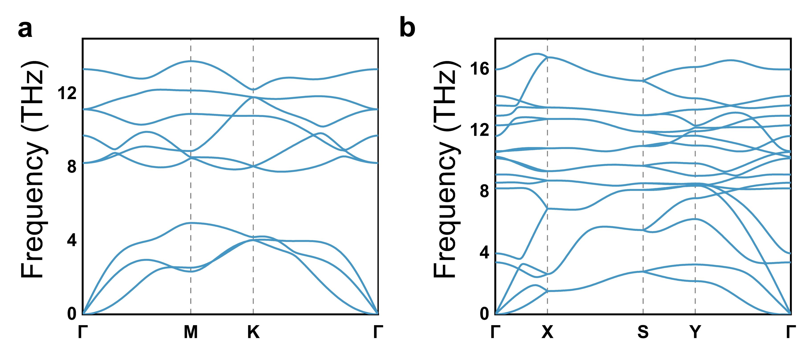
Supplementary Fig. 1. Dynamical stability of monolayer ScO₂. Phonon spectra of the ScO₂ monolayer in the a P-3m1 phase and b P2/c phase.
Supplementary Table 1. Mechanical stability of monolayer ScO₂. Elastic constants of monolayer ScO₂ in the P-3m1 and P2/c phases.
Structures | C₁₁ (GPa) | C₂₂ (GPa) | C₁₂ (GPa) | C₆₆ (GPa)
P-3m1-ScO₂ | 22.113 | 22.113 | 19.277 | 1.418
P2/c-ScO₂ | 38.005 | 33.947 | 8.195 | 6.482

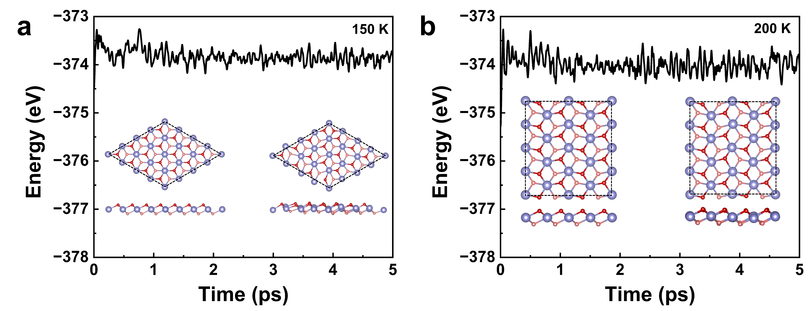
Supplementary Fig. 2. Thermal stability of monolayer ScO₂. Evolution of energies of monolayer ScO₂ in the a P-3m1 phase and b P2/c phase during the AIMD simulations. The inset shows representative structural snapshots at the beginning and end of the 5-ps simulation.

Section Ⅱ: Stoner ferromagnetic instability
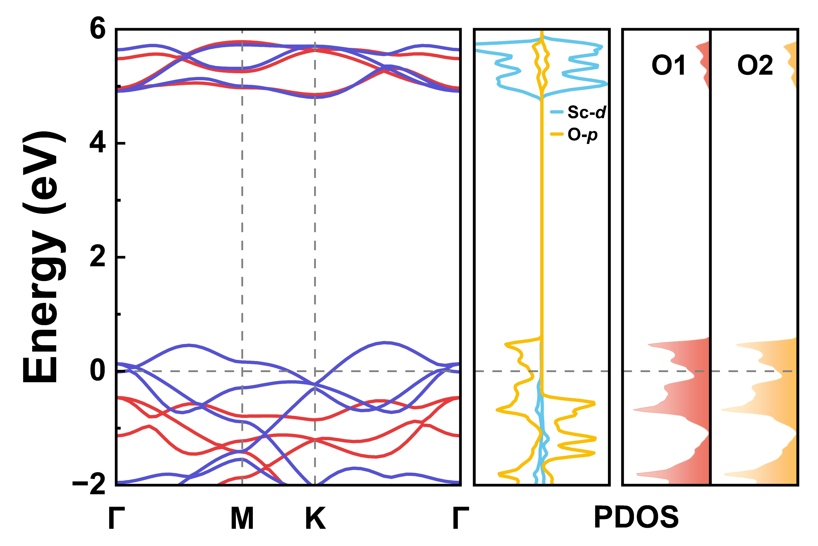
Supplementary Fig. 3. Band structure and PDOS of the P-3m1 phase. Spin-resolved band structures and projected density of states (PDOS) for the P-3m1 phase. The PDOS shown in the right panel corresponds to O atoms in the spin-down channel.
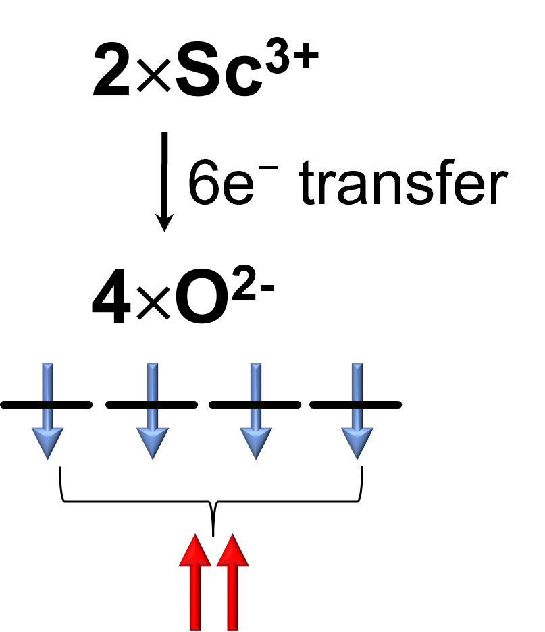
Supplementary Fig. 4. Charge-transfer mechanism of O-2p spin polarization. Schematic illustration of charge transfer from Sc to O atoms, leading to spin polarization of O-2p orbitals and the emergence of p-orbital magnetism.
According to the Stoner criterion, when N(E_{F})I > 1, the system becomes ferromagnetic; otherwise, it remains nonmagnetic. Here, I is the Stoner parameter related to the spin splitting around the Fermi level, which can be obtained using the equations [1]
$$E^{↑}(k)=E_{0}(k)−I\frac{n^{↑}}{n},E^{↓}(k)=E_{0}(k)+I\frac{n^{↓}}{n},$$
where E₀(k) is the energy of the nonmagnetic state, and $E^{↑,↓}(k)$and $n^{↑,↓}$represent the energy and number of spin-up ($↑$) and spin-down ($↓$) electrons in the FM state, respectively. Here, $n=n^{↑}+n^{↓}=2$, and without loss of generality we take $n^{↑}=n^{↓}=1$. The average value of $E^{↓}\left(k\right)−E^{↑}\left(k\right)$ is estimated from the energy difference between the spin-up and spin-down DOS peaks around the Fermi level [2]. For the nonmagnetic P-3m1 phase, we obtain N(E_{F}) = 5.17 states/eV and I = 1.03 eV, giving N(E_{F})I = 5.33. For the nonmagnetic P2/c phase, N(E_{F}) = 7.51 states/eV and I = 0.2 eV, yielding N(E_{F})I = 1.50. Since both values are larger than 1, the nonmagnetic states of the two phases are unstable against spin polarization, indicating that the ferromagnetic ground states of monolayer ScO₂ can be well understood within the Stoner ferromagnetic picture.
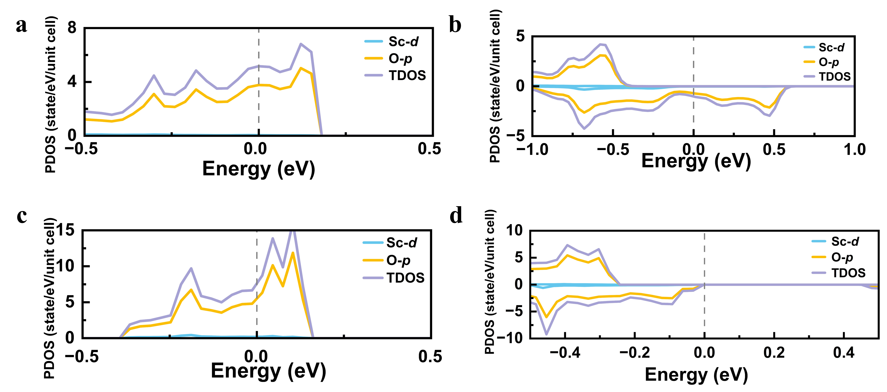
Supplementary Fig. 5. PDOS of monolayer ScO₂ in nonmagnetic and ferromagnetic states. Projected density of states (PDOS) of monolayer ScO₂ of a, b P-3m1 phase and c, d P2/c phase, for the nonmagnetic and ferromagnetic states.
Section Ⅲ: Strong coupling between magnetism and lattice distortion
As shown in Supplementary Fig. 6, the ferromagnetic state exhibits a double-well energy profile along the antipolar distortion coordinate, indicating that magnetism stabilizes the antipolar structure, whereas the nonmagnetic state favors the high-symmetry phase. These results demonstrate a strong coupling between magnetism and lattice distortion, where the FM state stabilizes the antipolar configuration.
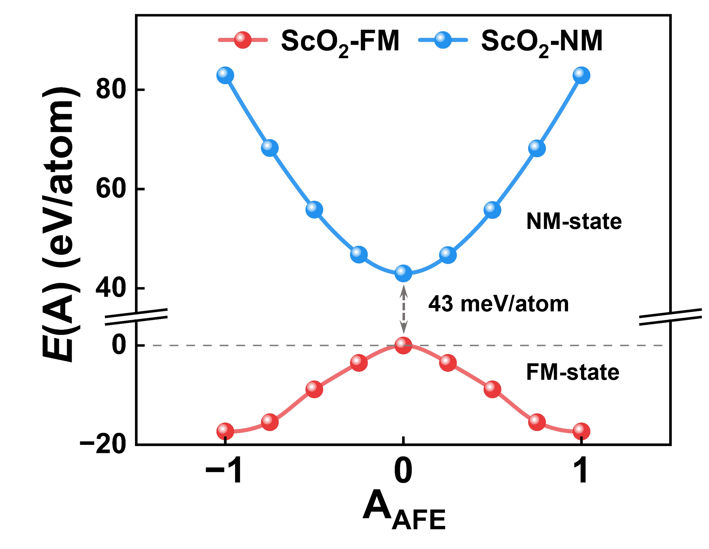
Supplementary Fig. 6. Strong coupling between magnetism and lattice distortion. Energy profiles of monolayer ScO₂ along the antipolar distortion coordinate A_{AFE}. A_{AFE} = 0 corresponds to the high-symmetry nonpolar P-3m1 phase, while A_{AFE} = ±1 denotes two equivalent antipolar states. The red and blue curves represent the ferromagnetic (FM) and nonmagnetic (NM) states, respectively.

Section Ⅳ: Magnetic ground state, easy magnetization axis, and Curie temperature
To determine the magnetic ground states of the monolayer ScO₂ in the P2/c phase, we considered six magnetic configurations. Their spin arrangements are shown in Supplementary Fig. 7, and the corresponding relative energies are summarized in Supplementary Table 2. Results show that P2/c phase favors a ferromagnetic ground state. Since the energy difference between the FM and AFM1 states in the P2/c phase is very small, we performed additional calculations using different computational approaches to further verify the ground state. As summarized in Supplementary Table 3, all results consistently indicate that the P2/c phase favors a FM ground state.

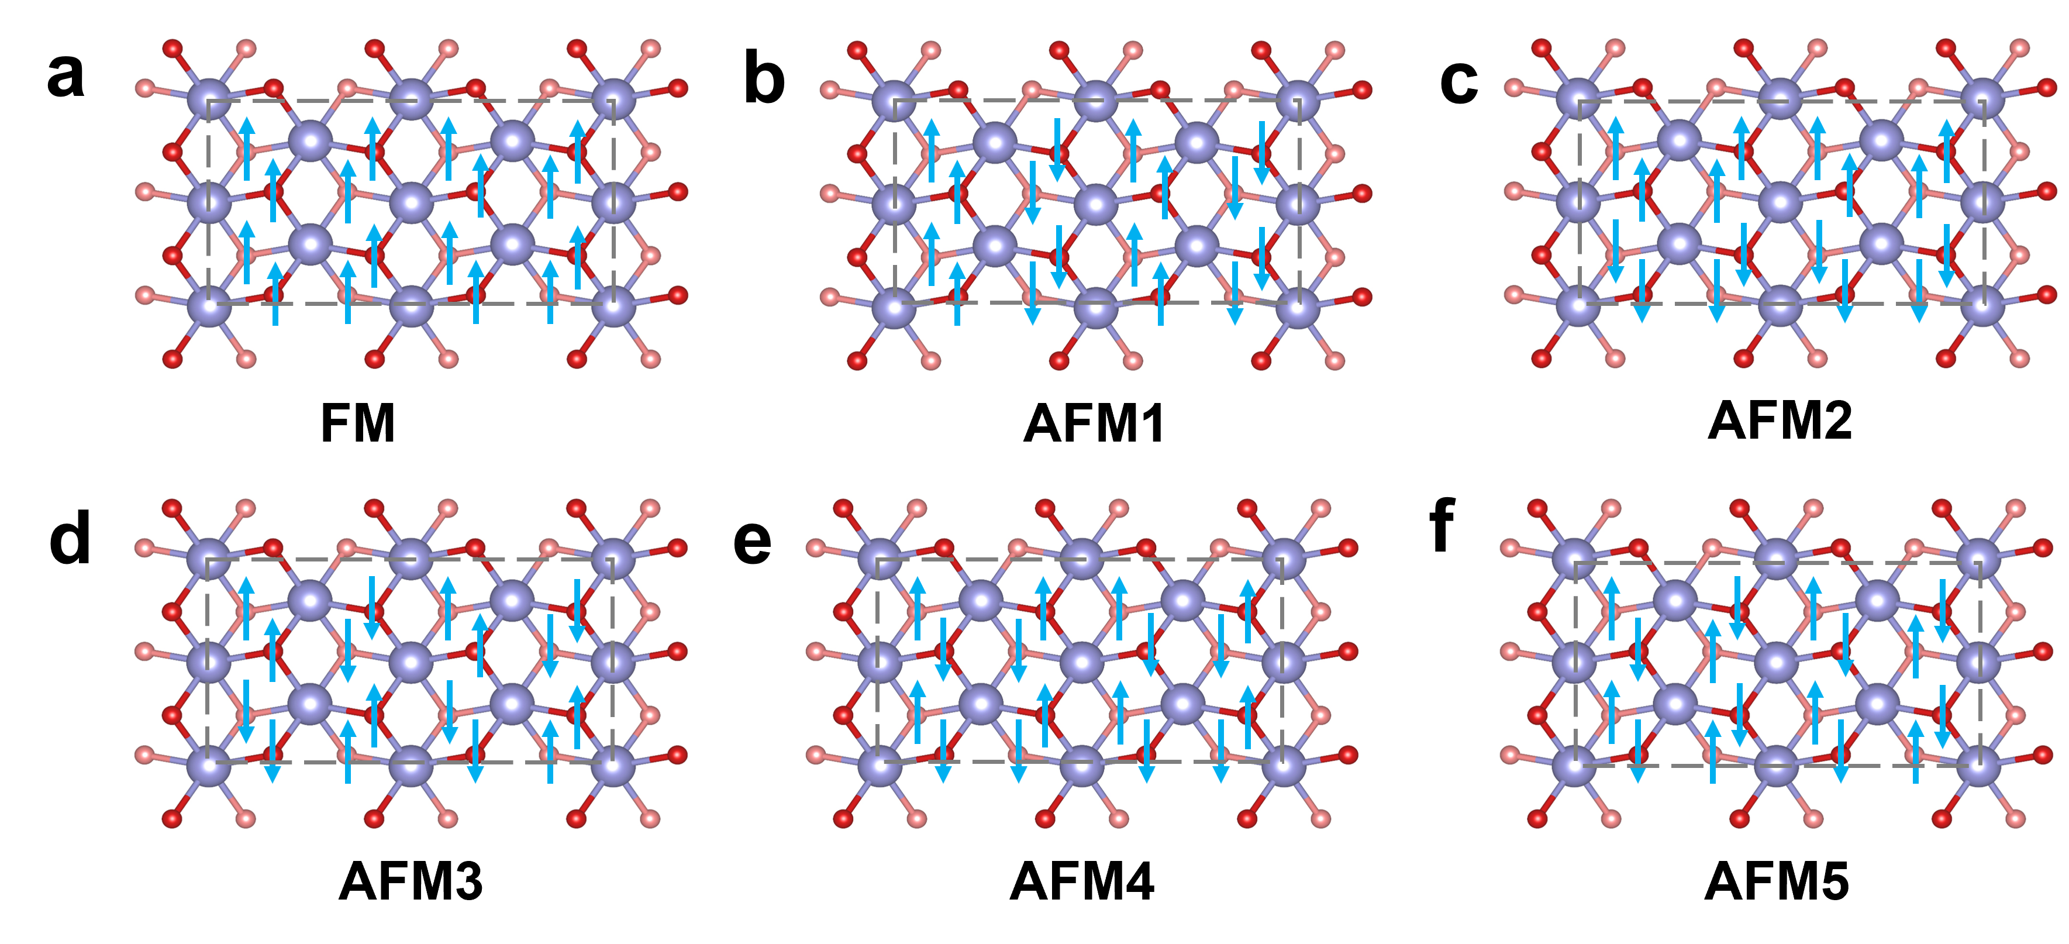
Supplementary Fig. 7. Magnetic configurations of the P2/c ScO₂ monolayer. Magnetic configurations considered for the P2/c ScO₂ monolayer. The arrows indicate the directions of the local magnetic moments.

Supplementary Table 2. Relative energies of different magnetic configurations. Relative energies (in meV/atom) of the six magnetic configurations for the P2/c ScO₂ monolayer obtained from fully relaxed calculations. The FM state is taken as the reference. NM indicates that the corresponding initial magnetic state converges to a nonmagnetic state.
Structure | FM | AFM1 | AFM2 | AFM3 | AFM4 | AFM5
ScO₂ | 0 | 2 | 2.9 | 4.8 | 7 | 49 (NM)

Supplementary Table 3. Relative energies of magnetic configurations calculated using different methods. Relative energies (in meV/atom) of different magnetic configurations for monolayer ScO₂ in the P2/c phase calculated using various computational methods. The FM state is taken as the reference. Both fully relaxed and static calculations, with different exchange-correlation functionals and inclusion of SOC, consistently confirm the FM ground state.
Methods |  | FM | AFM1
Full relaxation | PBE + vdw | 0 | 2
Full relaxation | PBE + U (U = 1 eV) | 0 | 2
Full relaxation | PBE + U (U = 2 eV) | 0 | 2
Full relaxation | PBE + U (U = 3.5 eV) | 0 | 2
Static calculations | PBE | 0 | 2
Static calculations | PBE + SOC | 0 | 8

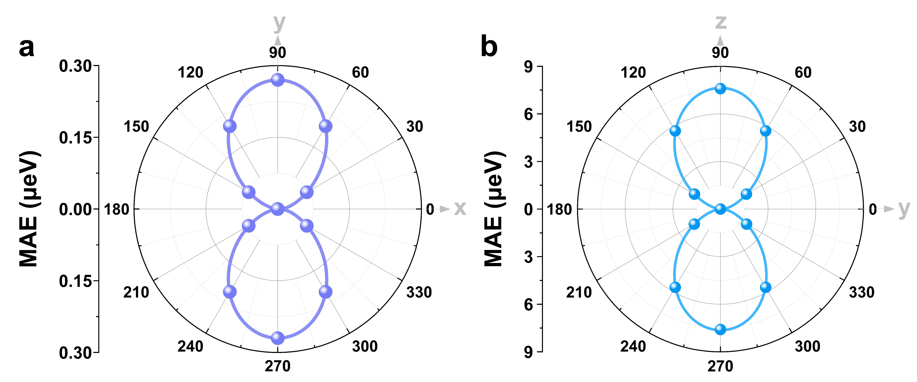
Supplementary Fig. 8. Magnetic anisotropy. Magnetic anisotropy energy (MAE) for the a, b P2/c ScO₂ monolayer.
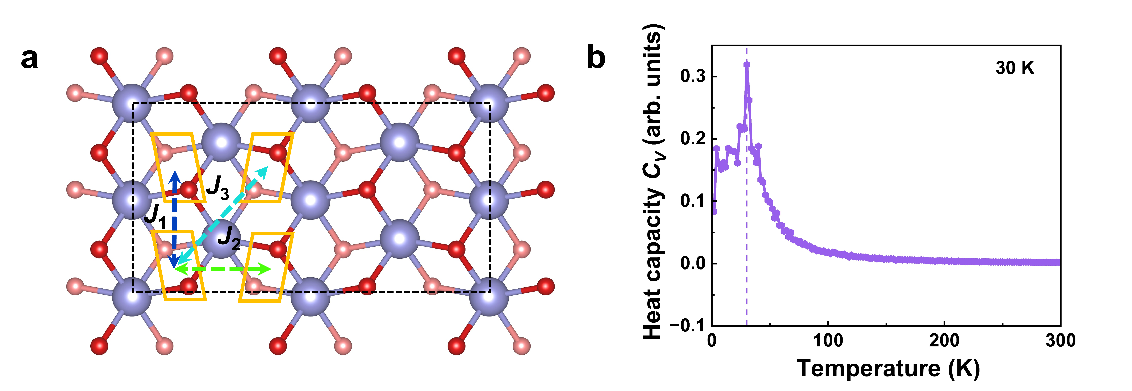
Supplementary Fig. 9. Curie temperature. Exchange interaction paths J₁, J₂, and J₃, as well as the temperature dependence of the heat capacity obtained from Monte Carlo simulations for P2/c ScO₂.
Section V: Electronic properties of the nonpolar C2/m intermediate phase
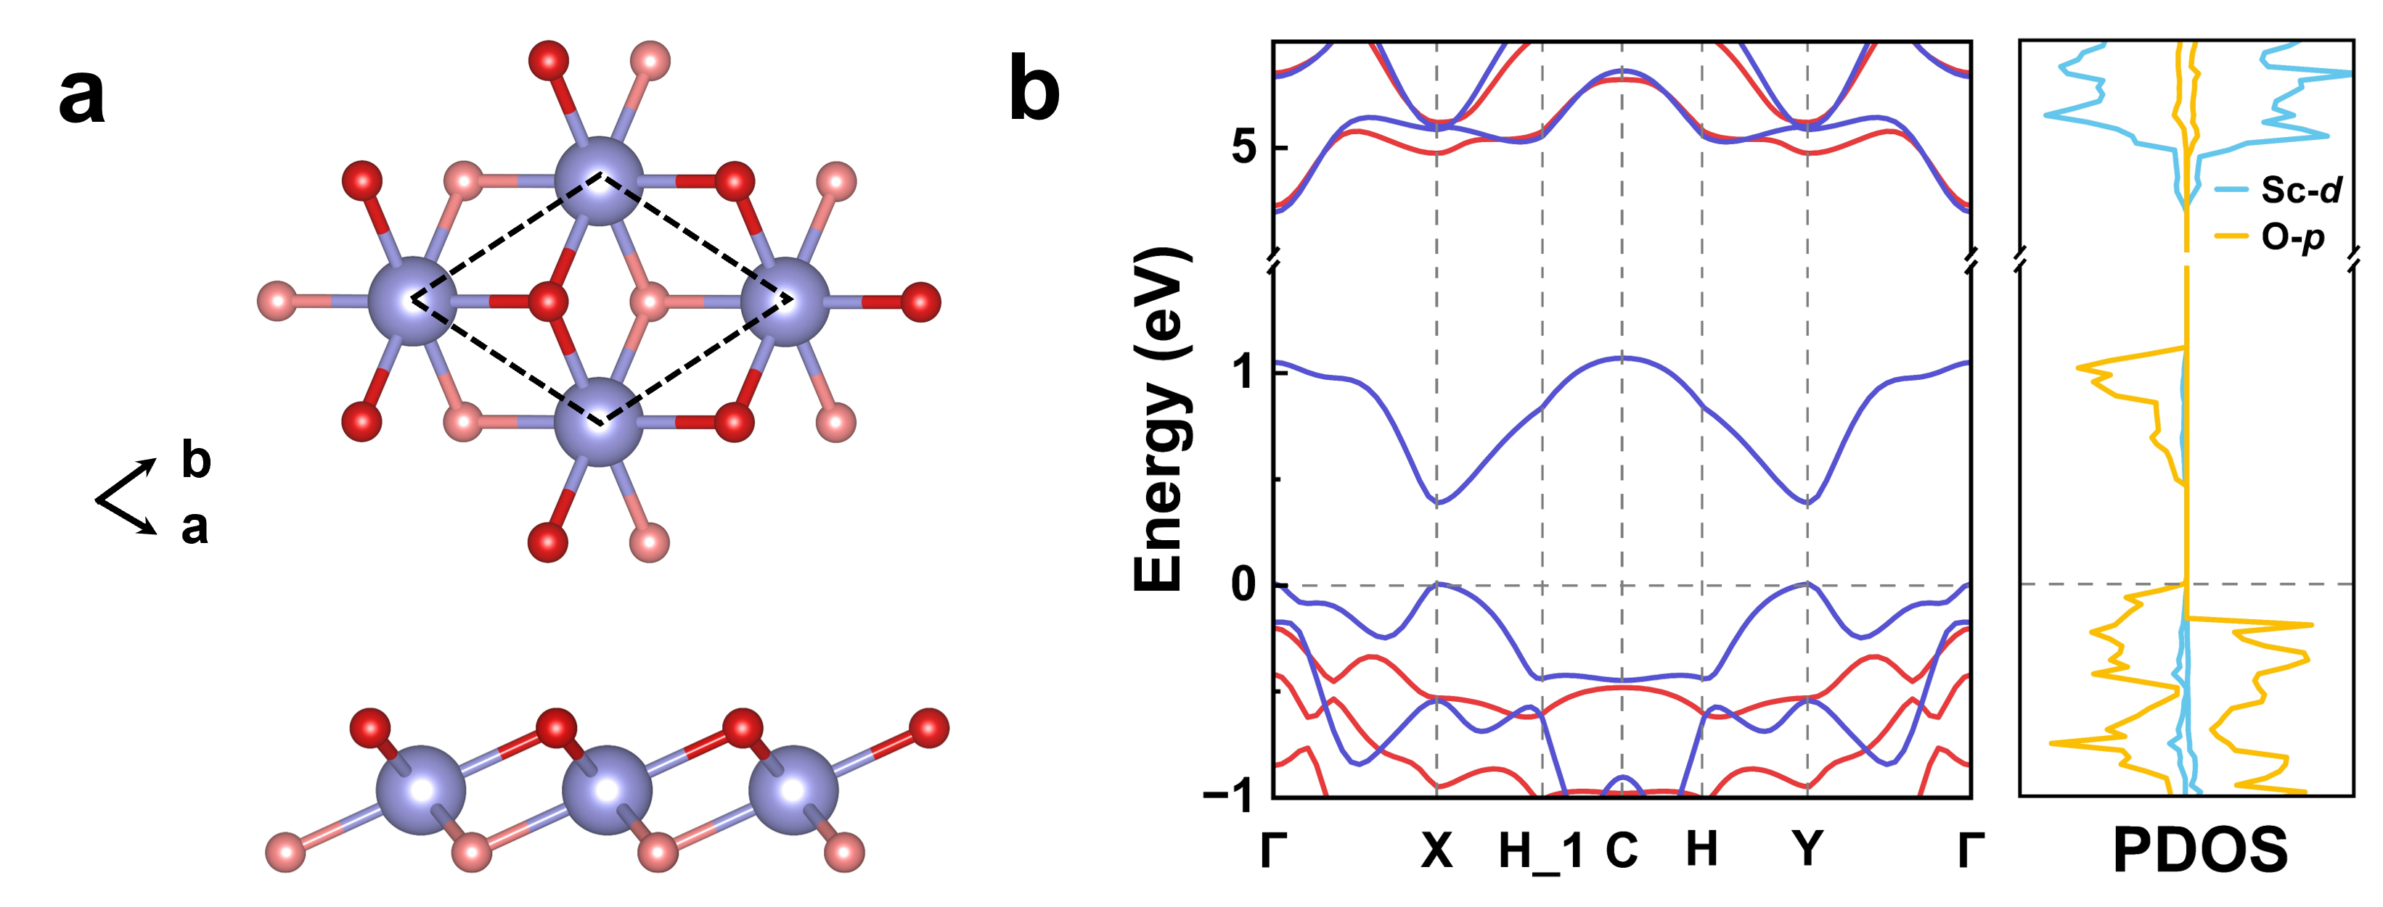
Supplementary Fig. 10. Crystal structure and electronic properties of the nonpolar C2/m intermediate phase. a Crystal structure of the nonpolar intermediate C2/m phase of monolayer ScO₂. b Spin-resolved band structure and projected density of states (PDOS) of the nonpolar intermediate C2/m phase of monolayer ScO₂. The red and blue lines denote spin-up and spin-down states, respectively.

Section VI: Antiferroelectric switchable altermagnetic spin splitting and anomalous Hall conductivity in P2/c ScO₂
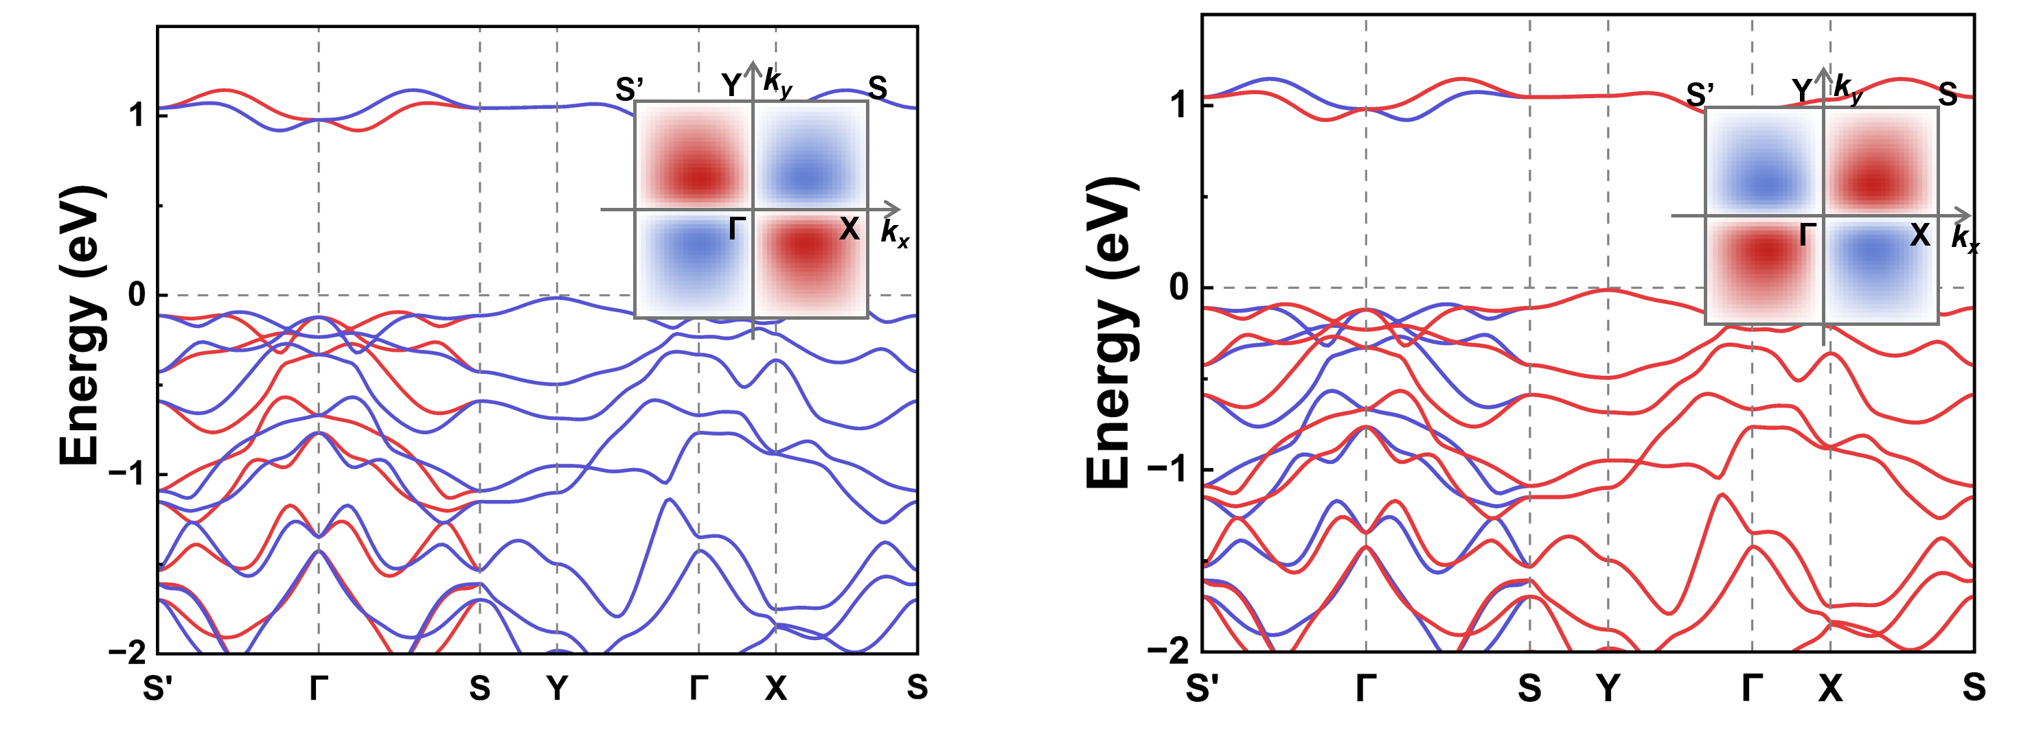
Supplementary Fig. 11. Electronic properties. Spin-resolved band structure of two equivalent AFE ScO₂ phases. The red and blue lines denote spin-up and spin-down states, respectively. The inset shows the two lowest conduction bands in the first Brillouin zone, exhibiting a characteristic d-wave symmetry. The red and blue regions denote positive and negative spin splitting of the conduction bands, respectively, while the white regions indicate spin degeneracy.

Supplementary Table 4. Magnetic space groups, magnetic point groups, and symmetry-allowed AHC components for P2/c ScO₂ with spin moments oriented along the x-, y-, and z- directions.
P2/c ScO₂ | x | y | z
Magnetic group | P2/c | P2'/c | P2/c
Magnetic point group | 2/m.1 | 2'/m' | 2/m.1
AHC | No | Yes | No

Section VII: Fractional-quantum ferroelectricity switchable altermagnetic spin splitting in P2/c ScO₂
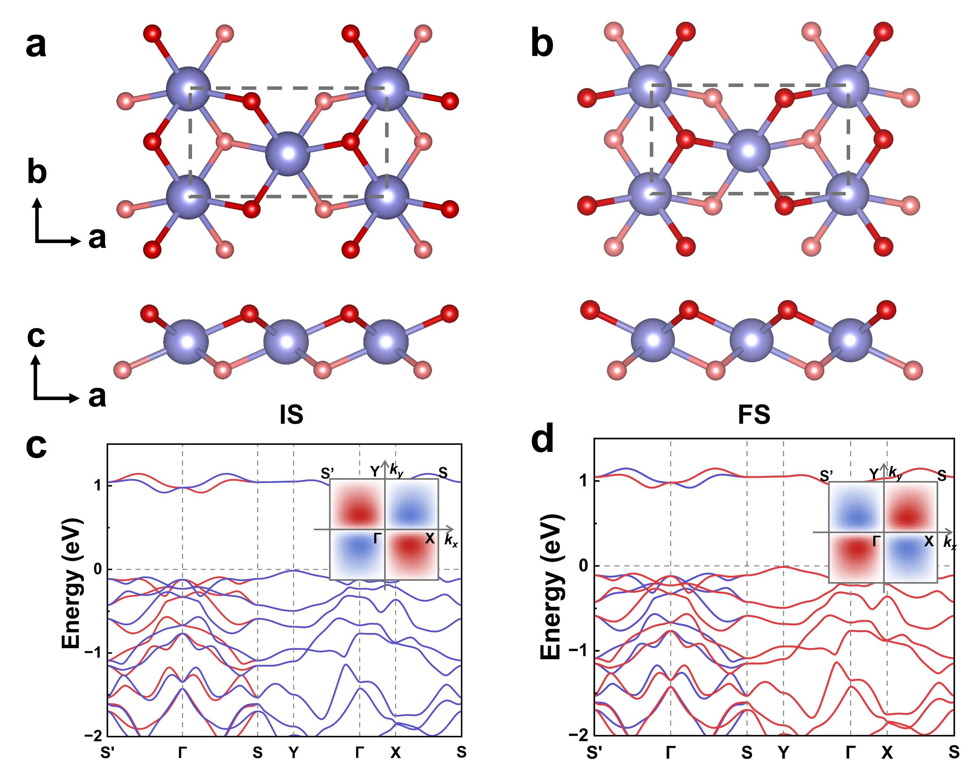
Supplementary Fig. 12. FQFE switchable altermagnetic spin splitting in P2/c ScO₂. a, b Top and side views of two structurally equivalent ScO₂ phases, denoted as the initial state (IS) and final state (FS), connected by FQFE switching. The dashed gray parallelograms indicate the unit cell. c, d Spin-resolved band structures of the IS and FS. Red and blue curves represent spin-up and spin-down states, respectively. The insets display the spin-splitting textures of the two lowest conduction bands in momentum space.

Section VIII: 120° antiferroelectric/ferroelastic switchable altermagnetic spin splitting texture and anomalous Hall conductivity in P2/c ScO₂

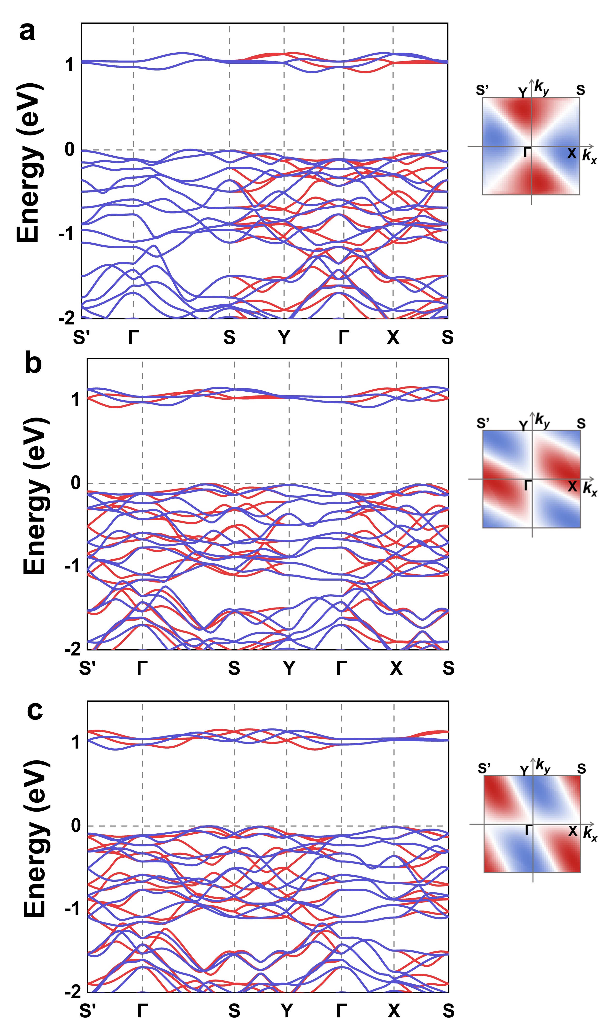
Supplementary Fig. 13. Electric properties for three equivalent AFE–FA–AM states of the P2/c ScO₂. Spin-resolved band structures of the three equivalent AFE–FA–AM states of monolayer ScO₂. a AFE1-FA1-AM, b AFE2-FA2-AM, and c AFE3- FA3-AM. Shown are the 2D momentum-dependent spin-splitting patterns of the two lowest conduction bands for the three AFE-FA-AM phases, obtained from uniform k-point sampling in the square Brillouin zone. Red and blue indicate positive and negative spin splitting, respectively, whereas white indicates spin degeneracy.

Supplementary Table 5. Magnetic space groups, magnetic point groups, and symmetry-allowed AHC for the three AFE–FA–AM states of monolayer ScO₂ with spin moments oriented along the x-, y-, and z- directions.
Structures |  | x | y | z
AFE1-FA1-AM | Magnetic group | P-1 | P-1 | P2/c
AFE1-FA1-AM | Magnetic point group | $$\overline{1}$$ | $$\overline{1}$$ | 2/m
AFE1-FA1-AM | AHC | Yes | Yes | No
AFE2-FA2-AM | Magnetic group | P2'/c' | P-1 | P2/c
AFE2-FA2-AM | Magnetic point group | 2′/m′ | $$\overline{1}$$ | 2/m
AFE2-FA2-AM | AHC | Yes | Yes | No
AFE3-FA3-AM | Magnetic group | P-1 | P2'/c' | P2/c
AFE3-FA3-AM | Magnetic point group | $$\overline{1}$$ | 2′/m′ | 2/m
AFE3-FA3-AM | AHC | Yes | Yes | No

Section Ⅸ: Phonon spectra, electric properties, magnetic properties, and fractional-quantum ferroelectricity of P2/c YO₂
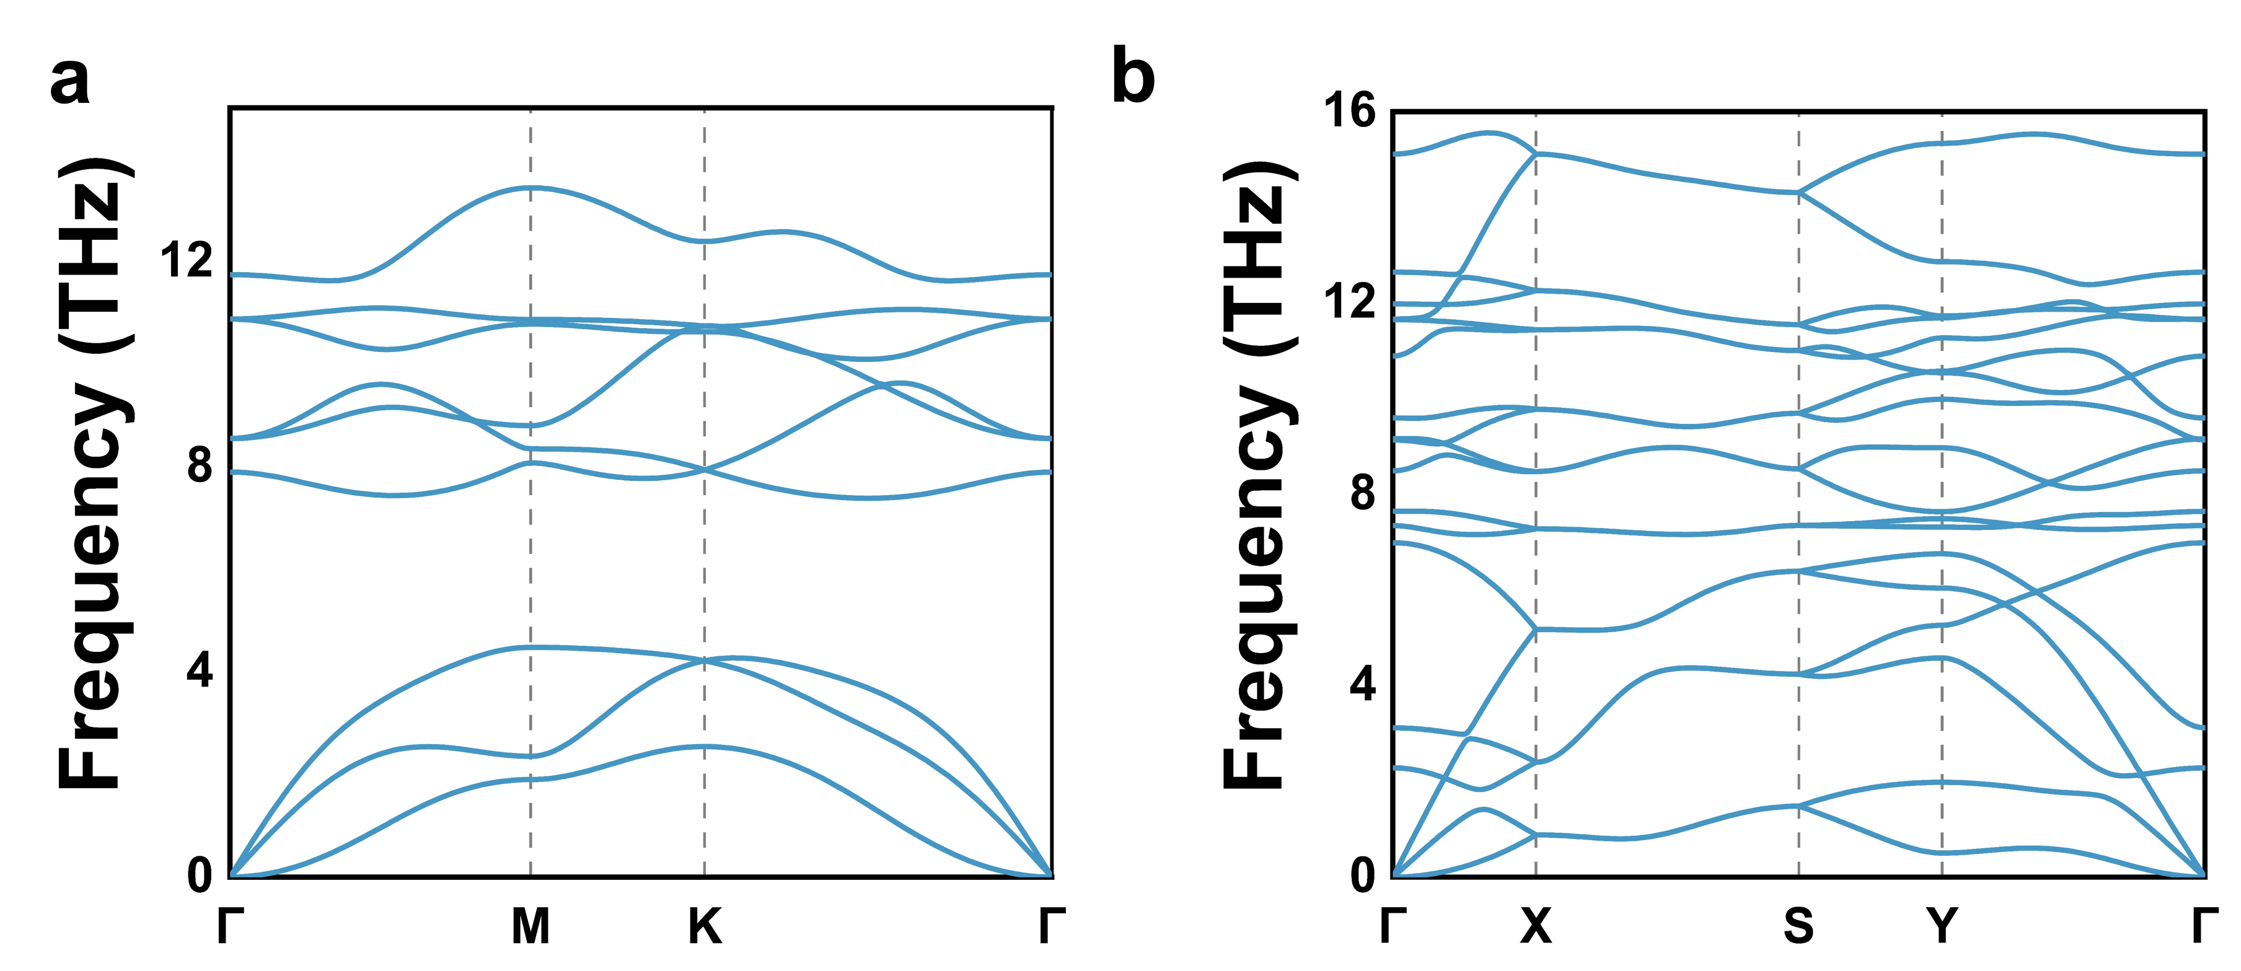
Supplementary Fig. 14. Dynamical stability of monolayer YO₂. Phonon spectra of the YO₂ monolayer in the a P-3m1 phase and b P2/c phase.
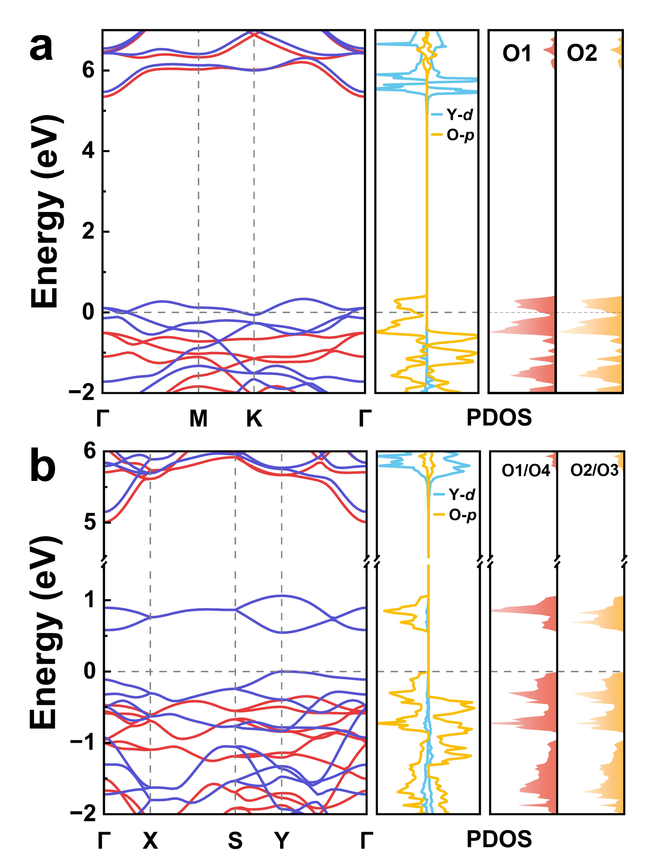
Supplementary Fig. 15. Electric properties of monolayer YO₂. Spin-resolved band structures and projected density of states (PDOS) of monolayer YO₂ in the a P-3m1 phase and b the P2/c phase. The red and blue lines denote the spin-up and spin-down states, respectively. The PDOS highlights the dominant contributions from Y-d and O-p orbitals (middle panels). The PDOS shown in the right panels of a and b corresponds to O atoms in the spin-down channel.
Supplementary Table 6. Magnetic properties of the P2/c YO₂. Relative energies (in meV/atom) of the two magnetic configurations (same as Supplementary Fig. 7) for P2/c YO₂ obtained from fully relaxed calculations. FM state is taken as the reference and set to zero.
Structure | FM | AFM1
YO₂ | 0 | 2

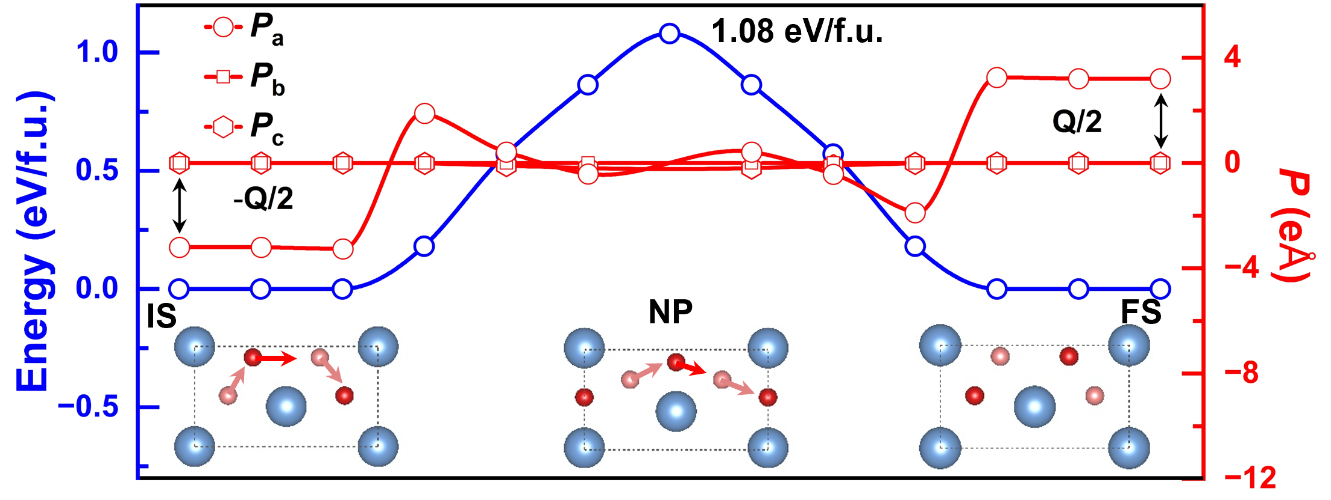
Supplementary Fig. 16. FQFE for P2/c YO₂. Minimum-energy pathway connecting the initial state (IS) and final state (FS), passing through a nonpolar (NP) intermediate for P2/c YO₂. The blue curve denotes the energy profile, while the red symbols represent the evolution of the polarization components P_{a}, P_{b}, and P_{c}. Here, Q represents the polarization quantum along the x-direction, i.e., the a-axis. The insets show the crystal structures of the IS, NP, and FS states, with arrows tracing the O displacement from IS to FS.

Section X: Electric control of ferromagnetic-to-altermagnetic phase transition enabled by fractional-quantum ferroelectricity in P2/c YO₂
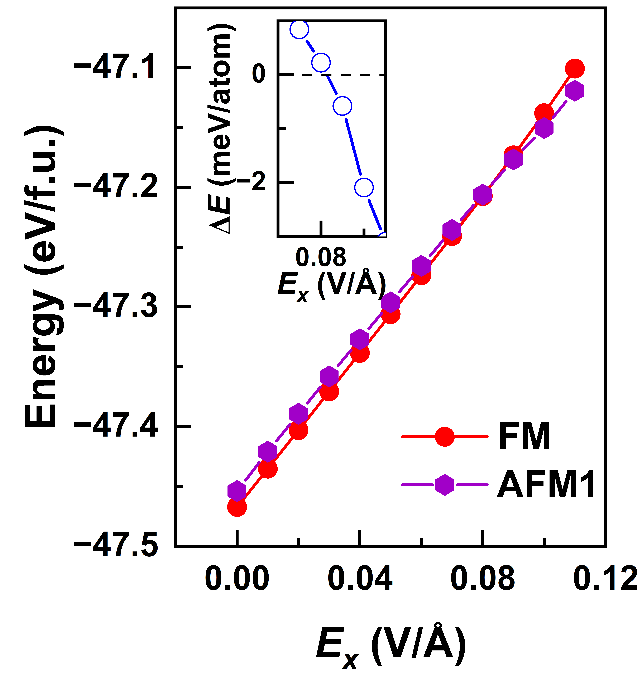
Supplementary Fig. 17. Electric control of ferromagnetic-to-altermagnetic phase transition in P2/c YO₂. Total energies of the FM and AFM1 states as a function of the electric field applied along the x-direction. The inset shows the corresponding energy difference ∆E = E_{AFM1} − E_{FM}, illustrating the field-driven FM-to-AFM1 transition.
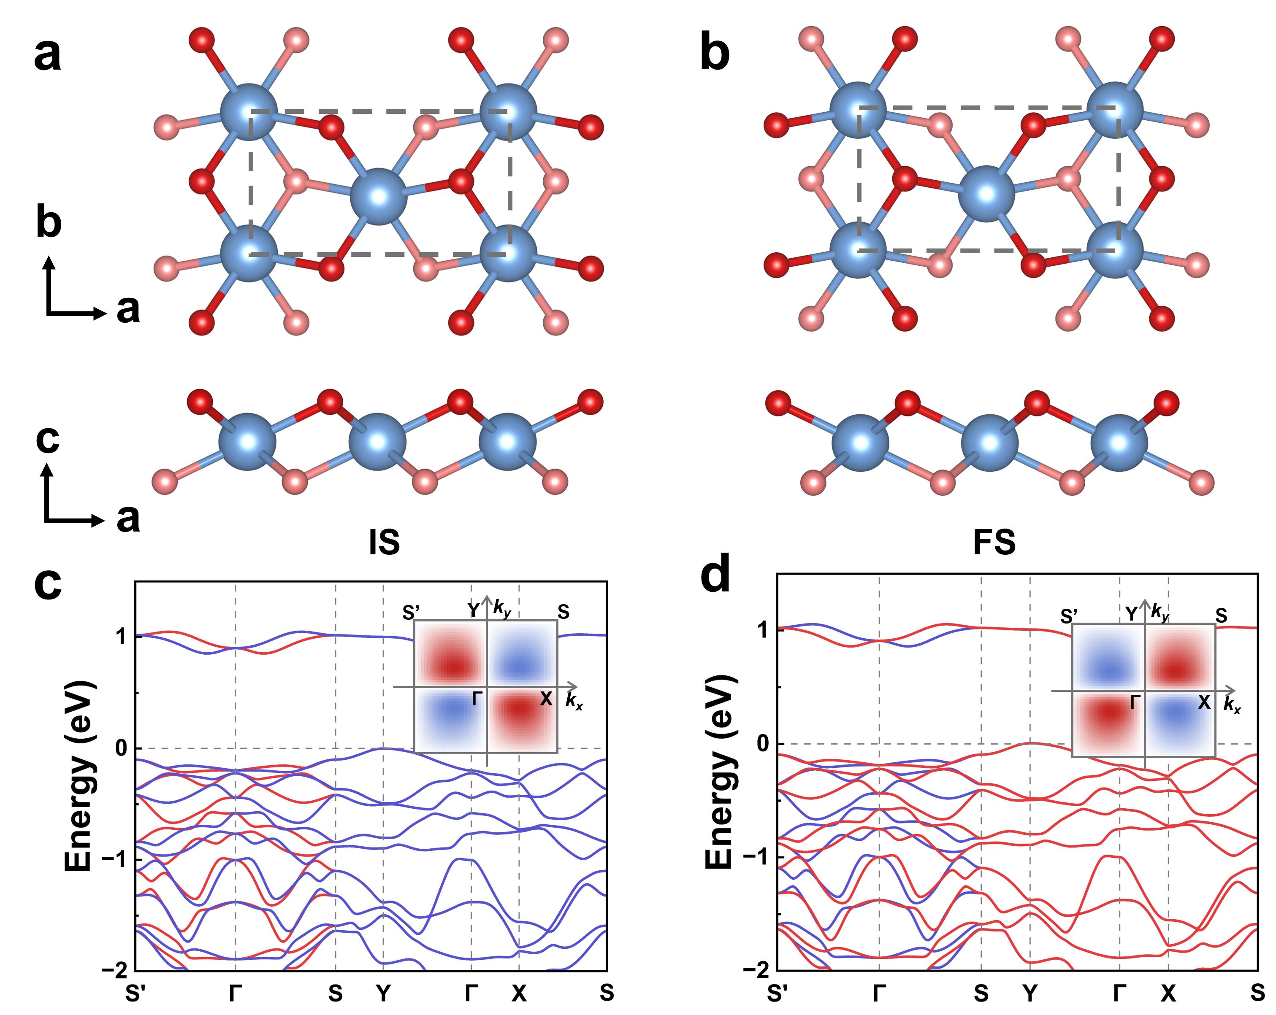
Supplementary Fig. 18. FQFE switchable altermagnetic spin splitting in P2/c YO₂. a, b Top and side views of two FQFE YO₂ phases, denoted as the initial state (IS) and final state (FS). The dashed gray parallelograms indicate the unit cell. c, d Spin-resolved band structures of the IS and FS. Red and blue curves represent spin-up and spin-down states, respectively. The insets display the spin-splitting textures of the two lowest conduction bands in momentum space. The red and blue regions denote positive and negative spin splitting of the conduction bands, respectively, while the white regions indicate spin degeneracy. The results are obtained from dense k-point sampling and projected onto the 2D momentum plane.
Section XI: Antiferroelectric and ferroelastic switchable altermagnetic spin splitting in P2/c YO₂
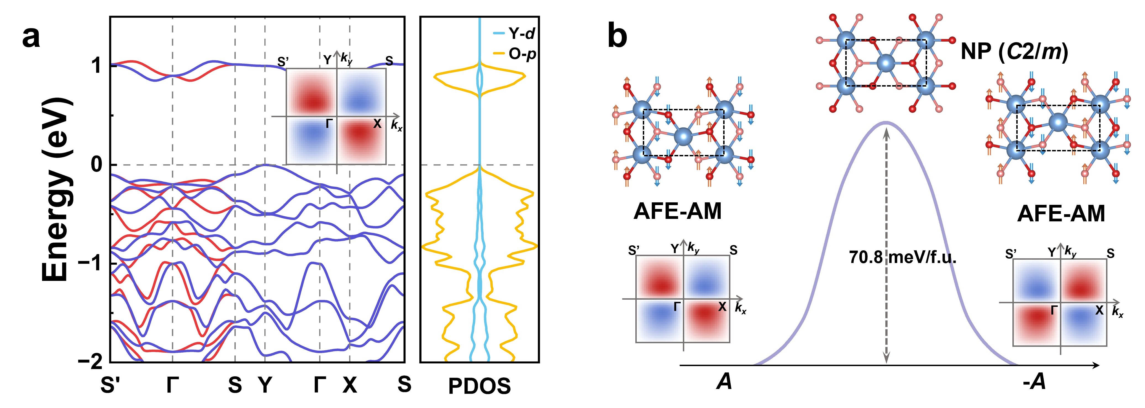
Supplementary Fig. 19. Antiferroelectric and ferroelastic switchable altermagnetic spin splitting in P2/c YO₂. a Spin-resolved band structures and projected density of states (PDOS) of the P2/c YO₂ phase in the AFM1 configuration. b Energy profile of antiferroelectric (AFE) switching through the nonpolar intermediate C2/m phase. The associated reversal of the d-wave spin splitting in momentum space demonstrates antiferroelectric switchable altermagnetism in YO₂. The inset in a shows the two lowest conduction bands in the first Brillouin zone, exhibiting a characteristic d-wave symmetry. The insets in b illustrate the reversal of the momentum-dependent spin splitting.
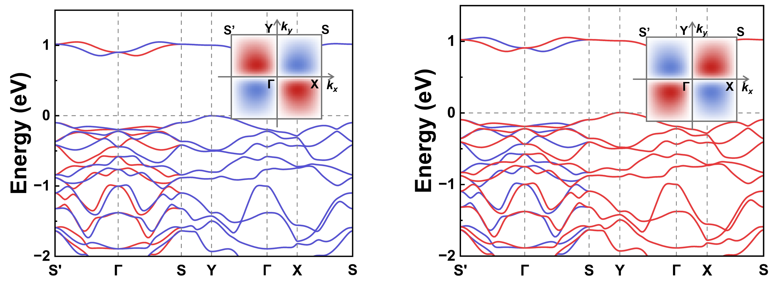
Supplementary Fig. 20. Antiferroelectric switchable altermagnetic spin splitting in two equivalent AFE YO₂ phases. Spin-resolved band structure of two equivalent AFE YO₂ phases. The red and blue lines denote spin-up and spin-down states, respectively. The inset shows the two lowest conduction bands in the first Brillouin zone, exhibiting a characteristic d-wave symmetry.

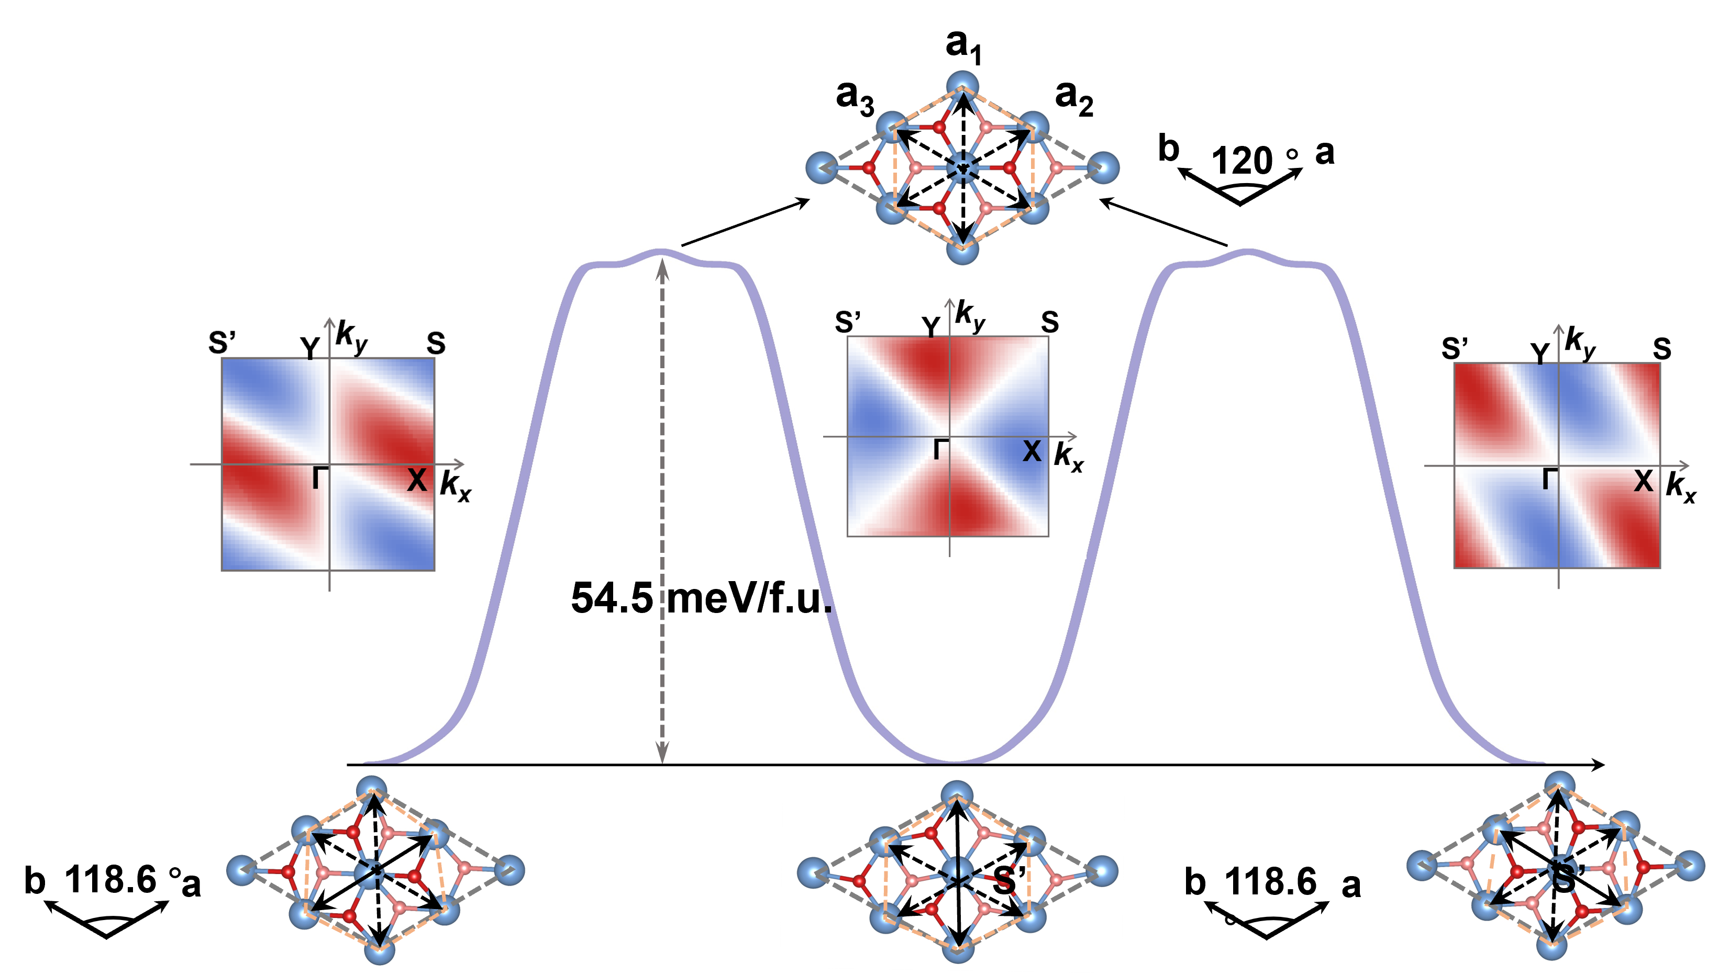
Supplementary Fig. 21. 120° antiferroelectric/ferroelastic switchable altermagnetic spin splitting in P2/c YO₂. Energy profiles of the three equivalent AFE–FA–AM switching pathways in P2/c YO₂. Red arrows denote the antipolar displacements of Y cations, illustrating the 120° AFE switching. a₁, a₂, and a₃ denote the three diagonal directions of the hexagon, indicated by the dotted blue lines, in the (√2×√2)-YO₂ supercell, showing the FA switching. The momentum-space spin-splitting patterns of the two lowest conduction bands are also shown for the three AFE–FA–AM phases.

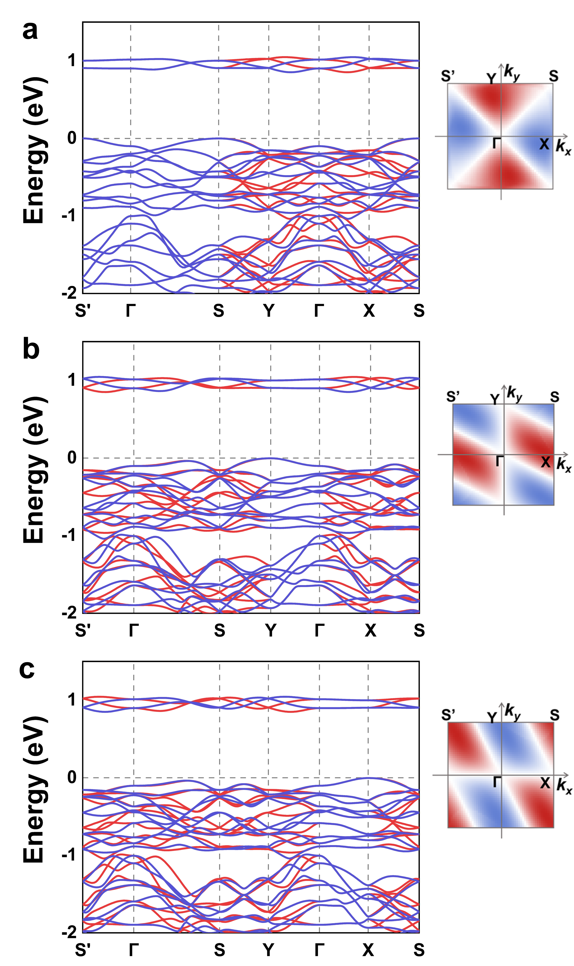
Supplementary Fig. 22. Electronic properties of three equivalent AFE–FA–AM states of the P2/c YO₂. Spin-resolved band structures of the three equivalent AFE–FA–AM states of monolayer YO₂. a AFE1-FA1-AM, b AFE2-FA2-AM, and c AFE3-FA3-AM. The insets show the momentum-dependent spin splitting of the two lowest conduction bands in the first Brillouin zone.

Section XIⅠ: POSCAR files for ScO₂ and YO₂ monolayers
P-3m1 ScO₂
1.0
3.2865058118 0.0000000000 0.0000000000
-1.6432529059 2.8461975227 0.0000000000
0.0000000000 0.0000000000 30.0000000000
Sc O
1 2
Direct
0.000000000 0.000000000 0.500000000
0.666666667 0.333333333 0.468721204
0.333333333 0.666666667 0.531278796

P2/c Sc₂O₄
1.0
5.8902835846 0.0000000000 0.0000000000
0.0000000000 3.2099471092 0.0000000000
0.0000000000 0.0000000000 30.0000000000
Sc O
2 4
Direct
0.250000000 0.700541992 0.500000000
0.750000000 0.299458008 0.500000000
0.432351249 0.191157913 0.469885741
0.932351249 0.808842087 0.469885741
0.067648751 0.191157913 0.530114259
0.567648751 0.808842087 0.530114259

P-3m1 YO₂
1.0
3.5800559932 0.0000000000 0.0000000000
-1.7900279966 3.1004194371 0.0000000000
0.0000000000 0.0000000000 30.0000000000
Y O
1 2
Direct
0.000000000 0.000000000 0.500000000
0.666666667 0.333333333 0.468385367
0.333333333 0.666666667 0.531614633

P2/c Y₂O₄
1.0
6.4109048843 0.0000000000 0.0000000000
0.0000000000 3.4956817627 0.0000000000
0.0000000000 0.0000000000 30.0000000000
Y O
2 4
Direct
0.000000000 0.999998795 0.000000000
0.500000000 0.398901205 0.000000000
0.817150726 0.512428639 0.030127972
0.317150726 0.886471361 0.030127972
0.182849274 0.512428639 0.969872028
0.682849274 0.886471361 0.969872028

References
[1] S. Blundell, Magnetism in Condensed Matter (OUP, Oxford, 2001).
[2] J. He, Q. Xie, and G. Xu, Confinement effect enhanced Stoner ferromagnetic instability in monolayer 1T-VSe₂, New J. Phys. 23, 023027 (2021).

