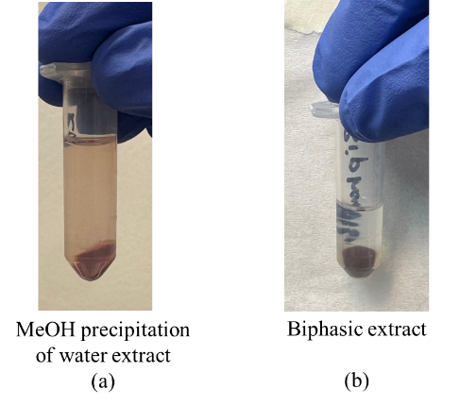
Figure S1: (a) Extraction solution of dried blood sampled on a VAMS tip using water extraction followed by MeOH precipitation (b) Biphasic extraction solution of dried blood sampled on a VAMS tip using the Matyash method

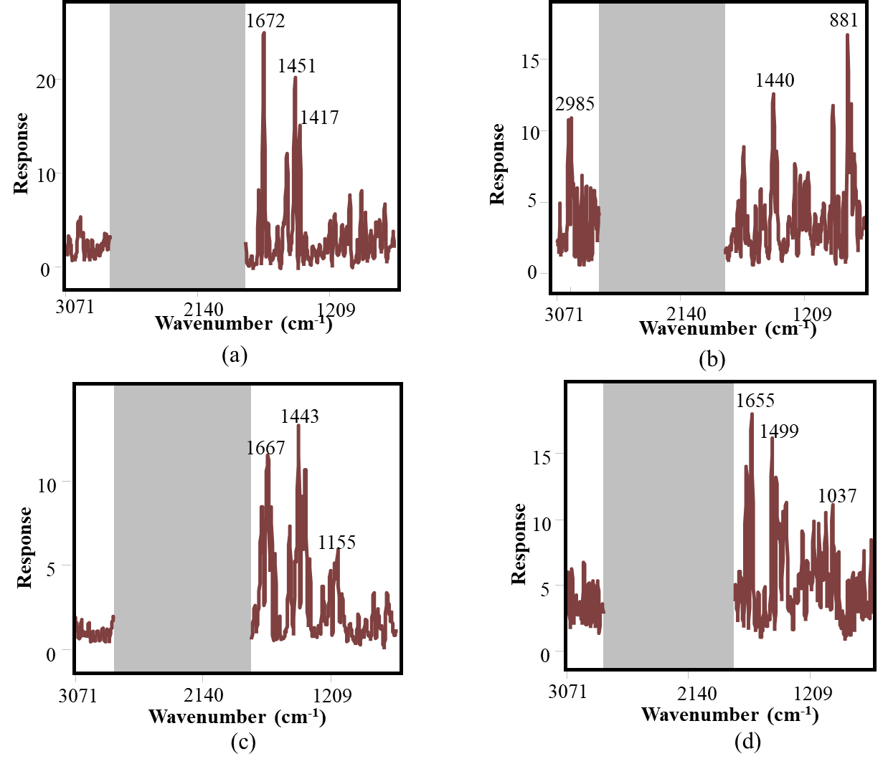
Figure S2: Discriminating power plot highlighting the key wave numbers important for differentiating the groups in MeOH extracts: (a) FM vs HC and (b) RA vs HC; and MeOH/BuOH extracts: (d) FM vs HC and (e) RA vs HC.

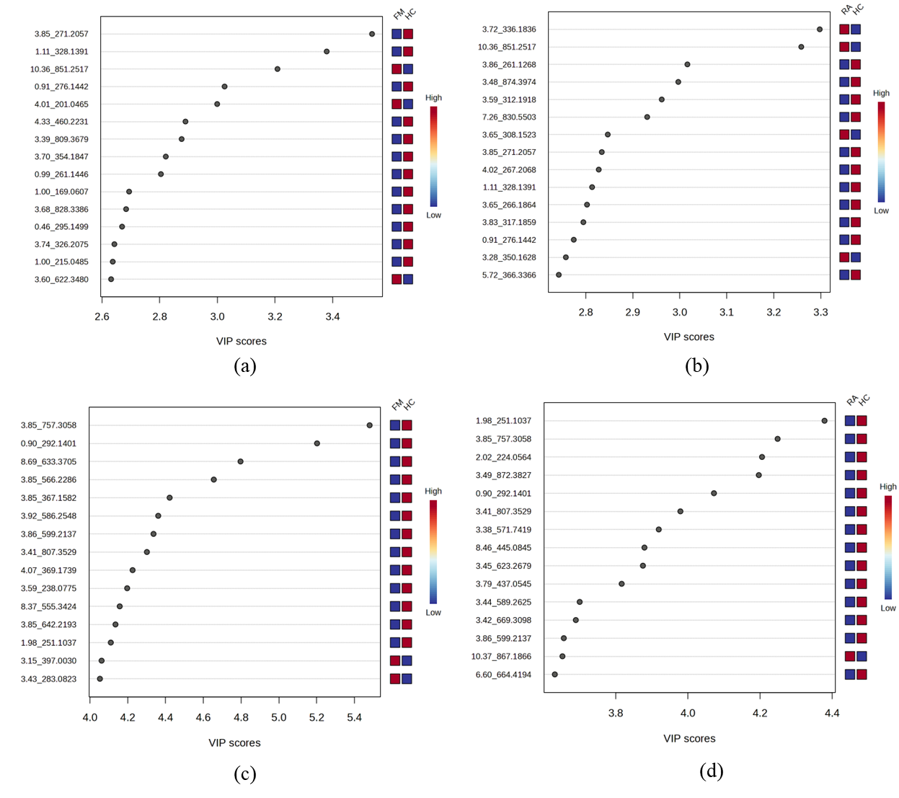
Figure S3: PLS-DA variable importance in projection (VIP) scores of positive-mode metabolomics data; (a) FM vs HC and (b) RA vs HC groups, and negative-mode metabolomics data; (c) FM vs HC and (d) RA vs HC groups, highlighting the top 15 features important for differentiating FM/RA vs HC.

