Supplementary Figures

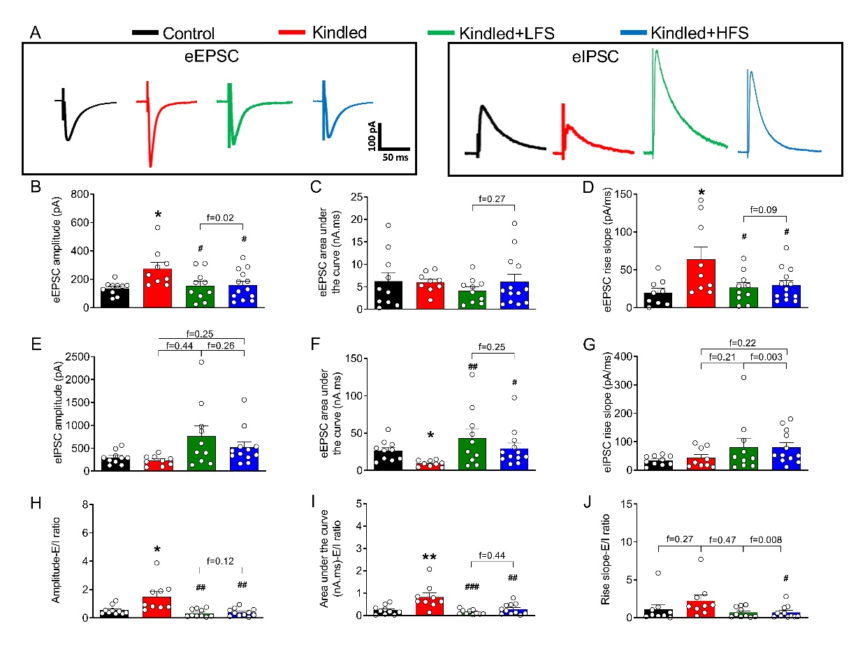
Supplementary Fig. 1. Applying LFS and HFS in olfactory bulb decreased the excitation/inhibition ratio in dorsal hippocampus in kindled animals. A: Sample records of eEPSC (holding potential=-52 mV) and eIPSC (holding potential=+10 mV) in dorsal pyramidal CA1 neurons when the stimulating electrodes were placed in the Shaffer collaterals in different experimental groups. B-D: Applying LFS and HFS decreased the eEPSC amplitude and rise slope in kindled animals. E-G: LFS and HFS administration increased the eIPSC amplitude and area under the curve in kindled animals. H-J: Applying both LFS and HFS decreased the excitation/inhibition (E/I) ratio in kindled animals. The data are presented as mean ± SEM. n=10 in control, n=9 in kindled, n=10 in kindled+LFS and n=12 in kindled+HFS groups. * P<0.05 and ** P<0.01, # P<0.05, ## P<0.01, ### P<0.001. There was no significant difference between the effects of LFS and HFS.
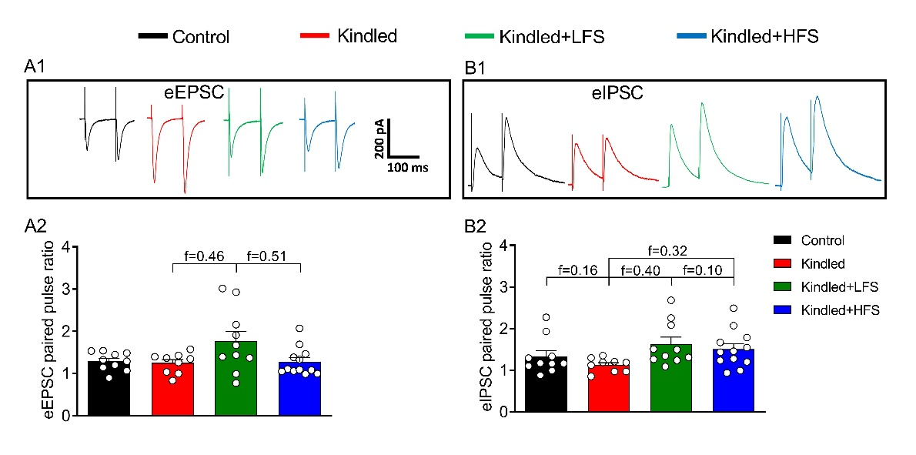
Supplementary Fig. 2. Paired-pulse ratio did not change in dorsal hippocampus of kindled animals or following LFS and HFS application in olfactory bulb of kindled animals. A1 and B1: Sample traces of paired eEPSCs (holding potential=-52 mV) and paired eIPSCs (holding potential=+10 mV) recorded from ventral pyramidal CA1 neurons in different experimental groups in response to paired pulsed at 100 ms inter-pulse interval. A2: Applying LFS and HFS did not change the eEPSC paired-pulse ratio. B2: Applying LFS and HFS did not change the eIPSC paired-pulse ratio. C-D: Similar results obtained from dorsal hippocampus. Data are presented as mean ± SEM. n=10 in control, n=9 in kindled, n=10 in kindled+LFS and n=12 in kindled+HFS groups.

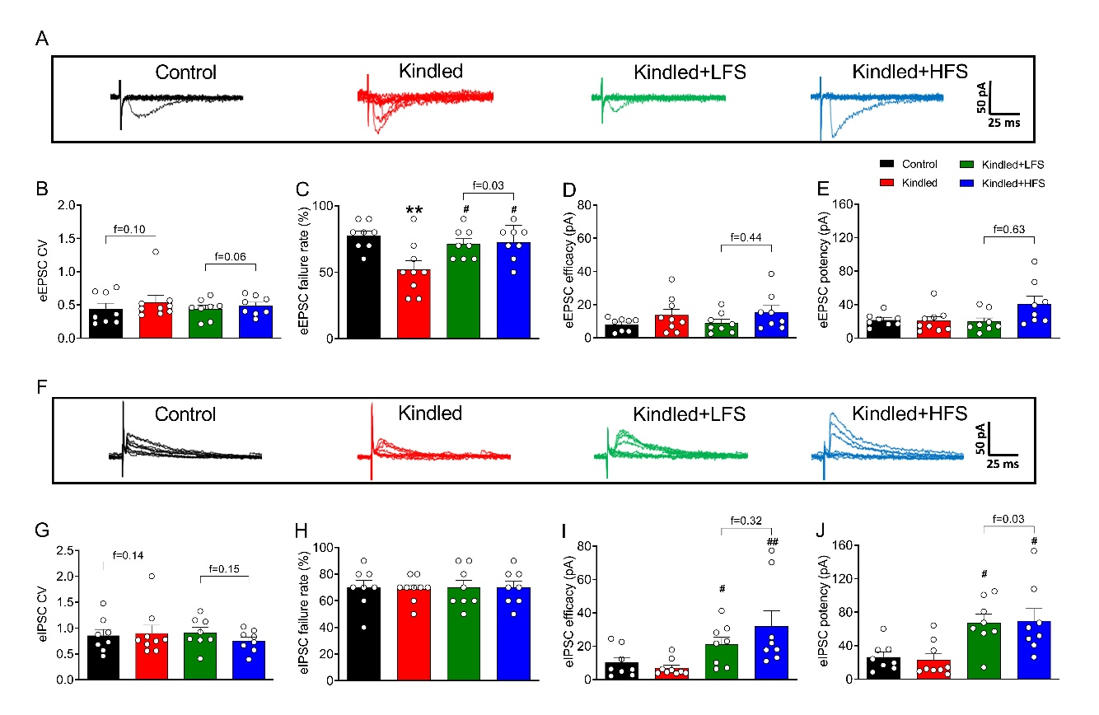Supplementary Fig. 3. Applying LFS and HFS in olfactory bulb did not change coefficient of variation (CV), but restored the changes in failure rate of eEPSC and increased efficacy and potency of eIPSCs in dorsal hippocampus in kindled animals. A: Sample traces of 10 superimposed eEPSCs (holding potential=-52 mV) recorded from ventral pyramidal CA1 neurons in response to threshold intensity in different experimental groups. B: Calculating the CV showed no significant changes among experimental groups. C-E: Both LFS and HFS application restored the kindling -induced changes in failure rate, efficacy and potency of eEPSCs. F: Sample traces of 10 superimposed eIPSCs (holding potential=+10 mV) recorded from dorsal pyramidal CA1 neurons in in response to threshold intensity in different experimental groups. G-H: There was not any significant difference in CV and failure rate. I-J: Application of both LFS and HFS in kindled animals significantly increased the efficacy and potency of eIPSCs. Data are presented as mean ± SEM. n=8 in control, n=9 in kindled, n=8 in kindled+LFS and n=8 in kindled+HFS groups. ** P<0.01 compared to control group. #P<0.05 and ##P<0.01 compared to kindled group. There was no significant difference between the effects of LFS and HFS.

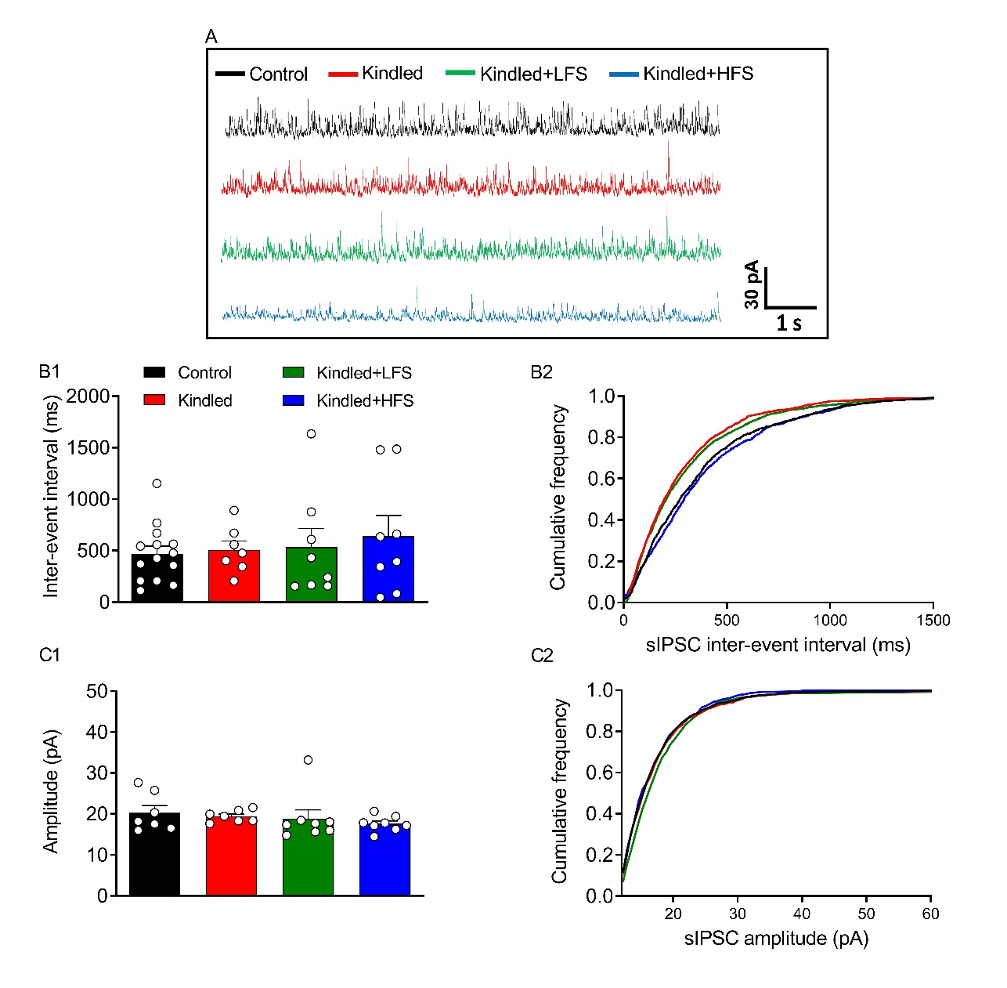Supplementary Fig. 4. Neither kindling, nor applying LFS and HFS changed the sIPSC interevent-intervals and amplitude in different experimental groups in dorsal hippocampus of kindled animals. A: Sample traces of sIPSCs recorded from dorsal pyramidal CA1 neurons. B1 and B2: Kindling, LFS and HFS did not change the sIPSCs inter-event intervals.C1 and C2: Kindling, LFS and HFS did not change the sIPSCs amplitude. Data are presented as mean ± SEM. n=7 in control, n=7 in kindled, n=8 in kindled+LFS and n=8 in kindled+HFS groups.

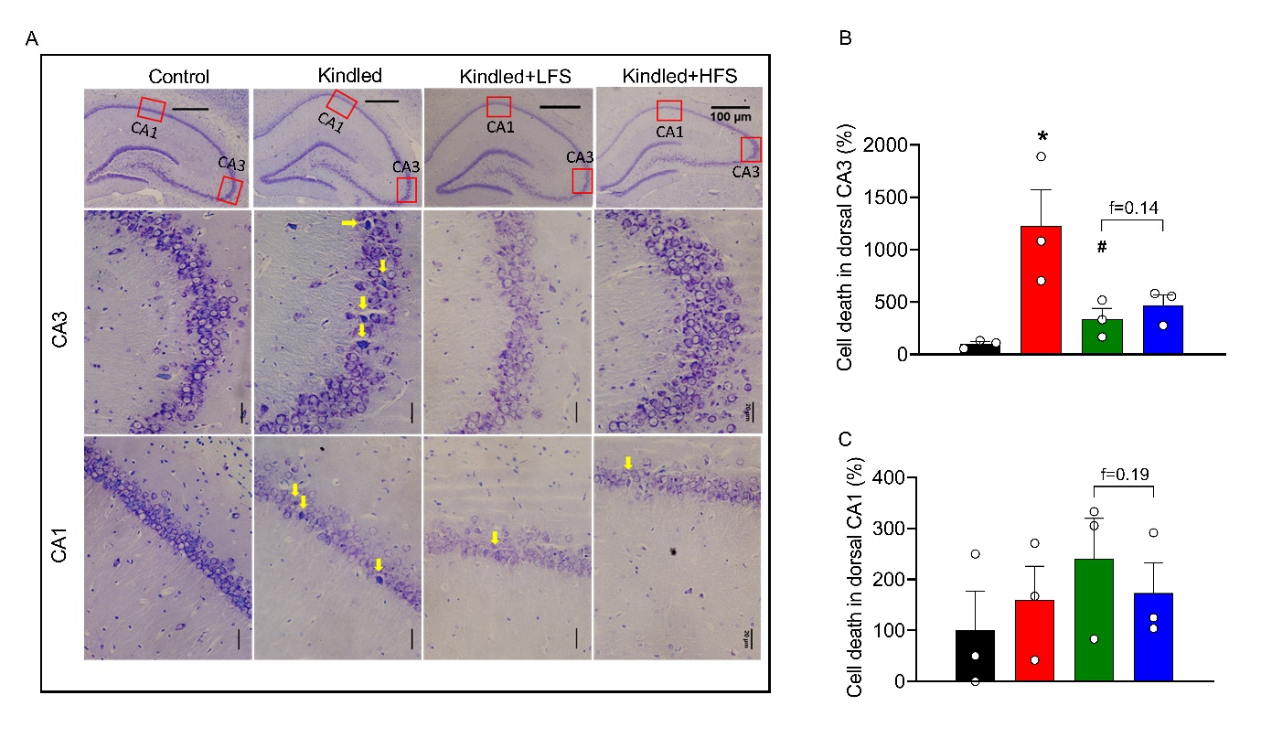
Supplementary Fig. 5. Applying LFS and HFS in olfactory bulb had protective effect against cell death in CA1 and CA3 regions of dorsal hippocampus in kindled animals. A: Representative Nissl staining images of the CA3, and CA1 areas of the dorsal hippocampus in different groups. B: The cell death percentage was increased in CA3 area of kindled animals. Applying LFS, but not HFS, significantly reduced the cell death. There was no significant difference among kindled+LFS and kindled+HFS groups C: No significant change was observed in cell death percentage in CA1 area among experimental groups. Data are resented as mean ± SEM. n=3 in all experimental groups. * P<0.05 compared to control group; # P<0.05 compared to kindled group.

