Extended Data

Tables
Extended Data Table 1. Clinical and pathological characteristics of monozygotic twin pairs with discordant IgA nephropathy phenotypes.
Extended Data Table 2. Isolation and culture of fecal bacteria from the Twin 3-1 IgA nephropathy patient.
Extended Data Table 3. Comparative 16S rRNA sequence analysis.
Extended Data Table 4. Altered schaedler flora core microbiota used for colonizing germ-free mice.
Extended Data Table 5. The clinical and pathological characteristics of the IgA nephropathy patients and healthy controls enrolled in this study.
Extended Data Table 6. Primers used in this study.

Figures
Extended Data Fig. 1| Pairwise comparison of microbial composition for each twin pair.
Extended Data Fig. 2| Pairwise comparison of relative abundance of the differentially distributed genus between each twin pair.
Extended Data Fig. 3| Transplantation of fecal sample with high abundance A. muciniphila induces IgA kidney deposition.
Extended Data Fig. 4| The isolation and colonization of patient-derived A. muciniphila.
Extended Data Fig. 5| Patient-isolated A. muciniphila promotes IgA renal deposition by inducing Akkermansia-mesangial cell cross-reactive IgA response.
Extended Data Fig. 6| Structural simulation screening process for A. muciniphila and mesangial proteins.
Extended Data Fig. 7| The structural alignments of the 11 high-confidence mimicry pairs.
Extended Data Fig. 8| Associations between anti-Q9UBV2, anti-Q14444, and anti-P23634 IgA and clinical-pathological phenotypes.
Extended Data Fig. 9| The IgA antibody titers against the immunized proteins.
Extended Data Fig. 10| Isolation of two A. muciniphila-specific lytic bacteriophages from environmental sources.
Extended Data Fig. 11| Phage treatment ameliorated the IgAN phenotypes induced by A. muciniphila in LCWE stimulated humanized IgA1 mouse model.
Extended Data Fig. 12| Phage treatment ameliorated the IgAN phenotypes induced by A. muciniphila in LCWE stimulated humanized IgA1 mouse model.

Extended Data Table 1. Clinical and pathological characteristics of monozygotic twin pairs with discordant IgA nephropathy phenotypes.
Twin Pair | Diagnosis | Sex | Age (years) | Serum creatinine (μmol/L) | eGFR  (ml/min/1.73m³ | Hematuria | Proteinuria (g/24h) | MEST-C
Twin1-1 | Severe IgAN | F | 15 | 94 | 78.18 | +++ | 1.80 | M0E1S0T0C2
Twin1-2 | Mild IgAN | F | 15 | 67.1 | 117.51 | ++ | 0.03 | M0E0S0T0C0
Twin2-1 | Severe IgAN | M | 21 | 1046.76 | 5.396 | ++ | 2.39 | M1E0S1T2C1
Twin2-2 | Mild IgAN | M | 21 | 77.08 | 123.255 | ++ | 0.57 | M1E0S0T0C0
Twin3-1 | IgAN | M | 36 | 208.57 | 33.201 | +++ | 12.60 | M0E1S0T1C2
Twin3-2 | Healthy control | M | 36 | NA | NA | NA | NA | NA
Twin4-1 | IgAN | M | 50 | 134 | 51.737 | +++ | 3.68 | M1E0S0T1C0
Twin4-2 | Healthy control | M | 50 | NA | NA | NA | NA | NA
Twin5-1 | IgAN | F | 67 | 44.9 | 99.95 | + | 5.93 | NA
Twin5-2 | Healthy control | F | 67 | NA | NA | NA | NA | NA
Note: NA, not applicable.

Extended Data Table 2. Isolation and culture of fecal bacteria from the Twin 3-1 IgA nephropathy patient.
ID | Species
BHI-1 | Bacillus licheniformis strain DSM 13
BHI-2 | Escherichia fergusonii strain NBRC 102419
BHI-3 | Bacteroides stercoris ATCC 43183
BHI-4 | Shigella sonnei strain CECT 4887
BHI-5 | Hungatella hathewayi strain 1313
BHI-6 | Escherichia fergusonii ATCC 35469
BHI-7 | Megasphaera indica strain NMBHI-10
BHI-8 | Bifidobacterium faecale strain CU3-7
BHI-9 | Bacillus nealsonii strain DSM 15077
BHI-10 | Collinsella aerofaciens strain JCM 10188
BHI-11 | Bacteroides thetaiotaomicron strain JCM 5827
BHI-12 | Bacteroides xylanisolvens XB1A
BHI-13 | Bacteroides uniformis strain JCM 5828
BHI-14 | Bacteroides fragilis strain NCTC 9343
BHI-15 | Lactobacillus mucosae strain S32
BHI-16 | Ruthenibacterium lactatiformans strain 585-1
BHI-17 | Enterococcus faecium strain NBRC 100486
BHI-18 | Parabacteroides distasonis ATCC 8503
BHI-19 | Bacteroides vulgatus ATCC 8482
BHI-20 | Collinsella stercoris strain JCM 10641
BHI-21 | Dialister succinatiphilus YIT 11850
BHI-22 | Parasutterella excrementihominis strain YIT 11859
BHI-23 | Blautia faecis strain M25
BHI-24 | Alistipes shahii WAL 8301
BHI-25 | Alistipes shahii strain JCM 16773
BHI-26 | Alistipes onderdonkii strain WAL 8169
BHI-27 | Proteiniphilum saccharofermentans strain M3/6
BHI-28 | Butyricimonas paravirosa strain 214-4
BHI-29 | Akkermansia muciniphila
M9-1 | Parasutterella excrementihominis strain YIT 11859
M9-2 | Megasphaera indica strain NMBHI-10
M9-3 | Collinsella aerofaciens strain JCM 10188
M9-4 | Bacteroides thetaiotaomicron strain VPI-5482
M9-5 | Enterococcus durans strain 98D
M9-6 | Bacteroides uniformis strain JCM 5828
M9-7 | Bacteroides xylanisolvens XB1A
M9-8 | Parabacteroides distasonis ATCC 8503
M9-9 | Lactobacillus mucosae strain S32
M9-10 | Ruthenibacterium lactatiformans strain 585-1
M9-11 | Dialister succinatiphilus YIT 11850
M9-12 | Bacteroides stercoris ATCC 43183
M9-13 | Bacteroides fragilis strain NCTC 9343
M9-14 | Blautia glucerasea strain JCM 17039
M9-15 | Collinsella stercoris strain JCM 10641
M9-16 | Dorea longicatena strain 111-35
M9-17 | Bacteroides koreensis strain YS-aM39

Extended Data Table 3. Comparative 16S rRNA sequence analysis.
Description | Scientific Name | Max Score | Total Score | Per. Ident | Acc. Len | Accession
Akkermansia muciniphila ATCC BAA-835 16S ribosomal RNA, partial sequence | Akkermansia muciniphila | 2503 | 2503 | 98.79% | 1505 | NR 074436.1
Akkermansia muciniphila ATCC BAA-835 STRAIN Muc 16S ribosomal RNA, partial sequence | Akkermansia muciniphila ATCC BAA-835 | 2492 | 2492 | 98.65% | 1433 | NR 042817.1
Note: The identity of the isolated strain to A. muciniphila ATCC BAA-835 reference strain is 98.79%.

Extended Data Table 4. Altered schaedler flora core microbiota used for colonizing germ-free mice.
Strains | Volume | The viable cell count at OD600 (CFU/mL)
Bacteroides thetaiotaomicron | 0.1 mL | 5×10⁹
Bifidobacterium adolescentis | 0.3 mL | 1×10⁹
Collinsella aerofaciens | 0.3 mL | 1×10⁹
Desulfovibrio piger | 0.3 mL | 1×10⁹
Eubacterium plautii | 0.6 mL | 5×10⁸
Prevotella copri | 0.6 mL | 5×10⁸
Roseburia inulinivorans | 0.3 mL | 1×10⁹
Ruminococcus gnavus | 0.3 mL | 1×10⁹

Extended Data Table 5. The clinical and pathological characteristics of the IgA nephropathy patients and healthy controls enrolled in this study.
Characteristics of IgA nephropathy patients
Total number | 161
Age, years | 35.58±10.37
Male (%) | 91 (56.5%)
Proteinuria, g/d | 1.16 (0.61-2.39)
eGFR, ml/min/1.73 m² | 68.00±34.36
Serum creatinine, umol/L | 106.42 (79.30-162.27)
Serum IgA, g/L | 3.10±0.98
Serum C3, g/L | 0.89±0.23
Renal biopsy manifestation, n (%)
IgA deposition, 1/2/3/4+ | 1 (0.62%)/18(11.18%)/129 (80.12%)/12 (7.45%)
C3 deposition, 0/1/2/3+ | 3(1.86%)/16(9.94%)/64(39.75%)/78 (48.45%)
Mesangial hypercellularity (M1) | 103/159 (64.78%)
Endocapillary hypercellularity (E1) | 74/159 (46.54%)
Segmental glomerulosclerosis (S1) | 112/159 (70.44%)
Tubular atrophy/Interstitial fibrosis (T1/2) | 78/159 (49.06%)
Crescents (C1/2) | 78/103 (75.73%)
Characteristics of healthy controls
Total number | 47
Age, years | 36.23±12.53
Male (%) | 23 (48.9%)

Extended Data Table 6. Primers used in this study.
Primers | Sequence（5’-3’） | Gene/Bacteria
Bacteria Identification
27-F | AGAGTTTGATCMTGGCTCAG | 16S rRNA full length
1492-R | TACGGYTACCTTGTTACGACTT | 16S rRNA full length
AKK-F | CAGCACGTGAAGGTGGGGAC | Akkermansia muciniphila-specific gene
AKK-R | CCTTGCGGTTGGCTTCAGAT | Akkermansia muciniphila-specific gene
In vivo colonization verification by RT-qPCR
27-F | AGAGTTTGATCMTGGCTCAG | 16S rRNA
342-R | CTGCTGCSYCCCGTAG | 16S rRNA
AKK-F | CAGCACGTGAAGGTGGGGAC | Akkermansia muciniphila
AKK-R | CCTTGCGGTTGGCTTCAGAT | Akkermansia muciniphila
Bvul-F | CGGGCTTAAATTGCAGATGA | Bacteroides vulgatus
Bvul-R | CATGCAGCACCTTCACAGAT | Bacteroides vulgatus
Bova-F | TGCAAACTRAAGATGGC | Bacteroides ovatus
Bova-R | CAAACTAATGGAACGCATC | Bacteroides ovatus

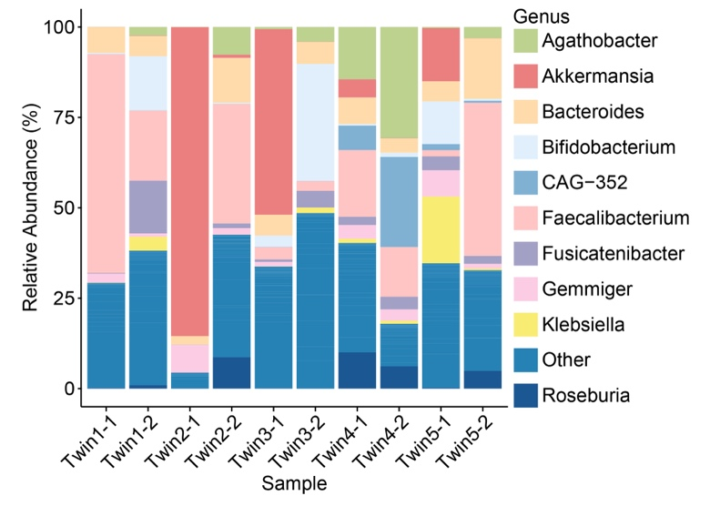
Extended Data Fig. 1| Pairwise comparison of microbial composition for each twin pair.

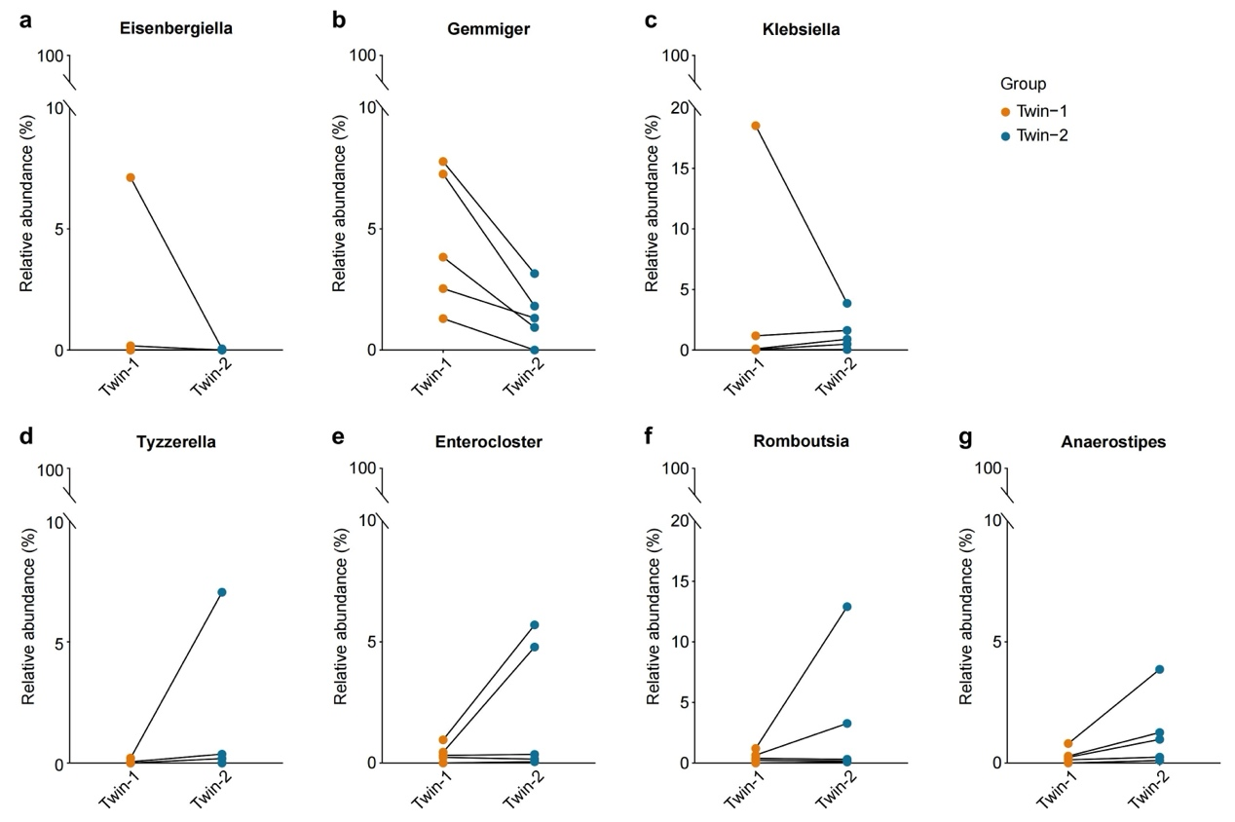
Extended Data Fig. 2| Pairwise comparison of relative abundance of the differentially distributed genus between each twin pair.

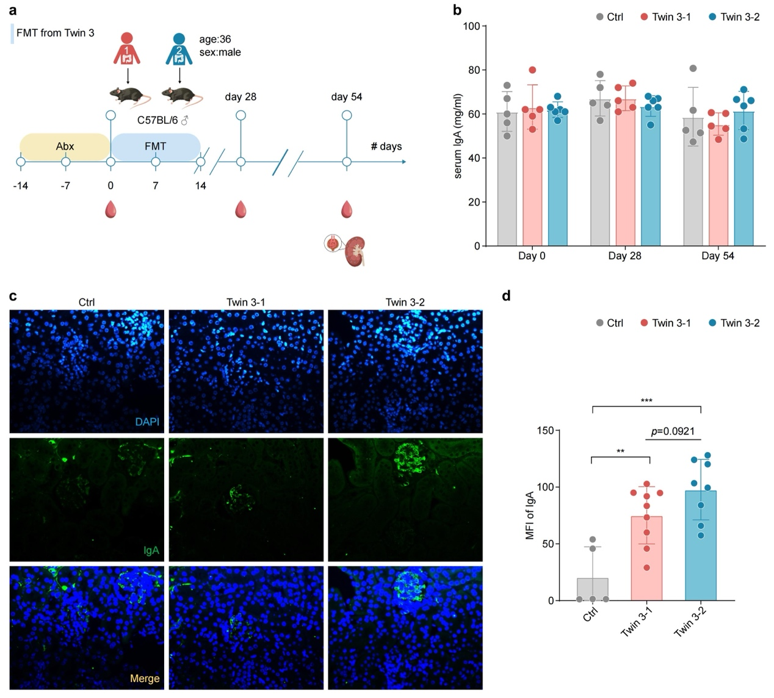
Extended Data Fig. 3| Transplantation of fecal sample with high abundance A. muciniphila induces IgA kidney deposition. a, FMT using fresh fecal samples from Twin 3-1 with high abundance of A. muciniphila during his active disease phase and his healthy sibling Twin 3-2 into C57BL/6 mice. The number of mice in five in Ctrl and Twin 3-2 group, six in Twin 3-1 group. b, Serum IgA concentrations were measured longitudinally post-FMT. c, Representative immunofluorescence images of kidney IgA deposition and corresponding semi-quantitative scoring at Day 54. Unpaired t-test has been used to analyze the significant differences between the groups. The error bars are represented as Mean ± SD. FMT: fecal microbiota transplantation; MFI: mean fluorescence intensity.

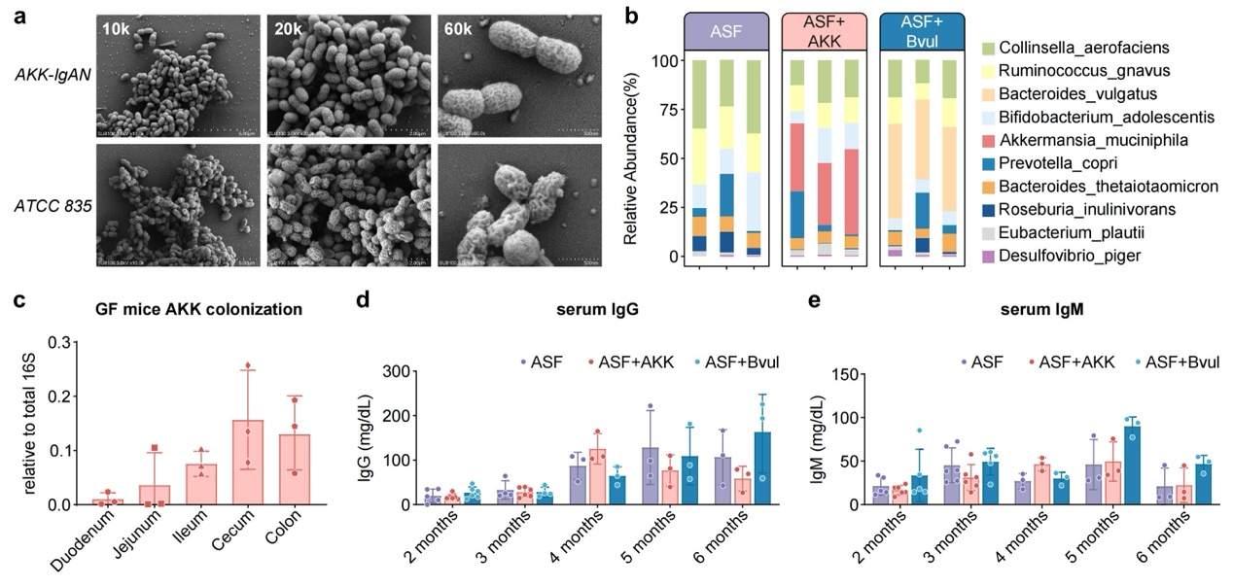
Extended Data Fig. 4| The isolation and colonization of patient-derived A. muciniphila. a, Scanning electron microscope shows difference in molecular surface of the two A. muciniphila. b, 16S rRNA sequencing results of the fecal microbiota after colonization. c, Intestinal colonization of A. muciniphila detected by real-time qPCR. d-e, Serum IgG and IgM concentrations were measured longitudinally post-colonization. Unpaired t-test has been used to analyze the significant differences between the groups. The error bars are represented as Mean ± SD. AKK-IgAN: A. muciniphila isolated and characterized from IgAN patient; ASF: Altered Schaedler Flora; ASF+AKK: ASF + A. muciniphila; ASF+Bvul: ASF + B. vulgatus.

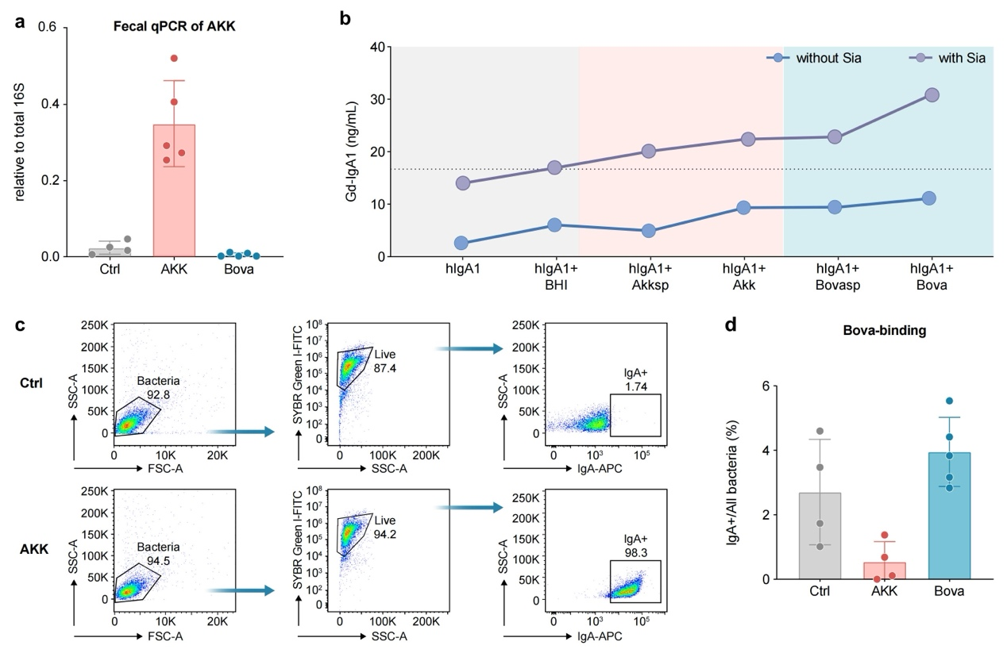
Extended Data Fig. 5| Patient-isolated A. muciniphila promotes IgA renal deposition by inducing Akkermansia-mesangial cell cross-reactive IgA response. a, Colonization verification by fecal 16S rDNA sequencing using bacterium-specific primers. b, A. muciniphila confirmed partial generation of Gd-IgA1, but the control strain Bova demonstrated even stronger deglycosylation activity. Recombinant human IgA1 (hIgA1; 1 μg) was incubated in a total volume of 200 μL containing 0.1 M Tris-HCl buffer (pH 5.0), culture supernatant from A. muciniphila, and sialidase (Sia; Sialidase treatment was included to facilitate exposure of O-glycan structures on IgA1). Specifically, the reaction mixture consisted of 1 μL hIgA1, 100 μL Tris-HCl buffer, 98 μL A. muciniphila culture supernatant, and 1 μL sialidase (5 U per 500 μL). The mixture was incubated at 37°C overnight. Following incubation, samples were centrifuged at 12,000 rpm for 1 min at 4°C to remove insoluble material. The supernatant was collected and Gd-IgA1 levels were quantified using a Gd-IgA1 ELISA according to the manufacturer’s instructions. c, Bacterial FACS gating strategy, the serum IgA from A. muciniphila-colonized mice was bind by cultured A. muciniphila and detected by flow cytometry. d, IgA induced by Bova tends to preferentially bind Bova. hIgA1: purified human IgA1 protein. Gd-IgA1: Galactose-deficient hIgA1. BHI: brain-heart medium. AKKsp: cultured A. municiphila supernatant. Bovasp: cultured B.ovatus supernatant. Sia: Sialidase.

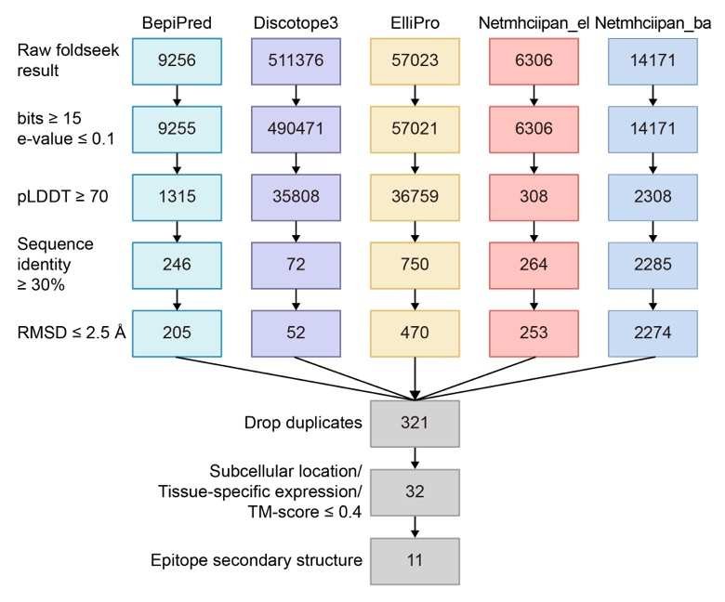
Extended Data Fig. 6| Structural simulation screening process for A. muciniphila and mesangial proteins. A total of 11 high-confidence mimicry pairs involving 10 distinct A. muciniphila antigen proteins and 9 mesangial proteins were identified.

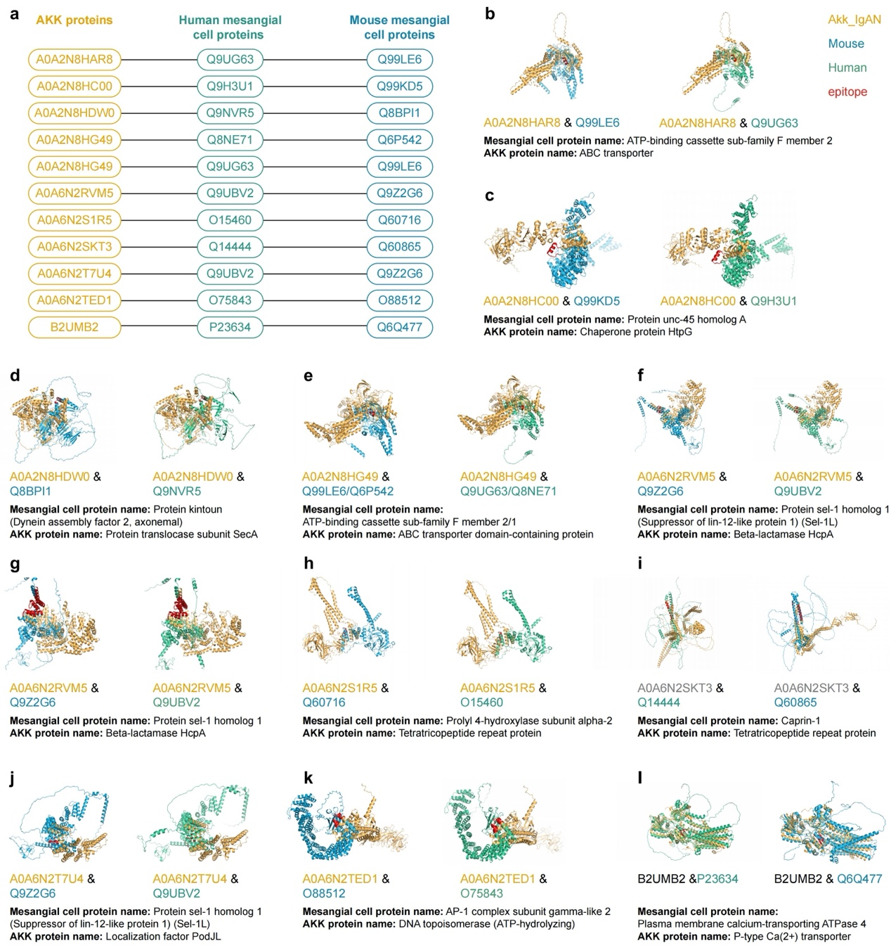
Extended Data Fig. 7| The structural alignments of the 11 high-confidence mimicry pairs.

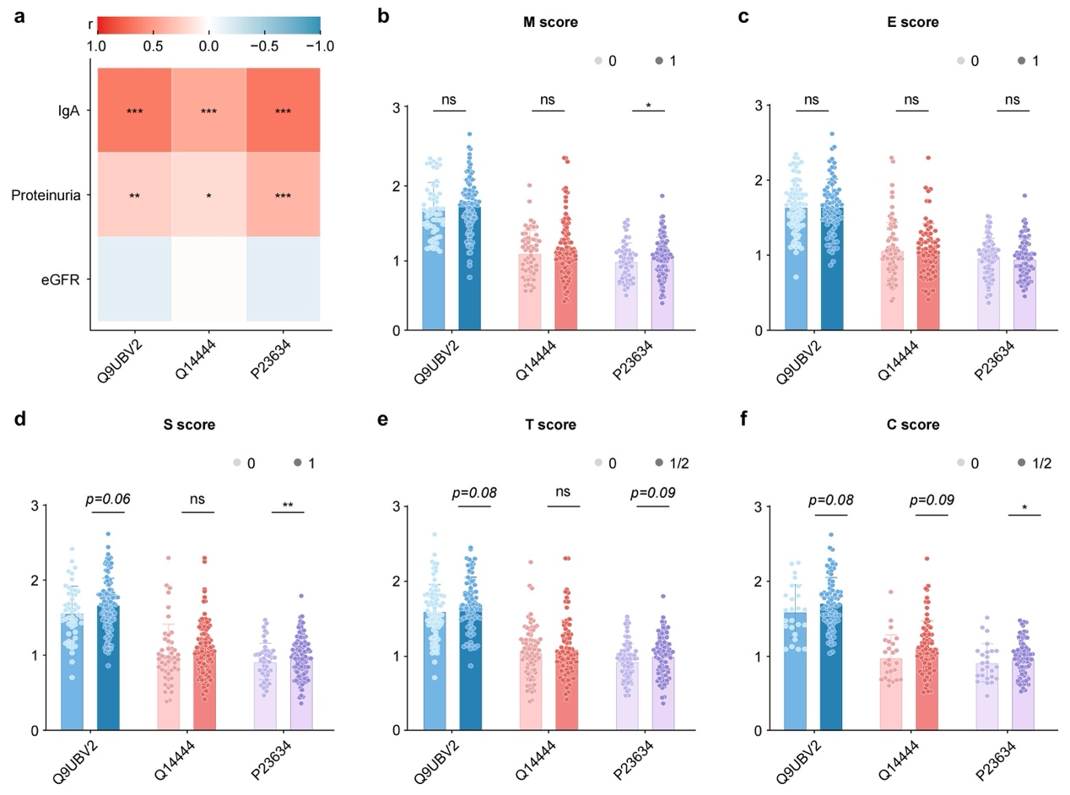
Extended Data Fig. 8| Associations between anti-Q9UBV2, anti-Q14444, and anti-P23634 IgA and clinical-pathological phenotypes. a, Clinico-pathological correlation analyses revealed that elevated anti-Q9UBV2, anti-Q14444, and anti-P23634 IgA levels were significantly associated with higher proteinuria; b-f, anti- P23634 IgA levels were more likely to be associated with pathologic lesions mesangial hypercellularity (“M”), segmental glomerulosclerosis (“S”), and cellular or fibrocellular crescents (“C”) scores.

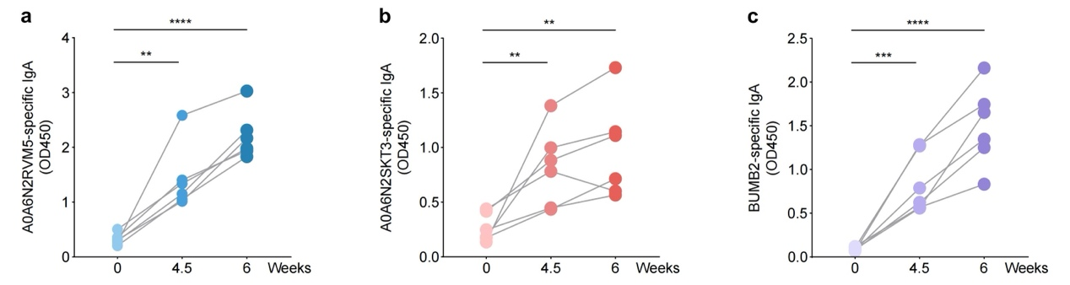
Extended Data Fig. 9| The IgA antibody titers against the immunized proteins.

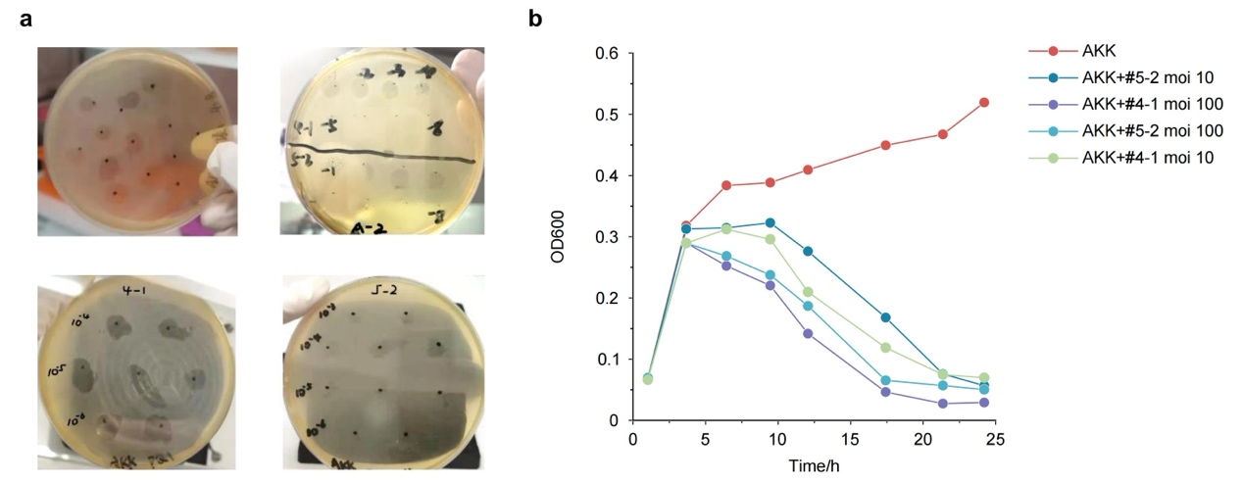
Extended Data Fig. 10| Isolation of two A. muciniphila-specific lytic bacteriophages from environmental sources. a, Phages isolated from experimental samples (#4-1 and #5-2). b, Phages lysis efficiency test against A. muciniphila isolated from the IgA nephropathy patient. moi: multiplicity of infection.

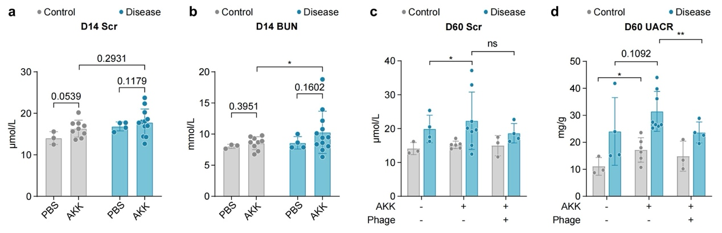
Extended Data Fig. 11| Phage treatment ameliorated the IgAN phenotypes induced by A. muciniphila in LCWE stimulated humanized IgA1 mouse model. a-b, The effects of A. muciniphila colonization on serum creatinine and BUN changes. c-d, The bacteriophage treatment ameliorated IgAN phenotypes measured at day 60, as demonstrated by the significant decrease of urine albumin to creatinine ratio (UACR), with minor effect on serum creatinine. Unpaired t-test has been used to analyze the significant differences between the groups. The error bars are represented as Mean ± SD.

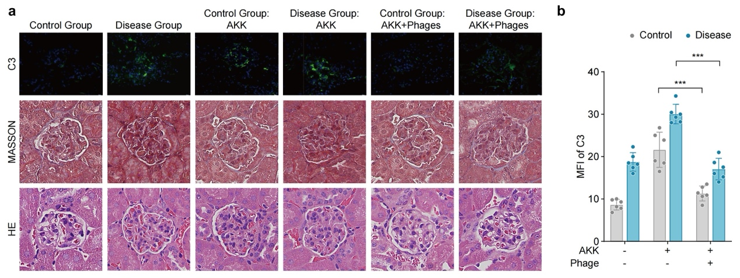
Extended Data Fig. 12| Phage treatment ameliorated the IgAN phenotypes induced by A. muciniphila in LCWE stimulated humanized IgA1 mouse model. Representative images and quantification of renal C3 deposition by immunofluorescence at day 60. A clear amelioration of IgAN in pathological examination was observed. Unpaired t-test has been used to analyze the significant differences between the groups. The error bars are represented as Mean ± SD. C3: complement component 3; HE: Hematoxylin-Eosin.

