Annex I

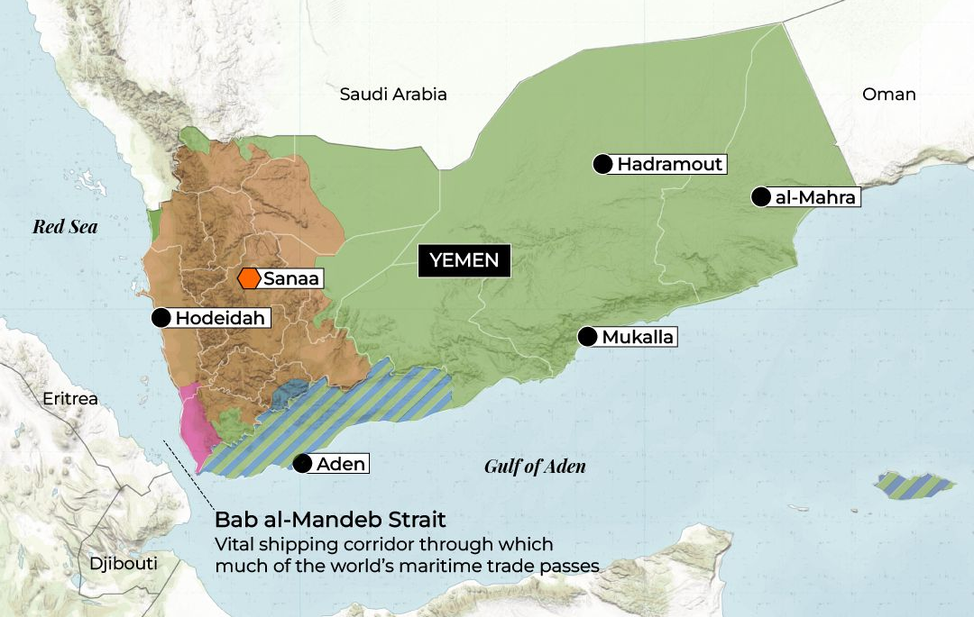
The influence areas in Yemen
(Source: www.aljazeera.com/news/2026/1/14/mapping-who-controls-what-in-yemen-in-2026)

 | Recognized Government  of Yemen | Houthis Control areas
Population | About 7.907.000 | About 26.543.000
Area | About 427.00 km2 | About 103.000 km2
Capital | Sana’a (currently moved to Aden) | Sana’a
Government | Presidential Leadership Council | Houthis-led Supreme Political Council
Governorates | - Abyan  - Aden  - Al-Dale  - Al-Maharah  - Hadhramaut  - Lahij  - Ma'rib  - Taiz  - Shabwah  - Socotra | 1. Al Jawf  2. Al Bayda  3. Al Hudaydah  4. Al Mahwit  5. Amran  6. Dhamar  7. Hajjah  8. Ibb  9. Raymah  10. Saada  11. Sanaa Governorate  12. Sanaa Municipality
Demographic, geographic, and administrative breakdown of Yemen

Annex II
