Supplement 1 – Figures, table, and videos
Supplementary Figures
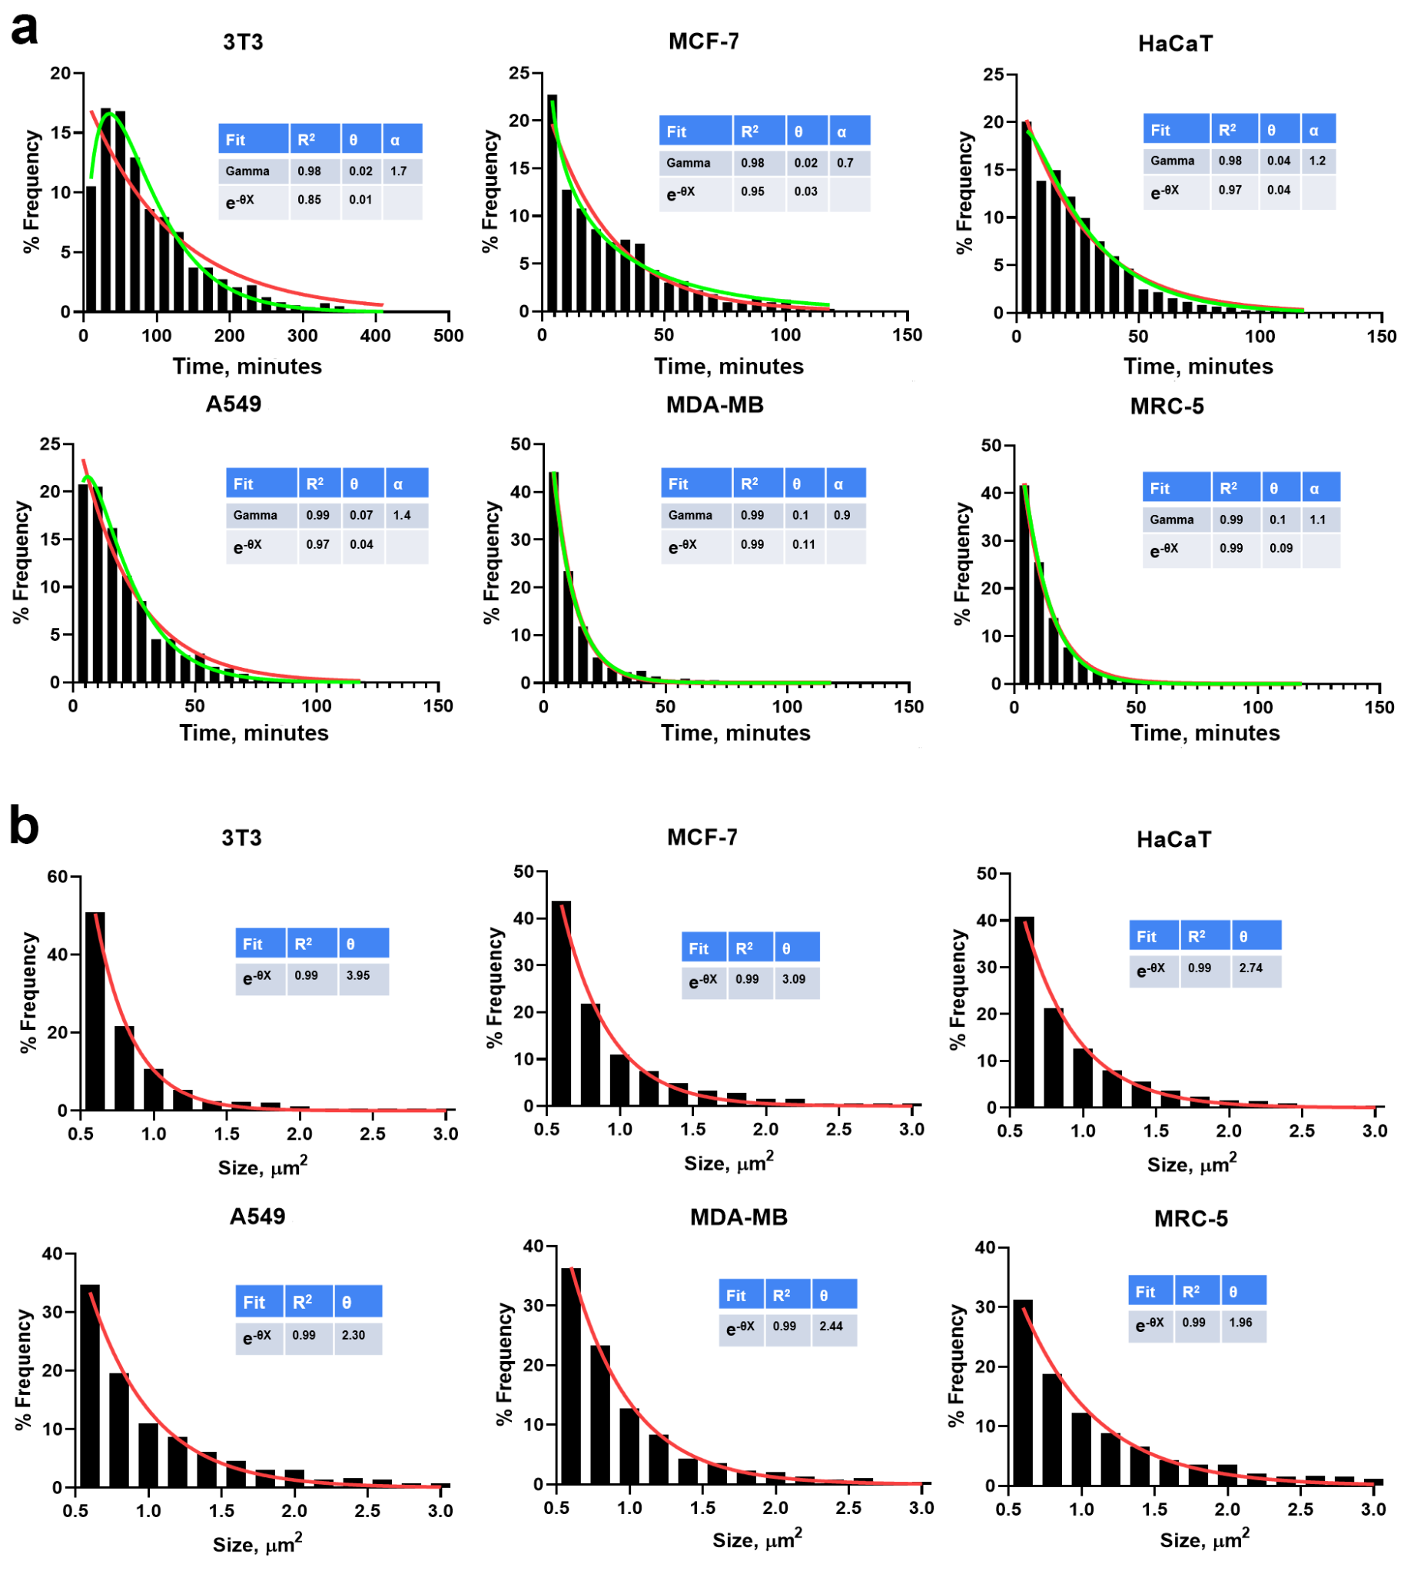
Figure S1. Differences in lifetime and size distributions of FAs between data obtained by automated analysis. (a) Lifespan and (b) size distributions of FAs six cultures expressing vinculin-RFP with exponential fitting (e^{-θx}) shown by red line, and gamma-fitting (x^{(α-1)}e^{-θx}θ^{α}/Γ(α)) shown by the green line. For all size distributions exponential fitting gives R²>0.99, thus an alternative fitting (gamma) is not shown.

Figure S2. Lifetime and size distributions of FAs using different thresholds for minimal size FA needs to reach during its lifetime. A549 cells expressing vinculin-RFP and mNeonGreen-paxillin, data shown is based on paxillin. (a) Distribution of FA lifetimes identified by automated tracking algorithm in A549 cells imaged at 30 frames per minute. Bin width is 5 frames (10 seconds). (b) Median sizes for FAs in corresponding bins from (a). FA filtering threshold set to 0.15 µm² (minimal threshold); (c), (d) – same as (a), (b) but filtering threshold set to 0.5 µm²;(e), (f) – same as (a), (b) but filtering threshold set to 1.0 µm². Line on (d) shows linear fit for the data with 95% CI. Based on data from N=13 cells.
Figure S3. Examples of different regimes of edge protrusion and retractions. A549 cells expressing vinculin-RFP recorded over 3 hours. Upper row shows microscopy image of a cell with kymograph line overlaid in yellow; middle row shows color-coded time-lapse of cell motion during 3 hours of observation with kymograph line overlaid as thick yellow line; lower row shows kymograph of edge motion over the 3 hours of observation. Scale bar, 20 µm. (a) Net directional cell motion achieved via multiple cycles of rapid edge protrusions alternating with partial edge retractions. (b) No significant net cell motion displaying multiple cycles of rapid edge protrusions alternating with edge retractions. (c) Net directional cell motion achieved via multiple cycles of rapid edge protrusions with no alternating edge retractions.

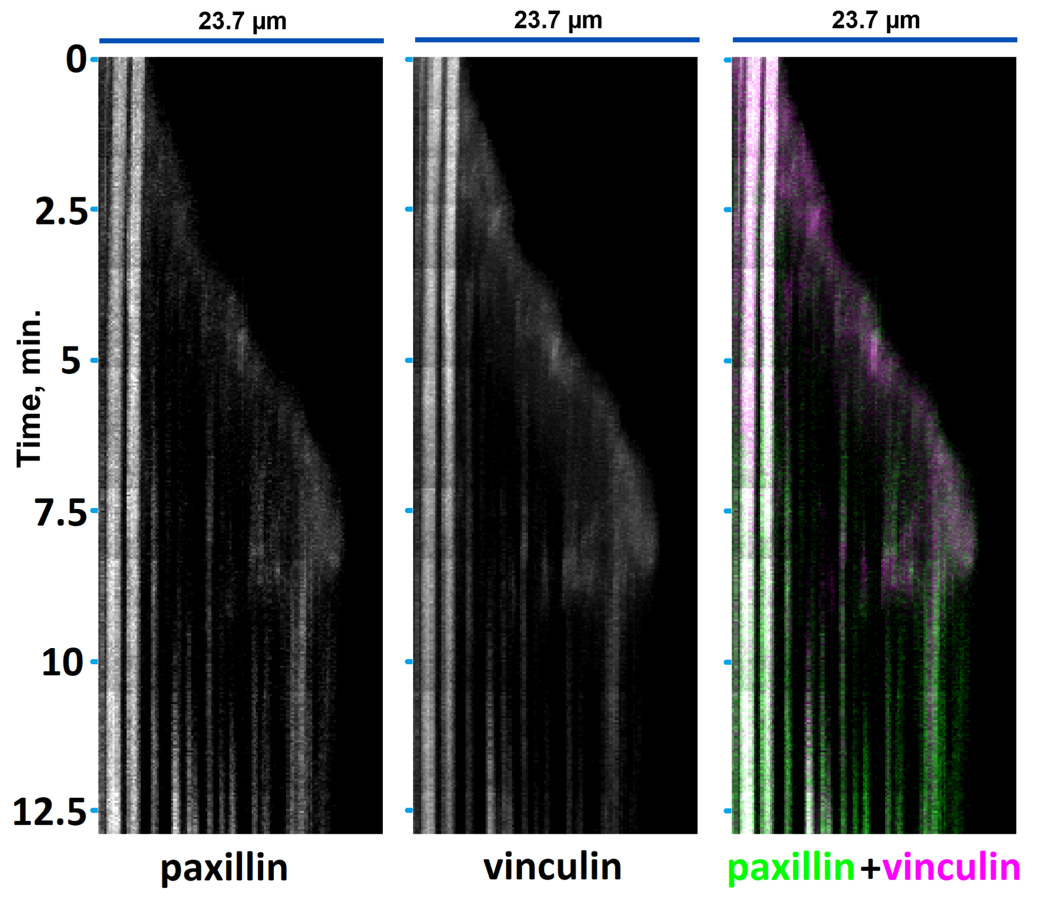
Figure S4. Kymograph of rapid edge protrusion. Close up view of a kymograph in Figure 2a shown separately in paxillin and vinculin channels (left and central image), as well as with both channels merged (rightmost image).
s
Figure S5. Validation of automated FA tracking against manual analysis. (a) Representative raw microscopy images of FAs (labelled with vinculin-RFP) in 6 different cell cultures. Scale bar, 10 µm. Cell culture type is indicated in the upper left corner. (b) Ranking of 6 different cell cultures by median FA lifetime. Manual (green on the left) vs algorithmic (default threshold of 0.5 µm²; blue in the center) vs. algorithmic with higher threshold (>1.5 µm²) for FA size (red on the right). Displayed values are median ± 95% CI.

Figure S6. Distribution of FAs according to the lifespan. A549 cells expressing vinculin-RFP and mNeonGreen-paxillin. Images shown are of paxillin. (a) Snapshots of two translocating cells. Orange arrows show direction of translocation. Scale bar, 20 µm. (b) Color coded images of the same cells over 30 min of recording. Time-based color map shown in lower left corner. (c), (d) and (e) Density distribution of FAs formed within 30 min in these cells: (c) all FAs, (d) only short-lived FAs (lifespan <3 min), (e) only long-lived FAs (lifespan >20 min). Total time of observation – 30 min, 901 frames.
Figure S7. FA speed of displacement in A549 cells. (a) Algorithmic tracking of moving FAs with FA of interest shown in orange. Time in minutes shown at the left. Scale bar, 10 µm. FAs labeled with mNeonGreen-paxillin. (b) FA displacement as a function of time for FA of interest shown in (a). Period with the most rapid displacement over 1 minute shown in green. Speed of displacement was calculated as a linear fit over this period and in this case was 4.7 µm/min. (c) Maximal FA displacement speeds (as calculated in (b)) for control cells. (d) The same as (c), but for cells after microtubule depolymerization. Data based on N=8 for control and N=9 for microtubule depolymerization in cells.
Figure S8. Microtubule dynamics reported by EB3-GFP protein. (a) Control and (b) A549 cells under microtubule depolymerization. Both images show EB3 protein behavior recorded over 10 min with 30 frame per minute recording rate, displayed as a maximum intensity projection over all 600 frames recorded. Lines on the left image show EB3 comet trails over time. No EB3 comets trails can be seen in the right image, indicating that all microtubules have been depolymerized. Scale bar, 10 µm.

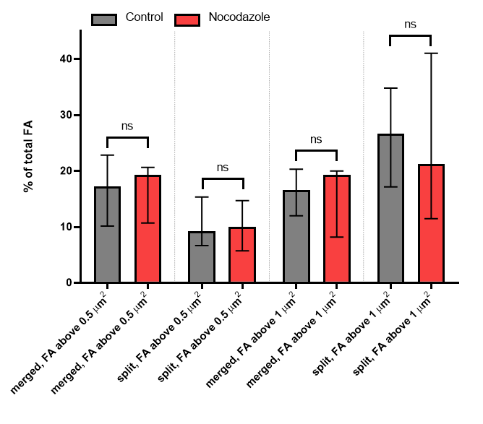
Figure S9. Fractions of FAs merged and split. Control (gray) and microtubule depolymerization (red), A549 cells expressing vinculin-RFP. “Merged” FAs correspond to percent of FAs that have been subsumed into larger FA, while “split” FAs correspond to percent of FAs that have split into one or more smaller FA during their lifetime. Displayed values are median ± 95% CI based on N=8 for control and N=9 for microtubule depolymerization in cells.

Figure S10. Comparison between FA assembly and disassembly rates. Rates were determined at different sampling frequencies and calculated in (a) absolute units (µm²/min) and in (b) normalized semi-log scale units (1/min) in A549 cells expressing vinculin-RFP. Displayed values for Y axis are median ± 95% CI based on N=1455 FA (for 30 FPS and decimated to 4 FPS) and N = 3258 (for 4 FPS).

Figure S11. Relative directions of displacements of FAs. A549 cells expressing vinculin-RFP recorded over 3-hour period. Only FAs with displacement ≥3 µm are displayed. Green lines indicate displacement toward the cell center, marked by a red dot; red lines indicate displacement away from the cell center; blue lines indicate lateral displacement relative to the cell center. FAs located closer than one quarter of the cell diameter to the cell center are not shown because their displacement direction relative to the cell center was poorly defined. Scale bar, 20 µm. (a) Control cell displaying continuous cell motion in one direction over the period of observation. The arrow shows direction of translocation. True cell center moves substantially over time, but for brevity considerations, displacement directions are still plotted relative to the red dot displayed in the image. (b) Cell under microtubule depolymerization displaying no significant net cell motion.

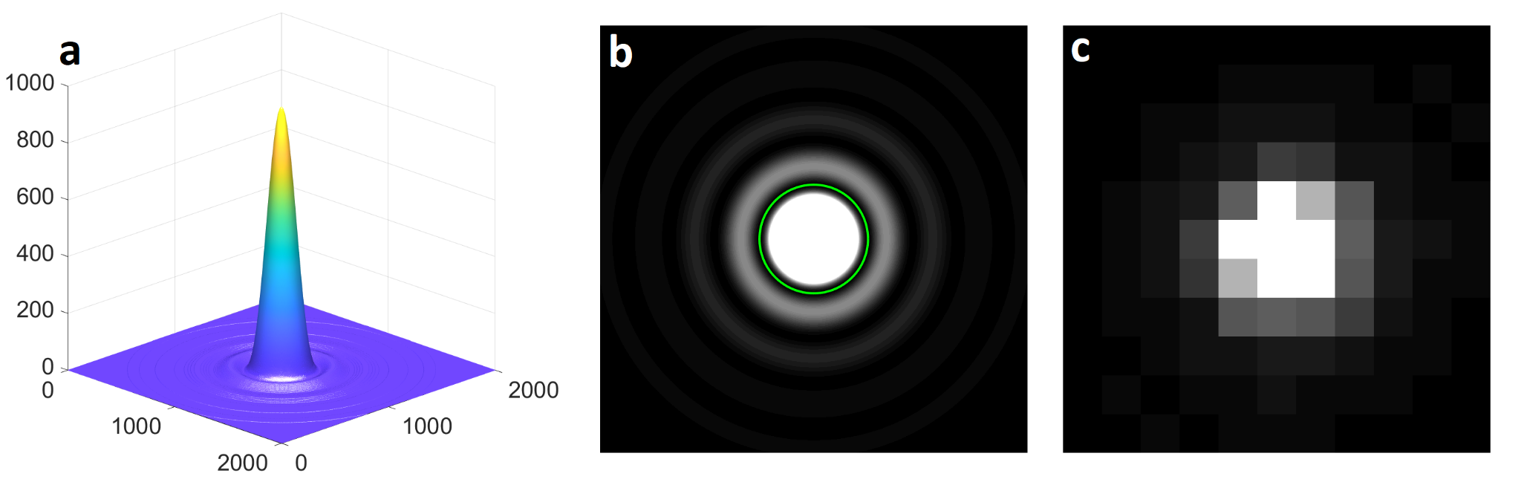
Figure S12. Simulation of brightness distribution of a point source. (a) Simulated brightness distribution (point spread function (PSF)) of a point source of light as seen by 63x objective with 1.40 N.A. X and Y distance in nanometers. Z (brightness) in arbitrary units. (b) Same point spread function as in (a) but shown as 2D plot. Green ring shows first Airy disk minimum. (c) Same point spread function as in (a) and (b), but after being pixelated (as seen by the camera). PSF calculated using $I(x)=I_{0}{\left(\frac{2B(x)}{x}\right)}^{2}$, where B is Bessel function of the first kind of order one.

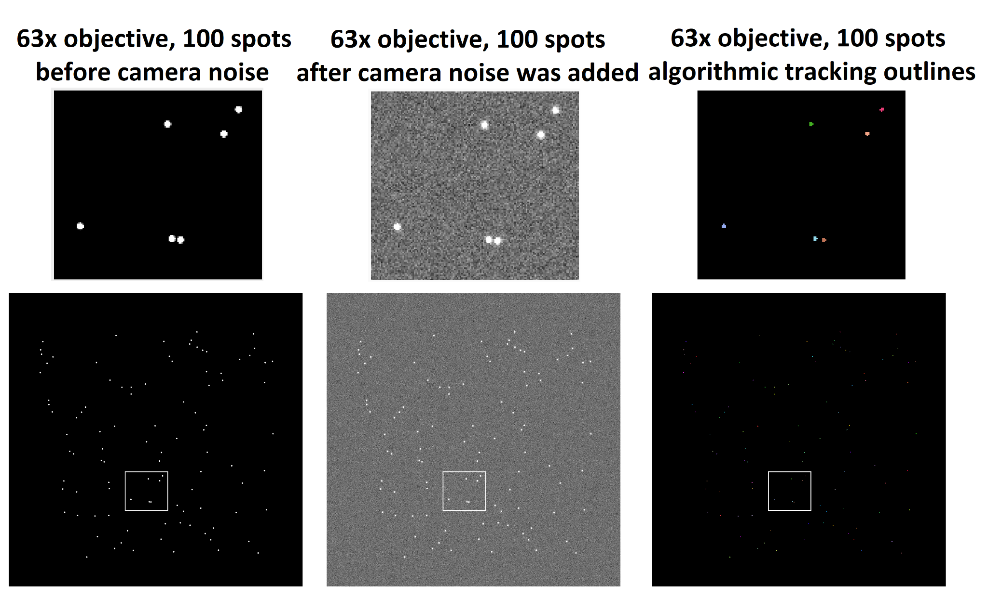
Figure S13. Simulation and tracking of pixelated point-spread functions under camera noise conditions. Simulated pixelated PSFs as in (S12c), randomly spread inside a camera field of view. 100 spots simulated in total. The exact position relative to the camera's pixels is randomized for each spot, so after being pixelated they give a somewhat different brightness distribution. The left image shows a base simulated image before camera noise was added. The central image shows the same image as the one on the left after the camera noise pattern was added. The right image shows FA tracking outlines after a video with one hundred simulated images was created and algorithmically tracked. Each frame in this video was created by applying a new camera noise pattern to the base (leftmost) image.
Figure S14. Differences in lifetime and size of FAs between six cultures. (a, b) Lifetime and (c, d) size of FAs in six cell cultures expressing vinculin-RFP determined manually with no threshold (a, c, N_{FA}=117, 186, 120, 182, 179, 158, from left to right) and by algorithmic analysis using 0.5 μm² threshold (b, d, N_{FA}=1206, 1447, 5226, 2075, 3061, 3250, from left to right).
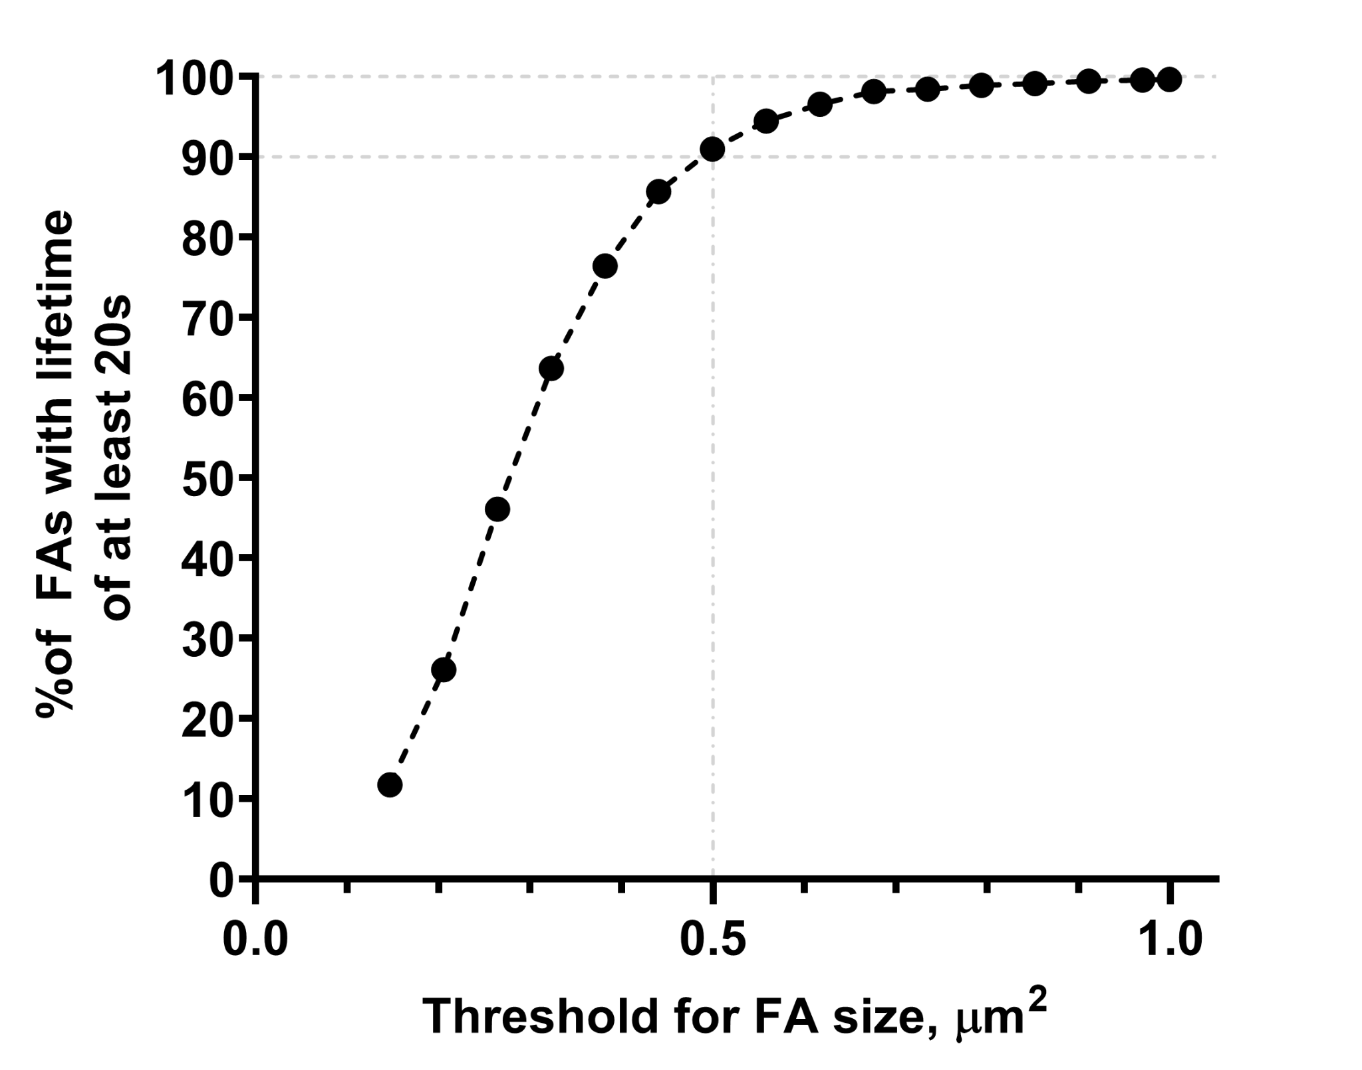
Figure S15. Dependence of FA fraction with measurable growth-disassembly periods on the size threshold used for inclusion in analysis. Fraction of FAs in a dataset with lifetime of at least 10 frames (20 seconds for data recorded at 30 frames per minute) is plotted as a function of size they must reach to be included into further analysis.
Figure S16. Automated tracking of FA dynamics. (a) Image of the entire A549 cell expressing vinculin-RFP, with regions of interest shown in (b), (c) and (d) highlighted with white rectangles. Scale bar, 10 µm. (b) Example of algorithmic tracking of FA undergoing splitting. FA outline shown in brown. A single FA splits into two, with both resulting FAs inheriting the same FA ID (and, thus, color). (c) Example of algorithmic tracking of FAs undergoing merging. Two initially independent FAs (green and purple outlines) merge into one (by 3 min mark), then split again (by 6 min mark). The merged FA inherits the ID (and color) of the larger original FA. (d) Example of algorithmic tracking of a single FA from assembly to disassembly, with pronounced displacement over its lifetime. FA outline shown in orange. For (b), (c) and (d) the upper row shows raw microscopy images of the region of interest. The middle row shows FA outlines from algorithmic tracking. The lower row shows elapsed time in minutes.

Table S1. Statistical significance of the differences in lifetime and size of FAs between six cultures obtained by manual and automated analysis. Data corresponding to that on Figure S14. Significance was determined using Mann-Whitney U-test. ns – p > 0.05; * — 0.05 > p > 0.01; ** — 0.01 > p > 0.001; *** — 0.001 > p > 0.0001; **** — 0.0001 > p
(a) Statistical significance of differences in manually analyzed lifetime between cultures
 | 3T3 | MCF-7 | HaCaT | A549 | MDA-MB-231 | MRC-5
3T3 | ns | ns | **** | **** | **** | ****
MCF-7 | ns | ns | **** | **** | **** | ****
HaCaT | **** | **** | ns | ns | **** | ****
A549 | **** | **** | ns | ns | **** | ****
MDA-MB-231 | **** | **** | **** | **** | ns | ns
MRC-5 | **** | **** | **** | **** | ns | ns
(b) Statistical significance of differences in manually analyzed size between cultures
 | 3T3 | MCF-7 | HaCaT | A549 | MDA-MB-231 | MRC-5
3T3 | ns | ns | * | **** | ns | **
MCF-7 | ns | ns | ns | ** | ns | ns
HaCaT | * | ns | ns | * | ns | ns
A549 | **** | ** | * | ns | ** | ns
MDA-MB-231 | ns | ns | ns | ** | ns | ns
MRC-5 | ** | ns | ns | ns | ns | ns
(c) Statistical significance of differences in automatically analyzed lifetime between cultures
 | 3T3 | MCF-7 | HaCaT | A549 | MDA-MB-231 | MRC-5
3T3 | ns | **** | **** | **** | **** | ****
MCF-7 | **** | ns | *** | **** | **** | ****
HaCaT | **** | *** | ns | **** | **** | ****
A549 | **** | **** | **** | ns | **** | ****
MDA-MB-231 | **** | **** | **** | **** | ns | ns
MRC-5 | **** | **** | **** | **** | ns | ns
(d) Statistical significance of differences in automatically analyzed size lifetime between cultures
 | 3T3 | MCF-7 | HaCaT | A549 | MDA-MB-231 | MRC-5
3T3 | ns | **** | **** | **** | **** | ****
MCF-7 | **** | ns | ** | **** | **** | ****
HaCaT | **** | ** | ns | **** | **** | ****
A549 | **** | **** | **** | ns | *** | **
MDA-MB-231 | **** | **** | **** | *** | ns | ****
MRC-5 | **** | **** | **** | ** | **** | ns

Supplementary Videos
Video S1. Time-lapse imaging of a directionally migrating A549 cell expressing vinculin-RFP during migration. Directional cell migration was achieved through multiple cycles of rapid edge protrusions alternating with partial edge retractions. Images were acquired at 4 FPM; total duration, 1.5 hours (361 frames). Scale bar, 10 μm.
Video S2. Time-lapse imaging of a rapidly protruding lamella in an A549 cell expressing vinculin-RFP. The cell exhibited repeated protrusion and retraction cycles propagating in a circular pattern around the cell edge, resulting in a “spinning-in-place” behavior without significant net cell displacement. Images were acquired at 4 FPM; total duration, 3 hours (721 frames). Scale bar, 10 μm.
Video S3. Effect of microtubule depolymerization on FA dynamics in an A549 cell expressing vinculin-RFP. Microtubules were depolymerized by treatment with 1 µM nocodazole. Time-lapse imaging shows rapid lamellar protrusion accompanied by dynamic focal adhesion nucleation and turnover. Images were acquired at 4 FPM; total duration, 1.5 hours (361 frames). Scale bar, 10 μm.

Supplement 2 - Supplementary Methods
FA identification, tracking and quantification
The task of identifying individual adhesions in a microscopy image requires establishment of some thresholds for protein aggregates size and brightness to classify them as FAs. The first step requires classification of individual pixels as potential parts of an FA (based on their brightness, etc.). We used a watershed-based segmentation procedure similar to that described in Berginski et al. [1,2], namely to establish the required brightness threshold based on mean pixel brightness across the whole cell. Specifically, pixels with intensities exceeding 1.2-3.0 standard deviations above the mean were classified as potential parts of an adhesion, with the exact threshold in this range determined by the signal-to-noise ratio. At the next step, the size of a cluster of pixels above the threshold is considered. Since we were interested in tracking even small FAs, keeping the threshold for FA size low was desirable. Analysis of simulated brightness distribution (Airy disk) showed that minimal object FA size at which our algorithm was able to correctly identify and track more than 95% of simulated point sources was 5 pixels (Fig. S12 and S13). Based on this, our minimal detection threshold for the size of FA was set at 0.15µm² (5 pixels for 63x objective). This threshold alone, however, is insufficient to adequately track individual focal adhesions over time, because for bright spots near this threshold minor intensity fluctuation may cause detected size to go above and below the threshold repeatedly, which will be identified by an algorithm as a number of very small and short-lived FAs with undetectable growth and disasssembly periods. To prevent this from happening, a “buffer zone” was introduced in which FAs that just passed above the threshold are not included into the further analysis unless they eventually reached a size threshold of 0.5 µm². Fig. S2 shows examples of lifetime and median size distributions with and without this secondary threshold.
The value of 0.5 µm² for this threshold was selected based on the following considerations: (1) Nascent adhesions described in literature have size of 0.2 - 0.4 µm² [3–7], so FAs that have never passed the threshold of 0.5 µm² during their lifetime likely haven’t developed into mature FAs. (2) Manually and algorithmically calculated median FA sizes agreed well for a threshold of 0.5 µm² (Fig. S14c, d). (3) Fraction of FAs in the dataset with lifetime of at least 10 frames (20 seconds for data recorded at 30 frames per minute) largely depends on this threshold: it starts at 12% (for the threshold of 0.15 µm²), exceeds 90% when this threshold is increased to 0.5 µm² and reaches 99% when it is increased to 0.7 µm² (Fig. S15). A lifetime of at least 10 frames is required for calculation of assembly and disassembly rates (described below), so with a threshold of 0.5 µm² >90% of total FA dataset satisfies this requirement, which we considered sufficiently representative for further detailed analysis.
After FA identification in each frame of the recording, life histories of individual FAs were tracked over time by assigning the same ID to an FA that shared the largest number of pixels with an FA in the subsequent frame. If no FA occupied any of the same pixels, that FA was classified as disassembled, and its ID was no longer assigned to any future FA.
In regions with high FA density, events of merging and splitting of individual FAs were prevalent enough that the tracking algorithm was modified to mark these events as separate entities (Fig. S16). Therefore, if multiple separate FAs fell within the one larger FA on the next frame, smaller FAs among them were marked as merged into the largest one, with their IDs no longer assigned to any future FAs and only the ID of the largest FA persisting (Fig. S16c). If FA splits into several unconnected FAs in the next frame, all “daughter” FAs inherited the same ID (Fig. S16b). FAs that appeared de novo (with no FAs being present in their space in the previous frame) were assigned new unique FA IDs.
A model of FA lifecycle previously used by Berginski et al. and Webb et al.[1,8] that assumes a single assembly phase at the beginning of FA’s lifetime with a single disassembly phase at the end of FA’s lifetime was used for assembly and disassembly rate measurement. Following Berginski et al.[1], exact rates were obtained by finding a pair of linear fits (one for assembly phase and one for disassembly phase) with the highest sum of their R-squared. The assembly phase was set to start on the first frame of FA lifetime, while the disassembly phase was constrained to end on the last frame of FA lifetime, and these two phases were not allowed to overlap. Time between the end of the assembly phase and start of disassembly phase was defined as the duration of the plateau. The minimal phase duration for both assembly and disassembly were set at 5 frames each (following [1]). Linear fit of integrated brightness (in arbitrary units – ADUs of brightness) or area (in µm²) vs. time (in frames) was used for calculation of FA assembly and disassembly rates. Only FAs with lifetimes contained fully within the period of recording with positive assembly and negative disassembly rates were included in analysis.
FA size was calculated as the number of its pixels on a frame-by-frame basis: the largest size reached over its lifetime was used as characteristic size for that FA. FA brightness was similarly calculated as a sum of brightness of all its pixels on a frame-by-frame basis; the highest brightness reached over its lifetime was used as characteristic brightness for that FA. The FA position was calculated as the weighted center of mass of its pixels, with pixel brightness used as weight. FA displacement was calculated as change in position of the center of mass from the earliest recorded position.
Since markers used in our study (paxillin and vinculin) are present in nascent and mature FAs [3,9,10] it might be difficult to discriminate between them by unsupervised analysis. Considering that majority of the FAs in cell cultures tested have area not exceeding 1-2 µm² and large elongated FAs undoubtedly belonging to mature FAs [3,11,12] were extremely rare, we did not separate nascent and mature FAs in the further population analysis.
For validation of the algorithm, FAs were manually tracked in Fiji [13] by drawing ROIs around individual adhesions in each frame of time-lapse sequences. Adhesion area and lifetime were recorded over time.
Validation of automated FA tracking algorithm
To validate the algorithm, we compared automated tracking with manual analysis across six different cell cultures (Fig. S5, S14). These cultures differed in FA organization: among them, only 3T3 cells contained numerous FAs in the cell body interior, whereas in the other five cultures FAs were located mainly at the cell periphery (Fig. S5a). The algorithmic and manual analyses produced the same lifetime-based ranking for all six cultures: 3T3 had the longest FA lifetimes, MCF-7 had the second longest, and the remaining cultures followed the same order in both analyses (Fig. S5b, green bars versus blue bars). Although the relative ranking was fully preserved, the absolute FA lifetime values obtained by automated analysis using the 0.5 µm² threshold were lower than manual estimates in five cultures. Increasing FA threshold from 0.5 µm² to 1.5 µm² results in lifetimes similar to or exceeding those obtained by manual analysis (Fig. S5b, green bars versus red bars). This initial discrepancy most likely reflects a sampling bias in manual analysis, where larger and more persistent FAs were preferentially selected.
Size measurements obtained by manual analysis showed insignificant differences in median FA size between most cell cultures, while automated tracking detected significant differences between all cultures, because of the much larger number of FAs analyzed (Fig. S14, Table S1b, d). In the automated dataset, median FA size was lowest in 3T3 cells and highest in MRC-5 cells (Fig. S14, Table S1d). At the same time, direct pairwise comparisons between manually and algorithmically measured FA sizes within each cell culture showed no significant differences (p > 0.03 for all six cultures). Thus, automated analysis preserved agreement with manual size measurements while providing greater statistical power to detect small inter-culture differences.
Finally, we examined the distributions of FA lifetime and size obtained by automated tracking. FA lifetime distributions were exponential in all cultures except 3T3 cells, where the distribution showed a distinct non-zero peak best described by a gamma distribution (Fig. S1a). This peak likely reflects the stable FAs in the cell interior that were uniquely abundant in 3T3 cells. FA size distributions were exponential in all six cultures (Fig. S1b), consistent with previously published data [14-16].
Supplementary methods References
1. Berginski, M. E., Vitriol, E. A., Hahn, K. M. & Gomez, S. M. High-Resolution Quantification of Focal Adhesion Spatiotemporal Dynamics in Living Cells. PLoS ONE 6, e22025 (2011) https://doi.org/10.1371/journal.pone.0022025.
2. Berginski, M. E. & Gomez, S. M. The Focal Adhesion Analysis Server: a web tool for analyzing focal adhesion dynamics. F1000Research 2, 68 (2013) https://doi.org/10.12688/f1000research.2-68.v1.
3. Han, S. J. et al. Pre-complexation of talin and vinculin without tension is required for efficient nascent adhesion maturation. eLife 10, e66151 (2021) https://doi.org/10.7554/eLife.66151.
4. Choi, C. K. et al. Actin and α-actinin orchestrate the assembly and maturation of nascent adhesions in a myosin II motor-independent manner. Nat. Cell Biol. 10, 1039–1050 (2008) https://doi.org/10.1038/ncb1763.
5. Würflinger, T., Gamper, I., Aach, T. & Sechi, A. S. Automated segmentation and tracking for large-scale analysis of focal adhesion dynamics: AUTOMATED SEGMENTATION AND TRACKING FOR LARGE-SCALE ANALYSIS OF FOCAL ADHESION DYNAMICS. J. Microsc. 241, 37–53 (2011) https://doi.org/10.1111/j.1365-2818.2010.03404.x.
6. Lee, S. T. et al. Transient Nascent Adhesion at the Initial Stage of Cell Adhesion Visualized on a Plasmonic Metasurface. Adv. NanoBiomed Res. 2, 2100100 (2022) https://doi.org/10.1002/anbr.202100100.
7. Bachir, A. I. et al. Integrin-Associated Complexes Form Hierarchically with Variable Stoichiometry in Nascent Adhesions. Curr. Biol. 24, 1845–1853 (2014) https://doi.org/10.1016/j.cub.2014.07.011.
8. Webb, D. J. et al. FAK–Src signalling through paxillin, ERK and MLCK regulates adhesion disassembly. Nat. Cell Biol. 6, 154–161 (2004) https://doi.org/10.1038/ncb1094.
9. Legerstee, K., Geverts, B., Slotman, J. A. & Houtsmuller, A. B. Dynamics and distribution of paxillin, vinculin, zyxin and VASP depend on focal adhesion location and orientation. Sci. Rep. 9, 10460 (2019) https://doi.org/10.1038/s41598-019-46905-2.
10. Liang, P. et al. Paxillin phase separation promotes focal adhesion assembly and integrin signaling. J. Cell Biol. 223, e202209027 (2024) https://doi.org/10.1083/jcb.202209027.
11. Gardel, M. L., Schneider, I. C., Aratyn-Schaus, Y. & Waterman, C. M. Mechanical Integration of Actin and Adhesion Dynamics in Cell Migration. Annu. Rev. Cell Dev. Biol. 26, 315–333 (2010) https://doi.org/10.1146/annurev.cellbio.011209.122036.
12. Thievessen, I. et al. Vinculin–actin interaction couples actin retrograde flow to focal adhesions, but is dispensable for focal adhesion growth. J. Cell Biol. 202, 163–177 (2013) https://doi.org/10.1083/jcb.201303129.
13. Schindelin, J. et al. Fiji: an open-source platform for biological-image analysis. Nat. Methods 9, 676–682 (2012) https://doi.org/10.1038/nmeth.2019.
14. Rosen, M. E. & Dallon, J. C. A mathematical analysis of focal adhesion lifetimes and their effect on cell motility. Biophys. J. 121, 1070–1080 (2022) https://doi.org/10.1016/j.bpj.2022.02.003.
15. Guerra, N. B. et al. Subtle variations in polymer chemistry modulate substrate stiffness and fibronectin activity. Soft Matter 6, 4748 (2010) https://doi.org/10.1039/c0sm00074d.
16. González-García, C., Moratal, D., Oreffo, R. O. C., Dalby, M. J. & Salmerón-Sánchez, M. Surface mobility regulates skeletal stem cell differentiation. Integr. Biol. 4, 531 (2012) https://doi.org/10.1039/c2ib00139j.

