Supplemental Materials
Supplementary Table 1 | Studies included in the data set after screening based on criteria for inclusion.
See attached data table file supp_data_table1.csv
Supplementary Table 2 | Model selection table used to select metaregression model.
See attached data table file supp_data_table2.csv
Supplementary Table 3 | Model selection results for dataset that excludes resids > 10 or <-10.
See attached data table file supp_data_table3.csv
Supplementary Fig. 1 | A summary of the number of studies processed during screening, the number of thermal limits before and after major filtering, and the number of population pairs and effect size estimates used in our analyses. 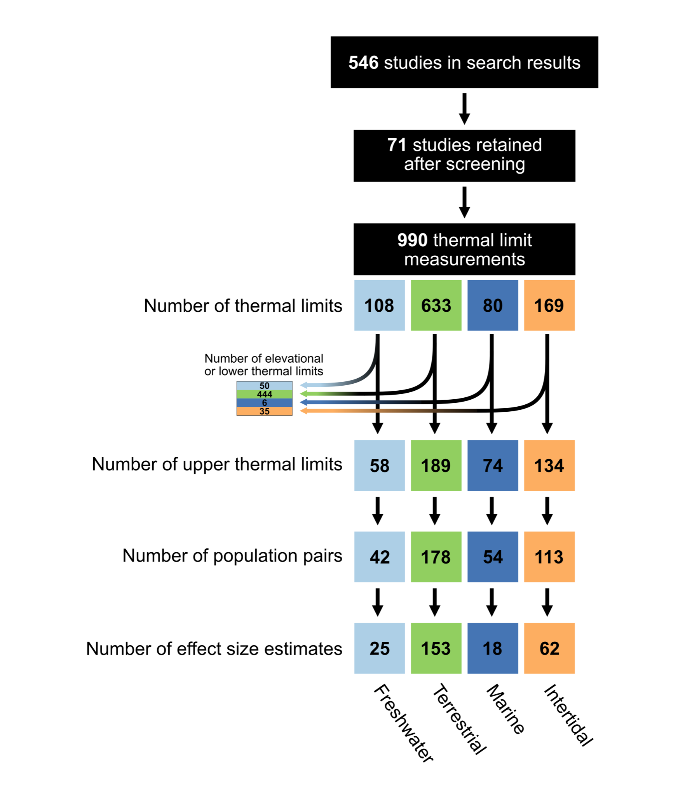
Supplementary Fig. 2 | Boxplots showing absolute value of difference in thermal limits between terrestrial populations from studies examining altitudinal or elevational gradients compared with studies examining latitudinal gradients.

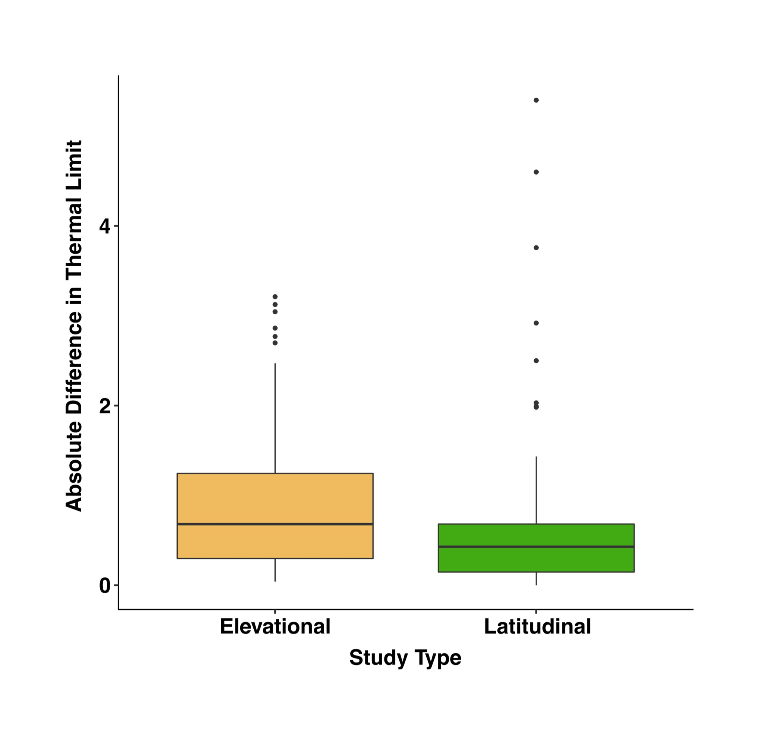
Supplementary Fig. 3 | Comparison of mean intraspecific slope estimates (+ SE) for upper and lower thermal tolerance values against latitude for terrestrial taxa. Studies examining elevational differences are excluded. For comparison, interspecific slope estimates are included from Sunday et al. 2019.

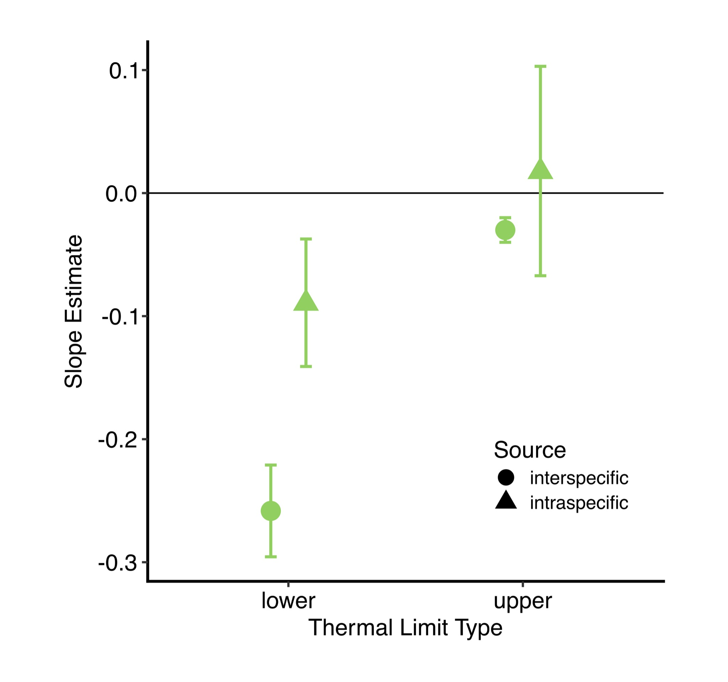
Supplementary Fig. 4 | Comparison of the absolute difference in upper thermal limits between motile and non-motile taxa (motility defined here as whether or not an individual could control their microhabitat sufficiently to regulate body temperature using environmental thermal heterogeneity), calculated using both (a) unweighted raw mean differences and (b) inverse-weighted standardized mean differences (Hedges’ d). Samples sizes (the number of pairwise comparisons) are shown below each boxplot.

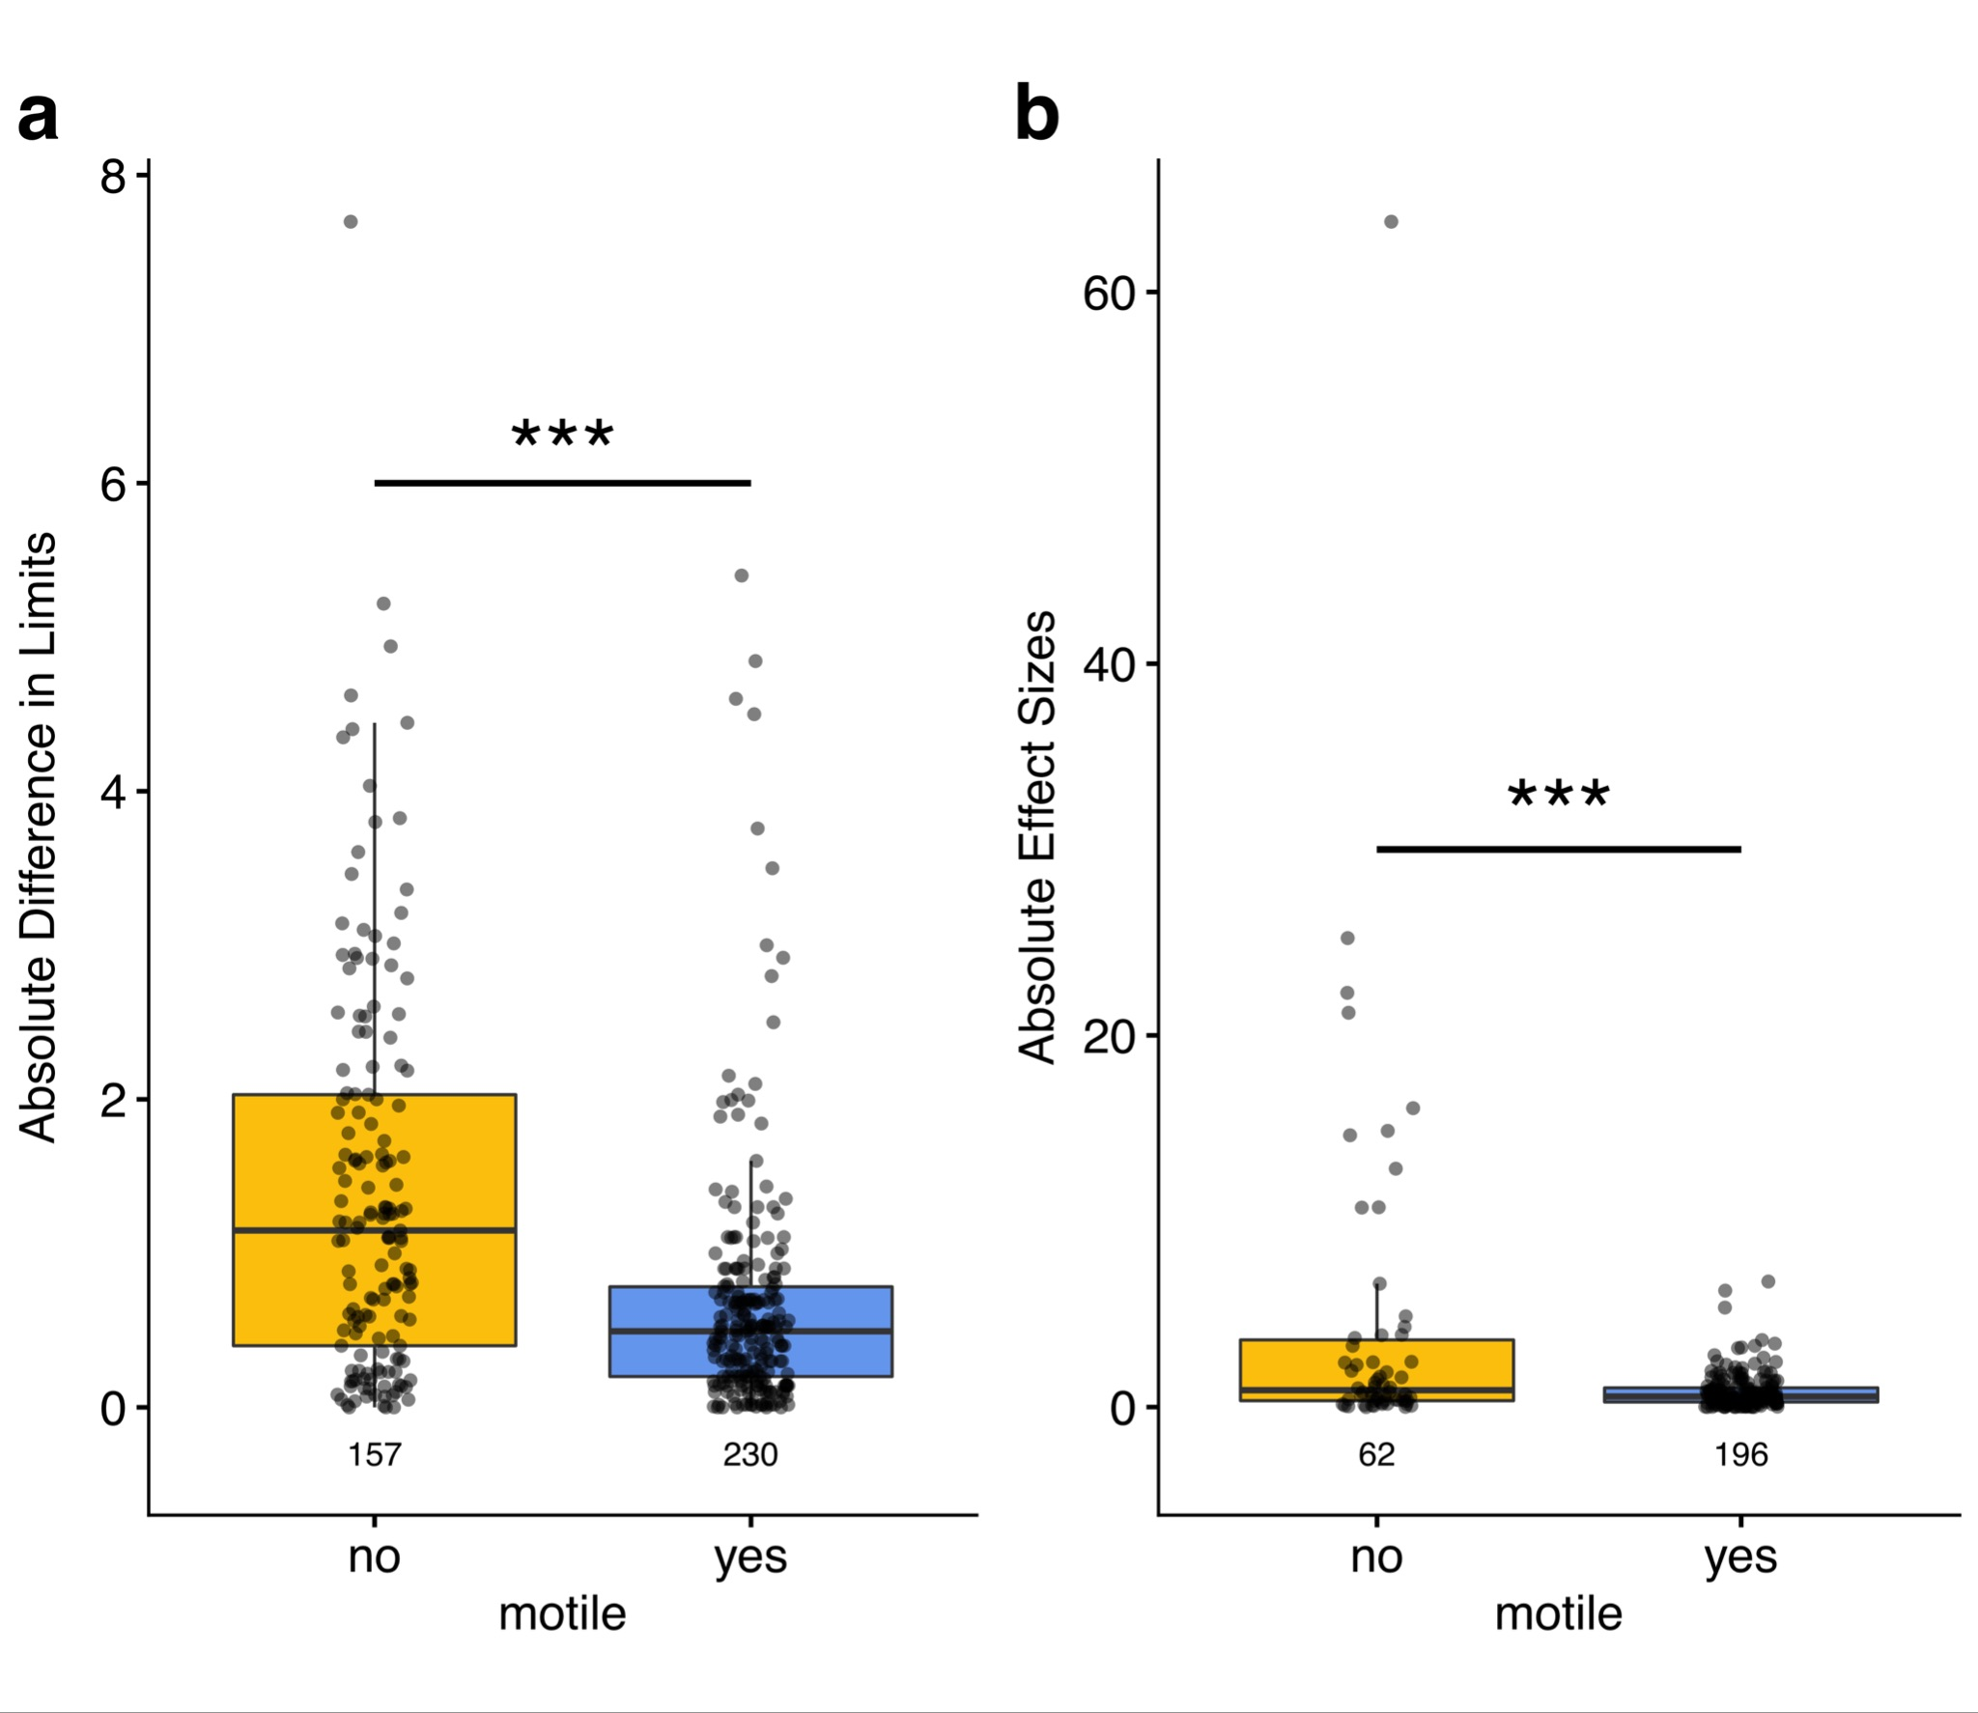

Supplementary Fig. 5 | A comparison of water temperature estimates from EarthEnv and air temperature estimates from CHELSA. The tight 1:1 relationship justifies the usage of CHELSA air temperature estimates for freshwater taxa. Mean temperatures are shown in blue and maximum temperatures are shown in red.

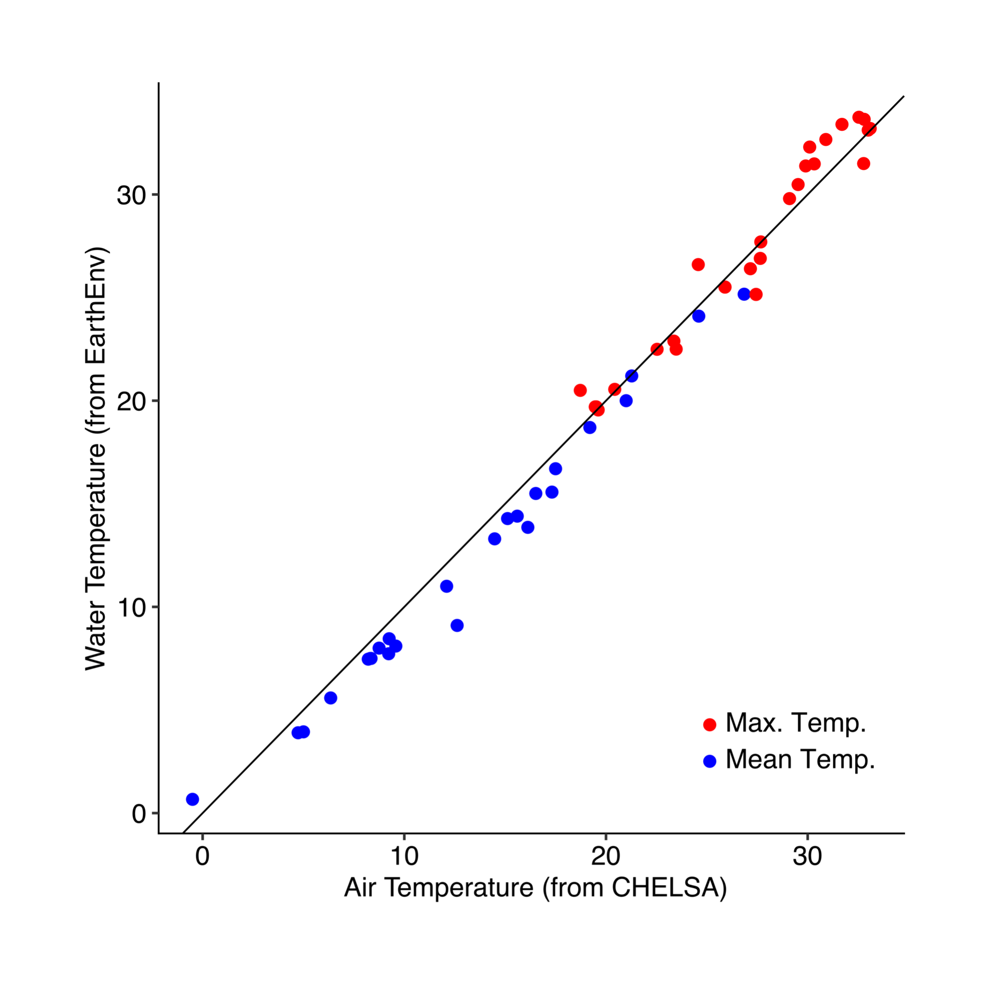

Supplementary Fig. 6 | Illustration of the two approaches used to estimate thermal tolerance in the field. Figure is for a hypothetical study that measures thermal tolerance in three populations. When a study exposes each of the populations to two acclimation temperatures (a), the resulting reaction norms are used to adjust thermal tolerance to reflect the mean temperature at the collection location for each population. When a study does not expose populations to multiple acclimation temperatures (b), Acclimation response ratio (ARR) is predicted for each population based on its thermal tolerance and the ecosystem. This ARR is then used to adjust thermal tolerance based on the difference between acclimation temperature and the mean temperature of each population’s collection location.

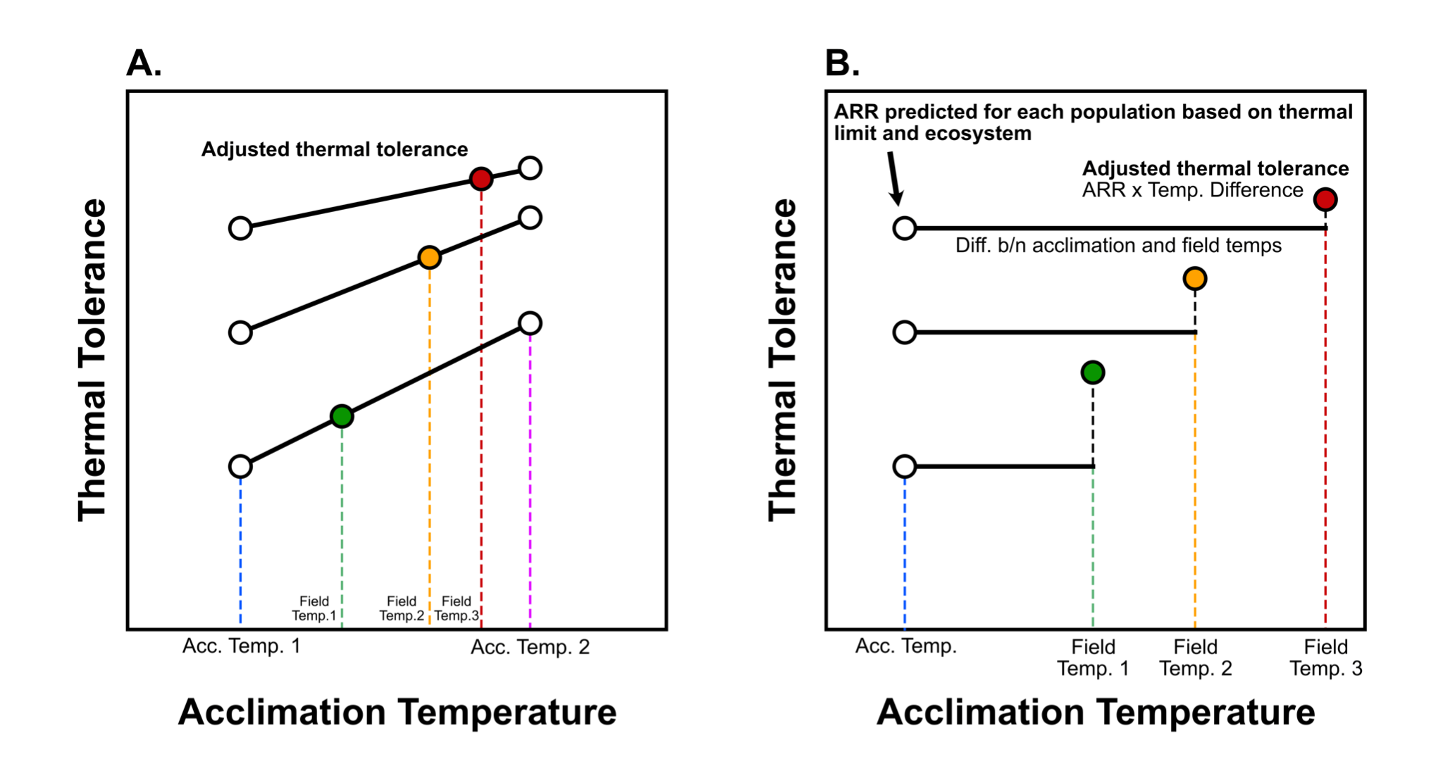
Supplementary Fig. 7 | Histograms of the predicted changes in mean temperature (a), maximum temperature (b), and warming tolerance (c). Positive changes indicate increases in the future (years 2040-2050 from RCP 4.5 / SSP 245) relative to current conditions, while negative changes indicate decreases. Bars along the zero-line indicate the mean changes for each ecosystem.

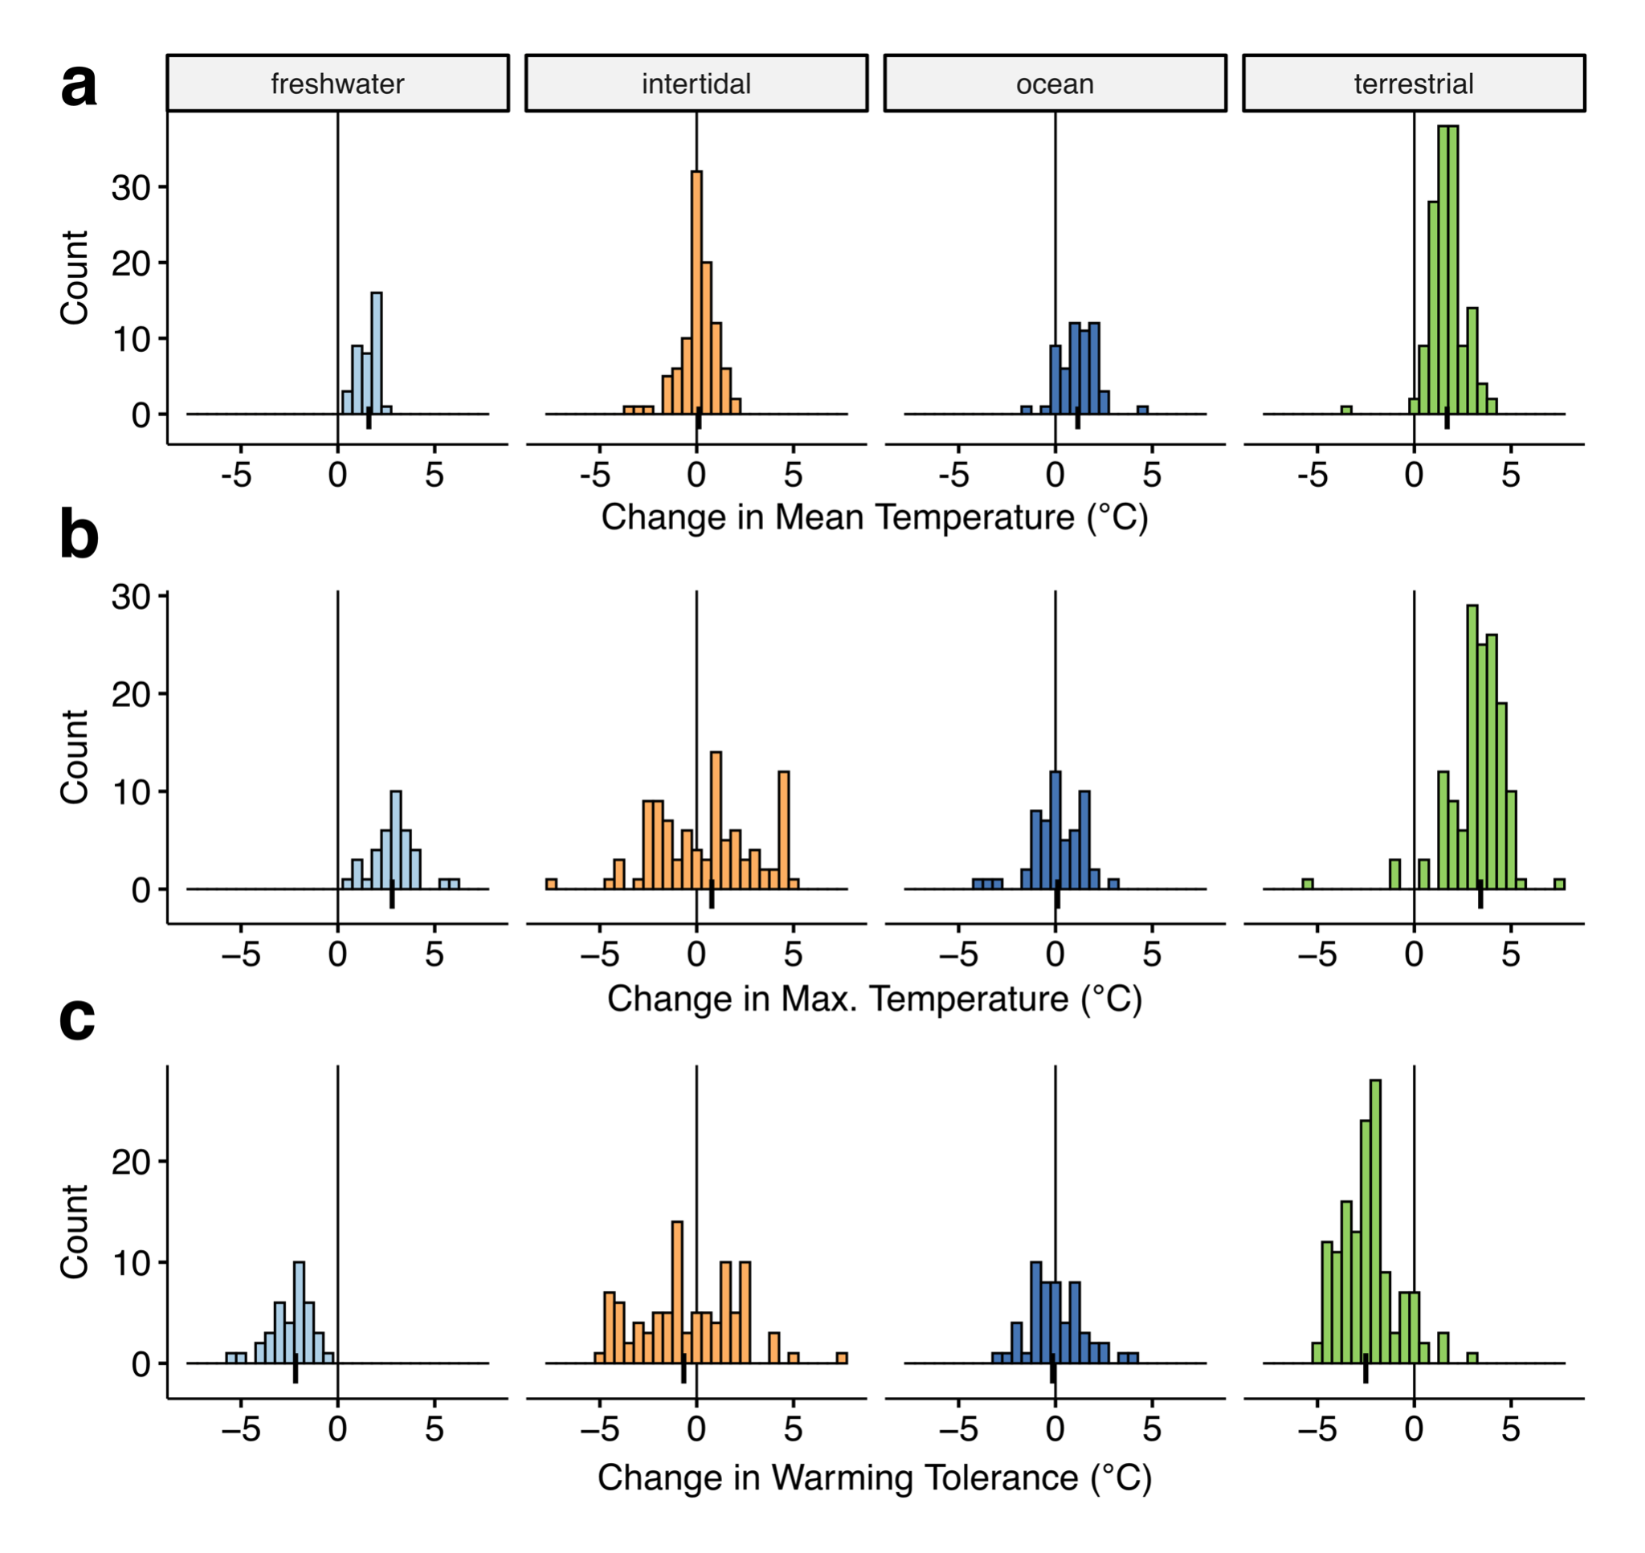
Supplementary Fig. 8 | Funnel plots depicting effect sizes and precision (standard error) from the metaregression model for the full data set (a) and for when effect sizes with absolute values greater than 10 are excluded from the model (b).
