Supplementary Information
Tuning Interlayer and Intralayer Interactions between Zero‑Dimensional Building Units to Construct High‑Porosity Metal-Organic Frameworks

Yating Wang¹, Feifei Zhang^{*1}, Yanan Yang¹, Yufei Dong1, Xiaoqing Wang¹, Jinping Li^{*1,2} and Jiangfeng Yang^{*1}
¹College of Chemical Engineering and Technology, Taiyuan University of Technology, Taiyuan 030024, Shanxi Province, China
²Shanxi Research Institute of Huairou Laboratory, Taiyuan 030032, Shanxi Province, China
*Corresponding author. E-mail: zhangfeifei0096@link.tyut.edu.cn; jpli211@hotmail.com; yangjiangfeng@tyut.edu.cn

Table of Contents
Experimental Procedures 3
Chemicals 3
Fitting of pure component isotherms 3
Isosteric heat of adsorption 3
Ideal Adsorbed Solution Theory (IAST) Calculations 3
Diffusional time constants and kinetic selectivity 4
In-situ IR spectroscopic analysis 4
Theoretical calculation methods 4
Supplementary Figures and Tables 5
References 37

Experimental Procedures

Chemicals
Cobalt(II) chloride hexahydrate (CoCl₂·6H₂O, 99%) was purchased from Innochem. Succinic acid (H₂SA, C₄H₆O₄, 99.5%) was obtained from Macklin. 2,2-Dimethylsuccinic acid (H₂DMSA, C₆H₁₀O₄, 98%) and 2-phenylsuccinic acid (H₂PhSA, C₁₀H₁₀O₄, 98%) were purchased from Aladdin. 4-tert-Butylsulfonylcalix[4]arene (H₄SC4A‑SO₂, C₄₄H₅₆O₆S₄, 98%) was supplied by Tci. Methanol (CH₃OH) and N,N-dimethylformamide (DMF, C₃H₇NO) were provided by Sinopharm Chemical Reagent Co., Ltd. All reagents were used as received without further purification. Deionized water used in the experiments was prepared in our laboratory.

Fitting of pure component isotherms
Following activation at 423 K under high vacuum (1 × 10⁻⁵ mbar) for 8 h, single-component adsorption isotherms for CH₄ and N₂ were collected on an ASAP 2460 analyzer at 298 K. The experimental data were fitted with the dual-site Langmuir–Freundlich (DSLF) model, which is well suited for describing adsorption on heterogeneous surfaces comprising two distinct site types. In this model, the equilibrium adsorption capacity q (cm³ g⁻¹) is given by:
where $q_{1}$ and $q_{2}$ are the saturation capacities (cm³ g⁻¹) of the two sites, $b_{1}$ and $b_{2}$ are the corresponding affinity coefficients (bar⁻¹), and $n_{1}$ and $n_{2}$ account for deviations from ideal surface homogeneity. The DSLF model provided excellent fits to the experimental isotherms, with correlation coefficients (R²) exceeding 0.999 for both adsorbates.

Isosteric heat of adsorption
The isosteric heats of adsorption (Q_{st}) for CH₄ and N₂ on the TUTJ materials were determined from single-component adsorption isotherms collected at 273 K, 298 K, and 313 K using the Clausius–Clapeyron equation. This method enables evaluation of the adsorption energetics and surface heterogeneity based on the temperature dependence of the adsorption isotherms.
The Clausius–Clapeyron equation is expressed as:
where $Q_{\text{st}}$ is the isosteric heat of adsorption (kJ·mol⁻¹), $R$ is the universal gas constant (8.314 J·mol⁻¹·K⁻¹), $T_{1}$ and $T_{2}$ are the two measurement temperatures (K), and $P_{1}$ and $P_{2}$ denote the pressures (bar) at which the same adsorbed amount is achieved on the isotherms measured at $T_{1}$ and $T_{2}$, respectively.

Ideal Adsorbed Solution Theory (IAST) Calculations
Ideal adsorbed solution theory (IAST) was employed to predict the adsorption behavior of gas mixtures in the TUTJ materials using the experimentally measured single-component isotherms. This approach assumes ideal mixing of the adsorbed species and allows the calculation of mixture equilibria solely from pure-component adsorption data. The selectivity for component 1 over component 2 in a binary mixture is defined as:
where $q_{1}$ and $q_{2}$ are the equilibrium adsorption uptakes (cm³ g⁻¹) of components 1 and 2 in the adsorbed phase, and $P_{1}$ and $P_{2}$ are their respective partial pressures (bar) in the bulk gas phase.

Diffusional time constants and kinetic selectivity
The diffusional time constants ($D$ and $D/r^{2}$) were derived using the short-time approximation of the Fickian diffusion model under the assumptions of a step change in gas phase concentration, initially clean adsorbent beds, and micropore diffusion as the rate-limiting step. The model is described by the following equation:
where $q_{t}$ is the gas uptake at time $t$, $q_{∞}$ is the equilibrium uptake, $D$ is the intracrystalline diffusivity, and $r$ is the radius of an equivalent spherical particle. The time constants were obtained from the slopes of the linear regions in the plots of $q_{t}/q_{∞}$ versus $\sqrt{t}$ at low fractional uptake.
The kinetic selectivity for CH₄ over N₂ was calculated using the following relationship:
Where and present the diffusional time constants for methane and nitrogen, respectively.

In-situ IR spectroscopic analysis
In situ infrared spectra of adsorbed CH₄ and N₂ were recorded at room temperature on a Bruker V70 spectrometer equipped with an MCT detector and a stainless steel in situ cell fitted with KBr windows. The spectral resolution was 4 cm⁻¹. Prior to measurement, the adsorbent powder was evenly placed in the sample cup of the reaction cell. The TUTJ samples were activated at 423 K under high vacuum (1 × 10⁻⁵ mbar) for 8 h, with heating and cooling rates of 5 K min⁻¹. After cooling to room temperature, the background spectrum of the activated sample was recorded immediately. Subsequently, adsorption of CH₄ and N₂ was carried out sequentially until saturation was reached.

Theoretical calculation methods
Binding energies (E_{b}) for CH₄ and N₂ adsorption in TUTJ-DMSA were calculated using DFT-D with the PBE functional. The binding energy was defined as:
Where E_{MOF} is the energy of the optimized bare framework, E_{gas} is the energy of the isolated gas molecule, and E_{gas+MOF} is the energy of the optimized gas–framework complex. More negative binding energies correspond to stronger interactions between the adsorbate and the framework.

Supplementary Figures and Tables
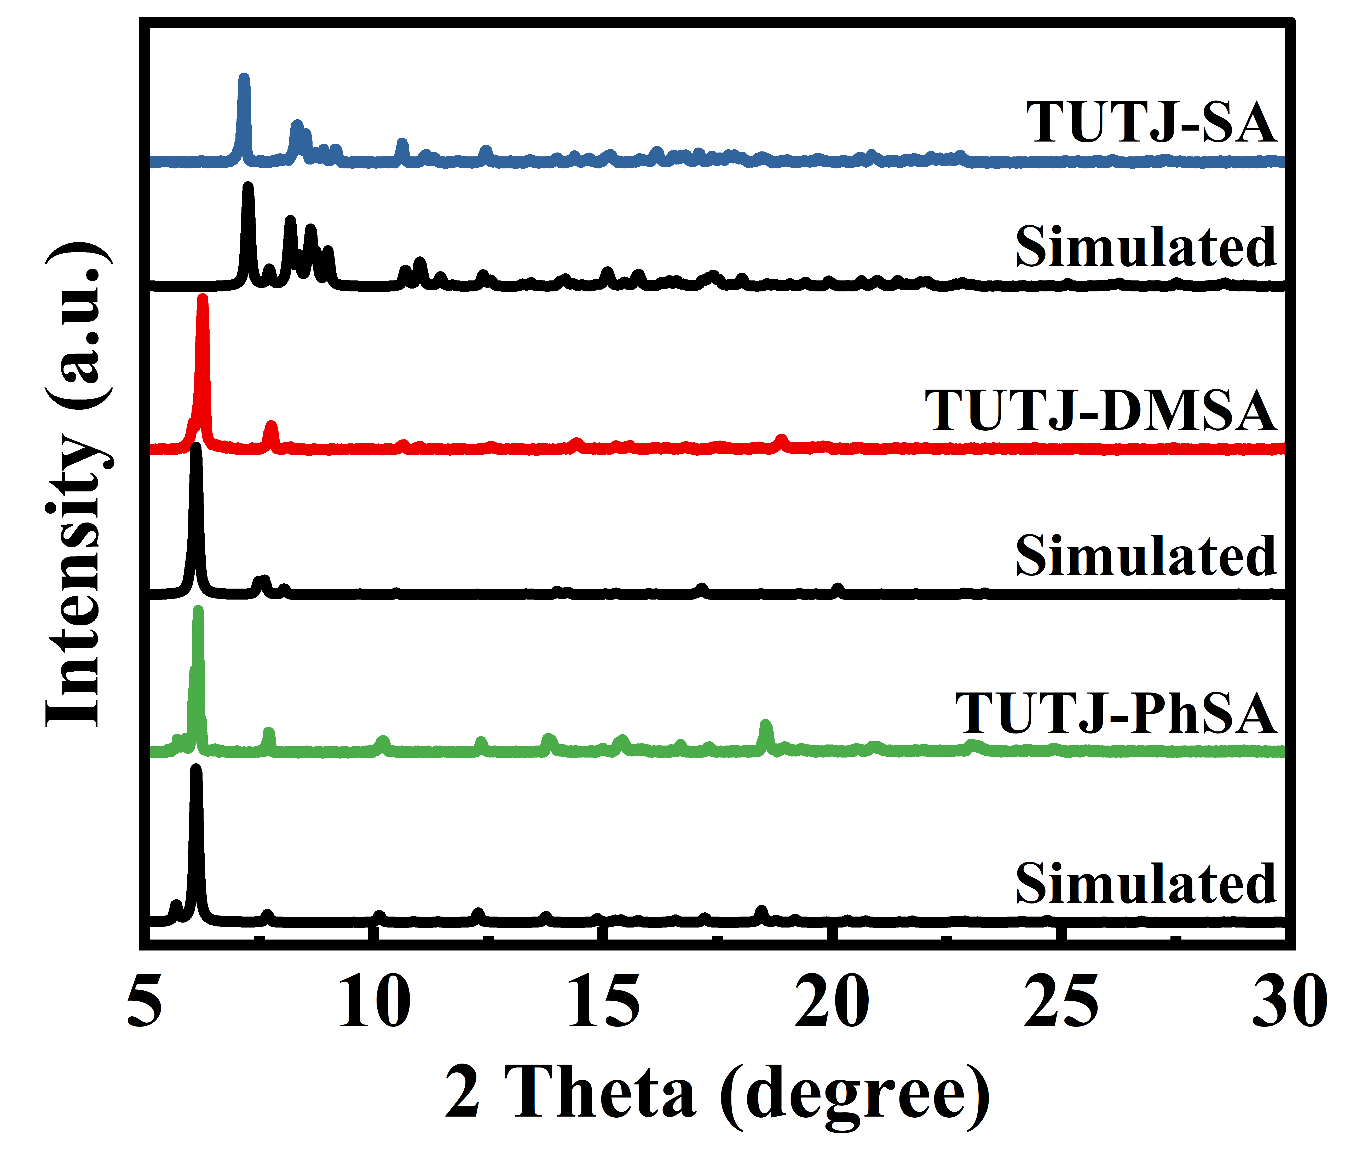
Supplementary Figure 1. PXRD patterns of TUTJ-SA, TUTJ-DMSA, TUTJ-PhSA
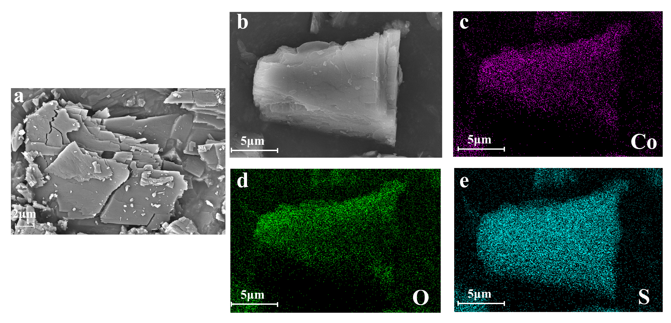
Supplementary Figure 2. (a,b) SEM images of TUTJ-SA crystals. (c–e) Corresponding energy-dispersive X-ray (EDX) elemental mapping images, revealing the homogeneous distribution of Co (c), O (d), and S (e) within the crystal.
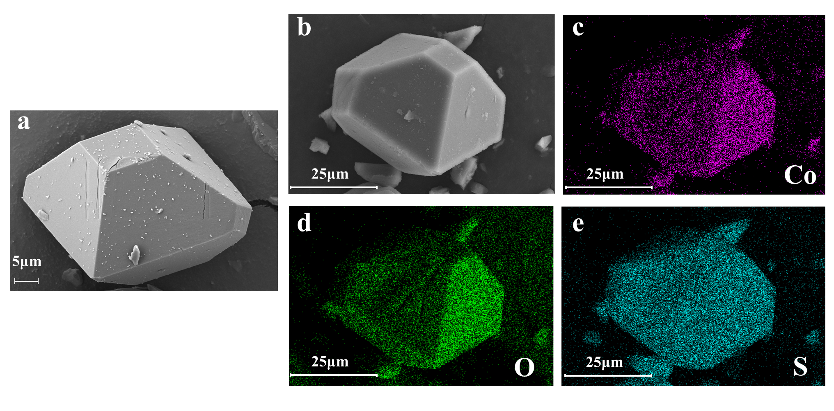
Supplementary Figure 3. (a,b) SEM images of TUTJ-DMSA crystals. (c–e) Corresponding energy-dispersive X-ray (EDX) elemental mapping images, revealing the homogeneous distribution of Co (c), O (d), and S (e) within the crystal.
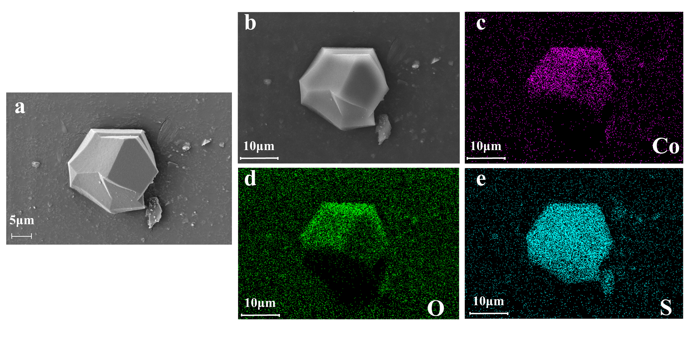
Supplementary Figure 4. (a,b) SEM images of TUTJ-PhSA crystals. (c–e) Corresponding energy-dispersive X-ray (EDX) elemental mapping images, revealing the homogeneous distribution of Co (c), O (d), and S (e) within the crystal.
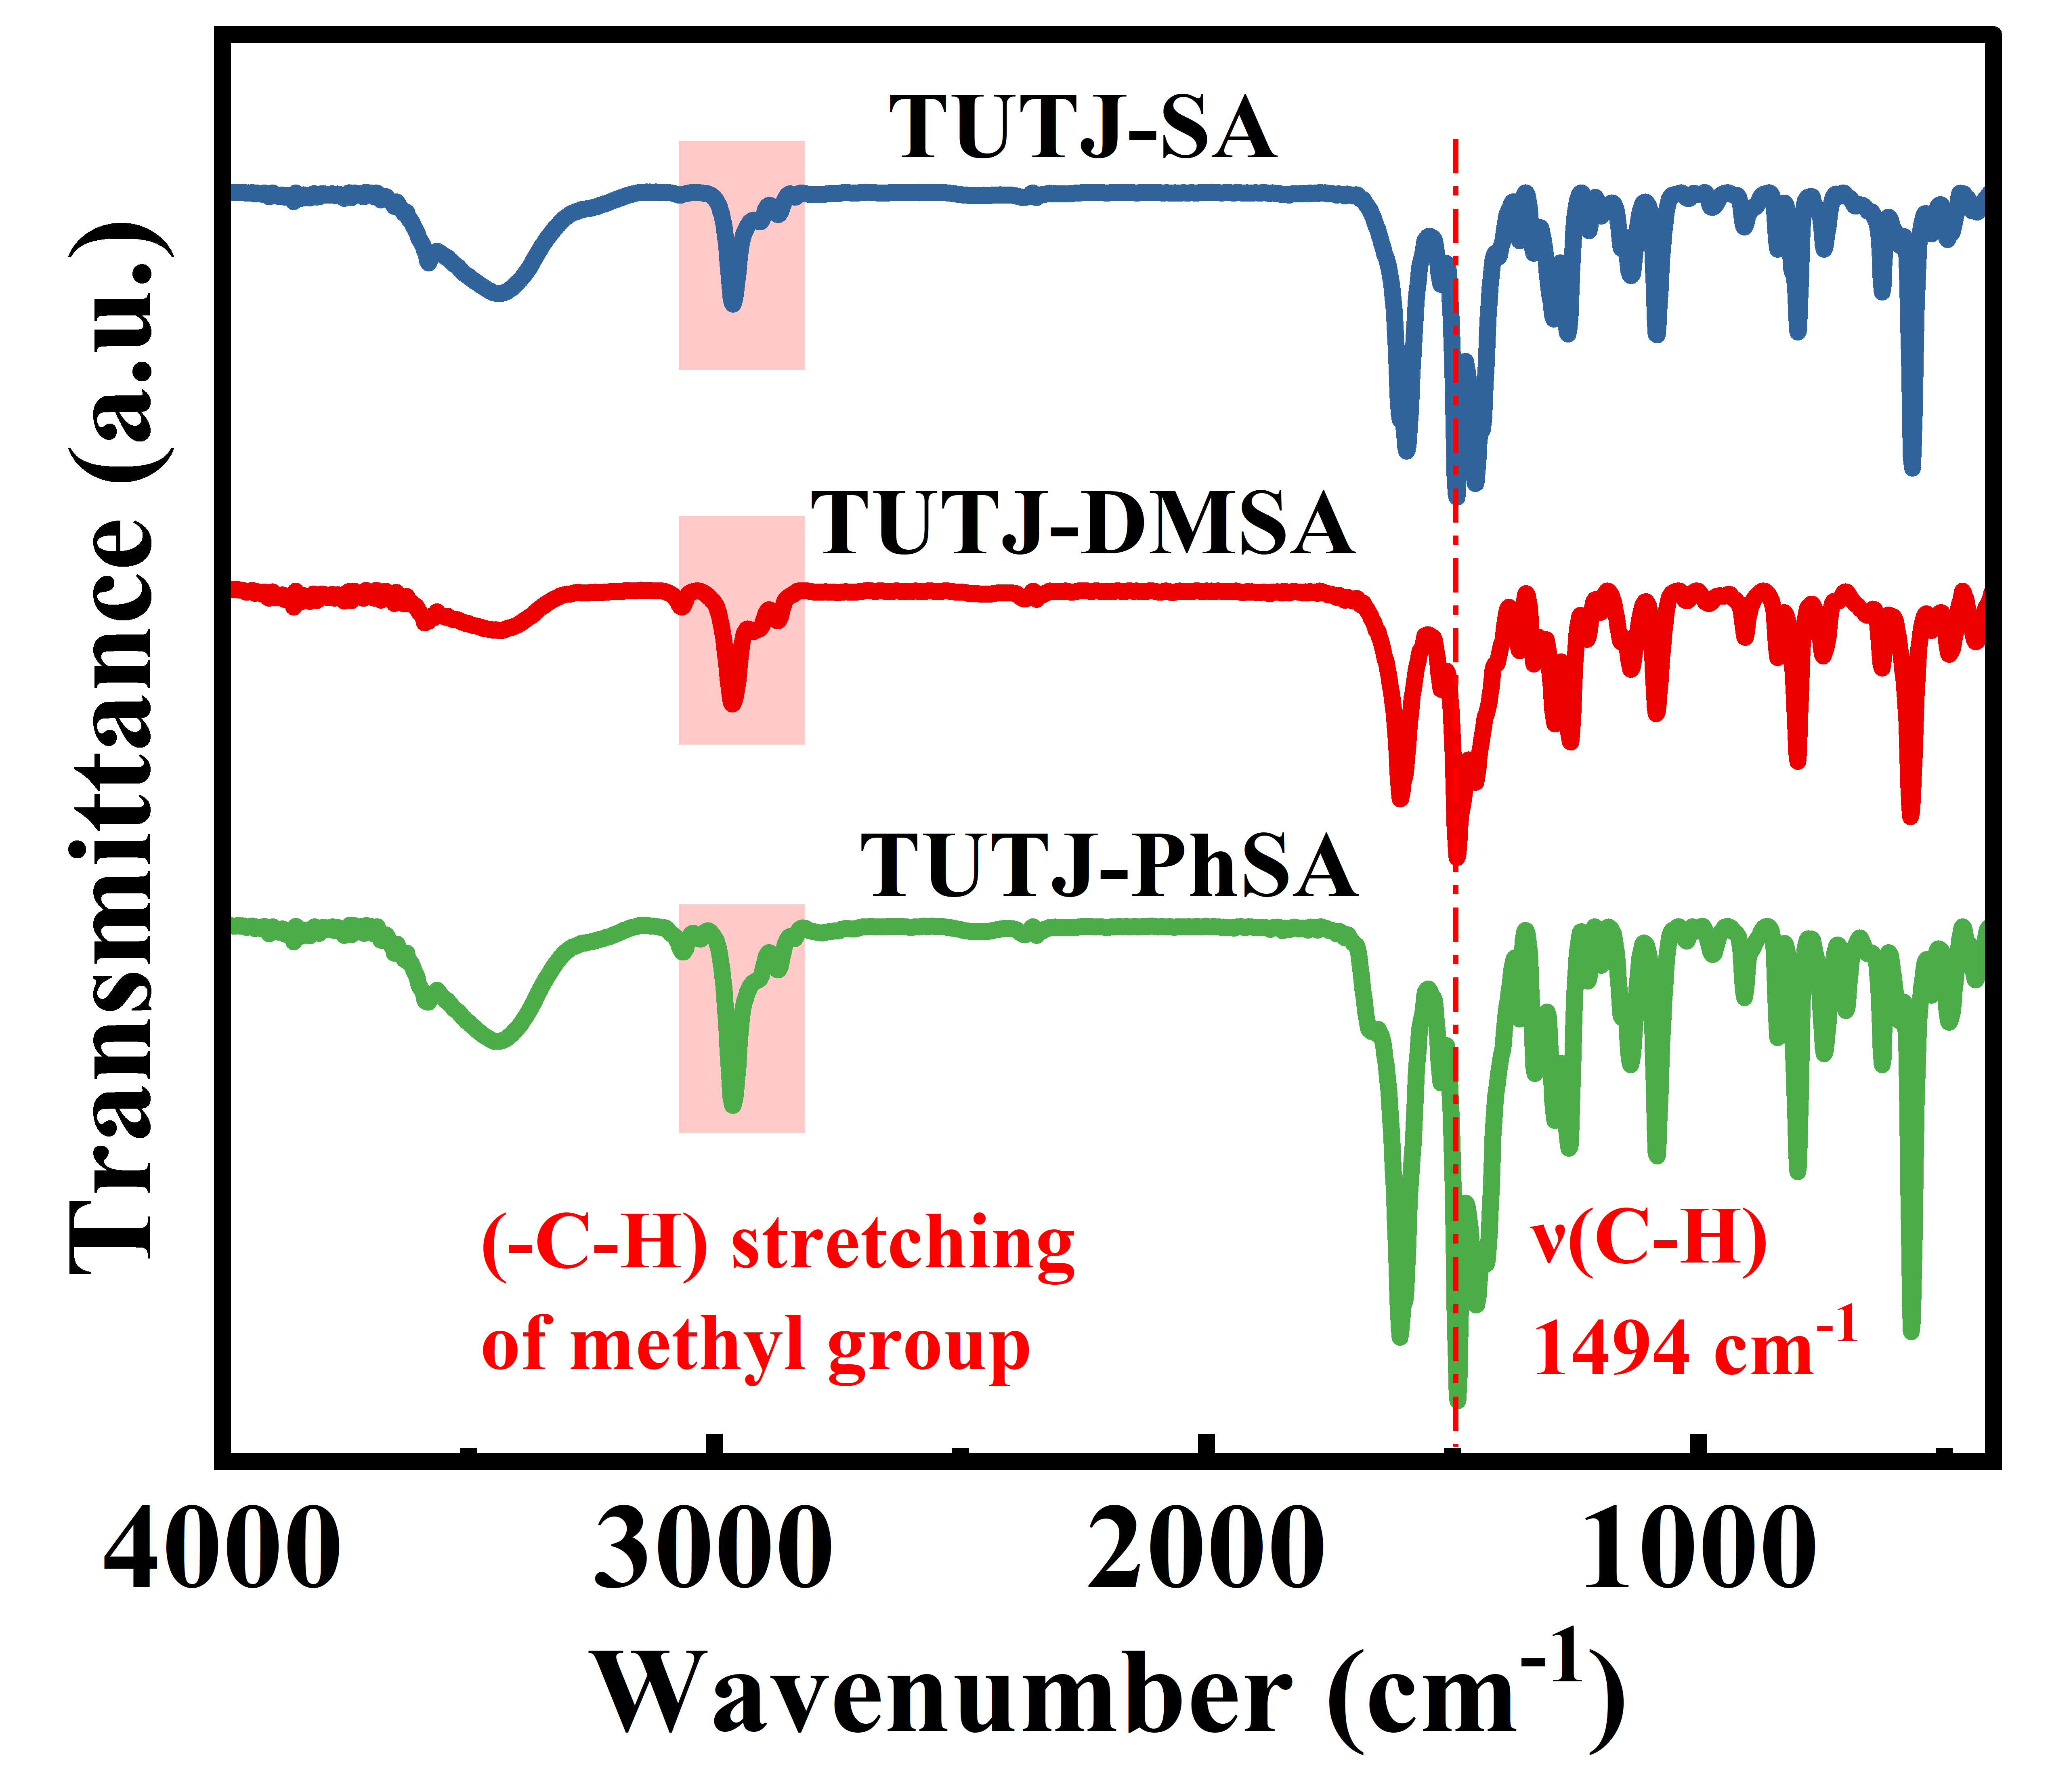
Supplementary Figure 5. FT-IR transmittance spectra of TUTJ-SA, TUTJ-DMSA, and TUTJ-PhSA.
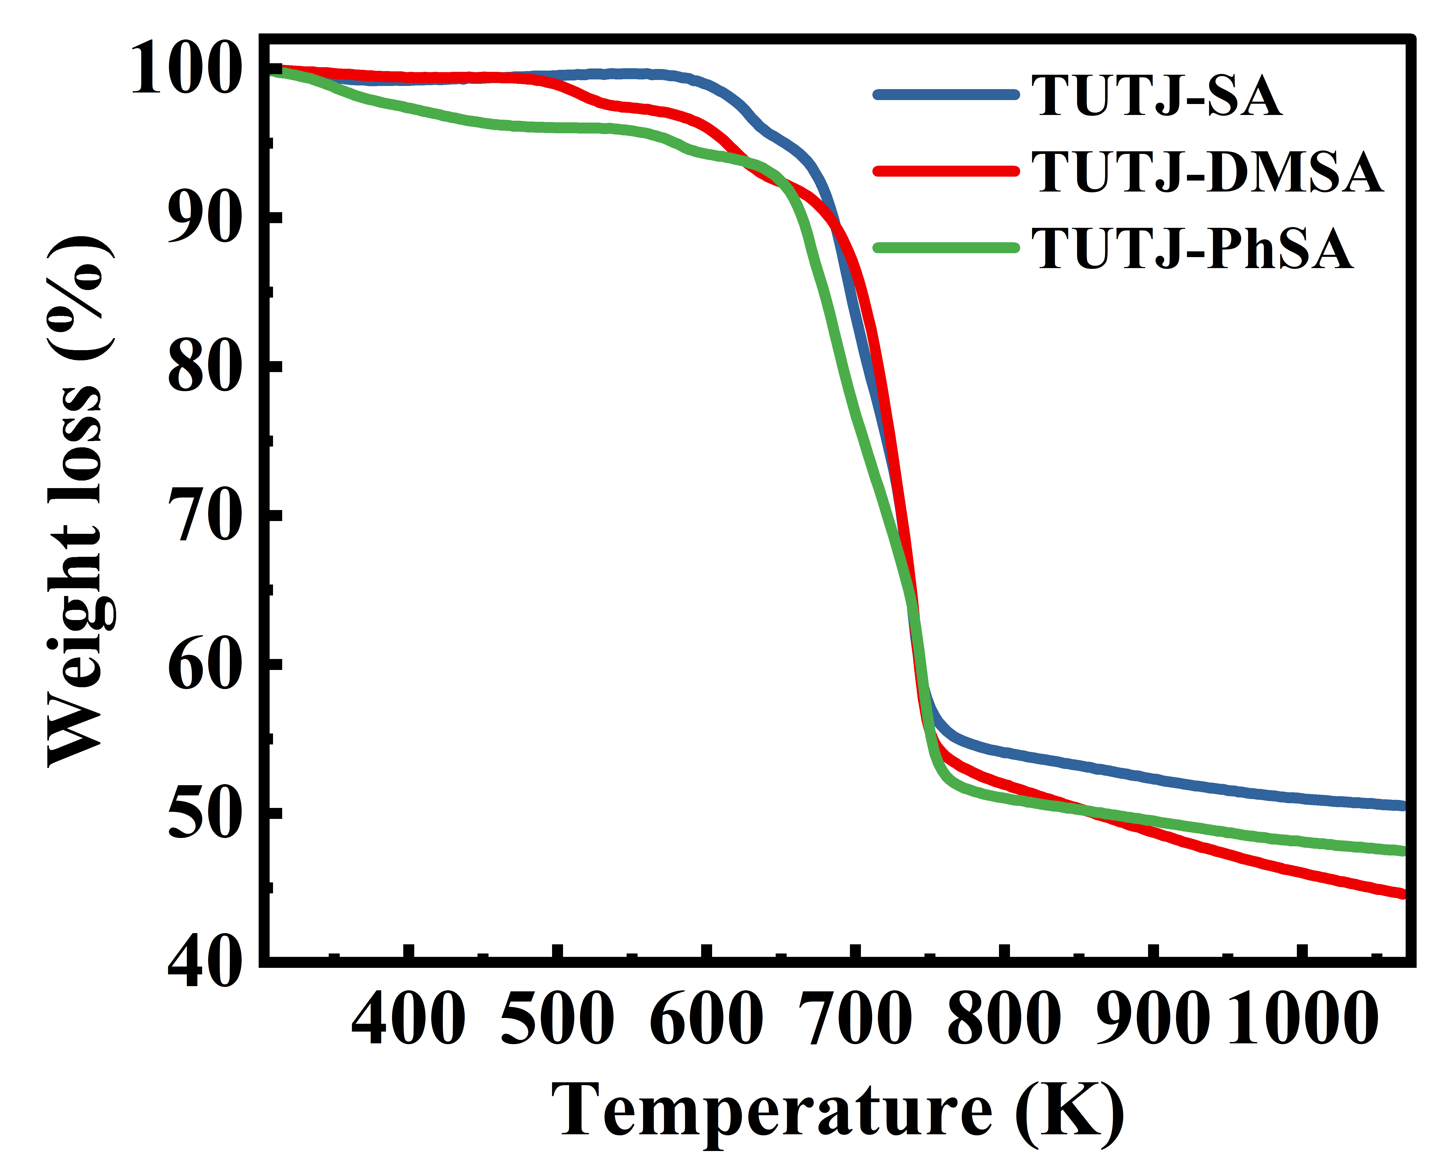
Supplementary Figure 6. Thermogravimetric analysis curves of TUTJ-SA, TUTJ-DMSA and TUTJ-PhSA.
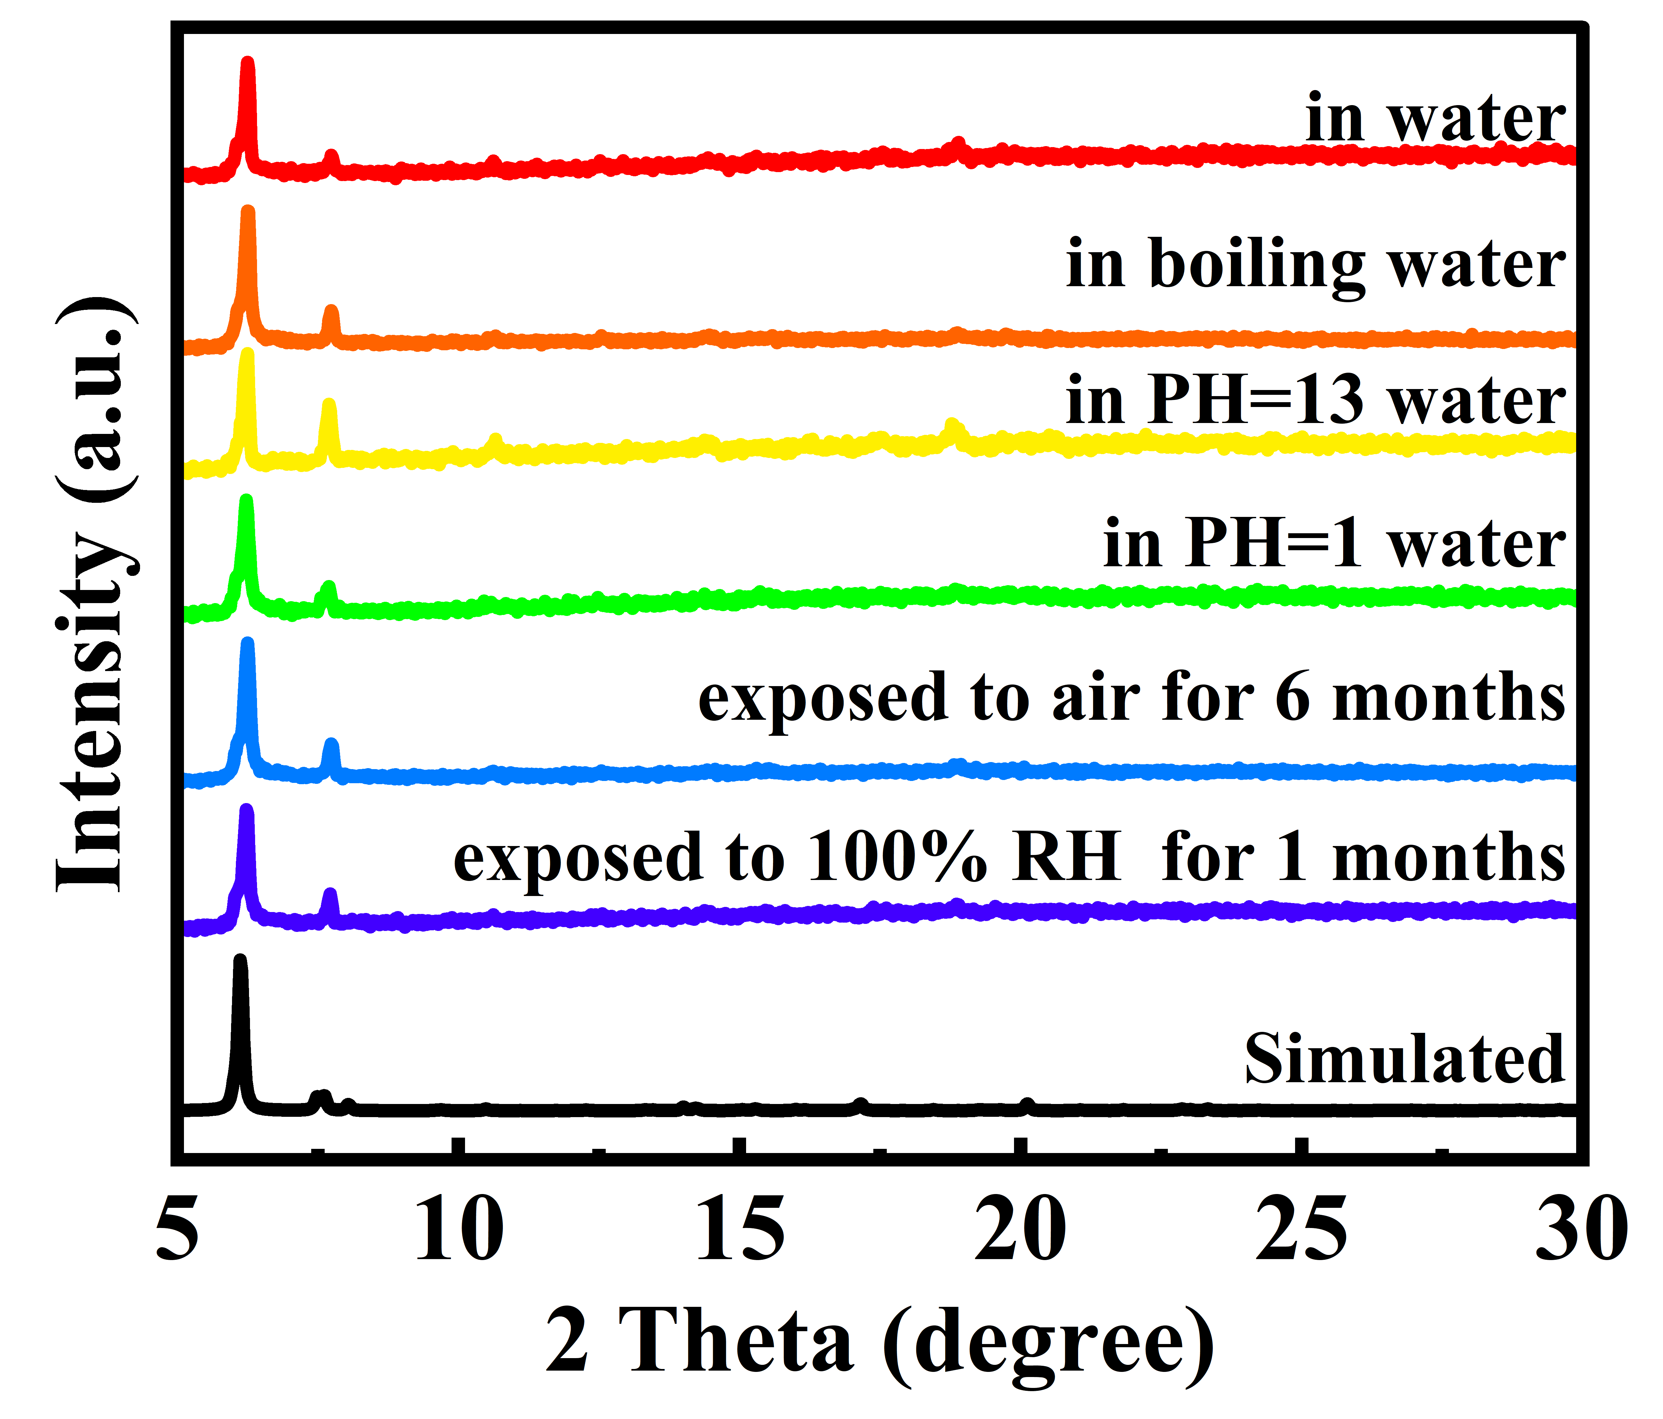
Supplementary Figure 7. The PXRD patterns of TUTJ-DMSA after exposure to various extreme conditions.
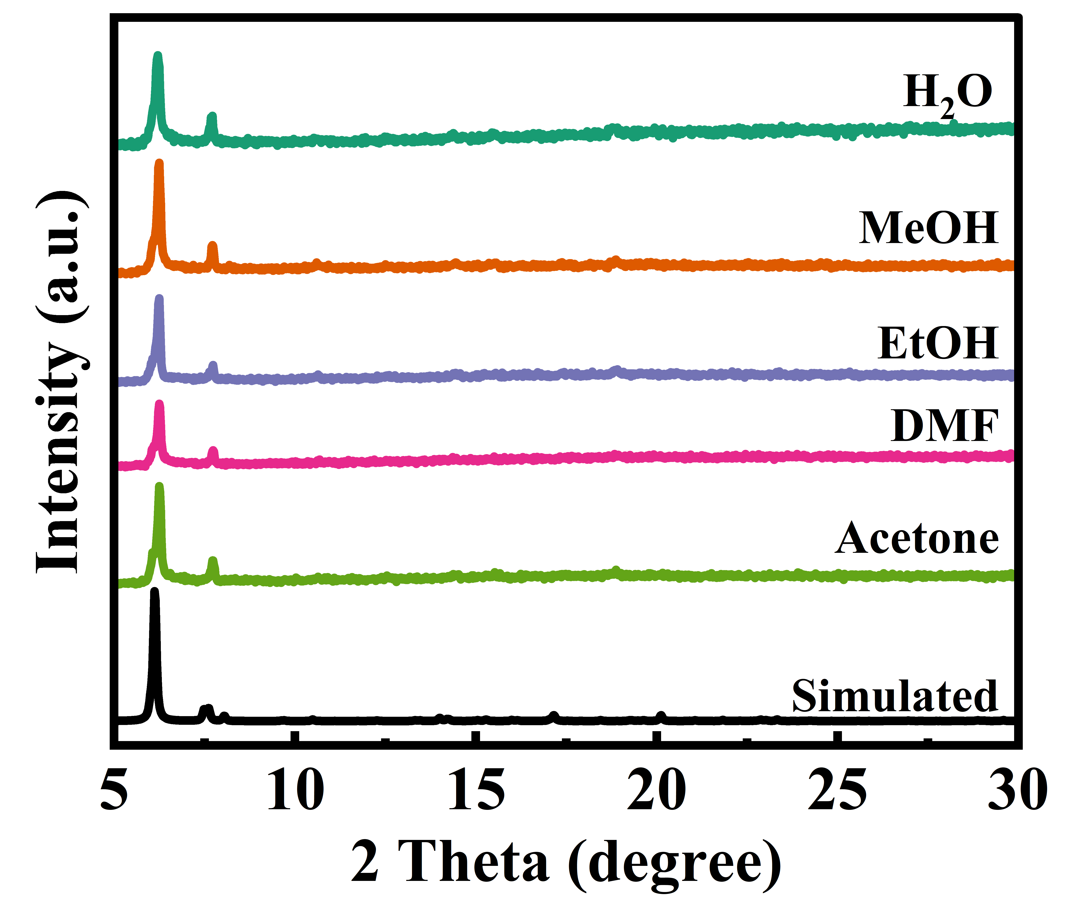
Supplementary Figure 8. The PXRD patterns of TUTJ-DMSA soaking different solvents for two weeks.

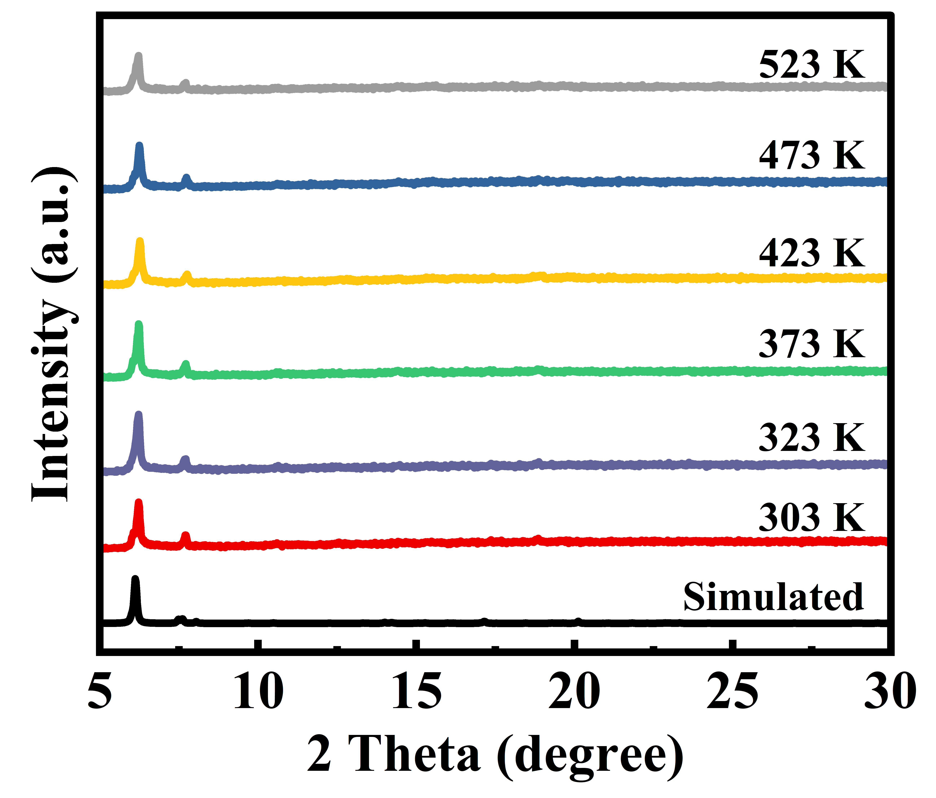
Supplementary Figure 9. The PXRD patterns of TUTJ-DMSA after activation at different temperatures.
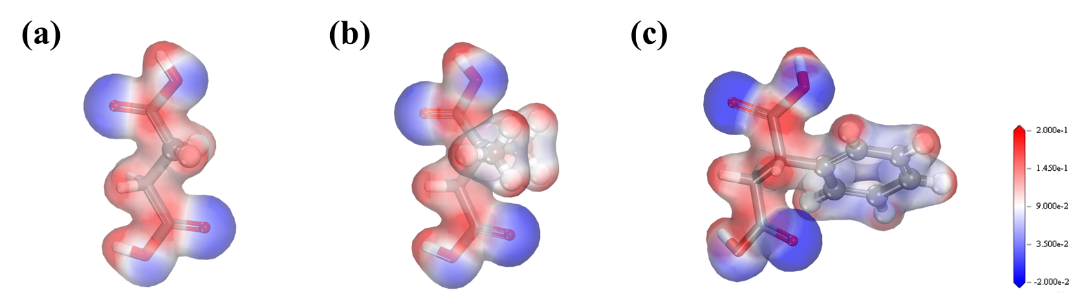
Supplementary Figure 10. Molecular electrostatic potential (ESP) maps of the three organic ligands.(a) TUTJ-SA, (b) TUTJ-DMSA, (c) TUTJ-PhSA. Blue regions denote negative electrostatic potential (δ-, electron-rich areas), while red regions represent positive electrostatic potential (δ+, electron-deficient areas).

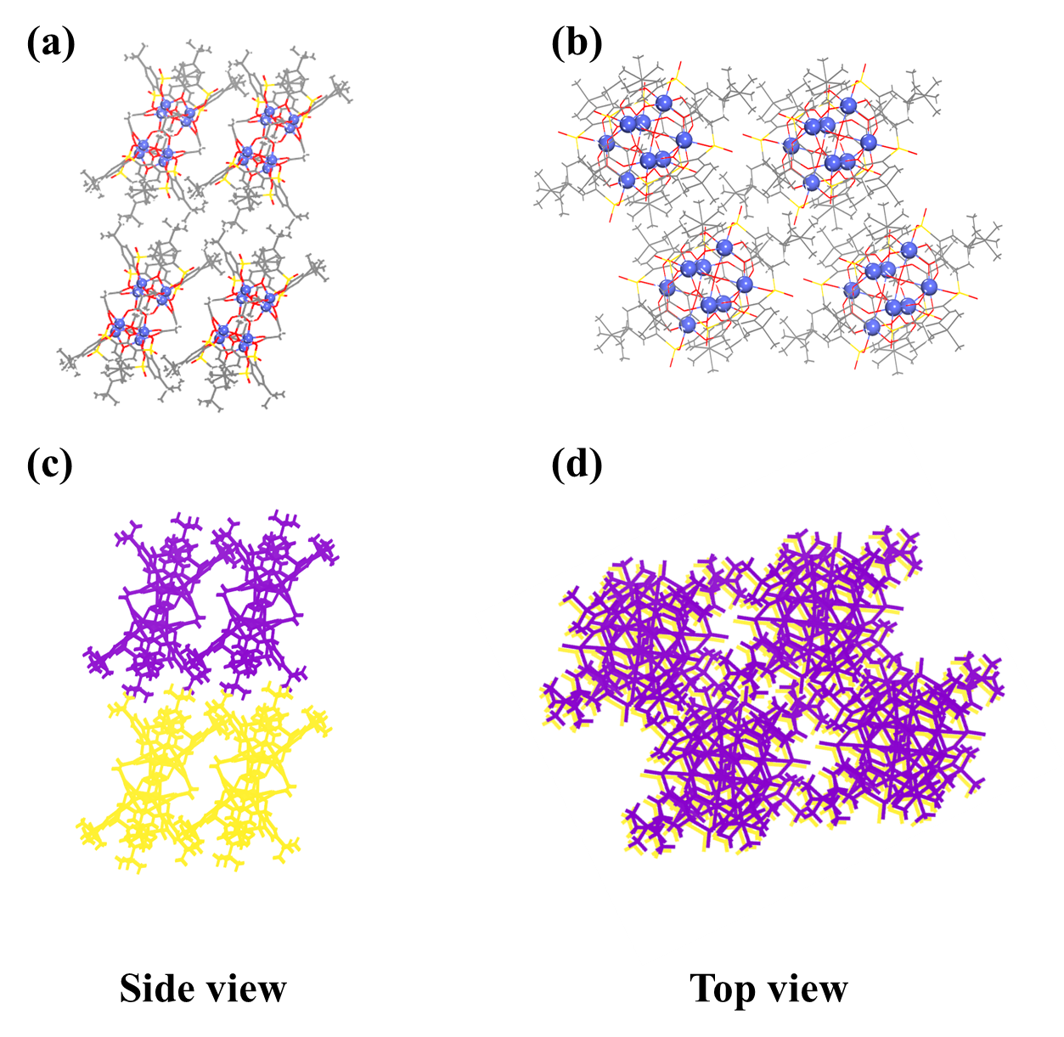
Supplementary Figure 11. Side (a, c) and top (b, d) views of the hierarchical packing arrangement of TUTJ-SA.
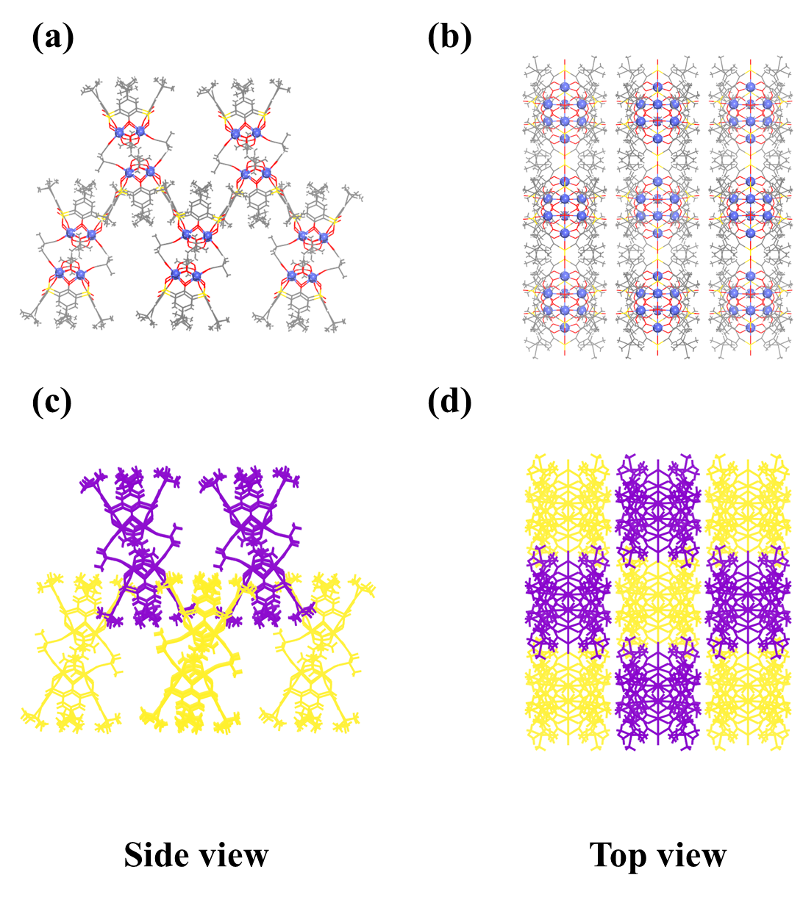
Supplementary Figure 12. Side (a, c) and top (b, d) views of the hierarchical packing arrangement of TUTJ-DMSA.
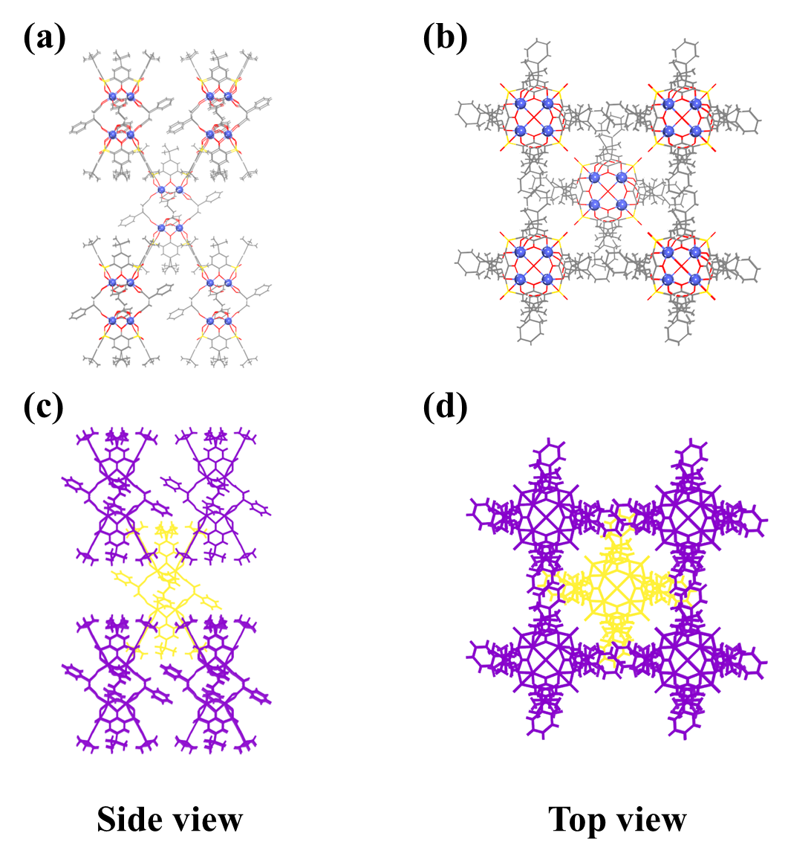
Supplementary Figure 13. Side (a, c) and top (b, d) views of the hierarchical packing arrangement of TUTJ-PhSA.

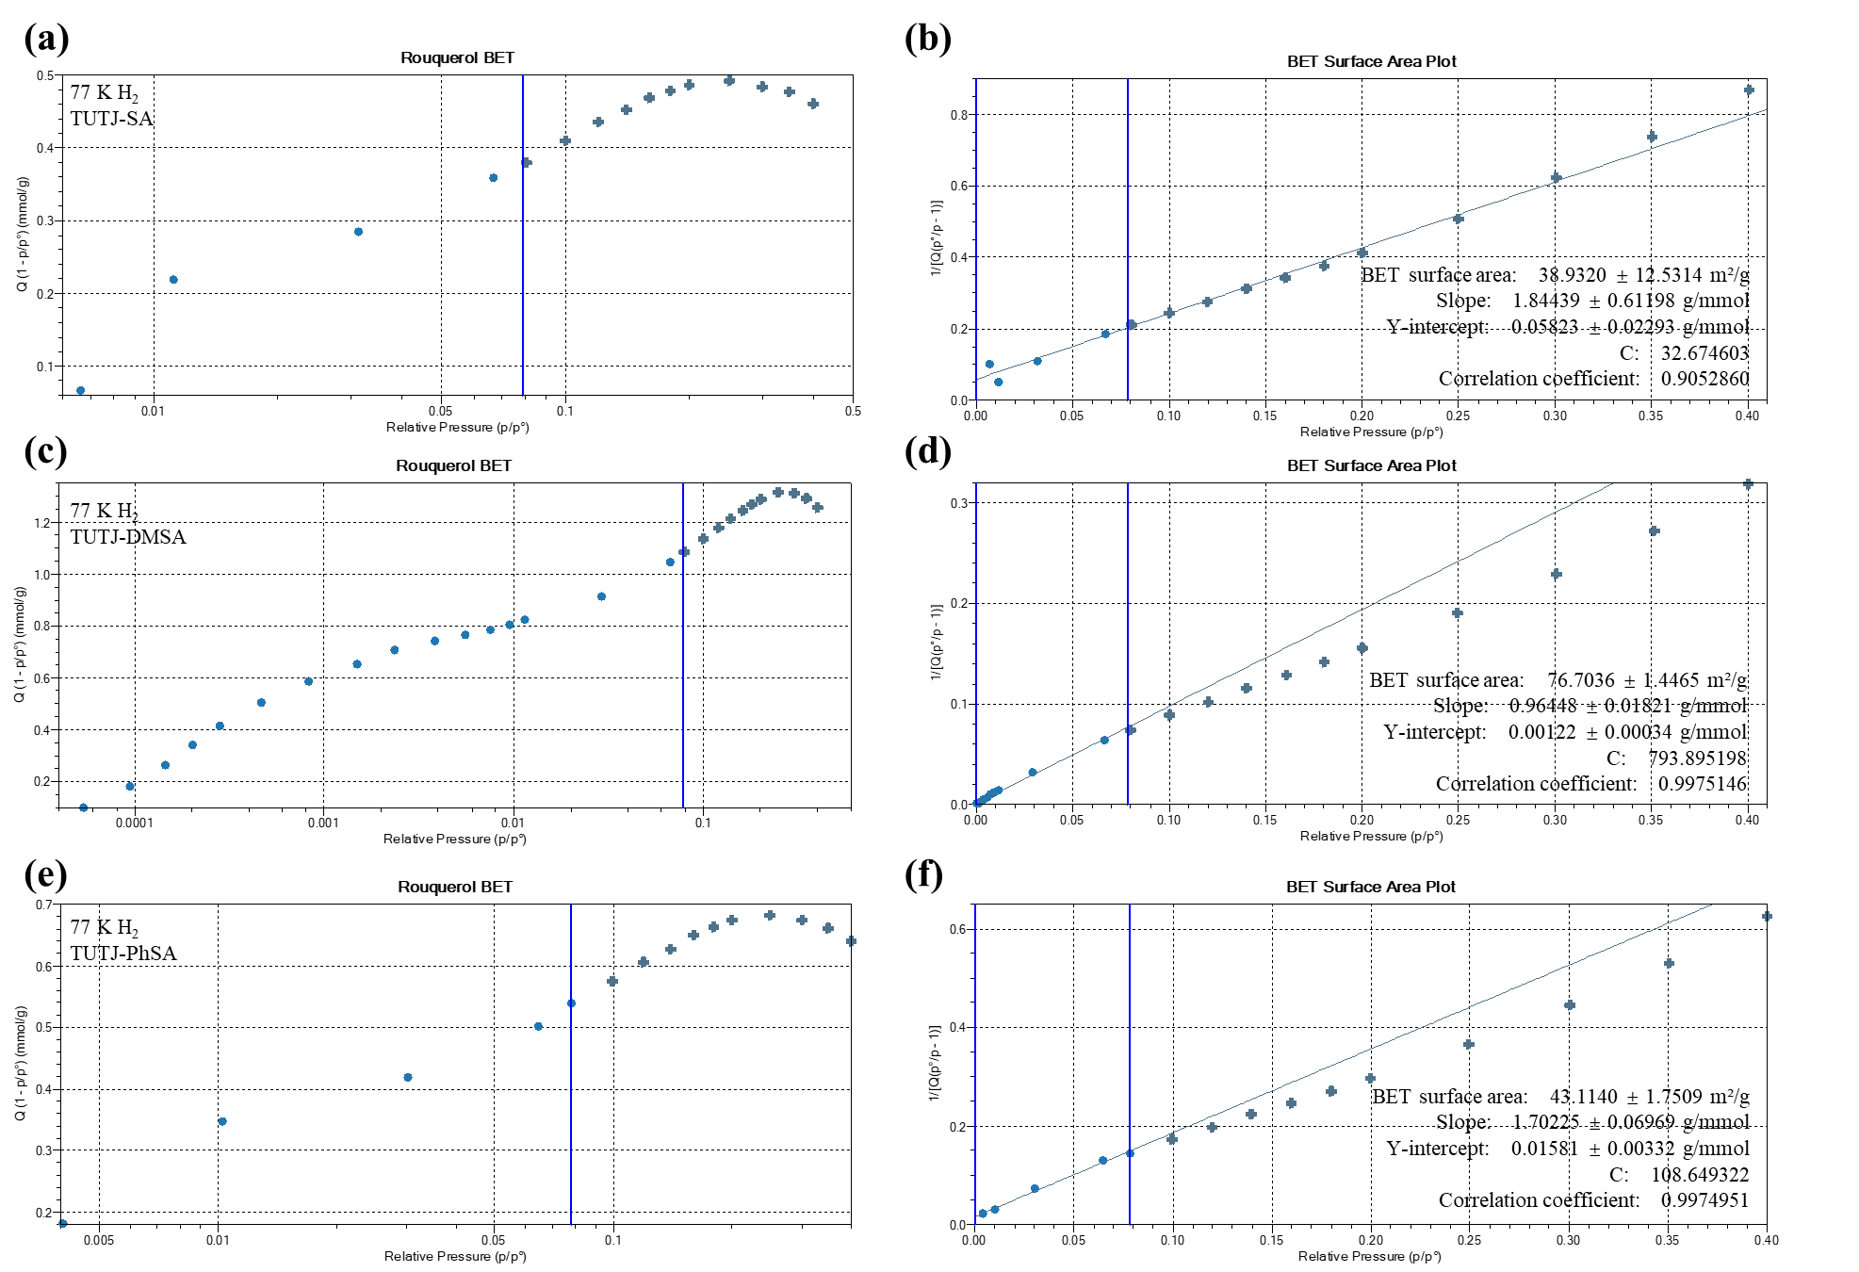
Supplementary Figure 14. BET surface area plot based on H₂@77 K isotherm.
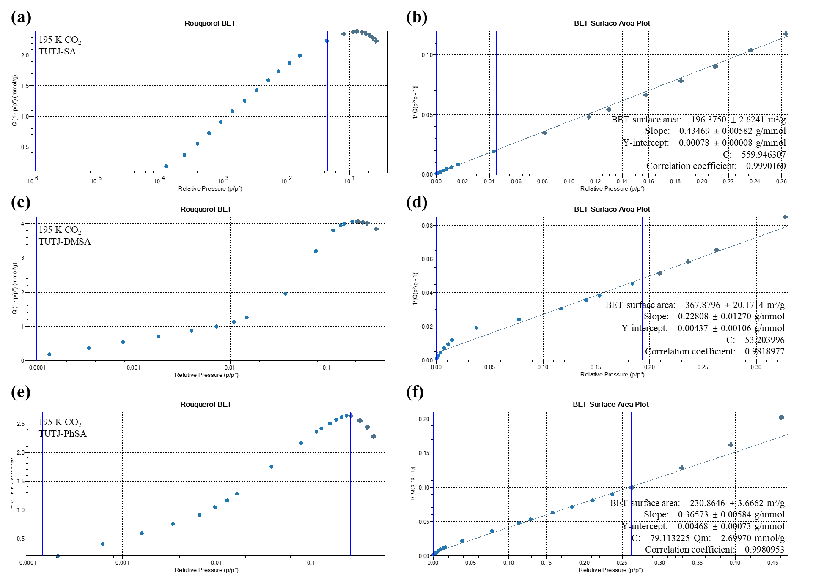
Supplementary Figure 15. BET surface area plot based on CO₂@195 K isotherm.
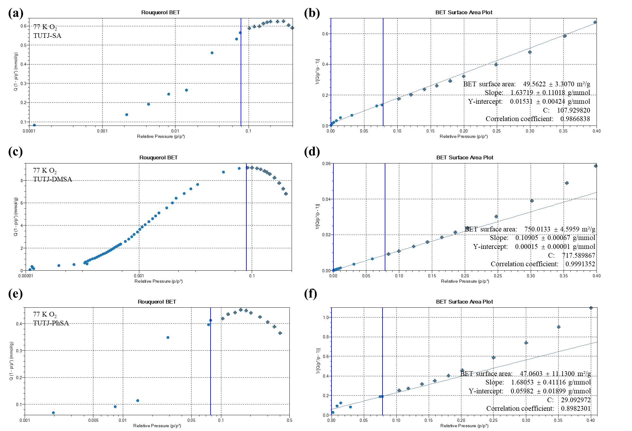
Supplementary Figure 16. BET surface area plot based on O₂@77 K isotherm.
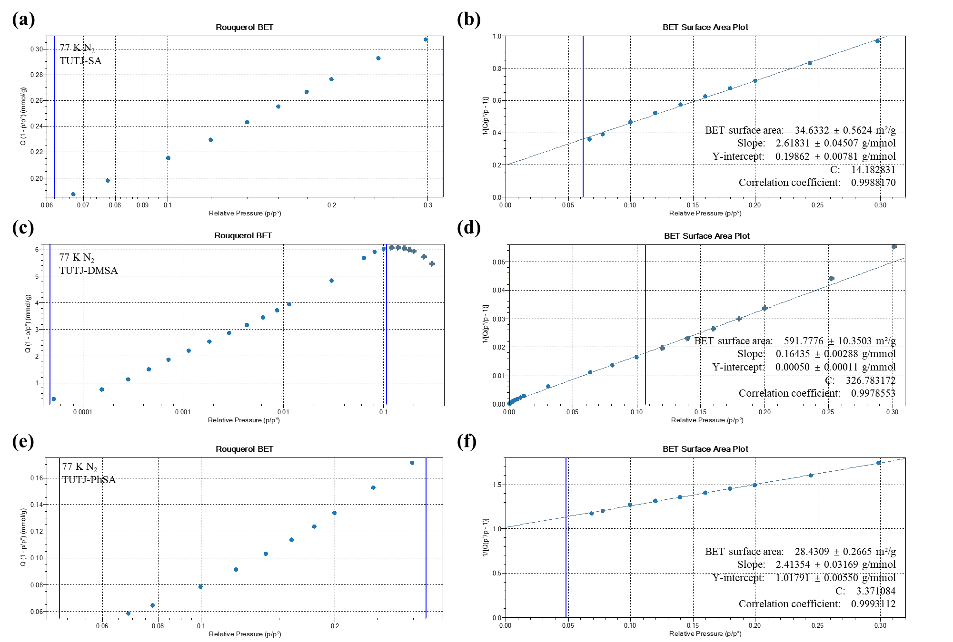
Supplementary Figure 17. BET surface area plot based on N₂@77 K isotherm.
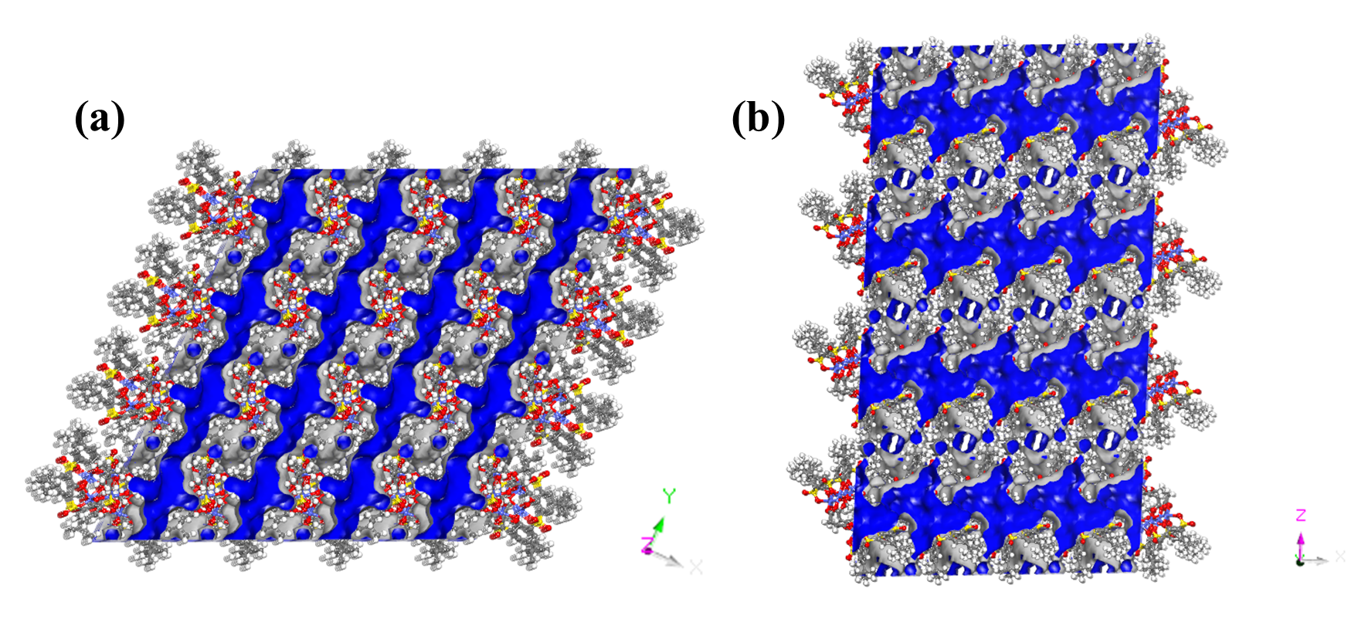
Supplementary Figure 18. Schematic diagram of pore distribution in directions for TUTJ-SA.
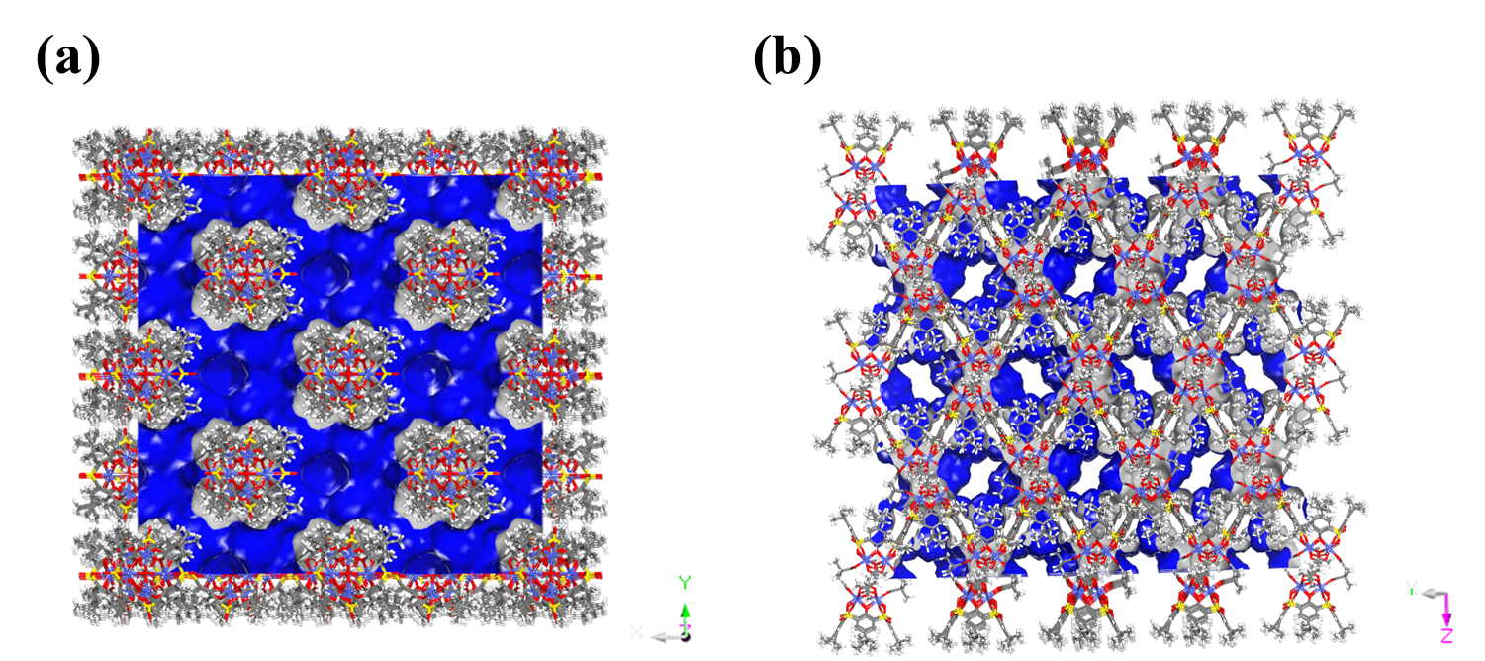
Supplementary Figure 19. Schematic diagram of pore distribution in directions for TUTJ-DMSA.
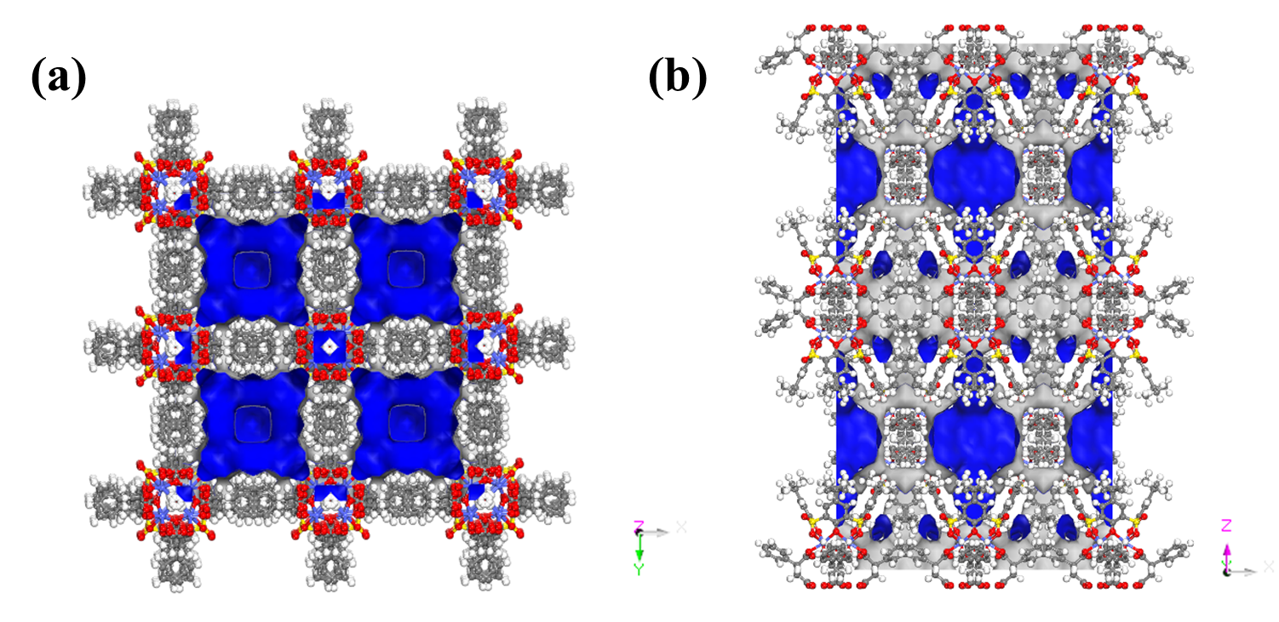
Supplementary Figure 20. Schematic diagram of pore distribution in directions for TUTJ-PhSA.

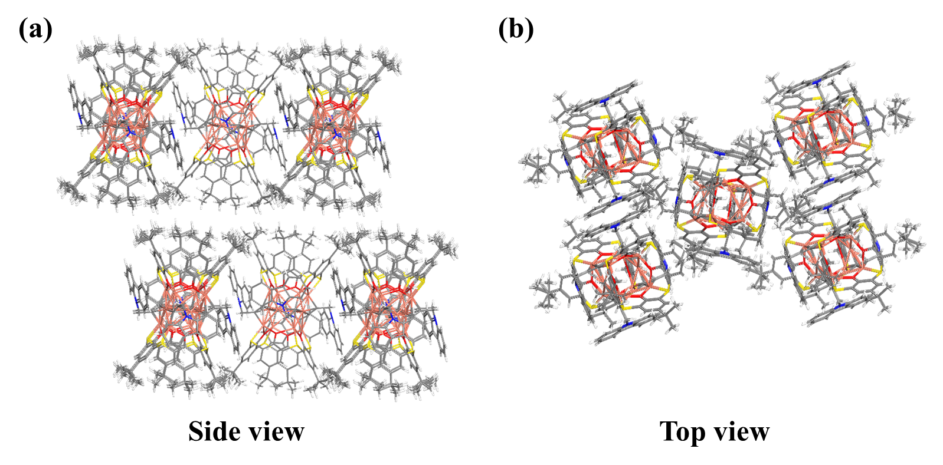
Supplementary Figure 21. Side (a) and top (b) views of the hierarchical packing arrangement of Cu12a-π.
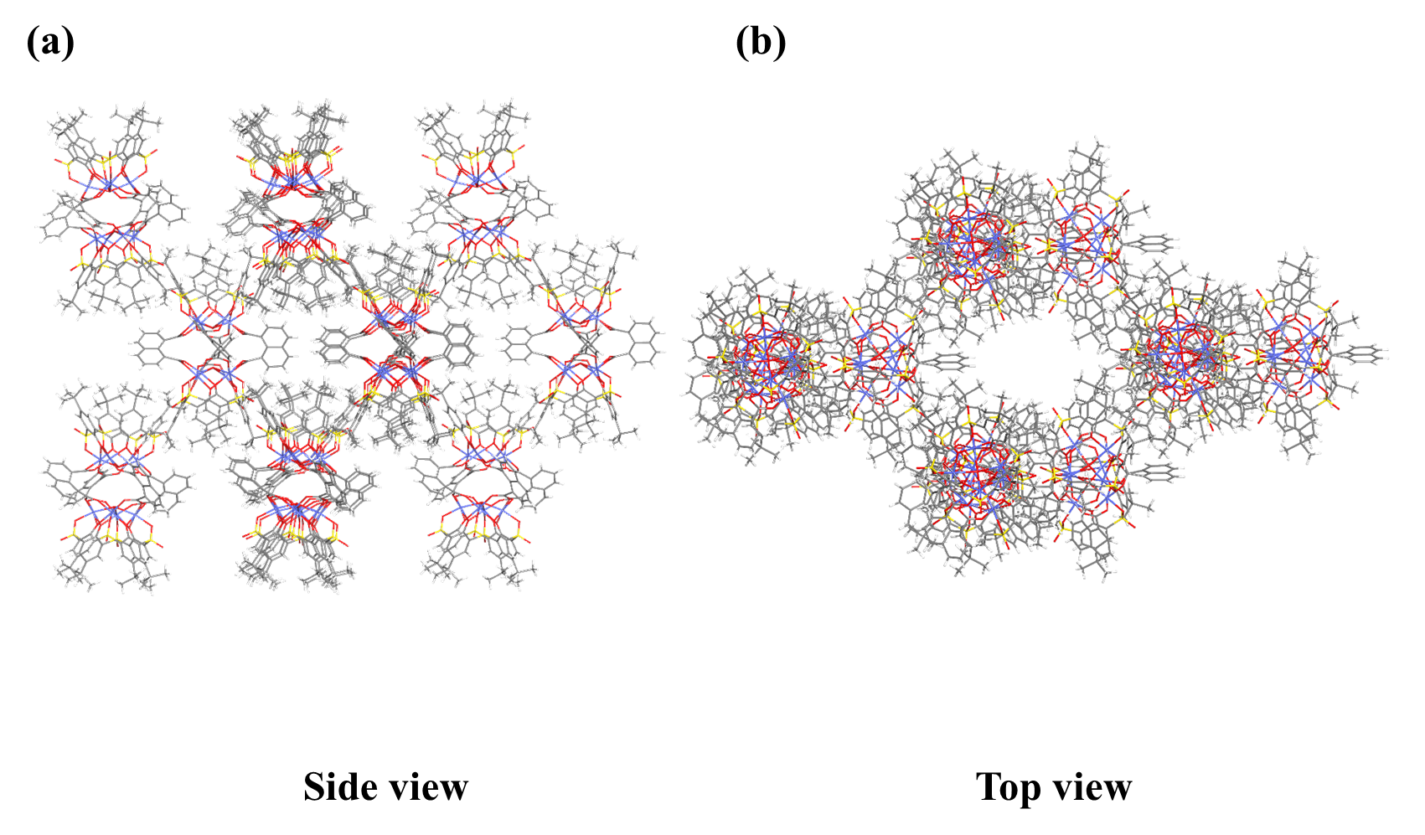
Supplementary Figure 22. Side (a) and top (b) views of the hierarchical packing arrangement of Co-NDC.
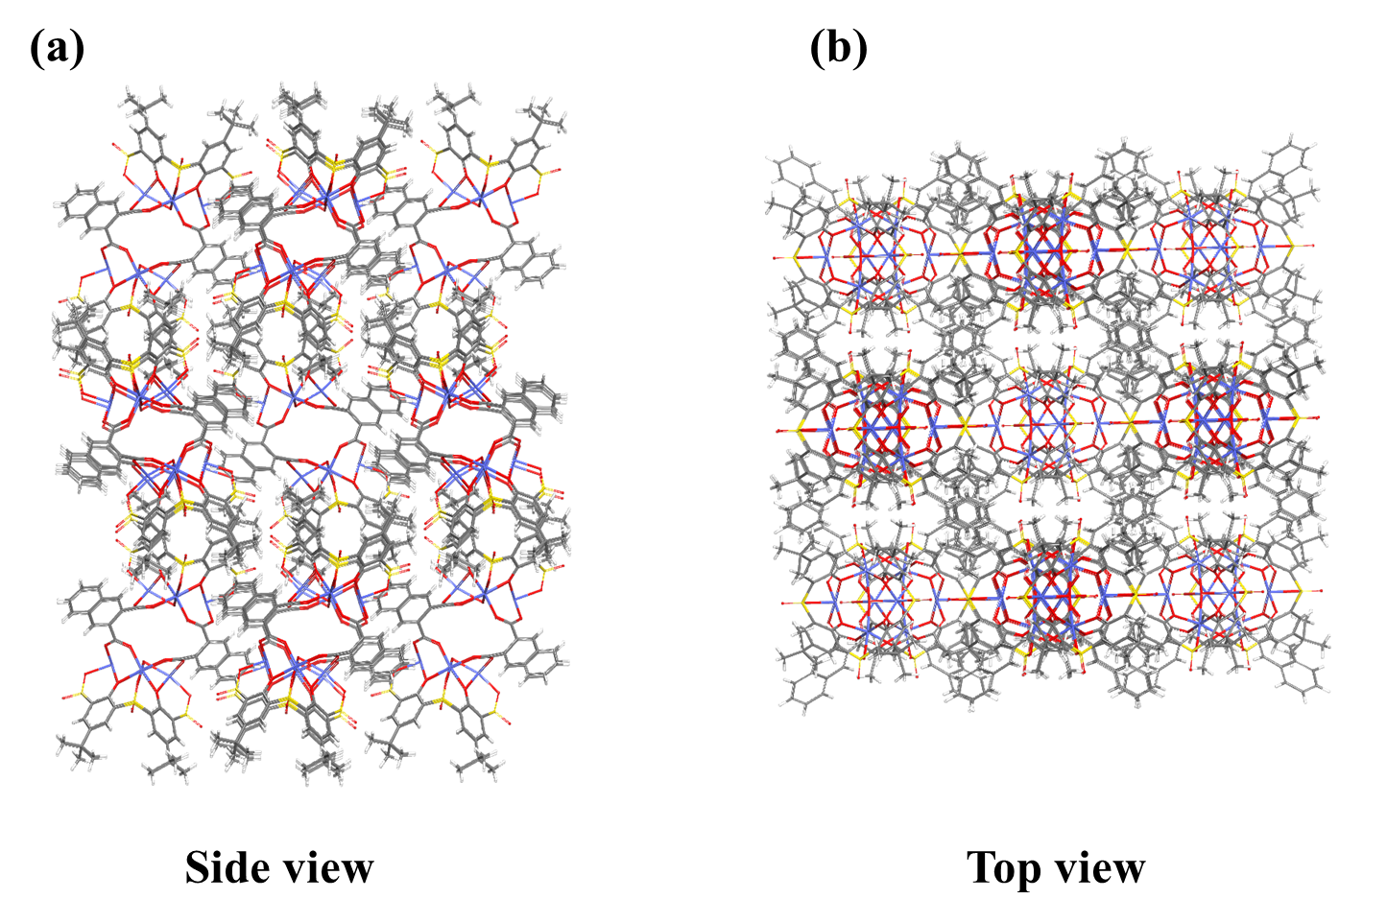
Supplementary Figure 23. Side (a) and top (b) views of the hierarchical packing arrangement of Co-2,3-NDC.
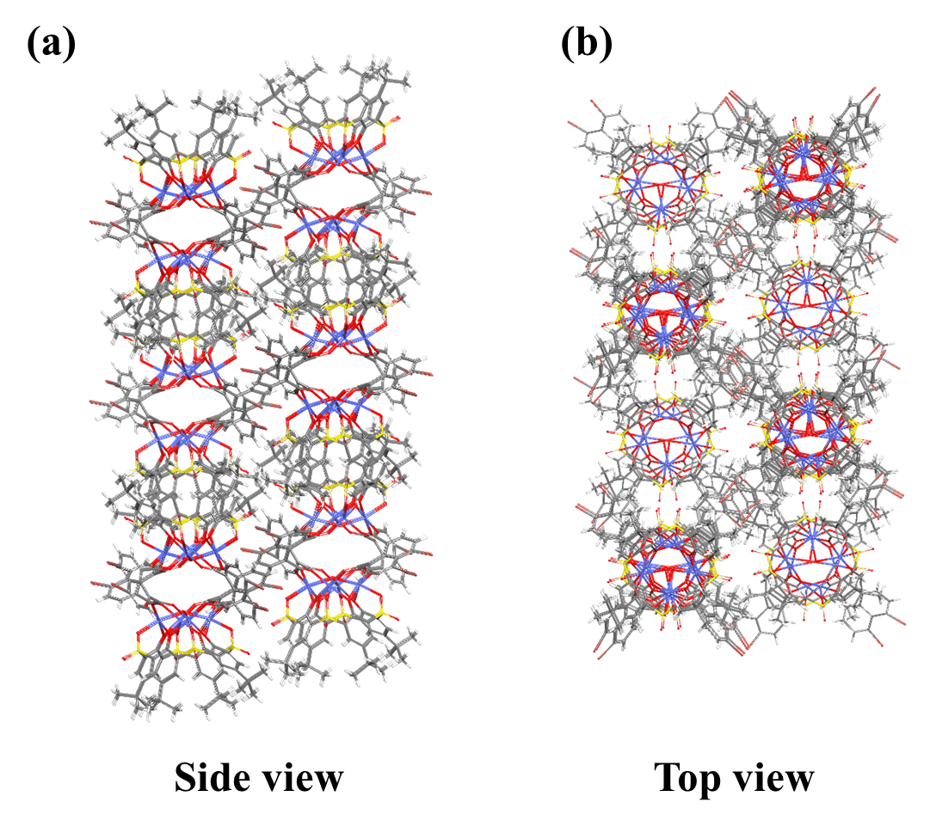
Supplementary Figure 24. Side (a) and top (b) views of the hierarchical packing arrangement of Co-NDC-Br.
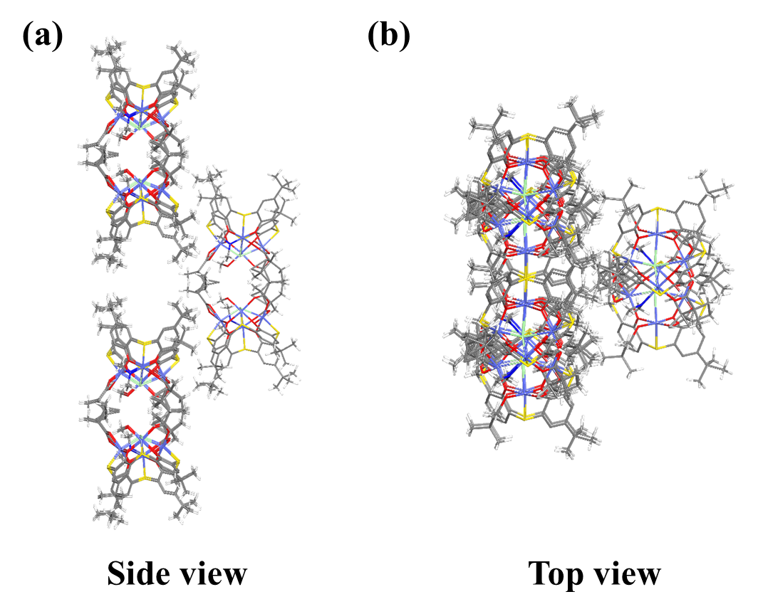
Supplementary Figure 25. Side (a) and top (b) views of the hierarchical packing arrangement of Co-CAM.
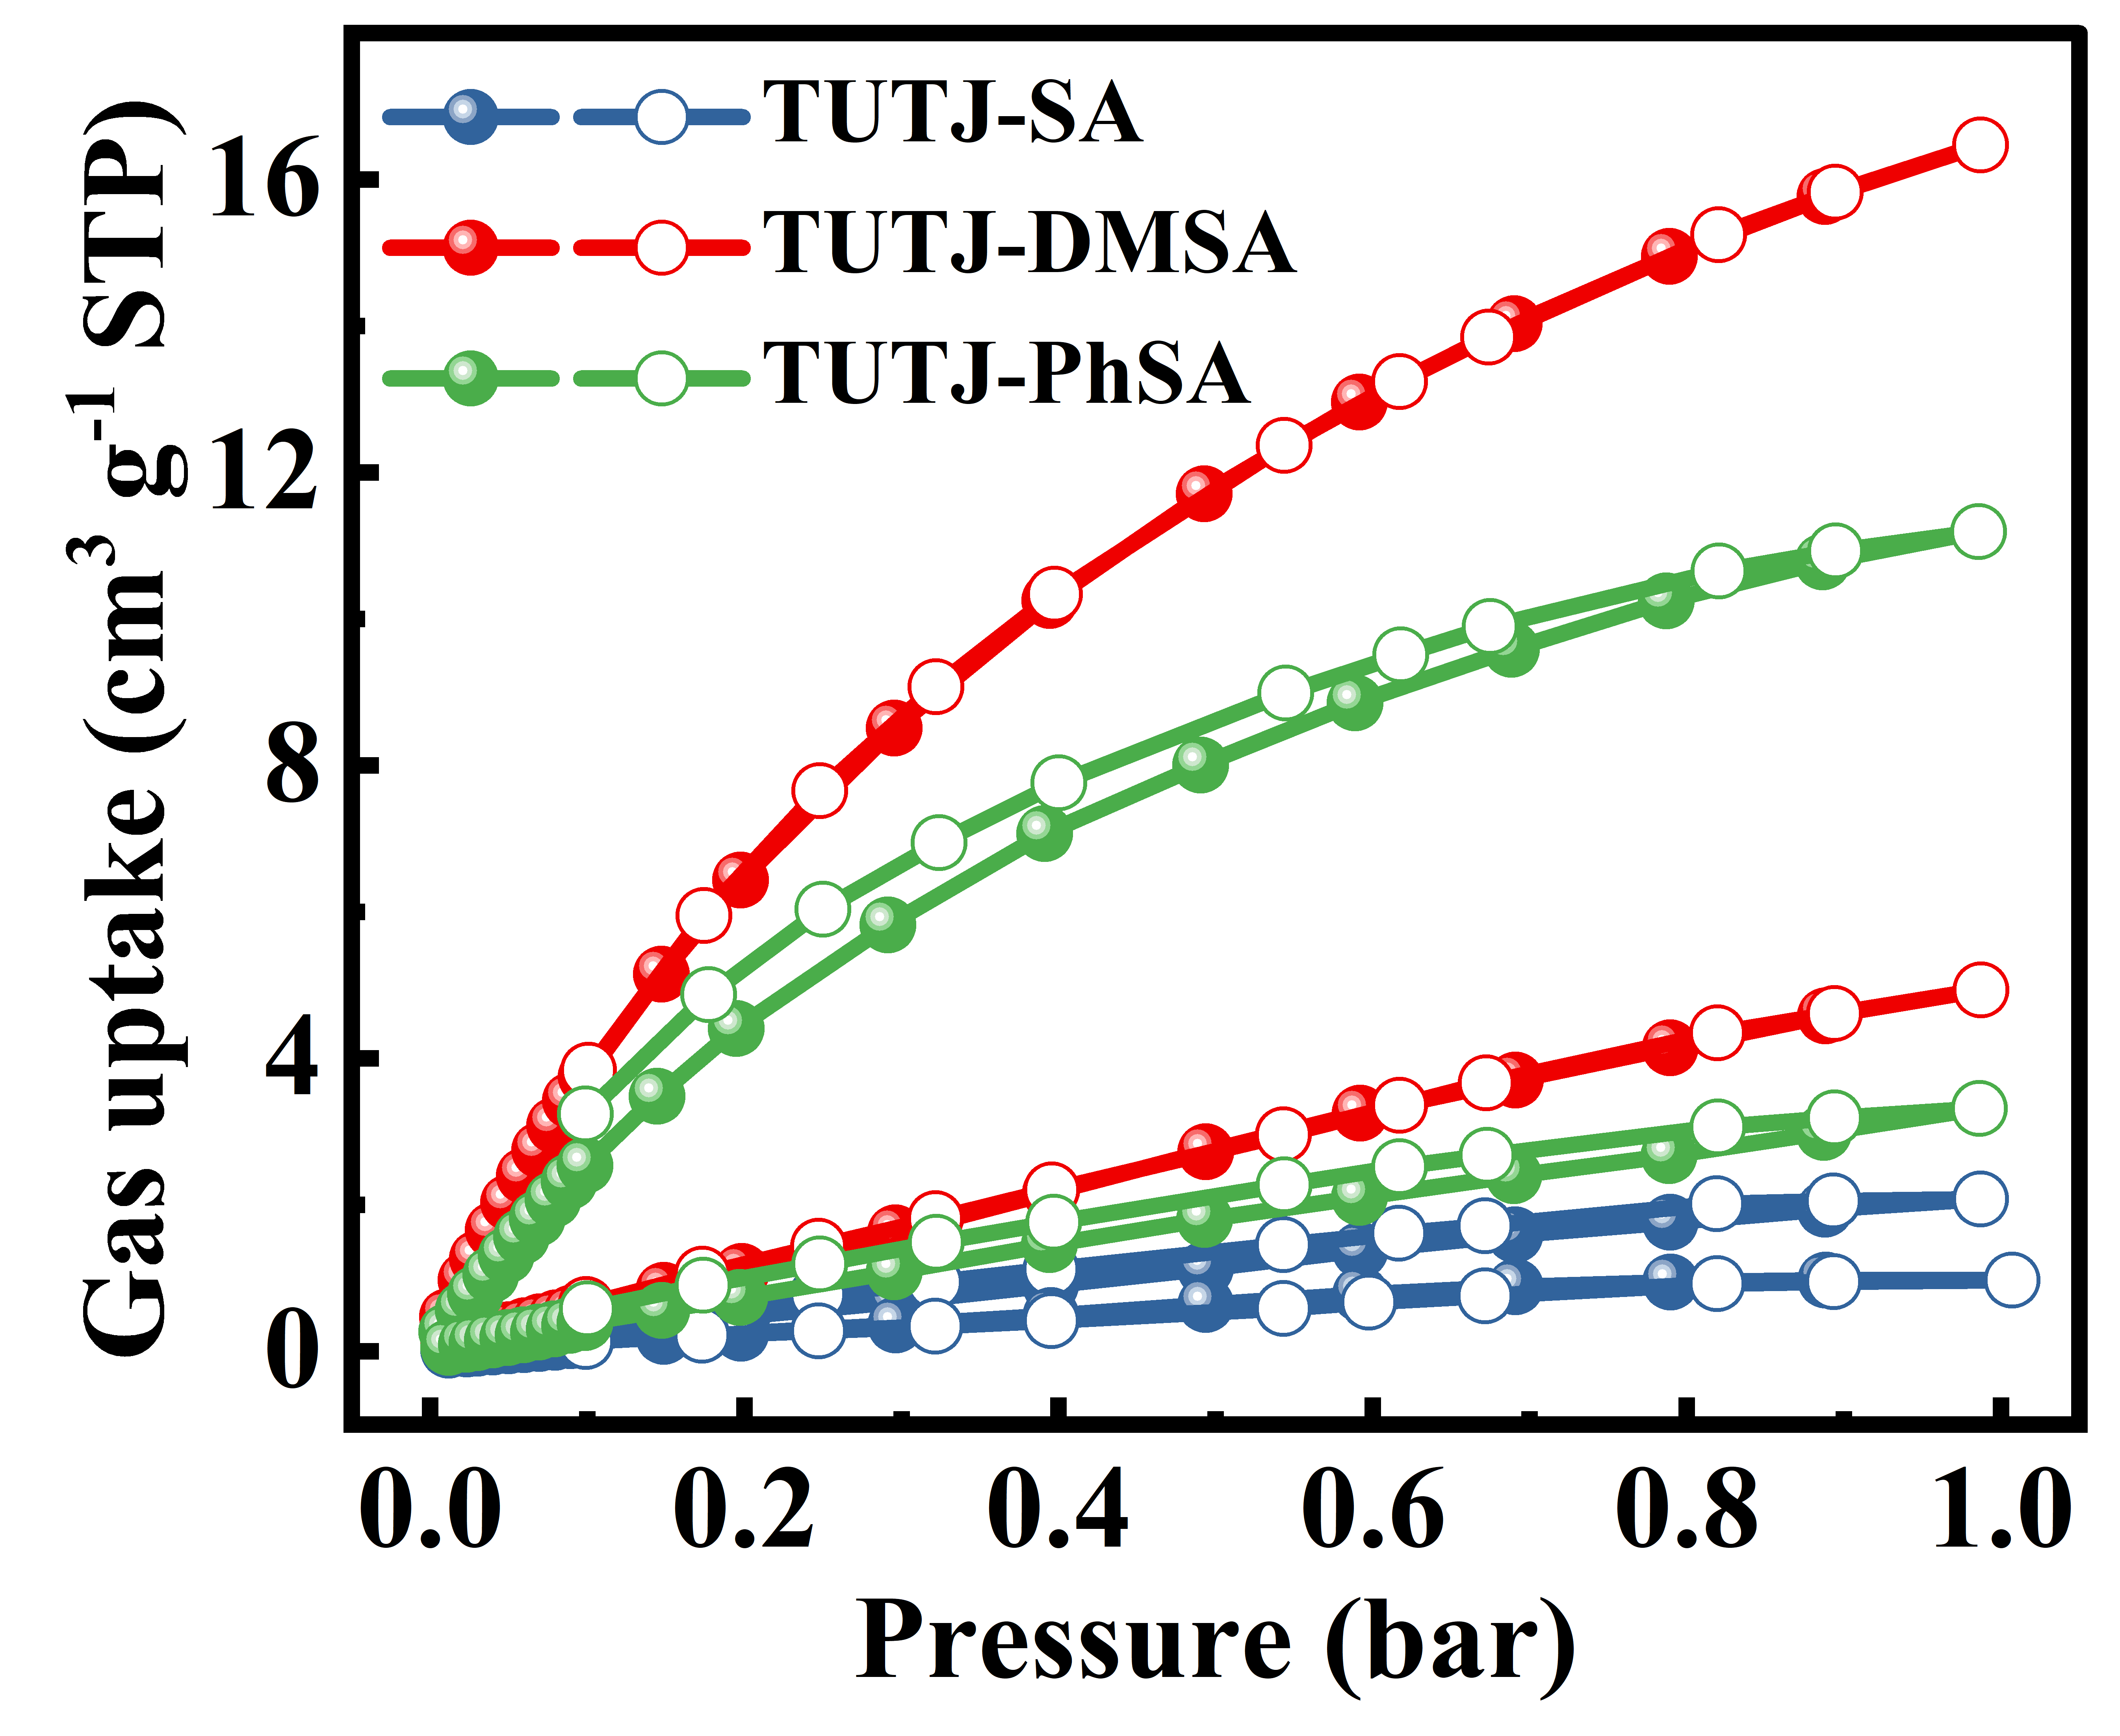
Supplementary Figure 26. Single-component CH₄ and N₂ adsorption isotherms of TUTJ-series MOFs at 298 K and 0–1 bar.
Supplementary Figure 27. Reusability test of TUTJ-DMSA for CH₄/N₂ separation: five consecutive cycles of CH₄ (red) and N₂ (blue) adsorption isotherms at 298 K and 0–1 bar.

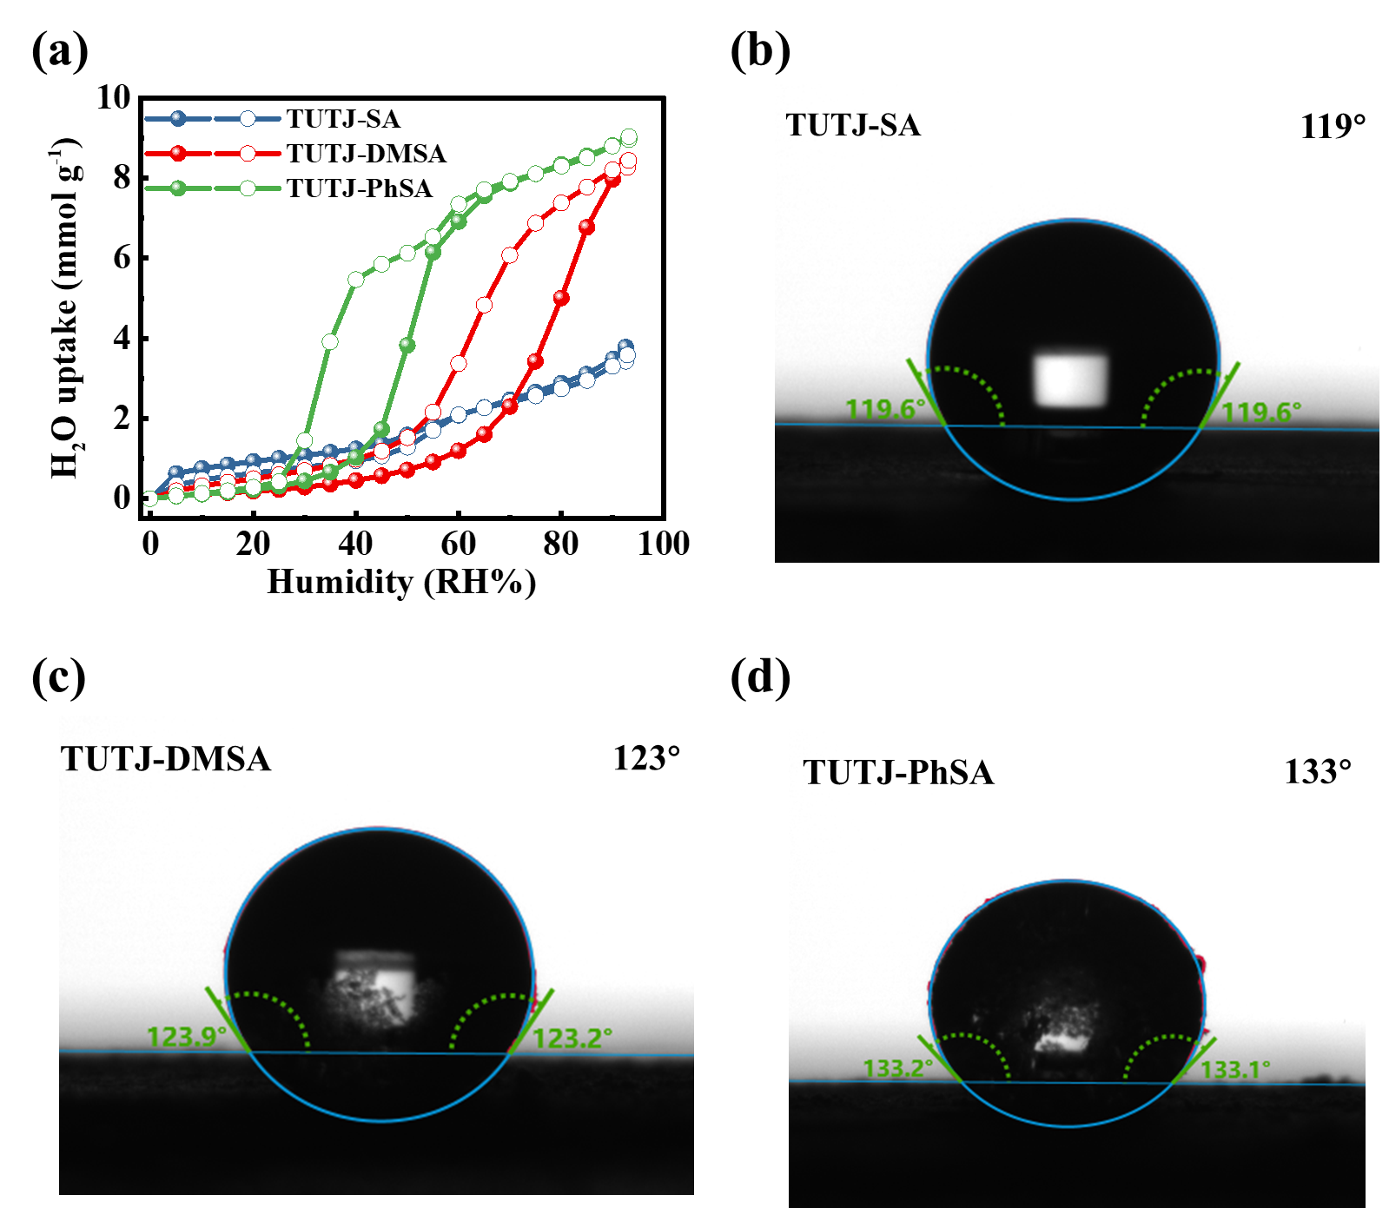
Supplementary Figure 28. Water vapor adsorption and surface wettability of TUTJ-series MOFs. (a) Water vapor adsorption isotherms of TUTJ-SA (blue), TUTJ-DMSA (red), and TUTJ-PhSA (green) at 298 K across 0–100% relative humidity (RH). (b–d) Water contact angle images of (b) TUTJ-SA, (c) TUTJ-DMSA, and (d) TUTJ-PhSA.
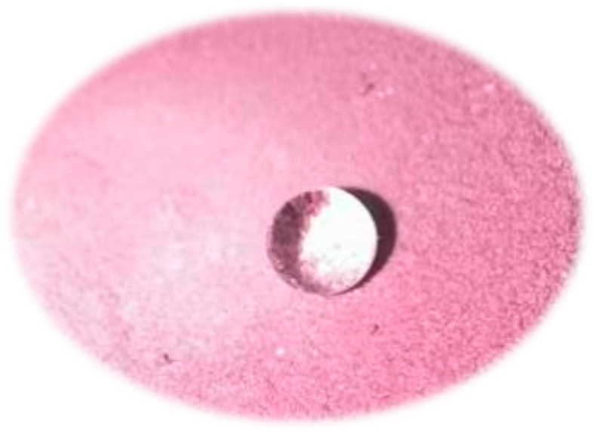
Supplementary Figure 29. Photograph of a water droplet on a compacted pellet of TUTJ-DMSA.

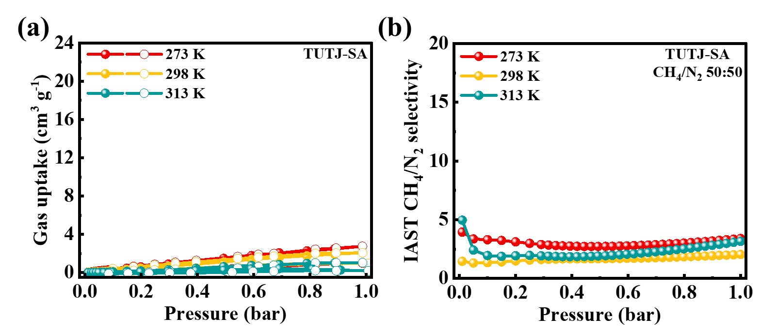
Supplementary Figure 30. (a) Single-component CH₄ and N₂ adsorption isotherms of TUTJ-SA at 273 K, 298 K, and 313 K, and (b) corresponding IAST-calculated CH₄/N₂ selectivity for an equimolar 50:50 mixture.
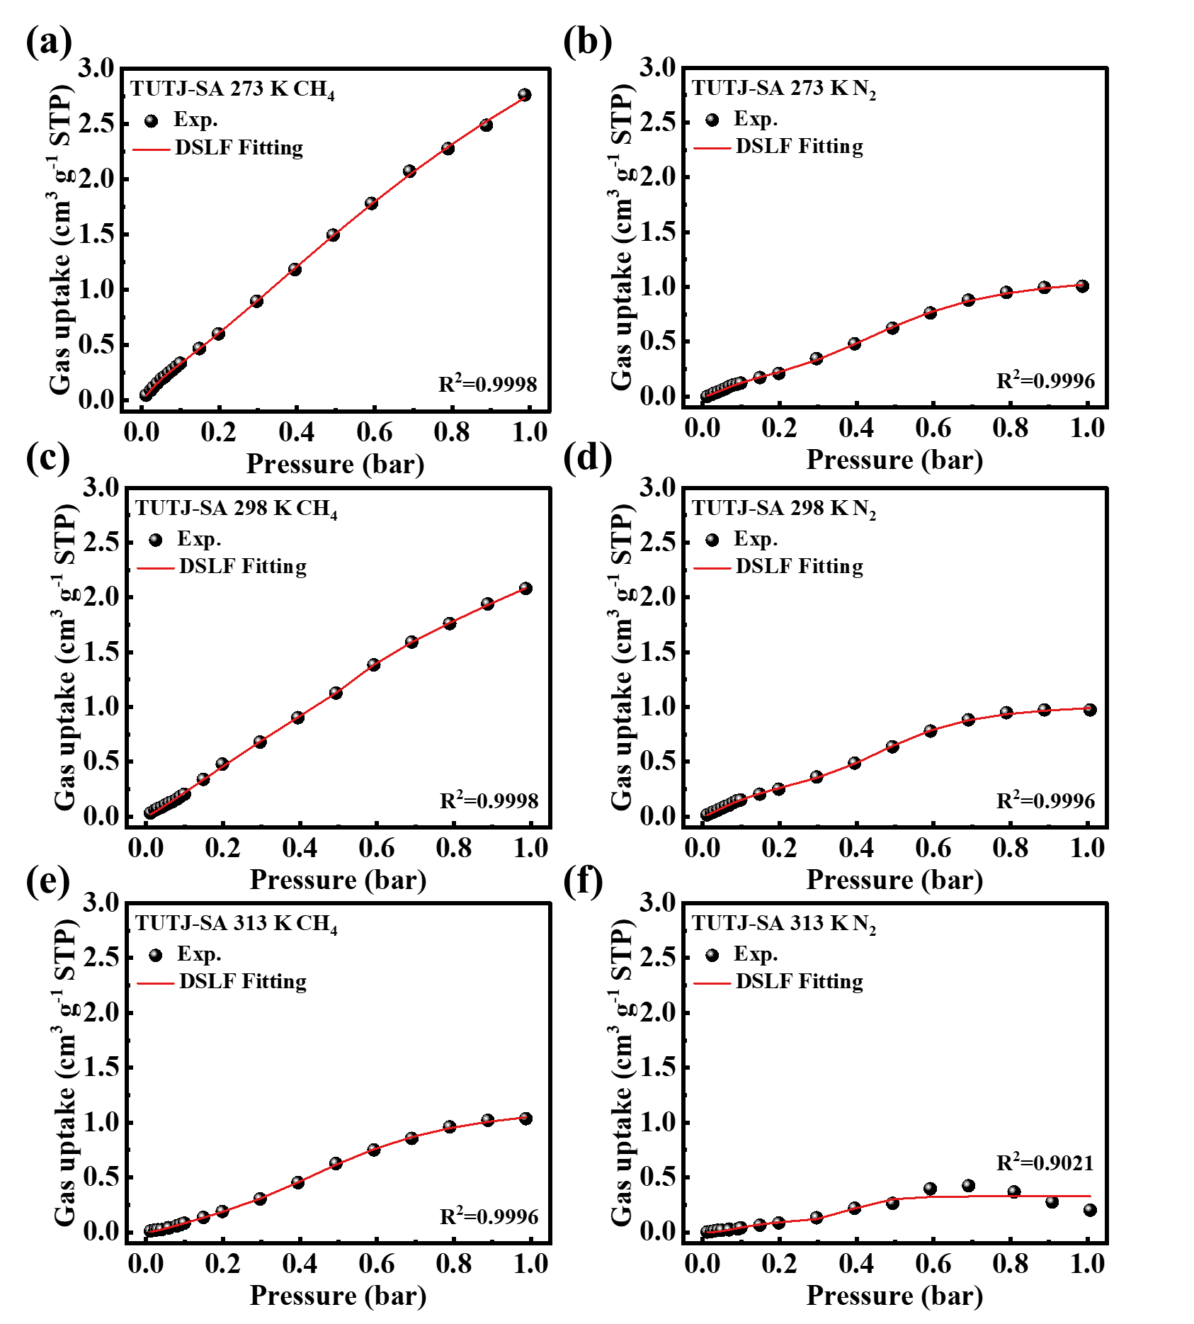
Supplementary Figure 31. CH₄ and N₂ adsorption isotherms at 273 K(a,b), 298 K(c,d), and 313 K(e,f) in TUTJ-SA with dual-site Langmuir-Freundlich model fits.
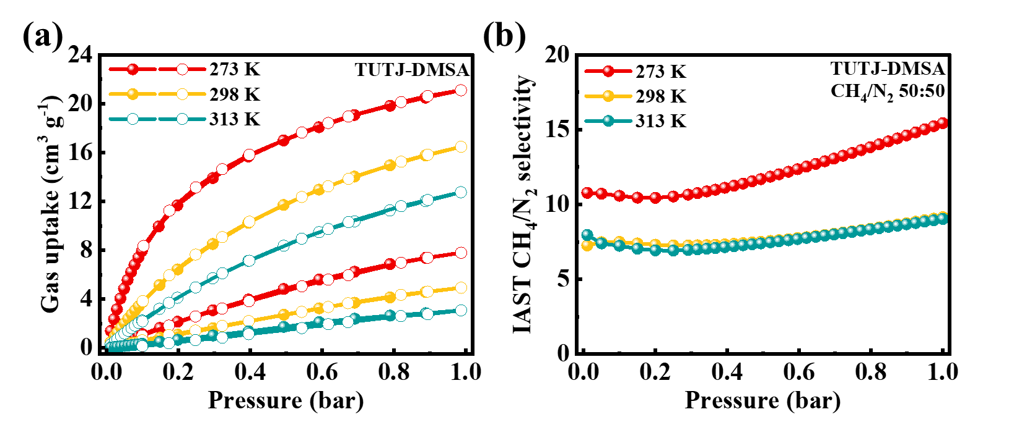
Supplementary Figure 32. (a) Single-component CH₄ and N₂ adsorption isotherms of TUTJ-DMSA at 273 K, 298 K, and 313 K, and (b) corresponding IAST-calculated CH₄/N₂ selectivity for an equimolar 50:50 mixture.
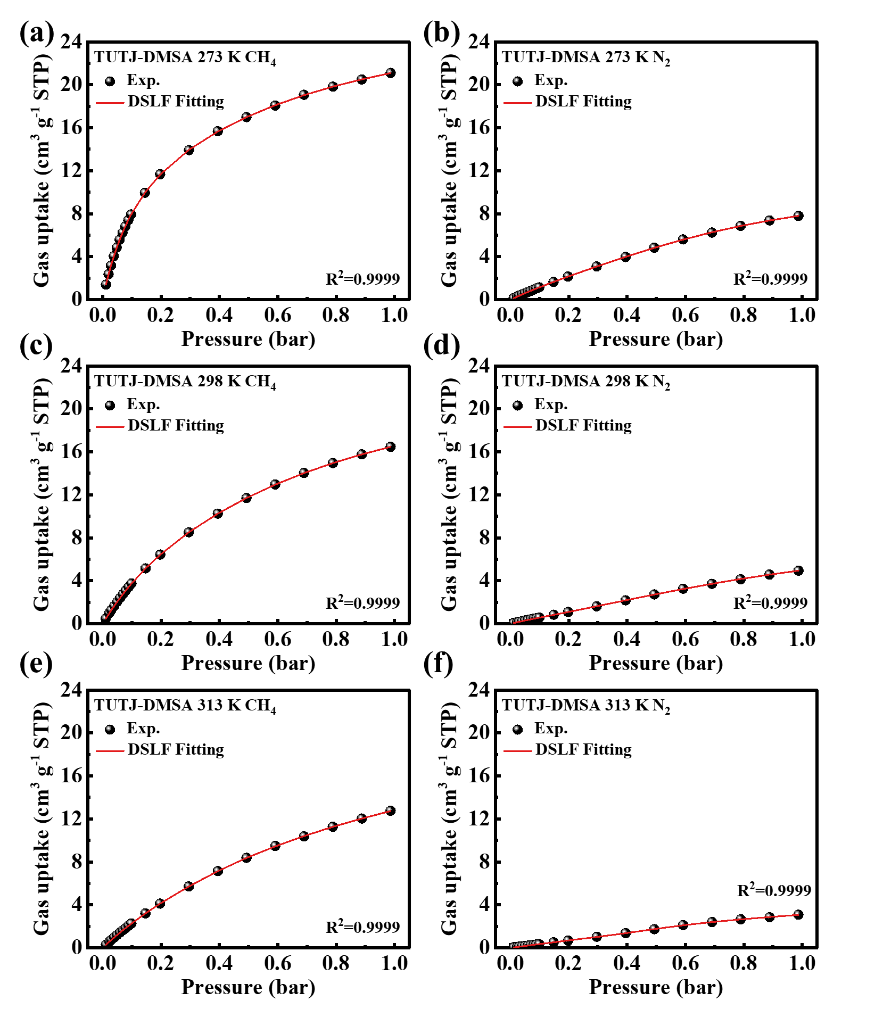
Supplementary Figure 33. CH₄ and N₂ adsorption isotherms at 273 K(a,b), 298 K(c,d), and 313 K(e,f) in TUTJ-DMSA with dual-site Langmuir-Freundlich model fits.
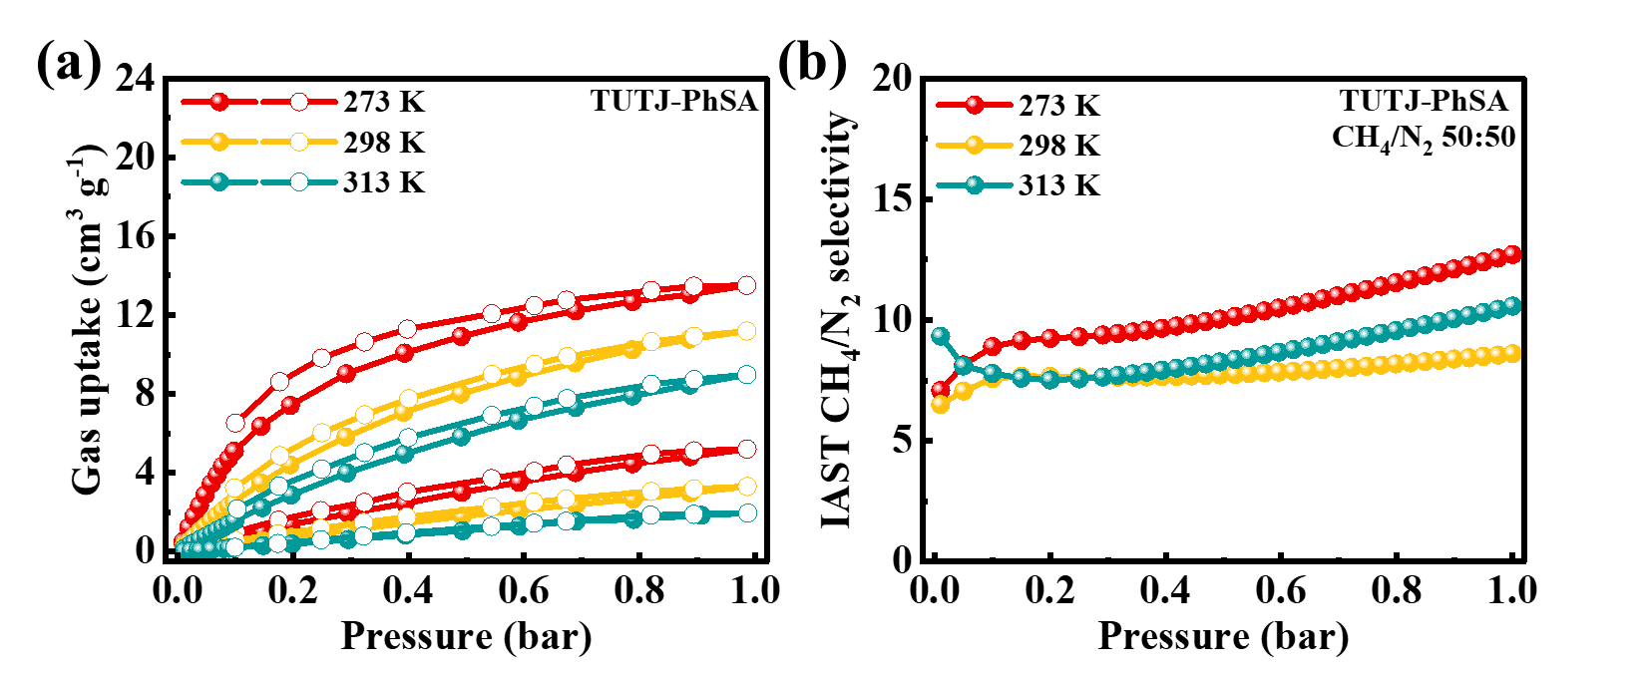
Supplementary Figure 34. (a) Single-component CH₄ and N₂ adsorption isotherms of TUTJ-PhSA at 273 K, 298 K, and 313 K, and (b) corresponding IAST-calculated CH₄/N₂ selectivity for an equimolar 50:50 mixture.
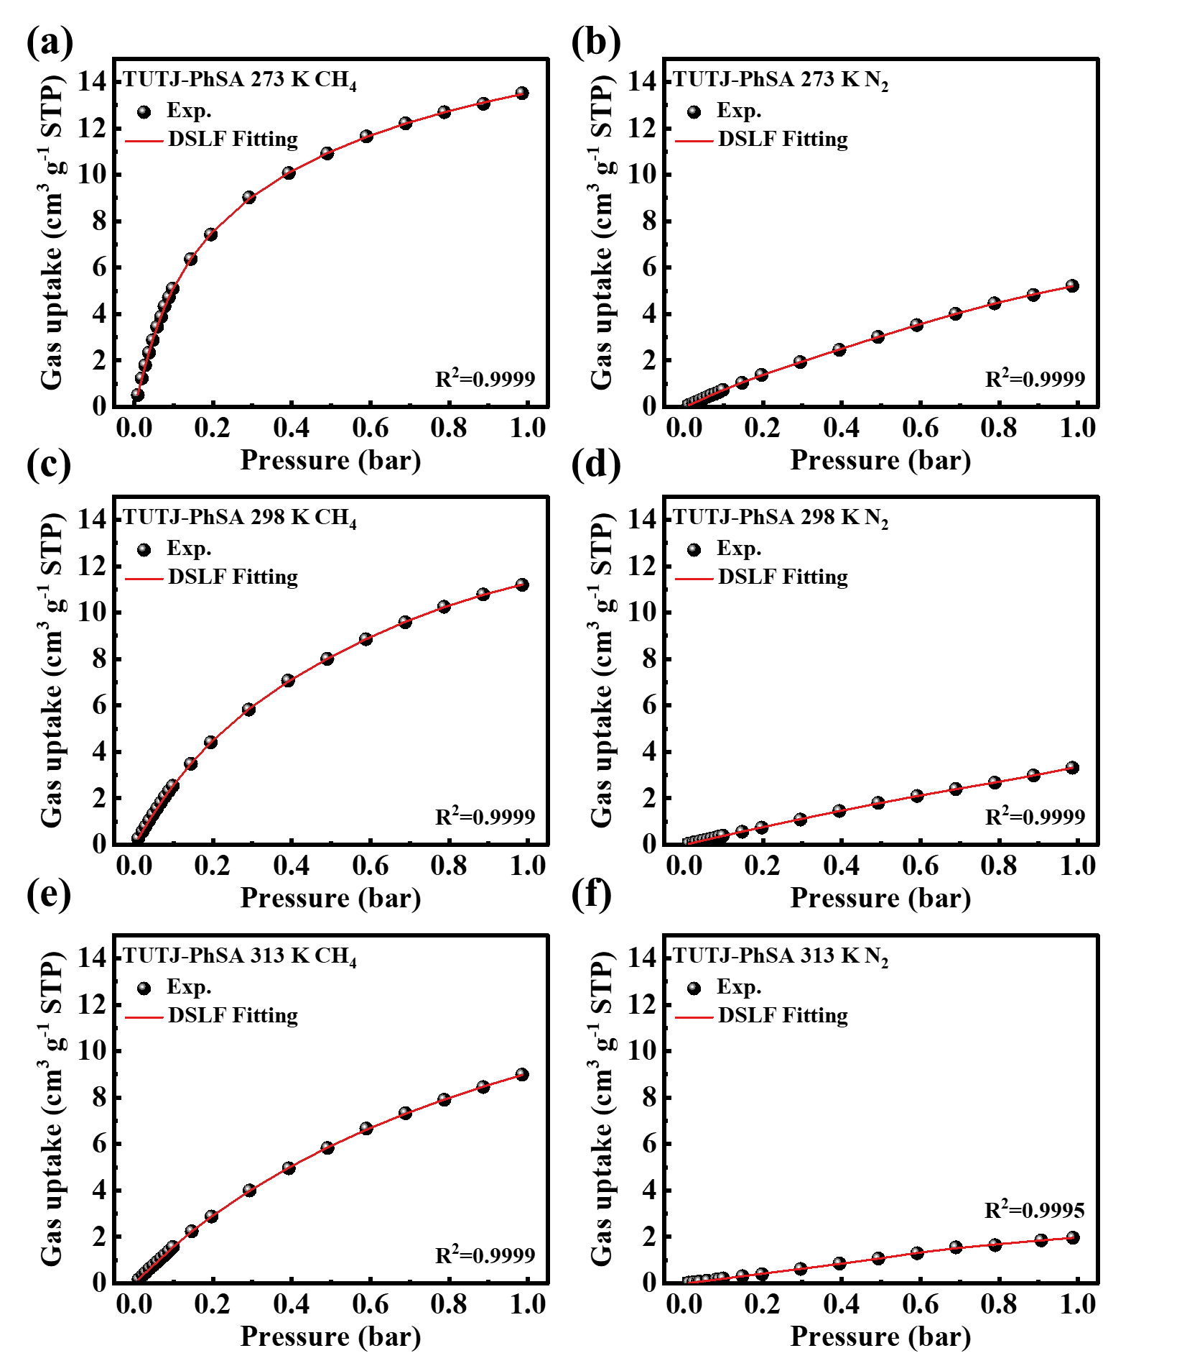
Supplementary Figure 35. CH₄ and N₂ adsorption isotherms at 273 K(a,b), 298 K(c,d), and 313 K(e,f) in TUTJ-PhSA with dual-site Langmuir-Freundlich model fits.

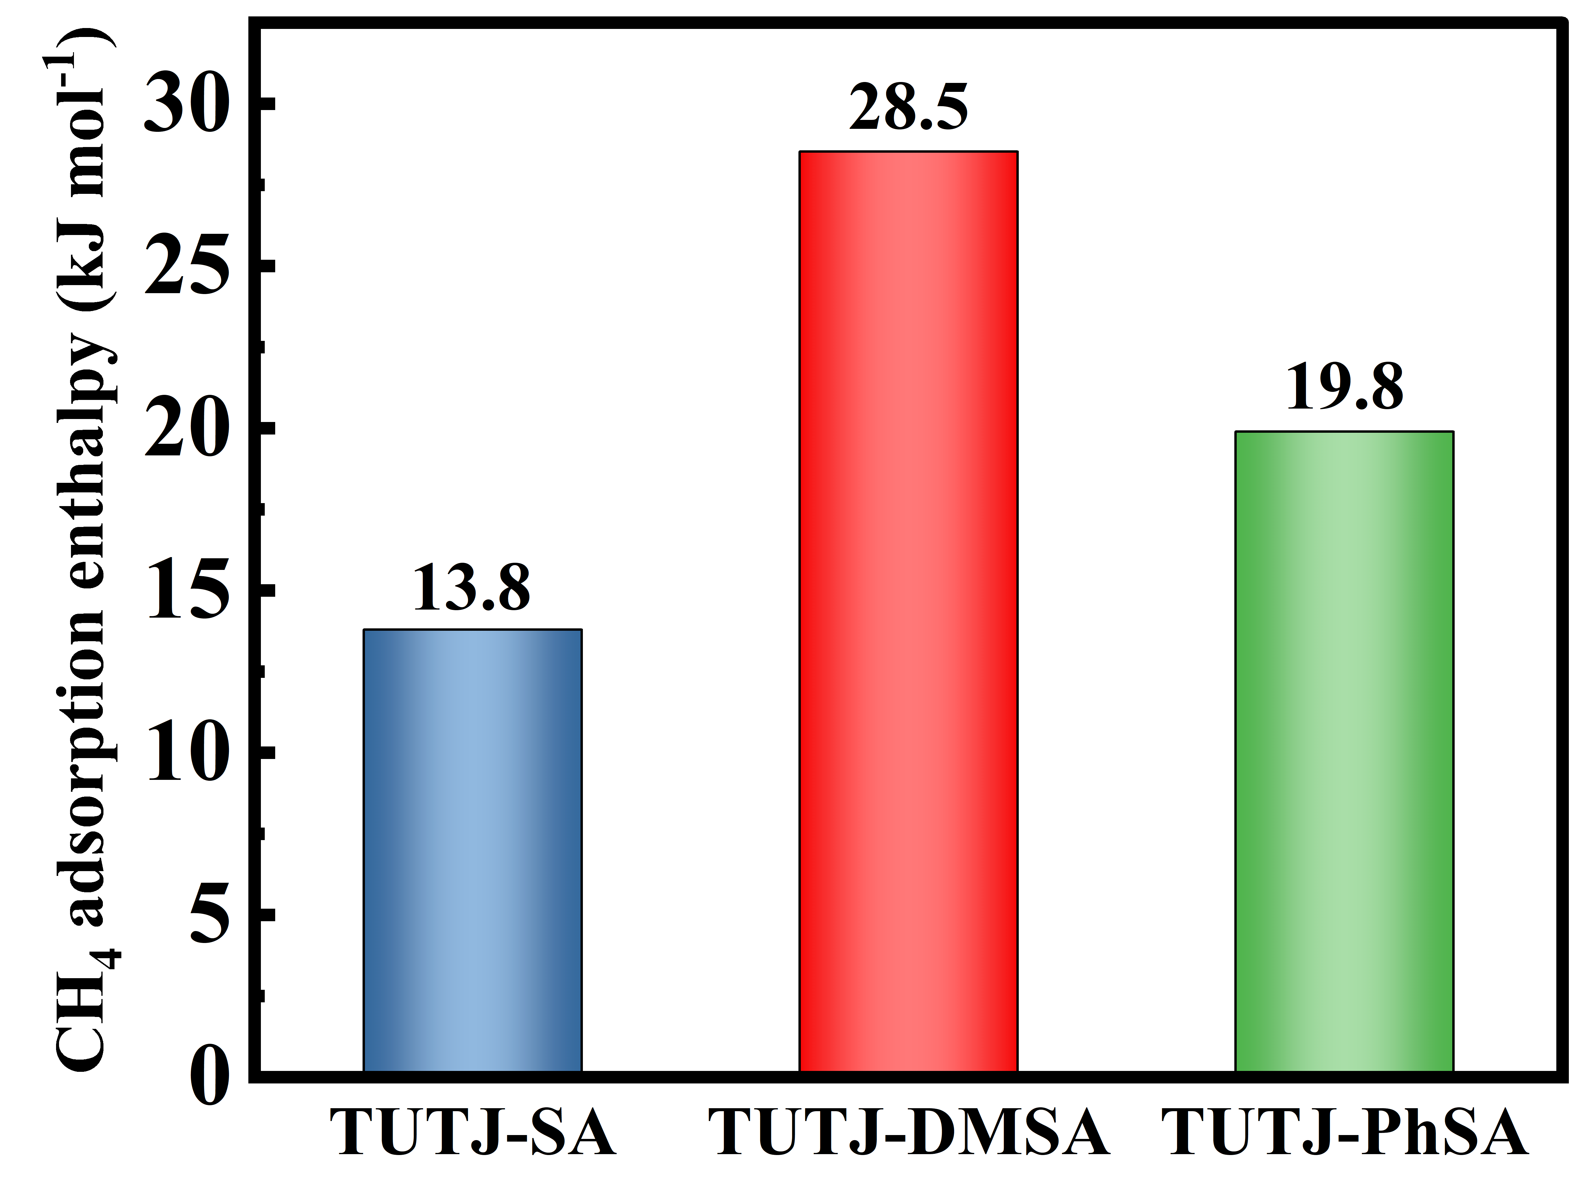
Supplementary Figure 36. The Q_{st} values of methane for TUTJ-SA, TUTJ-DMSA, TUTJ-PhSA.
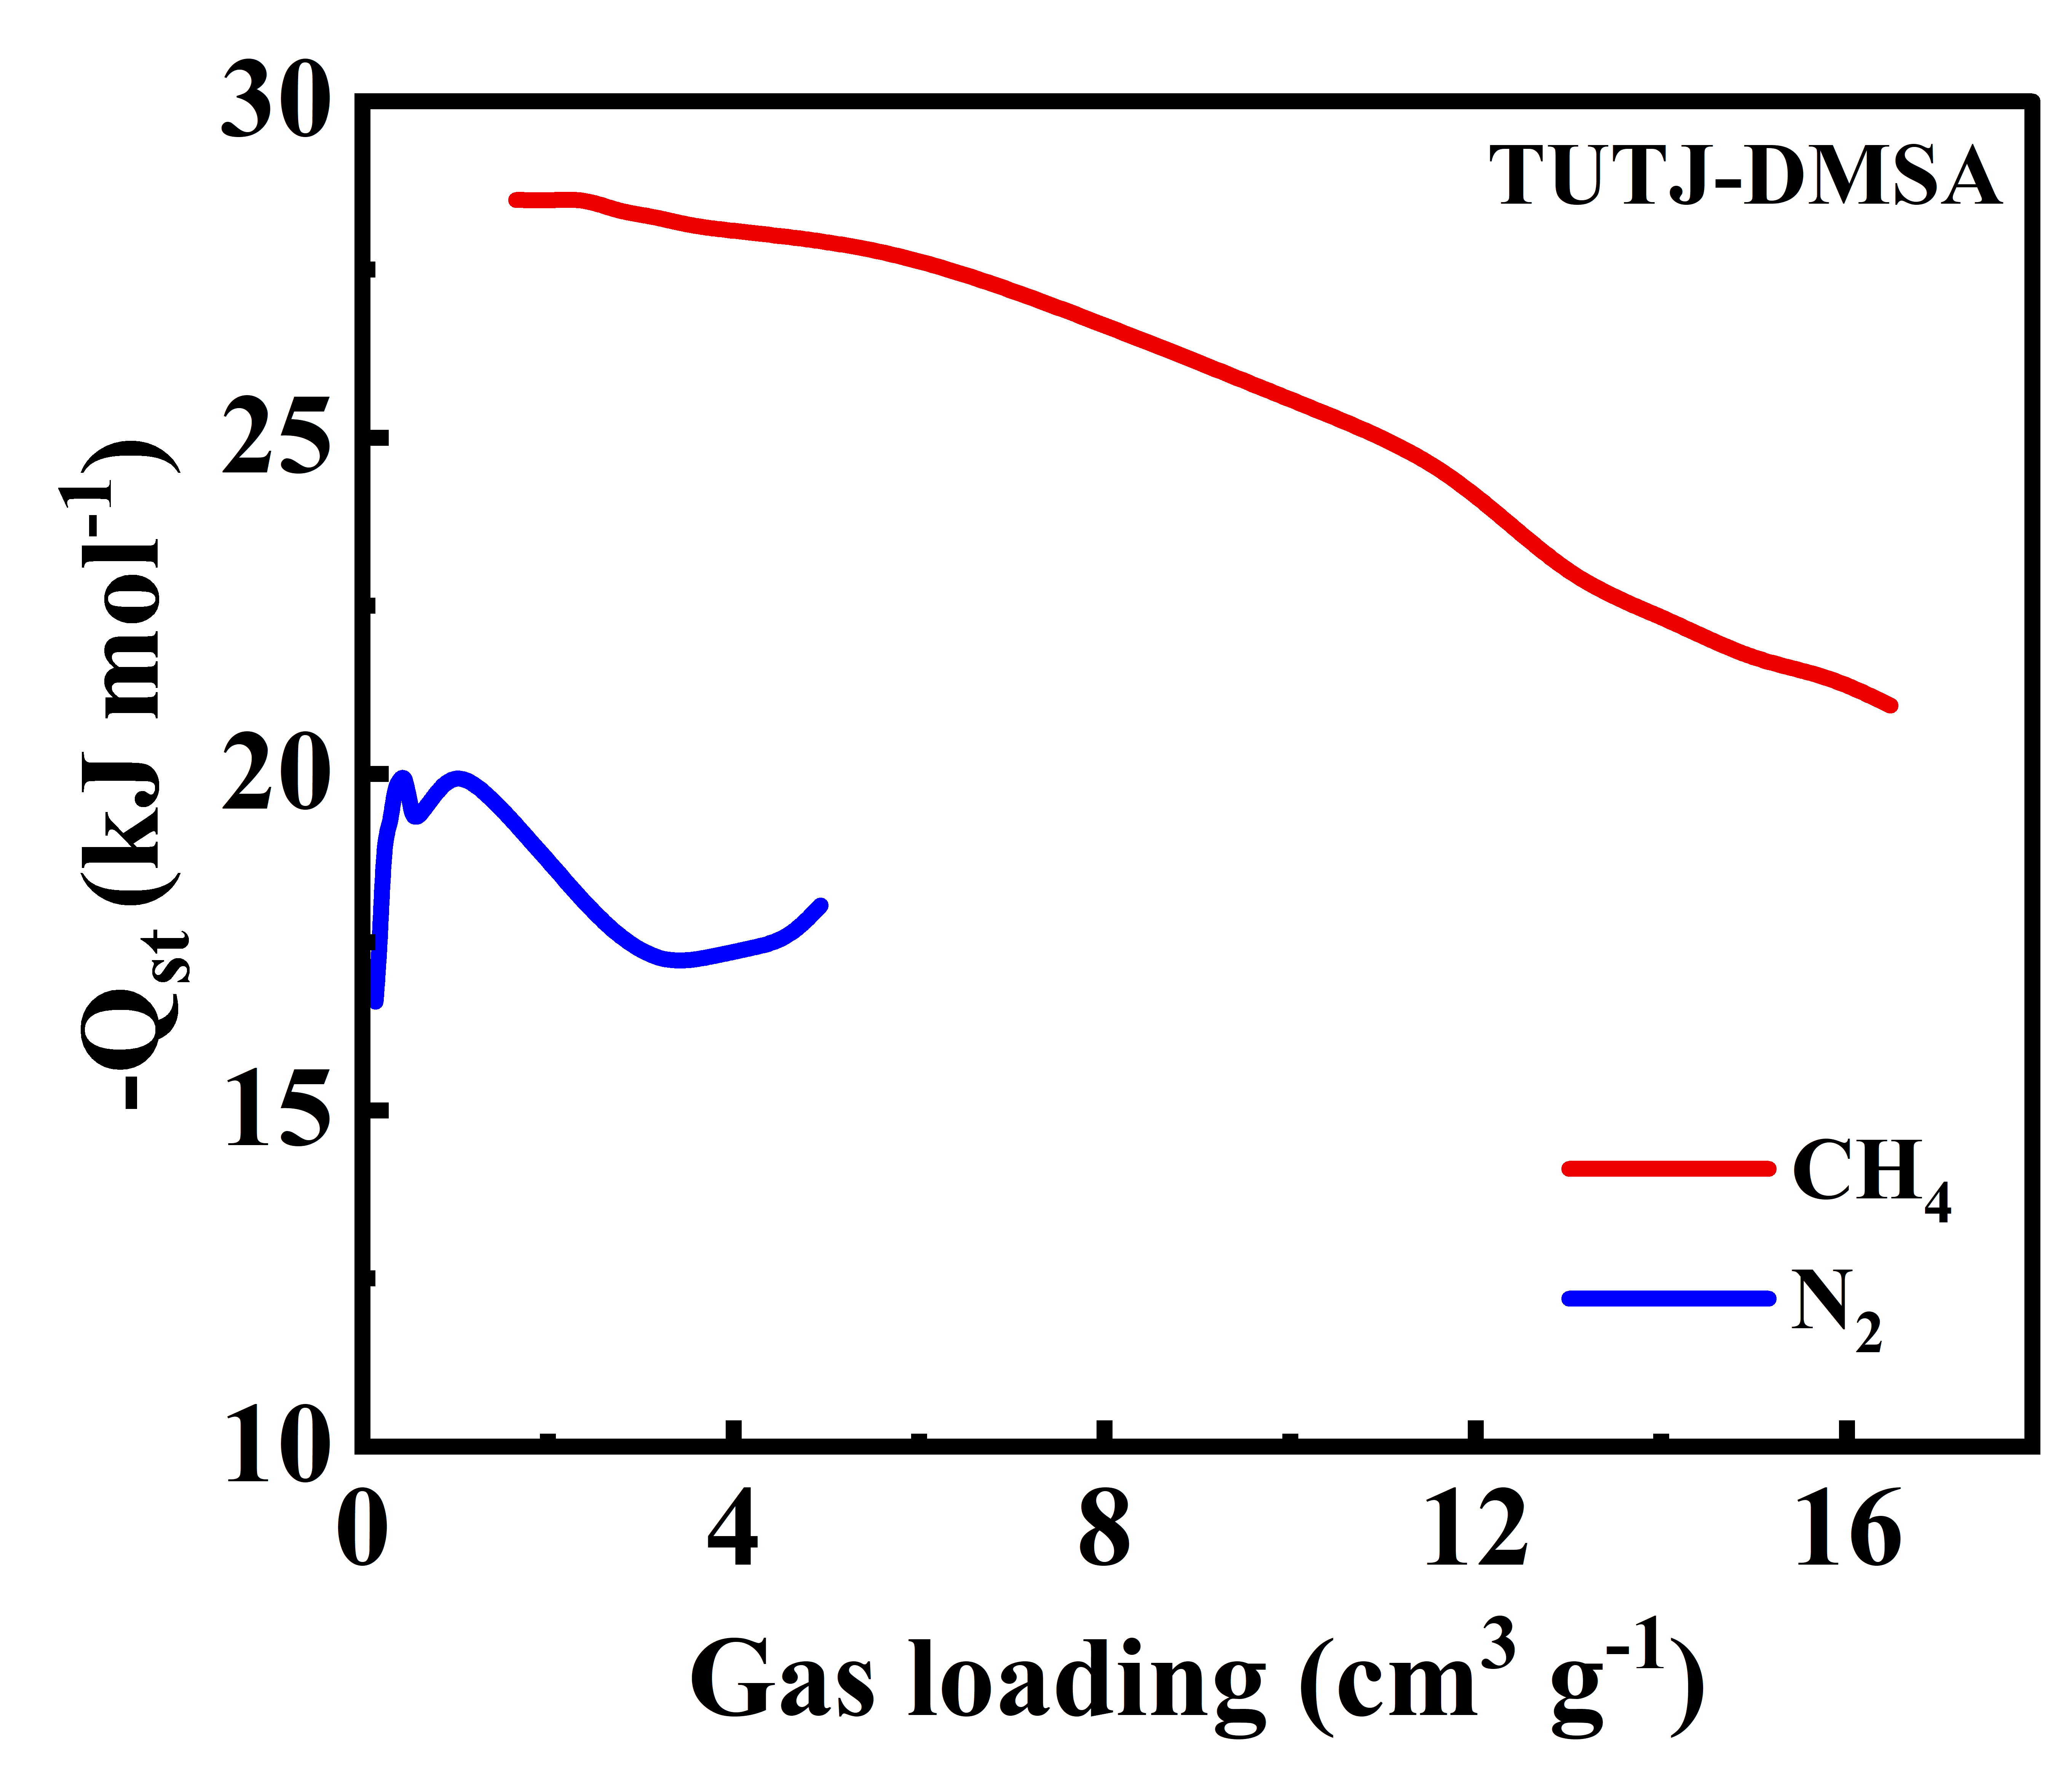
Supplementary Figure 37. The Q_{st} values of CH₄ and N₂ for TUTJ-DMSA.
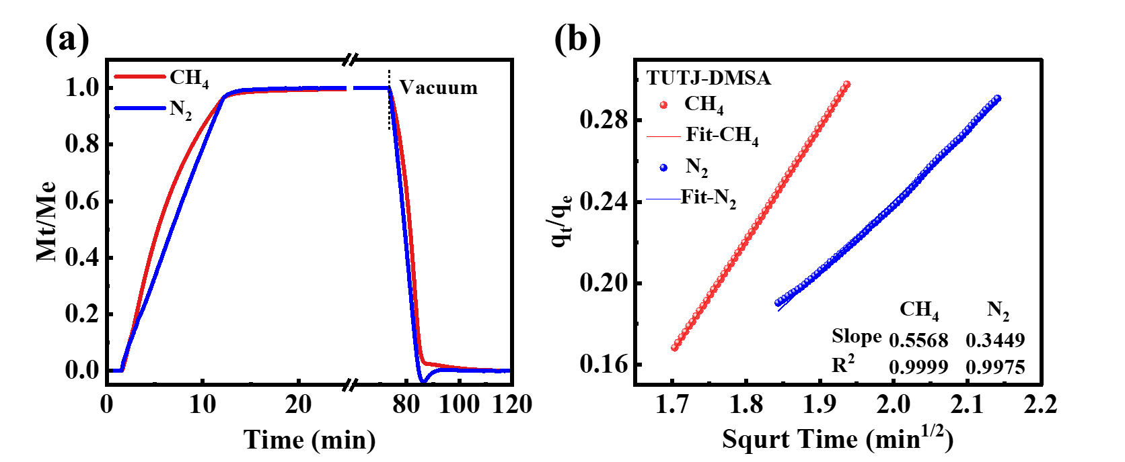
Supplementary Figure 38. (a) Kinetic adsorption/desorption profiles of CH₄ and N₂ for TUTJ-DMSA; (b) Diffusional time constant calculation details for TUTJ-DMSA at 298 K.
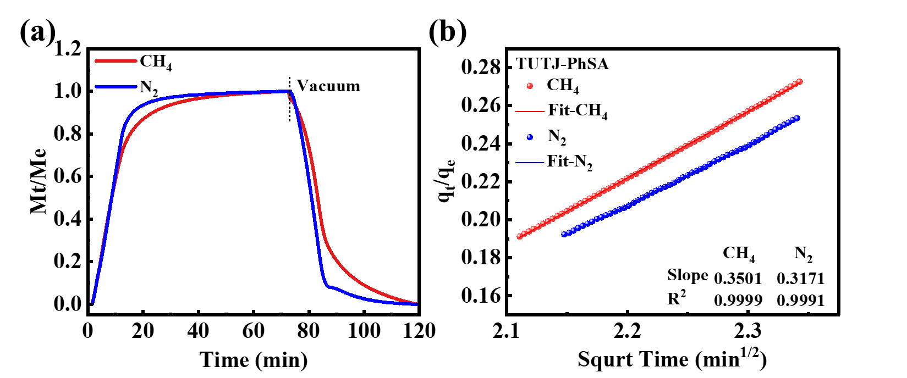
Supplementary Figure 39. (a) Kinetic adsorption/desorption profiles of CH₄ and N₂ for TUTJ-PhSA; (b) Diffusional time constant calculation details for TUTJ-PhSA at 298 K.
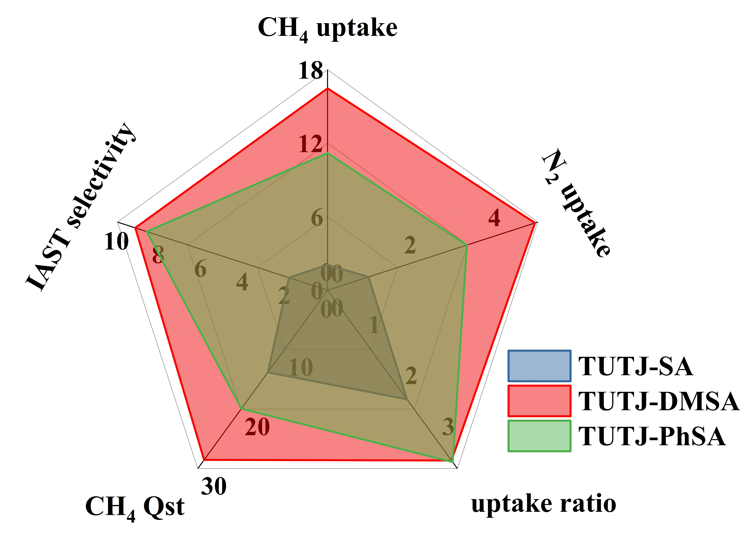
Supplementary Figure 40. Comprehensive performance radar chart comparing CH₄/N₂ separation metrics of TUTJ-SA (blue), TUTJ-DMSA (red), and TUTJ-PhSA (green).
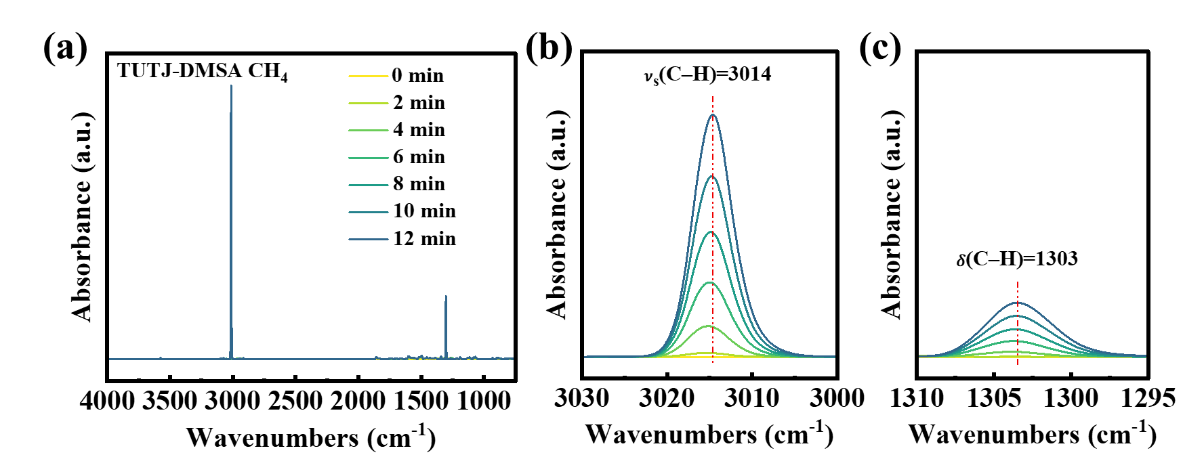
Supplementary Figure 41. (a) In-situ FTIR spectra collected during CH₄ adsorption, with zoomed views of the symmetric C–H stretching (b) and bending (c) vibrational modes of adsorbed CH₄.
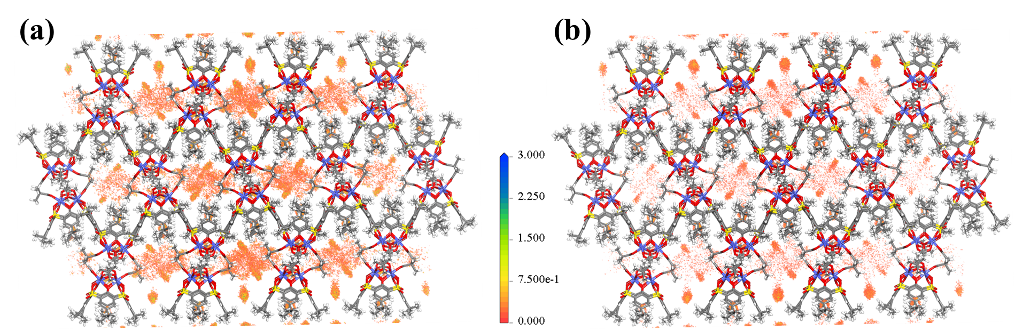
Supplementary Figure 42. GCMC-derived probability density distributions for adsorbed CH₄ (a) and N₂ (b) molecules in TUTJ-DMSA.
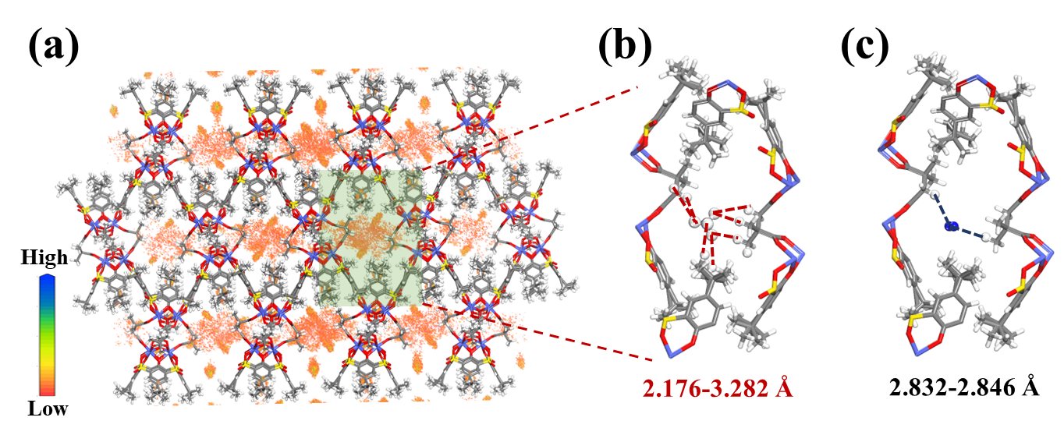
Supplementary Figure 43. (a) GCMC charge density distribution map; DFT-optimized binding configuration of CH₄ (b) and N₂ (c).
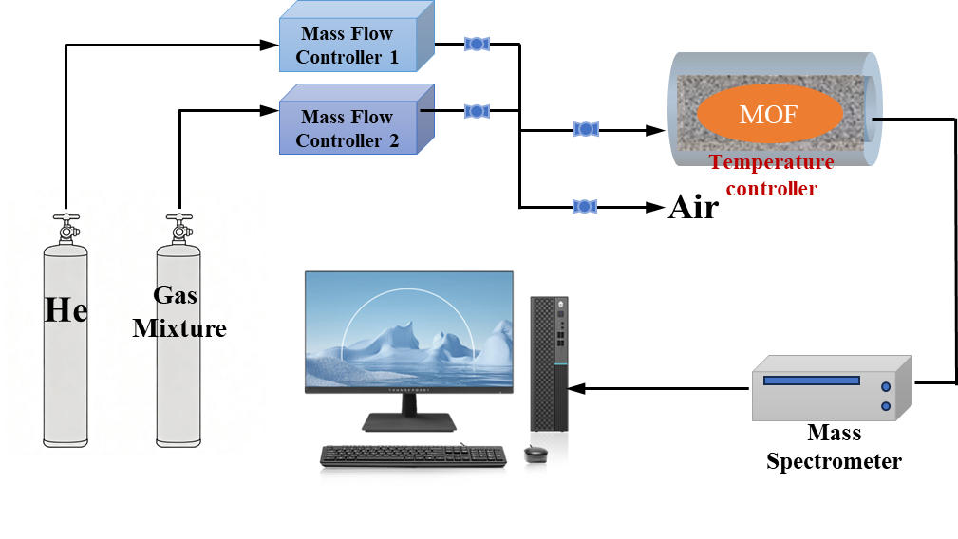
Supplementary Figure 44. Schematic illustration of the setup for breakthrough experiments.
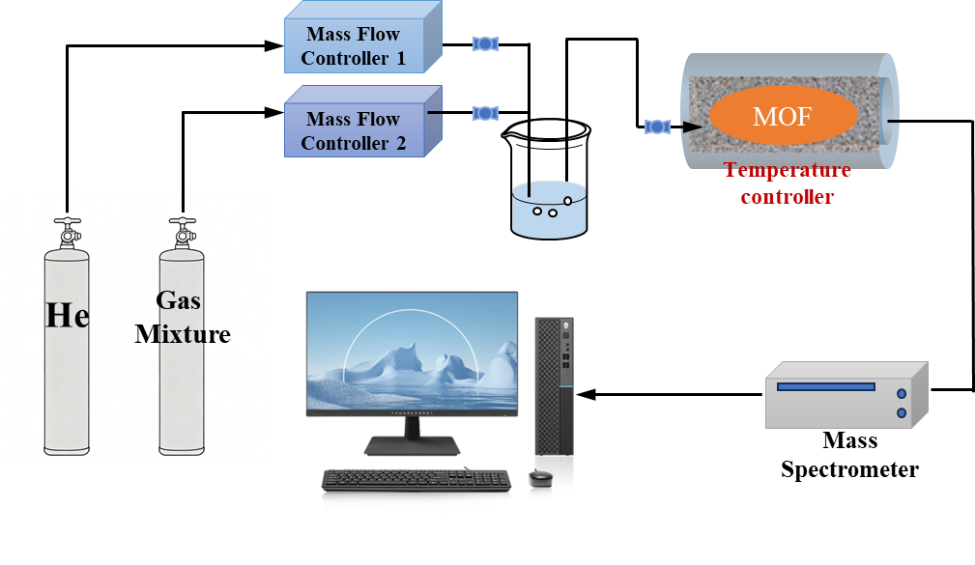
Supplementary Figure 45. Schematic illustration of the apparatus for the breakthrough experiments under humid conditions.

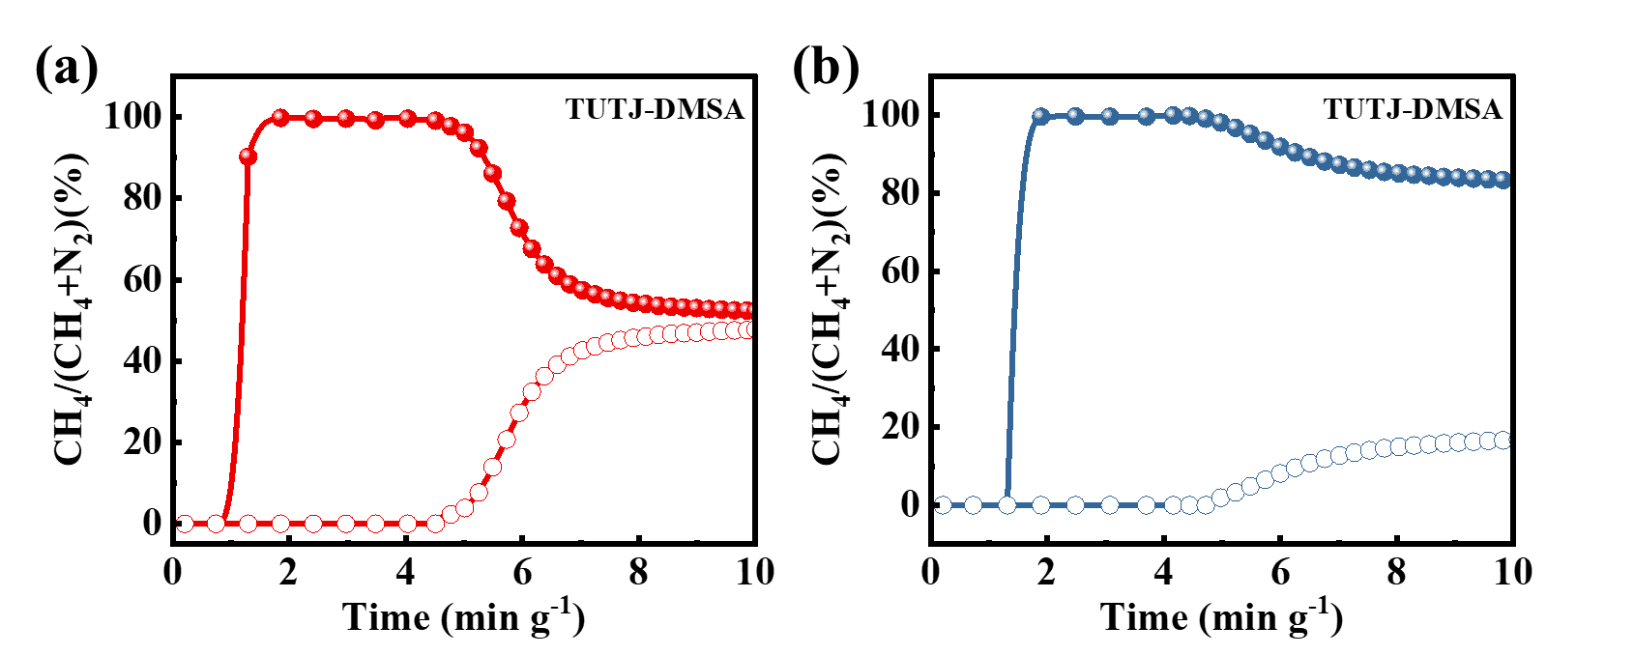
Supplementary Figure 46. Breakthrough curves of TUTJ-3Ni for 50:50 (a) and 20:80 (b) CH₄/N₂ mixtures.
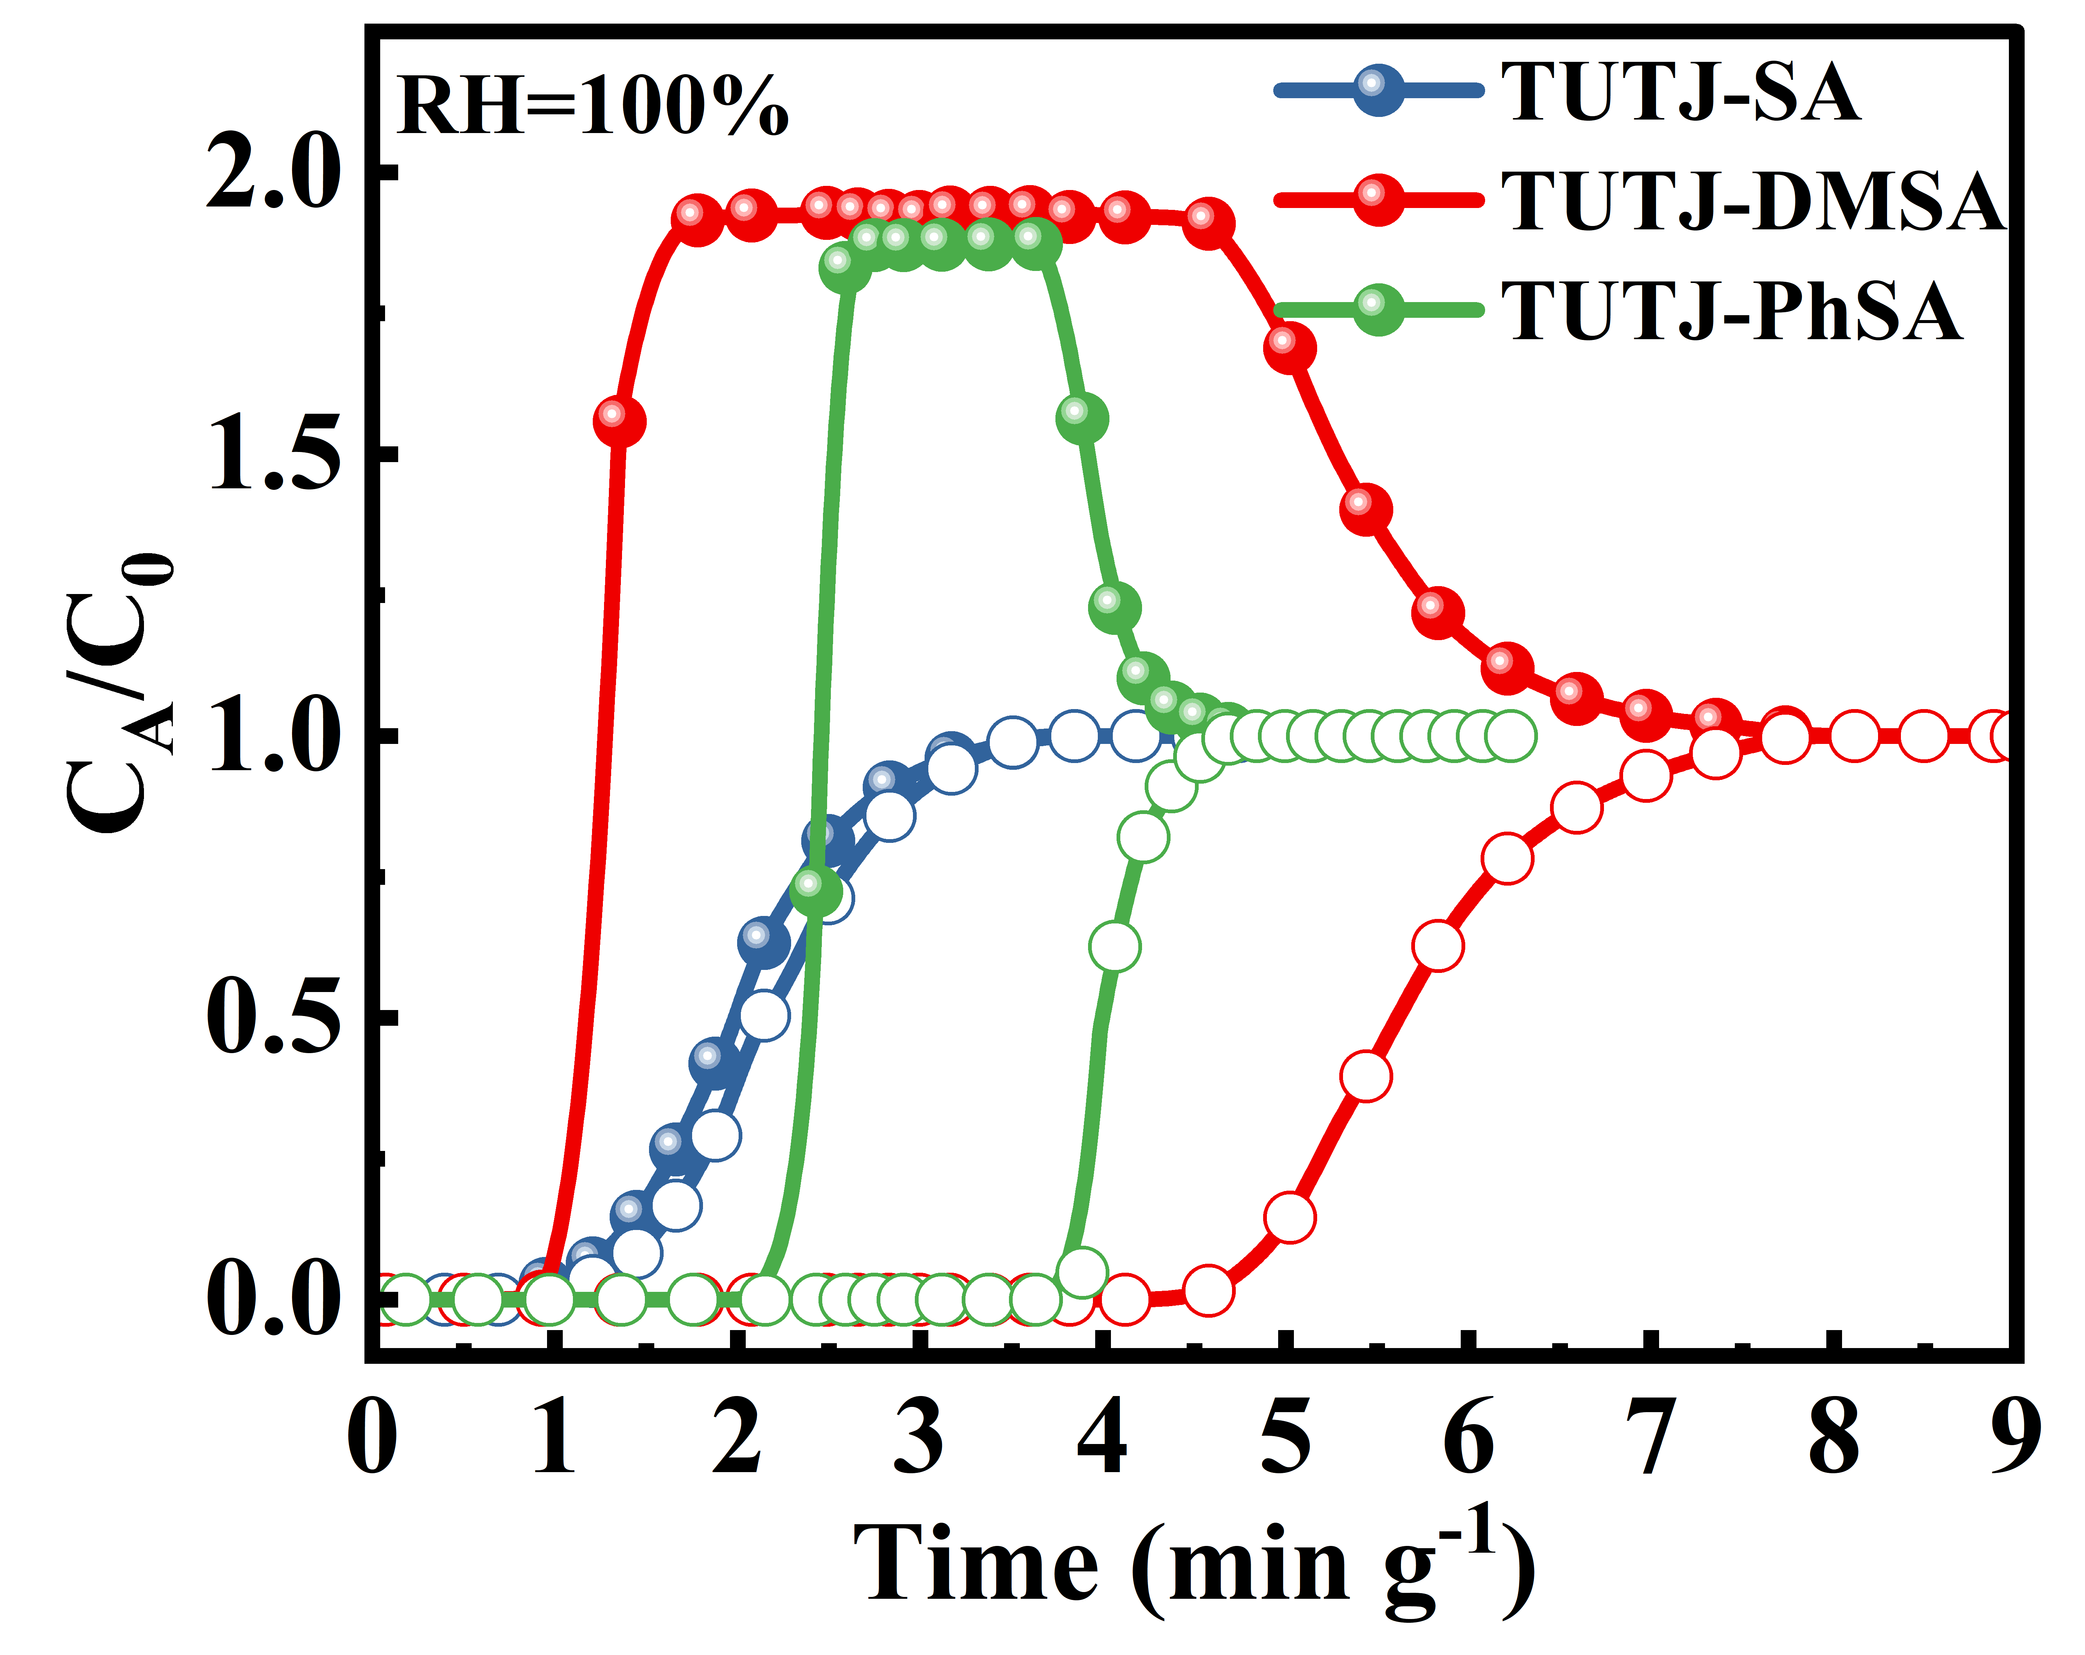
Supplementary Figure 47. Breakthrough curves of TUTJ-SA (blue), TUTJ-DMSA (red), and TUTJ-PhSA (green) at 100% RH and 298 K.
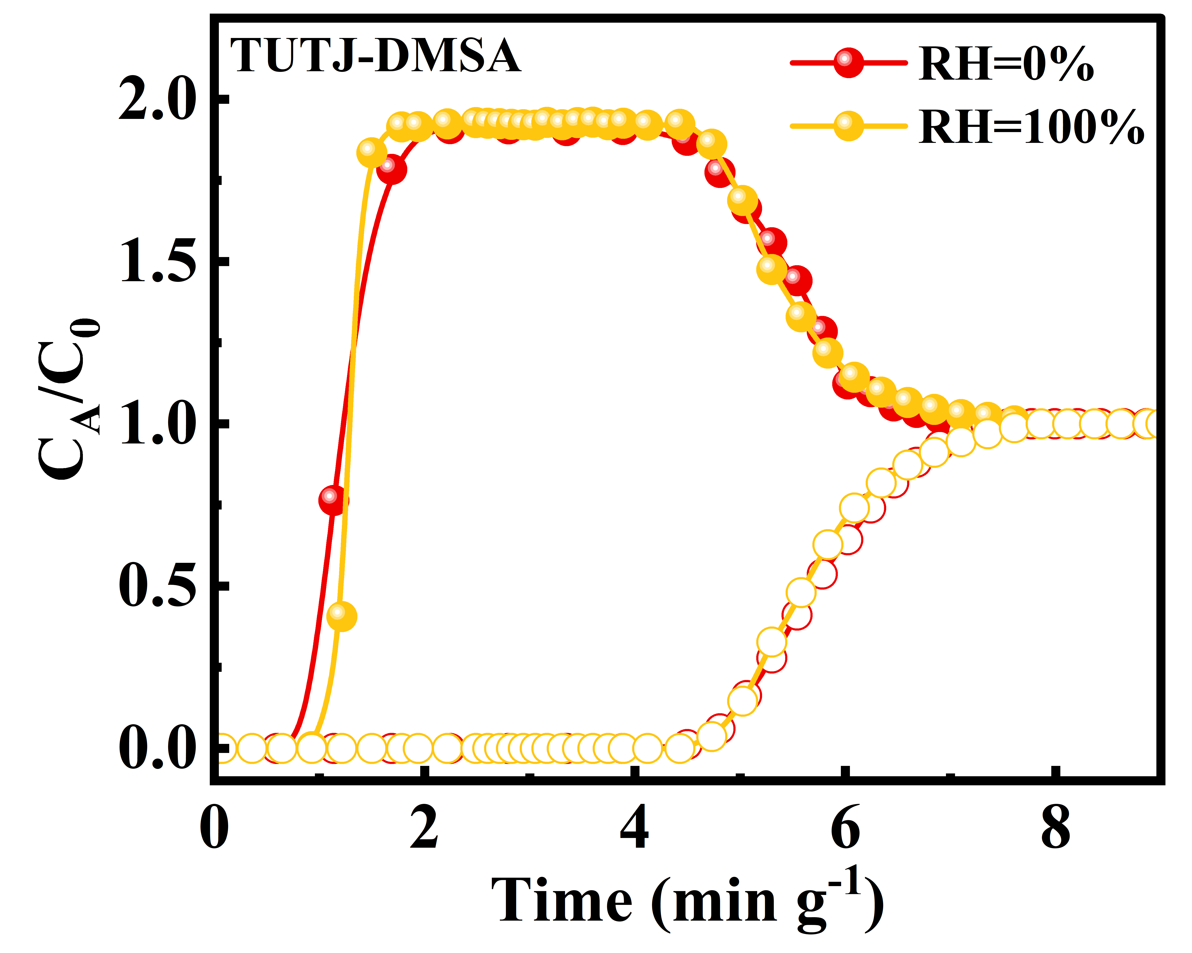
Supplementary Figure 48. Breakthrough curves of TUTJ-DMSA at 0% (red) and 100% (yellow) RH at 298 K.
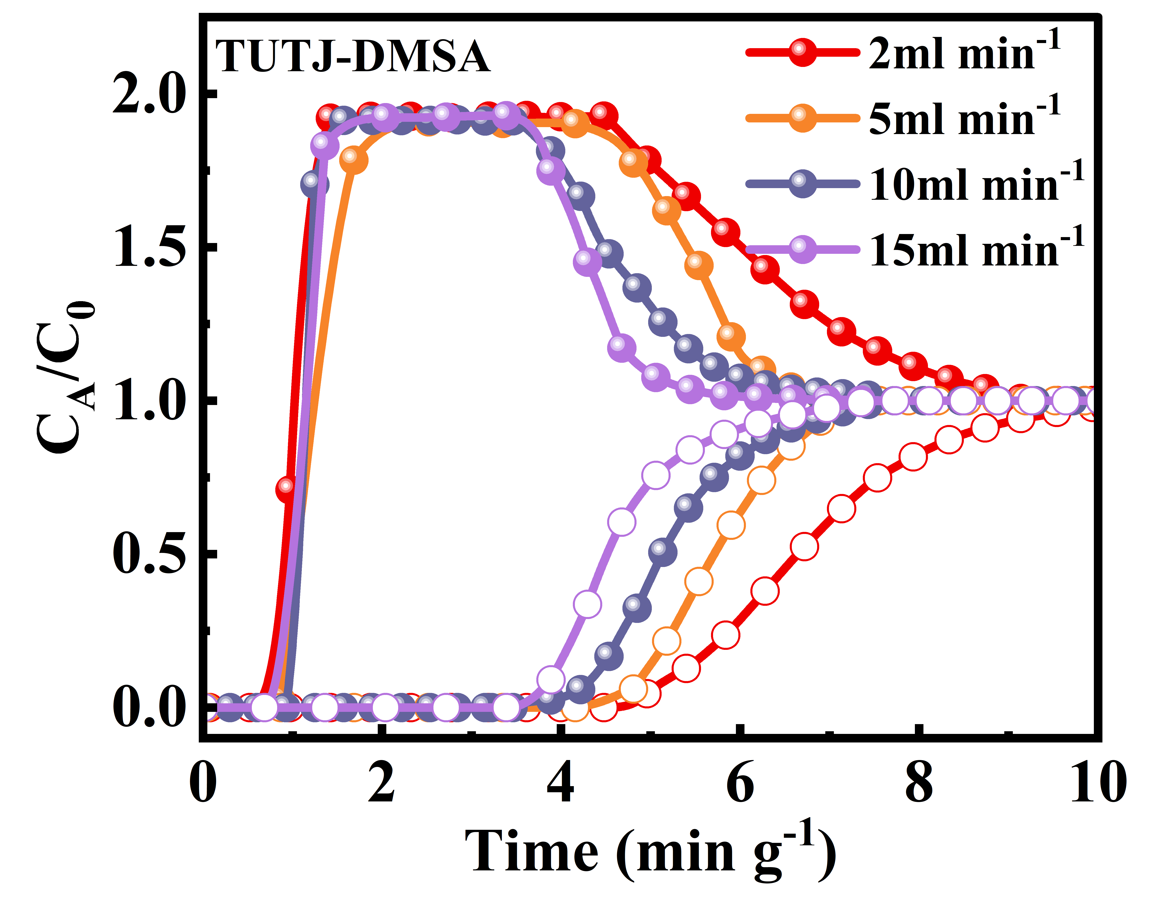
Supplementary Figure 49. Breakthrough curves of TUTJ-DMSA at 298 K under different flow rates.
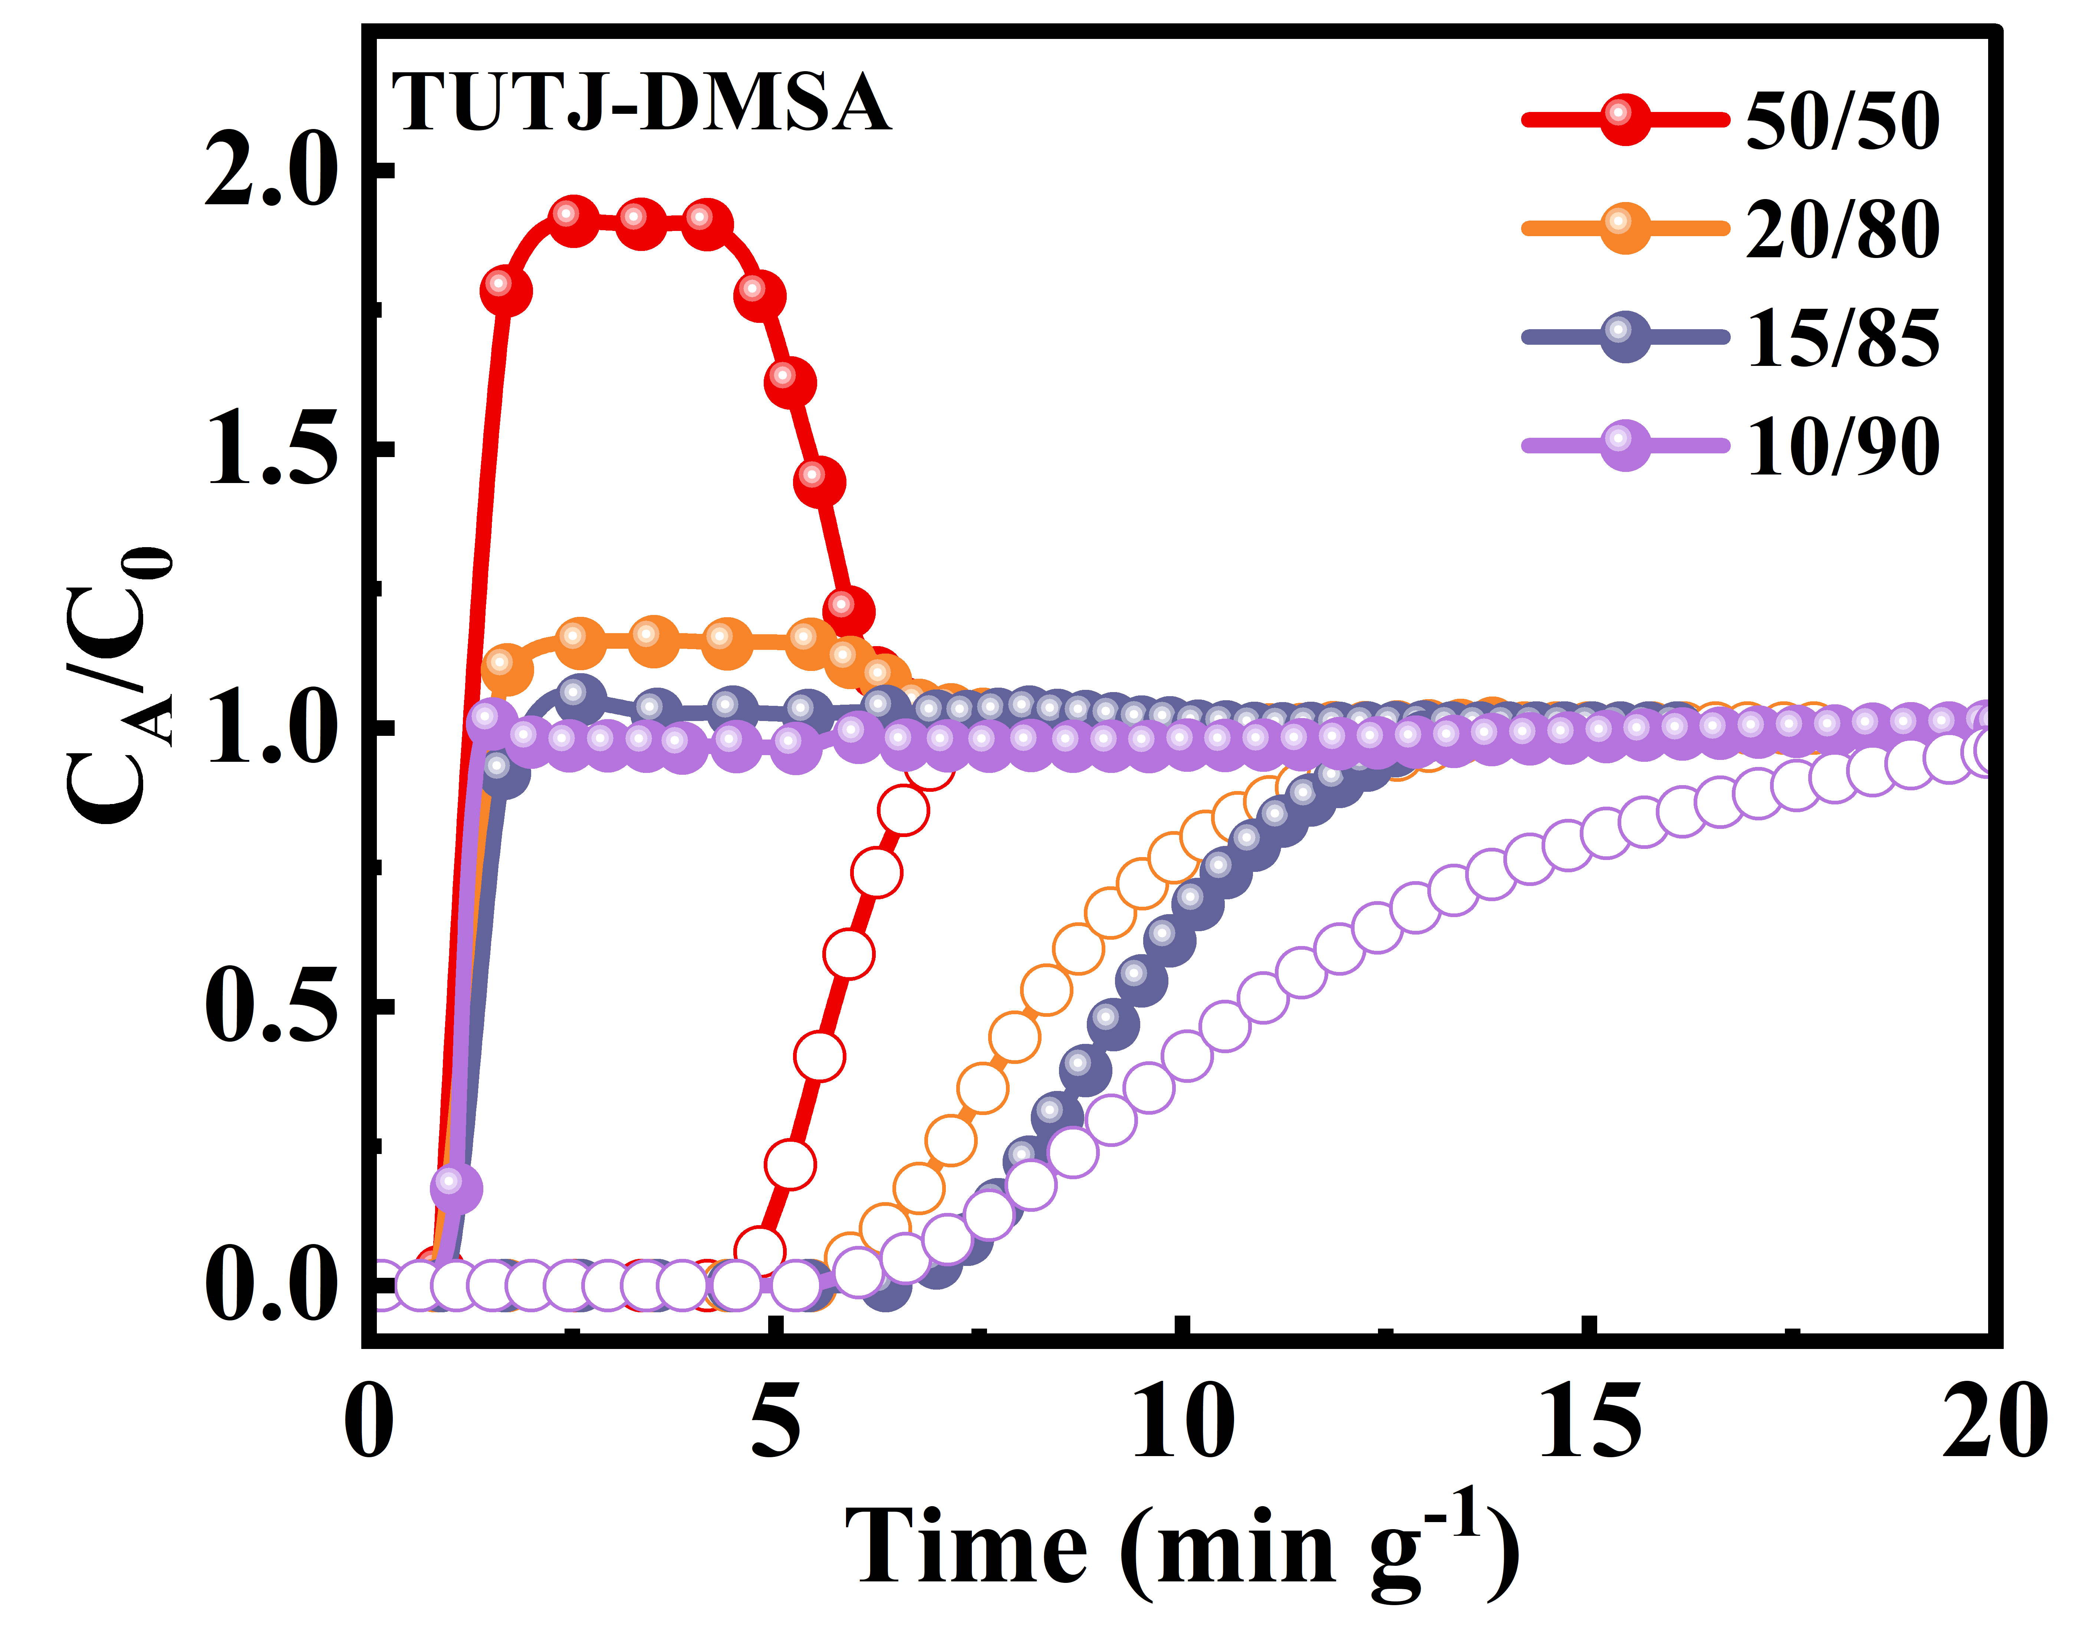
Supplementary Figure 50. Breakthrough curves of TUTJ-DMSA at 298 K with different CH₄/N₂ feed ratio.
Supplementary Table 1 Crystallographic Data for Coordination Containers TUTJ-SA, TUTJ-DMSA and TUTJ-PhSA.
Parameter | TUTJ-SA | TUTJ-DMSA | TUTJ-PhSA
empirical formula | C₉₈H₁₁₀Co₈O₄₂S₈ | C₁₀₇H₁₃₆Co₈O₄₅S₈ | C₁₂₈H₁₅₂Co₈N₄O₄₂S₈
formula weight | 2687.78 | 2870.08 | 3146.46
temperature (K) | 193 | 217 | 193
wavelength (Å) | 1.54178 | 1.54178 | 1.54178
crystal system | Triclinic | Orthorhombic | Tetragonal
space group | P-1 | Cmca | I4/mmm
a (Å) | 12.5702(3) | 23.2078(19) | 16.2763(3)
b (Å) | 13.3715(3) | 23.5946(19) | 16.2763(3)
c (Å) | 21.2980(4) | 29.377(3) | 31.0684(11)
α (°) | 84.105(1) | 90 | 90
β (°) | 84.441(1) | 90 | 90
γ (°) | 65.775(1) | 90 | 90
V (Å³) | 3241.41(13) | 16086(2) | 8230.6(4)
Z | 1 | 4 | 2
D(calcd) (g cm⁻³) | 1.377 | 1.185 | 1.270
μ (Mo Kα) (mm⁻¹) | 9.644 | 7.817 | 7.679
F (000) | 1378.0 | 5928.0 | 3256.0
θ_{max} (°) | 68.390 | 68.557 | 68.362
h,k,l_{max} | 15,16,25 | 28,28,35 | 19,19,37
Nref | 11895 | 7614 | 3871
Npar | 787 | 502 | 323
S | 1.067 | 1.165 | 1.141
R(reflections) | 0.0478(8821) | 0.1131(3855) | 0.1096(1983)
wR₂(reflections) | 0.1387(11829) | 0.3338(7448) | 0.3445(3836)

Supplementary Table 2 The atomic charges are derived from Mulliken population analysis of the fully optimized ligand geometries, reflecting the electronic charge distribution characteristics of each ligand.
TUTJ-SA Ligand |  | TUTJ-DMSA Ligand |  | TUTJ-PhSA Ligand
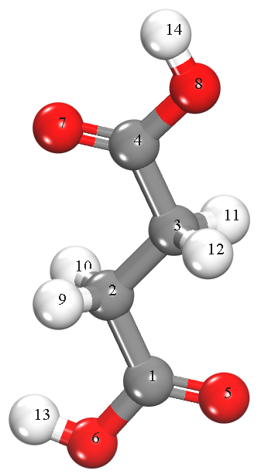 |  | 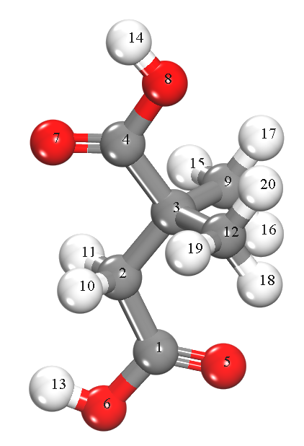 |  | 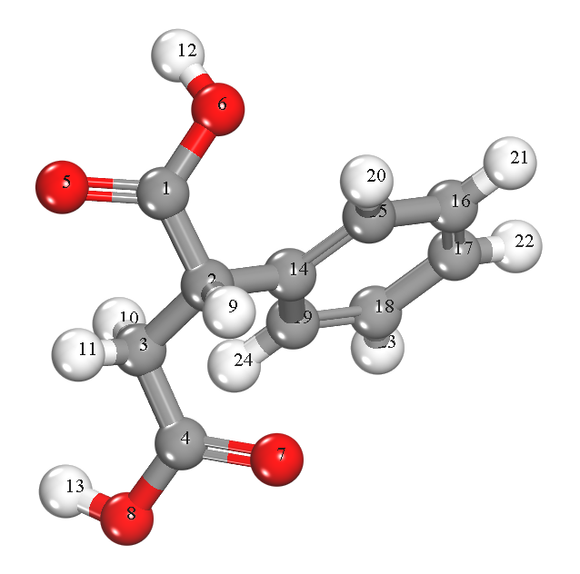
atom | charge | atom | charge | atom | charge
C (1) | 0.515 | C (1) | 0.519 | C (1) | 0.516
C (2) | -0.276 | C (2) | -0.24 | C (2) | -0.18
C (3) | -0.233 | C (3) | -0.231 | C (3) | -0.249
C (4) | 0.497 | C (4) | 0.543 | C (4) | 0.488
O (5) | -0.378 | O (5) | -0.388 | O (5) | -0.494
O (6) | -0.413 | O (6) | -0.409 | O (6) | -0.457
O (7) | -0.412 | O (7) | -0.418 | O (7) | -0.43
O (8) | -0.401 | O (8) | -0.403 | O (8) | -0.463
H (9) | 0.135 | C (9) | -0.208 | H (9) | 0.181
H (10) | 0.135 | H (10) | 0.133 | H (10) | 0.146
H (11) | 0.141 | H (11) | 0.136 | H (11) | 0.181
H (12) | 0.141 | C (12) | -0.209 | H (12) | 0.349
H (13) | 0.269 | H (13) | 0.268 | H (13) | 0.324
H (14) | 0.281 | H (14) | 0.284 | C (14) | 0.025
 |  | H (15) | 0.08 | C (15) | -0.077
 |  | H (16) | 0.123 | C (16) | -0.091
 |  | H (17) | 0.11 | C (17) | -0.098
 |  | H (18) | 0.123 | C (18) | -0.101
 |  | H (19) | 0.078 | C (19) | -0.074
 |  | H (20) | 0.109 | H (20) | 0.11
 |  |  |  | H (21) | 0.109
 |  |  |  | H (22) | 0.098
 |  |  |  | H (23) | 0.098
 |  |  |  | H (24) | 0.09

Supplementary Table 3 Computational packing configuration analysis of TUTJ-series MOFs.
 | Vertical | Synclinal | Staggered | Extended Synclinal | Perpendicular Cross
TUTJ-SA | 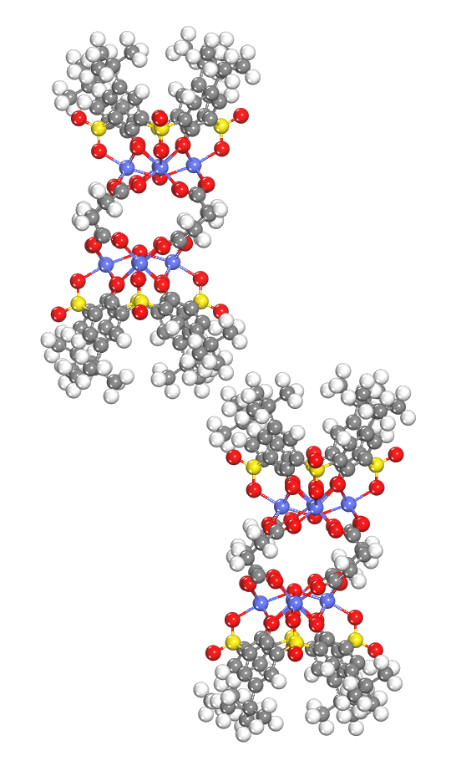 | 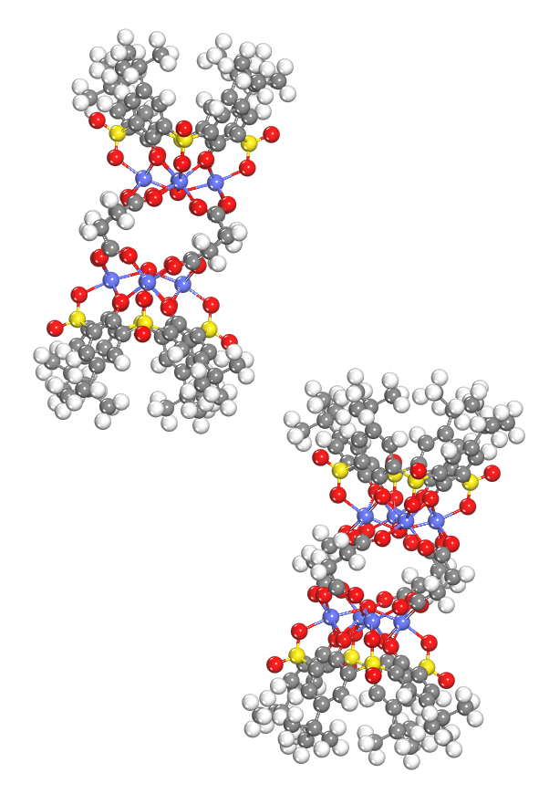 | 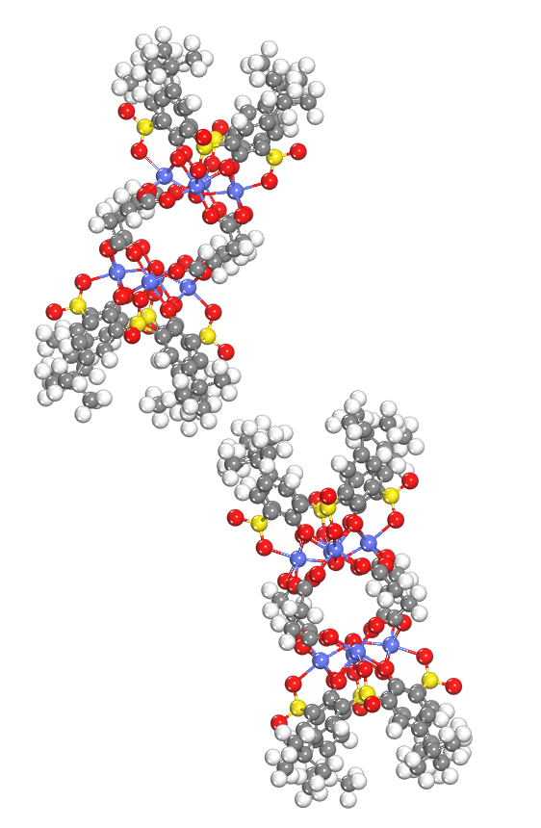 | 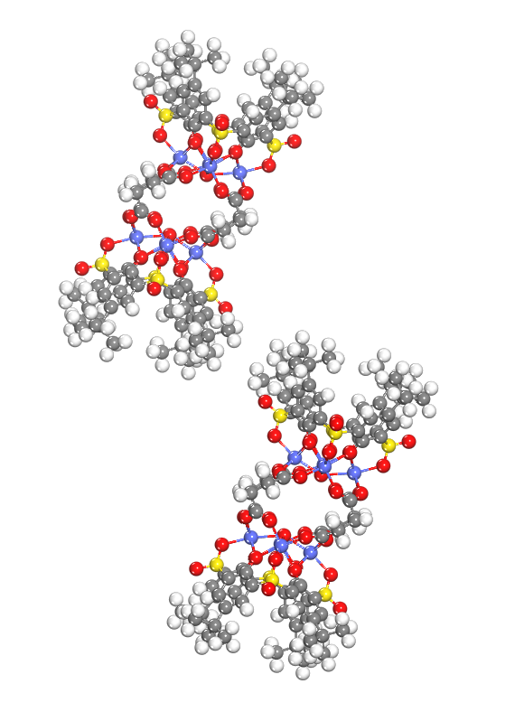 | 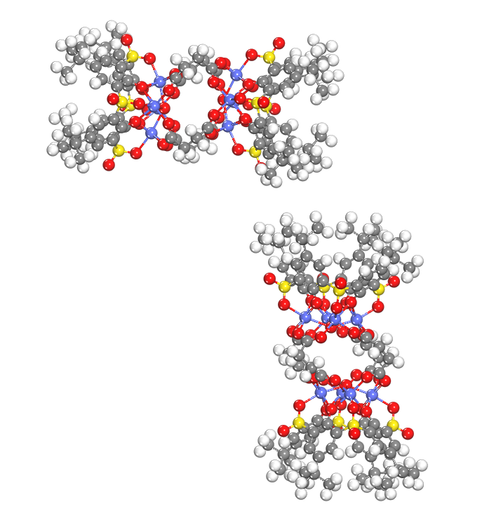
TUTJ-DMSA | 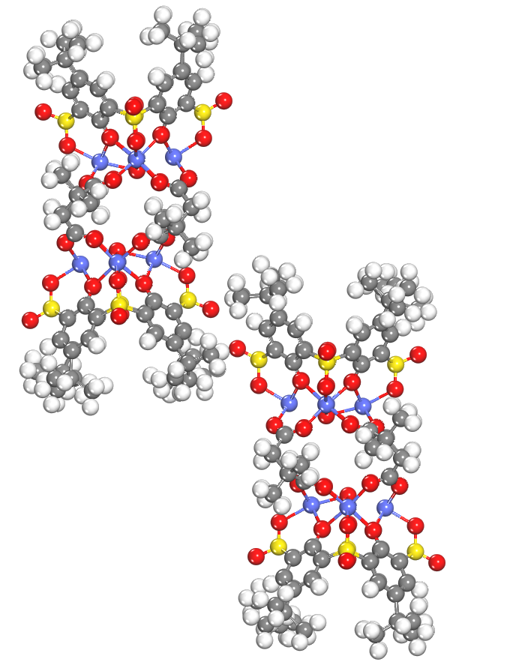 | 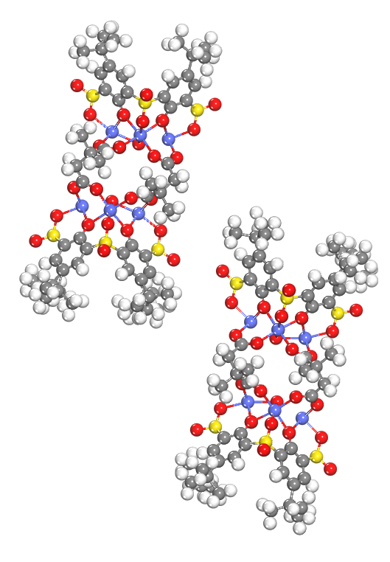 | 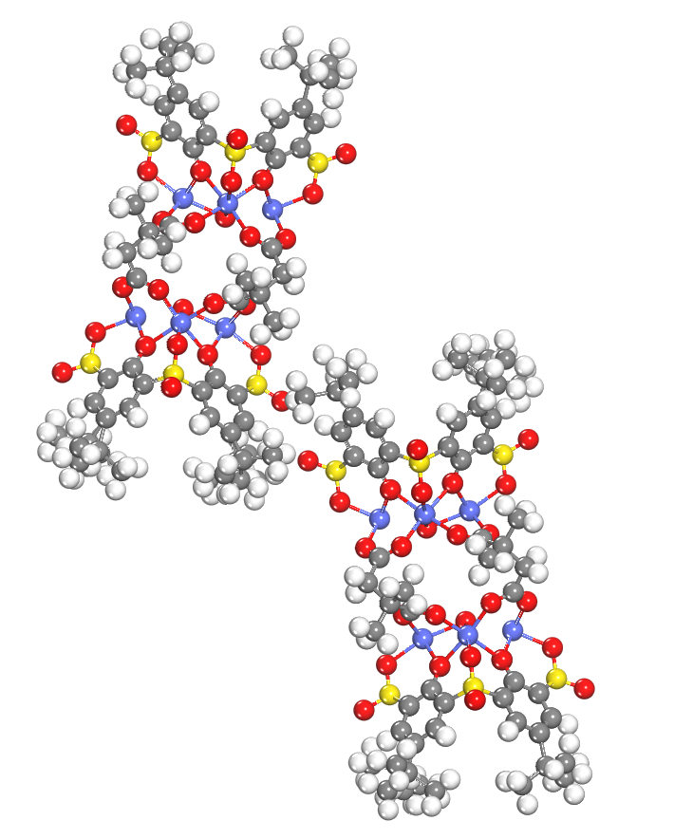 | 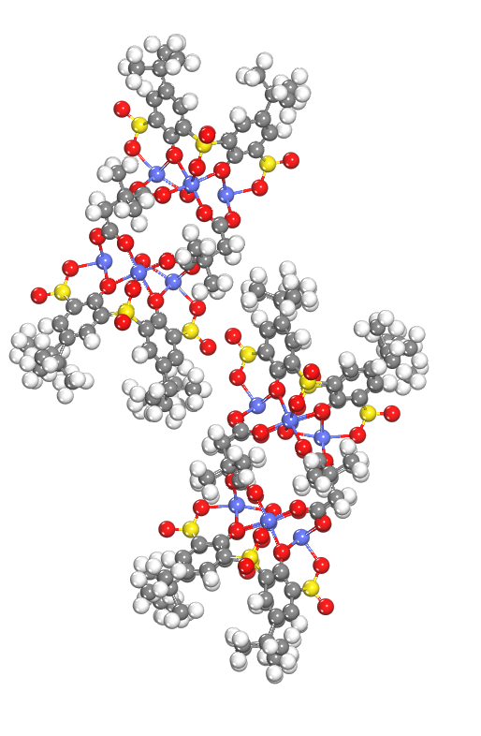 | 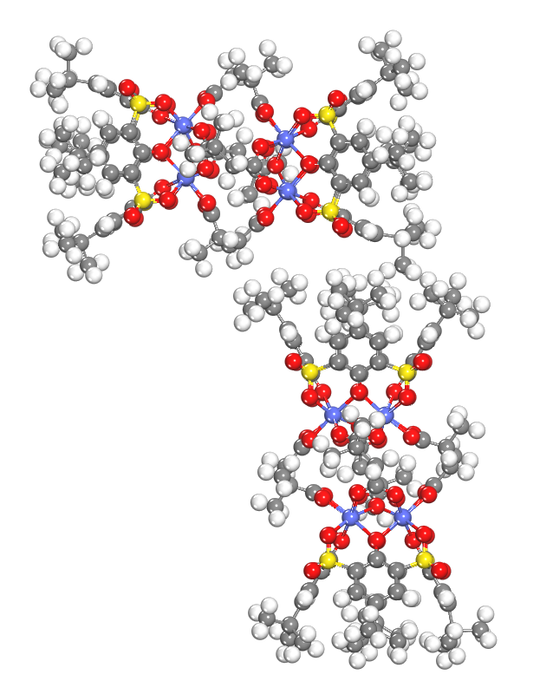
TUTJ-PhSA | 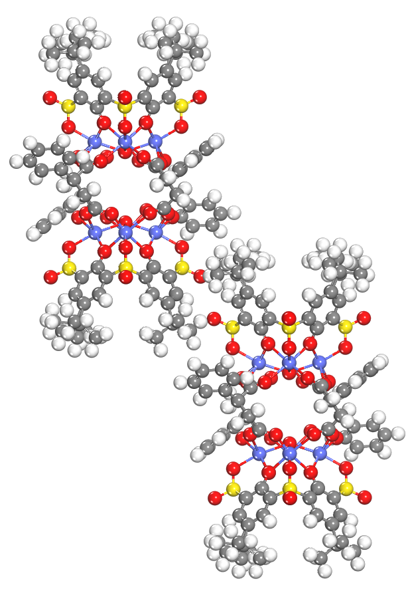 | 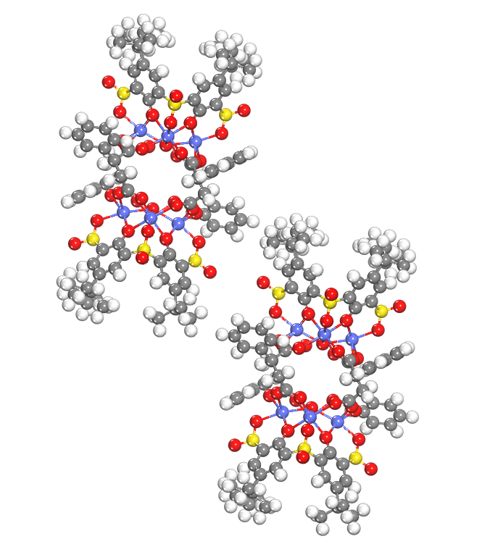 | 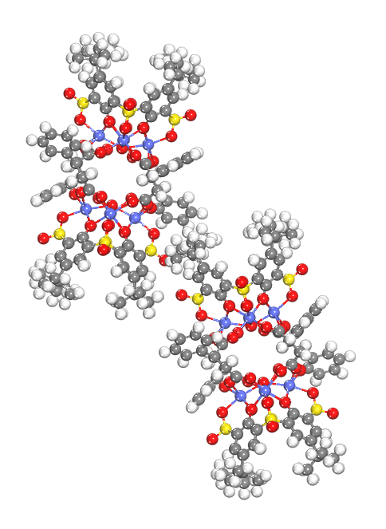 | 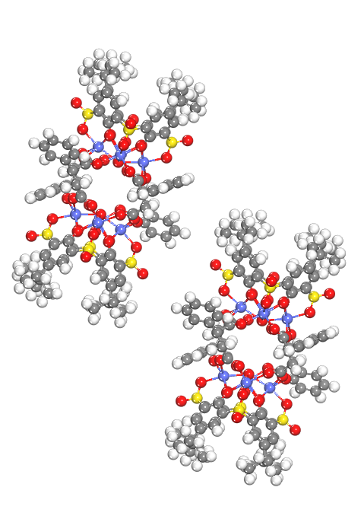 | 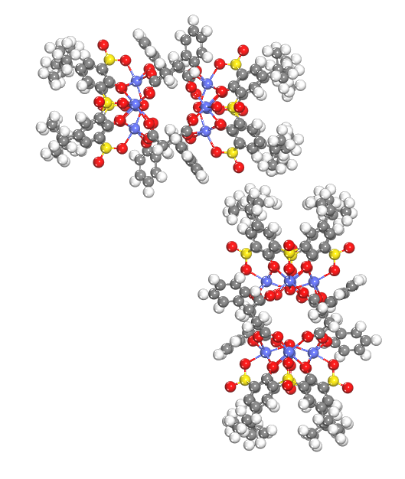

Supplementary Table 4 DFT-calculated total energies and relative energies of various conformational models for TUTJ-SA, TUTJ-DMSA, and TUTJ-PhSA. The most stable conformation (lowest total energy) for each framework is highlighted in red.
Name | Models | Energy (eV) | ΔE (eV) | ΔE (kJ mol⁻¹)
TUTJ-SA | Vertical | -92865.70 | 0.48 | 46.76
TUTJ-SA | Synclinal | -92865.87 | 0.31 | 30.00
TUTJ-SA | Staggered | -92865.86 | 0.32 | 30.86
TUTJ-SA | Extended Synclinal | -92866.18 | 0.00 | 0.00
TUTJ-SA | Perpendicular Cross | -92865.96 | 0.23 | 21.91
TUTJ-DMSA | Vertical | -95874.71 | 0.23 | 21.83
TUTJ-DMSA | Synclinal | -95874.28 | 0.66 | 63.40
TUTJ-DMSA | Staggered | -95874.94 | 0.00 | 0.00
TUTJ-DMSA | Extended Synclinal | -95869.24 | 5.70 | 549.99
TUTJ-DMSA | Perpendicular Cross | -95871.50 | 3.44 | 331.96
TUTJ-PhSA | Vertical | -87386.40 | 0.00 | 0.00
TUTJ-PhSA | Synclinal | -87385.69 | 0.71 | 68.57
TUTJ-PhSA | Staggered | -87385.38 | 1.02 | 98.57
TUTJ-PhSA | Extended Synclinal | -87385.80 | 0.60 | 57.88
TUTJ-PhSA | Perpendicular Cross | -87385.53 | 0.87 | 84.03

Supplementary Table 5 BET surface areas and 77 K N₂ uptakes of TUTJ-series MOFs and reference porous materials.
Material | BET surface area  (m² g⁻¹) | 77 K N₂ uptake  (cm³ g⁻¹) | Ref.
TUTJ-SA | 35 | 48 | This work
TUTJ-DMSA | 592 | 207 | This work
TUTJ-PhSA | 28 | 32 | This work
Cu12a-π | 32 | ~70 | ¹
Co-NDC | 120 | 98 | ²
Co-NDC-Br | 300 | 152 | ²
2-Co | 247 | ~88 | ³
Co-CAM | 317 | ~127 | ⁴

Supplementary Table 6 Comparison of the adsorptive separation performance between TUTJ-series MOFs and other reported hydrophobic adsorbents.
Adsorbent | CH₄/N₂ selectivity | Uptake  (cm³ g⁻¹) |  | Ref.
Adsorbent | CH₄/N₂ selectivity | CH₄ | N₂ | Ref.
TUTJ-DMSA | 9.2 | 16.5 | 4.9 | This work
TUTJ-SA | 1.8 | 11.2 | 3.3 | This work
TUTJ-PhSA | 8.6 | 2.1 | 0.9 | This work
TUTQ-1Ni | 11.0 | 19.2 | 4.4 | ⁵
NKMOF-8-Me | 9.0 | 39.5 | 7.0 | ⁶
Al-FUM-Me | 8.6 | 27.2 | 5.6 | ⁷
DMOF-A2 | 7.2 | 37.0 | 8.8 | ⁸
TUT-100 | 6.3 | 27.5 | 5.0 | ⁹
MIL-120Al | 6.0 | 33.7 | 10.5 | ¹⁰
CALF-20 | 3.6 | 24.8 | 8.9 | ¹¹
Zn-DMOF-TM | 4.6 | 30.2 | 7.6 | ¹²
Co-DMOF-TM | 4.9 | 30.9 | 8.2 | ¹²
Ni-DMOF-TM | 6.7 | 34.9 | 8.3 | ¹²
N.R. represents not reported.

Supplementary Table 7 The fitting parameters of the DSL model for CH₄ and N₂ adsorption on TUTJ-2Ni and TUTJ-3Ni.
Materials | Temperature  (K) | Gas | q₁  (cm³ g⁻¹) | b₁  (bar⁻¹) | n₁ | q₂  (cm³ g⁻¹) | b₂  (bar⁻¹) | n₂ | R²
TUTJ-SA | 273 | CH₄ | 5.45 | 0.85 | 0.66 | 0.25 | 63.81 | 0.75 | 0.9997
TUTJ-SA | 273 | N₂ | 0.82 | 9.89 | 0.28 | 0.28 | 26.78 | 0.64 | 0.9996
TUTJ-SA | 298 | CH₄ | 5.81 | 0.52 | 0.88 | 0.09 | 18888.01 | 0.05 | 0.9998
TUTJ-SA | 298 | N₂ | 0.56 | 28.73 | 0.20 | 0.50 | 7.88 | 1.25 | 0.9996
TUTJ-SA | 313 | CH₄ | 0.44 | 5.86 | 0.70 | 0.75 | 8.24 | 0.28 | 0.9996
TUTJ-SA | 313 | N₂ | 0.11 | 195.39 | 0.39 | 0.21 | 4682.66 | 0.10 | 0.9021
TUTJ-DMSA | 273 | CH₄ | 6.97 | 1.46 | 0.52 | 19.45 | 6.99 | 0.99 | 0.9999
TUTJ-DMSA | 273 | N₂ | 4.54 | 2.11 | 0.42 | 7.07 | 2.06 | 1.04 | 0.9999
TUTJ-DMSA | 298 | CH₄ | 17.18 | 2.86 | 0.97 | 6.62 | 1.35 | 0.52 | 0.9999
TUTJ-DMSA | 298 | N₂ | 8.00 | 1.05 | 0.59 | 0.96 | 8.60 | 0.92 | 0.9999
TUTJ-DMSA | 313 | CH₄ | 0.05 | 702663.3 | 0.06 | 27.25 | 0.88 | 1.01 | 0.9999
TUTJ-DMSA | 313 | N₂ | 0.36 | 74.37 | 0.15 | 8.36 | 0.48 | 0.95 | 0.9999
TUTJ-PhSA | 273 | CH₄ | 5.53 | 30.49 | 0.75 | 13.42 | 1.55 | 1.00 | 0.9999
TUTJ-PhSA | 273 | N₂ | 4.15 | 1.46 | 0.40 | 3.55 | 3.56 | 0.86 | 0.9999
TUTJ-PhSA | 298 | CH₄ | 14.68 | 2.42 | 0.94 | 1.07 | 3.88 | 0.24 | 0.9999
TUTJ-PhSA | 298 | N₂ | 0.09 | 159137.02 | 0.09 | 15.11 | 0.27 | 0.98 | 0.9999
TUTJ-PhSA | 313 | CH₄ | 0.07 | 1359648 | 0.16 | 18.87 | 0.90 | 0.98 | 0.9999
TUTJ-PhSA | 313 | N₂ | 0.17 | 309.88 | 0.10 | 4.92 | 0.57 | 0.88 | 0.9995

References
1 Zhang, C. et al. Dynamic and transformable Cu₁₂ cluster-based C-H···π-stacked porous supramolecular frameworks. Nat. Commun. 14, 6413 (2023).
2 Liu, J.-Y. et al. Iodine Adsorption via Porous Molecular Solids Based on Coordination Containers Derived from Naphthalene-1,8-dicarboxylate. Cryst. Growth Des. 22, 3182-3189 (2022).
3 Sun, C.-Z., Sheng, T.-P., Dai, F.-R. & Chen, Z.-N. Sulfonylcalixaren-Based ortho-Dicarboxylate-Bridged Coordination Containers for Guest Encapsulation and Separation. Cryst. Growth Des. 19, 1144-1148 (2019).
4 Su, K. et al. Bridging different Co₄–calix[4]arene building blocks into grids, cages and 2D polymers with chiral camphoric acid. CrystEngComm 17, 1750-1753 (2015).
5 Zhao, Z. et al. Hydrophobic metal-organic framework Featuring multiple O/S active sites for efficient CH₄/N₂ separation under humid conditions. Sep. Purif. Technol. 361, 131382 (2025).
6 Chang, M. et al. Separation of CH₄/N₂ by an ultra-stable metal–organic framework with the highest breakthrough selectivity. AIChE J. 68, e17794 (2022).
7 Chang, M. et al. Enhancing CH₄ Capture from Coalbed Methane through Tuning van der Waals Affinity within Isoreticular Al-Based Metal–Organic Frameworks. ACS Appl. Mater. Interfaces 14, 25374-25384 (2022).
8 Li, T. et al. Tuning the Pore Environment of MOFs toward Efficient CH₄/N₂ Separation under Humid Conditions. ACS Appl. Mater. Interfaces 14, 15830-15839 (2022).
9 Liu, J. et al. Superhydrophobic zeolitic imidazolate framework with suitable SOD cage for effective CH₄/N₂ adsorptive separation in humid environments. AIChE J. 68, e17589 (2022).
10 Zhang, F. et al. Thermodynamic-kinetic synergistic separation of CH₄/N₂ on a robust aluminum-based metal-organic framework. AIChE J. 69, e18079 (2023).
11 Su, J. et al. Cost-Effective Zinc-Based Metal–Organic Framework for Highly Efficient Methane Purification. Ind. Eng. Chem. Res. 63, 18544-18551 (2024).
12 Li, T. et al. Tailoring methyl-functionalized pore environment in pillar-layered MOFs for enhanced CH₄/N₂ separation under humid conditions. Chem. Eng. J. 534, 175176 (2026).

