Supplementary information
Policy-driven winter-to-spring emissions shift enhances oxidizing capacity in China
Mengwei Jia¹, Fei Jiang^{*,1,2,3}, Xin Huang⁴, Zilin Wang⁴, Nikolaos Evangeliou⁵, Nan Wang⁶, Shuzhuang Feng¹, Tianliang Zhao⁷, Lian Xue⁸, Yuning Xie⁹, Runxi Pan^{1,9}, Weimin Ju¹, & Aijun Ding^{4,8}

1 Jiangsu Provincial Key Laboratory for Advanced Remote Sensing and Geographic Information Technology, International Institute for Earth System Science, Nanjing University, Nanjing, 210023, China
2 Frontiers Science Center for Critical Earth Material Cycling, Nanjing University, Nanjing, 210023, China
3 Jiangsu Center for Collaborative Innovation in Geographical Information Resource Development and Application, Nanjing, 210023, China
4 School of Atmospheric Sciences, Nanjing University, Nanjing, 210023, China
5 Department of Atmospheric and Climate Research, NILU, Kjeller, 2007, Norway
6 College of carbon Neutrality Future Technology, Sichuan University, Chengdu, 610065, China
7 School of Atmospheric Physics, Nanjing University of Information Science and Technology, Nanjing, 210044, China
8 Nanjing-Helsinki Institute in Atmospheric and Earth System Sciences, Nanjing University, Suzhou, 215163, China
9 Guangxi Zhuang Autonomous Region Ecological and Environmental Monitoring Centre, Nanning, 530000, China

*Corresponding author. Email: jiangf@nju.edu.cn

Contents
- Supplementary Text
- Supplementary Figures
- Supplementary Tables

Supplementary Text
Evaluation of WRF-Chem simulations
The performance of the meteorological simulations was evaluated against ground-based observations from the National Centers for Environmental Information (NCEI). Among 411 stations in mainland China, all stations with continuous hourly observations in both 2014 and 2017 were selected, yielding 36 sites that cover 87% of the provinces across mainland China. The selected stations are distributed across six regions: East (Qingdao, Nanjing, Ningbo, Hefei, Shanghai Pudong, Shanghai Hongqiao, Hangzhou, Fuzhou, Xiamen); North (Shijiazhuang, Hohhot, Taiyuan, Beijing, Tianjin); Northeast (Changchun, Harbin, Shenyang, Dalian); Northwest (Kashgar, Urumqi, Lanzhou, Xi’an); South-Central (Haikou, Zhengzhou, Wuhan, Sanya, Guilin, Guangzhou, Changsha, Shantou, Shenzhen, Nanning); and Southwest (Chengdu, Kunming, Chongqing, Guiyang). Simulated temperature and wind speed were compared with observations across six regions and at the national scale (Table S1). Overall, the model reproduces the observed meteorological conditions well, with temperature correlations of 0.95 in both 2014 and 2017, RMSEs of ~2.2–2.3 °C, and small mean biases (−0.11 °C in 2014 and −0.57 °C in 2017). Wind speed simulations also show reasonable agreement with observations, with correlations of ~0.6, RMSEs of ~1.6 m s⁻¹, and near-zero mean biases in both years. Importantly, the model performance and error magnitudes are comparable between 2014 and 2017 across all regions, suggesting that meteorological simulation uncertainties are unlikely to affect the inferred interannual differences in meteorological contributions to AOC. Since temperature and wind fields strongly influence atmospheric chemistry, transport, and dispersion processes, the consistent model performance across the two years provides confidence in the robustness of the attribution analyses.

Supplementary Figures
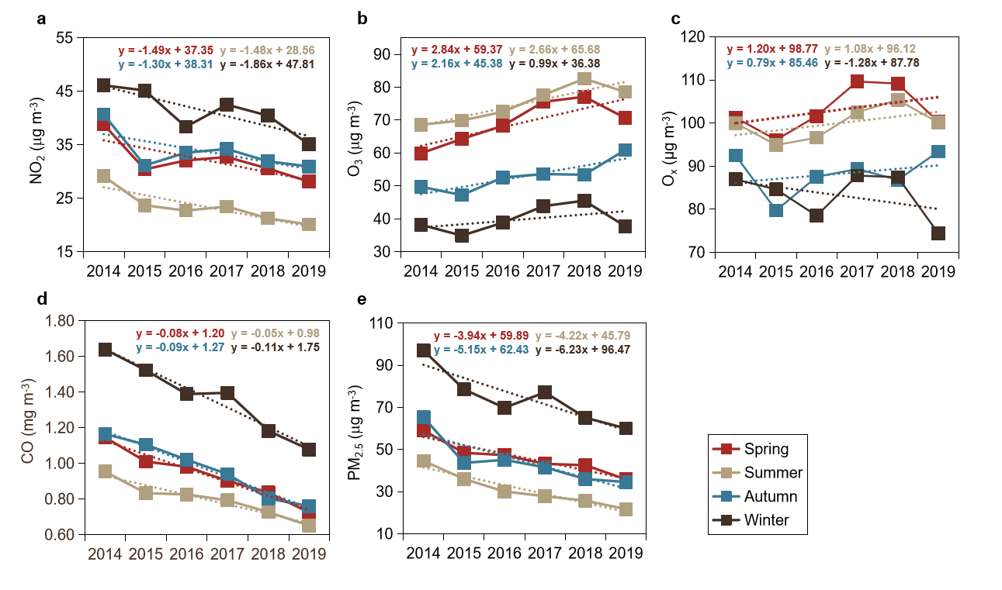

Fig. S1. Time series of national annual mean concentrations of major air pollutants and the AOC index from 2014 to 2019. (a) NO₂; (b) O₃; (c) O_{x}; (d) CO; (e) PM_{2.5}. Dashed lines are linear regression fits, and the equations represent the fitted relationships.

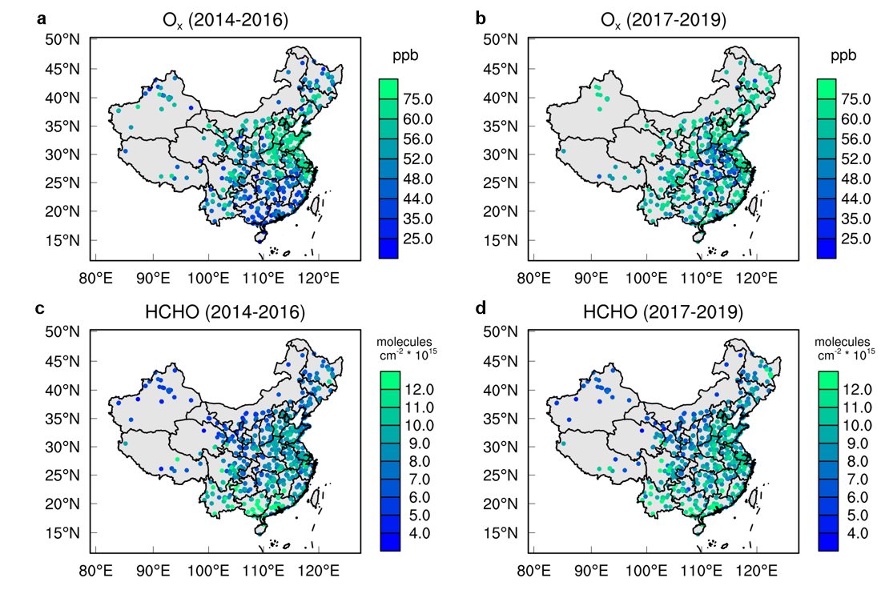

Fig. S2. Spatial distributions of ground-based O_{x} concentrations and satellite-based HCHO VCD in spring. (a) O_{x} concentrations during 2014-2016; (b) O_{x} concentrations during 2017-2019; (c) HCHO VCD during 2014-2016; (d) HCHO VCD during 2017-2019.

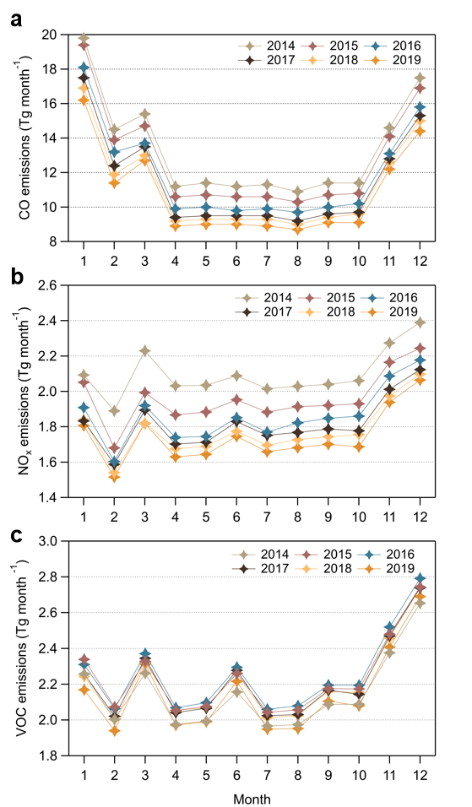

Fig. S3. Monthly emissions in the emission inventory from 2014 to 2019. (a) CO; (b) NO_{x}; (c) VOC.

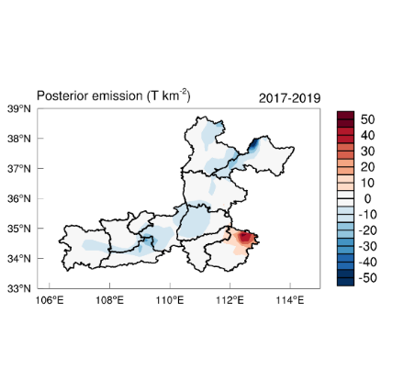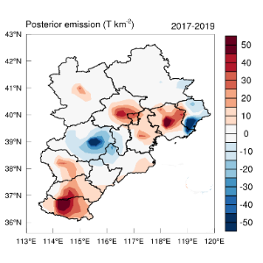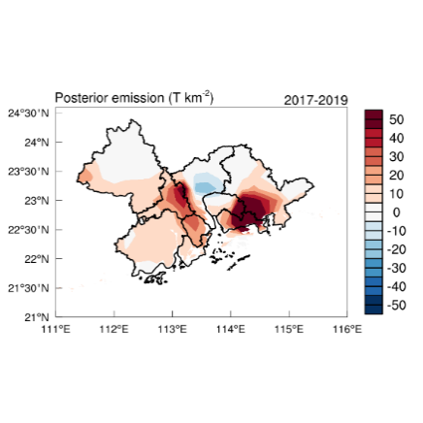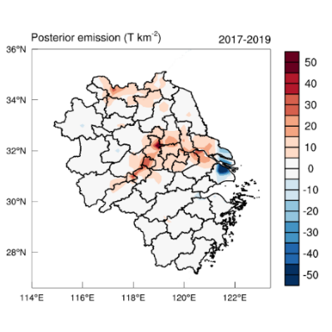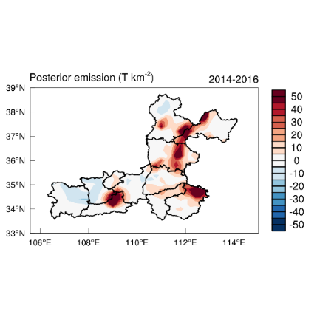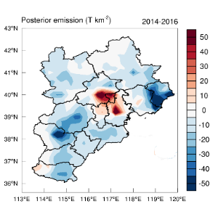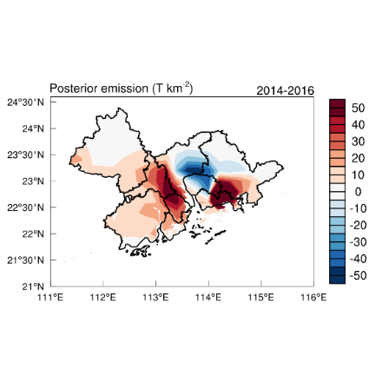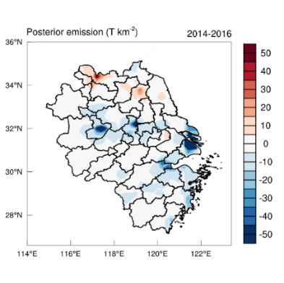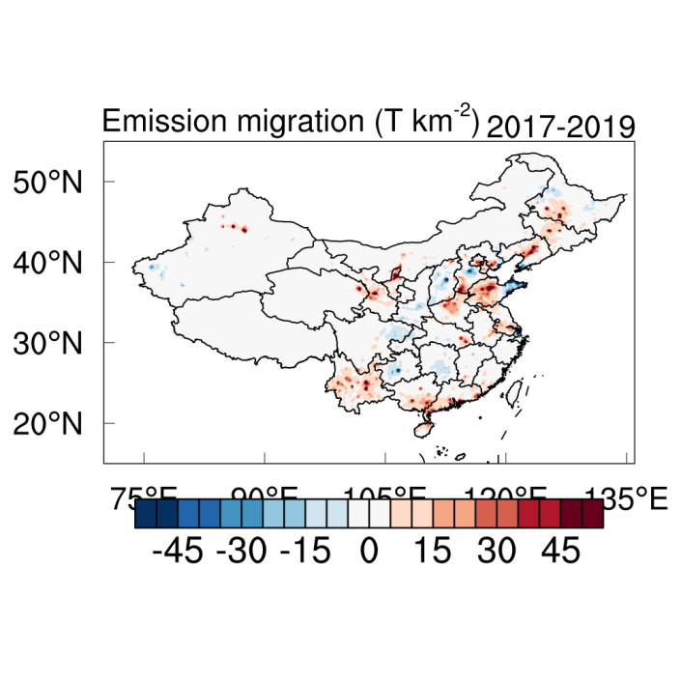
(T km⁻²)
2014 - 2016
BTH
BTH
YRD
YRD
FWP
FWP
PRD
PRD
Spring minus Winter
2017 - 2019

Fig. S4. Differences in anthropogenic CO emissions between spring and winter (spring minus winter) during 2014–2016 and 2017–2019 in key regions of China. BTH represents Beijing-Tianjin-Hebei region, YRD represents the Yangtze River Delta, FWP represents the Fenwei Plain, and PRD represents the Pearl River Delta.

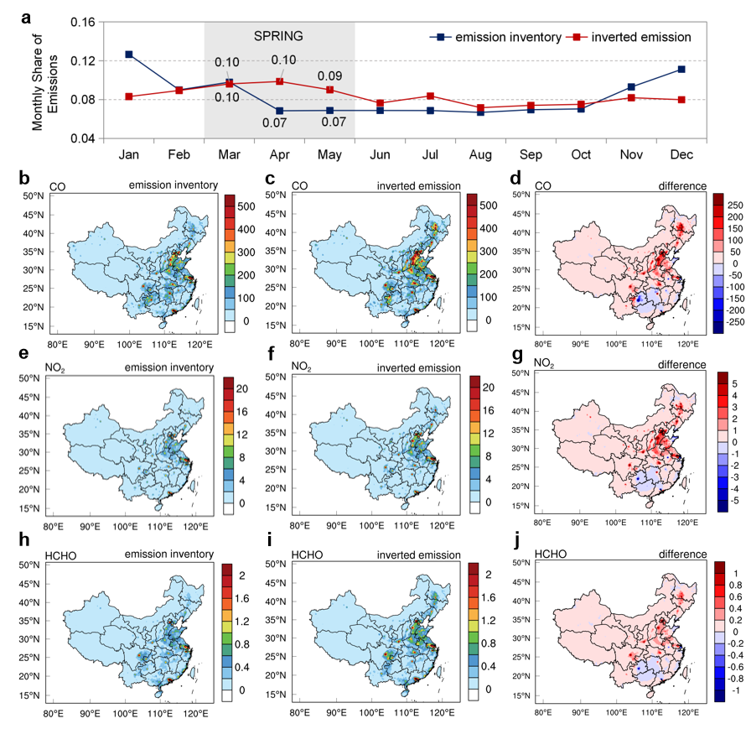

Fig. S5. Spatiotemporal differences before and after emission shift. (a) Share of monthly emissions; (b – j) Spatial distribution of CO emissions, NO₂ emissions and HCHO emissions. The unit of emissions is mol k⁻² hr⁻¹.

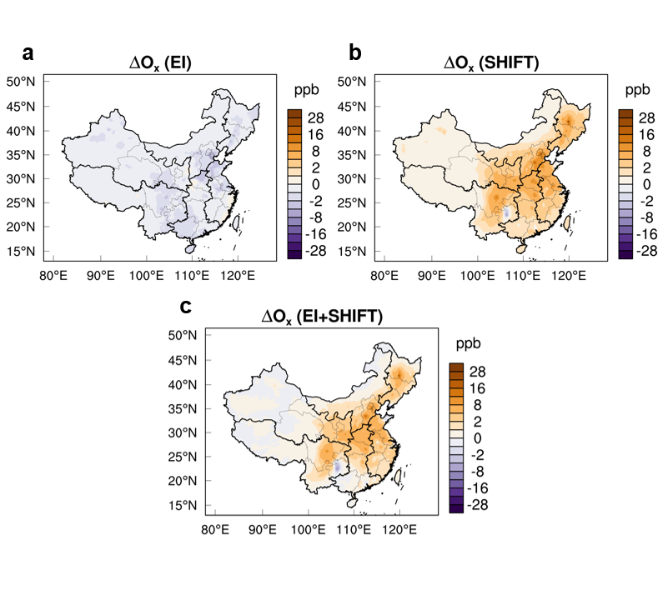
Fig. S6. Contributions of emission changes to ∆Ox from 2014 to 2017 in China. (a) Contribution of emissions without seasonal shift; (b) Contribution of emissions with seasonal shift only; (c) Contribution of emissions incorporating seasonal shift.

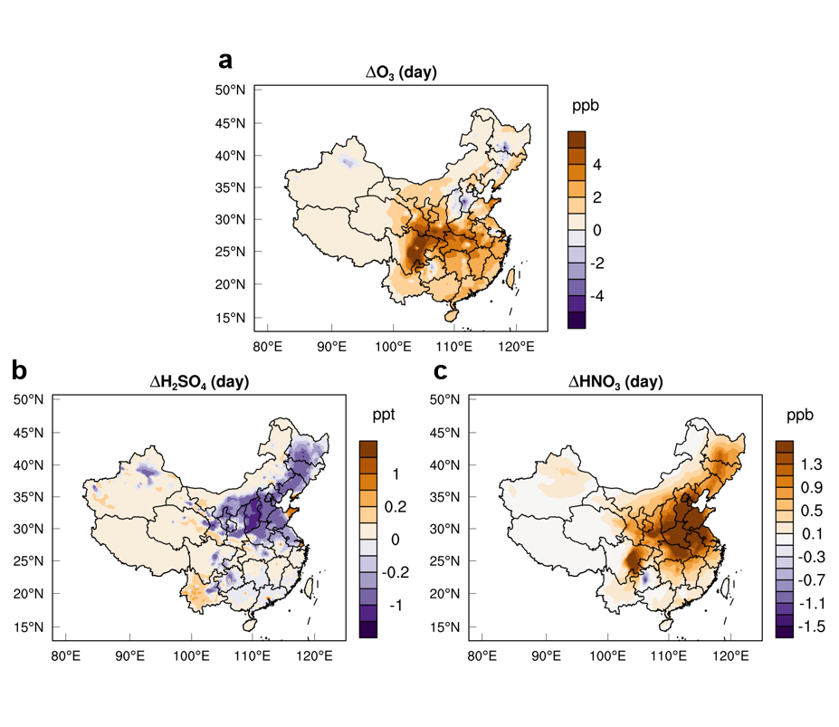

Fig. S7. Spatial distribution of emission-shift-induced changes in daytime oxidants. (a) O₃; (b) H₂SO₄; and (c) HNO₃.

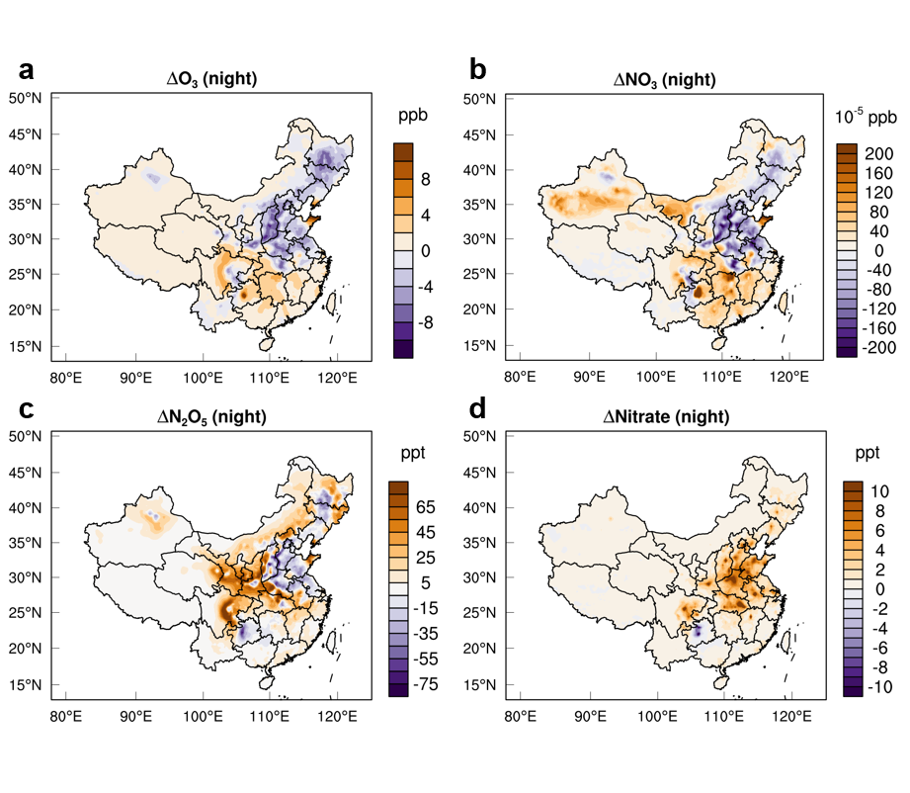

Fig. S8. Spatial distribution of emission-shift-induced changes in nighttime oxidants. (a) O₃; (b) NO₃; (c) N₂O₅; (d) Nitrate.

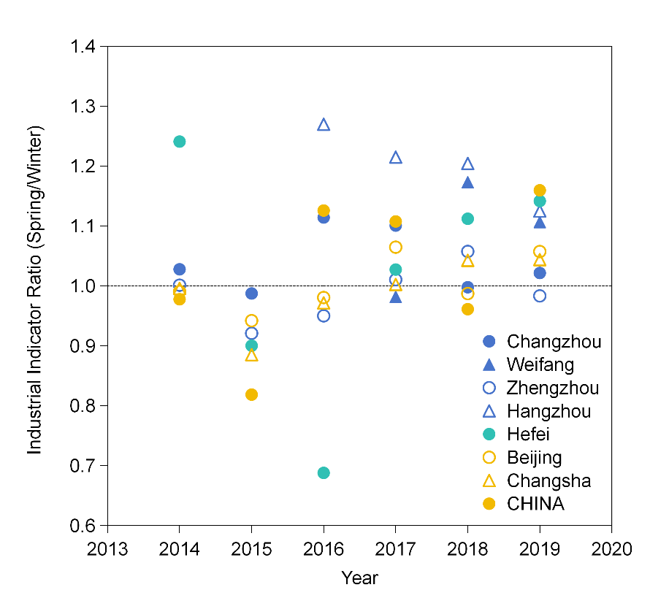

Fig. S9. Ratio of springtime to wintertime industrial activity indicators from 2014 to 2019 in China and in cities with pronounced seasonal emission shifts. The statistical indicators are industrial electricity consumption for Changzhou, Weifang, Zhengzhou and Hangzhou; total export value for Hefei; and industrial output value for enterprises above designated size, including total output value in Beijing, value added in Changsha and year-on-year growth rate of value added for China.

Supplementary Tables

Table S1. Correlation coefficient, root mean square error (RMSE) and mean bias (MB) between WRF-Chem simulated and observed temperature (°C) and wind speed (m s⁻¹) for 2014 and 2017.
2014 | T |  |  | WS
2014 | r | RMSE | MB | r | RMSE | MB
East | 0.96 | 4.88 | -0.37 | 0.73 | 1.41 | -0.13
North | 0.97 | 2.31 | -0.54 | 0.67 | 1.63 | -0.14
Northeast | 0.97 | 2.26 | -0.28 | 0.74 | 1.54 | -0.09
Northwest | 0.96 | 2.56 | 0.22 | 0.51 | 1.84 | 0.02
South-Central | 0.93 | 2.34 | 0.04 | 0.51 | 1.56 | 0.25
Southwest | 0.93 | 2.47 | 0.26 | 0.54 | 1.82 | -0.07
All | 0.95 | 2.23 | -0.11 | 0.62 | 1.60 | -0.01
2017 | T |  |  | WS
2017 | r | RMSE | MB | r | RMSE | MB
East | 0.96 | 1.74 | -0.54 | 0.70 | 1.41 | -0.15
North | 0.97 | 2.57 | -0.97 | 0.64 | 1.65 | -0.08
Northeast | 0.96 | 2.65 | -0.78 | 0.76 | 1.64 | 0.09
Northwest | 0.96 | 2.81 | -0.49 | 0.44 | 1.95 | 0.30
South-Central | 0.91 | 2.28 | -0.48 | 0.52 | 1.56 | 0.11
Southwest | 0.93 | 2.40 | -0.30 | 0.57 | 1.76 | -0.08
All | 0.95 | 2.30 | -0.57 | 0.61 | 1.61 | 0.01

Table S2. Summary of sensitivity experiments and attribution framework.
Case ID | Meteorological data | Emission inventory
Case 1 | FNL 2017 | MEIC 2017
Case 2 | FNL 2017 | MEIC 2017 shifted by inverted emissions
Case 3 | FNL 2017 | MEIC 2014
Case 4 | FNL 2014 | MEIC 2017
Attribution |  | Experiment
Case 1 – Case 3 |  | EI
Case 2 – Case 1 |  | SHIFT
Case 1 - Case 4 |  | METEO

Table S3. Emission species modified by the monthly share of inverted CO emissions.
Abbreviation |  | Species
CO |  | Carbon Monoxide
NO_{x} |  | Nitrogen Oxides
NMVOC | MEOH | Methanol
NMVOC | PAR | Paraffin / Alkanes
NMVOC | OLE | Olefins / Alkenes
NMVOC | IOLE | Internal Olefins
NMVOC | ISOP | Isoprene
NMVOC | TOL | Toluene
NMVOC | XYL | Xylene
NMVOC | FORM | Formaldehyde
NMVOC | ALD2 | Acetaldehyde
NMVOC | ALDX | Higher Aldehydes
NMVOC | ETH | Ethylene
NMVOC | ETHA | Ethane
NMVOC | ETOH | Ethanol
NMVOC | TERP | Terpenes

Beijing
Zhengzhou
Guangzhou

