Supporting Information
Built-in electric field-boosted attomolar Pb²⁺ sensing on carboxylated black phosphorene
Fan Yang^{1, 2, 8}, Xixi Yuan^{3, 8}, Jiaqi Zhu^{1, 2}, Yuanyuan Pan⁴, Zhongjun Li⁵, Jianqing Li⁴, Yanqi Ge⁶, Leiming Wu^{1, 2,} *, Yuanjiang Xiang^{7,} *, Han Zhang^{6,} *, Jun Yang ^{1, 2,} *, Yuwen Qin ^{1, 2}

¹Institute of Advanced Photonics Technology, School of Information Engineering, Guangdong University of Technology, Guangzhou, China
²Key Laboratory of Photonic Technology for Integrated Sensing and Communication（Guangdong University of Technology）, Ministry of Education of China, Guangzhou, China
³School of Computer Science and Technology, Guangdong University of Technology, Guangzhou, China
⁴School of Computer Science and Engineering, Macau University of Science and Technology, Macau, China
⁵Institute of Systems Engineering, Macau University of Science and Technology, Macau, China
⁶State Key Laboratory of Radio Frequency Heterogeneous Integration, College of Physics and Optoelectronic Engineering, Shenzhen University,
Shenzhen, China
⁷College of Electrical and Electronic Engineering, Wenzhou University, Wenzhou, China
⁸These authors contributed equally: Fan Yang, XixiYuan

*Corresponding Author: leiming_wu@gdut.edu.cn; xiangyuanjiang@126.com; hzhang@szu.edu.cn; yangj@gdut.edu.cn

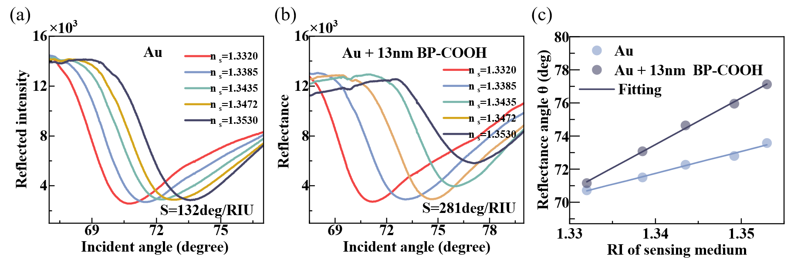
Fig. S1 Experimental refractive-index calibration of bare-Au SPR and SPR+BP-COOH. (a) Angle-scanned reflectance curves of bare-Au SPR measured in sensing media with refractive indices nₛ = 1.3320, 1.3385, 1.3435, 1.3472 and 1.3530. (b) Angle-scanned reflectance curves of the 13 nm SPR+BP-COOH structure measured in sensing media with refractive indices nₛ = 1.3320, 1.3385, 1.3435, 1.3472 and 1.3530. (c) Resonance angle as a function of refractive index for bare-Au SPR and the 13 nm SPR+BP-COOH structure, together with linear fitting curves.
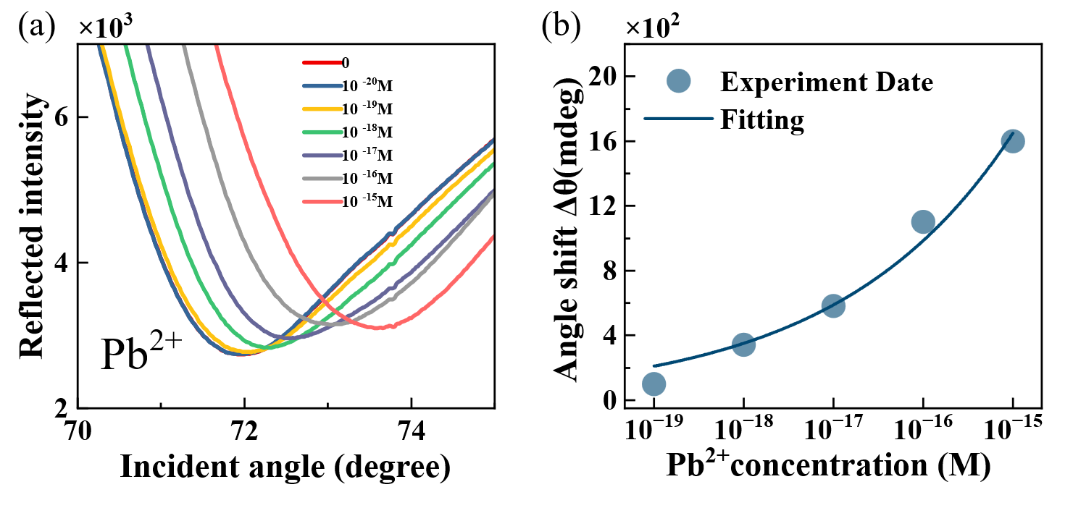
Fig. S2 Repeatability test of Pb²⁺ sensing performed on the same 13 nm SPR+BP-COOH structure. (a) Angle-scanned reflectance curves of the same 13 nm SPR+BP-COOH structure measured for Pb²⁺ concentrations of 0, 10⁻²⁰, 10⁻¹⁹, 10⁻¹⁸, 10⁻¹⁷, 10⁻¹⁶ and 10⁻¹⁵ M. (b) Resonance-angle shift Δθ as a function of Pb²⁺ concentration for the same 13 nm SPR+BP-COOH structure, together with the nonlinear fitting curve.
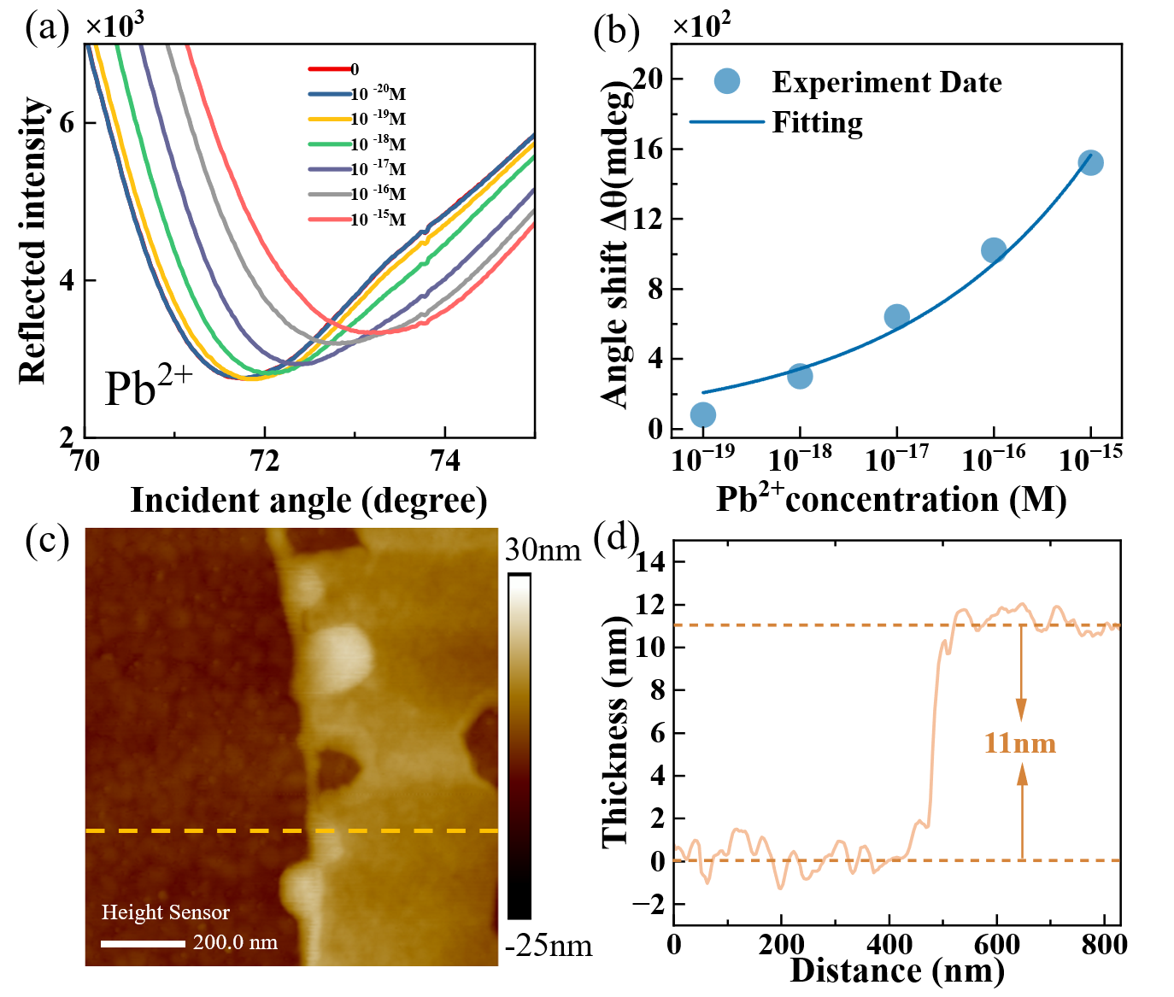
Fig. S3 Pb²⁺ sensing results obtained from an SPR+BP-COOH structure with a thickness of approximately 11 nm. (a) Angle-scanned reflectance curves of the 11 nm SPR+BP-COOH structure measured for Pb²⁺ concentrations of 0, 10⁻²⁰, 10⁻¹⁹, 10⁻¹⁸, 10⁻¹⁷, 10⁻¹⁶ and 10⁻¹⁵ M. (b) Resonance-angle shift Δθ as a function of Pb²⁺ concentration for the 11 nm SPR+BP-COOH structure, together with the nonlinear fitting curve. (c) AFM image of the 11 nm BP-COOH functional layer. (d) Height profile extracted from the AFM image in c, showing a thickness of approximately 11 nm.
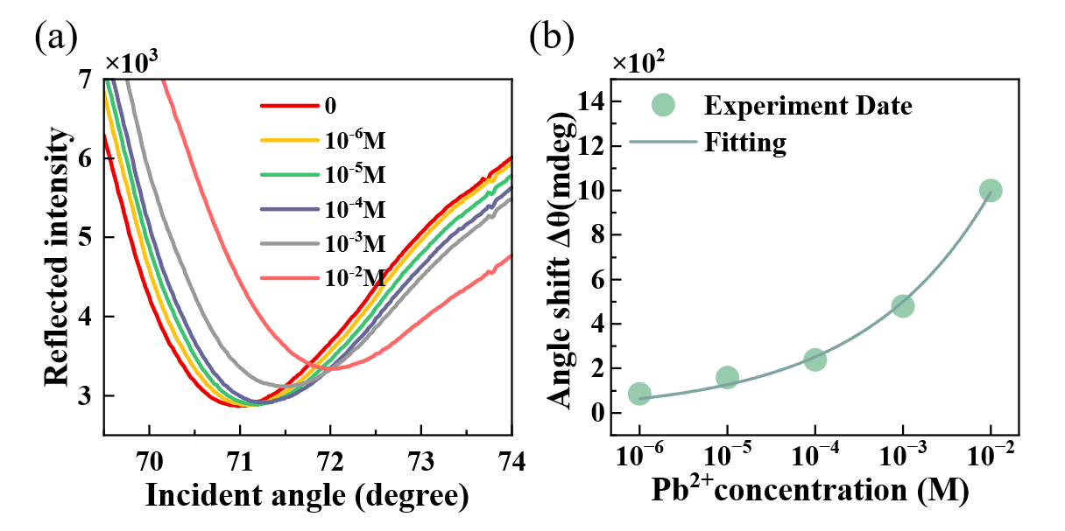
Fig. S4 Angle-scanned reflectance curves and resonance-angle fitting results for Pb²⁺ detection by bare-Au SPR. (a) Angle-scanned reflectance curves of bare-Au SPR measured for Pb²⁺ concentrations of 0, 10⁻⁶, 10⁻⁵, 10⁻⁴, 10⁻³ and 10⁻² M. (b) Resonance-angle shift Δθ as a function of Pb²⁺ concentration for bare-Au SPR, together with the nonlinear fitting curve.
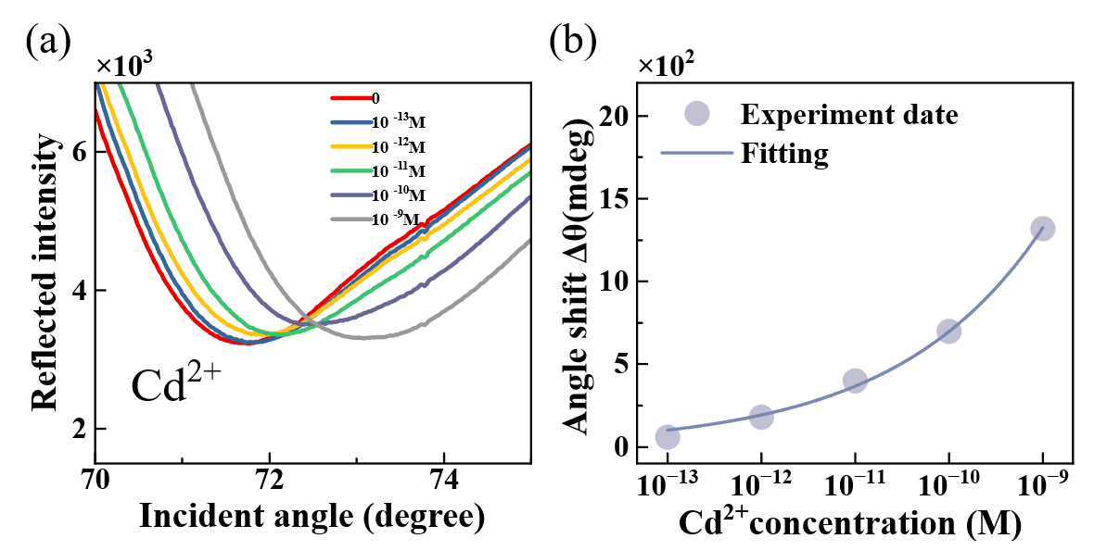
Fig. S5 Angle-scanned reflectance curves and resonance-angle fitting results for Cd²⁺ detection by SPR+BP-COOH. (a) Angle-scanned reflectance curves of SPR+BP-COOH measured for Cd²⁺ concentrations of 0, 10⁻¹³, 10⁻¹², 10⁻¹¹, 10⁻¹⁰ and 10⁻⁹ M. (b) Resonance-angle shift Δθ as a function of Cd²⁺ concentration, together with the nonlinear fitting curve.
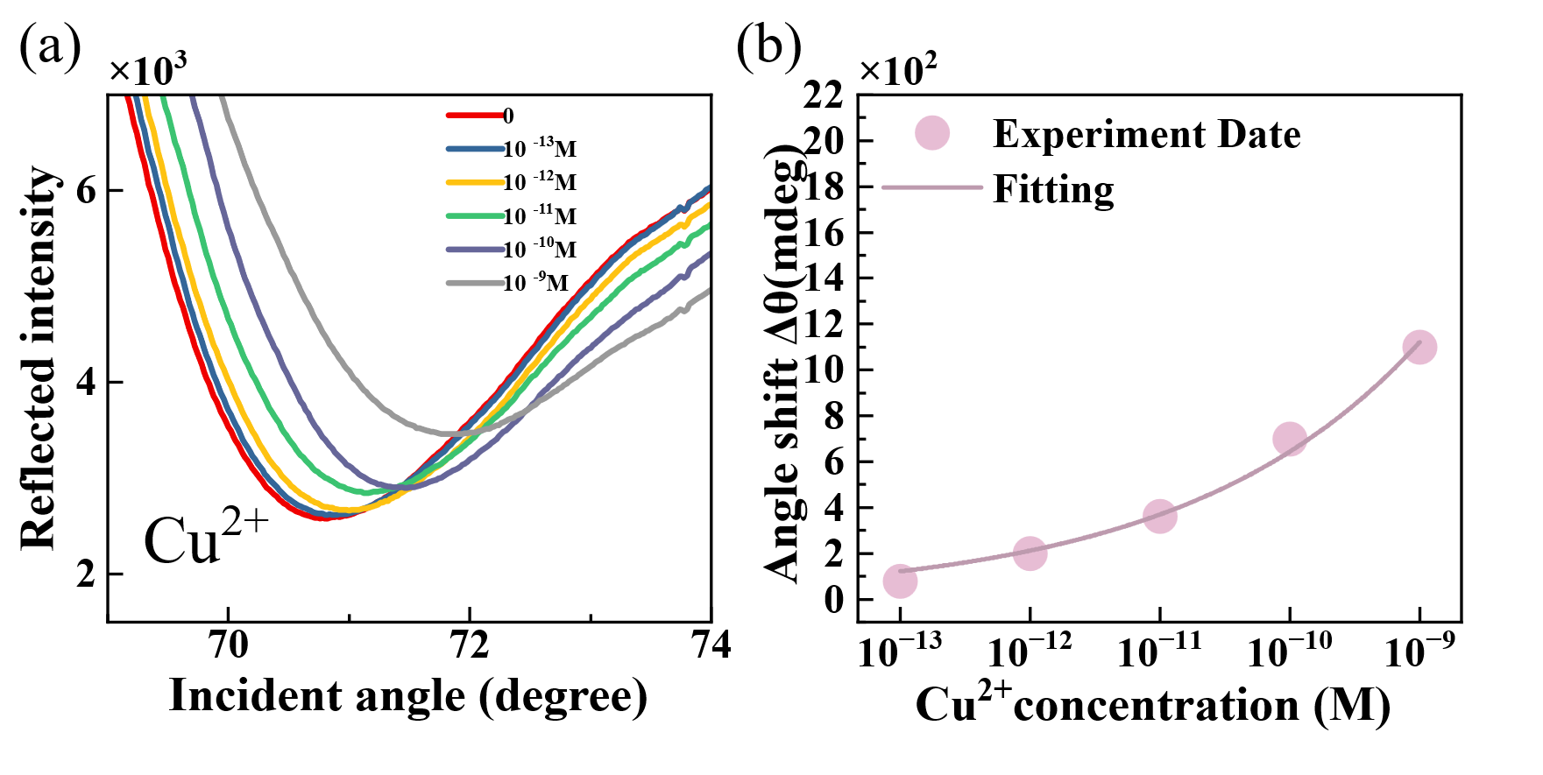
Fig. S6 Angle-scanned reflectance curves and resonance-angle fitting results for Cu²⁺ detection by SPR+BP-COOH. (a) Angle-scanned reflectance curves of SPR+BP-COOH measured for Cu²⁺ concentrations of 0, 10⁻¹³, 10⁻¹², 10⁻¹¹, 10⁻¹⁰ and 10⁻⁹ M. (b) Resonance-angle shift Δθ as a function of Cu²⁺ concentration, together with the nonlinear fitting curve.
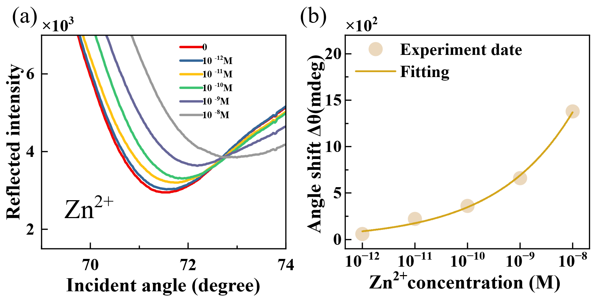
Fig. S7 Angle-scanned reflectance curves and resonance-angle fitting results for Zn²⁺ detection by SPR+BP-COOH. (a) Angle-scanned reflectance curves of SPR+BP-COOH measured for Zn²⁺ concentrations of 0, 10⁻¹², 10⁻¹¹, 10⁻¹⁰, 10⁻⁹ and 10⁻⁸ M. (b) Resonance-angle shift Δθ as a function of Zn²⁺ concentration, together with the nonlinear fitting curve.
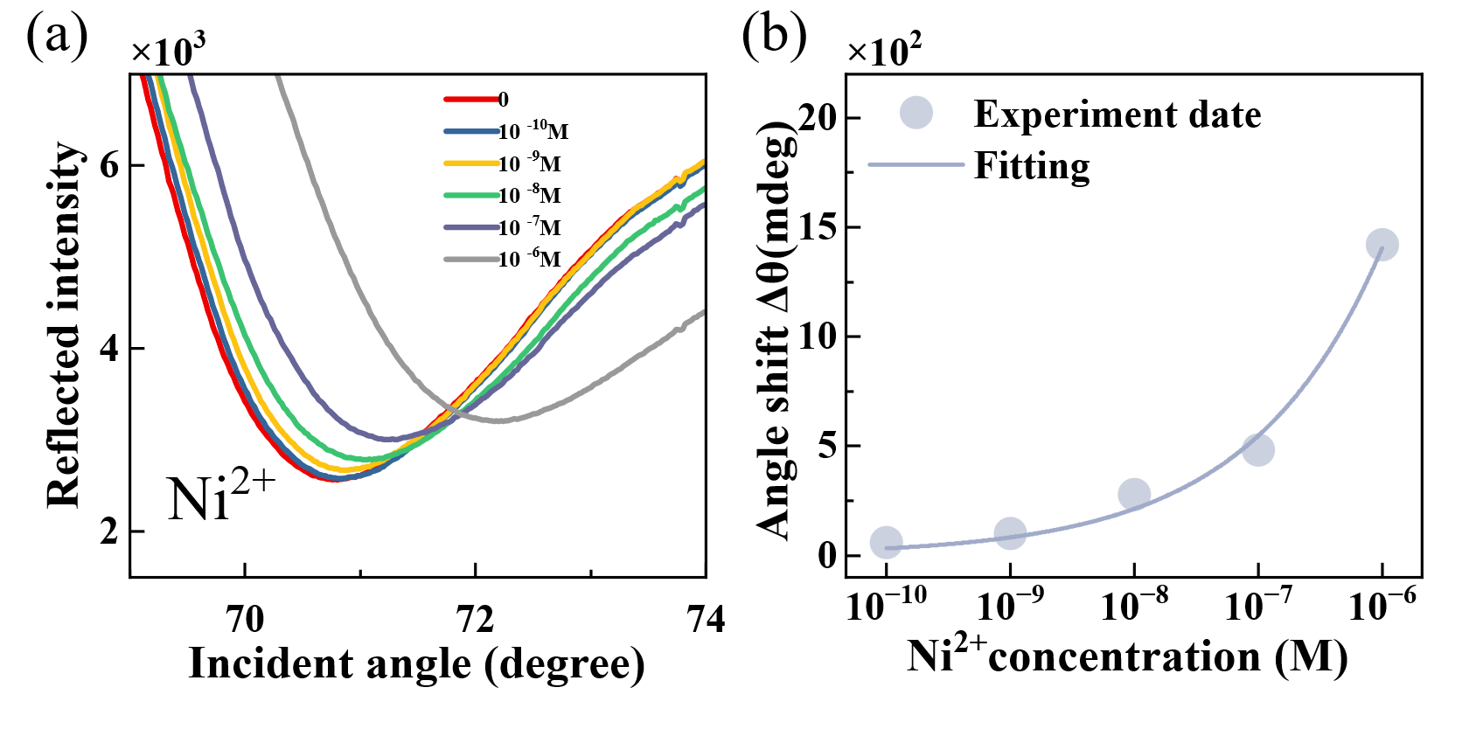
Fig. S8 Angle-scanned reflectance curves and resonance-angle fitting results for Ni²⁺ detection by SPR+BP-COOH. (a) Angle-scanned reflectance curves of SPR+BP-COOH measured for Ni²⁺ concentrations of 0, 10⁻¹⁰, 10⁻⁹, 10⁻⁸, 10⁻⁷ and 10⁻⁶ M. (b) Resonance-angle shift Δθ as a function of Ni²⁺ concentration, together with the nonlinear fitting curve.
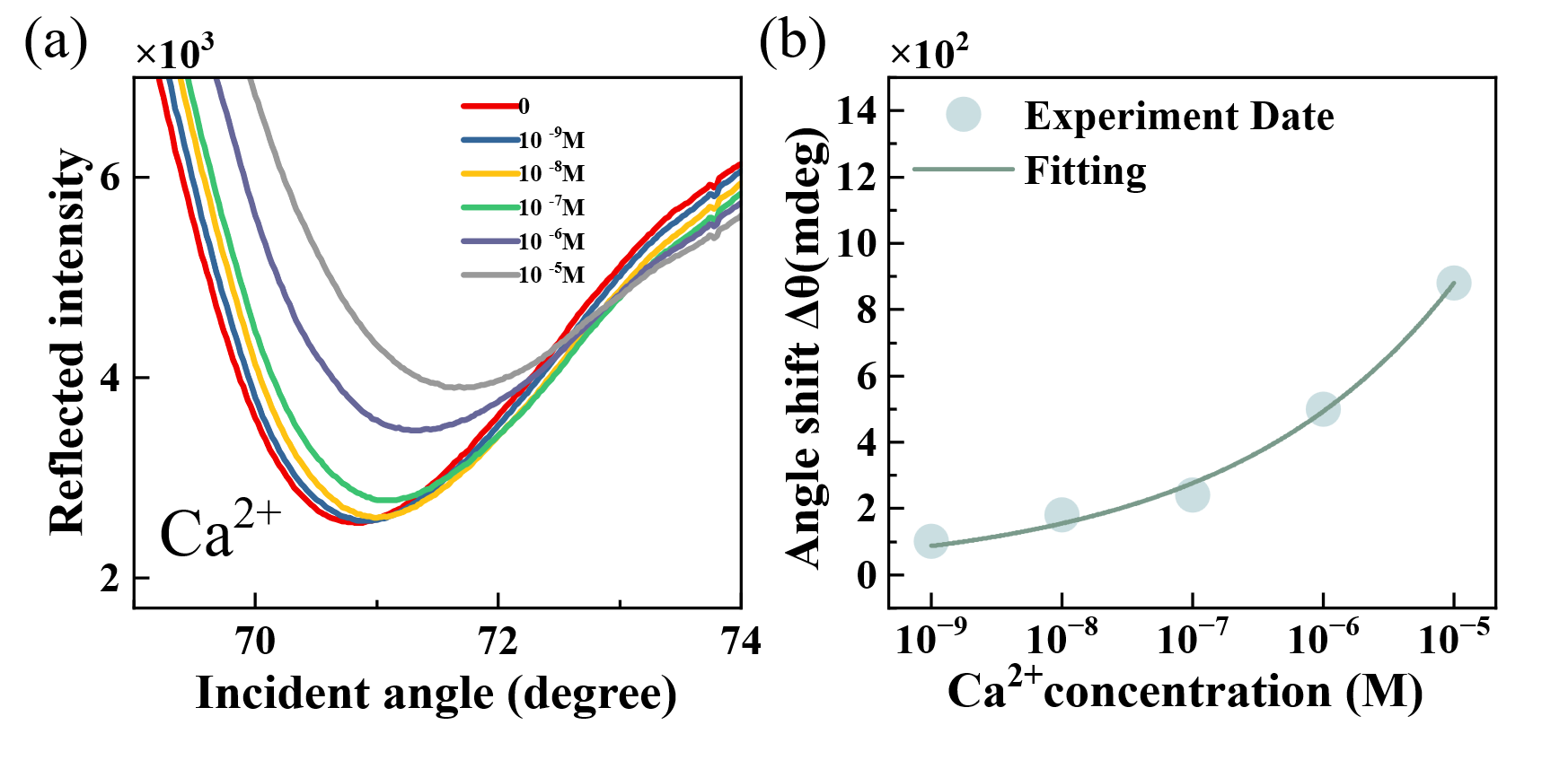
Fig. S9 Angle-scanned reflectance curves and resonance-angle fitting results for Ca²⁺ detection by SPR+BP-COOH. (a) Angle-scanned reflectance curves of SPR+BP-COOH measured for Ca²⁺ concentrations of 0, 10⁻⁹, 10⁻⁸, 10⁻⁷, 10⁻⁶ and 10⁻⁵ M. (b) Resonance-angle shift Δθ as a function of Ca²⁺ concentration, together with the nonlinear fitting curve.
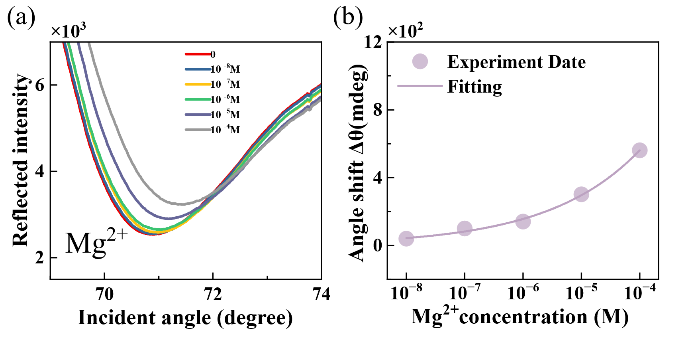
Fig. S10 Angle-scanned reflectance curves and resonance-angle fitting results for Mg²⁺ detection by SPR+BP-COOH. (a) Angle-scanned reflectance curves of SPR+BP-COOH measured for Mg²⁺ concentrations of 0, 10⁻⁸, 10⁻⁷, 10⁻⁶, 10⁻⁵ and 10⁻⁴ M. (b) Resonance-angle shift Δθ as a function of Mg²⁺ concentration, together with the nonlinear fitting curve.
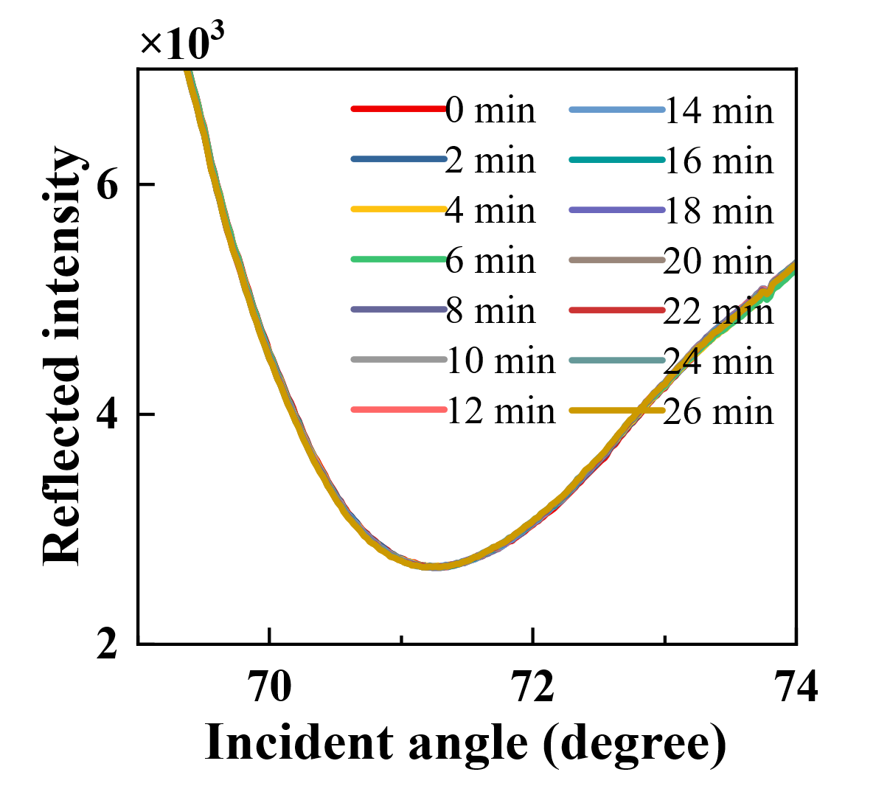
Fig. S11 Repeated measurements of the same pure-water sample on SPR+BP-COOH at 2 min intervals. Angle-scanned reflectance curves recorded at 0, 2, 4, 6, 8, 10, 12, 14, 16, 18, 20, 22, 24 and 26 min after deposition of the BP-COOH functional layer.

