Supplementary Material
Tropical Pacific Teleconnection to Southwestern US precipitation in the historical observations and climate change projections
Rosa Luna-Niño, Alexander Gershunov, Alexander Weyant, Chris Castellano, Daniel Cayan, Julie Kalansky, Kristen Guirguis, Rachel Clemesha

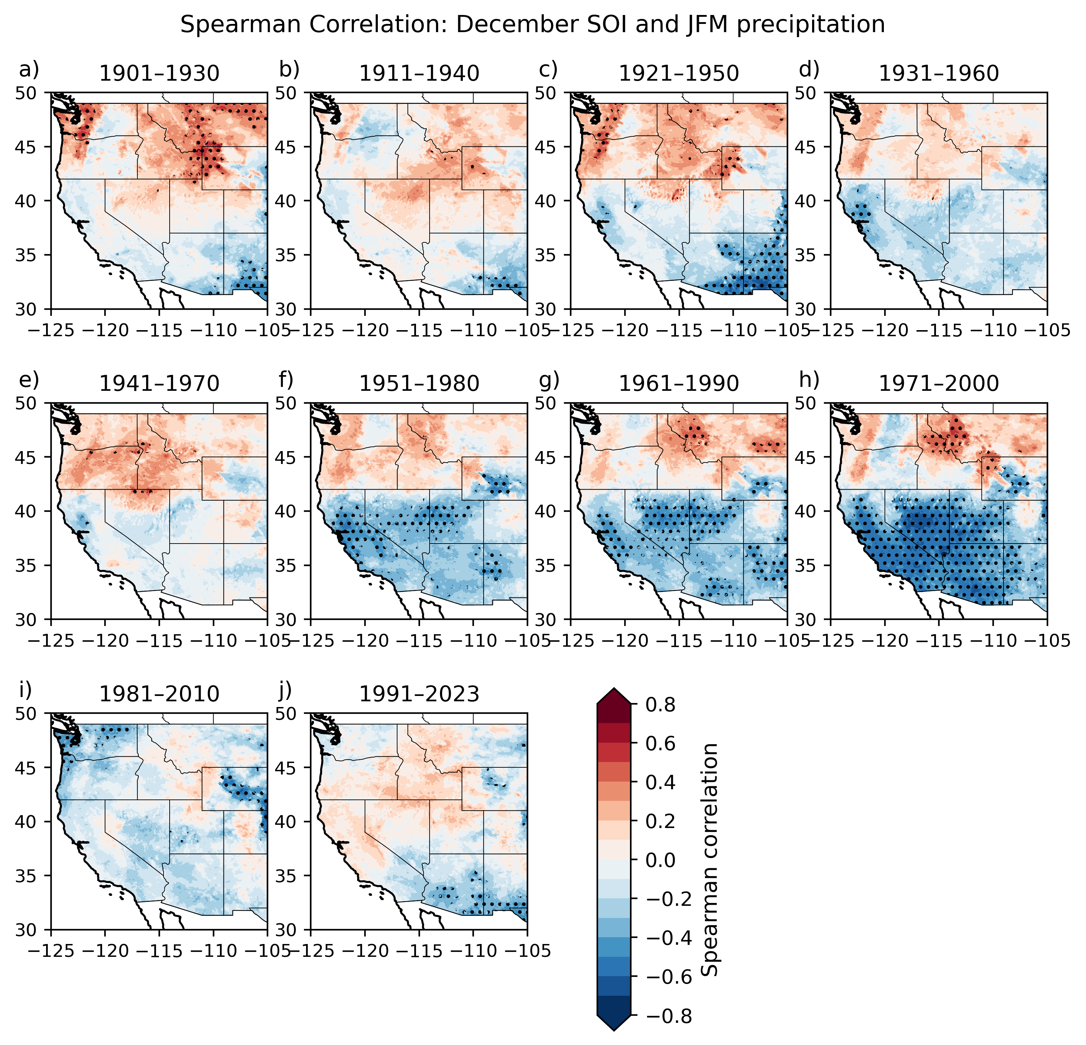
Figure S1. Spearman correlation between the December SOI index and January-March (JFM) accumulated precipitation during WYs. Dotted points indicate where the correlation is significant at the 95% confidence level. Correlations show opposite signs to those based on Niño3.4 SST (Figure 1) because negative (positive) SOI values are associated with El Niño (La Niña) events.

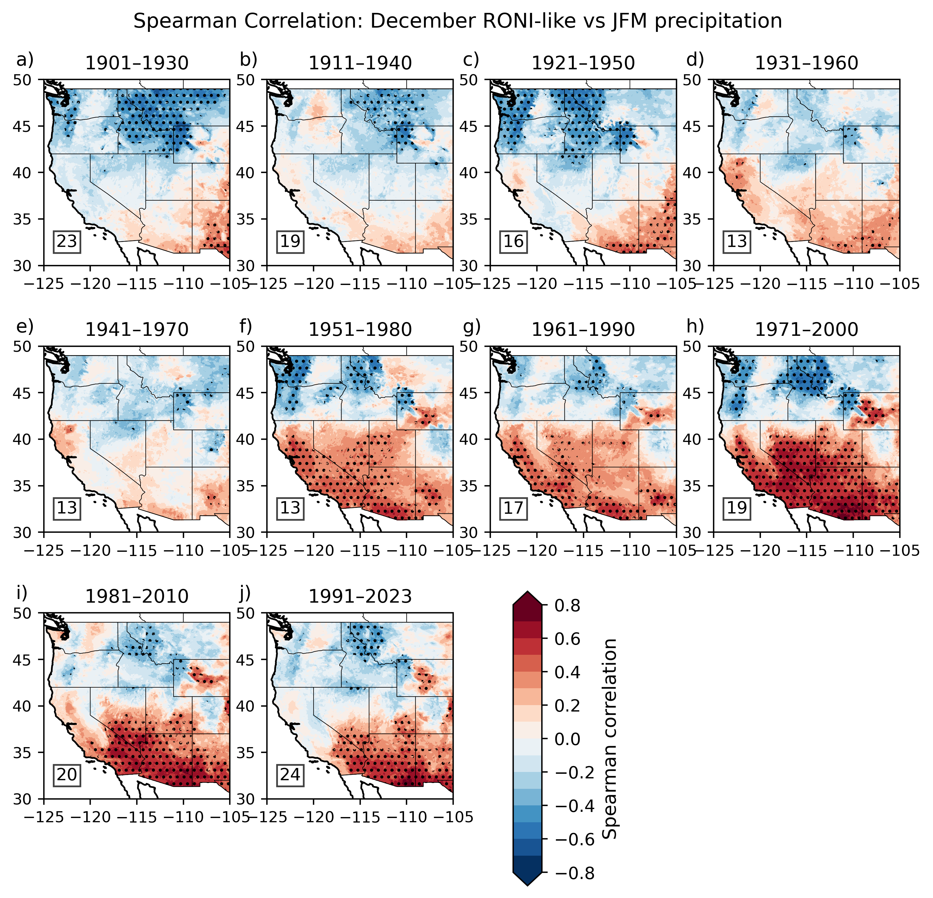
Figure S2. Spearman correlation between the December RONI-like index and January-March (JFM) accumulated precipitation during WYs. Dotted points indicate where the correlation is significant at the 95% confidence level. Numbers in the lower-left corners indicate ENSO activity for each period, defined as the number of El Niño + La Niña events. Figures S1-S3 show the correlations based on SOI, RONI-like, and ELI indices, respectively.

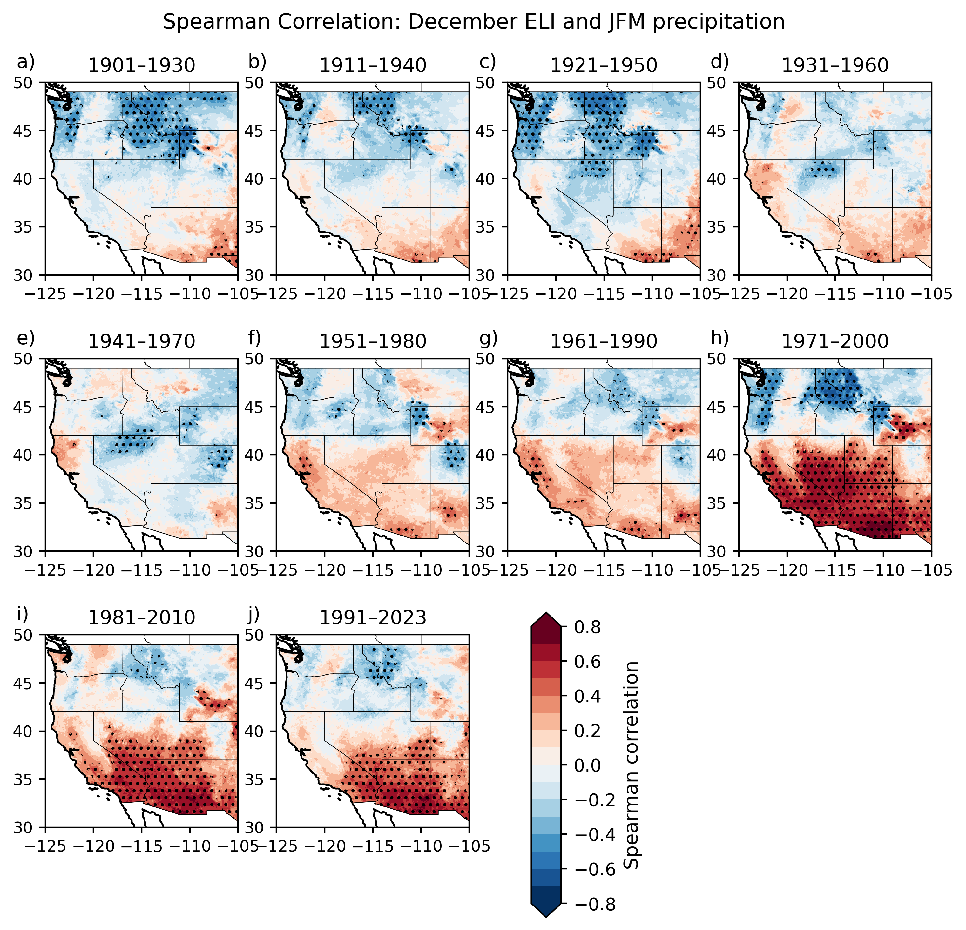
Figure S3. Spearman correlation between the December ELI index and January-March (JFM) accumulated precipitation during WYs. Dotted points indicate where the correlation is significant at the 95% confidence level. Numbers in the lower-left corners indicate ENSO activity for each period, defined as the number of El Niño + La Niña events. Figures S1-S3 show the correlations based on SOI, RONI-like, and ELI indices, respectively.

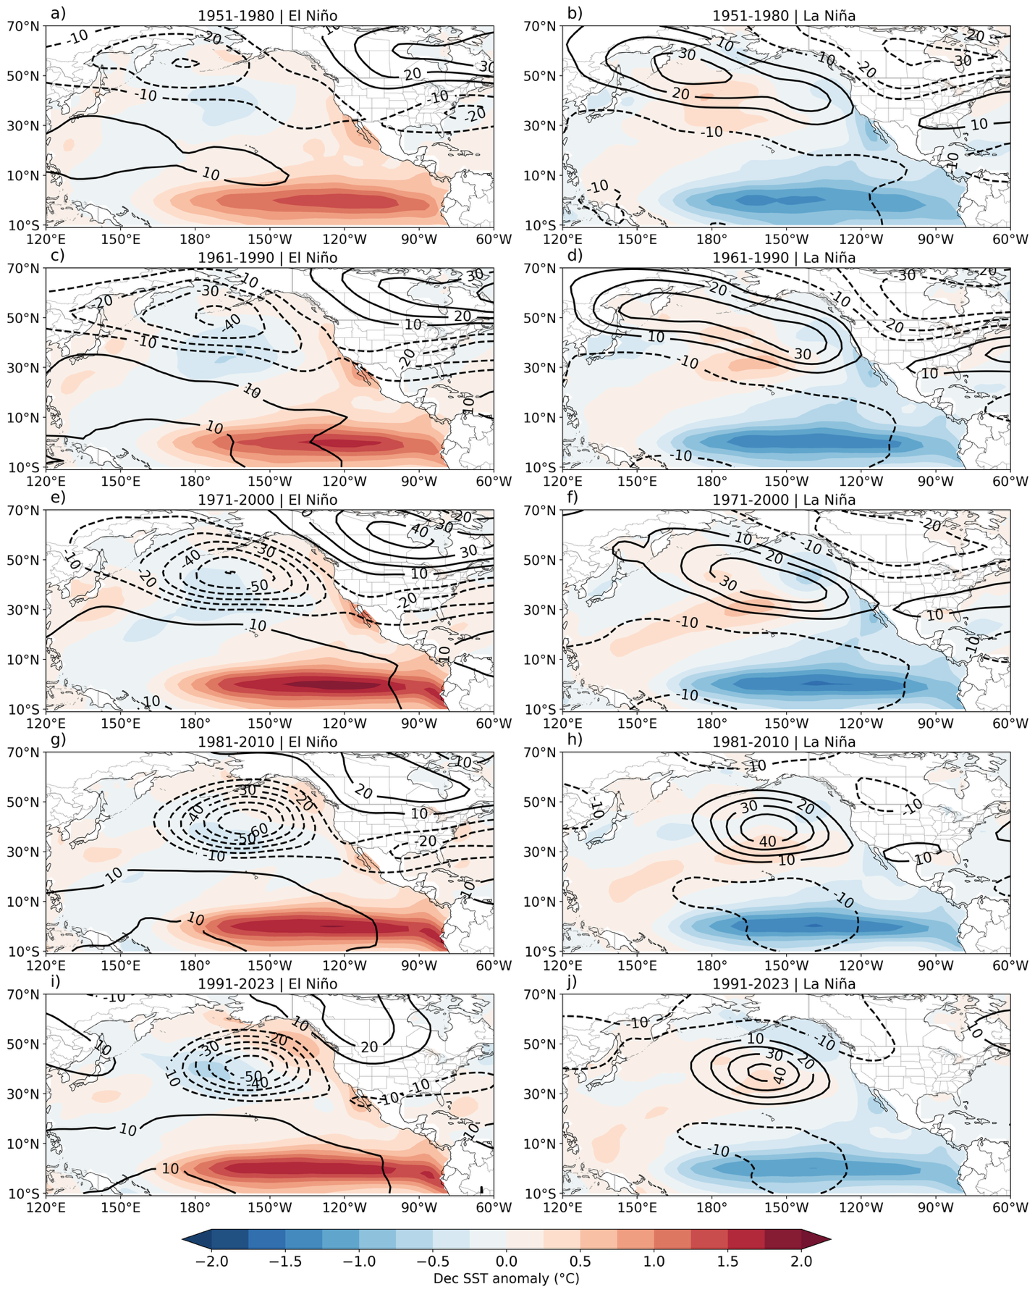
Figure S4. Composites in December SST and JFM geopotential height (500hPa) anomalies during El Niño and La Niña years for different periods starting in 1951 based on the availability of NCEP reanalysis data. The anomalies are calculated relative to each individual period.

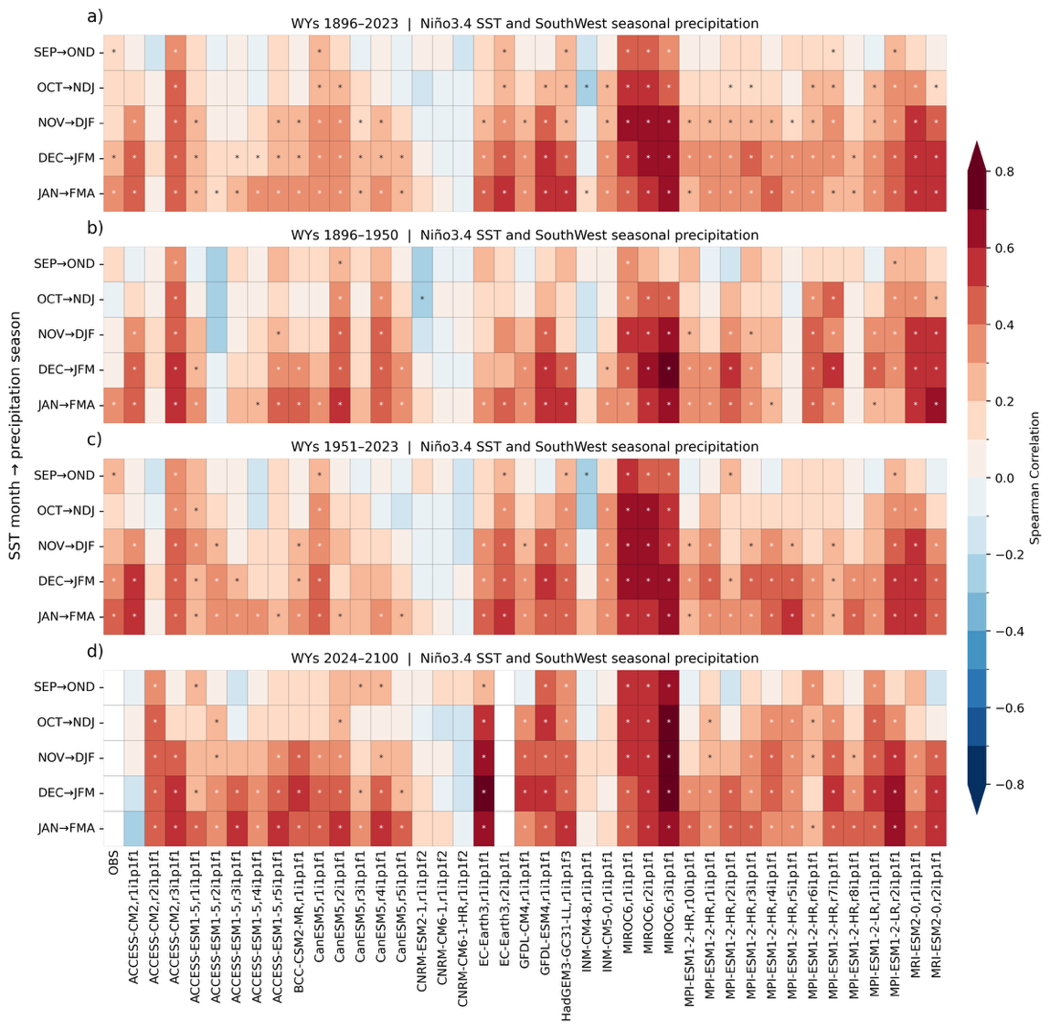
Figure S5. Correlation between seasonal precipitation over the Southwest and previous SST in the Niño 3.4 region across the periods a) WYs 1896 – 2023, b) WYs 1986-1950, c) WYs 1951-2023, and d) WYs 2024-2100.

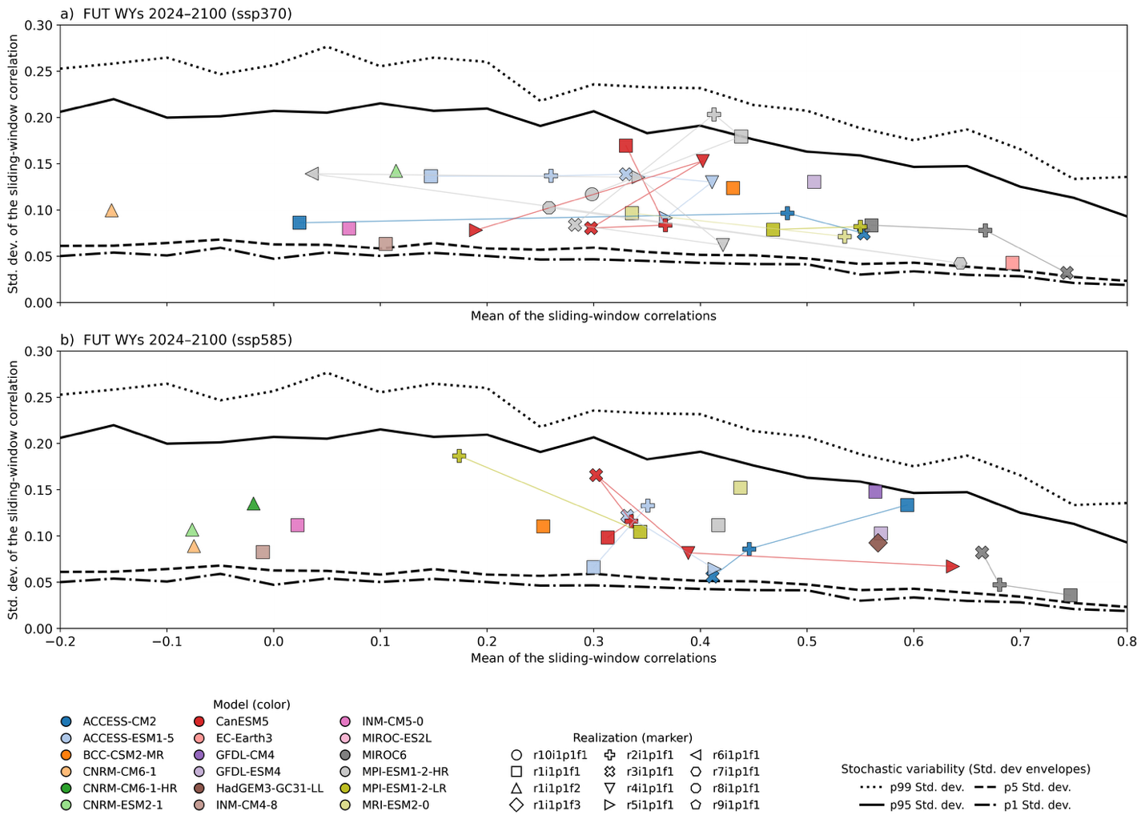
Figure S6. Scatter plot of the mean and standard deviation of the sliding window 31yrs Spearman correlation between December Niño 3.4 SST and January-March (JFM) accumulated precipitation over the US Southwest (yellow box in Figure 1) for the future period 2024-2100.

Table S1. List of CMIP6 GCMs realizations used to study the seasonality predictability of JFM precipitation over the SWUS during the historical period.
 | SST and precipitaiton from CMIP6 GCMs | IVT, IWV, and landfalling AR based on CMIP6 GCMs
ACCESS-CM2 | r1i1p1f1, r2i1p1f1, r3i1p1f1 | r1i1p1f1, r4i1p1f1, r5i1p1f1
ACCESS-ESM1-5 | r1i1p1f1, r2i1p1f1, r3ip1f1, r4i1p1f1, r5i1p1f1
BCC-CSM2-MR | r1i1p1f1 | r1i1p1f1
CNRM-CM6-1 | r1i1p1f2 | r1i1p1f2, r2i1p1f2, r3i1p1f2, r4i1p1f2,  r5i1p1f2, r6i1p1f2
CNRM-ESM2-1 | r1i1p1f2 | r1i1p1f2
CNRM-CM6-1-HR | r1i1p1f2 | r1i1p1f2
CanESM5 | r1i1p1f1, r2i1p1f1, r3i1p1f1, r4i1p1f1, r5i1p1f1, | r1i1p2f1, r2i1p2f1, r3i1p2f1
EC-Earth3 | r1i1p1f1 | r1i1p1f1, r4i1p1f1
EC-Earth3-Veg |  | r1i1p1f1,
GFDL-CM4 | r1i1p1f1 | r1i1p1f1
GFDL-ESM4 | r1i1p1f1 | r1i1p1f1
HadGEM3-GC31-LL | r1i1p1f3 | r1i1p1f3
INM-CM4-8 | r1i1p1f1 | r1i1p1f1
INM-CM5-0 | r1i1p1f1 | r1i1p1f1
MIROC6 | r1i1p1f1, r2i1p1f1, r3i1p1f1 | r1i1p1f1, r2i1p1f1, r3i1p1f1
MPI-ESM1-2-HR | r1i1p1f1, r2i1p1f1, r3i1p1f1, r4i1p1f1, r5i1p1f1, r6i1p1f1, r7i1p1f1, r8i1p1f1, r10i1p1f1 | r1i1p1f1, r2i1p1f1
MPI-ESM1-2-LR | r1i1p1f1, r2i1p1f1 | r1i1p1f1, r2i1p1f1, r3i1p1f1,  r4i1p1f1, r5i1p1f1, r6i1p1f1, r7i1p1f1, r8i1p1f1, r9i1p1f1, r10i1p1f1
MRI-ESM2-0 | r1i1p1f1, r2i1p1f1 | r1i1p1f1, r2i1p1f1, r3i1p1f1, r4i1p1f1, r5i1p1f1

Table S2. List of CMIP6 GCMs realizations used to study the seasonality predictability of JFM precipitation over the SWUS during the future period. *, ** indicates models only available for the scenario ssp370 or ssp585, respectively.
 | SST and precipitaiton from CMIP6 GCMs | IVT, IWV, and landfalling AR based on CMIP6 GCMs
ACCESS-CM2 | r1i1p1f1, r2i1p1f1, r3i1p1f1 | r1i1p1f1, r4i1p1f1, r5i1p1f1
ACCESS-ESM1-5 | r1i1p1f1, r2i1p1f1, r3ip1f1, r4i1p1f1*, r5i1p1f1
BCC-CSM2-MR | r1i1p1f1 | r1i1p1f1
CNRM-CM6-1 | r1i1p1f2 | r1i1p1f2, r2i1p1f2, r3i1p1f2, r4i1p1f2,  r5i1p1f2, r6i1p1f2
CNRM-ESM2-1 | r1i1p1f2 | r1i1p1f2
CNRM-CM6-1-HR | r1i1p1f2** | r1i1p1f2
CanESM5 | r1i1p1f1, r2i1p1f1, r3i1p1f1, r4i1p1f1, r5i1p1f1, | r1i1p2f1, r2i1p2f1, r3i1p2f1
EC-Earth3 | r1i1p1f1* | r1i1p1f1, r4i1p1f1
EC-Earth3-Veg |  | r1i1p1f1
GFDL-CM4 | r1i1p1f1** | r1i1p1f1
GFDL-ESM4 | r1i1p1f1 | r1i1p1f1
HadGEM3-GC31-LL | r1i1p1f3** | r1i1p1f3
INM-CM4-8 | r1i1p1f1 | r1i1p1f1
INM-CM5 | r1i1p1f1 | r1i1p1f1
MIROC6 | r1i1p1f1, r2i1p1f1, r3i1p1f1 | r1i1p1f1, r2i1p1f1, r3i1p1f1
MPI-ESM1-2-HR | r1i1p1f1, r2i1p1f1*, r3i1p1f1*, r4i1p1f1*, r5i1p1f1*, r6i1p1f1*, r7i1p1f1*, r8i1p1f1*, r9i1p1f1*, r10i1p1f1* | r1i1p1f1, r2i1p1f1
MPI-ESM1-2-LR | r1i1p1f1, r2i1p1f1 | r1i1p1f1, r2i1p1f1, r3i1p1f1,r4i1p1f1, r5i1p1f1, r6i1p1f1, r7i1p1f1, r8i1p1f1, r9i1p1f1, r10i1p1f1
MRI-ESM2-0 | r1i1p1f1, r2i1p1f1* | r1i1p1f1, r2i1p1f1, r3i1p1f1, r4i1p1f1, r5i1p1f1

