ToxDL: protein toxicity predictor
------------ Prediction result of ToxDL------------

ToxDL | score
Being toxic protein | 0.0009817759

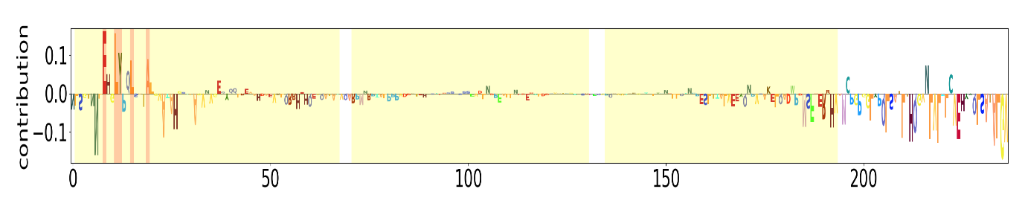

------------ Any toxic domain detected by InterProScan in this protein------------

No toxic domain is detected in this protein

