Supporting Information
Relative Stability of Chlorthalidone (CTD) Forms I and II: Integrated Experimental and Theoretical Insights into the Superior Thermodynamic Stability of CTD-I Driven by Intra- and Intermolecular Interactions
Singaravel Nathiya,^{1#} Jarede Da Silva Martins,^{1#} Murugesan Panneerselvam¹ Leandro M. Santos,² Antônio C. Doriguetto²* and Luciano T. Costa^{1*}
¹MolMod-CS - Instituto de Química, Universidade Federal Fluminense, Campos Valonginho s/n, Centro, Niterói 24020-14, Rio de Janeiro, Brazil.
²Laboratório de Cristalografia, Universidade Federal de Alfenas, Rua Gabriel Monteiro da Silva, 700, 37130-000, Alfenas, MG, Brazil.
#Contributed equally to this work
*Corresponding Authors: E-mail: ltcosta@id.uff.br & doriguetto@unifal-mg.edu.br

CONTENT CAPTIONS
Figures |  | Page No.
Figure S1 | Gas-phase optimized geometries of CTD-I and CTD-II, including their stable conformer energy differences (in kcal/mol) and possible intramolecular interactions for each conformer. | S2
Figure S2 | Peaks of the Raman spectra in the region related to breathing of the rings for CTD-I (A) and CTD-II (B). | S3
Figure S3 | Packing structures of CTD-I (A) and CTD-II (B) along with the possible interactions. | S4

Figure S1. Gas-phase optimized geometries of CTD-I and CTD-II, including their stable conformer energy differences (in kcal/mol) and possible intramolecular interactions for each conformer.

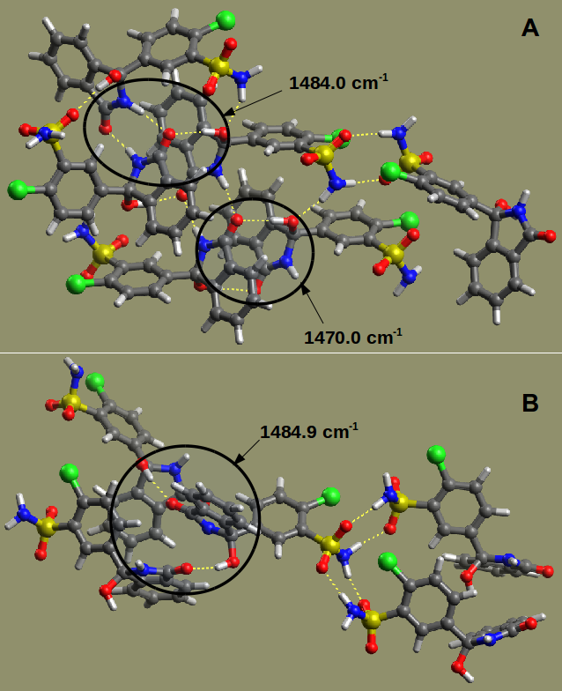
Figure S2. Peaks of the Raman spectra in the region related to breathing of the rings for CTD-I (A) and CTD-II (B).
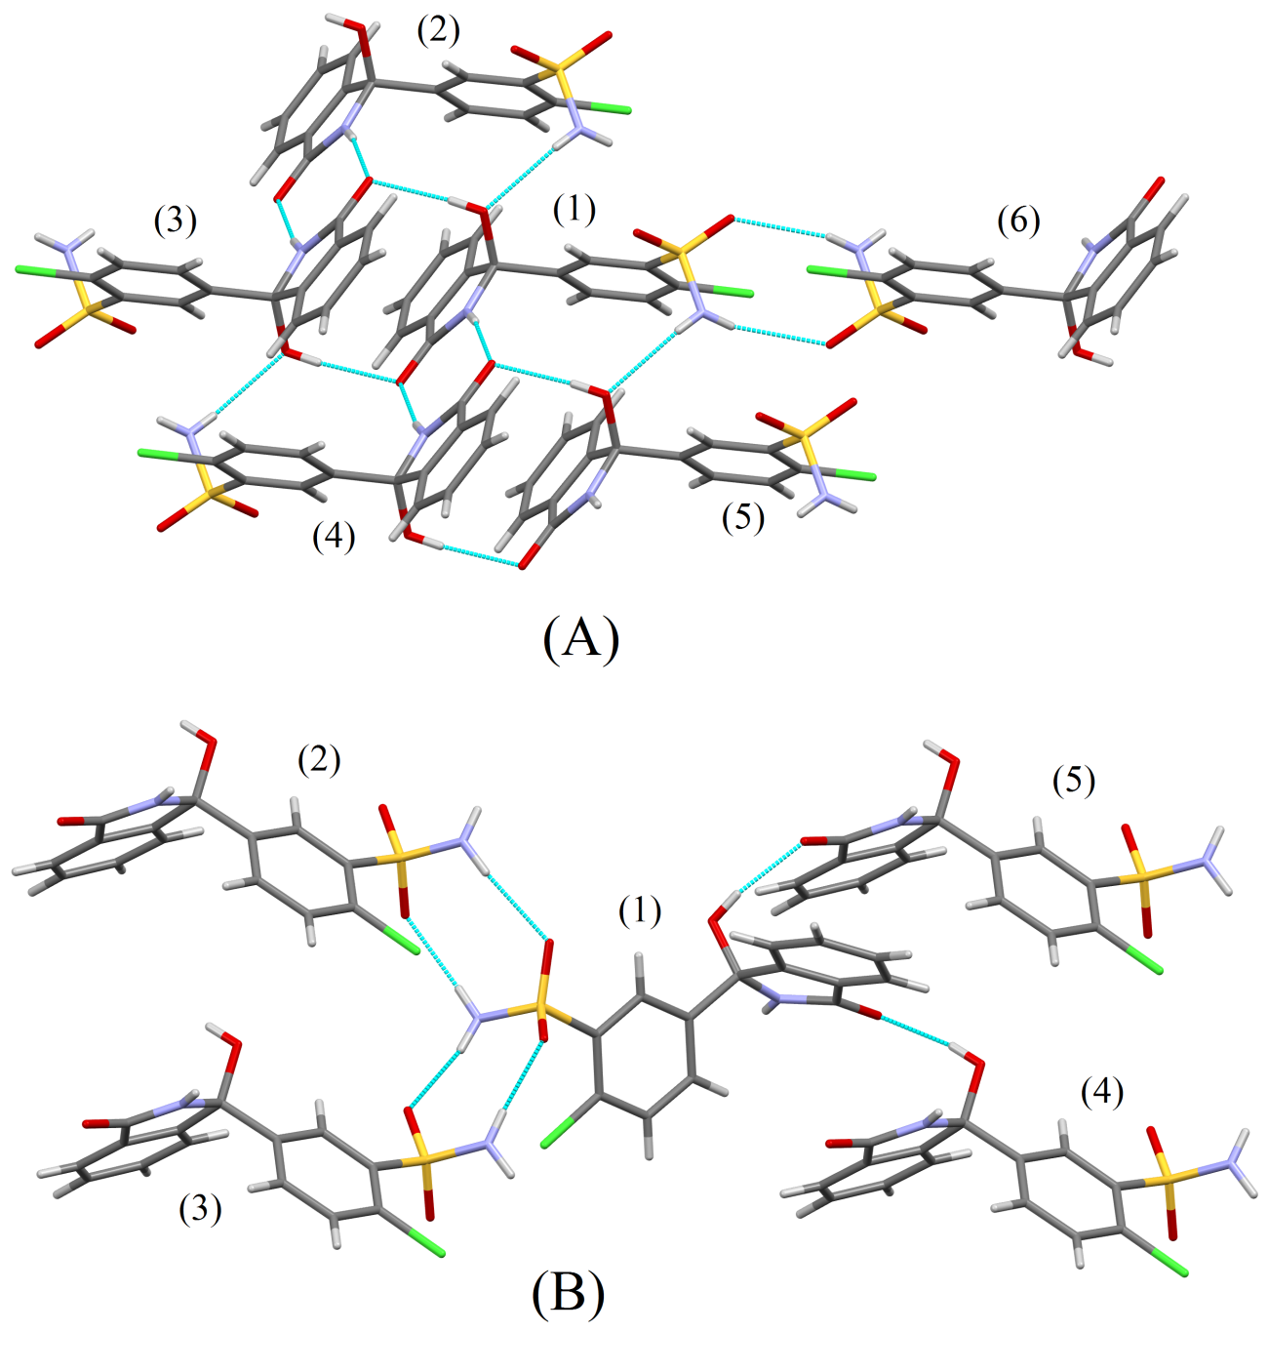
Figure S3. Packing structures of CTD-I (A) and CTD-II (B) along with the possible interactions.

