Supplementary Information for: Monitoring and evaluating biodiversity in estuaries with eDNA: Successes, challenges, and trends. Submitted to Estuaries and Coasts
A.W. Watts (corresponding author), alison.watts@unh.edu
E.J. Buskey, L.C. Crane, N. Dix, F. El Baidouri, M. Ferner, J. Garwood, H. Gilbert, J.S. Goldstein, T.M. Grothues, M. Lamb, S. Lucas, J.T. Miller, C.R. Peter, S. Rii, N. Schirmer, S. Schooler, S. Yang

The 10 participating NERRs in this study were distributed across the US, from Atlantic, Gulf of Mexico, to Pacific coasts and ocean (Fig. 1). NERRs were selected to represent a range of geographical, ecological, and anthropogenic conditions across the United States. eDNA samples were collected by Reserve staff quarterly, and sent to the University of New Hampshire for laboratory processing and analysis. Our goal was to incorporate eDNA collection as an additional method set in the existing program, and thus water samples for eDNA and regular parameters for SWMP were collected concurrently at most sites.

Sampling approach. Samples were collected quarterly (May, August, November and February) over two years (May 2022 to February 2024) to capture seasonal and annual variation. Each Reserve collected triplicate water samples (1L each) at 4-5 of their existing SWMP sampling locations, resulting in over 1,300 total water samples. Water samples were filtered, processed, and amplified using a 12S rRNA gene primer that targets fish species (Miya et al., 2015), and an 18S rRNA gene primer for eukaryotes (Amaral-Zettler et al., 2009). 18S data were only available for the second year, May 2023 - February 2024.

Samples were collected by personnel at each location in conjunction with SWMP data collection. At each sampling location 3 1-Liter water samples were collected from the surface. All sample supplies were prepared and sanitized in a clean location prior to sample collection, and care was taken to avoid sample contact with boat surfaces, site water, or other non-sterile surfaces. One trip blank, consisting of bottled or lab tap water poured into a sample container, was generated at each sample site. On-site filtering was not practical at most locations due to time constraints, so collected samples were stored on ice and transported to a lab for filtering. Samples were filtered onto 1.5 μm glass fiber filters within 24 hrs of collection. If necessary, multiple filters were sequentially used to process all of the sample water. All filtering and sampling equipment was either acid washed or cleaned with 50% bleach. A lab blank was collected prior to the first sample filter, and every 10 samples thereafter by filtering deionized or lab tap water through a 1.5um glass fiber filter. Approximately 10% of the sample blanks contained at least 1 fish read, primarily in the trip blanks. Samples were collected from small boats which in many cases are also used for more traditional water and fisheries sampling, and the fish detected generally reflected the species expected to be present at the site. After discussion with managers, for the purposes of this paper (which is general fish assemblage), we elected to not filter samples associated with contaminated blanks, as that also removes many common species. In cases where precise identification of specific species is important, the results should be thoroughly screened to ensure that all detections are true field sequences.

Laboratory analyses and sequencing. All lab work was conducted in dedicated Biosafety Level 2 (BSL2) molecular laboratory facilities at the University of New Hampshire.
DNA extraction and handling: As discussed above, extraction and PCR protocols were modified after the first year. Filters collected in year 1 were extracted on a QIAcube Connect system (QIAGEN®, Hilden, Germany) following the QIAamp DNA Mini protocol (Qiagen Cat. 51326). In the second year we moved to a bead-based extraction conducted on a KingFisher Flex System (Thermo Fisher, Waltham, MA), as described in El Baidouri et al., 2025. Samples from both methods were eluted to 100 μl. The ZYMO OneStep-96 PCR Inhibitor Removal Kit (CAT: D6035) was used to remove inhibition from all samples following the manufacturer's instructions.
MiFish PCR protocols were changed after year 1 review indicated underrepresentation of species in comparison to expected fish community. Underrepresentation was more pronounced at sites with high turbidity. Turbidity is frequently associated with inhibitors (e.g. lignins, tannins, humic subtablestances) that bind to eDNA and inhibit PCR amplification. In response we updated our PCR protocols to enhance fish detection. Details and processes are discussed in El Baidouri et al. (2025), and summarized in the methods section. Changing protocols mid-way through the project enhanced detection, but complicates inter-year comparisons, as elaborated in the discussion section.
18S rRNA gene/Eukaryotic PCR Amplification - For each sample the PCR reaction was prepared using 6 µL of Kapa Master Mix, 2.6 µL of nuclease-free water, and 0.7 µL of each of the 18S primers with Nextera adapters (see below). Next, 2 µL of 1:5 ZYMO clean-up genomic DNA was added to 10 µL of the mix, resulting in a total reaction volume of 12 µL. The PCR program consisted of an initial denaturation at 94°C for 3 minutes, followed by 25 cycles of 94°C for 30 seconds, 57°C for 30 seconds, and 72°C for 30 seconds, a final extension at 72°C for 7 minutes, and a hold at 4°C indefinitely.
MiFish PCR Amplification Our initial protocol used KAPA HiFi HotStart (KAPA) and a touchdown thermal profile modified from (Pitz et al., 2020). In year 2, the PCR reaction was modified to use Platinum SuperFi II Master Mix, and an equimolar primer mix of MiFish-U and MiFish-E.
Primer selection. In addition to the 18S-Euk primers (Table 1), the MiFish-U primer was used to amplify bony fish species, while the MiFish-E targets elasmobranch (sharks and rays). Both types are important in estuarine systems, and multiplexing these primers expands the list of potential target species. Table 1 shows the primer sequences used in this study.
Table 1. Primer sequences
MiFish-MIX-F (forward)
MiFish-U-F: 5′- GTCGGTAAAACTCGTGCCAGC-3′
MiFish-E-F: 5′- GTTGGTAAATCTCGTGCCAGC-3′
MiFish-MIX-R (reverse)
MiFish-U-R: 5′-CATAGTGGGGTATCTAATCCCAGTTTG-3′
MiFish-E-R: 5′-CATAGTGGGGTATCTAATCCTAGTTTG-3′
18S Primers
18s-Euk_1391f: 5′-GTACACACCGCCCGTC-3′
18s-EukBr: 5′-TGATCCTTCTGCAGGTTCACCTAC-3′
PCR Verification. Amplification of target regions was verified on 2% E-Gel electrophoresis (Thermo Fisher, Waltham, MA, CAT: G820802). Absent or muted bands in samples with verified DNA concentrations indicate that the samples are likely to contain inhibiting agents. E-Gel images are also used as an initial screen for successful amplification of positive controls, and absence of contamination in negative controls.
Library preparation and Sequencing. Most of the samples were run on an Illumina NovaSeq 6000 instrument, with a subset of the May 2023 samples run on an Illumina iSeq. Briefly, the amplicon products from the 1st PCR were indexed using dual-index barcodes and Illumina sequencing adapters (P5 and P7). The PCR amplification conditions were set as follows: initial denaturation at 95°C for 3 minutes, followed by 11 cycles of denaturation at 95°C for 10 seconds, annealing at 55°C for 30 seconds, and extension at 72°C for 30 seconds. A final extension phase was conducted at 72°C for 5 minutes to ensure complete amplification of target sequences.The amplified libraries were purified using AMPure XP beads (Beckman Coulter) to selectively remove short fragments and primer dimers.
Sequence Processing and Taxonomic Assignment. Fastp v 0.23.0 was used to trim the poly-g tails and low-quality sequences (mean quality < 25, window size 2 bp from the raw, demultiplexed fastq files (Chen et al. 2018). The demultiplexed fastqs were then imported to QIIME 2 (QIIME 2-2022.8) for adapter trimming, denoising, and taxonomic classification (Bolyen et al. 2018). The cutadapt plugin in QIIME 2 was used to trim primer sequences and filter out read-pairs that do not contain the priming sequences (Martin 2011). Read-pairs were retained if the primer sequences matched the allowed error rate of 0.1. Retained read-pairs were then denoised, merged, and checked for chimeras with the DADA2 QIIME 2 plugin (Callahan et al. 2016). Forward and reverse reads were truncated to have at least 12 base-pairs (QIIME 2 default) of overlap to merge the forward and reverse reads. To reduce the number of false positive unique ASVs, we used the ‘pseudo’ pooling method where samples are initially denoised independently, and then denoised a second time with prior knowledge of the ASVs that are found in at least two samples in the initial denoising step. We classified ASVs using two complementary approaches in QIIME 2: the classify-consensus-vsearch classifier and the scikit-learn naïve Bayes classifier. For 12S sequences, taxonomic assignment was performed against MitoFish, a dereplicated reference database of fish sequences (Lim and Thompson 2021). For 18S sequences, we used the SILVA database (Pruesse et al. 2007) alongside a CRUX-generated reference database from CALeDNA (Curd et al. 2019).
Feature classification was run using default parameters with two modifications: the percent-identity threshold for accepted reference sequences was raised from 80% to 90%, and maxaccepts was set to all rather than the default of 10 to retain the full set of matching sequences. BLAST search results were retained to confirm taxonomic assignments for each ASV.
Apalachicola NERR Trawl methods. Sampling is conducted quarterly at 9 stations over a two to three-day period. At each station, five, two-minute tows are taken using a 4.8 m wide otter trawl with 2.54 cm mesh (stretched) fitted with a 0.32 cm liner into the cod-end of the net while towing into the current at a rate of approximately 1 m/s. The catch efficiency of the net is mostly limited to slower swimming, young-of the year fishes and macroinvertebrates ranging, on average, from 8mm to 150mm and slower moving, but larger adult species. Therefore, larger, faster swimming species are most likely underestimated because they could effectively avoid the net. Upon capture, fishes and benthic macroinvertebrates are identified to species, and counted, while the first 20 individuals of each species are measured to standard length (SL), carapace width (CW), or carapace length (CL) to the nearest mm when appropriate. When possible, all organisms are returned to the water immediately after being processed to minimize mortality. Trawl surveys were conducted quarterly from March 2022 to Dec 2023 and eDNA samples were collected quarterly, but not in the same months, from May 2022 to Feb 2024. Trawling stations are located near SWMP stations, though co-location is not usually possible due to inability to trawl over certain bottom habitats.
Water Quality Monitoring. Water quality parameters are measured at each collection event, including temperature (ºC), salinity (psu), dissolved oxygen (mg/L), pH, turbidity (FNU), nutrients (phosphorus and nitrogen), chlorophyll a, and weather data. All parameters associated with this sample set are included as metadata in Table S3. SWMP data and details of the methods used are publicly available through the National Estuarine Research Reserve System Centralized Data Management Office (NOAA 2019).
Analyses. Rarefaction curves (Fig. 4a) were generated by randomly accumulating samples within each site and calculating cumulative species richness across permutations (n = 300). Mean richness and 95% confidence intervals were derived from the permutation distribution following standard approaches (Colwell et al., 2012). Species richness in replicated samples (Fig. 4b was calculated per sampling location using one, two, and three replicate samples, with richness defined as the union of taxa detected across replicates. Mean richness and 95% confidence intervals were estimated using bootstrap resampling across locations (1,000 iterations). Trip blanks were excluded from all analyses.
PERMANOVA: Community composition analyses were conducted using permutational multivariate analysis of variance (PERMANOVA) based on Bray–Curtis dissimilarities calculated from species-level 18S metabarcoding detections. Statistical significance was assessed using permutation tests with 199–499 permutations, and effect sizes were quantified using pseudo-F statistics and coefficients of determination (R²). PERMANOVA analysis indicated significant differences in 18S community composition between northern and southern sites (Bray–Curtis; pseudo-F = 33.79, R² = 0.063, p = 0.005). Salinity was significantly associated with variation in 18S community composition (Bray–Curtis; pseudo-F = 76.37, R² = 0.195, p = 0.002).

Supplemental Information: Figure S1 and S2

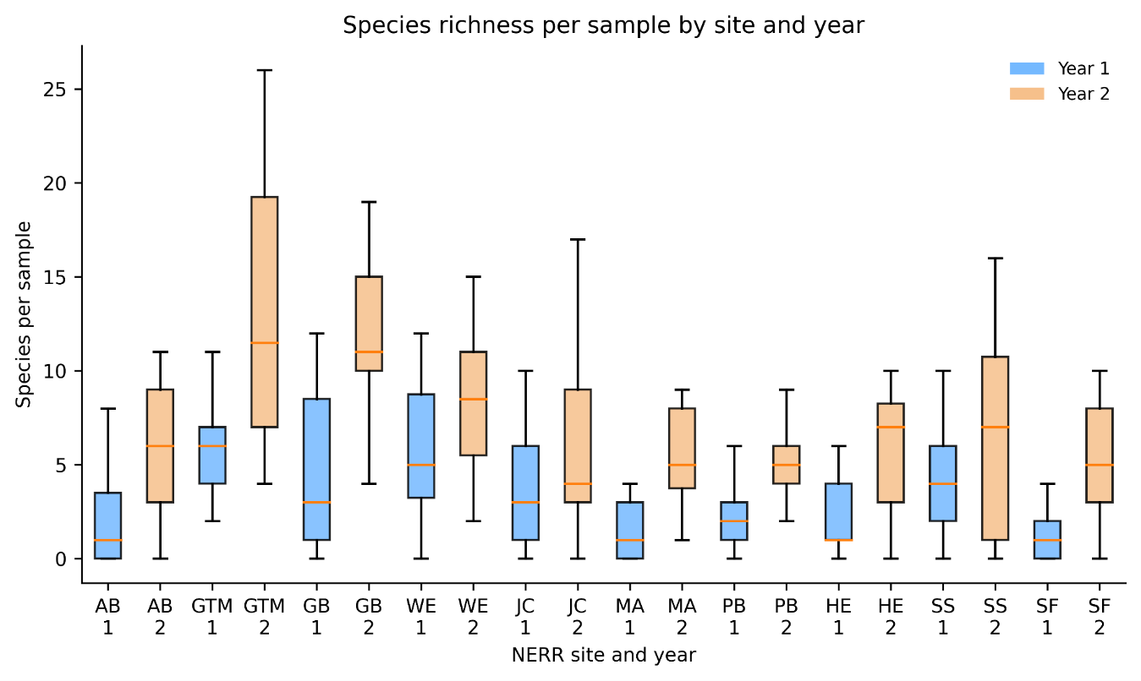

Fig. S1 Number of fish species detected at each site with yr1 protocol vs yr2 protocol. The change in methods increased detection, but reduced compatibility of year to year comparisons

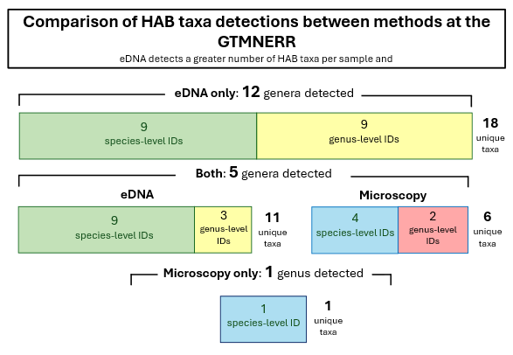

Fig S2. Comparing eDNA methods to GTMNERR’s microscopy-based HAB dataset using samples collected concurrently (n = 9). eDNA detects a greater number of genera (eDNA: 17, microscopy: 6) and species (eDNA: 18, microscopy: 5) than microscopy. In the 5 genera shared between both methods eDNA detected nearly double the total number of taxa and species-level identifications. Pellicer Creek (GTMPC) excluded due to samples not being collected concurrently

