A multivariate multi-step LSTM forecasting model for tuberculosis incidence with model explanation in Liaoning Province, China

Enbin Yang^{1,2}, Hao Zhang^{1,2,3}, Xinsheng Guo^{1,2}, Zinan Zang^{1,2}, Zhen Liu^{1,4}, Yuanning Liu^{1,2,3*}

¹College of Computer Science and Technology, Jilin University, 130012, Changchun, China.
²Key Laboratory of Symbolic Computation and Knowledge Engineering of Ministry of Education, Jilin University, 130012, Changchun, China.
³College of Software, Jilin University, 130012, Changchun, China.
⁴Graduate School of Engineering, Nagasaki Institute of Applied Science, 536 Aba-machi, 851-0193, Nagasaki, Japan.
*Correspondence: liuyn@jlu.edu.cn

List and Introduction of Additional Files
- Supplementary Information: this word document includes an introduction to the full names of the factors, as well as additional figures of the model solution.
- Complete data after processing: the data set used for the prediction model in this paper.
- Raw meteorological data: 15 sets of raw meteorological data were obtained from seven monitoring stations.
- Raw economic and social data: 14 sets of raw economic and social data.

When we solved the model, all the factors were given a variable name to simply express the meaning of the factors, as in Supplementary Table T1. Among them, each meteorological data was taken from seven meteorological monitoring stations in Liaoning province, which are Changwu, Chaoyang, Shenyang, Benxi, Yingkou, Dandong, and Dalian. The additional files "raw_economic_and_social_data.xls" and "raw_meteorological_data.xls" store the raw values of all the factor data. values for all factors, however, there are many missing values.
Supplementary Table T1 Variable names and factor names
Factor Category | Variable Name | Factor Name (unit)
Meteorological  data | avr_air_pressure | Average air pressure (hPa)
Meteorological  data | avr_wind_spd | Average 2-minute wind speed (m/s)
Meteorological  data | avr_temp | Average temperature (℃)
Meteorological  data | avr_water_pressure | Average water pressure (hPa)
Meteorological  data | rel_humidity | Average relative humidity (%)
Meteorological  data | day_precipitation | Number of days with daily precipitation ≥ 0.1mm (days)
Meteorological  data | month_sun | Monthly sunshine percentage (%)
Meteorological  data | hour_sun | Sunshine hours (h)
Meteorological  data | extreme_wind_speed | Extreme wind speed (m/s)
Meteorological  data | min_air_pressure | Minimum air pressure (hPa)
Meteorological  data | min_temp | Minimum temperature (℃)
Meteorological  data | max_air_pressure | Maximum air pressure (hPa)
Meteorological  data | max_temp | Maximum temperature (℃)
Meteorological  data | max_wind_speed | Maximum wind speed (m/s)
Meteorological  data | day_max_precipitation | Maximum daily precipitation (mm)
Economic  and  social data | power | Electricity generation (billion kWh)
Economic  and  social data | industrial_add | Value added of industries above the scale  (Year-on-year growth %)
Economic  and  social data | sales_rate | Industrial product sales rate (%)
Economic  and  social data | fin_budget | Local budget revenue (cumulative growth %)
Economic  and  social data | cpi_rural | Rural Consumer Price Index
Economic  and  social data | cpi_urban | Urban Consumer Price Index
Economic  and  social data | cpi | Average Consumer Price Index
Economic  and  social data | pas_turn_road | Road passenger turnover
Economic  and  social data | pas_turn_water | Waterway passenger turnover
Economic  and  social data | pas_turn | Average passenger turnover
Economic  and  social data | im_ex | Total value of imports and exports to and from domestic destinations/sources (thousands of USD)
Economic  and  social data | residential_investment | Residential investment volume  (Cumulative year-on-year %)
Economic  and  social data | ex_factory_index | Ex-factory price index of industrial products

Supplementary Figure F1 AIC and BIC heat maps of the ARIMA model

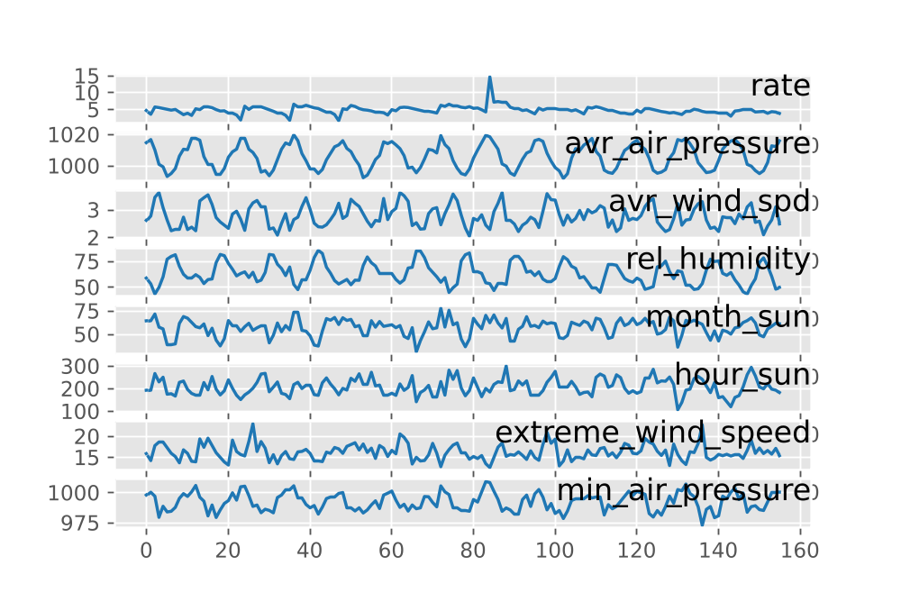
Supplementary Figure F2 Relationship between morbidity and various factors

