Supplementary materials

Efficacy and safety of first line systemic therapies for mTNBC patients ineligible/not candidate for anti-PD-(L)1 inhibitors: A systematic review and network meta-analysis

Supplementary methods 2
Research query 2
Supplementary Tables 3
Supplementary Table 1: P-scores in the primary analysis including 3
Supplementary Table 2: P-scores in the secondary analysis including all treatment 3
Supplementary Figures 4
Supplementary Figure 1. Network for the secondary analysis including PARPis 4
Supplementary Figure 2. Forest plot with efficacy outcomes in the secondary analysis 5
Supplementary Figure 3. Risk of bias analysis 6

Supplementary methods

Research query
(trial OR study OR randomized OR randomised OR randomly) AND (breast OR mammary) AND (cancer OR neoplasm OR oncology OR tumor OR malignancy OR carcinoma OR adenocarcinoma) AND (metastasis OR metastatic OR advanced OR secondary OR recurrent OR inoperable OR disseminated OR incurable OR relapsed) AND (first line OR first-line) AND (chemotherapy OR cyclophosphamide OR physician’s choice OR TPC OR methotrexate OR fluorouracil OR 5FU OR 5-FU OR doxorubicin OR epirubicin OR paclitaxel OR docetaxel OR liposomal doxorubicin OR pegylated liposomal doxorubicin OR nab-paclitaxel OR nab paclitaxel OR albumin-bound paclitaxel OR pegylated OR eribulin OR capecitabine OR vinorelbine OR carboplatin OR cisplatin OR platinum OR gemcitabine OR metronomic OR bevacizumab OR ixabepilone OR iniparib OR veliparib OR PARP inhibitor OR high dose OR dose-dense OR dose-intense OR dose dense OR dose intense OR olaparib OR talazoparib OR sacituzumab-govitecan OR govitecan OR pembrolizumab OR atezolizumab OR datopotamab-deruxtecan OR deruxtecan OR sacituzumab-tirumotecan OR tirumotecan OR trastuzumab-deruxtecan)

Supplementary Tables

Supplementary Table 1. P-scores in the primary analysis
P-scores | PFS analysis | OS analysis | ORR analysis
Dato-DXd | 0.90 | 0.93 | 0.99
Sacituzumab govitecan | 0.77 | 0.46 | 0.33
Bevacizumab plus CT | 0.72 | 0.64 | 0.80
Atezolizumab plus CT | 0.27 | 0.30 | 0.54
Pembrolizumab plus CT | 0.24 | 0.28 | 0.14
CT alone | 0.09 | 0.39 | 0.20
Legend. CT: Chemotherapy; PFS: Progression-free survival; ORR: Overall response rate; OS: Overall survival.

Supplementary Table 2. P-scores in the secondary analysis including all treatment
P-scores | PFS analysis | OS analysis | ORR analysis
Olaparib | 0.75 | 0.96 | 0.81
Talazoparib | 0.74 | 0.74 | 0.82
Dato-DXd | 0.78 | 0.69 | 0.92
Sacituzumab govitecan | 0.66 | 0.35 | 0.23
Bevacizumab plus CT | 0.61 | 0.51 | 0.60
Atezolizumab plus CT | 0.20 | 0.22 | 039
Pembrolizumab plus CT | 0.18 | 0.22 | 0.10
CT alone | 0.07 | 0.30 | 0.14
Legend. CT: Chemotherapy; PFS: Progression-free survival; ORR: Overall response rate; OS: Overall survival.

Supplementary Figures

Supplementary Figure 1. Network for the secondary analysis including PARPi
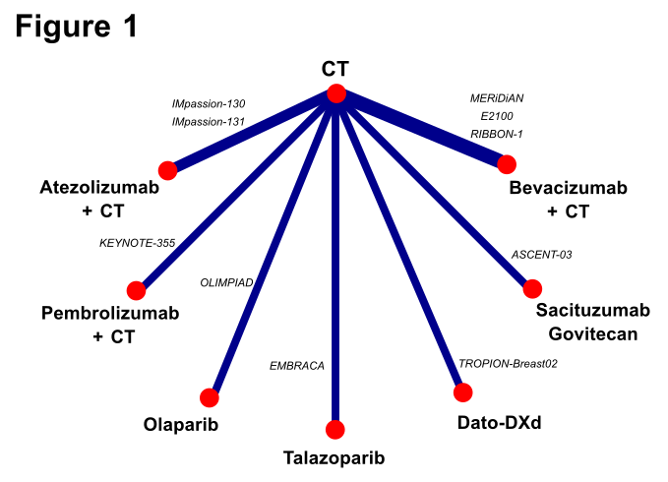
Legend. CT: chemotherapy; PARPi: poly(ADP-ribose) polymerase inhibitors. PARPi were included in the secondary analysis.

Supplementary Figure 2. Forest plot with efficacy outcomes in the secondary analysis
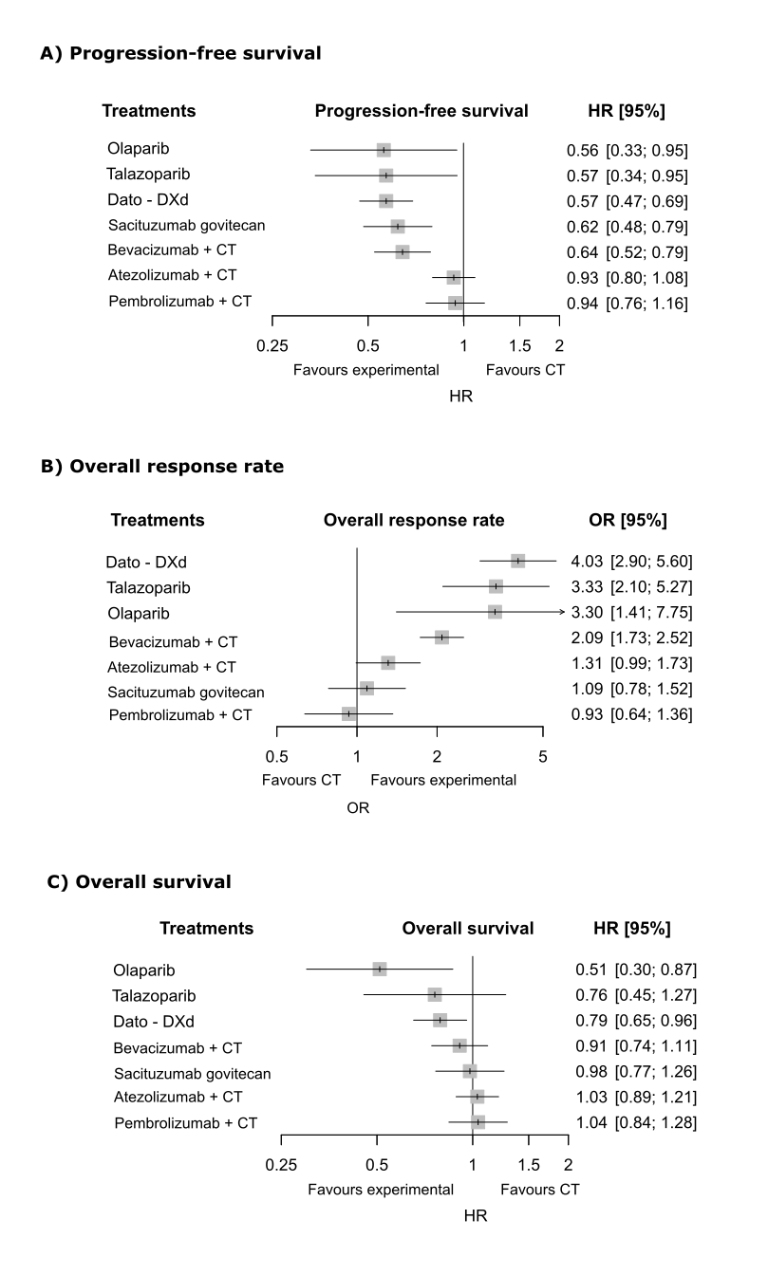
Legend. HR: hazard ratio; CI: confidence interval; CT: chemotherapy; Dato-DXd: datopotamab-deruxtecan.

Supplementary Figure 3. Risk of bias analysis

Legend. A: RoB for the PFS analysis; B: RoB for the OS analysis; C: RoB for the ORR analysis. ORR: overall response rates; OS: overall survival; PFS: progression-free survival; RoB: risk of bias. The bar plots illustrate the relative impact of each domain on the overall risk of bias for each endpoint selected.

