Supplementary material

Supplementary Figure 1. The MIA is calculated by dividing the total interglomerular area (minimum area between glomeruli, except GSG, in yellow) by the number of glomeruli (except GSG, in red) minus one.

$$Mean interglomerular area ({μm}^{2}) = \frac{total interglomerular area ({μm}^{2})}{total number of glomeruli except GSG - 1}$$

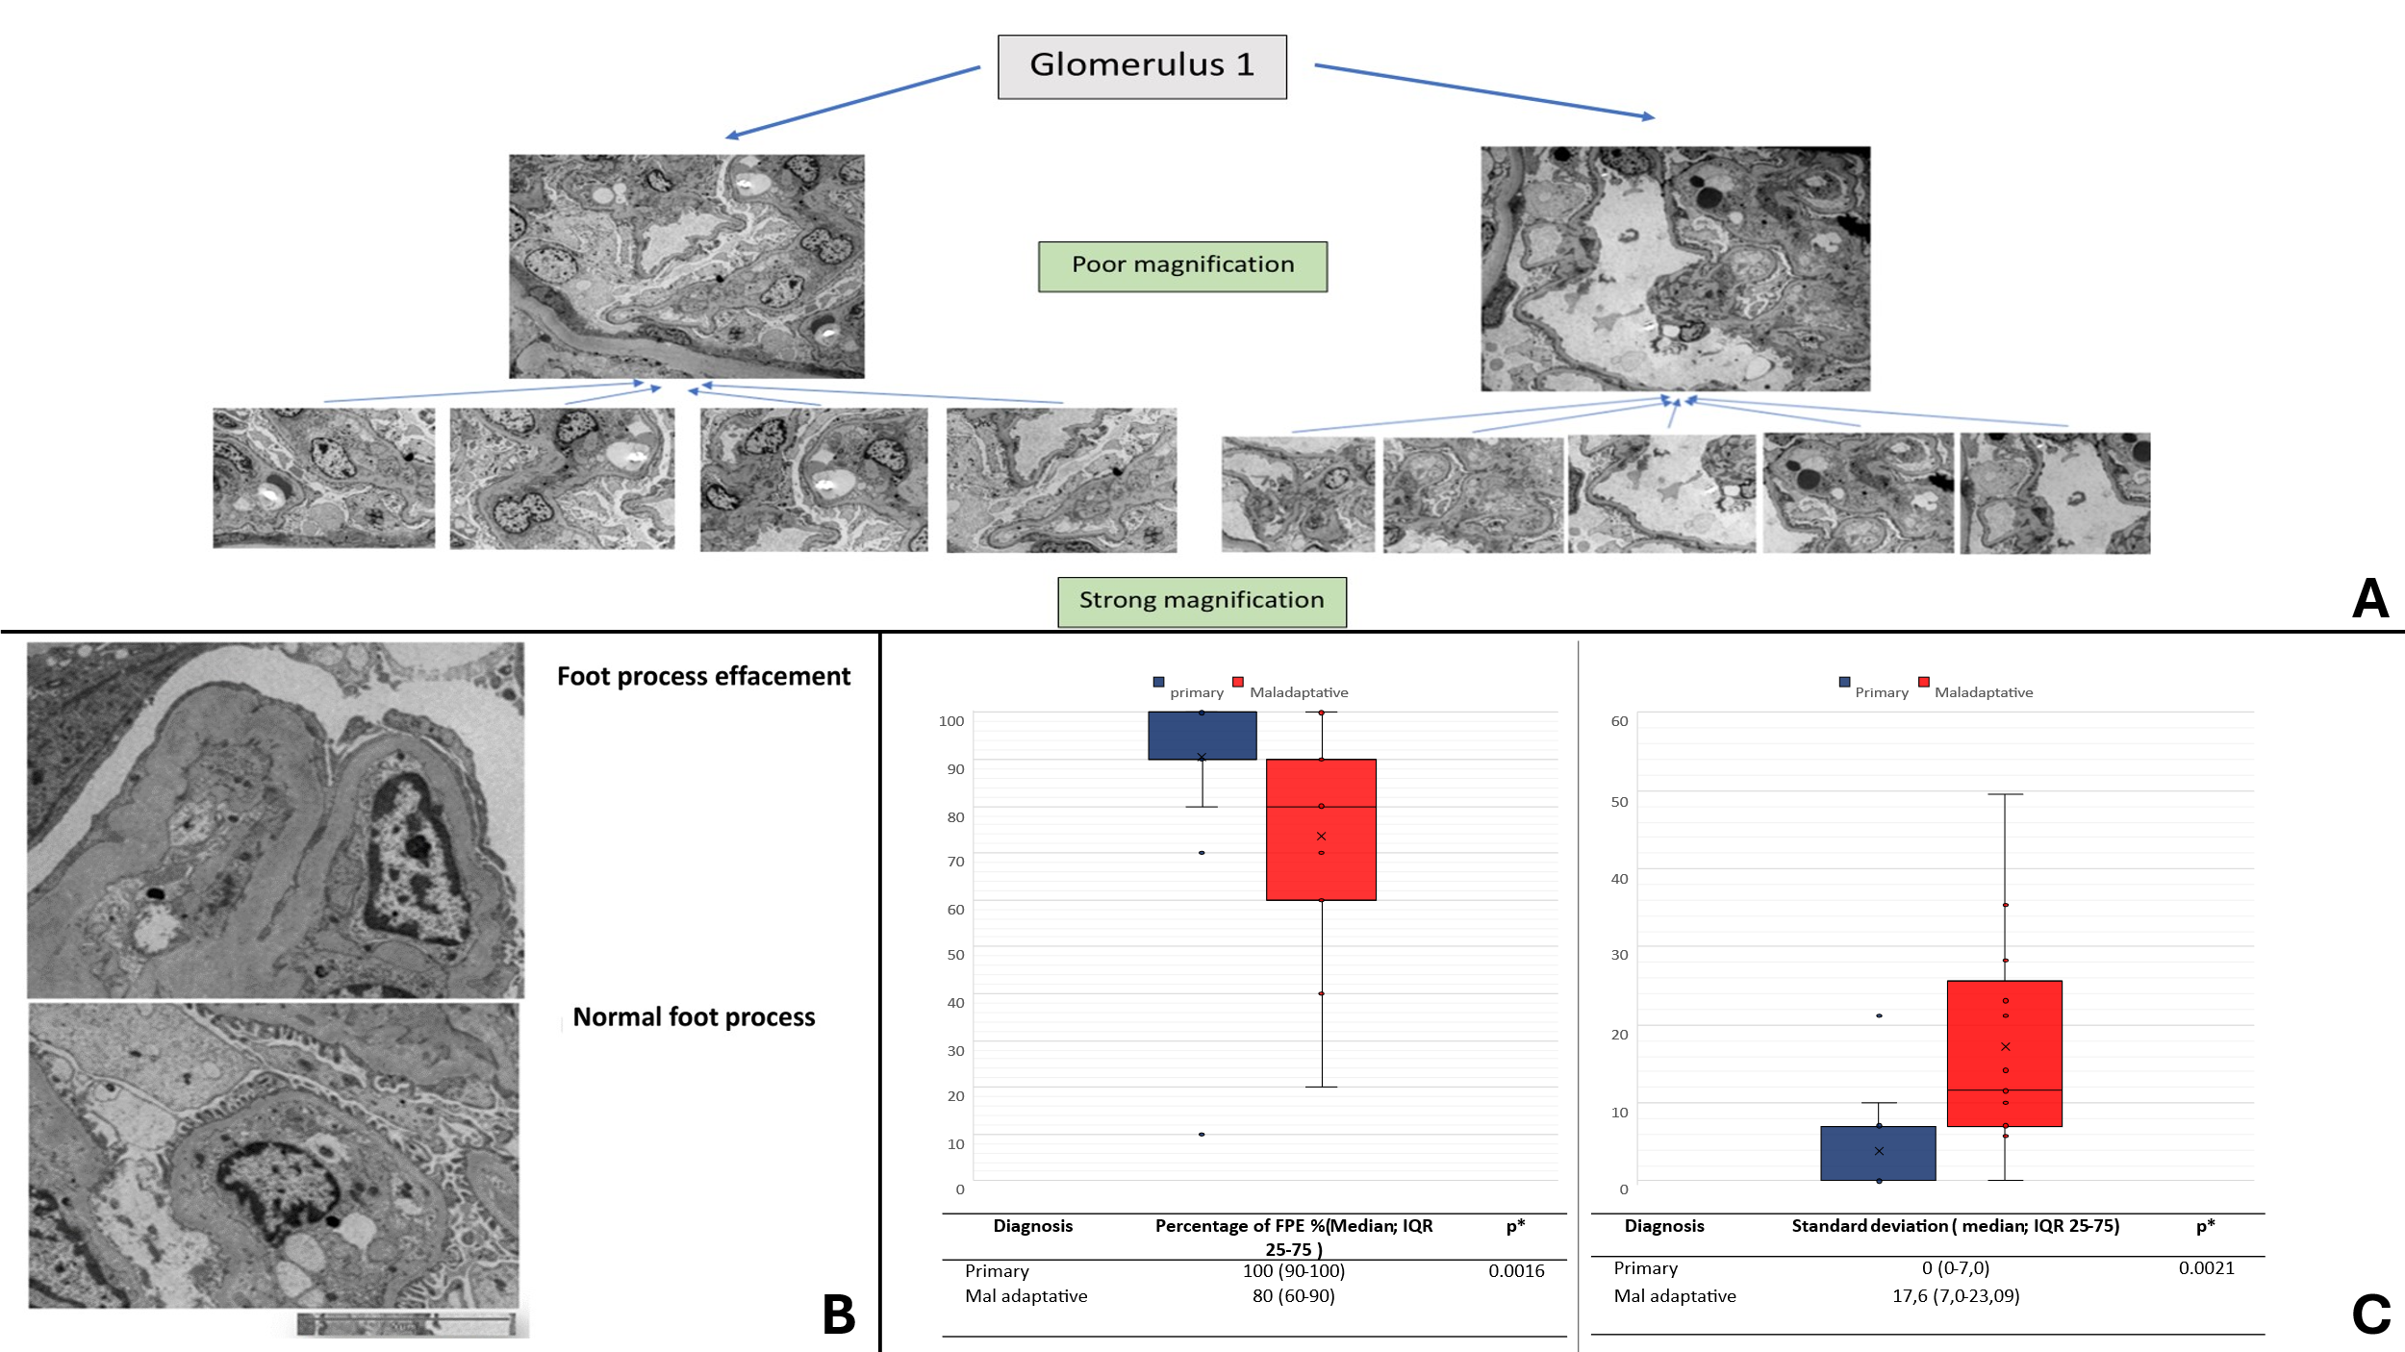
Supplementary Figure 2 Foot process effacement in electronic microscopy: Of the 58 patients included in the study, electron microscopy analysis was possible for 38. A For each patient included who had a sample for study by electron microscopy, we analysed 1 to 3 glomeruli depending on the quality of the sample. The mean number of glomeruli studied per patient was 1.89 (+/- 0.76), and the number of capillary vascular coves analyzed per patient was 27 (+/- 12.08). Each section of glomerulus was studied at two different magnifications: a lower magnification for the study of 2 to 5 sections per glomerulus and a higher magnification for the study of each zone of the same section, allowing better analysis of podocyte abnormalities. For each glomerulus studied, we established a semi-quantitative evaluation of the deletion of the feet of the podocytes from 10% to 10%. B example of preserved foot process and foot process effacement. C Electronic microscopy between primary and maladaptive FSGS in Tenon’s cohort : Left: Comparison of percentage of FPE between primary and maladaptative FSGS, right : comparison of standard deviation of percentage of FPE between each glomerulus per patient (analyze done on 25/38 patients who had more than one glomerulus studied), Interestingly, in the primary FSGS group, the standard deviation of podocyte foot effacement between each glomerulus studied per patient was significantly lower than in the maladaptive FSGS group (0.0 (0.0-7.0) vs. 11.0 (7.0-23.09), p= 0.0021), possibly reflecting a greater homogeneity of podocyte involvement in the case of a diagnosis of primary FSGS; * compared with Mann-Withney-Wilcoxon test
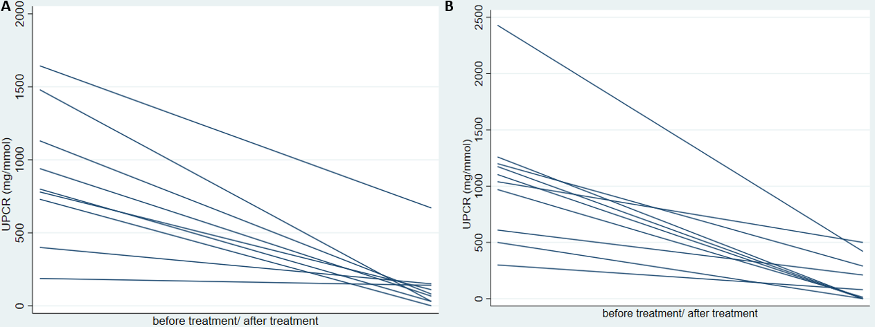Supplementary Figure 3. Evolution of proteinuria after treatment in patient with primary FSGS in developmental cohort .A. Observation cohort B. Validation cohort

