Supplementary Information

First-in-human in vivo imaging and quantification of monoacylglycerol lipase in the brain: A PET study with ¹⁸F-T-401

Keisuke Takahata^{1,2}, Chie Seki¹, Yasuyuki Kimura^{1,3}, Manabu Kubota^{1,4}, Masanori Ichise^{1,3}, Yasunori Sano¹, Yasuharu Yamamoto¹, Kenji Tagai¹, Hitoshi Shimada^{1,5}, Soichiro Kitamura¹, Kiwamu Matsuoka¹, Hironobu Endo¹, Hitoshi Shinotoh¹, Kazunori Kawamura⁶, Ming-Rong Zhang⁶, Yuhei Takado¹, Makoto Higuchi¹

- Department of Functional Brain Imaging, Institute for Quantum Medical Science, Quantum Life and Medical Science Directorate, National Institutes for Quantum Science and Technology, 4-9-1 Anagawa, Inage, Chiba, Chiba, Japan
- Department of Neuro-Psychiatry, Keio University School of Medicine, 35 Shinanomachi, Shinjuku, Tokyo, Japan
- Department of Clinical and Experimental Neuroimaging, Center for Development of Advanced Medicine for Dementia, National Center for Geriatrics and Gerontology, 7-430 Morioka, Obu, Aichi, Japan
- Department of Psychiatry, Graduate School of Medicine, Kyoto University, 54 Shogoin-Kawara-cho, Sakyo-ku, Kyoto, Japan
- Department of Functional Neurology & Neurosurgery, Center for Integrated Human Brain Science, Brain Research Institute, Niigata University, 1-757 Asahimachi-Dori, Chuo, Niigata, Niigata, Japan
- Department of Advanced Nuclear Medicine Sciences, National Institute of Radiological Sciences, National Institute of Radiological Sciences, National Institutes for Quantum Science and Technology, 4-9-1 Anagawa, Inage, Chiba, Chiba, Japan

Supplementary Methods
- Measurement of ¹⁸F-T-401 in plasma
To obtain arterial input functions, arterial blood samples were taken manually 35 times after injection of ¹⁸F-T-401 at time points with 10-s intervals at 0 - 2 min, 30-s intervals at 2 - 3 min, 1-min intervals at 3 - 10 min, at 12, 15, 20, 25, 30 min, and with 10-min intervals at 30 - 120 min after injection. An aliquot of each blood sample was centrifuged to obtain plasma. Plasma and whole blood radioactivity concentrations were measured with an auto-gamma counter (WIZARD 1480, Perkin Elmer). The plasma free fraction was measured by ultrafiltration (Centrifree, Merck Millipore, Billerica, MA) in triplicate.
The fractions of the parent radioligand and its radiometabolites in plasma were determined by high-performance liquid chromatography (HPLC) from eight samples in each scan (collected at 3, 10, 20, 30, 50, 70, 90, and 120 min after ¹⁸F-T-401 injection). A plasma sample was deproteinized with an equivalent volume of acetonitrile by centrifugation. An aliquot of the supernatant was analyzed by radio-HPLC (Analytical column: Waters XBridge OST C18 (10 x 50 mm; particle size, 2.5 μm), acetonitrile (90 %; A) and ammonium acetate (0.02 M; B) were used as mobile phases (40/60 A/B) at a flow rate of 5.0 mL/min. Radioactivity of the eluent was detected with a house-made NaI(Tl) scintillation detector system (1).

- Assessment of test-retest reproducibility
Test–retest reproducibility was assessed by calculating intrasubject variability and test–retest reliability. The absolute variability (Var) was defined as the absolute value of the difference in the parameter between the first (Scan1) and second (Scan2) measurements expressed as the percentage of the mean value of the two measurements as follows:
$$Var\left(\%\right)=\left|\frac{Scan1-Scan2}{(Scan1+Scan2)×0.5}\right|×100$$
A measure of the test–retest reliability was assessed by the intraclass correlation coefficient (ICC) according to the following equation:
$$ICC= \frac{MSBS-MSWS}{MSBS+MSWS}$$
where MSBS is the mean sum of squares between subjects, and MSWS is the mean sum of squares within subjects. This coefficient is an estimate of the reliability of the two sets of measurement and varies from – 1 (no reliability) to + 1 (perfect reliability with identical test and retest estimates). The level of the test-retest reliability is regarded as poor, adequate, and excellent when ICC < 0.40, 0.40 ≤ ICC ≤ 0.75, and 0.75 < ICC ≤ 1.00, respectively.

- 3-tissue compartment model (2-tissue + metabolite compartment model)
Based on the initial analysis of monkeys under pharmacological blocking conditions (1), we considered the possibility that ¹⁸F-T-401 is metabolized inside the brain, and its major radiometabolite does not cross the blood-brain barrier. Then, we modified 2TCM by incorporating a compartment reflecting a radiometabolite converted irreversibly from ¹⁸F-T-401 in the brain. We calculated V_{T} values using this three-tissue compartment model (3TCM) with k₆=0 (2-tissue + metabolite compartment model) (Supplementary Figure 1). V_{T} was calculated as K₁/k₂(1+k₃/k₄), where K₁[mL/min/cm³] and k₂[min⁻¹] represent influx and efflux of the radioligand across the blood-brain barrier, and k₃[min⁻¹] and k₄[min⁻¹] are association and dissociation rate constants of specific binding. To assess whether ¹⁸F-T-401 radiometabolites accumulate in the brain, time stability of V_{T} estimation was examined by increasingly truncating the 120-min scan by 10-minute increments to the shortest length of 30 min.

Supplementary Figure 1. 3-tissue compartment model (2-tissue + metabolite compartment model)
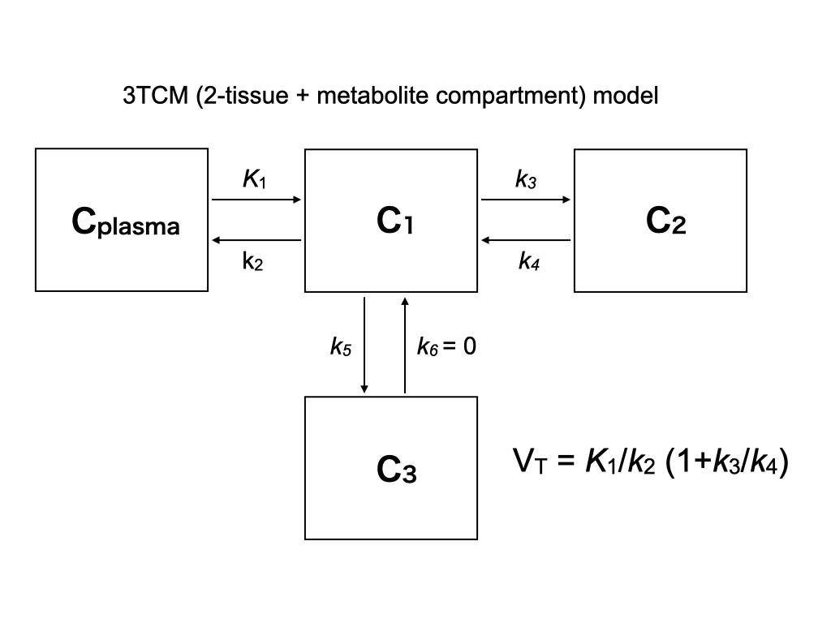

- Correlational analysis of ¹⁸F-T-401 V_{T} values with human brain mRNA levels of MGLL
Recently, several studies have reported that the radioligand binding measured by PET correlates with the mRNA expression level of serotonin receptors in the human brain (2,3). An anatomically comprehensive atlas of the adult human brain transcriptome was recently made freely available by the Human Protein Atlas. In this atlas, publicly available RNA sequencing data generated by the GTEx consortium (4) and cap analysis of gene expression (CAGE) data from the FANTOM consortium (5) were integrated with data from the Human Protein Atlas program (6), generating a mRNA sequencing atlas for a total of 1710 samples from selected human brain regions. Details of the procedures for tissue collection and processing are reported in Sjöstedt’s paper (7). For each of the three transcriptomics datasets, within-sample normalization and between-sample normalization were performed as described in the technical information of the Human Protein Atlas, resulting in normalized expression levels of each gene across 10 brain regions.
In the current study, we used this atlas as a source of mRNA transcription maps of MGLL, a gene coding MAGL. We extracted normalized expression value for the cerebral cortex, hippocampal formation, basal ganglia, cerebellum, midbrain and pons. Comparison between mRNA expression levels with ¹⁸F-T-401 V_{T} values was performed by correlation analysis. Due to the limited number of genomic samples per region, we could not assume normal distribution of the expression data. We therefore employed nonparametric statistics. To match regions of interest, mRNA expression levels in the cortex were compared with the average of V_{T} values in the frontal, temporal, parietal, occipital and cingulate.

Supplementary Results
- Test-retest reliability of Logan graphical analysis and 2TCM
V_{T} values in the first and second PET sessions showed excellent test-retest reproducibility in all brain regions (Supplementary Figure 2)

Supplementary Figure 2. Test-retest reliability of 2TCM
Regional V_{T} values of scan 1 (black) and scan 2 (gray) estimated by MA1 (A), Logan graphical analysis (B) and 2TCM (C) are shown. The vertical line indicates standard deviation.

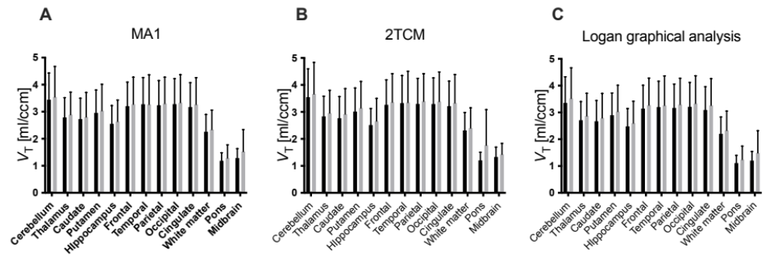

- 3-tissue compartment model (2-tissue + metabolite compartment model)
Compared to 2TCM, 3TCM showed unstable estimation with a standard error of 5.5%, perhaps due to the effect of the estimation of micro-parameters such as k₅. Time-stability analysis showed that V_{T} values estimated by 3TCM gradually increased throughout all scan lengths (Supplementary Figure 3). 3TCM V_{T} values showed an average negative bias of -4.1% ± 2.4% when the 90-min time interval was used, and showed an average negative bias of -15.4% ± 11.2% when the 60-min time interval was used. These data showed that 2TCM is more suitable for quantification of MAGL in the human brain, and that 60 min of scanning with ¹⁸F-T-401 is adequate.

Supplementary Table 1. Parameters estimated for ¹⁸F-T401 PET data with 3TCM in human brain.
Kinetic rate constants (K₁, k₂, k₃, k₄ and k₅) and total distribution volume (V_{T}) from 7 subjects are shown as mean ± SD. Brain regions and median standard errors are also listed and are expressed as % of the variable itself.

Region |  | K₁ [mL/ccm/min] | % SE | k₂ [1/min] | % SE | k₃ [1/min] | % SE | k₄ [1/min] | % SE | k₅ [1/min] | % SE | V_{T} [ml/ccm] | % SE
Cerebellum |  | 0.2 ± 0.13 | 4.4 | 0.6 ± 5.62 | 12.7 | 0.3 ± 2.24 | 14.8 | 0.062 ± 0.009 | 7.5 | 0.02 ± 0.019 | 16 | 2.38 ± 0.66 | 3.7
Thalamus |  | 0.14 ± 0.07 | 4.5 | 0.33 ± 5.41 | 16.9 | 0.26 ± 3.71 | 18 | 0.077 ± 0.013 | 6.9 | 0.01 ± 0.007 | 19 | 2.18 ± 0.49 | 4.8
Hippocampus |  | 0.17 ± 0.1 | 6.4 | 0.7 ± 6.69 | 17.9 | 0.36 ± 4.33 | 16.5 | 0.064 ± 0.008 | 7.6 | 0.02 ± 0.011 | 20.1 | 1.8 ± 0.44 | 4.1
Frontal |  | 0.15 ± 0.07 | 3.5 | 0.31 ± 6.74 | 15.1 | 0.3 ± 4.85 | 16.5 | 0.089 ± 0.02 | 5.7 | 0.01 ± 0.005 | 23.4 | 2.85 ± 0.7 | 3.4
Temporal |  | 0.16 ± 0.08 | 4.6 | 0.43 ± 7.38 | 17.1 | 0.37 ± 5.26 | 14.6 | 0.074 ± 0.014 | 5.8 | 0.01 ± 0.008 | 24.1 | 2.78 ± 0.68 | 3.1
Parietal |  | 0.15 ± 0.06 | 3.5 | 0.29 ± 7.65 | 15.4 | 0.32 ± 3.39 | 15.3 | 0.093 ± 0.02 | 5.4 | 0.01 ± 0.005 | 21.1 | 2.85 ± 0.68 | 3.2
Occipital |  | 0.37 ± 0.21 | 6.2 | 2.7 ± 8.03 | 12.8 | 0.81 ± 3.41 | 10.6 | 0.067 ± 0.016 | 5.2 | 0.03 ± 0.026 | 16.8 | 2.66 ± 0.71 | 2.6
Cingulate |  | 0.25 ± 0.13 | 8.2 | 1.93 ± 10.32 | 18 | 0.95 ± 3.06 | 15 | 0.071 ± 0.016 | 7.2 | 0.03 ± 0.024 | 30.7 | 2.7 ± 0.76 | 3.6
Pons |  | 0.12 ± 0.07 | 10.2 | 0.59 ± 16.22 | 27.6 | 0.23 ± 14.86 | 44.6 | 0.111 ± 0.025 | 22.9 | 0.01 ± 0.01 | 24.6 | 0.74 ± 0.18 | 19.9
Midbrain |  | 0.14 ± 0.1 | 7.9 | 0.69 ± 13.97 | 18.9 | 0.24 ± 12.27 | 29.6 | 0.112 ± 0.041 | 16.8 | 0.02 ± 0.012 | 15.9 | 0.71 ± 0.14 | 7.2

Supplementary Figure 3. Time-stability analysis of V_{T} estimation by 2TCM, Logan graphical analysis and 3TCM
Results of time-stability analysis of V_{T} values estimated by 2TCM (A), Logan graphical analysis (B) and 3TCM (C) were plotted as a function of duration of image acquisition, which truncated from 120 to 30 min. Values are normalized as percentage of terminal value attained from 120 min of imaging. Dotted lines indicate 100% of the normalized V_{T} value. Time-stability analysis showed that V_{T} values estimated by 2CTM and Logan graphical analysis were stable in the stepwise truncation of the dynamic data from 120 to 60 min. 3TCM showed that V_{T} values gradually increased throughout all scan lengths.
A
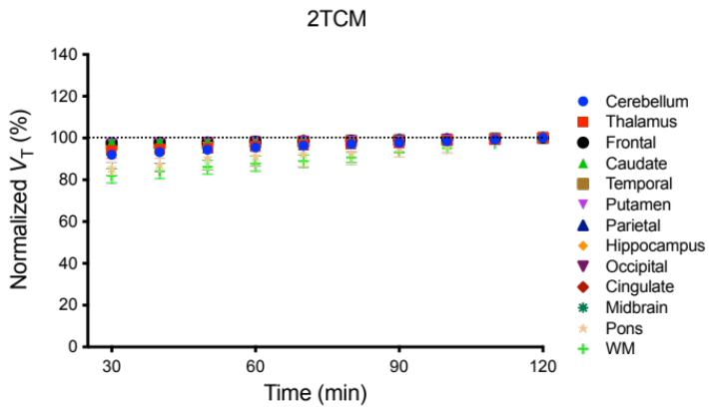
B
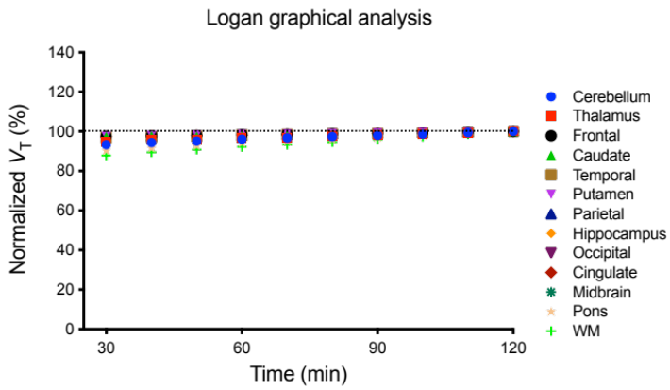
C
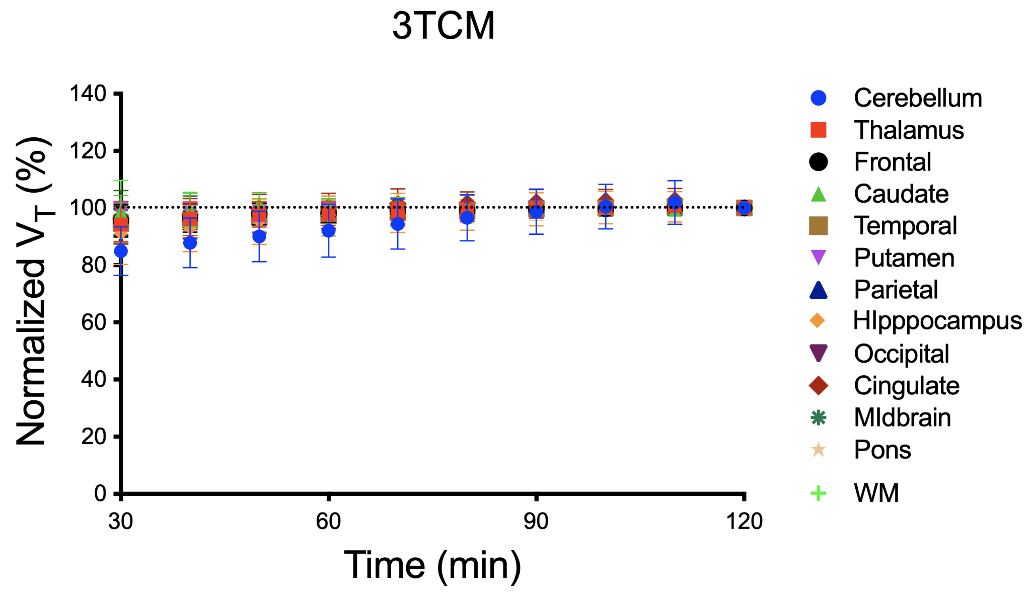
References
1. Takei M, Kida T, Suzuki K. Sensitive measurement of positron emitters eluted from HPLC. Appl Radiat Isot. 2001;55:229-234.
2. Beliveau V, Ganz M, Feng L, et al. A High-Resolution In Vivo Atlas of the Human Brain’s Serotonin System. J Neurosci. 2017;37:120-128.
3. Rizzo G, Veronese M, Heckemann RA, et al. The predictive power of brain mRNA mappings for in vivo protein density: a positron emission tomography correlation study. J Cereb Blood Flow Metab. 2014;34:827-835.
4. GTEx Consortium. Erratum: Genetic effects on gene expression across human tissues. Nature. 2018;553:530-530.
5. Noguchi S, Arakawa T, Fukuda S, et al. FANTOM5 CAGE profiles of human and mouse samples. Sci Data. 2017;4:170112.
6. Tissue-based map of the human proteome. https://www-science-org.kras1.lib.keio.ac.jp/doi/epdf/10.1126/science.1260419.
7. Sjöstedt E, Zhong W, Fagerberg L, et al. An atlas of the protein-coding genes in the human, pig, and mouse brain. Science. 2020;367.

