Supplementary Figures S1-S3
Supplementary Figure S1: Participant Disposition

246 Potential participants from the EBOVAC-Salone trial control group

98 Not enrolled in the EBL2012 study:
1 deceased
1 already vaccinated against Ebola
21 not interested
16 relocated to another area
59 unreachable

148 agreed to participate and were screened

129 completed the study
1 participant returned for the last visit of the study
128 received dose 2 vaccination
133 enrolled in the study and received dose 1 vaccination
15 screening failures:
13 did not meet laboratory inclusion criteria
2 lost to follow-up after screening

5 did not receive dose 2 vaccination
2 withdrawal of consent
2 lost to follow-up
1 missed the visit

Supplementary Figure S2. Representative IFN-γ ELISpot plate images

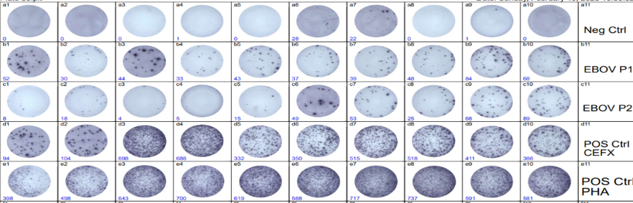
Representative images of IFN-γ ELISpot wells following stimulation of PBMCs with EBOV GP peptide pools. Shown are examples of (top to bottom): negative control (medium only), antigen-specific stimulation (EBOV GP peptide Pool 1 or Pool 2), and positive control (e.g., PHA or CEFX). Samples are run in duplicates, and each pair of columns represents a sample (e.g., a1 & a2, a3 & a4, a5 & a6, etc)
Spots represent individual IFN-γ–secreting cells. Images are representative of responses observed across participants at D78 (21 days post-dose 2 vaccination)

Supplementary Figure S3. Gating strategy for intracellular cytokine staining and flow cytometry

