Supplemental Table 1. List of 54 myeloid neoplasm-relevant genes studied in targeted NGS sequencing
Gene name | Target region (exon) | Gene name | Target region (exon)
ABL | 4-6 | JAK3 | 13
ASXL1 | 12 | KDM6A | full
ATRX | 8-10, 17-31 | KIT | 2, 8-11, 13, 17
BCOR | full | KRAS | 2, 3
BCORL1 | full | MLL | 5-8
BRAF | 15 | MPL | 10
CALR | 9 | MYD88 | 3-5
CBL | 8, 9 | NOTCH1 | 26-28, 34
CBLB | 9, 10 | NPM1 | 12
CBLC | 9, 10 | NRAS | 2, 3
CDKN2A | full | PDGFRA | 12, 14, 18
CEBPA | full | PHF6 | Full
CSF3R | 14-17 | PTEN | 5, 7
CUX1 | full | PTPN11 | 3, 13
DNMT3A | full | RAD21 | Full
ETV6 | full | RUNX1 | Full
EZH2 | full | SETBP1 | 4 (partial)
FBXW7 | 9-11 | SF3B1 | 13-16
FLT3 | 14, 15, 20 | SMC1A | 2, 11, 16, 17
GATA1 | 2 | SMC3 | 10, 13, 19, 23, 25, 28
GATA2 | 2-6 | SRSF2 | 1
GNAS | 8, 9 | STAG2 | full
HRAS | 2, 3 | TET2 | 3-11
IDH1 | 4 | TP53 | 2-11
IDH2 | 4 | U2AF1 | 2, 6
IKZF1 | full | WT1 | 7, 9
JAK2 | 12, 14 | ZRSR2 | full

Supplemental Table 2. Classification based on French-American-British classification, 2016, 2022 World Health Organization classification and International Consensus Classification
Classification | Number (%) | Classification | Number (%)
FAB |  | AML with
RA | 23 (12.0) | NPM1 | 11 (5.7)
RAS | 7 (3.6) | MDS-related genes mutations | 17 (8.9)
RAEB | 107 (55.7) | MDS-related cytogenetics | 3 (1.6)
RAEB-T | 55 (28.6) | NUP98 rearrangement | 3 (1.6)
2016 WHO classification |  | defined by differentiation | 27 (14.1)
MDS-5q | 1 (0.5) | ICC
MDS-SLD | 5 (2.6) | MDS
MDS-MLD | 17 (8.9) | del(5q) | 1 (0.5)
MDS-RS-SLD | 3 (1.6) | mutated SF3B1 | 6 (3.1)
MDS-RS-MLD | 4 (2.1) | NOS, with SLD | 5 (2.6)
MDS-EB1 | 51 (26.6) | NOS, with MLD | 18 (9.4)
MDS-EB2 | 56 (29.2) | EB | 51 (26.6)
MDS-U | 0 (0.0) | mutated TP53 | 5 (2.6)
AML with MRC | 10 (5.2) | MDS/AML
Therapy relaetd AML | 2 (1.0) | MDS-related genes mutations | 28 (14.6)
AML with mutated NPM1 | 7 (3.6) | MDS-related cytogenetics | 1 (0.5)
AML with mutated RUNX1 | 8 (4.2) | mutated TP53 | 2 (1.0)
AML, NOS | 28 (14.6) | NOS | 14 (7.3)
2022 WHO classification |  | AML with
MDS-5q | 1 (0.5) | NPM1 | 10 (5.2)
MDS-SF3B1 | 6 (3.1) | CEBPA | 2 (1.0)
MDS-h | 9 (4.7) | TP53 | 3 (1.6)
MDS-LB | 14 (7.3) | MDS-related genes mutations | 18 (9.4)
MDS-IB1 | 42 (21.9) | MDS-related cytogenetics | 8 (4.2)
MDS-IB2 | 46 (24.0) | NUP98 rearrangement | 2 (1.0)
MDS-f | 9 (4.7) | NOS | 18 (9.4)
MDS-biTP53 | 4 (2.1)
Abbreviations: AML, acute myeloid leukemia; FAB, French-American-British classification; MDS-RS, MDS with ring sideroblasts; ICC, international consensus classification; MDS-EB, MDS with excess blasts; MDS-SLD, MDS with single lineage dysplasia; MDS-MLD, MDS with multilineage dysplasia; MDS-RS-SLD, MDS with ring sideroblasts and single lineage dysplasia; MDS-RS-MLD, MDS with ring sideroblasts and multilineage dysplasia; MDS-U, MDS, unclassifiable; MDS-5q, MDS with low blasts and isolated 5q deletion; MDS-SF3B1, MDS with low blasts and SF3B1 mutation; MDS-LB, MDS with low blasts; MDS-h, hypoplastic MDS; MDS-IB1, MDS with increased blasts-1; MDS-IB2, MDS with increased blasts-2; MDS-f, MDS with fibrosis; MDS-biTP53, MDS with biallelic TP53 inactivation; MRC, myelodysplasia-related changes; NOS, not otherwise specified; RA, refractory anemia; RAS, refractory anemia with ring sideroblasts; RAEB, refractory anemia with excess blasts; RAEB-T, refractory anemia with excess blasts in transformation; WHO, world health organization;

Supplemental Table 3. Genetic landscape
Gene | Number (%) | Gene | Number (%)
Epigenetics modifiers | 104 (54.2) | CBL | 5 (2.6)
DNA methylation | 58 (30.2) | PTPN11 | 10 (5.2)
DNMT3A | 21 (10.9) | JAK2 | 4 (2.1)
TET2 | 16 (8.3) | Transcription factor | 53 (27.6)
IDH1 | 6 (3.1) | CEBPA | 18 (9.4)
IDH2 | 13 (6.8) | CEBPA biZIP | 2 (1.0)
WT1 | 16 (8.3) | RUNX1 | 27 (14.1)
Chromatin modifiers | 60 (31.3) | GATA2 | 7 (3.6)
ASXL1 | 30 (15.6) | ETV6 | 7 (3.6)
EZH2 | 8 (4.2) | Spliceosome-complex | 60 (31.3)
KMT2A | 3 (1.6) | U2AF1 | 28 (14.6)
SETBP1 | 6 (3.1) | SRSF2 | 8 (4.2)
BCOR | 17 (8.9) | ZRSR2 | 10 (5.2)
BCORL1 | 3 (1.6) | SF3B1 | 17 (8.9)
PHF6 | 8 (4.2) | Cohesin complex | 13 (6.8)
Activated signaling | 39 (20.3) | SMC3 | 1 (0.5)
FLT3-ITD | 5 (2.6) | STAG2 | 12 (6.3)
FLT3-TKD | 4 (2.1) | Tumor suppressor | 17 (8.9)
KIT | 3 (1.6) | TP53 | 14 (7.3)
KRAS | 6 (3.1) | CUX1 | 3 (1.6)
NRAS | 12 (6.3) | NPM1 | 13 (6.8)
P values of <0.05 are statistically significant.
Data are presented as n (%).
Note: Large insertion in FLT3-ITD and high GC content in CEBPA limited the detection and quantification by NGS.

Supplemental Table 4. Univariable Cox regression analysis for relapse-free survival (RFS) and overall survival (OS)
Variables  (N=192) | RFS |  | OS
Variables  (N=192) | HR (95% CI) | P value | HR (95% CI) | P value
Age* | 1.02 (1.01-1.04) | 0.006 | 1.02 (1.00-1.04) | 0.019
Male | 1.03 (0.70-1.53) | 0.876 | 1.25 (0.82-1.91) | 0.298
IPSS-M (at diagnosis) |  | 0.002 |  | 0.009
Very low/low | Reference | - | Reference | -
Moderate low | 1.27 (0.36-4.51) | 0.711 | 1.33 (0.30-5.98) | 0.707
Moderate high | 2.31 (0.89-6.03) | 0.086 | 2.82 (0.91-8.76) | 0.072
High | 1.90 (0.74-4.85) | 0.182 | 2.56 (0.86-7.62) | 0.091
Very high | 3.91 (1.67-9.14) | 0.002 | 4.38 (1.58-12.16) | 0.005
IPSS-R (at diagnosis) |  | 0.003 |  | 0.012
Very low/low | Reference | - | Reference | -
Intermediate | 1.77 (0.80-3.96) | 0.161 | 1.95 (0.79-4.84) | 0.149
High | 2.67 (1.23-5.80) | 0.013 | 2.65 (1.10-6.41) | 0.030
Very high | 3.51 (1.64-7.54) | 0.001 | 3.56 (1.50-8.45) | 0.004
IPSS-R (pre-transplant) |  | 0.182 |  | 0.357
Very low/low | Reference | - | Reference | -
Intermediate | 0.87 (0.46-1.62) | 0.650 | 0.91 (0.45-1.83) | 0.787
High | 1.48 (0.88-2.50) | 0.143 | 1.42 (0.80-2.52) | 0.226
Very high | 1.92 (0.81-4.59) | 0.141 | 1.86 (0.72-4.82) | 0.200
Pre-transplant BM blast
<10% | Reference | - | Reference | -
10-<30% | 1.34 (1.06-1.71) | 0.017 | 1.25 (1.05-1.47) | 0.011
Pre-transplant BM blast
<5% | Reference | - | Reference | -
5-30% | 1.74 (1.13-2.67) | 0.012 | 1.59 (1.00-2.54) | 0.052
Pre-transplant MRD by MFC | 1.18 (0.74-1.89) | 0.487 | 1.13 (0.68-1.86) | 0.639
Pre-transplant disease status
CR+CRh+CR_{L} (vs. others) | 1.28 (0.83-1.97) | 0.272 | 0.76 (0.48-1.20) | 0.238
Pre-transplant treatment
HMA monotherapy | 0.82 (0.56-1.21) | 0.323 | 0.82 (0.55-1.24) | 0.354
Venetoclax-based | 1.00 (0.44-2.29) | 0.996 | 0.81 (0.33-2.01) | 0.650
Intensive chemotherapy | 1.62 (1.07-2.45) | 0.022 | 1.41 (0.92-2.18) | 0.117
Post 1-month MRD by MFC | 1.46 (0.88-2.44) | 0.147 | 1.68 (0.99-2.87) | 0.056
Post 1-month MRD by NGS† | 5.12 (2.83-9.24) | <0.001 | 2.44 (1.30-4.61) | 0.006
Conditioning regimen
RIC | Reference | - | Reference | -
MAC | 0.79 (0.63-1.00) | 0.053 | 0.84 (0.66-1.07) | 0.167
Acute GVHD |  | 0.027 |  | <0.001
Grade 0 | Reference | - | Reference | -
Grade 1-2 | 0.84 (0.48-1.45) | 0.529 | 0.86 (0.52-1.42) | 0.559
Grade 3-4 | 2.19 (1.14-4.23) | 0.019 | 2.55 (1.56-4.18) | <0.001
Chronic GVHD |  | 0.005 |  | <0.001
no cGVHD | Reference | - | Reference | -
mild | 0.52 (0.33-0.82) | 0.005 | 0.33 (0.20-0.55) | <0.001
moderate | 0.40 (0.21-0.77) | 0.006 | 0.29 (0.14-0.60) | 0.001
severe | 0.57 (0.29-1.12) | 0.105 | 0.33 (0.15-0.74) | 0.007
Post-transplant maintenance | 0.73 (0.32-1.67) | 0.458 | 0.69 (0.28-1.71) | 0.420
P values of <0.05 are statistically significant.
*As continuous variables analysis.
†DNMT3A, TET2, ASXL1 mutations were excluded.
Abbreviations: BM, bone marrow; CI, confidence interval; CR, complete remission; CR_{L}, CR with limited count recovery; CRh, CR with partial hematologic recovery; MRD, measureable residual disease; GVHD, graft-versus-host disease; HR, hazard ratio; HMA, hypomethylating agents; IPSS-M, Molecular International Prognostic Scoring System; IPSS-R, Revised International Prognostic Scoring System; MRD, measurable residual disease; MFC, multiparametric flow cytometry; MAC, myeloablative conditioning; NGS, next generation sequencing; PR, partial response; PD, progressive disease; RIC, reduced intensity conditioning

Supplemental Table 5. Sensitivity analysis excluding patients diagnosed with AML based on 2016 World Health Organization (WHO) classification, 2022 WHO classification and International Consensus classification (ICC)
Analysis cohort | N | Endpoint | HR (95% CI) | P value
Primary cohort | 192 | RFS | 10.22 (2.84-36.82) | <0.001
Excluding AML by 2016 WHO definition | 137 | RFS | 10.19 (3.07-33.77) | <0.001
Excluding AML by 2022 WHO definition | 130 | RFS | 9.67 (2.91-32.10) | <0.001
Excluding AML by ICC definition | 130 | RFS | 9.45 (2.84-31.44) | <0.001
Primary cohort | 192 | OS | 5.46 (2.04-14.62) | 0.001
Excluding AML by 2016 WHO definition | 137 | OS | 2.97 (0.84-10.55) | 0.092
Excluding AML by 2022 WHO definition | 130 | OS | 2.92 (0.83-10.33) | 0.097
Excluding AML by ICC definition | 130 | OS | 2.96 (0.84-10.47) | 0.092
Abbreviation: AML, acute myeloid leukemia; HR, hazard ratio; RFS, relapse-free survival; OS, overall survival

Supplemental Figure 1. Study flow diagram of patient selection.
Enrollment
Assessed for eligibility
(n = 1687)
HSCT recipients
(n = 288)
Excluded (n = 15)
No cryopreserved BM sample
at 1 month post-transplant
Excluded (n = 81)
Missing diagnostic NGS data or absence of mutations
Excluded (n = 1399)
No HSCT
Analysis
Final cohort
(n = 192)
1-month cryopreserved BM samples available
(n = 192)
NGS at diagnosis available
(n = 207)

Abbreviation: BM, bone marrow; HSCT, allogeneic hematopoietic stem cell transplantation; NGS, next-generation sequencing

Supplemental Figure 2. Time to disease relapse (a), relapse-free survival (RFS) (b) and overall survival (OS) (c) in patients with myelodysplastic syndromes/neoplasms undergoing allogeneic hematopoietic stem cell transplantation (HSCT) according to pre-transplant disease status
(a) | (b)
P=0.001  CR + CR_{L} + CRh, n=63, median time to relapse: not reached  PR, n=7, median time to relapse: 9.4 months  No response, n=98, median time to relapse: not reached  PD, n=20, median time to relapse: 136.2 months | 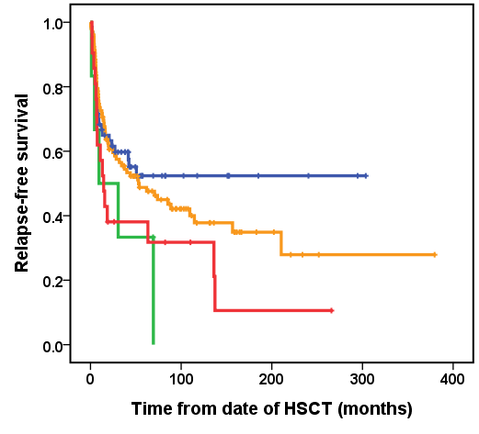  P=0.081  CR + CR_{L} + CRh, n=63, median RFS: not reached  PR, n=7, median RFS: 9.4 months  No response, n=98, median RFS: 53.0 months  PD, n=20, median RFS: 14.5 months
(c)
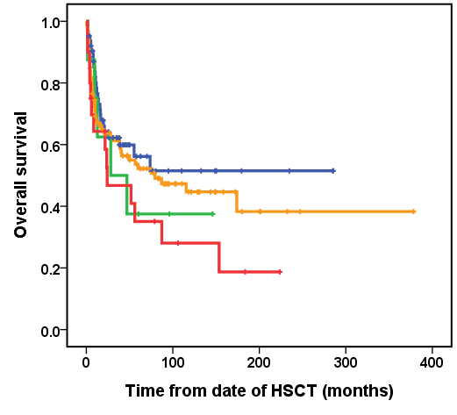
P=0.298
CR + CR_{L} + CRh, n=63, median OS: not reached
PR, n=7, median OS: 28.2 months
No response, n=98, median OS: 79.3 months
PD, n=20, median OS: 24.1 months

Abbreviation: CR, complete remission; CR_{L}, CR with limited count recovery; CRh, CR with partial hematologic recovery; PR, partial response; PD, progressive disease

Supplemental Figure 3. Time to disease relapse (a), relapse-free survival (RFS) (b) and overall survival (OS) (c) in patients with myelodysplastic syndromes/neoplasms undergoing allogeneic hematopoietic stem cell transplantation (HSCT) according to pre-transplant bone marrow blast percentage
(a) | (b)
P=0.36  BM blast <5% (-), n=87, median time to relapse: not reached  BM blast 5-30%, n=67, median time to relapse: 136.2 months | 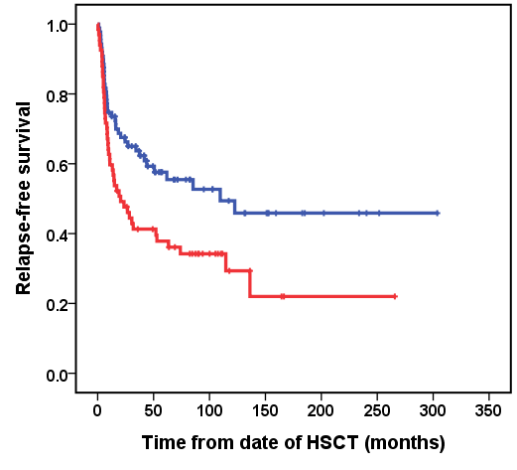  P=0.011  BM blast <5% (-), n=87, median RFS: 109.6 months  BM blast 5-30%, n=67, median RFS: 20.5 months
(c)
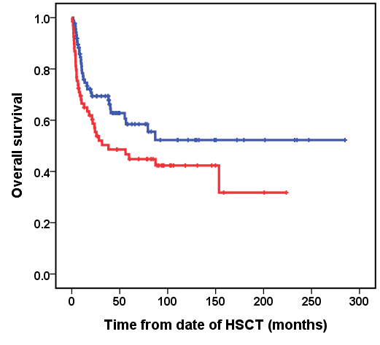
BM blast <5% (-), n=87, median OS: not reached
BM blast 5-30%, n=69, median OS: 38.2 months
P=0.050

Supplemental Figure 4. Time to disease relapse (a), relapse-free survival (RFS) (b), and overall survival (OS) (c) in patients with myelodysplastic syndromes/neoplasms undergoing allogeneic hematopoietic stem cell transplantation (HSCT) according to pre-transplant multiparametric flow cytometry–based measurable residual disease (MRD)
(a) | (b)
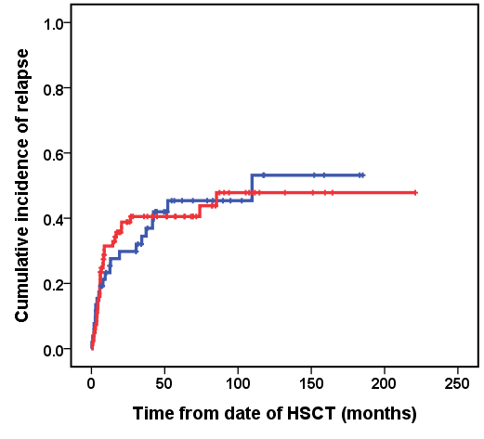  MRD (-), n=52, median time to relapse: 109.6 months  MRD (+), n=77, median time to relapse: not reached  P=0.98 | 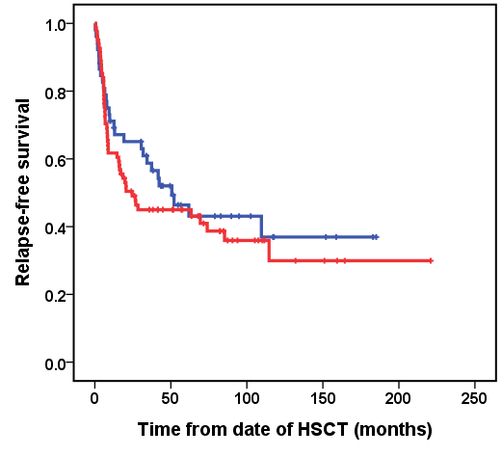  P=0.487  MRD (-), n=52, median RFS: 50.6 months  MRD (+), n=77, median RFS: 24.5 months
(c)
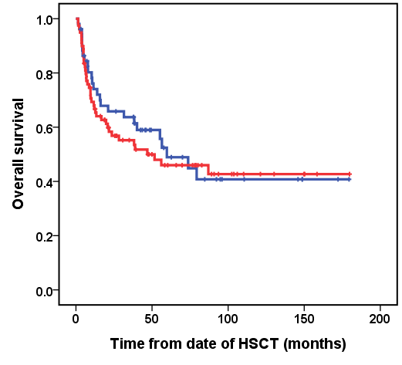
MRD (-), n=52, median OS: 59.7 months
MRD (+), n=79, median OS: 46.9 months
P=0.639

Supplemental Figure 5. Time to disease relapse (a), relapse-free survival (RFS) (b) and overall survival (OS) (c) in patients with myelodysplastic syndromes/neoplasms undergoing allogeneic hematopoietic stem cell transplantation (HSCT) according to next-generation sequencing–based measurable residual disease (MRD) status at 1 month post-transplant.
(a) | (b)
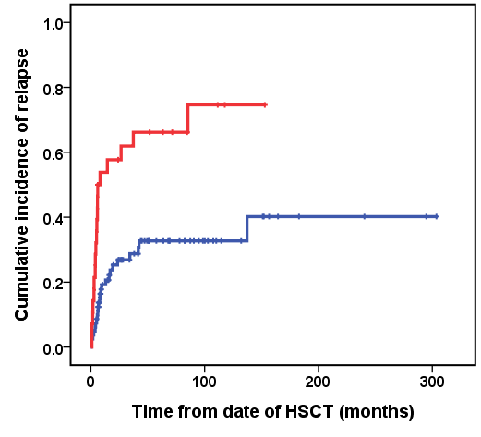  P<0.001  MRD (-), n=79, median time to relapse: not reached  MRD (+), n=28, median time to relapse: 6.0 months | 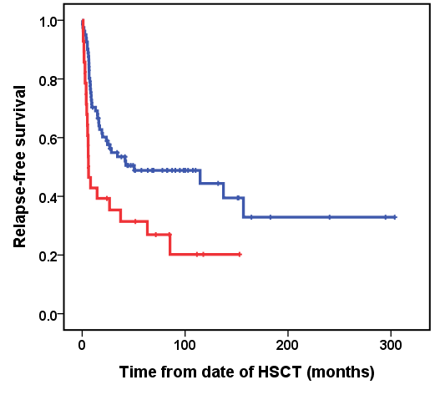  MRD (-), n=79, median RFS: 50.6 months  MRD (+), n=28, median RFS: 6.0 months  P=0.004
(c)
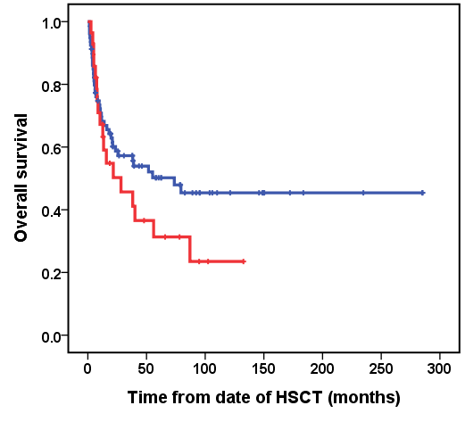
P=0.210
MRD (-), n=80, median OS: 73.7 months
MRD (+), n=28, median OS: 28.2 months

Supplemental Figure 6. Time to disease relapse (a), relapse-free survival (RFS) (b) and overall survival (OS) (c) in patients with revised international prognostic scoring system very low, low, or intermediate-risk group myelodysplastic syndromes/neoplasms at diagnosis undergoing allogeneic hematopoietic stem cell transplantation (HSCT) according to next-generation sequencing–based measurable residual disease (MRD) status at 1 month post-transplant. MRD assessment excluded mutations in DNMT3A, TET2, and ASXL1.
(a) | (b)
P=0.82  MRD (-), n=35, median time to relapse: not reached  MRD (+), n=2, median time to relapse: 5.8 months | 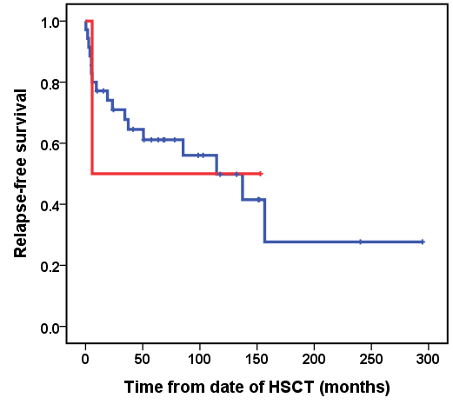  MRD (-), n=35, median RFS: 114.6 months  MRD (+), n=2, median RFS: 5.8 months  P=0.958
(c)
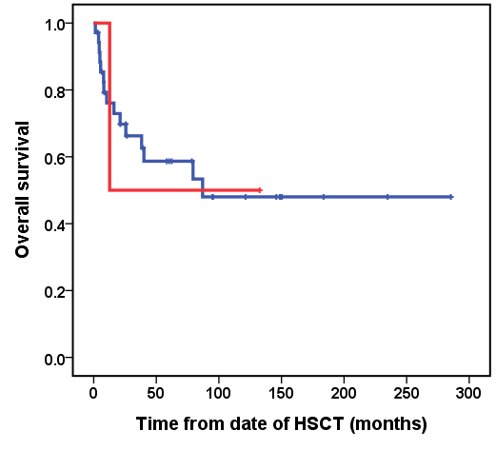
P=0.996
MRD (-), n=35, median OS: 87.0 months
MRD (+), n=2, median OS: 12.7 months

Supplemental Figure 7. Time to disease relapse (a), relapse-free survival (RFS) (b) and overall survival (OS) (c) in patients with revised international prognostic scoring system high or very high-risk group myelodysplastic syndromes/neoplasms at diagnosis undergoing allogeneic hematopoietic stem cell transplantation (HSCT) according to next-generation sequencing–based measurable residual disease (MRD) status at 1 month post-transplant. MRD assessment excluded mutations in DNMT3A, TET2, and ASXL1.
(a) | (b)
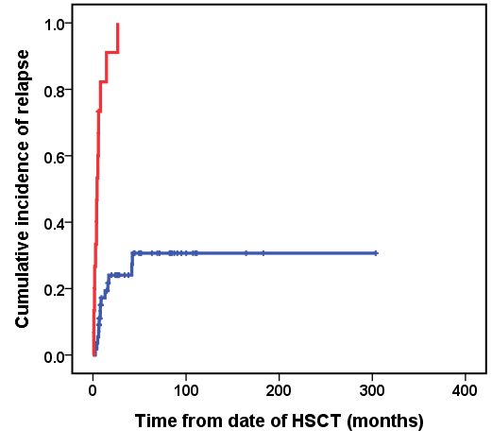  MRD (-), n=55, median time to relapse: not reached  MRD (+), n=15, median time to relapse: 4.4 months  P<0.001 | 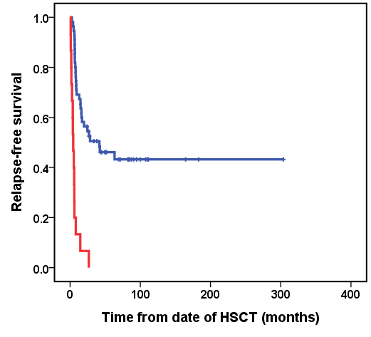  P<0.001  MRD (-), n=55, median RFS: 41.7 months  MRD (+), n=15, median RFS: 4.4 months
(c)
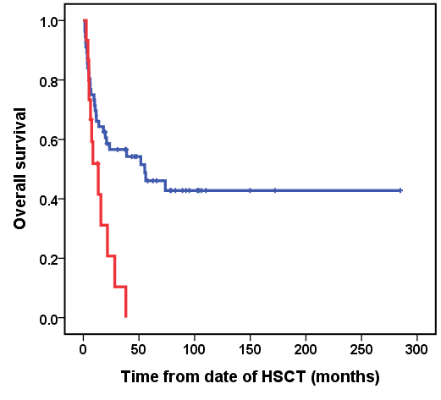
P=0.006
MRD (-), n=56, median OS: 55.2 months
MRD (+), n=15, median OS: 13.4 months

Supplemental Figure 8. Time to disease relapse (a), relapse-free survival (RFS) (b) and overall survival (OS) (c) in patients with pre-transplant revised international prognostic scoring system very low, low and intermediate-risk group myelodysplastic syndromes/neoplasms undergoing allogeneic hematopoietic stem cell transplantation (HSCT) according to next-generation sequencing–based measurable residual disease (MRD) status at 1 month post-transplant. MRD assessment excluded mutations in DNMT3A, TET2, and ASXL1.
(a) | (b)
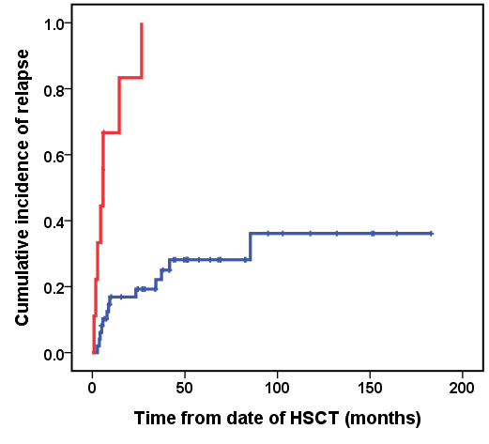  MRD (-), n=49, median time to relapse: not reached  MRD (+), n=9, median time to relapse: 5.8 months  P<0.001 | 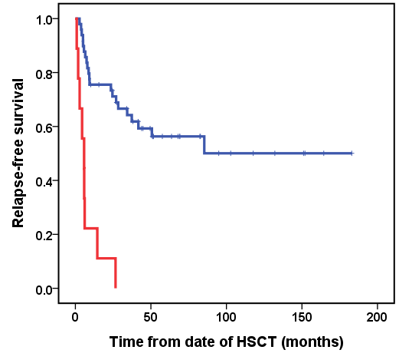  MRD (-), n=49, median RFS: not reached  MRD (+), n=9, median RFS: 5.8 months  P<0.001
(c)
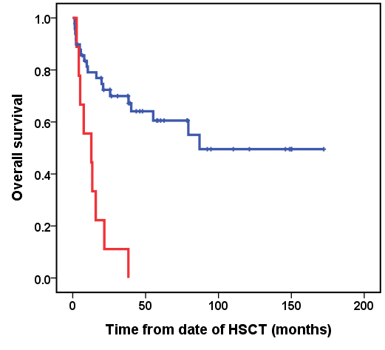
P<0.001
MRD (-), n=49, median OS: 87.0 months
MRD (+), n=9, median OS: 12.7 months

Supplemental Figure 9. Time to disease relapse (a), relapse-free survival (RFS) (b) and overall survival (OS) (c) in patients with pre-transplant revised international prognostic scoring system high or very high-risk group myelodysplastic syndromes/neoplasms undergoing allogeneic hematopoietic stem cell transplantation (HSCT) according to next-generation sequencing–based measurable residual disease (MRD) status at 1 month post-transplant. MRD assessment excluded mutations in DNMT3A, TET2, and ASXL1.
(a) | (b)
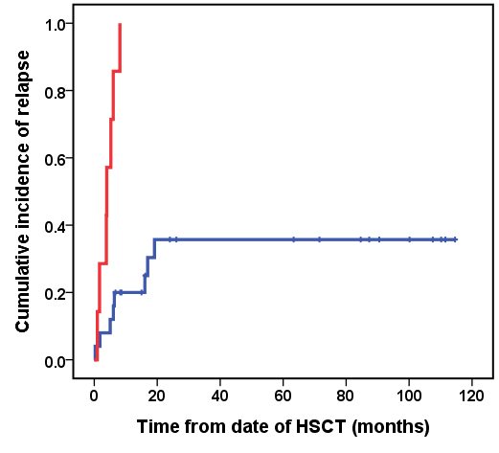  MRD (-), n=25, median time to relapse: not reached  MRD (+), n=7, median time to relapse: 4.0 months  P<0.001 | 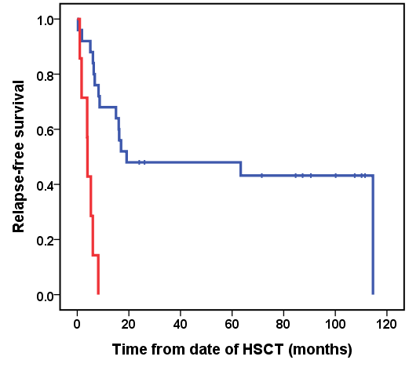  MRD (-), n=25, median RFS: 19.1 months  MRD (+), n=7, median RFS: 4.0 months  P<0.001
(c)
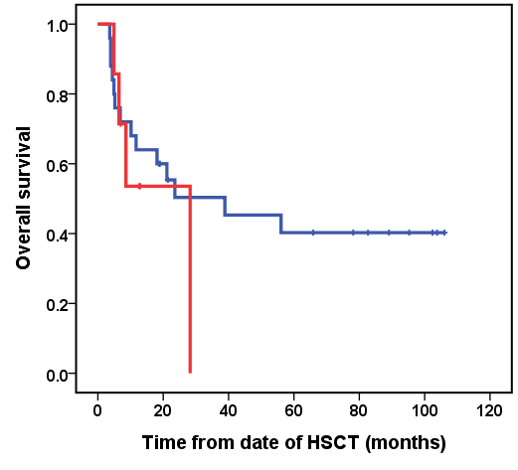
P=0.452
MRD (-), n=25, median OS: 38.9 months
MRD (+), n=7, median OS: 28.3 months

Supplemental Figure 10. Time to disease relapse (a), relapse-free survival (RFS) (b) and overall survival (OS) (c) in patients with myelodysplastic syndromes/neoplasms undergoing allogeneic hematopoietic stem cell transplantation (HSCT), stratified by conditioning regimen
(a) | (b)
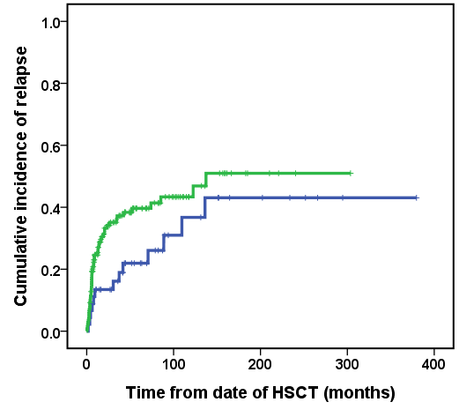  MAC, n=45, median time to relapse: not reached  RIC, n=141, median time to relapse: 137.2 months  P=0.10 | 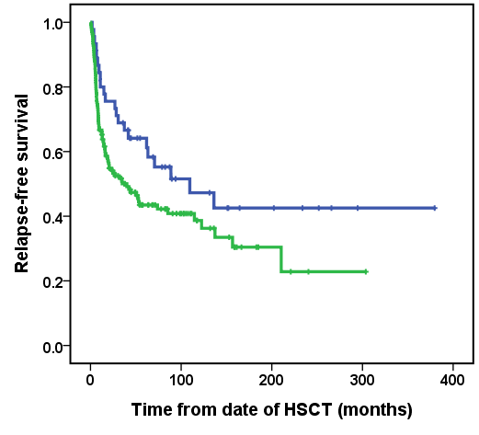  MAC, n=45, median RFS: 109.6 months  RIC, n=141, median RFS: 40.1 months  P=0.050
(c)
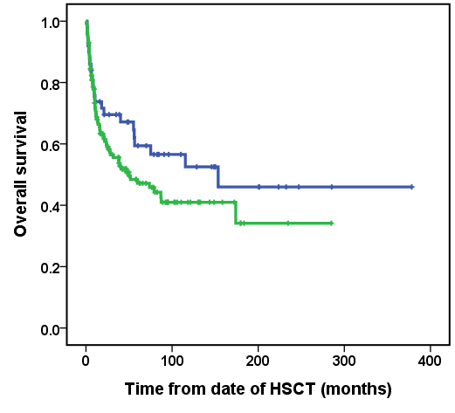
MAC, n=50, median OS: 153.5 months
RIC, n=142, median OS: 50.1 months
P=0.165
Abbreviation: MAC, myeloablative conditioning; RIC, reduced intensity conditioning

Supplemental Figure 11. Time to disease relapse, (b) relapse-free survival (RFS), and (c) overall survival (OS) in patients with myelodysplastic syndromes/neoplasms undergoing allogeneic hematopoietic stem cell transplantation (HSCT) with pre-transplant bone marrow blasts <5%, stratified by conditioning regimen.
(a) | (b)
P=0.32  MAC, n=21, median time to relapse: not reached  RIC, n=66, median time to relapse: not reached | 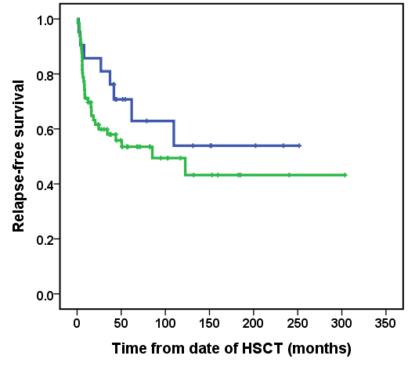  P=0.250  MAC, n=21, median RFS: not reached  RIC, n=66, median RFS: 85.3 months
(c)
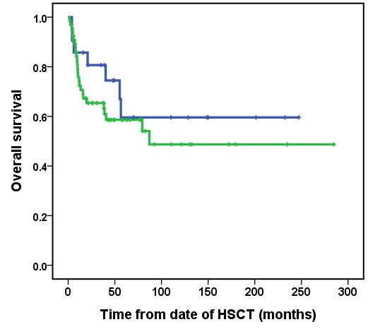
P=0.353
MAC, n=21, median OS: not reached
RIC, n=66, median OS: 87.0 months
Abbreviation: MAC, myeloablative conditioning; RIC, reduced intensity conditioning

