Additional file 1
Supplementary Figure S1 and Supplementary Table S1
Supplementary Figure S1 Model-specific variance inflation factors for QCT-derived parameters in the fully adjusted logistic regression models.
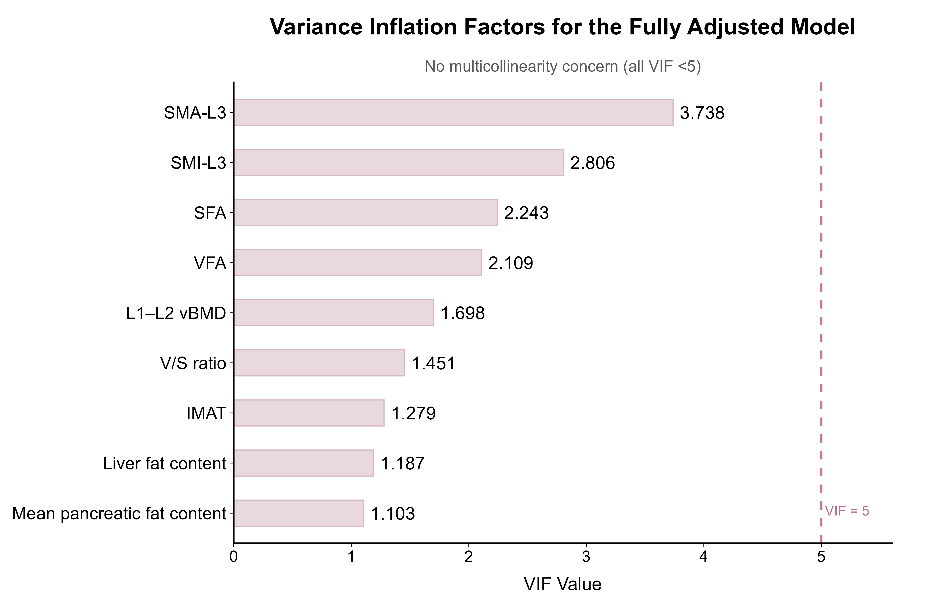
Each QCT-derived parameter was entered separately into a fully adjusted model together with the prespecified covariates. The dashed vertical line indicates the VIF threshold of 5. All VIF values were <5.
Supplementary Table S1 Model-specific variance inflation factors in fully adjusted models

QCT-derived parameter | Tolerance for QCT-derived parameter | VIF for QCT-derived parameter
VFA | 0.474 | 2.109
SFA | 0.446 | 2.243
V/S ratio | 0.689 | 1.451
IMAT | 0.782 | 1.279
SMA-L3 | 0.268 | 3.738
SMI-L3 | 0.356 | 2.806
Liver fat content | 0.843 | 1.187
Mean pancreatic fat content | 0.907 | 1.103
L1–L2 vBMD | 0.589 | 1.698
Note: Values represent model-specific collinearity diagnostics. Each QCT-derived parameter was entered separately into a fully adjusted logistic regression model together with age, sex, BMI, and diabetes duration. Tolerance and VIF values shown in the table refer to the QCT-derived parameter in each corresponding model. A VIF value <5 was considered to indicate no substantial multicollinearity.
Abbreviations: QCT, quantitative computed tomography; VIF, variance inflation factor; BMI, body mass index; VFA, visceral fat area; SFA, subcutaneous fat area; V/S ratio, visceral-to-subcutaneous fat area ratio; IMAT, intermuscular adipose tissue; SMA-L3, skeletal muscle area at the third lumbar vertebra; SMI-L3, skeletal muscle index at the third lumbar vertebra; vBMD, volumetric bone mineral density.

