Infomorphic Computing Enabled by Spintronic Devices Toward Localized and Interpretable Machine Learning

Ziyi Teng^{1,2,*}, Jiaxuan Chen^{1,2,*}, Yining Zhao^{1,2}, Yihao Zhang^{1,2}, Huijun Li^{1,2}, Zhaochun Liu^{1,2}, Zhihua Xiao³, Qiming Shao³, Yuxuan Yao^{1,2}, Hongchao Zhang⁴, Hongxi Liu⁴, Shouzhong Peng^{1,2,#}, Sai Li^{1,2,#}, Weisheng Zhao^{1,2,#}

¹School of Integrated Circuit Science and Engineering, Beihang University, Beijing 100191, China.
²National Key Lab of Spintronics, Institute of International Innovation, Beihang University, Hangzhou, 311115, China.
³Department of Electronic and Computer Engineering, The Hong Kong University of Science and Technology, Hong Kong, China.
⁴Truth Memory Corporation, Beijing, 100083, China.
*These authors contributed equally: Ziyi Teng, Jiaxuan Chen
#Corresponding author. Email: shouzhong.peng@buaa.edu.cn, saili@buaa.edu.cn, weisheng.zhao@buaa.edu.cn

This Supplementary Information contains:

Supporting Note1 to Note 7
Figures S1 to S6
Tables S1 to S2
SI References

Supplementary Note 1. Training Parameter Settings for Spintronic Infomorphic Networks

All simulations were implemented in Python (PyTorch 2.2) using 32-bit floating-point precision. The receptive and contextual weight (${\text{w}}_{\text{R}}\text{,}{\text{w}}_{\text{C}}$) were initialized from a uniform distribution within the range $\text{[-scaling,} \text{+scaling]}$. The scaling factor was set to 0.01 for supervised learning and 0.1 for unsupervised and associative-memory tasks. Weights were updated through gradient ascent on the information-theoretic goal function derived from Partial Information Decomposition (PID).
Unless otherwise specified, the weight-decay factor was set to zero. PID statistics were estimated using discretized histograms with the number of bins indicated in Supplementary Table 1. “PID bins”denote the number of histogram partitions used to estimate the joint probability distribution for computing unique, redundant, and synergistic information terms. PID updates were performed every 20 (supervised tasks and associative-memory tasks) or 40 (unsupervised tasks) iterations.

Task | Network size (neurons number) | Update  steps | Learning target (γ) | Weight decay (λ) | Learning rate (η) | PID bins
Supervised  (MNIST) | 10 | 800 | (0.1, 0.1, 1, 0.1, 0) | 0 | 0.001 | 500
Unsupervised  (Breast-cancer) | 2 | [47,53] | (1, 0, 0, 0, 0) | [0.01, 0.0] | [0.75, 0.85] | 200
Associative-memory  (5×7 letters) | 35 | 300 | (0.1, 0.1, 1, 0.1, 0) | 0 | 0.001 | 20
Supplementary Table 1. Training parameters and task configurations for the spintronic infomorphic networks.

Supplementary Note 2. Network Training Using the Local Learning Rule

Each neuron optimizes its local goal function derived from Partial Information Decomposition (PID), which provides a decomposition framework with well-defined and intuitive interpretations for understanding a neuron’s information processing. The value of the goal function is dependent on the neuron-specific parameter vector $\text{γ}$ and the joint distribution $p(R, C, Y)$ of a neuron’ s integrated receptive and contextual inputs and its output:
$$G_{i}=γ_{goal}^{T}∙I_{PID}=γ_{unq, R}I_{unq, R}+γ_{unq, C}I_{unq, C}+γ_{red}I_{red}+γ_{syn}I_{syn}+γ_{res}H_{res}$$
where the information atoms quantify unique, redundant, and synergistic contributions of ${\text{R}}_{\text{i}}$ and ${\text{C}}_{\text{i}}$ to the neuron’s output $Y_{i}$. The coefficients $γ$ specify the targeted information flow: $γ=(1, 0, 0, 0, 0)$ for unsupervised learning (unique information), and $γ=(0.1, 0.1, 1, 0.1, 0)$ for supervised and associative-memory learning (redundant information maximization).
Learning happens by changing the afferent weights ${\text{w}}_{\text{R}}$ and ${\text{w}}_{C}$ which determine how the inputs to the neuron influence its output. The weight updates are derived from the gradient of $G_{i}$ with respect to $w_{R}$ and $w_{C}$:
$$\frac{∂G_{i}}{∂w_{R}}=E \left[f_{Γ,p\left(R_{i},C_{i}\right)}\frac{∂A\left(V_{SOT},V_{G}\right)}{∂R_{i}}x_{R_{i}}\right],\frac{∂G_{i}}{∂w_{C}}=E [f_{Γ,p(R_{i},C_{i})}\frac{∂A(V_{SOT},V_{G})}{∂C_{i}}x_{C_{i}}],$$
where ${\text{f}}_{\text{Γ,}\text{p}\text{(}{\text{R}}_{\text{i}}\text{,}{\text{C}}_{\text{i}}\text{)}}$ encodes the local dependency of ${\text{R}}_{\text{i}}$ and ${\text{C}}_{\text{i}}$ on the neuron’s output. The full derivation of the PID-based local goal function and its analytical gradients with respect to receptive and contextual weights follows the framework in the work¹ reported by Makkeh et al. and is therefore not repeated here.
In particular, the gradients are estimated from empirical histograms collected during network propagation, and weights are updated as:
$$w_{R}←w_{R}+η_{R}\frac{∂G_{i}}{∂w_{R}},{ w}_{C}←w_{C}+η_{C}\frac{∂G_{i}}{∂w_{C}}.$$
Where no global objective or backpropagation is required; each neuron adapts independently based on its own local information statistics. This distributed update mechanism ensures parallel and interpretable learning consistent with the infomorphic computing framework.

Supplementary Note 3. Energy consumption of a spintronic infomorphic neuron

The energy consumption of a single Infomorphic Nonlinear Probabilistic Activation (INPA) update in the VGSOT-MTJ neuron consists of one write operation and one read operation. Circuit schematics of the MTJ write and read configurations for probabilistic switching and resistance-state sensing is shown in Supplementary Figure 5. The detailed calculations of the corresponding energy components² include MTJ cell and access-transistors, which are as follows and summarized in Supplementary Table 2:
- Write energy: $E_{write}=E_{MTJ, write}+3×E_{tr,write}=11pJ+3×1.6pJ=15.8pJ$
At the intrinsic device level, the MTJ write energy is approximately 11 pJ for a 0.8 ns pulse, determined by the switching energy of the VGSOT-MTJ (Supplementary Fig. 6).
- Read energy: $E_{read}=E_{MTJ, read}+2×E_{tr,write}=0.024pJ+2×0.018pJ=0.06pJ$

Item | Energy consumption
MTJ write (0.8 ns) | 15.8 pJ
MTJ read (0.8 ns) | 0.06 pJ
Total | 15.86 pJ
Supplementary Table 2. The energy consumption per INPA update implemented by VGSOT-MTJ.

For system-level energy estimation per INPA update, the overall energy consumption is dominated by the controller rather than the intrinsic device energy of the VGSOT-MTJ. To quantify this contribution, we consider three representative scenarios: the experimental platform, a projected FPGA implementation, and a projected ASIC implementation. The controller energy per update is given by
$$E_{platform}=\frac{P_{platform}}{f_{s}}$$
where $P_{platform}$ is the average controller power and $f_{s}$ is the sampling rate (updates per second). The detailed calculations are as follows and summarized in Supplementary Table 3:
- For the laboratory MCU-based prototype, the controller power is obtained from the device datasheets. Each MCU has a typical active power consumption of ~102 mW under full peripheral operation. The operational amplifiers consume ~20 mW, the precision analog switches consume ~0.6 mW, and the DAC contributes ~1 mW. Other components (ESD protection, resistors, capacitors) have negligible power and are omitted. The total controller power $P_{Prototype}$ is therefore on the order of ~120 mW. This value is used to estimate the controller energy for the laboratory implementation. The resulting system-level energy is dominated by external control and instrumentation overhead and should therefore be interpreted as a non-optimized laboratory upper bound rather than the intrinsic efficiency limit of the spintronic primitive.
- For the projected FPGA implementation, the average FPGA (28nm FD-SOI process) power is estimated from Lattice Semiconductor’s reported typical dynamic power under high-utilization operation at ~500 MHz, yielding a representative controller power⁴ 200 mW.
- For the projected ASIC implementation (4 nm node), the controller power is estimated via a double-factor scaling approach from the FPGA baseline: $P_{ASIC}=P_{FPGA}×\frac{1}{η_{arch}}×\frac{1}{η_{node}}$, where $η_{arch}≈14$ represents the architectural efficiency gain achieved by eliminating programmable routing overhead5, and $η_{node}≈3$ represents a conservative power scaling gain from the 28 nm to 4 nm technology node at iso-frequency. This projection yields an estimated power of 5 mW.
The projected FPGA and ASIC results represent architecture-dependent estimates based on a dedicated Spin-CMOS co-design. By operating at update rates approaching the intrinsic MTJ timescale and by minimizing peripheral overhead through integration and specialization (e.g., pulse generation, routing, and sensing), these implementations can significantly reduce the system-level energy per INPA update.

Platform | Sampling rate | Controller energy | Energy per INPA update (estimated)
Prototype (MCU containing DAC and others) | ~0.1MHz (instrument-limited) | 1.2 μJ | ~1.2 μJ  (dominated by external instrumentation overhead)
Projected FPGA³ (Spin-CMOS codesign) | ~500 MHz | 360 pJ | ~400 pJ
Projected ASIC³ (MTJ-integrated, 4 nm node) | ≥2 GHz (intrinsic MTJ < 1 ns switching) | 2.5 pJ | ~20 pJ
Supplementary Table 3. The analysis of energy consumption for representative scenarios of the controller.

Supplementary Note 4. Speed and Energy Estimation of INPA Update Implemented by CPU and GPU

We benchmarked the INPA, the core computational step of the infomorphic neuron involving nonlinear activation computation, sigmoid-based probability mapping, and Bernoulli sampling state update, using Python on both CPU and GPU platforms. The CPU used in this work is an Intel Core Ultra 7 258V processor, and the GPU is an NVIDIA GeForce RTX 4090 (4 nm node).
- CPU⁶
- The probabilistic activation update code was executed 200 times, and the runtime was recorded using the timeit library, yielding an average time of $\text{8.83×}{\text{10}}^{\text{-6}} \text{s}$ per update.
- During this process, the average CPU utilization was measured as 10% using the psutil library.
- Given the effective Thermal Design Power (TDP) of 28 W, the energy consumption of one INPA update is estimated as:
$${\text{E}}_{\text{CPU}}\text{=}{\text{P}}_{\text{TDP}}\text{×}\text{Utilization}\text{×}{\text{T}}_{\text{update}}\text{=28 }\text{W}\text{×}\text{10}\text{\%×8.83×}{\text{10}}^{\text{-6}} \text{s}\text{≈}\text{24.8}\text{×}{\text{10}}^{\text{-}\text{6}} \text{J}$$
Thus, the CPU implementation requires approximately $\text{24.8}\text{×}{\text{10}}^{\text{-}\text{6}} \text{J}$ per INPA update.
- GPU⁶
- The GPU execution was implemented using PyTorch, specifically benchmarking the single-update latency of the INPA kernel on the NVIDIA GeForce RTX 4090.
- The kernel was configured to update 10 neurons in parallel. The code was executed 200 times, with runtime recorded via PyTorch's timing mechanism, yielding an average latency of 0.212 ms per update.
- During this process, the average total board power consumption reported by pynvml was 23 W. Normalizing this by the 10 parallel operations gives an average energy consumption of 2.3 W per neuron update.
- The measured energy consumption for one INPA update is calculated as:
$${\text{E}}_{\text{GPU}}\text{=}{\text{P}}_{\text{avg}}\text{×}{\text{T}}_{\text{update}}\text{ =2.3 }\text{W}\text{×0.212×}{\text{10}}^{\text{-3}}\text{s}\text{≈4.9×}{\text{10}}^{\text{-4}} \text{J}$$
Thus, the GPU implementation requires approximately $\text{4.9×}{\text{10}}^{\text{-4}} \text{J}$ per INPA update.
- Comparison to VGSOT-MTJ INPA Update
At the system level of INPA update, our laboratory prototype (~1.2 μJ) already outperforms GPU-based execution by approximately 400×. With projected Spin-CMOS co-designed FPGA (~400 pJ) and ASIC (~20 pJ) implementations, the energy per update is expected to decrease by approximately 5 orders of magnitude compared to CPU implementations (~24.8 μJ) and 6orders of magnitude compared to GPU implementations (~490 μJ).

Supplementary Note 5. Energy and Computation Comparison Between SINN and Backpropagation

Taking supervised learning on MNIST as a representative example, we benchmark the energy consumption of the VGSOT-MTJ-based SINN local update against standard Backpropagation (BP) on a Digital Compute-in-Memory (DCIM) platform. The comparison uses consistent hardware baselines: DCIM efficiency of 7088 GOPS/W (${\text{E}}_{\text{MAC}}\text{=1.41×}{\text{10}}^{\text{-13}}$ J)⁷ and data movement cost of ${\text{E}}_{\text{bit}}\text{=4.2}$ pJ/bit⁸, with per-sample update ($\text{batc}\text{h}\text{size}\text{=1}$) for fair comparison.
- Local Update Energy Calculation (${\text{E}}_{\text{SINN}}$)
The SINN local update energy includes INPA energy (${\text{E}}_{\text{INPA}}$), PID computation energy (${\text{E}}_{\text{PID}}$), and data movement energy for weight access (${\text{E}}_{\text{access}}$).
- Computation:
With ${\text{N}}_{\text{w}}\text{=8.16×}{\text{10}}^{\text{3}}$ weights
${\text{E}}_{\text{INPA}}\text{=}\text{16.4}\text{×}{\text{10}}^{\text{-12}}$ J (per sample)
${\text{N}}_{\text{MAC,local}}\text{=1}\text{×}{\text{N}}_{\text{w}}\text{=8.16×}{\text{10}}^{\text{3}}$ MACs
${\text{E}}_{\text{MAC}}\text{=}{\text{N}}_{\text{MAC,local}}\text{×}{\text{E}}_{\text{MAC}}\text{≈1.15×}{\text{10}}^{\text{-9}}$ J
- Data movement:
Estimation With INT8 precision (16 bits per weight update):
${\text{N}}_{\text{bit}}\text{=16×}{\text{N}}_{\text{w}}\text{≈1.31×}{\text{10}}^{\text{5}}$ bits
${\text{E}}_{\text{move}}\text{=}{\text{N}}_{\text{bit}}\text{×}{\text{E}}_{\text{bit}}\text{≈5.5×}{\text{10}}^{\text{-7}}$ J
${\text{E}}_{\text{SINN}}\text{=}{\text{E}}_{\text{INPA}}\text{+}{\text{E}}_{\text{MAC}}\text{+}{\text{E}}_{\text{move}}\text{≈5.5×}{\text{10}}^{\text{-7}}$J
Therefore, the total per-sample local update energy of SINN is ${\text{E}}_{\text{SINN}}\text{≈}\text{5.5×}{\text{10}}^{\text{-7}}$J

- BP Update Energy Calculation (${\text{E}}_{\text{BP}}$)
BP update energy comprises computation energy (${\text{E}}_{\text{comp}}$) for three MVM operations and data movement energy (${\text{E}}_{\text{move}}$).
- Computation:
For an MLP with ${\text{N}}_{\text{w}}\text{=5.5×}{\text{10}}^{\text{5}}$ weights
${\text{N}}_{\text{MAC,BP}}\text{=3×}{\text{N}}_{\text{w}}\text{=1.65×}{\text{10}}^{\text{6}}$ MACs
${\text{E}}_{\text{comp}}\text{=}{\text{N}}_{\text{MAC,BP}}\text{×}{\text{E}}_{\text{MAC}}\text{≈2.3×}{\text{10}}^{\text{-7}}$ J
- Data movement:
${\text{N}}_{\text{bit}}\text{=16×}{\text{N}}_{\text{w}}\text{≈8.8×}{\text{10}}^{\text{6}}$ bits
${\text{E}}_{\text{move}}\text{=}{\text{N}}_{\text{bit}}\text{×}{\text{E}}_{\text{bit}}\text{≈3.7×}{\text{10}}^{\text{-5}}$ J
${\text{E}}_{\text{BP}}\text{=}{\text{E}}_{\text{comp}}\text{+}{\text{E}}_{\text{move}}\text{≈3.7×}{\text{10}}^{\text{-5}}$J
Therefore, the total per-sample local update energy of BP is ${\text{E}}_{\text{BP}}\text{≈3.7×}{\text{10}}^{\text{-5}}$J. Data movement dominates BP energy ($\text{>99\%}$ of total).

- Energy Comparison
- SINN local update: $\text{5.5×}{\text{10}}^{\text{-7}}$ J
- BP update: $\text{3.7×}{\text{10}}^{\text{-5}}$ J
Thus, the VGSOT-MTJ-based SINN achieves ~68× lower update energy consumption than DCIM-based BP under the same hardware baseline.

- Per-Sample Update Computation Comparison
It should be noted that the compared network sizes are determined by the learning mechanisms required to accomplish the same task, rather than by arbitrary model selection. For supervised MNIST classification, BP typically relies on a multi-layer perceptron (3-layer MLP, $\text{5.5×}{\text{10}}^{\text{5}}$ weights) to achieve effective feature extraction and classification, whereas the present SINN implementation achieves the same task with a single-layer network ($\text{8.16×}{\text{10}}^{\text{3}}$ weights) through local neuron-autonomous updates.
Accordingly, compared with BP, the VGSOT-MTJ-based SINN requires only ~0.5% of the per-sample update computation ($\text{8.16×}{\text{10}}^{\text{3}}$vs $\text{1.65×}{\text{10}}^{\text{6}}$ MACs). This reduction arises from the elimination of global error backpropagation and the associated full-network matrix-vector multiplications, and therefore contributes directly to the lower update energy of SINN.
Supplementary Note 6. Infomorphic computing system and measurement-control scheme

To implement probabilistic neuron operations and system-level validation of infomorphic computing, a custom printed circuit board (PCB) and measurement-control platform based on voltage-gated spin-orbit-torque magnetic tunnel junctions (VGSOT-MTJs) was developed. The MTJ samples were fabricated on a silicon wafer with a multilayer structure comprising, from top to bottom, metallic electrodes, a magnetic tunnel junction stack, and a conductive underlayer. After wafer cleavage, individual MTJ dies were mounted onto the PCB and electrically connected via wire bonding (Supplementary Figure 5b).
The PCB was interfaced with the external test circuit using Dupont wires, enabling flexible electrical access to the MTJ terminals for both write and read operations. To protect the MTJ devices from electrostatic discharge (ESD) during handling and operation, the PCB integrates SP3010-04UTG and SMBJ3.3CA protection components. The SP3010-04UTG provides four channels of ultra-low-capacitance rail-to-rail diode protection together with an integrated zener diode, while the SMBJ3.3CA serves as a secondary transient voltage suppressor, enhancing the robustness of the system against ESD events.
The experimental platform consists of a STM32F767IGT6 microcontroller units (MCU) and a custom-designed test circuit, as illustrated in Supplementary Fig. 5. Each STM32F767IGT6 MCU integrates two 12-bit digital-to-analog converters (DAC), three 12-bit analog-to-digital converters (ADC), and 132 general-purpose input/output (GPIO) pins, operating within a voltage range of 0-3.3 V. The MCUs are connected to a host computer via the Serial Wire Debug (SWD) interface through DAP emulators, enabling real-time circuit control and data acquisition.
The test circuit comprises operational amplifiers, transistors, and precision measurement resistors. The LM324N operational amplifiers are configured as voltage followers to buffer the DAC outputs and improve load-driving capability. The transistors act as electronic switches, allowing dynamic reconfiguration between write and read modes. This configuration enables electrical separation of write and read operations using a shared MTJ device.
The test circuit comprises operational amplifiers, precision analog switches, protection diodes, RC filtering networks, and meature resistors. The operational amplifiers are configured as voltage followers to buffer the DAC outputs and enhance the drive capability during MTJ excitation. The mode switching between write and read operations is implemented by precision analog electronic switches, which dynamically route the MTJ terminals under digital control. This configuration enables effective electrical isolation between write and read paths while allowing the same MTJ device to be shared by both operations. In addition, the diode-clamp and RC filtering networks provide input protection and noise suppression for the ADC measurement path, improving the stability and reliability of MTJ state readout.
During the write operation, programmed voltage pulses generated by the DACs are applied to the MTJ terminals, inducing spin-orbit-torque-assisted magnetization switching in the magnetic free layer. After each applied pulse, the MTJ resistance state is measured. During the read operation, a low-amplitude sensing current is applied, and the resulting voltage drop across a precision measurement resistor is sampled by the ADC. The digitized signals are processed by a C language-based control program to retrieve the MTJ resistance states and switching voltages.

Supplementary Note 7. Incorporating device-to-device variation into SINN

As shown in Supplementary Fig. 2, device-to-device variation of VGSOT-MTJ neurons was experimentally characterized by measuring the probabilistic switching behavior of six independent devices under identical write conditions. The gate voltage $V_{G}$ was set to 0.4 V, and the spin-orbit torque voltage $V_{SOT}$ was swept with a step size of 0.02 V. At each $V_{SOT}$ value, 100 repeated write operations were applied to each device, from which the switching probability $P_{SW}$ was extracted.
For a given $V_{SOT}$, the distribution of $P_{SW}$ across the six devices directly reflects the intrinsic device-to-device variation in probabilistic switching characteristics. By statistically analyzing these distributions over the measured voltage range, an average standard deviation of the switching probability, $σ_{SW}=0.031$was obtained. This value quantitatively captures the variation among nominally identical VGSOT-MTJ devices fabricated and measured under the same conditions.
To incorporate this experimentally observed device variation into the SINN simulations, each neuron was assigned a fixed probabilistic offset sampled from the measured distribution. Specifically, for neuron i, a Gaussian-distributed random offset $δ_{i}$was drawn as:
$δ_{i}\sim N(0,σ_{SW}^{2})$，
and added to the ideal activation probability generated by the sigmoid function:
$θ_{i}=σ(A_{i})+δ_{i}$,
where $A_{i}$ denotes the neuron’s internal activation function variable. The offset $δ_{i}$ was kept constant throughout both training and inference, representing static device-to-device variations originating from fabrication, rather than transient cycle-to-cycle noise. This modeling approach enables a realistic evaluation of SINN robustness against experimentally measured probabilistic switching variations.

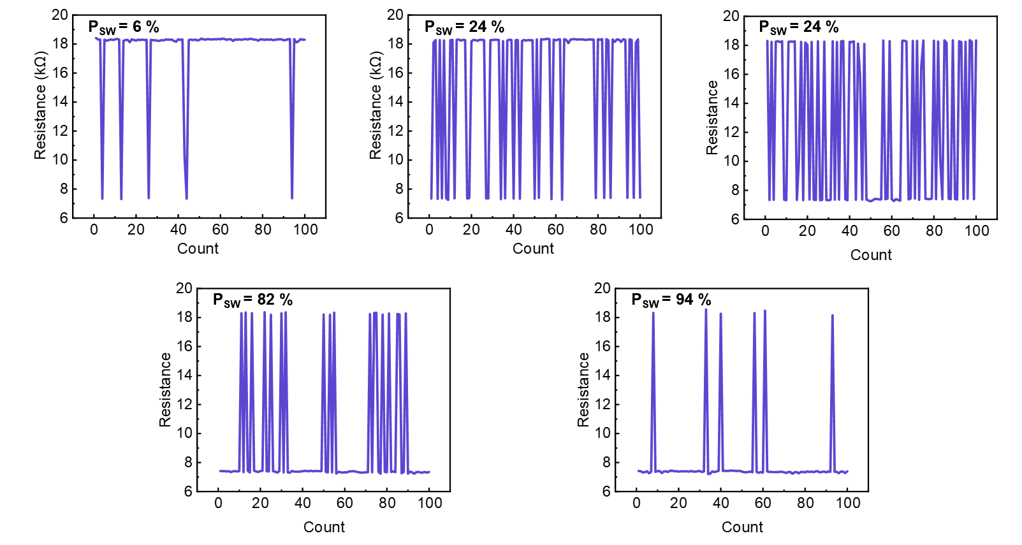
Supplementary Figure 1. Measurement procedure for extracting each probability point in the probabilistic switching curve. Each data point in the probabilistic switching curve corresponds to the statistical average of 100 identical pulsed switching tests performed under the same gate voltage, SOT voltage, and pulse width.
σ_{SW}=0.031
V_{G}=0.4 V
$${\text{t}}_{\text{write}}\text{=100 }\text{μ}\text{s}$$
V₀+0.04
V₀+0.08
V₀
V₀-0.04
V₀-0.08
Supplementary Figure 2. Probability switching characteristics of 6 devices under the same write condition. Switching probability (${\text{P}}_{\text{SW}}$) as a function of SOT voltage for six nominally identical devices. The curves exhibit consistent sigmoidal behavior, demonstrating stable stochastic switching across devices. The device-to-device variation yields an average P_{sw} standard deviation of ${\text{σ}}_{sw}\text{= 0.031}$.

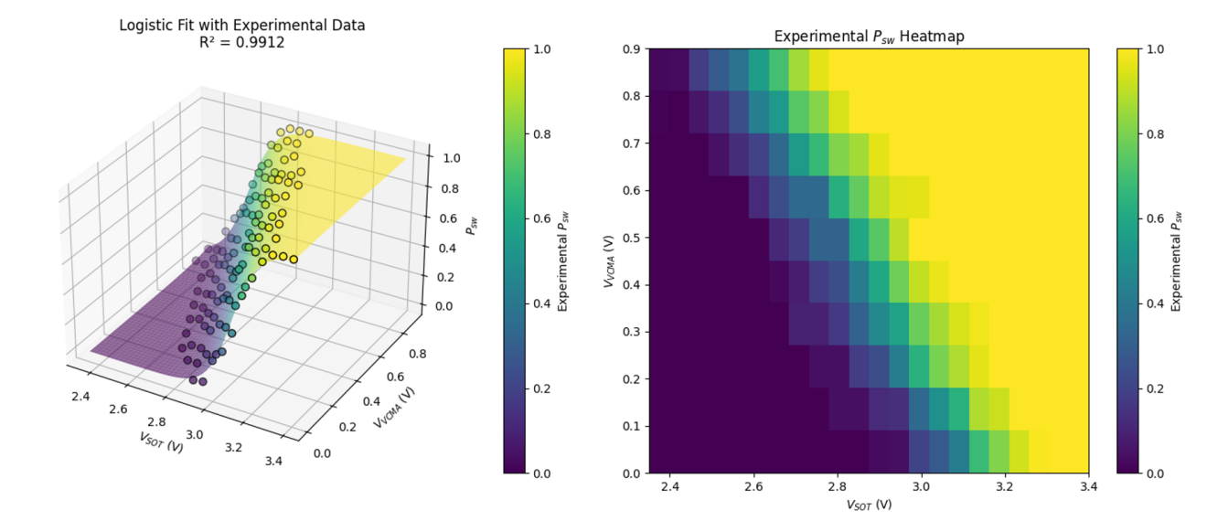
Supplementary Figure 3. Fitted Activation Function and Parameter Value. The left panel shows the same dataset as in Fig. 3d, but with the 3D plot rotated to provide a clearer view of the relationship between the experimentally measured switching probabilities and the fitted surface under varying ${\text{V}}_{\text{SOT}}$ and ${ \text{V}}_{\text{G}}$. The fitting is based on the discretized outputs, resulting in the activation function $\text{σ}\text{(}\text{A}\text{(}{\text{V}}_{\text{SOT}}\text{,}{ \text{V}}_{\text{G}}\text{))}$. The right panel presents a two-dimensional heatmap illustrating the dependence of the VGSOT–MTJ switching probability ${\text{P}}_{\text{SW}}$ on ${\text{V}}_{\text{SOT}}$ and${ \text{V}}_{\text{G}}\text{)}$. The fitted function is given by: $\text{σ}\text{(}\text{A}\text{(}{\text{V}}_{\text{SOT}}\text{,}{ \text{V}}_{\text{G}}\text{))=}\text{a}\text{⋅}{\text{V}}_{\text{SOT}}\text{+}\text{b}\text{⋅}{ \text{V}}_{\text{G}}\text{+}\text{c}\text{⋅}{\text{V}}_{\text{SOT}}\text{⋅}{ \text{V}}_{\text{G}}\text{)}$, with a = 3.4300, b = 2.4874, c = -0.0757 and ${\text{R}}^{\text{2}}\text{=0.99}$.

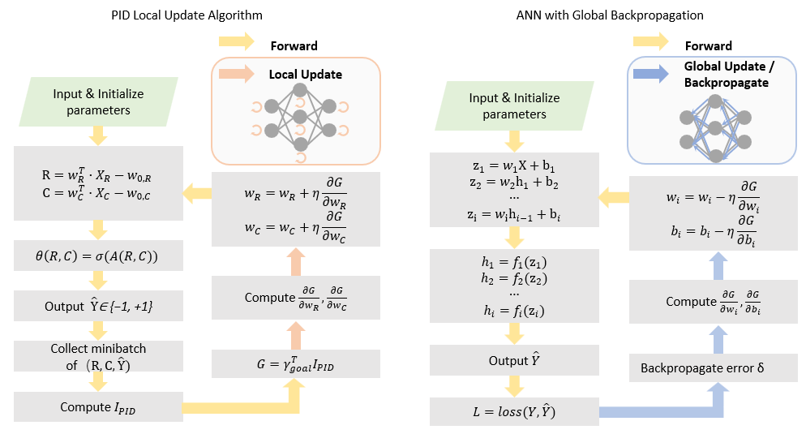
Supplementary Figure 4. Comparison of PID-based local update and conventional ANN training with backpropagation.
Left: In the PID-based local update scheme, each neuron computes receptive and contextual variables $\text{(}\text{R}\text{,}\text{C}\text{)}$, generates a stochastic output $\hat{\text{Y}}$ through the nonlinear probabilistic activation $\text{θ}\text{(}\text{R}\text{,}\text{C}\text{)}$, and collects minibatches of ($\text{R}\text{, }\text{C}\text{,} \hat{\text{Y}}$) to estimate the PID information vector ${\text{I}}_{\text{PID}}$. A local goal function, $\text{G=}{\text{γ}}_{\text{goal}}^{\text{T}}\text{∙}{\text{I}}_{\text{PID}}$, is then constructed, and the receptive and contextual weights are updated from the local gradients $\frac{\text{∂G}}{\text{∂}{\text{w}}_{\text{R}}}$ and $\frac{\text{∂G}}{\text{∂}{\text{w}}_{\text{C}}}$. This learning process is neuron-local and does not require network-wide error propagation.
Right: In contrast, conventional ANN training performs parameter updates by propagating a global error $\text{δ}$ backward through all network layers, with hidden unit activations ${\text{h}}_{\text{i}}$ computed from pre-activations ${\text{z}}_{\text{i}}$ and weights ${\text{w}}_{\text{i}}$ and biases ${\text{b}}_{\text{i}}$ updated based on the loss gradient. The schematic highlights the distinction between localized, independent neuron updates and network-wide gradient-based optimization.
In conventional ANN training, each layer computes pre-activations ${\text{z}}_{\text{i}}$ and hidden activations ${\text{h}}_{\text{i}}$ during the forward pass, and the network output $\hat{\text{Y}}$ is compared with the target $\text{Y}$ to form a global loss $\text{L}$. Parameter updates are then obtained by backpropagating the global error $\text{δ}$ through all network layers, yielding gradients for the weights ${\text{w}}_{\text{i}}$ and biases ${\text{b}}_{\text{i}}$. The schematic emphasizes the contrast between localized PID-driven neuron updates and global gradient-based optimization in standard backpropagation.
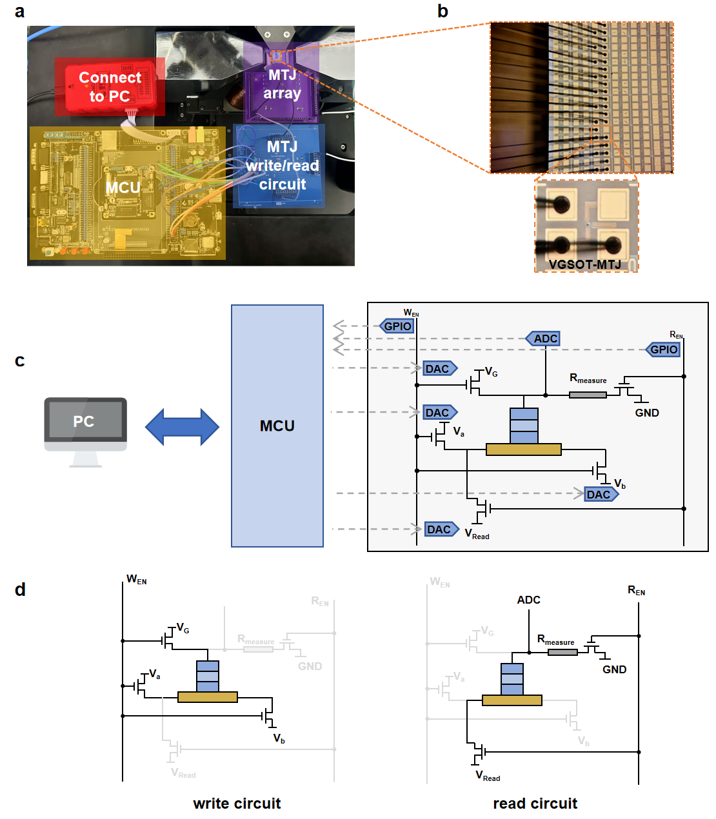
Supplementary Figure 5. Infomorphic computing system and system-level circuit schematics. a, Photograph of the infomorphic computing experimental platform, including the MCU interfaced with a host computer, the MTJ write/read peripheral circuit, and the VGSOT-MTJ array. b, Microscope image of VGSOT-MTJ with bonding wires. c, Block-level schematic of the measurement and control system, illustrating the interfaces between the host PC, MCU, and the MTJ write/read circuitry. d, Circuit schematics of the VGSOT-MTJ write (left) and read (right) configurations for probabilistic switching and resistance-state sensing.

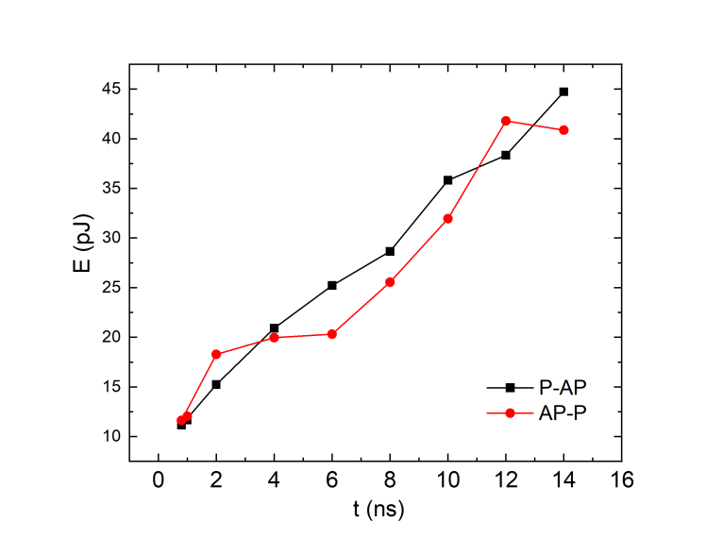

Supplementary Figure 6. Critical switching energy as a function of pulse width t. Square symbols correspond to P-AP reversal and circle symbols correspond to AP-P reversal measured with gate voltage of 0.5V. Switching is observed down to a pulse width of 0.8 ns, corresponding to a critical switching energy of 11 pJ, confirming that the underlying SOT-driven magnetization dynamics supports sub-nanosecond operation.

References

1. Makkeh, A. et al. A general framework for interpretable neural learning based on local information-theoretic goal functions. Proc. Natl. Acad. Sci. U.S.A. 122, e2408125122 (2025).
2. Si, J. et al. Energy-efficient superparamagnetic Ising machine and its application to traveling salesman problems. Nat Commun 15, 3457 (2024).
3. Kämpfe, T. et al. Probabilistic Greedy Algorithm Solver Using Magnetic Tunneling Junctions for Traveling Salesman Problem. Preprint at https://doi.org/10.21203/rs.3.rs-5700548/v1 (2025).
4. TIRIAS Research. Lattice Crosslink-NX: Embedded Vision Processing at the Edge. White paper sponsored by Lattice, Jan. 2020.
5. Kuon, I. et al. Measuring the Gap Between FPGAs and ASICs. IEEE Trans. Comput.-Aided Des. Integr. Circuits Syst. 26, 203–218 (2007). doi: 10.1109/TCAD.2006.884574.
6. Yue, W. et al. A scalable universal Ising machine based on interaction-centric storage and compute-in-memory. Nat Electron 7, 904–913 (2024).
7. Qin, Y. et al. MECLA: Memory-Compute-Efficient LLM Accelerator with Scaling Sub-matrix Partition. in 2024 ACM/IEEE 51st Annual International Symposium on Computer Architecture (ISCA) 1032–1047 (IEEE, Buenos Aires, Argentina, 2024). doi:10.1109/ISCA59077.2024.00079.
8. Kyung, K., Yun, S. & Ahn, J. H. SSD Offloading for LLM Mixture-of-Experts Weights Considered Harmful in Energy Efficiency. IEEE Comput. Arch. Lett. 24, 265–268 (2025).

