Supporting Information

A new topological Cu-MOF constructed via ligand desymmetrization strategy for natural gas liquids separation

Jingjing Chen,^{[a]} Xiuping Liu,^{[b]} Xuemei Song,^{[a]} Yinping Liu,^{[a]} Fei Gao,^{[a]} Xueying Feng,^{[a]} Xueyan Zhang,^{[a]} Yifan Zhang,^{[a]} Qirong Liu,^{[a]} Xiaokang Wang,*^{[a]} Rongming Wang,*^{[a]} and Daofeng Sun*^{[a]}

^{[a]}Shandong Key Laboratory of Intelligent Energy Materials, School of Materials Science and Engineering, China University of Petroleum (East China), Qingdao Shandong 266580, China
^{[b]}School of Materials Science and Engineering, Linyi University, Linyi, Shandong 276000, China
*Corresponding author E-mail: dfsun@upc.edu.cn; rmwang@upc.edu.cn; xiaokangwang0625@163.com
Table of Contents
Experimental Procedures S2
Materials and instruments S2
Synthesis of H₄CPTT-NH₂ S3
Synthesis of UPC-114 S5
Single-crystal X-ray diffraction S6
Gas sorption measurements S7
Breakthrough experiments S8
Computational methods S9
Figures S1-S25 S12
Tables S1-S2 S25
References S27

Experimental Procedures

Materials and instruments
All reagents were commercially available and used without further purification.
¹H nuclear magnetic resonance (NMR) spectrum was obtained on a Bruker 400 MHz nuclear magnetic resonance spectrometer. Single crystal X-ray diffraction experiment was carried out on a SuperNova diffractometer equipped with mirror Cu-Kα radiation (λ = 1.54184 Å) and an Eos CCD detector. Powder X-ray diffraction (PXRD) patterns were collected on a Bruker D8-Focus Bragg-Brentano X-ray powder diffractometer equipped with a Cu sealed tube at 40 kV and 15 mA. Thermogravimetric analysis (TGA) was performed on a Mettler Toledo TGA/DSC1 instrument under a static N₂ atmosphere with a heating rate of 10 °C/min at the range of 40-900 °C. Infrared (IR) spectroscopy spectrum was collected on a Nicolet 330 FTIR Spectrometer within 4000-400 cm⁻¹ region. Gas sorption measurements were conducted on a Micrometritics ASAP 2020 surface area analyzer. Breakthrough experiments were carried out on BSD-MAB multi-component adsorption breakthrough curve analyzer monitored by Hiden HPR-20EGA mass spectrometer.

Synthesis of H₄CPTT-NH₂
Scheme S1. Synthetic procedure of H₄CPTT-NH₂ ligand
(1) dimethyl 4'-amino-[1,1'-biphenyl]-3,5-dicarboxylate
4-bromoaniline (0.68 g, 4 mmol), dimethyl 5-(4,4,5,5-tetramethyl-1,3,2-dioxaborolan-2-yl)isophthalate (1.54 g, 4.8 mmol), Pd(PPh₃)₄ (0.075 g, 0.065 mmol) and K₃PO₄ (1.91 g, 9.0 mmol) were placed in a 200 mL two-necked round bottom flask under a N₂ gas atmosphere. The flask was further charged with a 100 mL of dry 1,4-dioxane, and the contents were heated for 48 h. After the mixture was cooled to room temperature, the solvent was removed, water was added. The water phase was washed with CH₂Cl₂. The mixed organic phases were dried with MgSO₄. After the solvent was removed, the crude product was purified by column chromatography with CH₂Cl₂ as the eluent. ¹H NMR (400 MHz, CDCl₃): 3.96 (s, 6H), 6.77 (d, 2H), 7.48 (s, 2H), 8.40 (s, 2H), 8.56 (s, 1H).
(2) dimethyl 4'-amino-3',5'-diiodo-[1,1'-biphenyl]-3,5-dicarboxylate
Dimethyl 4'-amino-[1,1'-biphenyl]-3,5-dicarboxylate (7.1 g, 25 mmol) and 50 mL of CH₂Cl₂ were added to a 50 mL three-neck round-bottom flask equipped with a reflux condenser and a pressure equalizing dropping funnel. The solution was placed in an oil bath at 40 ºC, and 11 mL of an ICl solution (5 M in CH₂Cl₂, 55 mmol) was added dropwise with rapid stirring over 30 min, eliciting an exothermic reaction. The resulting dark brown mixture was heated at reflux for 1.5 h. The reaction mixture was allowed to cool to room temperature, during which the product crystallized. The crystals were collected, washed with 10 mL hexanes, and dried under vacuum to afford a reddish solid. ¹H NMR (400 MHz, CDCl₃): 3.98 (s, 6H), 5.30 (s, 2H), 7.94 (s, 2H), 8.32 (s, 2H), 8.60 (s, 1H).
(3) Trimethyl 4'-amino-5'-(4-(methoxycarbonyl)phenyl)-[1,1':3',1''-terphenyl]-3,4'',5-tricarboxylate
Dimethyl 4'-amino-3',5'-diiodo-[1,1'-biphenyl]-3,5-dicarboxylate (2.15 g, 4 mmol), Methyl 4-boronobenzoate (1.57 g, 9.6 mmol), Pd(PPh₃)₄ (0.15 g, 0.13 mmol) and K₃PO₄ (3.82 g, 18.0 mmol) were placed in a 500 mL two-necked round bottom flask under a N₂ gas atmosphere. The flask was further charged with a 200 mL of dry 1,4-dioxane, and the contents were heated for 48 h. After the mixture was cooled to room temperature, the solvent was removed, water was added. The water phase was washed with CH₂Cl₂. The mixed organic phases were dried with MgSO₄. After the solvent was removed, the crude product was purified by column chromatography with CH₂Cl₂ as the eluent. ¹H NMR (400 MHz, CDCl₃): 3.96 (d, 12H), 7.47 (s, 2H), 7.64 (d, 4H), 8.17 (d, 4H), 8.43 (s, 2H), 8.59 (s, 1H).
(4) 4'-amino-5'-(4-carboxyphenyl)-[1,1':3',1''-terphenyl]-3,4'',5-tricarboxylic acid (H₄CPTT-NH₂)
Trimethyl 4'-amino-5'-(4-(methoxycarbonyl)phenyl)-[1,1':3',1''-terphenyl]-3,4'',5-tricarboxylate (2.0 g, 3.6 mmol) was dissolved in 50 mL MeOH, 50 mL 2 M NaOH aqueous solution was added. The mixture was stirred at 80 ºC overnight. The organic phase was removed, the aqueous phase was acidified with diluted hydrochloric acid to give yellow precipitate, which was filtered and washed with water several times. ¹H NMR (400 MHz, DMSO-d₆): 7.45 (s, 2H), 7.71 (d, 4H), 8.07 (d, 4H), 8.37 (s, 3H), 13.15 (s, 4H).

Synthesis of UPC-114
A mixture of H₄CPTT-NH₂ ligand (5 mg, 0.01 mmol), Cu(NO₃)₂·3H₂O (12 mg, 0.05 mmol), and HBF₄ (70 μL) in 2 mL of N,N'-dimethylformamide (DMF) and 0.5 mL of H₂O was ultrasonically dissolved in a Pyrex vial (10 mL) and heated at 90°C for 18 h. The vial was then cooled to room temperature at a rate of 5 °C/h. The obtained bright green block crystals were filtered, washed with methanol and dried in air (yield: 78%).

Single-crystal X-ray diffraction
The as-synthesized crystals were taken from the mother liquid without further treatment, transferred to oil and mounted on to a loop for single crystal X-ray data collection. The data were collected on an Agilent Technologies SuperNova diffractometer equipped with graphite monochromatic Cu Kα radiation (λ = 1.54184 Å). With the help of Olex2, the structure was solved with the Superflip structure solution program using charge flipping and refined with the ShelXL refinement package using least squares minimization. The structure was treated anisotropically, whereas the hydrogen atoms were placed in calculated ideal positions and refined as riding on their respective nonhydrogen atoms. PLATON and SQUEEZE were used to calculate the diffraction contribution of the solvent molecules and thereby produced a set of partly solvent-free diffraction intensities.

Gas sorption measurements
The activated samples were prepared by immersing the as-synthesized MOFs in chromatography-grade methanol for solvent exchange followed by activation at 353 K under vacuum for 12 h. Gas adsorption experiments containing N₂ at 77 K, as well as C₂H₆, C₃H₈, and C₄H₁₀ at 273 and 298 K, were performed by using ASAP-2020 surface area analyzer. The Brunauer-Emmett-Teller (BET) specific surface area and the pore size distribution were calculated based on the N₂ adsorption isotherm at 77 K. Liquid nitrogen bath was used to stabilize the temperature at 77 K, respectively, whereas other test temperatures were maintained via a circulating water bath. The BET surface area was calculated using multi-point BET equation with the P/P₀ range of 0.005-0.035. Pore volume was calculated with the maximal adsorption capacity.

Breakthrough experiments
Breakthrough experiments were carried out on BSD-MAB multi-component adsorption breakthrough curve analyzer. The activated samples were packed in a quartz tube and further flushed with He at 353 K for 10 h with a flow rate of 15 mL/min. During the experiments at 298 K, the equimolar binary mixture was used at a flow rate of 2 mL/min (5 mL/min for ternary mixture), and the outlet gas was monitored by Hiden HPR-20EGA mass spectrometer. The captured gas during the breakthrough experiment can be recovered by desorption process at 298 K with He at a flow rate of 10 mL/min.

Computational methods
Isosteric heat of adsorption
A Virial equation comprising the temperature-independent parameters a_{i} and b_{j} was employed to calculate the enthalpies of adsorption for C₂H₆, C₃H₈, and C₄H₁₀, which were measured at 273 and 298 K.
$$\ln{P}=\ln{N}+\frac{1}{T}\sum_{i}^{m}{a_{i}N_{i}}+\sum_{j}^{n}{b_{j}N_{j}}$$
$$Q_{st}=-R\sum_{i=0}^{m}{a_{i}}N_{i}$$
Here, P is the pressure expressed in mmHg, N is the amount absorbed in mmol/g, T is the temperature in K, a_{i} and b_{j} are virial coefficients, and m, n represent the number of coefficients required to adequately describe the isotherms (herein, m =5 and n = 2). Q_{st} is the coverage-dependent isosteric heat of adsorption and R is the universal gas constant.
Selectivity based on ideal adsorbed solution theory
Before estimating the selectivity for binary gas mixture, the single-component gas adsorption isotherms were first fitted to dual-site Langmuir-Freundlich (DSLF) model:
$$q=q_{A,sat}\frac{b_{A}p^{n_{1}}}{1+b_{A}p^{n_{1}}}+q_{B,sat}\frac{b_{B}p^{n_{2}}}{1+b_{B}p^{n_{2}}}$$
where q is the amount of adsorbed gas (mmol/g), p is the bulk gas phase pressure (kPa), q_{sat} is the saturation amount (mmol/g), b is the Langmuir-Freundlich parameter (kPa⁻¹), and n is the Langmuir-Freundlich exponent (dimensionless) for two adsorption sites A and B indicating the presence of weak and strong adsorption sites. b_{A} and b_{B} are both temperature-dependent.
$$b_{A}=b_{A0}\exp\left(\frac{E_{A}}{RT}\right); b_{B}=b_{B0}\exp\left(\frac{E_{B}}{RT}\right)$$
The adsorption selectivity S_{ads} was calculated by ideal adsorbed solution theory:
$$S_{ads}=\frac{{q_{1}}/{q_{2}}}{{p_{1}}/{p_{2}}}$$
where q₁ and q₂ are the molar loadings in the adsorbed phase in equilibrium with the bulk gas phase, p₁ and p₂ are partial pressure.
Grand canonical Monte Carlo simulations
Grand canonical Monte Carlo (GCMC) simulations were carried out using the Sorption module of Materials Studio package. The Locate and Metropolis methods were used to predict the possible binding sites of C₂H₆, C₃H₈, and C₄H₁₀ onto the framework. During the simulation, the C₂H₆, C₃H₈, and C₄H₁₀ molecules including the frameworks were considered as rigid bodies. The optimal adsorption sites were simulated under 298 K and 100 kPa by the fixed loading task and Metropolis method. The atomic partial charges of the host MOF skeleton and all gas molecules were obtained from QEq method. The equilibration steps and the production steps were set to 5.0 × 10⁶ and 1.0 × 10⁷, respectively. The gas-skeleton interaction and the gas-gas interaction were characterized by the standard universal force field (UFF). The cut-off radius used for the Lennard-Jones interactions is 15.5 Å and the long-range electrostatic interactions were considered by the Ewald summation method.
Density functional theory calculations
Density functional theory (DFT) calculations were performed using Dmol3 module embedded in the Materials Studio software. Since it is a vast task to do the DFT calculations using a whole MOF unit cell, we used fragmented cluster models cleaved from unit cells representing the actual situations as high as possible, and the cleaved bonds at cluster boundaries were saturated by protons. The generalized gradient approximation (GGA) with the Perdewe Burkee Ernzerh of (PBE) exchange-correlation functional was employed for the spin-unrestricted DFT calculations. The electronic wave functions were expanded by the double numerical plus polarization (DNP) basis set. The van der Waals correction was considered by Grimme to precisely describe the adsorption of gas molecules on the MOF framework. The convergence criterion was 1 × 10⁵ Ha for energies, 2 × 10³ Ha/ Å for forces, and 5 × 10³ Å for atomic displacements. The global cutoff radius was set as 6.0 Å. In all the DFT calculations, all the atoms were allowed to fully relax. The adsorption energy (ΔE_{ads}) is expressed by the equation:
ΔE_{ads} = E_{ads+fram} – E_{fram} – E_{ads}
where E_{ads+fram}, E_{fram}, and E_{ads} are the total energy of the adsorbate-framework adsorption system, adsorbent framework, and adsorbate molecule, respectively.
Contribution percentage
The contribution percentage of SBU, amino group, and aromatic framework in UPC-114 for the adsorption of C₂H₆, C₃H₈, and C₄H₁₀ was calculated by code written in Python and C++ based on the polarizability (C₂H₆: 4.4 × 10⁻²⁴ cm³‌; C₃H₈: 6.3 × 10⁻²⁴ cm³‌; C₄H₁₀: 8.2 × 10⁻²⁴ cm³‌;). The number of SBU, amino group, and aromatic framework within the pore walls of a single unit cell in the UPC-114 (SBU sites: Cu = 96, O = 392; amino sites: N = 48; aromatic site: C = 1152) was automatically identified, and use this value as the intensity factor.
Equilibrium adsorption capacity and separation factor
The gas adsorption capacity can be calculated from the breakthrough curves by the equation:
$$q=\frac{F_{i}t_{0}-\int_{0}^{t_{0}}{F_{e}dt}}{mV_{m}}$$
where q is the equilibrium adsorption capacity (mmol/g), F_{i} is the influent flow rate of the specific gas (mL/min), t₀ is the adsorption time (min), F_{e} is the effluent flow rate of the specific gas (mL/min), m is the mass of the adsorbents (g), and V_{m} is the molar volume of gas (L/mol).
The separation factor of the breakthrough experiment is determined as:
$$α=\frac{{q_{1}}/{q_{2}}}{{y_{1}}/{y_{2}}}$$
where α is the separation factor, q is the equilibrium adsorption capacity, y is the molar fraction of gas.

Figures S1-S25
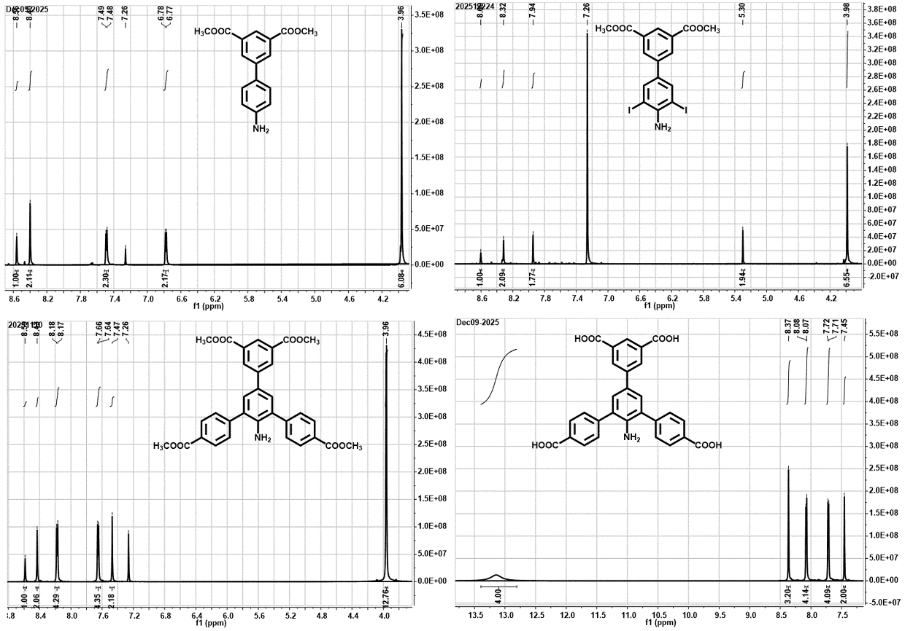
Fig. S1. ¹H NMR spectra of synthesized ligand intermediates and H₄CPTT-NH₂.
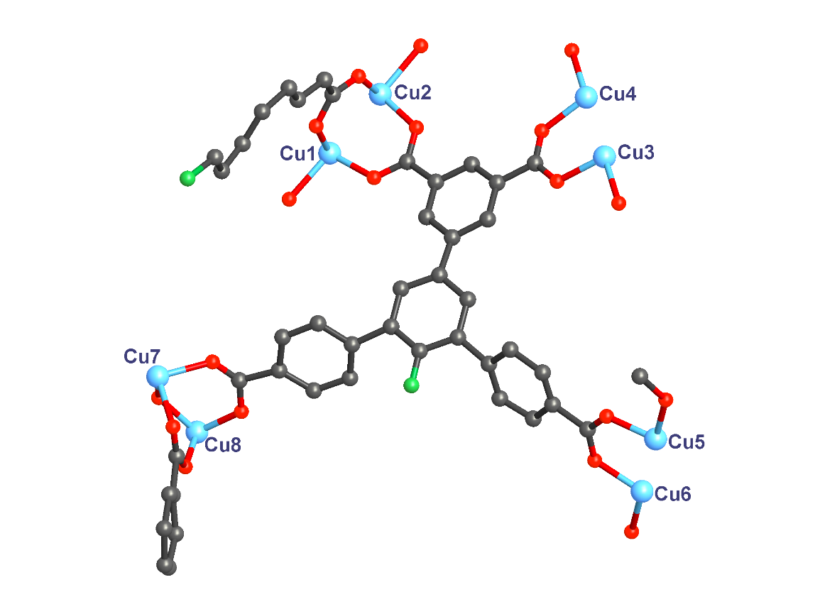
Fig. S2. The asymmetric unit of UPC-114.
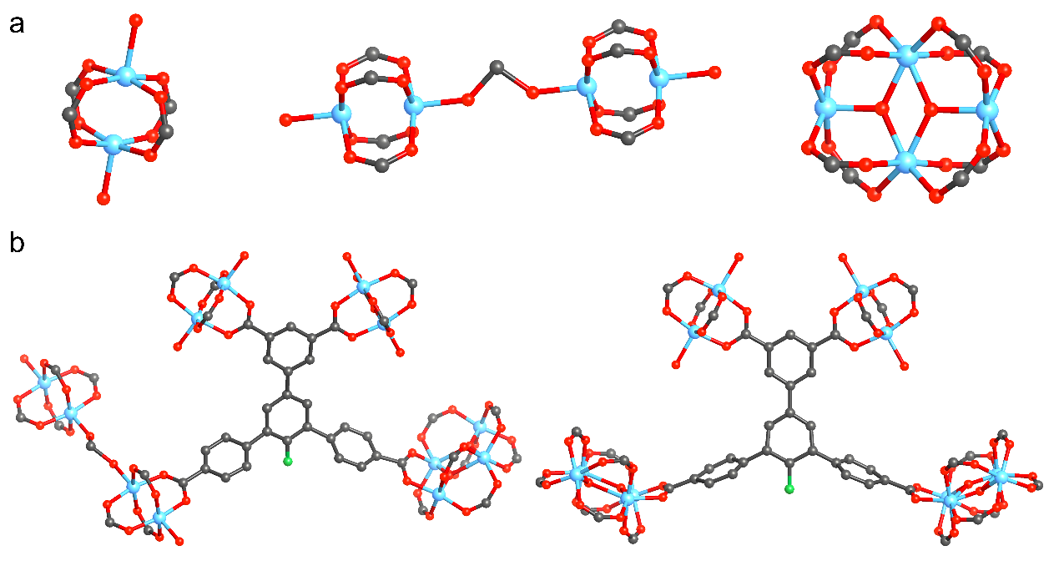
Fig. S3. (a) Three different SBUs in UPC-114: the typical Cu₂(COO)₄ paddle-wheel, two Cu₂(COO)₄ paddle-wheels linked by formic acid, and tetranuclear Cu₄(H₂O)₂(COO)₈ cluster. (b) Two different linking modes of H₄CPTT-NH₂ ligand in UPC-114.
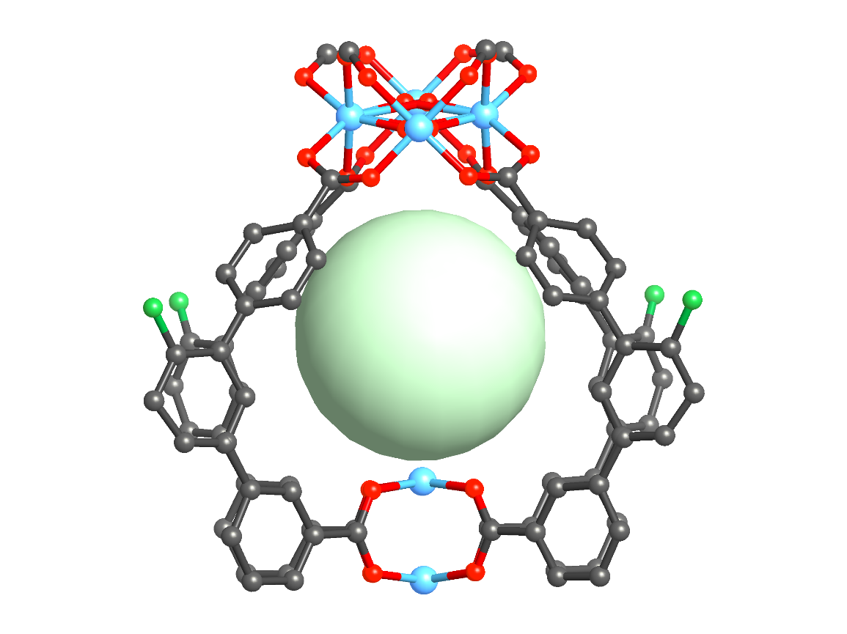
Fig. S4. The pocket of 6.8 Å around the cages in UPC-114.
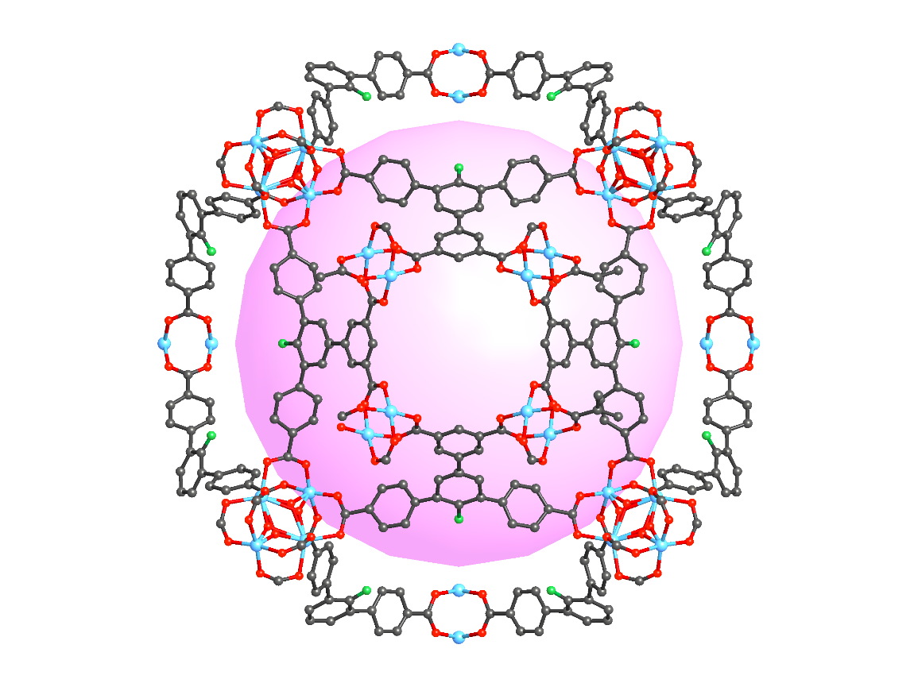
Fig. S5. The large cage with an inner diameter of 26.1 Å and the window of 8.8 Å in UPC-114.
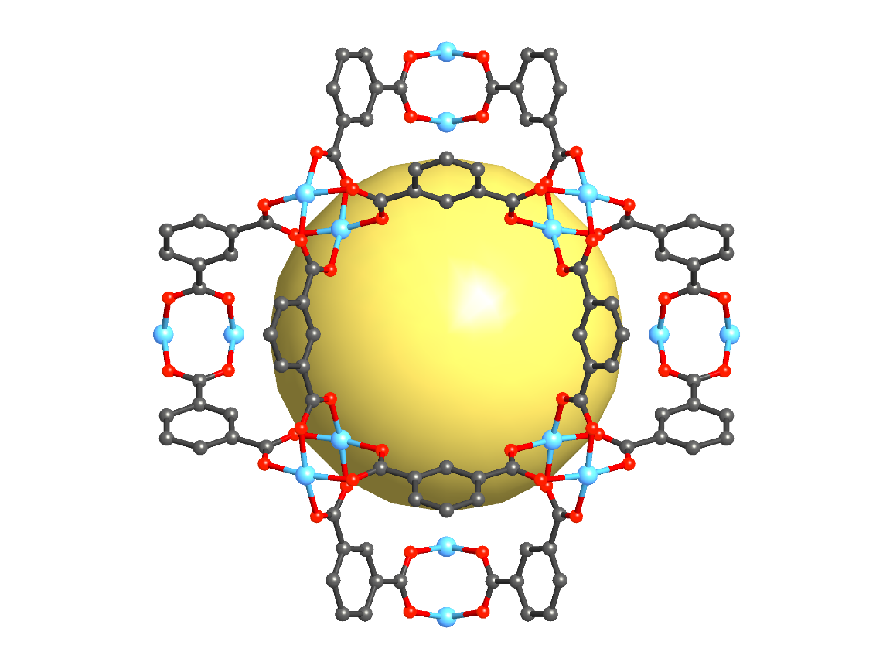
Fig. S6. The small cage with an inner diameter of 13.4 Å and the window of 8.8 Å in UPC-114.
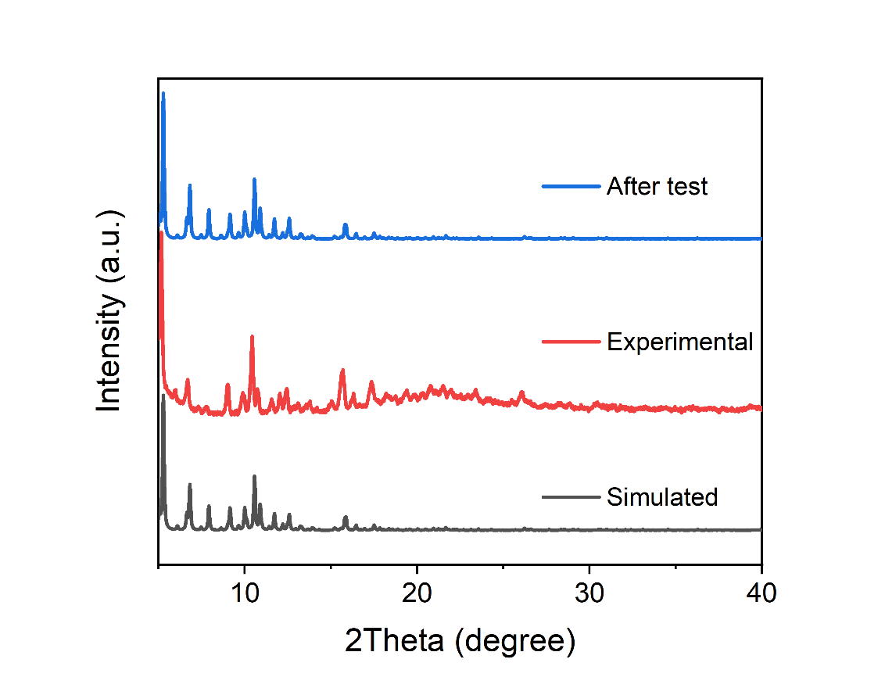
Fig. S7. PXRD patterns of UPC-114.
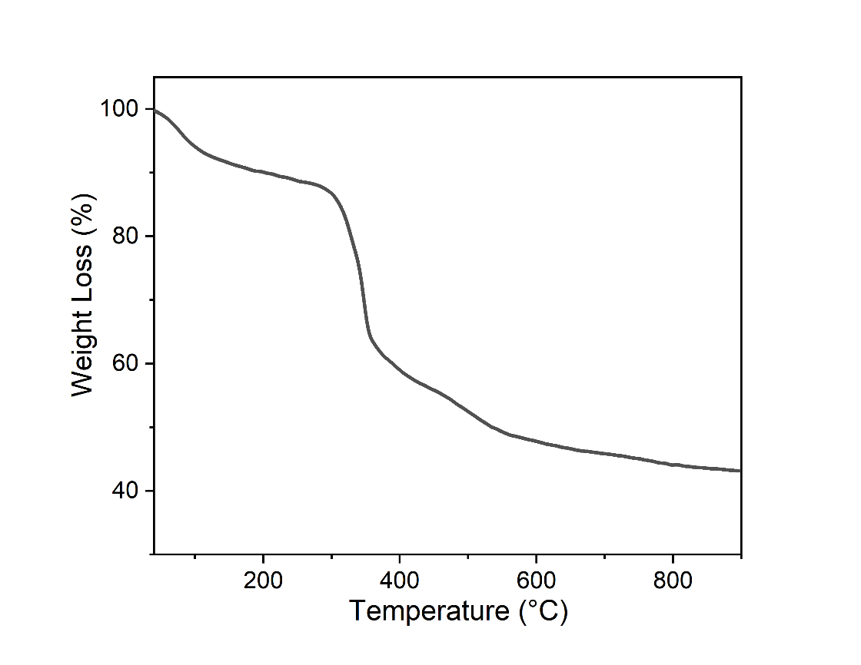
Fig. S8. TGA curve of UPC-114.
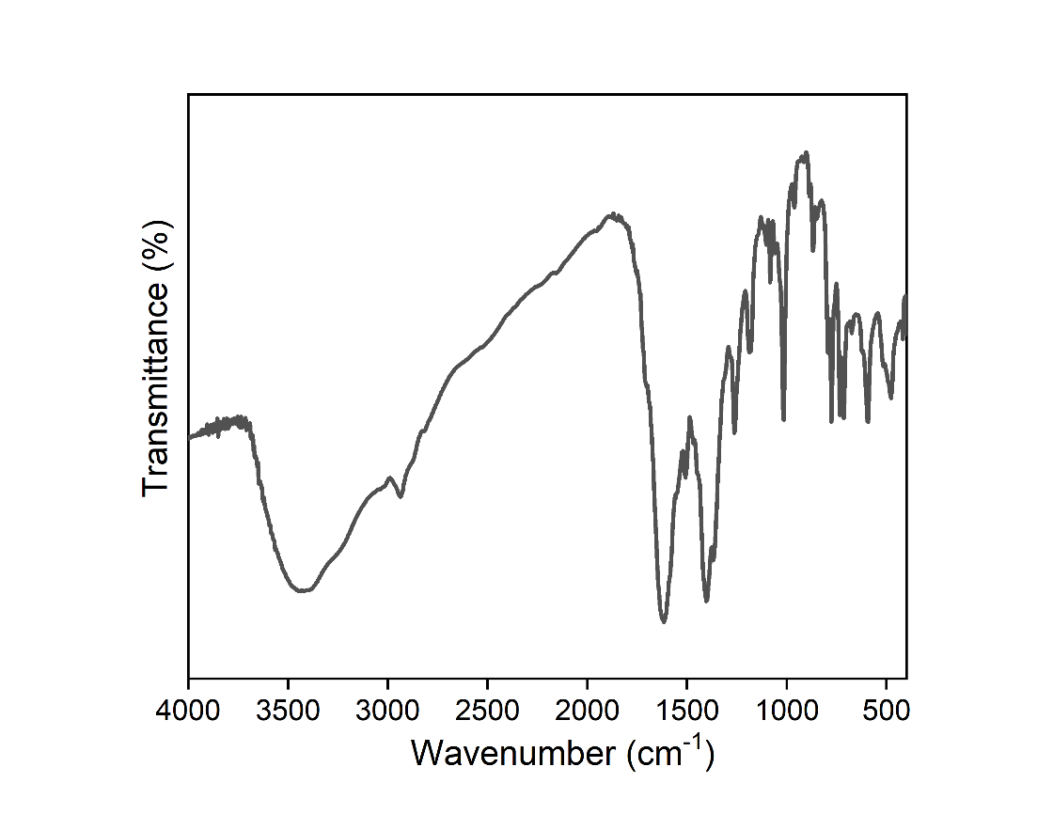
Fig. S9. IR spectrum of UPC-114.
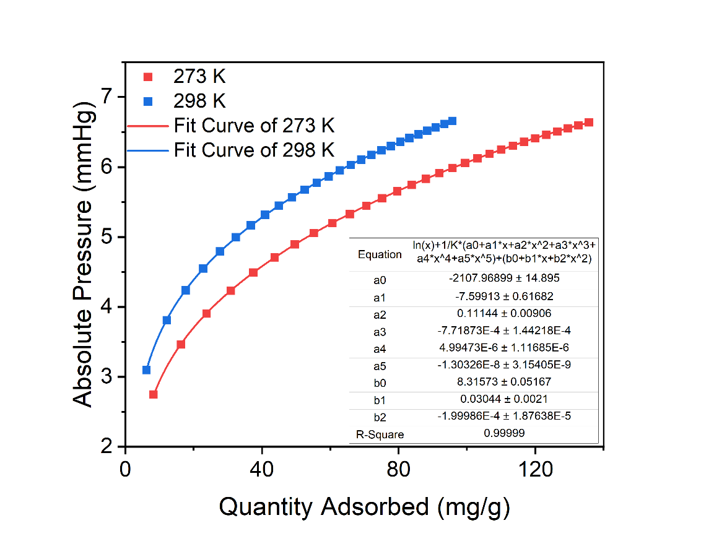
Fig. S10. Virial fitting of C₂H₆ for UPC-114.
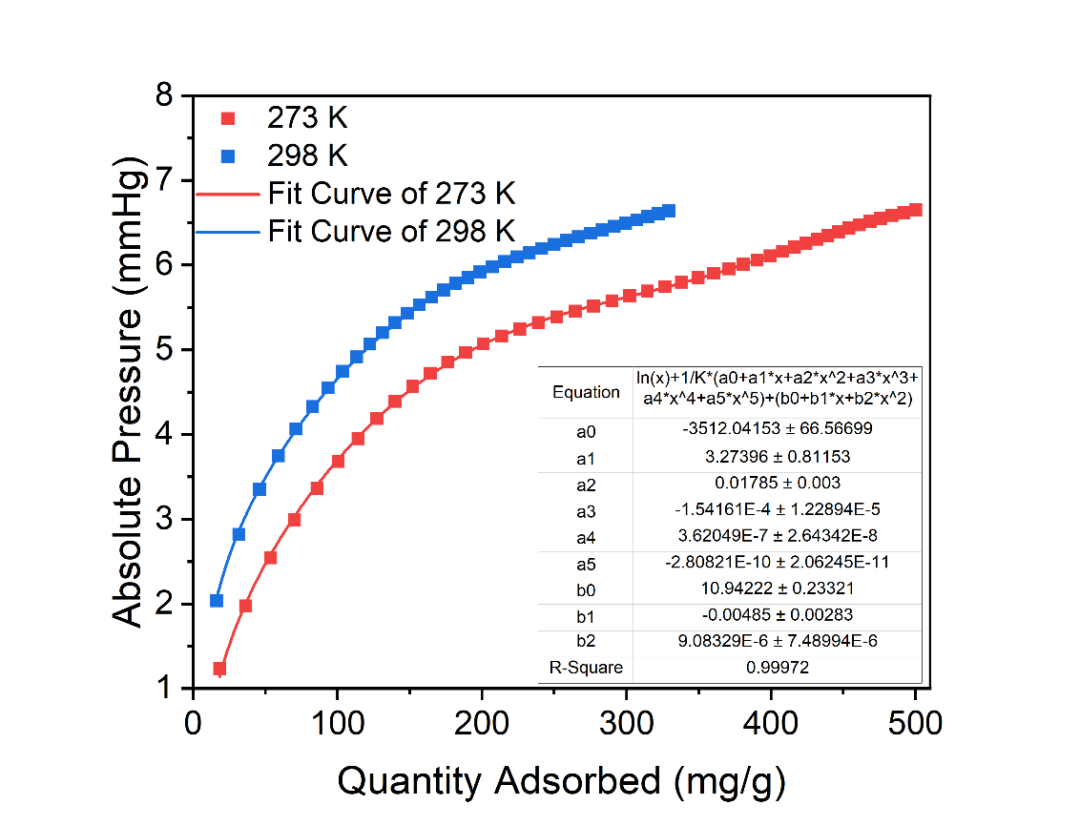
Fig. S11. Virial fitting of C₃H₈ for UPC-114.
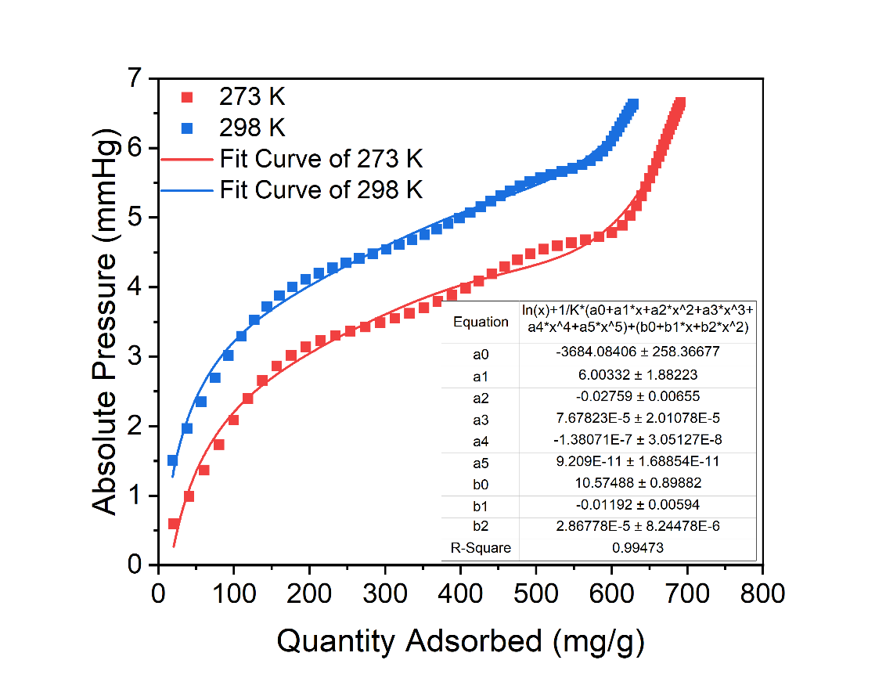
Fig. S12. Virial fitting of C₄H₁₀ for UPC-114.
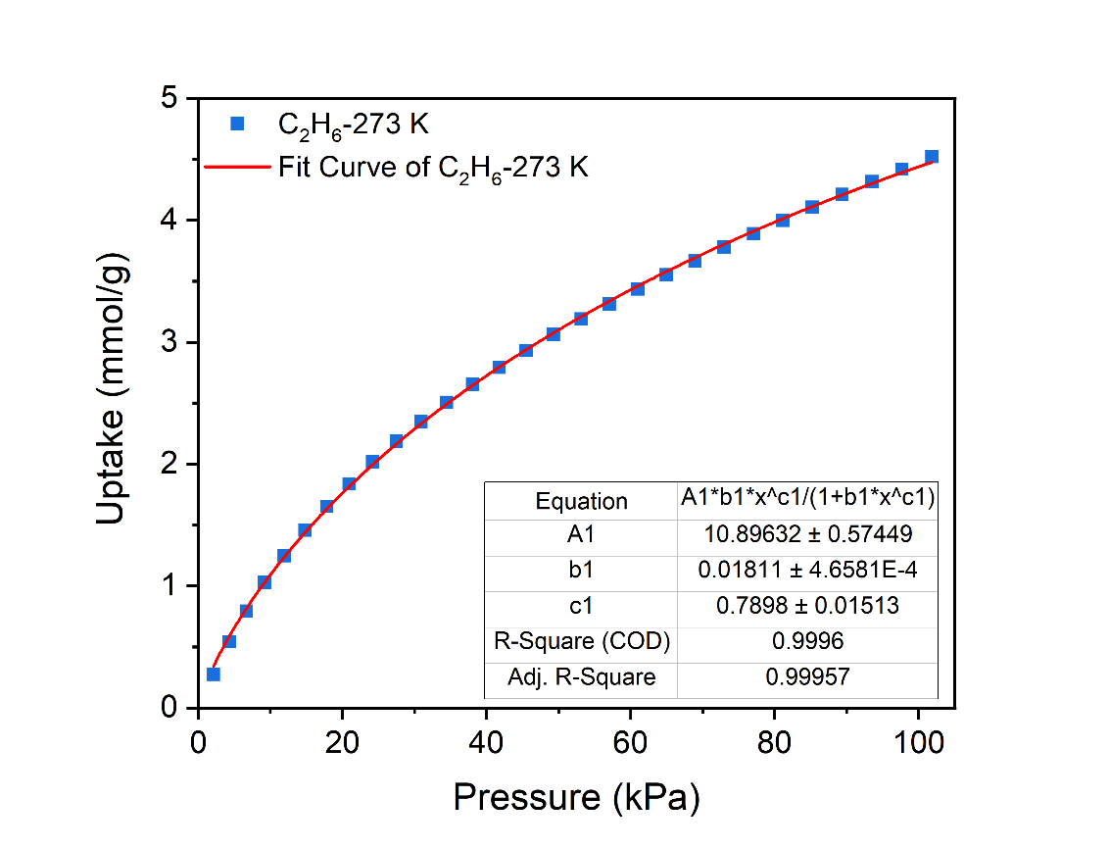
Fig. S13. Langmuir-Freundlich fitting of C₂H₆ for UPC-114 at 273 K.
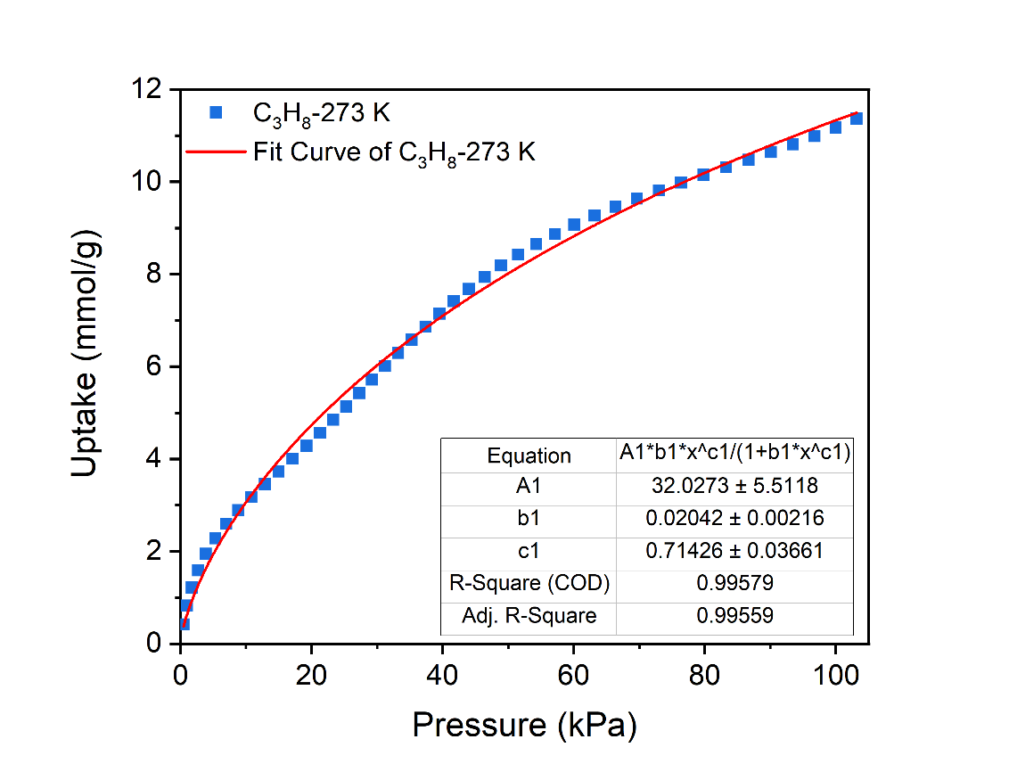
Fig. S14. Langmuir-Freundlich fitting of C₃H₈ for UPC-114 at 273 K.
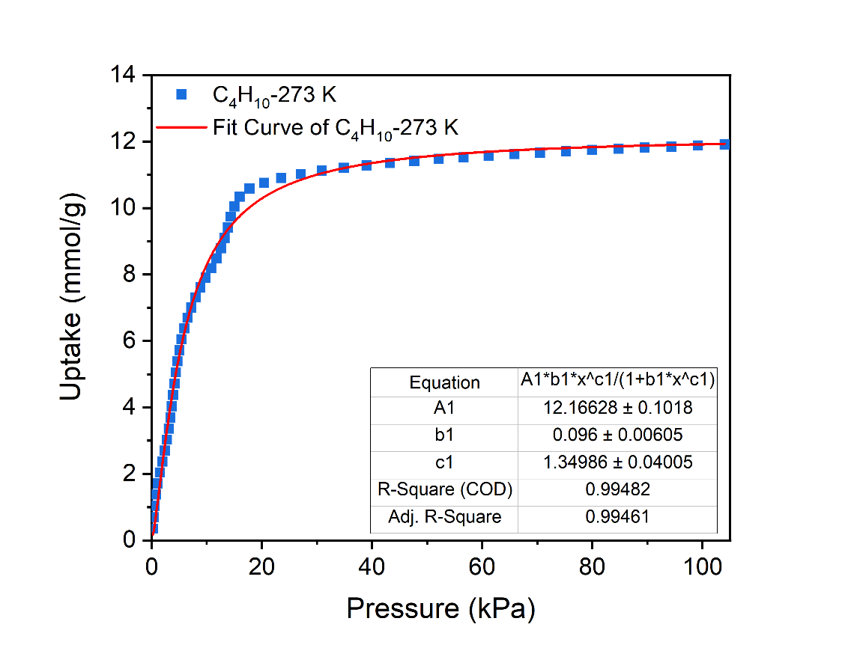
Fig. S15. Langmuir-Freundlich fitting of C₄H₁₀ for UPC-114 at 273 K.
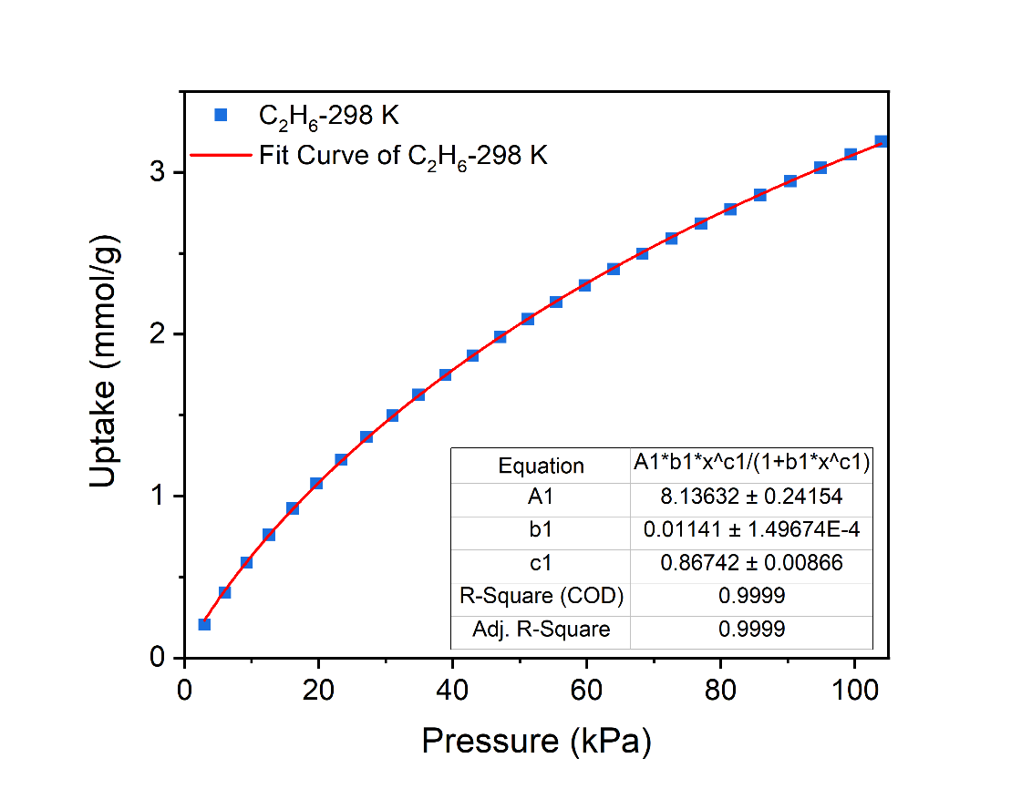
Fig. S16. Langmuir-Freundlich fitting of C₂H₆ for UPC-114 at 298 K.
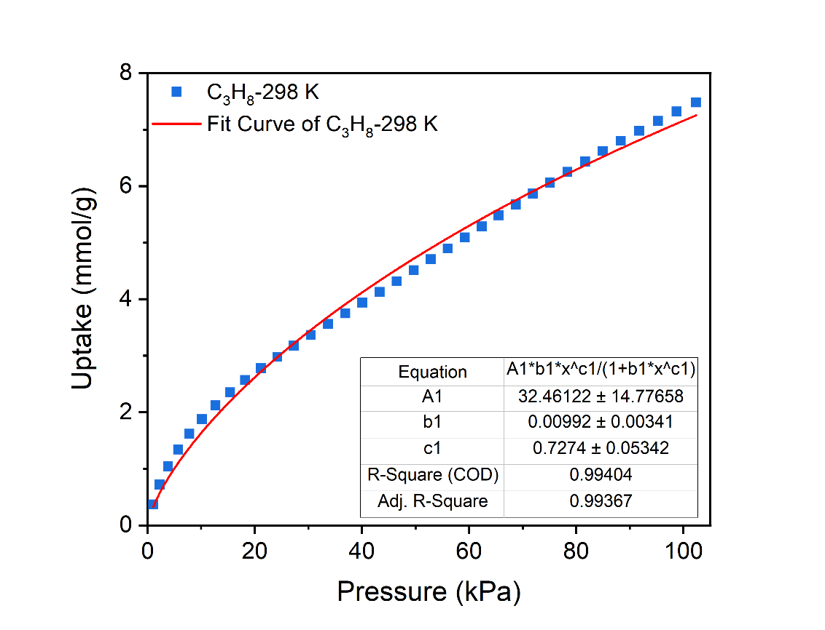
Fig. S17. Langmuir-Freundlich fitting of C₃H₈ for UPC-114 at 298 K.
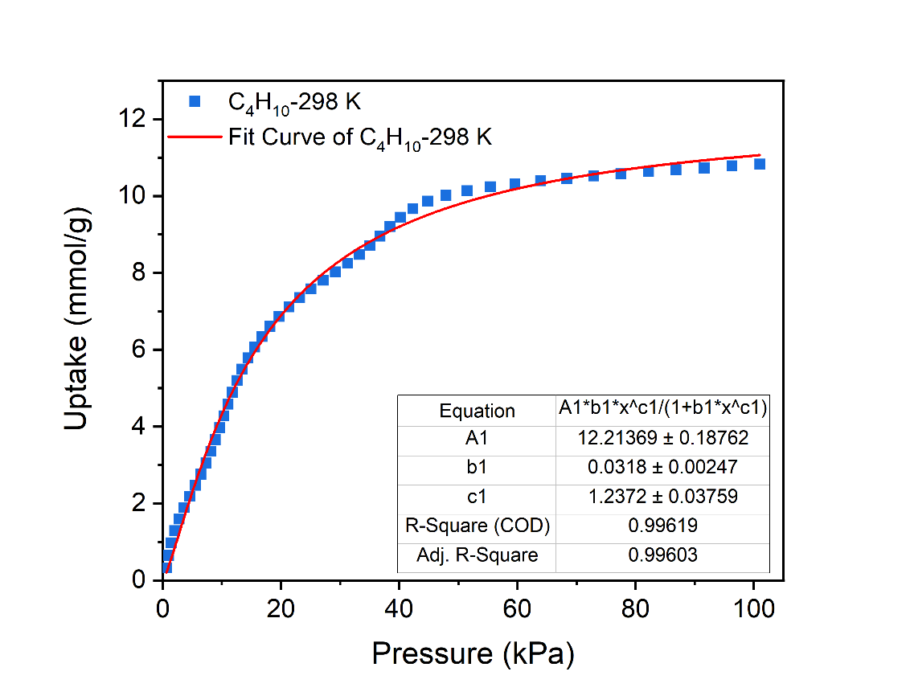
Fig. S18. Langmuir-Freundlich fitting of C₄H₁₀ for UPC-114 at 298 K.
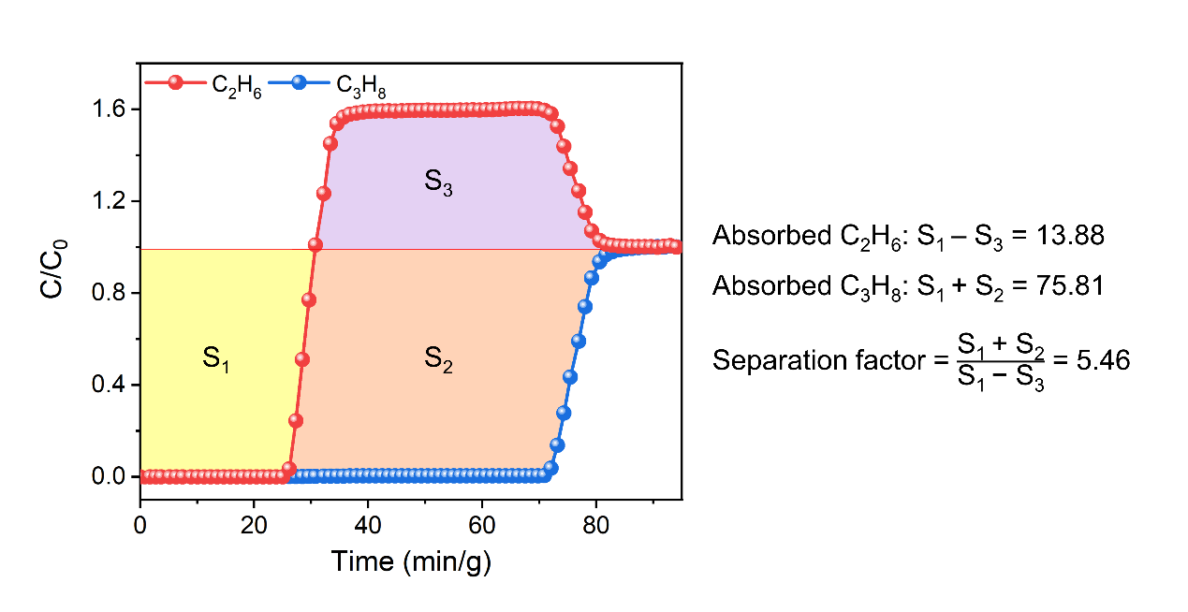
Fig. S19. Calculated dynamic adsorption capacity and separation factor of UPC-114 based on breakthrough curve of equimolar C₃H₈/C₂H₆ binary mixture (2 mL/min) at 298 K and 1 bar.
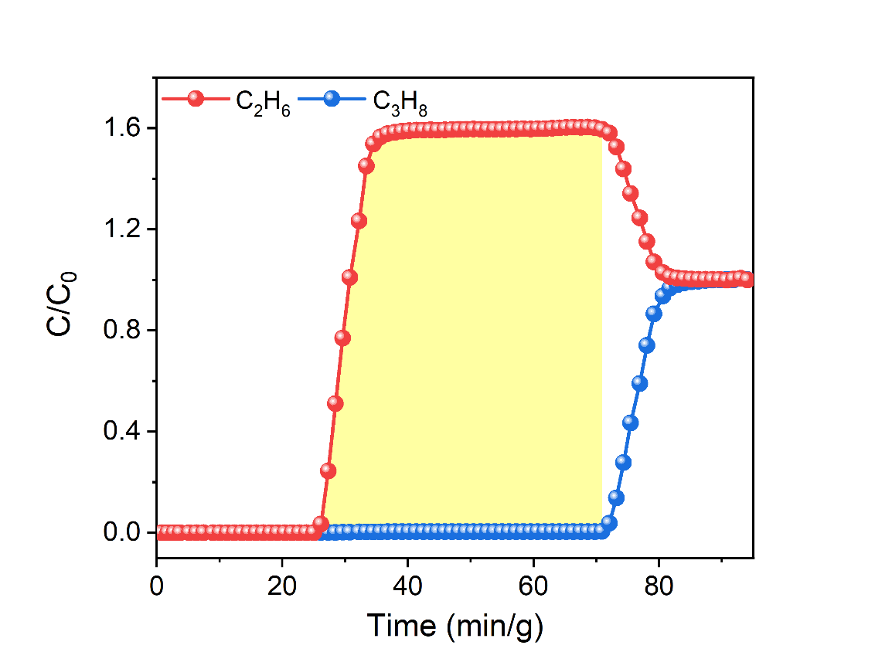
$Productivity \text{=} \text{F}{\text{c}}_{\text{i}}{\text{t}}_{\text{i}} \text{=} \frac{\text{F} \text{×}{\text{ yC}}_{\text{2}}{\text{H}}_{\text{6}}\text{ ×} \int_{\text{0}}^{\text{t}}{\text{(1}\text{-}\frac{{\text{C}}_{t}}{{\text{C}}_{\text{0}}}}\text{)dt}}{\text{22.4 ×} \text{m}}\text{=}\frac{\text{F} \text{×} {\text{yC}}_{\text{2}}{\text{H}}_{\text{6}} \text{×} \text{S}}{\text{22.4 × m}}$ =$\frac{\text{2} \text{×} \text{0.5} \text{×} \text{65.18}}{\text{22.4 × 1}}=2.90 mmol/g$
Fig. S20. Calculated pure C₂H₆ productivity of UPC-114 based on breakthrough curve of equimolar C₃H₈/C₂H₆ binary mixture (2 mL/min) at 298 K and 1 bar.
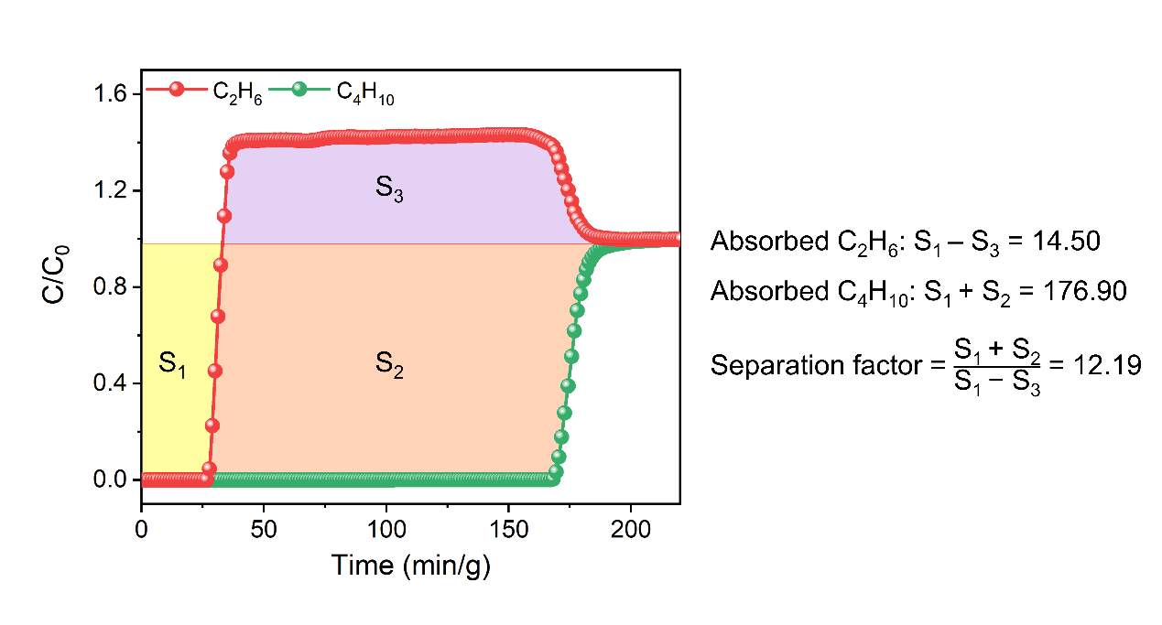
Fig. S21. Calculated dynamic adsorption capacity and separation factor of UPC-114 based on breakthrough curve of equimolar C₄H₁₀/C₂H₆ binary mixture (2 mL/min) at 298 K and 1 bar.
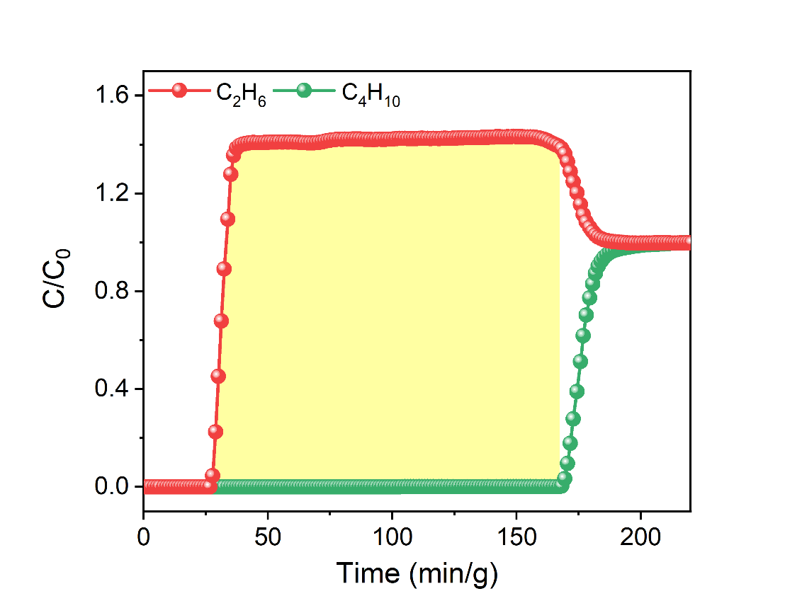
$Productivity \text{=} \text{F}{\text{c}}_{\text{i}}{\text{t}}_{\text{i}} \text{=} \frac{\text{F} \text{×}{\text{ yC}}_{\text{2}}{\text{H}}_{\text{6}}\text{ ×} \int_{\text{0}}^{\text{t}}{\text{(1}\text{-}\frac{{\text{C}}_{t}}{{\text{C}}_{\text{0}}}}\text{)dt}}{\text{22.4 ×} \text{m}}\text{=}\frac{\text{F} \text{×} {\text{yC}}_{\text{2}}{\text{H}}_{\text{6}} \text{×} \text{S}}{\text{22.4 × m}}$ =$\frac{\text{2} \text{×} \text{0.5} \text{×} \text{192.61}}{\text{22.4 × 1}}=8.59 mmol/g$
Fig. S22. Calculated pure C₂H₆ productivity of UPC-114 based on breakthrough curve of equimolar C₄H₁₀/C₂H₆ binary mixture (2 mL/min) at 298 K and 1 bar.
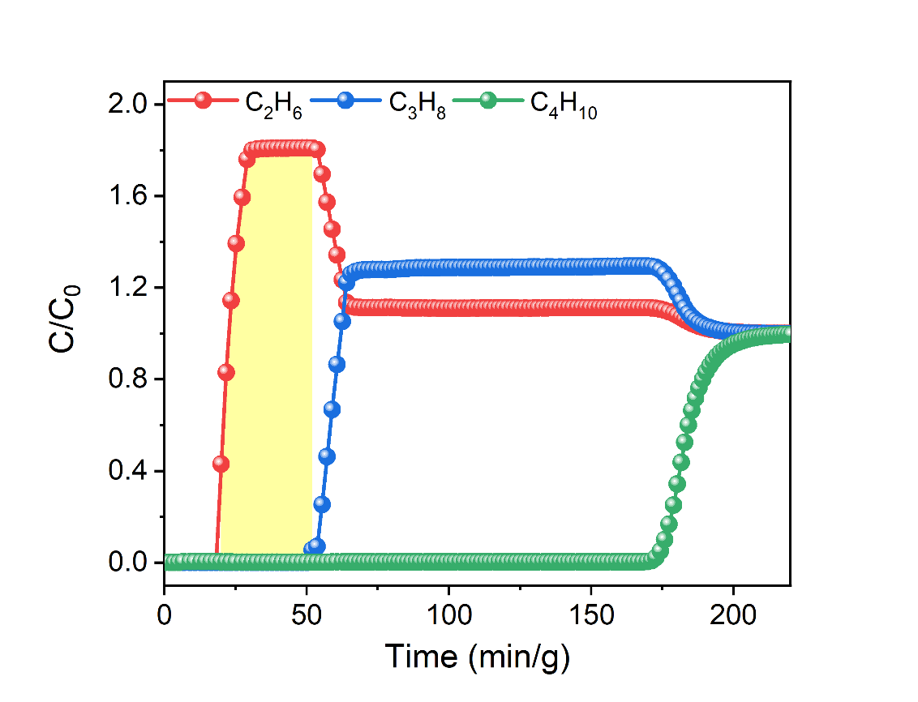
$Productivity \text{=} \text{F}{\text{c}}_{\text{i}}{\text{t}}_{\text{i}} \text{=} \frac{\text{F} \text{×}{\text{ yC}}_{\text{2}}{\text{H}}_{\text{6}}\text{ ×} \int_{\text{0}}^{\text{t}}{\text{(1}\text{-}\frac{{\text{C}}_{t}}{{\text{C}}_{\text{0}}}}\text{)dt}}{\text{22.4 ×} \text{m}}\text{=}\frac{\text{F} \text{×} {\text{yC}}_{\text{2}}{\text{H}}_{\text{6}} \text{×} \text{S}}{\text{22.4 × m}}$ =$\frac{\text{5} \text{×} \text{0.46} \text{×} \text{52.35}}{\text{22.4 × 1}}=5.37 mmol/g$
Fig. S23. Calculated pure C₂H₆ productivity of UPC-114 based on breakthrough curve of C₄H₁₀/C₃H₈/C₂H₆ (20/34/46, v/v/v) ternary mixture (5 mL/min) at 298 K and 1 bar.
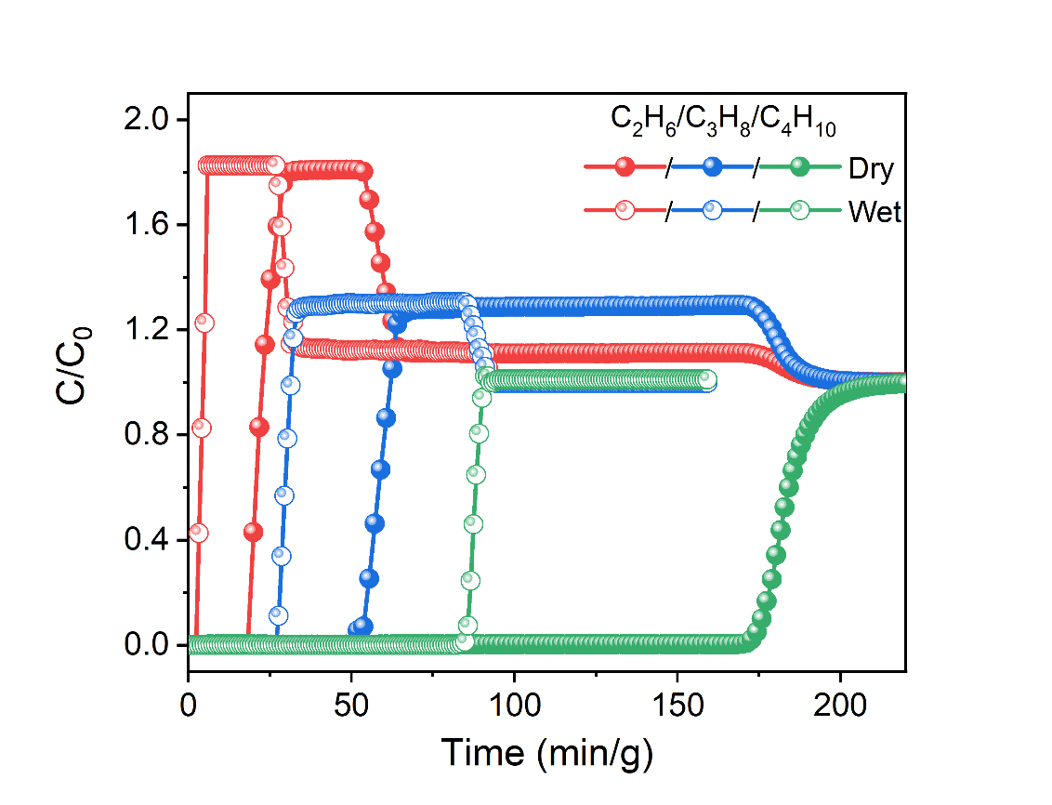
Fig. S24. Breakthrough curves of C₄H₁₀/C₃H₈/C₂H₆ (20/34/46, v/v/v) ternary mixture (5 mL/min) on UPC-114 under dry and wet conditions at 298 K and 1 bar.
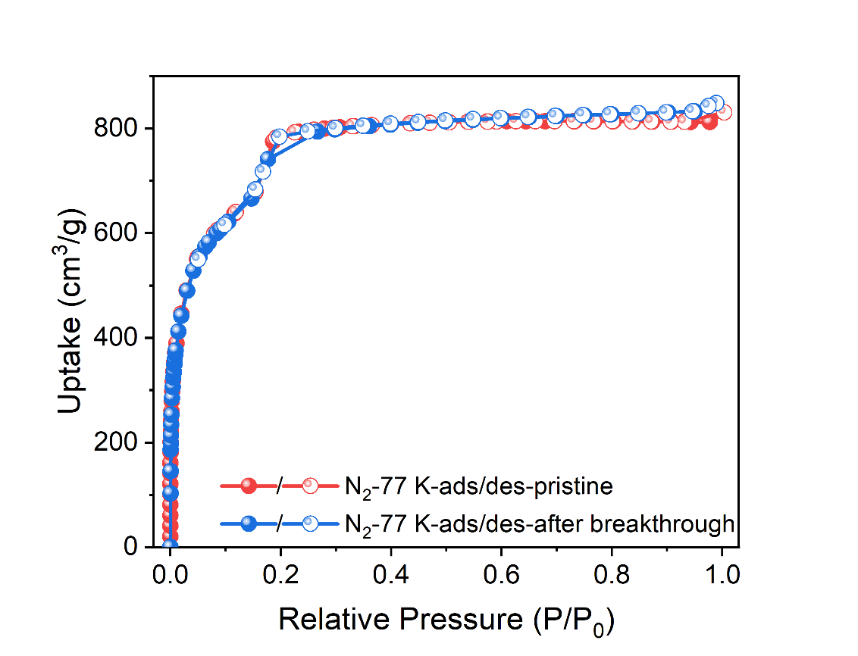
Fig. S25. N₂ adsorption/desorption isotherms of UPC-114 at 77 K before and after breakthrough tests.

Tables S1-S2
Table S1. Crystal data of UPC-114.
Compound | UPC-114
CCDC | 2530133
Formula | C_{42.125}H_{26.75}N_{1.5}O_{14.25}Cu₃
Formula weight | 7780.15
Temperature/K | 293(2)
Crystal system | tetragonal
Space group | I4/mmm
a/Å | 40.980(6)
b/Å | 40.980(6)
c/Å | 57.955(12)
α/° | 90
β/° | 90
γ/° | 90
Volume/Å³ | 97328(34)
Z | 32
ρ g/cm³ | 0.530
μ/mm⁻¹ | 0.544
F(000) | 15656.0
2θ range for data collection | 1.218 to 48.8
Index ranges | -47 ≤ h ≤ 45
Index ranges | -47 ≤ k ≤ 47
Index ranges | -67 ≤ l ≤ 65
Reflections collected | 366404
R_{int} | 0.0961
Data/restraints/parameters | 21286/444/515
Goodness-of-fit on F² | 1.093
Final R indexes [I>=2σ (I)] | R₁ = 0.1045  wR₂ = 0.2574
Final R indexes [all data] | R₁ = 0.1219  wR₂ = 0.2700
Largest diff. peak/hole /eÅ⁻³ | 1.23/-0.57

Table S2. Comparison of adsorption capacity and adsorption enthalpy for adsorbents at 298 K.
Materials | Adsorption capacity (mmol/g) |  |  | Adsorption enthalpy (kJ/mol) |  |  | Ref.
Materials | C₄H₁₀ | C₃H₈ | C₂H₆ | C₄H₁₀ | C₃H₈ | C₂H₆ | Ref.
MAF-68 | 5.64 | 6.26 | 4.9 | 40.4 | 31.4 | 24.0 | ¹
RE-fcu-MOF-1 | 1.57 | 1.93 | 1.96 | - | - | - | ²
ZJU-HOF-8a | 3.65 | 3.05 | 2.51 | 41.3 | 34.2 | 23.3 | ³
CaCu₆-MOF-1 | 4.09 | 4.19 | 3.5 | - | - | - | ⁴
Y-ftw-MOF-2 | 11.19 | 11 | 2.87 | - | - | - | ⁵
FJI-H19 | 7.72 | 7.77 | 5.79 | - | - | - | ⁶
LIFM-Z1 | 5.83 | 4.78 | 2.47 | 39.3 | 32 | 29.8 | ⁷
HOF-TCBP | 7.08 | 7.2 | 1.93 | 30.2 | - | - | ⁸
LIFM-233 | 11.73 | 10.24 | 2.34 | 29.4 | 25.4 | 16.8 | ⁹
Zr-HDTB-alb | 2.48 | 2.37 | 2.37 | - | - | - | ¹⁰
Fe-HDTB-alb | 3.85 | 3.58 | 3.58 | - | - | - | ¹⁰
UPC-114 | 10.83 | 7.48 | 3.19 | 30.62 | 29.19 | 17.52 | This work

References
1. Li, Y.-G.; Chen, J.-X.; Li, J.-H.; Zhuo, H.; Han, D.-C.; Li, L.; Li, J.; Lin, R.-B.; Chen, X.-M., Selective adsorption of C₂₊ alkanes over methane by using a zinc tris-pyrazolate framework. J. Mater. Chem. A 2025, 13 (44), 38034-38038.
2. Xue, D.-X.; Belmabkhout, Y.; Shekhah, O.; Jiang, H.; Adil, K.; Cairns, A. J.; Eddaoudi, M., Tunable Rare Earth fcu-MOF Platform: Access to Adsorption Kinetics Driven Gas/Vapor Separations via Pore Size Contraction. J. Am. Chem. Soc. 2015, 137 (15), 5034-5040.
3. Jiang, C.; Wang, J. X.; Liu, D.; Wu, E.; Gu, X. W.; Zhang, X.; Li, B.; Chen, B.; Qian, G., Supramolecular Entanglement in a Hydrogen‐Bonded Organic Framework Enables Flexible‐Robust Porosity for Highly Efficient Purification of Natural Gas. Angew. Chem. Int. Ed. 2024, 63 (26), e202404734.
4. Grancha, T.; Mon, M.; Ferrando-Soria, J.; Gascon, J.; Seoane, B.; Ramos-Fernandez, E. V.; Armentano, D.; Pardo, E., Tuning the selectivity of light hydrocarbons in natural gas in a family of isoreticular MOFs. J. Mater. Chem. A 2017, 5 (22), 11032-11039.
5. Luebke, R.; Belmabkhout, Y.; Weseliński, Ł. J.; Cairns, A. J.; Alkordi, M.; Norton, G.; Wojtas, Ł.; Adil, K.; Eddaoudi, M., Versatile rare earth hexanuclear clusters for the design and synthesis of highly-connectedftw-MOFs. Chem. Sci. 2015, 6 (7), 4095-4102.
6. Hu, F.; Huang, P.; Di, Z.; Wu, M.; Jiang, F.; Hong, M., A robust cage-based framework for the highly selective purification of natural gas. Chem. Commun. 2019, 55 (69), 10257-10260.
7. Zheng, H.-T.; Song, L.; Yan, L.; Xiong, X.-H.; Lu, Y.-L.; Chen, C.-X.; Barboiu, M.; Wei, Z.-W.; Jiang, J.-J.; Su, C.-Y., Three-dimensional linker-promoted hierarchical porous metal–organic framework for natural gas purification. Sep. Purif. Technol. 2025, 354, 129466.
8. Hu, F.; Liu, C.; Wu, M.; Pang, J.; Jiang, F.; Yuan, D.; Hong, M., An Ultrastable and Easily Regenerated Hydrogen‐Bonded Organic Molecular Framework with Permanent Porosity. Angew. Chem. Int. Ed. 2017, 56 (8), 2101-2104.
9. Meng, L.-L.; Xiong, X.-H.; Zhang, L.; Song, L.; Chen, C.-X.; Wei, Z.-W.; Su, C.-Y., Introducing π-electron-rich aromatic rings into a robust Zr-MOF for efficient natural gas purification and C₃H₈/n-C₄H₁₀ recovery. J. Mater. Chem. A 2024, 12 (23), 13689-13693.
10. Yang, J.; Zhang, Z.; Jiang, Y.; Zhong, Y.; Yang, Z.; Chen, Z., Net-Coded Organic Building Blocks for the Reticular Assembly of High-Connectivity Metal–Organic Frameworks. J. Am. Chem. Soc. 2025, 147 (24), 20218-20224.

