SUPPLEMENTARY INFORMATION
Mixed layer and thermocline dynamics driving El Niño–La Niña modes since the middle Miocene
Ayushi Ram¹, Anil K. Gupta^{1*}, Jacek Raddatz²

¹Department of Geology and Geophysics, Indian Institute of Technology Kharagpur,
Kharagpur 721302, India
²GEOMAR Helmholtz Centre for Ocean Research Kiel, Wischhofstr. 1-3, D-24148, Kiel, Germany
*Corresponding author.
Email address: anilg@gg.iitkgp.ac.in (Anil K. Gupta)

- Age model
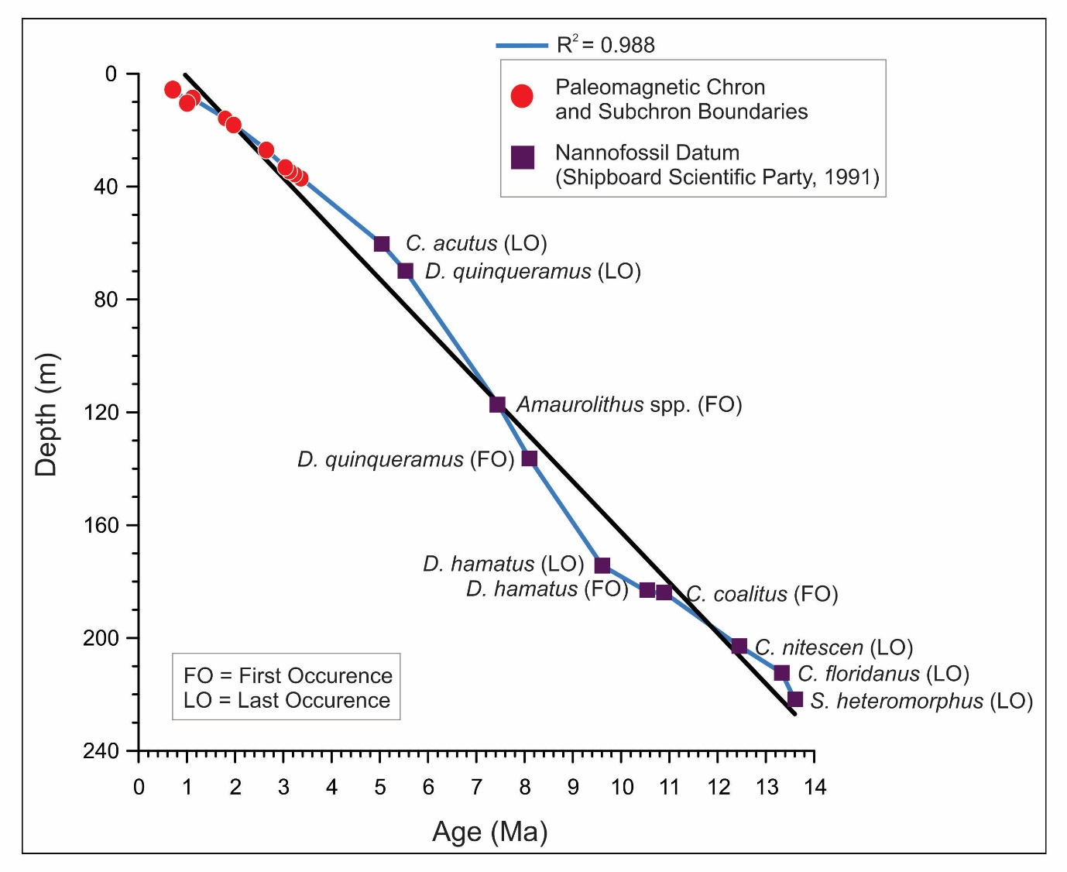
Fig. S1. Age vs. Depth plot for ODP Site 803D. The chronology is based on ten paleomagnetic stratigraphy (spanning 0 to ~3.33 Ma) and ten calcareous nannofossil datums (spanning ~3.33 to ~13.60 Ma) following Kroenke et al.¹ and updated to Raffi et al.² (see Table S1, Supplementary Material). FO = First Occurrence; LO = Last occurrence.

Table S1
Age datums are based on chron and subchron paleomagnetic boundaries of ODP Site 803D¹ and updated to Raffi et al.².
Sl. no. | Depth(mbsf) | Datums | Age (Ma)²
1 | 6.4 | Brunches | 0.773
2 | 9.6 | Jaramillo(O) | 1.008
3 | 8.3 | Jaramillo(T) | 1.076
4 | 15.6 | Olduvai(T) | 1.775
5 | 17.6 | Olduvai(O) | 1.934
6 | 26.4 | Gauss(T) | 2.61
7 | 32.9 | Kaena(T) | 3.032
8 | 34.1 | Kaena(O) | 3.116
9 | 35.1 | Mammoth(T) | 3.207
10 | 36.5 | Mammoth(O) | 3.33
11 | 60.35 | LO C. acutus | 5.04
12 | 69.85 | LO D. quinqueramus | 5.53
13 | 117.15 | FO Amaurolithus spp | 7.45
14 | 136.35 | FO D. quinqueramus | 8.1
15 | 174.35 | LO D. hamatus | 9.61
16 | 183.85 | FO D. hamatus | 10.57
17 | 183.85 | FO C. coalitus | 10.89
18 | 202.85 | LO C. nitescen | 12.45
19 | 212.35 | LO C. floridanus | 13.33
20 | 221.95 | LO S. heteromorphus | 13.6

- Trends in major planktic foraminifera species
Figure 3c illustrates the relative abundance of Neogloboquadrina spp., which increases following the appearance of the Neogloboquadrina acostaensis–Neogloboquadrina humerosa–Neogloboquadrina dutertrei lineage at ~9.8 Ma. The relative abundance of this species increases to ~35% at ~8.3 Ma, followed by a gradual decrease until ~8 Ma. At ~8 Ma, this species again increases from ~7% to a peak of ~67% at ~7 Ma. Thereafter, a steady decrease occurs from ~7 to 6 Ma, with relative abundance reaching at ~4% by ~6 Ma.
The relative abundance of Dentoglobigerina venezuelana decreased markedly from ~30% to ~2% between ~13 and 11 Ma, followed by a rapid increase to ~26% (Fig. 3d). From ~11 to 9.8 Ma, it maintained relatively elevated values, averaging ~12.5% of the total assemblage (Fig. 3d). Thereafter, it gradually decreased to ~2% by ~8 Ma. Between ~8 and 7 Ma, its relative abundance increased markedly, reaching ~25% of the total assemblage, which again decreased gradually to ~2% by ~5.2 Ma.
The relative abundance of Trilobatus sacculifer was relatively high between ~13 and 11 Ma, averaging ~21% of the total assemblage (Fig. 3e). Thereafter, its abundance decreased markedly, becoming nearly absent between ~11 and 9.8 Ma. From ~9.8 Ma onward, T. sacculifer exhibits a stepwise increase. However, beginning at ~8 Ma, its relative abundance gradually decreased, reaching a minimum of ~3% at ~7 Ma. Following this interval, the relative abundance of this species increased again from ~7 to 6.5 Ma, with a pronounced rise to ~30%, establishing a dominant presence during the late Miocene.
Figure 3f shows that the relative abundance of Globigerinita glutinata increased markedly from ~2% to ~20% between ~13 and 11 Ma. From ~11 to 8 Ma, this species maintained relatively increased values, averaging ~10.8% of the total assemblage. After ~8 Ma, its relative abundance decreased abruptly to ~5%. Thereafter, until ~6.5 Ma, G. glutinata remained at consistently low levels, with a mean relative abundance of ~4.3%.
- Paleoecology of the major planktic foraminiferal species used in this study
Neogloboquadrina dutertrei, a modern thermocline-dwelling eutrophic species, flourishes under nutrient-enriched environment during enhanced primary productivity^{3,4,5,6}. It exhibits a broad tolerance to environmental conditions, inhabiting waters with salinity levels between 25 and 46 PSU and temperatures between 13°C and 33°C⁷. At temperatures below 15°C, N. dutertrei develops calcite crusts, which are commonly observed in subsurface sediment assemblages⁸. Neogloboquadrina acostaensis and Neogloboquadrina humerosa are considered to have similar ecological preferences with N. dutertrei^{4,9}. Together these tropical Neogloboquadrinids (N. dutertrei, N. acostaensis, and N. humerosa) are collectively referred to as Neogloboquadrina spp. These species are primarily herbivorous, feeding on diatoms and other eukaryotes^{8,10}. As thermocline dwellers, they are widely used as indicators of subsurface productivity, typically calcifying near the deep chlorophyll maximum^{3,5,11}.
Globigerinita glutinata is a cosmopolitan species that tolerates a broad range of temperatures (14°C to 30°C) and salinities (34.4–36.4 PSU)¹². It is moderately susceptible to dissolution and occurs widely across mid- to high-latitude regions as well as in low-latitude upwelling zones^{3,13,14,15}. The distribution of G. glutinata is closely associated with paleoproductivity, as it thrives in nutrient-rich thermocline waters, particularly in upwelling settings^{10,16,17}. This pattern is likely driven by the upwelling of cold, nutrient-rich subsurface waters, which leads to a shallower mixed layer and enhanced surface productivity.
Trilobatus sacculifer is a tropical, shallow-dwelling mixed layer species that prefers warm water with temperatures above 24°C and is typically associated with oligotrophic conditions with minimal seasonal changes in sea surface temperature^{3,14,15,18,19,20}. This species reaches its highest abundances in low-nutrient environments, reflecting its adaptation to nutrient-poor surface waters⁷.
Globorotalia menardii is a cosmopolitan species that thrives in tropical-subtropical waters of low-to-medium productivity^{21,22}. Maximum standing stocks of this species occur at the upper thermocline, pycnocline, nutricline, or Deep Chlorophyll Maximum depths^{5,23}.
Dentoglobigerina venezuelana is a large, cosmopolitan planktic foraminiferal species widely distributed from the early Oligocene to the early Pliocene²⁴. Stable isotope and geochemical evidence indicate that it predominantly inhabits the lower thermocline to sub-thermocline waters, particularly during the late Oligocene–Miocene, reflecting relatively deeper calcification depths compared to surface-dwelling species^{25,26,27}. Ontogenetic studies suggest that juveniles initially calcify in shallower waters before migrating downward into deeper thermocline habitats during later growth stages²⁸. The species lacks photosymbionts, implying a reduced dependence on surface light conditions and a stronger association with subsurface nutrient dynamics²⁵. Its ecological distribution is closely linked to thermocline structure and ocean stratification, with shifts in habitat depth through time reflecting changes in thermocline intensity and vertical water column structure^{26,29,28,30,31}. Consequently, D. venezuelana is considered a reliable indicator of deeper water mass conditions and thermocline variability in paleoceanographic reconstructions.
Fohsella fohsi is a Miocene planktic foraminiferal species predominantly associated with tropical to subtropical regions and is widely regarded as a thermocline-dwelling taxon. Stable isotope evidence indicates that it calcifies at intermediate depths within the upper to middle thermocline^{26,31,32}. This species is considered to lack photosymbionts, suggesting a reduced dependence on light and a stronger linkage to subsurface nutrient availability^{8,32}. Its distribution is closely associated with stratified water columns, where a well-developed thermocline supports distinct ecological niche. Variations in the abundance of F. fohsi have been linked to changes in thermocline structure, vertical stratification, and nutrient distribution during the Miocene³¹. Consequently, F. fohsi serves as a reliable indicator of thermocline dynamics and subsurface oceanographic conditions in paleoceanographic reconstructions.
- Planktic foraminiferal mixed layer and thermocline species assemblages:
Tropical planktic foraminifera exhibit diverse assemblages governed by factors such as temperature, diet, and chlorophyll concentration, reflecting their adaptations to varying environmental conditions. These adaptations enable them to inhabit deep waters and turbid surface layers, with distinct species occupying specific depths within the water column³³. Studies on the ecological distribution of planktic foraminifera have demonstrated their strong association with particular surface water masses^{34,35}. Due to the stratification of water masses across varying depths, these species serve as critical indicators for reconstructing the interactions and properties of water masses in the Western Equatorial Pacific (WEP).
The planktic foraminiferal record is categorized into two distinct assemblages, representing water mass stratification and depth-specific habitats. These assemblages, delineated by species abundance, provide valuable insights into mixed layer and thermocline dynamics^{36,37}. For paleo-productivity, species exhibiting notable seasonality and depth preference, such as Globigerina bulloides, G. glutinata, and Neogloboquadrinids, are studied^{38,39}. For each target age, the relative abundance of mixed-layer and thermocline species was calculated by summing the relative abundances of the respective individual species. The species list for each assemblage is presented in Table S2.
Table S2
Planktic foraminiferal groups and their constituent species.
Assemblages and Groups (Name of the species included) | Literature Referred
Mixed layer species  G. bulloides, G. falconensis, G. conglobatus, G. ruber, G. obliquus, G. extremus, T. sacculifer, T. immaturus, T. quadrilobatus, T. trilobus, G. fistulosus, G. rubescens, G. decoraperta, G. apertura, G. woodi, G. nepenthes, G. druryi, O. universa, O. suturalis, D. altispira, D. baroemoenensis, D. globosa, G. glutinata, G. tenallus, P. continuosa, P. mayeri, P. siakensis | 12, 16, 19, 28, 29, 40, 41, 42, 43, 44, 45
Thermocline species  G. Calida, G. siphonifera, G. Obesa, S. dehiscens, S. praedehiscens, G. conglomerata, G. inflata, G. puncticulata, G. exilis, G. multicamerate, G. mioceanica, G. limbate, G. menardii, F. fohsi, G. ungulata, G. tumida, G. plesiotumida, G. margaritae, N. dutertrei, N. humerosa, N. inglei, N. pachyderma, N. incompta, N. acostansis, P. obliquiloculata, P. praecursor, P. spectabilis, P. primalis, S. seminulina, S. kochi, G. dehiscens, B. digitata, B. praedigitata, C. unicavus, G. hexagonus, G. hirsuta, G. scitula, G. truncatulinoides, G. tosaensis, G. crassaformis, G. crassula, D. venezuelana | 29, 37, 40, 41, 43, 44, 45

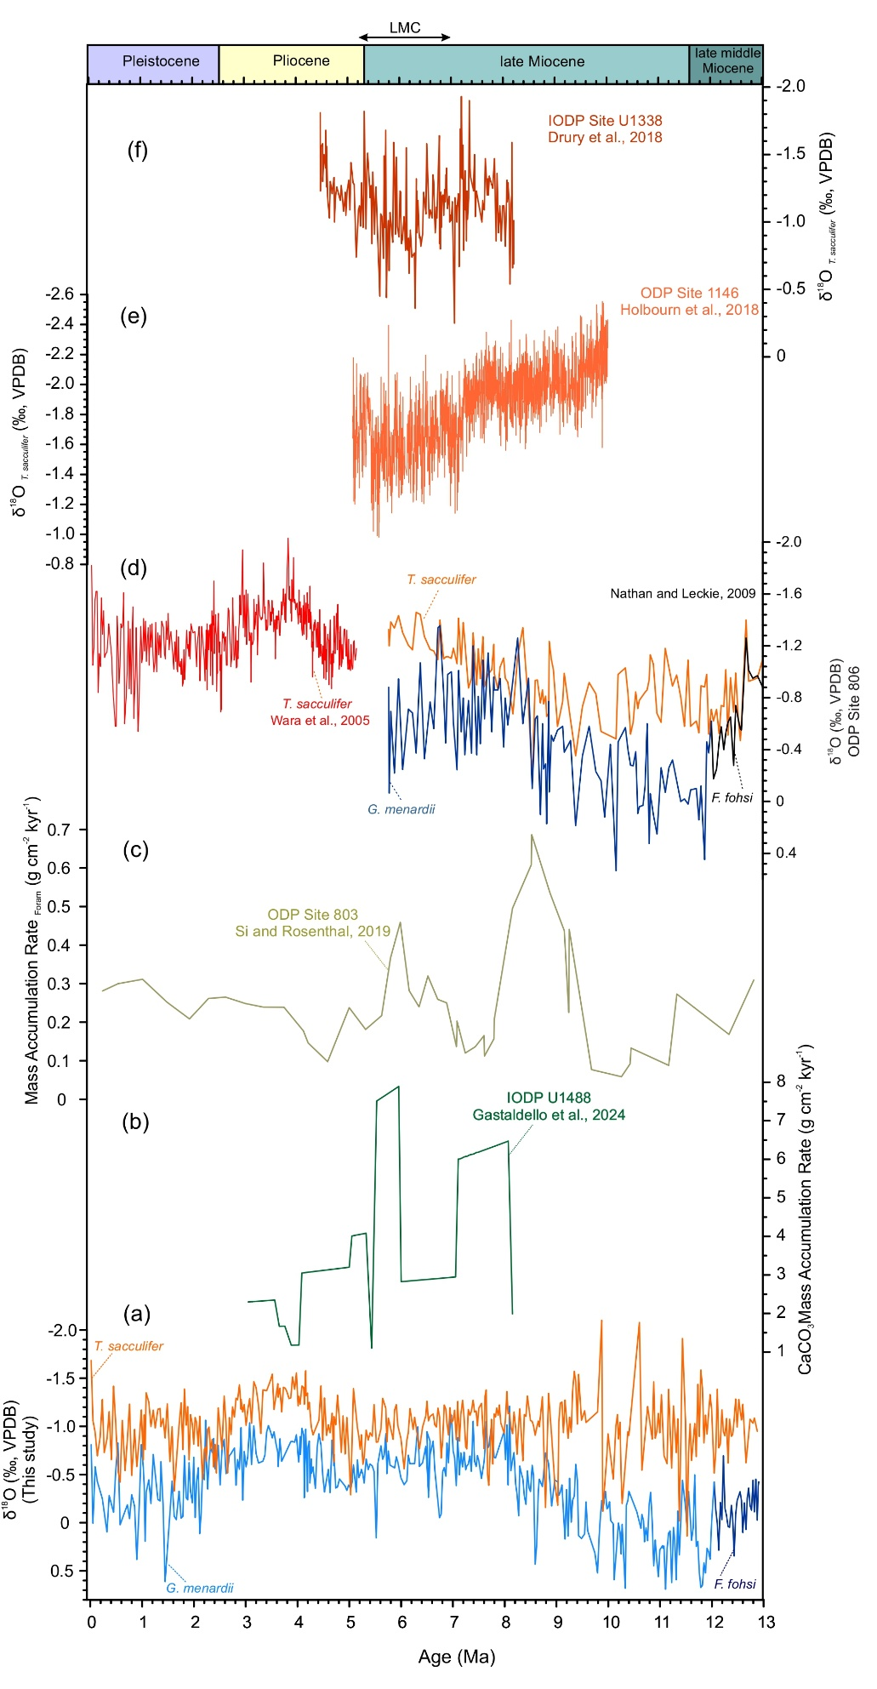

Fig. S2. Comparison of proxy data from ODP Site 803D with data from previously published sites. (a) The δ¹⁸O (‰) values of mixed layer planktic foraminifer (T. sacculifer in orange) and upper thermocline planktic foraminifera (G. menardii in blue and F. fohsi in deep blue) (this study), (b) Mass Accumulation Rate of Carbonates at IODP Site 1488⁴⁶, (c) Mass Accumulation Rate of Foraminifera at ODP Site 803⁴⁷, (d) the δ¹⁸O (‰) values of T. sacculifer from ODP Site 806 in the WEP spanning ~5.3 Ma to Present⁴⁸ (red), the δ¹⁸O (‰) values of T. sacculifer from ODP Site 806 spanning ~13 to 5.8 Ma²⁶ (orange); and the δ¹⁸O (‰) values of thermocline-dwelling species from the same site (F. fohsi (~13–12 Ma, black)) and G. menardii (~12–5.8 Ma, blue)²⁶, (e) the δ¹⁸O (‰) values of T. sacculifer from ODP Site 1146 (South China Sea)⁴⁹, (f) δ¹⁸O (‰) values of T. sacculifer from IODP Site U1338 (Pacific Ocean)⁵⁰.

Supplementary References
- Kroenke, L. W., Berger, W. H. & Janecek, T. R. Proc. ODP, Init. Repts. 130, 369–493 (Ocean Drilling Program, College Station, TX, 1991). https://doi.org/10.2973/odp.proc.ir.130.109.1991.
- Raffi, I., Wade, B. S., Pälike, H., Beu, A. G., Cooper, R., Crundwell, M. P. & Vernyhorova, Y. V. The Neogene period. In Geologic Time Scale 2020 (pp. 1141–1215) (Elsevier, 2020). https://doi.org/10.1016/B978-0-12-824360-2.00029-2
- Fairbanks, R. G., Sverdlove, M., Free, R., Wiebe, P. H. & Bé, A. W. Vertical distribution and isotopic fractionation of living planktonic foraminifera from the Panama Basin. Nature 298, 841–844 (1982). https://doi.org/10.1038/298841a0.
- Podder, R. S., Gupta, A. K. & Clemens, S. Surface paleoceanography of the eastern equatorial Indian Ocean since the latest Miocene: foraminiferal census and isotope records from ODP Hole 758A. Palaeogeogr. Palaeoclimatol. Palaeoecol. 579, 110617 (2021). https://doi.org/10.1016/j.palaeo.2021.110617.
- Ravelo, A. C., Fairbanks, R. G. & Philander, S. G. H. Reconstructing tropical Atlantic hydrography using planktonic foraminifera and an ocean model. Paleoceanography 5, 409–431 (1990). https://doi.org/10.1029/PA005i003p00409.
- Schiebel, R., Waniek, J., Bork, M. & Hemleben, C. Planktic foraminiferal production stimulated by chlorophyll redistribution and entrainment of nutrients. Deep-Sea Res. Part I 48, 721–740 (2001). https://doi.org/10.1016/S0967-0637(00)00065-0.
- Bijma, J., Faber, W. W. & Hemleben, C. Temperature and salinity limits for growth and survival of some planktonic foraminifers in laboratory cultures. J. Foraminiferal Res. 20, 95–116 (1990). https://doi.org/10.2113/gsjfr.20.2.95.
- Hemleben, C., Spindler, M. & Anderson, O. R. Modern Planktonic Foraminifera (Springer, New York, 1989). https://doi.org/10.1007/978-1-4612-3544-6
- Dowsett, H. J. & Poore, R. Z. A new planktic foraminifer transfer function for estimating Pliocene–Holocene paleoceanographic conditions in the North Atlantic. Mar. Micropaleontol. 16, 1–23 (1990). https://doi.org/10.1016/0377-8398(90)90026-I.
- Martinez, J. I., Taylor, L., De Deckker, P. & Barrows, T. Planktonic foraminifera from the eastern Indian Ocean: distribution and ecology in relation to the Western Pacific Warm Pool (WPWP). Mar. Micropaleontol. 34, 121–151 (1998). https://doi.org/10.1016/S0377-8398(97)00045-5.
- Schiebel, R. & Hemleben, C. Interannual variability of planktic foraminiferal populations and test flux in the eastern North Atlantic Ocean (JGOFS). Deep-Sea Res. Part II Top. Stud. Oceanogr. 47, 1809–1852 (2000). https://doi.org/10.1016/S0967-0645(00)00008-4.
- Bé, A. W. H. & Hutson, W. H. Ecology of planktonic foraminifera and biogeographic patterns of life and fossil assemblages in the Indian Ocean. Micropaleontology 23, 369–414 (1977). https://doi.org/10.2307/1485406.
- Kawahata, H., Nishimura, A. & Gagan, M. K. Seasonal change in foraminiferal production in the western equatorial Pacific warm pool: evidence from sediment trap experiments. Deep-Sea Res. Part II Top. Stud. Oceanogr. 49, 2783–2800 (2002). https://doi.org/10.1016/S0967-0645(02)00058-9.
- Pflaumann, U. & Jian, Z. Modern distribution patterns of planktonic foraminifera in the South China Sea and western Pacific: a new transfer technique to estimate regional sea-surface temperatures. Mar. Geol. 156, 41–83 (1999).https://doi.org/10.1016/S0025-3227(98)00173-X.
- Thunell, R. C. & Reynolds, L. A. Sedimentation of planktic foraminifera: seasonal changes in species flux in the Panama Basin. Micropaleontology 30, 243–262 (1984). https://doi.org/10.2307/1485688
- Bali, H., Gupta, A. K., Mohan, K., Thirumalai, K., Tiwari, S. K. & Panigrahi, M. K. Evolution of the oligotrophic West Pacific warm pool during the Pliocene–Pleistocene boundary. Paleoceanogr. Paleoclimatol. 35, e2020PA003875 (2020). https://doi.org/10.1029/2020PA003875.
- Crundwell, M., Scott, G., Naish, T. & Carter, L. Glacial–interglacial ocean climate variability from planktonic foraminifera during the Mid-Pleistocene transition in the temperate Southwest Pacific, ODP Site 1123. Palaeogeogr. Palaeoclimatol. Palaeoecol. 260, 202–229 (2008). https://doi.org/10.1016/j.palaeo.2007.08.023.
- Bé, A. W. An ecological, zoogeographic and taxonomic review of recent planktic foraminifera. Ocean Micropaleontol. 1, 1–100 (1977). https://doi.org/10.2307/1485406
- Cannariato, K. G. & Ravelo, A. C. Pliocene–Pleistocene evolution of eastern tropical Pacific surface water circulation and thermocline depth. Paleoceanography 12, 805–820 (1997). https://doi.org/10.1029/97PA02514.
- Patrick, A. & Thunell, R. C. Tropical Pacific sea surface temperatures and upper water column thermal structure during the Last Glacial Maximum. Paleoceanogr. Paleoclimatol. 12, 649–657 (1997). https://doi.org/10.1029/97PA01553.
- Kroon, D. & Ganssen, G. Northern Indian Ocean upwelling cells and the stable isotope composition of living planktonic foraminifers. Deep-Sea Res. Part I 36, 1219–1236 (1989). https://doi.org/10.1016/0198-0149(89)90102-7.
- Schmuker, B. & Schiebel, R. Planktic foraminifers and hydrography of the eastern and northern Caribbean Sea. Mar. Micropaleontol. 46, 387–403 (2002). https://doi.org/10.1016/S0377-8398(02)00082-8.
- Fairbanks, R. G. & Wiebe, P. H. Foraminifera and chlorophyll maximum: vertical distribution, seasonal succession, and paleoceanographic significance. Science 209, 1524–1526 (1980). https://doi.org/10.1126/science.209.4464.1524.
- Wade, B. S., Berggren, W. A. & Olsson, R. K. The biostratigraphy and paleobiology of Oligocene planktonic foraminifera from the equatorial Pacific Ocean (ODP Site 1218). Mar. Micropaleontol. 62, 167–179 (2007). https://doi.org/10.1016/j.marmicro.2006.08.005
- Stewart, J. A., Wilson, P. A., Edgar, K. M., Anand, P. & James, R. H. Geochemical assessment of the palaeoecology, ontogeny, morphotypic variability and palaeoceanographic utility of “Dentoglobigerina” venezuelana. Mar. Micropaleontol. 84, 74–86 (2012). https://doi.org/10.1016/j.marmicro.2011.11.003
- Nathan, S. A. & Leckie, R. M. Early history of the Western Pacific Warm Pool during the middle to late Miocene (~13.2–5.8 Ma): role of sea-level change and implications for equatorial circulation. Palaeogeogr. Palaeoclimatol. Palaeoecol. 274, 140–159 (2009). https://doi.org/10.1016/j.palaeo.2009.01.007
- Kennett, J. P., Keller, G. & Srinivasan, M. S. Miocene planktic foraminiferal biogeography and paleogeographic development of the Indo-Pacific region. In Kennett, J. P. (ed.) The Miocene Ocean: Paleoceanography and Biogeography, pp. 197–236 (Geological Society of America Memoir 163, Boulder, CO, 1985).
- Gasperi, J. T. & Kennett, J. P. Vertical thermal structure evolution of Miocene surface waters: western equatorial Pacific DSDP Site 289. Mar. Micropaleontol. 22, 235–254 (1993). https://doi.org/10.1016/0377-8398(93)90046-Z
- Keller, G. Depth stratification of planktonic foraminifers in the Miocene ocean. In Kennett, J. P. (ed.) The Miocene Ocean: Paleoceanography and Biogeography (Geological Society of America Memoir 163), 177–196 (1985). https://doi.org/10.1130/MEM163-p177.
- Hodell, D. A. & Vayavananda, A. Middle Miocene paleoceanography of the western equatorial Pacific (DSDP Site 289) and the evolution of Globorotalia (Fohsella). Mar. Micropaleontol. 22, 279–310 (1993). https://doi.org/10.1016/0377-8398(93)90019-T
- Pearson, P. N. & Shackleton, N. J. Neogene multispecies planktonic foraminifer stable isotope record, Site 871, Limalok Guyot. In Proc. ODP Sci. Results 144, 401–410 (1995).
- Norris, R. D. Planktonic foraminifer biostratigraphy: eastern equatorial Atlantic. In Proc. ODP Sci. Results 357, 445 (1998).
- Cifelli, R. & Smith, R. K. Distribution of planktonic foraminifera in the vicinity of the North Atlantic Current. Smithson. Contrib. Paleobiol. 4, 1–52 (1970). https://doi.org/10.5479/si.00810266.4.1.
- Perner, K., Moros, M., De Deckker, P., Blanz, T., Wacker, L., Telford, R., Siegel, H., Schneider, R. & Jansen, E. Heat export from the tropics drives mid to late Holocene palaeoceanographic changes offshore southern Australia. Quat. Sci. Rev. 180, 96–110 (2018). https://doi.org/10.1016/j.quascirev.2017.11.033.
- Singh, A. K. & Sinha, D. K. Northward migration of Antarctic Polar Front during the Quaternary: planktic foraminiferal record from Southeast Indian Ocean. J. Clim. Change 7, 13–24 (2021).https://doi.org/10.3233/jcc210002.
- Chaisson, W. Planktonic foraminiferal assemblages and palaeoceanographic change in the transtropical Pacific Ocean: a comparison of the west (Leg 130) and east (Leg 138), latest Miocene to Pleistocene. In Proc. ODP Sci. Results 138, 555–597 (1995). https://doi.org/10.2973/odp.proc.sr.138.129.1995.
- Chaisson, W. P. & Ravelo, A. C. Pliocene development of the east–west hydrographic gradient in the equatorial Pacific. Paleoceanography 15, 497–505 (2000). https://doi.org/10.1029/1999PA000442
- Boscolo-Galazzo, F., Jones, A., Dunkley Jones, T., Crichton, K. A., Wade, B. S. & Pearson, P. N. Late Neogene evolution of modern deep-dwelling plankton. Biogeosciences 19, 743–762 (2022). https://doi.org/10.50194/bg-19-743-2022
- Palei, R. R. et al. Leeuwin Current dynamics in the SE Indian Ocean and implications for regional surface hydrography since the latest Miocene: results from ODP Site 763A. Glob. Planet. Change 237, 104459 (2024). https://doi.org/10.1016/j.gloplacha.2024.104459
- Aze, T., Ezard, T. H. G., Purvis, A., Coxall, H. K., Stewart, D. R. M., Wade, B. S. & Pearson, P. N. A phylogeny of Cenozoic macroperforate planktonic foraminifera from fossil data. Biol. Rev. 86, 900–927 (2011). https://doi.org/10.1111/j.1469-185x.2011.00178.x.
- Brummer, G. J. A. & Kučera, M. Taxonomic review of living planktonic foraminifera. J. Micropalaeontol. 41, 29–74 (2022). https://doi.org/10.5194/jm-41-29-2022
- Gupta, A., Anderson, D. & Overpeck, J. Abrupt changes in the Asian southwest monsoon during the Holocene and their links to the North Atlantic Ocean. Nature 421, 354–357 (2003). https://doi.org/10.1038/nature01340.
- Ivanova, E., Schiebel, R., Singh, A. D., Schmiedl, G., Niebler, H. & Hemleben, C. Primary production in the Arabian Sea during the last 135,000 years. Palaeogeogr. Palaeoclimatol. Palaeoecol. 197, 61–82 (2003). https://doi.org/10.1016/S0031-0182(03)00386-9.
- Lam, A. R. & Leckie, R. M. Late Neogene and Quaternary diversity and taxonomy of subtropical to temperate planktic foraminifera across the Kuroshio Current Extension, northwest Pacific Ocean. Micropaleontology 66, 177–268 (2020). https://www.jstor.org/stable/27143634
- Kennett, J. P. & Srinivasan, M. S. Neogene Planktonic Foraminifera: A Phylogenetic Atlas (Hutchinson Ross, Stroudsburg, PA, 1983).
- Gastaldello, M. E., Agnini, C., Westerhold, T., Drury, A. J. & Alegret, L. Unravelling changes in the productivity regime during the Late Miocene–Early Pliocene Biogenic Bloom: insights from the western equatorial Pacific (IODP Site U1488). Mar. Micropaleontol. 191, 102395 (2024). https://doi.org/10.1016/j.marmicro.2024.102395
- Si, W. & Rosenthal, Y. Reduced continental weathering and marine calcification linked to late Neogene decline in atmospheric CO₂. Nat. Geosci. 12, 833–838 (2019). https://doi.org/10.1038/s41561-019-0450-3
- Wara, M. W., Ravelo, A. C. & Delaney, M. L. Permanent El Niño-like conditions during the Pliocene warm period. Science 309, 758–761 (2005). https://doi.org/10.1126/science.1112596
- Holbourn, A. E., Kuhnt, W., Clemens, S. C., Kochhann, K. G., Jöhnck, J., Lübbers, J. & Andersen, N. Late Miocene climate cooling and intensification of southeast Asian winter monsoon. Nat. Commun. 9, 1584 (2018). https://doi.org/10.1038/s41467-018-03950-1
- Drury, A. J., Lee, G. P., Gray, W. R., Lyle, M., Westerhold, T., Shevenell, A. E. & John, C. M. Deciphering the state of the late Miocene to early Pliocene equatorial Pacific. Paleoceanogr. Paleoclimatol. 33, 246–263 (2018). https://doi.org/10.1002/2017PA003245

