Contents
1. Methods 3
2. Results 5
2.1. Heatmaps with other central tendency and measure of dispersion 5
2.2. Constituents of DFs 7
2.3. Prospective results for key supply chain processes 9
2.4. Elementary flow contribution 11
2.5. Process contribution 13
2.5.1. Construction, primary 13
2.5.2. Construction, secondary 13
2.5.3. Energy 13
2.5.4. Furniture 13
2.5.5. Packaging 14
2.5.6. Chemicals and textiles 14
2.5.7. Process contribution by product 14
2.6. Sensitivity analysis 23
2.6.1. SA1: Prospective modelling 23
2.6.2. SA2: Lifetime extension 24
2.6.3. SA3: Reduced electricity consumption 25
2.6.4. SA4: Reduced heat consumption 26
2.6.5. SA5: Heat pump integration 27
2.6.6. SA6: Low production losses 28
2.6.7. SA7: Local transport 29
Publication bibliography 31

Table of Figures
Figure S1: Time-explicit displacement factors by end-use category across different years and scenarios using simple mean and interquartile ranges (q25 - q75). n = number of products per end-use category. Products and semifinished material variants and their lifetimes are listed in Table 2. 5
Figure S2: Time-explicit displacement factors by end-use category across different years and scenarios using simple mean and standard deviation (SD). n = number of products per end-use category. Products and semifinished material variants and their lifetimes are listed in Table 2. 6
Figure S3: Results for displacement factor, GWI of wood-based product and alternative product for the products in the end-use category chemicals & textiles. Opposing trend visible: increasing DF in adhesive, decreasing DF in lyocell and viscose. 7
Figure S4: Displacement factors of individual product-semifinished material variants for the production years 2020 and 2070 under SSP2-M, decomposed into the contributions by the wood-based products and its alternatives. GWI = Global Warming Impact. The diagonal represents a displacement factor of zero. 7
Figure S5: Displacement factors of individual product-semifinished material variants for the production years 2020 and 2070 under SSP3-H, decomposed into the contributions by the wood-based products and its alternatives. GWI = Global Warming Impact. The diagonal represents a displacement factor of zero. 8
Figure S6: Displacement factors of individual product-semifinished material variants for the production years 2020 and 2070 under SSP2-M, decomposed into production and end-of-life contributions. GWI = Global Warming Impact. DF = Displacement factor. The diagonal represents a displacement factor of zero. 8
Figure S7: Displacement factors of individual product-semifinished material variants for the production years 2020 and 2070 under SSP3-H, decomposed into production and end-of-life contributions. GWI = Global Warming Impact. DF = Displacement factor. The diagonal represents a displacement factor of zero. 9
Figure S8: Climate change impacts of 1 kWh of electricity produced by electricity markets in Western Europe (WEU) in the IMAGE scenarios in premise. 9
Figure S9: Climate change impacts of 1 MJ of heat produced by different heat markets in Western Europe (WEU) in the IMAGE scenarios in premise. 10
Figure S10: Climate change impacts of 1 kg of steel by market for steel, low-alloy in Western Europe (WEU) in the IMAGE scenarios in premise. 10
Figure S11: Climate change impacts of 1 m3 of concrete by market for concrete, normal strength, CH, which is linked to clinker production in WEU. 11
Figure S12: Elementary flow contributions to displacement factors for the year 2020 in SSP1-L. Fossil CO₂ dominates with secondary contributors from fossil CH₄, non-fossil CH₄, soil CO₂, and N₂O, all substantially smaller in magnitude. 12
Figure S13: Process contributions for a selection of products for the year 2020 and 2070 in SSP2-M for displacement factors, and its constituents of the wood-based and alternative product 15
Figure S14: Process contributions for a selection of products for the year 2020 and 2070 in SSP3-H. The process contribution of DF (displacement factors), and its constituents of fossil-based (fossil) and wood-based product (wood) are shown. According to Eq. 2, DF = impact of fossil product – impact of wood product, scaled to the carbon content in the wood product. 16
Figure S15: process contributions of DFs for all products in 2020 in background scenario SSP1-L. 17
Figure S16: process contributions of DFs for all products in 2070 in background scenario SSP1-L. 18
Figure S17: process contributions of DFs for all products in 2020 in background scenario SSP2-M. 19
Figure S18: process contributions of DFs for all products in 2070 in background scenario SSP2-M. 20
Figure S19: process contributions of DFs for all products in 2020 in background scenario SSP3-H. 21
Figure S20: process contributions of DFs for all products in 2070 in background scenario SSP3-H. 22
Figure S21: SA1: Heatmap of the differences in DFs between the time-explicit baseline model and a prospective only model. 24
Figure S22: SA2: Heatmap of the differences in DFs between the time-explicit baseline model and a model with extended lifetimes. 25
Figure S 23: SA3: Heatmap of the differences in DFs between the time-explicit baseline model and a model with 25% lower electricity consumption. 26
Figure S 24: SA4: Heatmap of the differences in DFs between the time-explicit baseline model and a model with 25% lower heat consumption in the foreground. 27
Figure S25: SA5: Heatmap of the differences in DFs between the time-explicit baseline model and a model in which all heat replaced in energy recovery is provided by heat pumps. 28
Figure S26: SA6: Heatmap of the differences in DFs between the time-explicit baseline model and a model in which production losses are reduced by 25%. 29
Figure S 27: SA7: Heatmap of the differences in DFs between the time-explicit baseline model and a model in which foreground transportation distances are reduced by 80%. 30

Methods
Table S1: Material characteristics and ecoinvent processes of semi-finished wood materials.
Semi-finished wood material | Density [kg/m3]ª | LHV [MJ/kg]^{b} | Moisture content [%, dry basis] | Carbon fraction [kg C/kg wood, dry] [%] | Woody mass fraction^{c} [kg wood/kg material] [%] | Name of ecoinvent v3.11 (Wernet et al. 2016) process [location]
glulam | 540 | 14.9 | 20 | 50 | 98 | glued laminated timber production, average glue mix [RER]
CLT | 540 | 14.9 | 20 | 50 | 98 | Modelled based on Valada et al. (2016)
plywood | 784 | 16.3 | 10 | 50 | 88 | plywood production [RER]
MDF | 780 | 16.3 | 10 | 50 | 85 | medium density fibreboard production, uncoated [RER]
softwood | 540 | 14.9 | 20 | 50 | 1 | board, softwood, raw, kiln drying to u=20% [Europe without Switzerland]
hardwood | 715 | 16.3 | 10 | 50 | 1 | board, hardwood, raw, kiln drying to u=10% [Europe without Switzerland]
OSB | 585 | 16.3 | 10 | 50 | 93 | oriented strand board production RER]
softboard | 140 | 16.3 | 10 | 50 | 93 | fibreboard production, soft, from wet & dry processes [Europe without Switzerland]
hardboard | 900 | 16.3 | 10 | 50 | 97 | fibreboard production, hard [RER]
particleboard | 680 | 16.3 | 10 | 50 | 98 | particleboard production, uncoated, average glue mix [RER]
pellets | n/a^{d} | 19 | 0e | 50 | 100 | Wood pellet, measured as dry mass production [RER], with adjusted shares of primary and secondary pellets.
post-consumer wood | n/a^{d} | 14.8 | 0e | 50 | 100 | market for wood chips, from post-consumer wood, measured as dry mass [RER]
wood chips | n/a^{d} | 18.9 | 0e | 50 | 100 | Market for wood chips, wet, measured as dry mass [RER], adjusted for only primary wood chips
wood residues | n/a^{d} | 14.8 | 0e | 50 | 100 | market for wood chips, dry, measured as dry mass [RER]
fuel wood | n/a^{d} | 14.7 | 0e | 50 | 100 | market for cleft timber, measured as dry mass [Europe without Switzerland]
black liquor | n/a^{d} | 11.6 | 70 | 65 | 100 | Own modelling based on ecoinvent processes electricity and heat production from sulfate pulp production [from hardwood, bleached; softwood, unbleached; softwood bleached] [RER]
ª at respective moisture content
^{b} LHV of semifinished wood in material applications did not distinguish between semi-finished wood types, with 14.8 MJ/kg for wood at 10% moisture, and 16.3 MJ/kg for wood at 20% moisture.
^{c} other mass fractions are glue, fillers etc.
^{d} density not required because calculations used only LHV (energy products)
^{e} original process is modelled at dry mass, so moisture content is modelled at 0%.

Table S.2: Thermal and electrical efficiencies used in the study
 | Efficiency type | Efficiency η | Source
Pellet household stove | Thermal efficiency | 0.8 | (Caserini et al. 2010)
Other wood household stove | Thermal efficiency | 0.5 | (Caserini et al. 2010)
CHP | Total efficiency | 0.8 | (Padinger et al. 2019)
CHP | Thermal efficiency | 0.5 | (Padinger et al. 2019)
CHP | Electrical efficiency | 0.3 | (Padinger et al. 2019)

Results

Heatmaps with other central tendency and measure of dispersion

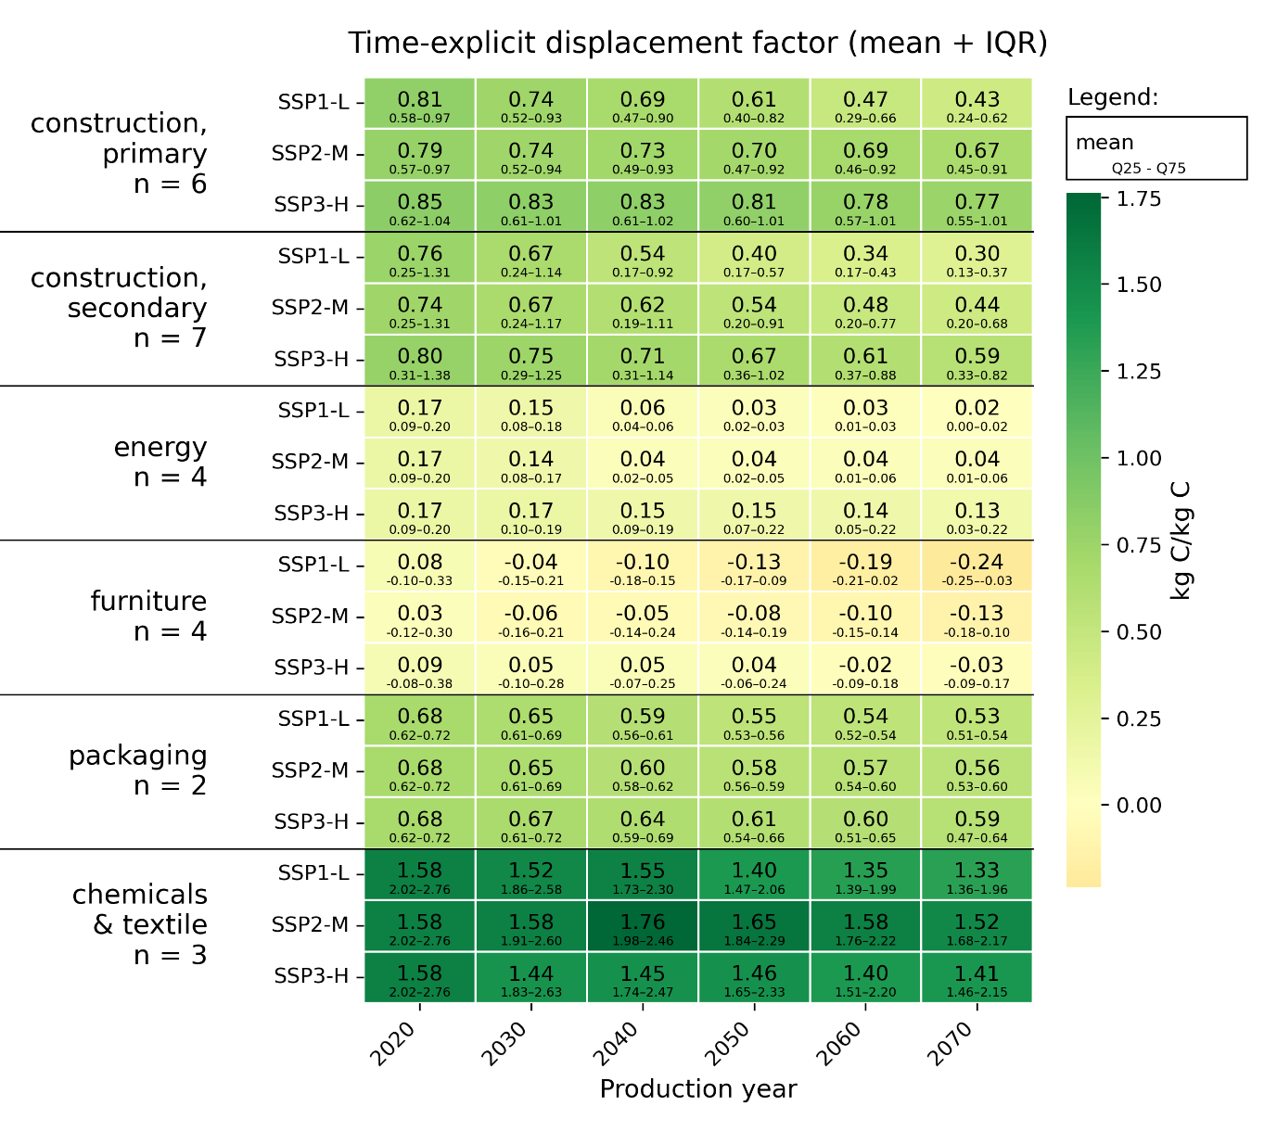
Figure S1: Time-explicit displacement factors by end-use category across different years and scenarios using simple mean and interquartile ranges (q25 - q75). n = number of products per end-use category. Products and semifinished material variants and their lifetimes are listed in Table 2.
The simple mean shown in Figure S1 lead to slightly different category-level results than the weighted average in Figure 2, while the general trends stayed the same. Compared to the weighted average, higher DFs were obtained for construction, primary, chemicals and textiles, while lower values occurred for construction, secondary. Results for energy and furniture were largely unchanged, as products in these end-use categories are represented by a similar number of semi-finished material variants. Packaging remained largely unchanged because the two packaging products, while having a different number of semi-finished material variants, have very similar scores.

For chemicals and textiles, displacement factors were high for viscose and lyocell and negative for the chemical adhesive. As a result, the two aggregation approaches lead to noticeably different category-level results. For the simple mean, viscose and lyocell, each modelled using both hardwood and softwood pulp, received greater weight because they are represented by multiple product–material combinations, while the adhesive was only modelled with one semi-finished wood type. In contrast, the weighted averaging approach assigned equal weight to the product-level results of viscose, lyocell, and adhesive.
Figure S2 shows the results for the simple mean combined with standard deviation (SD) for the tendency of spread.
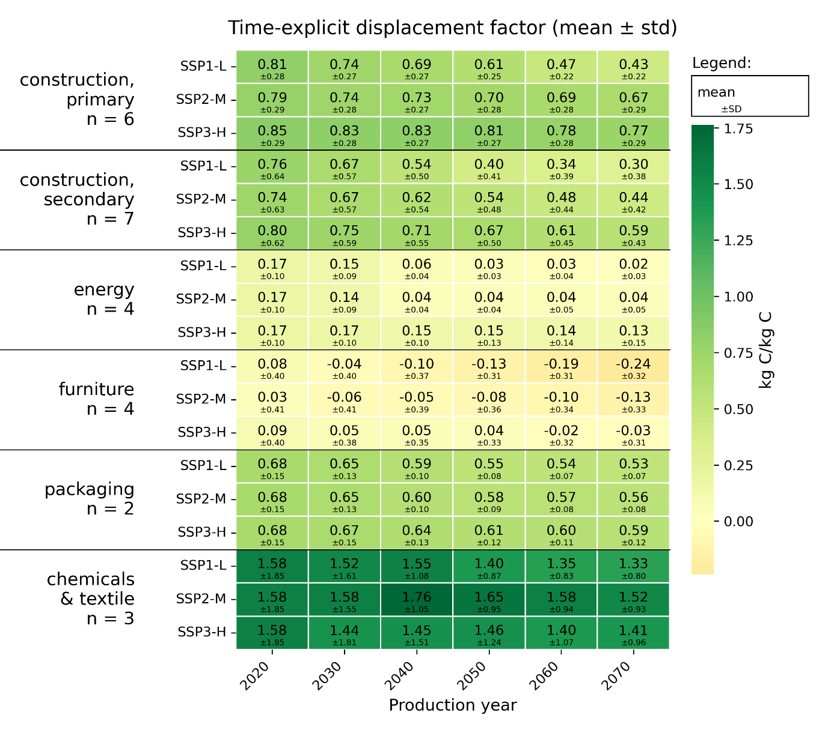
Figure S2: Time-explicit displacement factors by end-use category across different years and scenarios using simple mean and standard deviation (SD). n = number of products per end-use category. Products and semifinished material variants and their lifetimes are listed in Table 2.

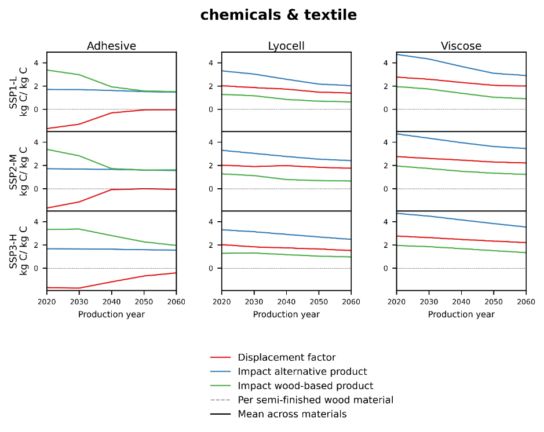
Figure S3: Results for displacement factor, GWI of wood-based product and alternative product for the products in the end-use category chemicals & textiles. Opposing trend visible: increasing DF in adhesive, decreasing DF in lyocell and viscose.

Constituents of DFs
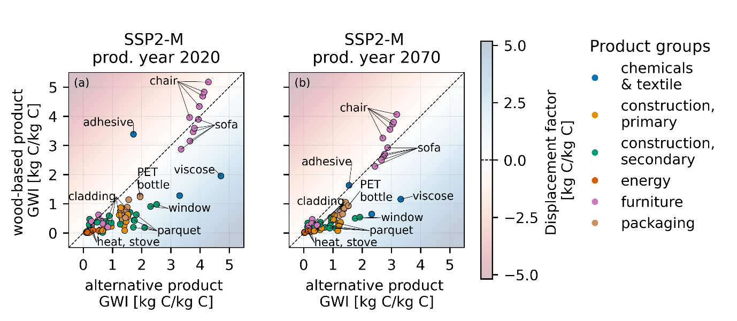
Figure S4: Displacement factors of individual product-semifinished material variants for the production years 2020 and 2070 under SSP2-M, decomposed into the contributions by the wood-based products and its alternatives. GWI = Global Warming Impact. The diagonal represents a displacement factor of zero.

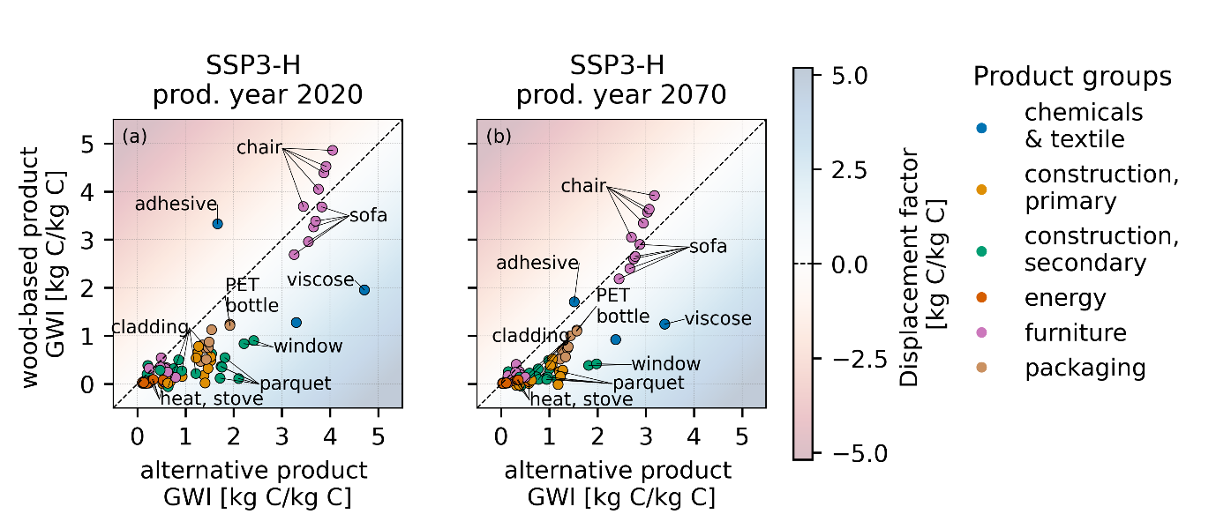
Figure S5: Displacement factors of individual product-semifinished material variants for the production years 2020 and 2070 under SSP3-H, decomposed into the contributions by the wood-based products and its alternatives. GWI = Global Warming Impact. The diagonal represents a displacement factor of zero.
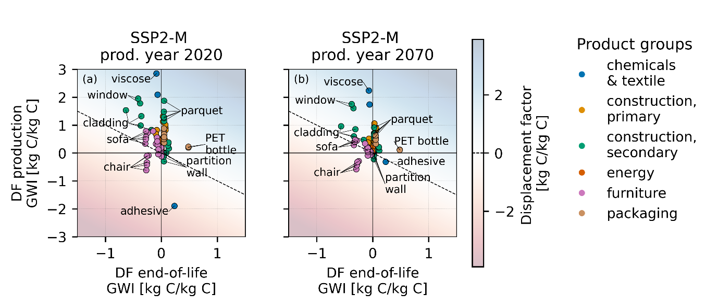
Figure S6: Displacement factors of individual product-semifinished material variants for the production years 2020 and 2070 under SSP2-M, decomposed into production and end-of-life contributions. GWI = Global Warming Impact. DF = Displacement factor. The diagonal represents a displacement factor of zero.
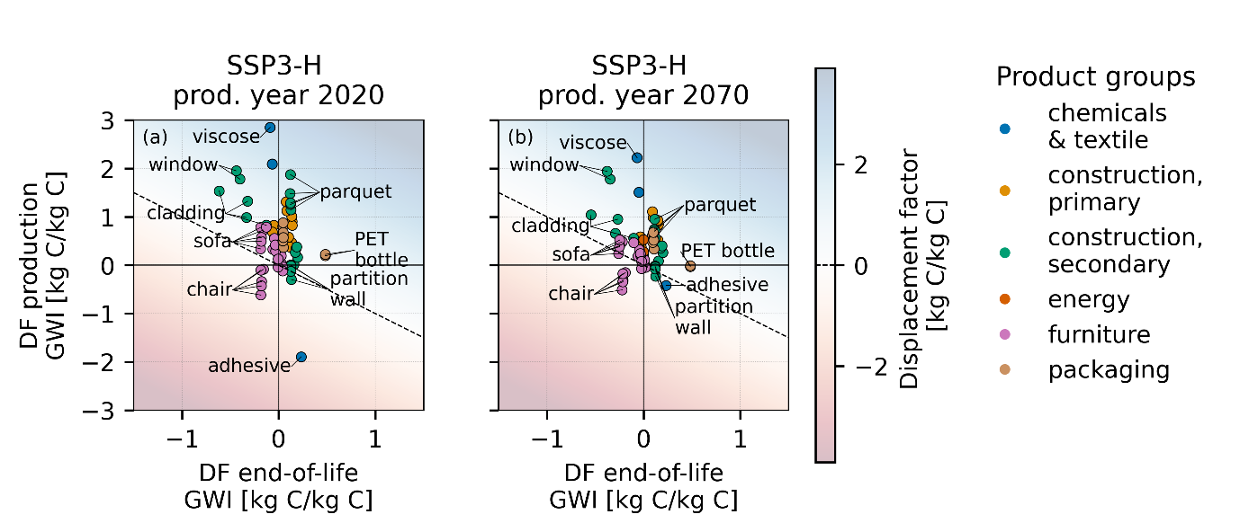
Figure S7: Displacement factors of individual product-semifinished material variants for the production years 2020 and 2070 under SSP3-H, decomposed into production and end-of-life contributions. GWI = Global Warming Impact. DF = Displacement factor. The diagonal represents a displacement factor of zero.

Prospective results for key supply chain processes

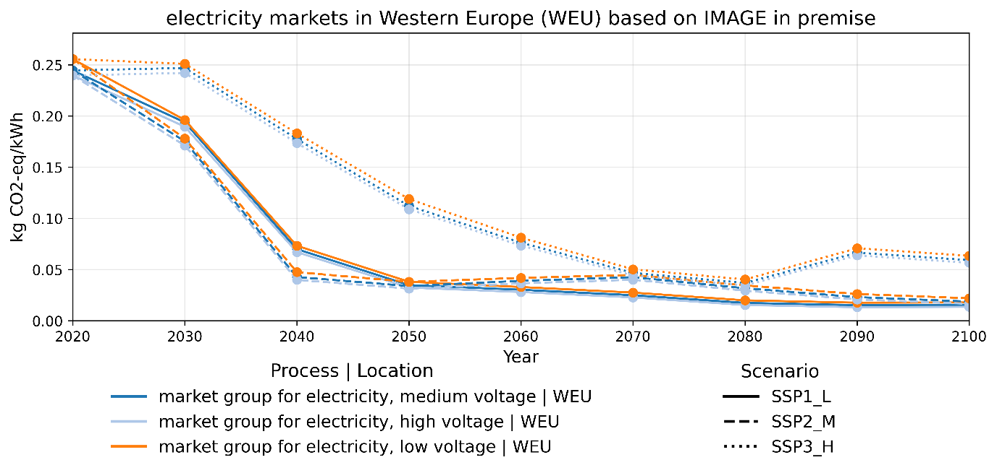

Figure S8: Climate change impacts of 1 kWh of electricity produced by electricity markets in Western Europe (WEU) in the IMAGE scenarios in premise.

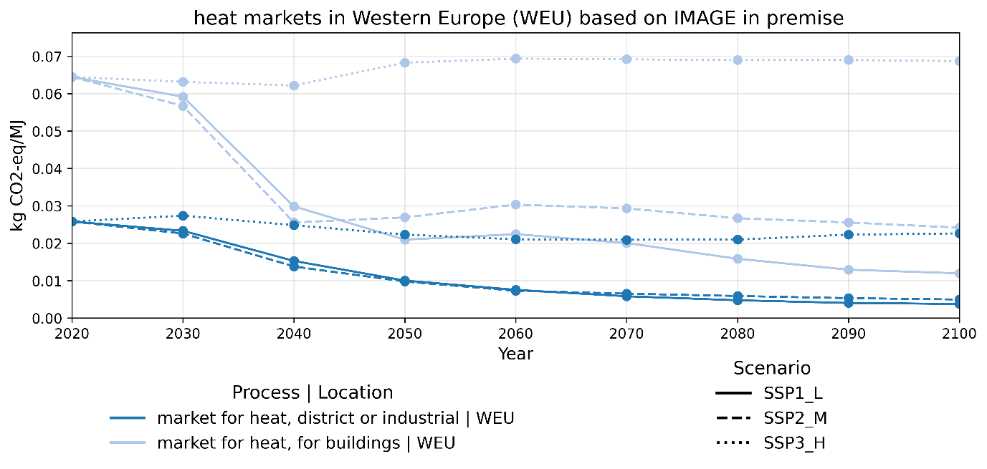
Figure S9: Climate change impacts of 1 MJ of heat produced by different heat markets in Western Europe (WEU) in the IMAGE scenarios in premise.

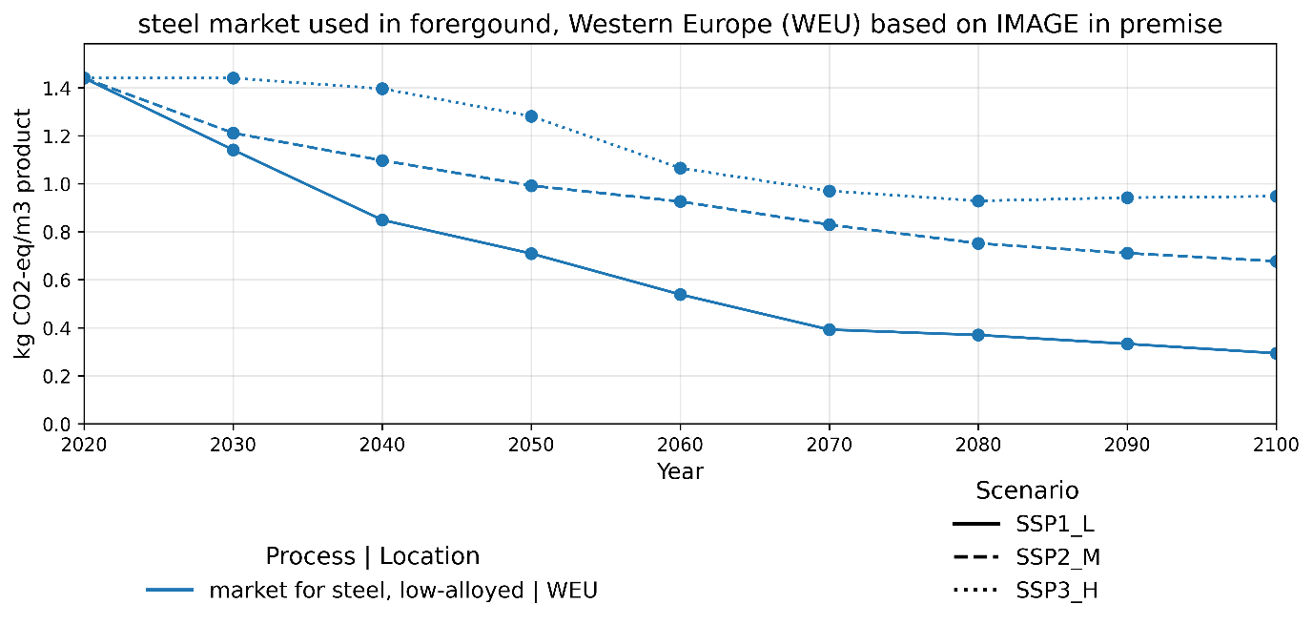
Figure S10: Climate change impacts of 1 kg of steel by market for steel, low-alloy in Western Europe (WEU) in the IMAGE scenarios in premise.

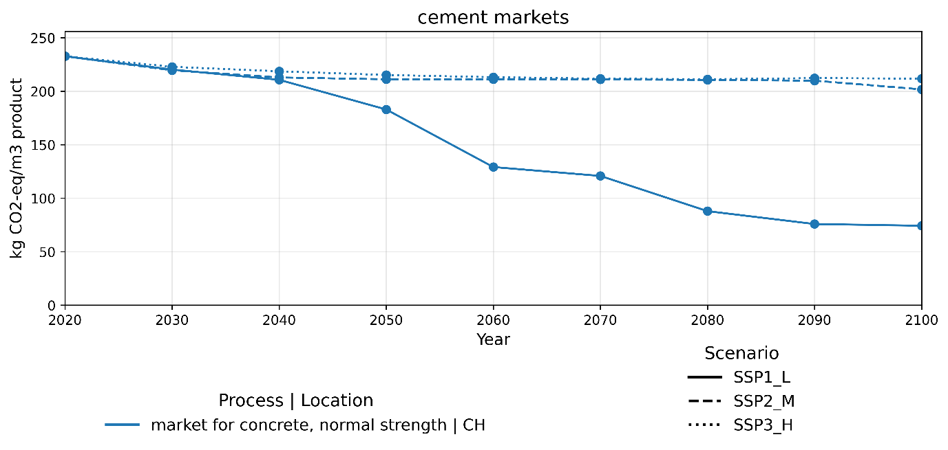
Figure S11: Climate change impacts of 1 m3 of concrete by market for concrete, normal strength, CH, which is linked to clinker production in WEU.

Elementary flow contribution
An elementary flow contribution analysis was conducted for the three background scenarios and the years 2020, and 2070 using the Brightway package bw2analyzer. Figure S12 shows the elementary flow contributions to the DFs of all products in the year 2020 for the background scenario SSP1-L. As the share of different elementary flows is similar for the other scenarios and years, these are not shown separately.

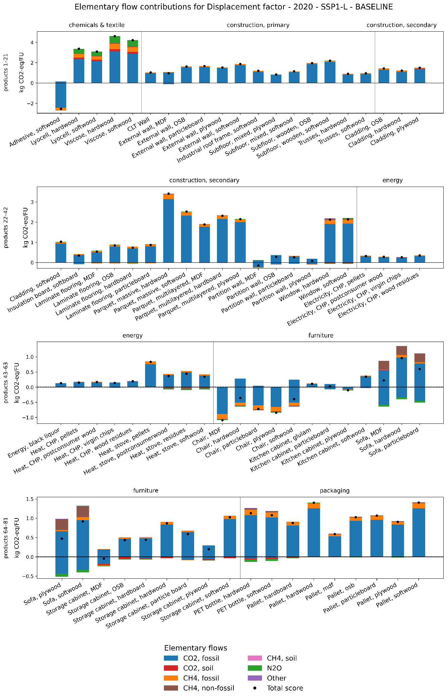
Figure S12: Elementary flow contributions to displacement factors for the year 2020 in SSP1-L. Fossil CO₂ dominates with secondary contributors from fossil CH₄, non-fossil CH₄, soil CO₂, and N₂O, all substantially smaller in magnitude.

Process contribution
A process contribution analysis was conducted for the three background scenarios and the starting 2020, and 2070 using the Brightway package bw2analyzer. A cutoff of the 50 largest contributors was applied. The contributing processes were manually grouped into 13 categories. Processes below the cut-off were grouped into the category “below cutoff”.

The following section provides a summary of the contribution analysis per product group, followed by an in-depth analysis of individual products in figure SXZ to SXZ.

Construction, primary
Primary construction products generally show high DFs that decline over time. The dominant process contributions are the displacement of cement, bricks, and steel in alternative products and energy recovery credits in the wood-based products. DFs decrease over time due to faster decarbonization of alternative systems relative to wood-based systems. As electricity and heat supply decarbonize, energy recovery credits diminish, reducing the relative climate benefit of wood-based alternatives. The composition of the wood-based system also matters: products where the wood-based alternative consists entirely of wood, such as fully wooden subfloors, show higher DFs than products where the wood-based system includes emission-intensive materials such as cement, e.g. in a mixed subfloor. Semi-finished material choice has a secondary but consistent effect on production-related impacts.

Construction, secondary
Secondary construction products show more varied DFs than primary construction products, reflecting greater diversity in product composition between the two alternatives. Windows and parquets show consistently high DFs, while partition walls and insulation board show lower DFs that approach or become negative by 2070 in the climate-ambitious scenario. Unlike primary construction products, where cement and bricks dominate impacts, secondary construction product DFs are driven by a broader mix of contributors, including plastics, metals, electricity, and surface treatment processes. Semi-finished material choice has a more pronounced effect on DFs for secondary than for primary construction products. Across all secondary construction products, DFs decline over time as alternative products decarbonize faster, with energy recovery providing diminishing credits over time.

Energy
Energy products show low, positive DFs that decline over time. The wood-based energy systems have few inputs beyond the wood feedstock itself, processing steps are limited, and biogenic CO₂ from combustion is excluded from the impact assessment. As a result, DFs are largely determined by the displaced emissions of the non-wood alternative, which is modelled as market mixes, not individual technologies. Since prospective heat and electricity markets are projected to decarbonize substantially, particularly under low-emission scenarios, displaced emissions decline over time, driving DFs toward near-zero in the future. The LHV of wood feedstock influences DFs by determining the amount of fuel required per unit of energy delivered. The type of displaced energy also matters: residential stoves are assumed to displace the residential heat mix, while CHP heat displaces the less carbon-intensive district and industrial heat mix, resulting in lower DFs for the latter.

Furniture
Furniture products show consistently low or negative DFs, with several products showing negative values in 2020 or becoming negative by 2070. Both wood-based and alternative products have high impacts due to the high inputs of foam, textiles, plastic, steel or varnishes, combined with a comparatively small input of wood per unit of product. The low or negative DFs are also shaped by the alternatives’ material compositions: in some cases, the alternative product also contains some wood, reducing the impact difference between systems, while in other cases the wood-based product contains more emission-intensive materials than the alternative (e.g., the higher PP content in the wood-based chair). The DFs for furniture should therefore be interpreted with caution, as they are based on individual products per furniture type from Geng et al. (2019), and may not be representative of furniture production at large. Semi-finished material choice has a strong influence on DFs across all furniture products, with energy-intensive variants consistently showing the lowest DFs.

Packaging
Packaging products show medium and stable DFs over time. DFs are dominated by plastic-related processes, such as chemicals, plastic waste treatment, and fossil fuel extraction, which either do not or only slowly decarbonize over time. Only two packaging products are included in this study, limiting the representativeness of these results for the packaging sector. Furthermore, the relative stability of DFs over time partly reflects modelling assumptions around plastics in the prospective background scenarios, which do not include major decarbonization efforts in the plastic supply chains.

Chemicals and textiles
Chemicals and textiles are a diverse product group with contrasting DFs: viscose and lyocell show the highest DFs across all products, while the wood-based adhesive shows the lowest, highly negative DF in 2020. It is also the only product group with an increasing DF trend over time, driven by the adhesive. Its high electricity demand in the wood-based alternative means that decarbonization of the electricity system reduces wood-based adhesive production impacts faster than those of the non-wood alternative, substantially increasing its DF over time. In SSP2-M, where electricity decarbonizes particularly strongly between 2030 and 2040, this effect is especially pronounced, explaining the high DF observed in 2040 for this scenario. Because the category contains only three products, the adhesive strongly influences category-level results, and the increasing trend should not be generalized to chemicals and textiles at large. The two textile products, by contrast, show high and slowly declining DFs driven by the displacement of emission-intensive non-wood textile mix.

Process contribution by product

Selected products in Figure 6 in the other two scenarios SSP2-M and SSP3-H:

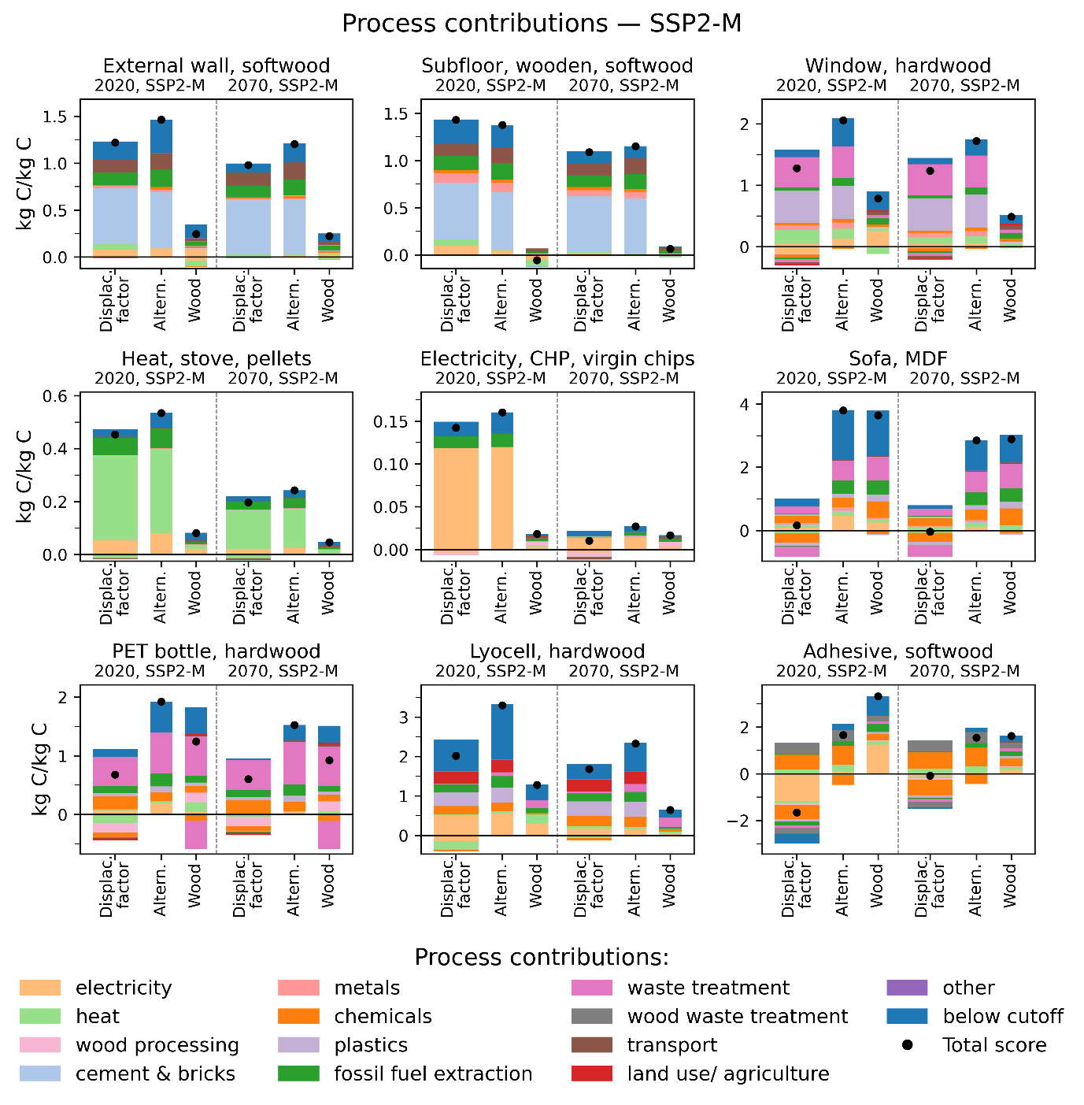
Figure S13: Process contributions for a selection of products for the year 2020 and 2070 in SSP2-M for displacement factors, and its constituents of the wood-based and alternative product

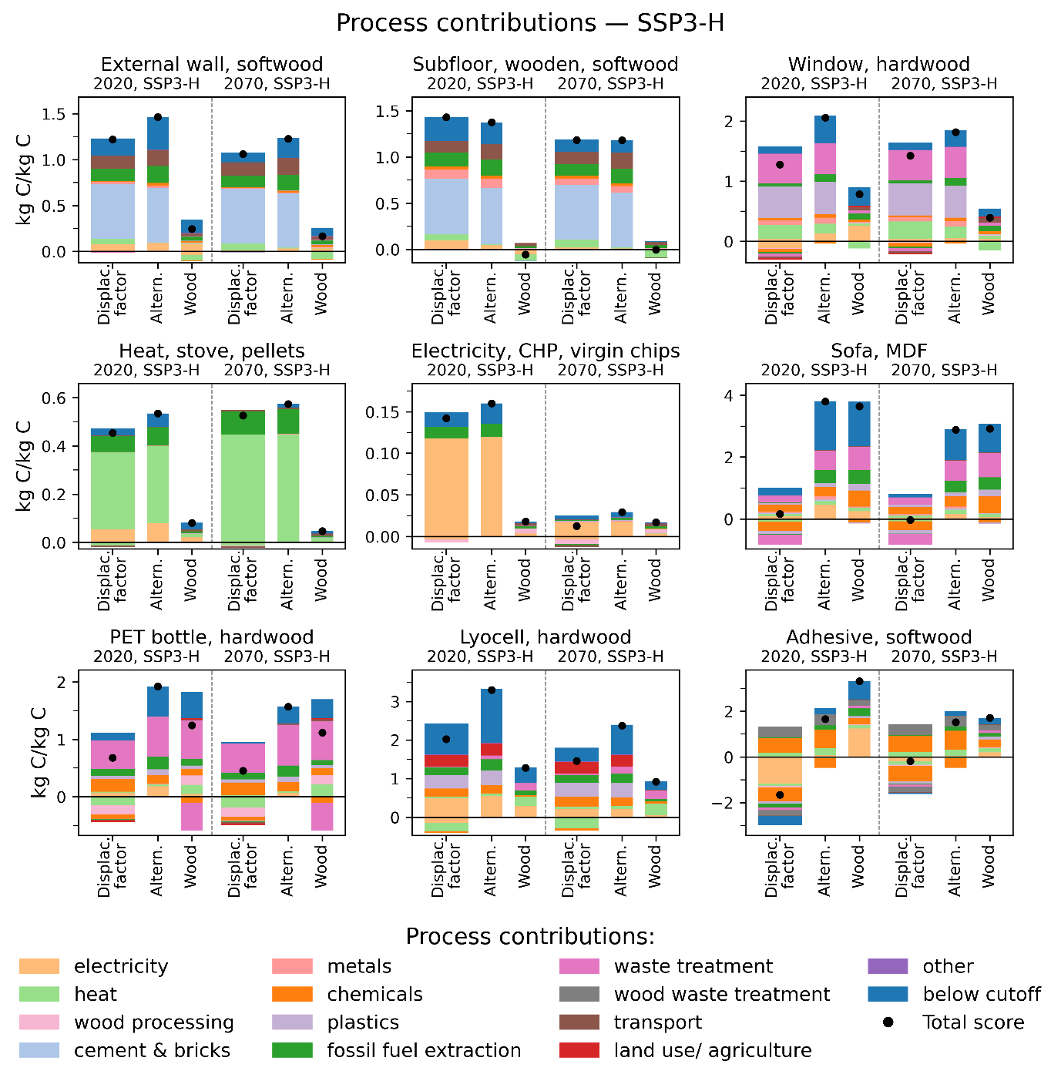

Figure S14: Process contributions for a selection of products for the year 2020 and 2070 in SSP3-H. The process contribution of DF (displacement factors), and its constituents of fossil-based (fossil) and wood-based product (wood) are shown. According to Eq. 2, DF = impact of fossil product – impact of wood product, scaled to the carbon content in the wood product.

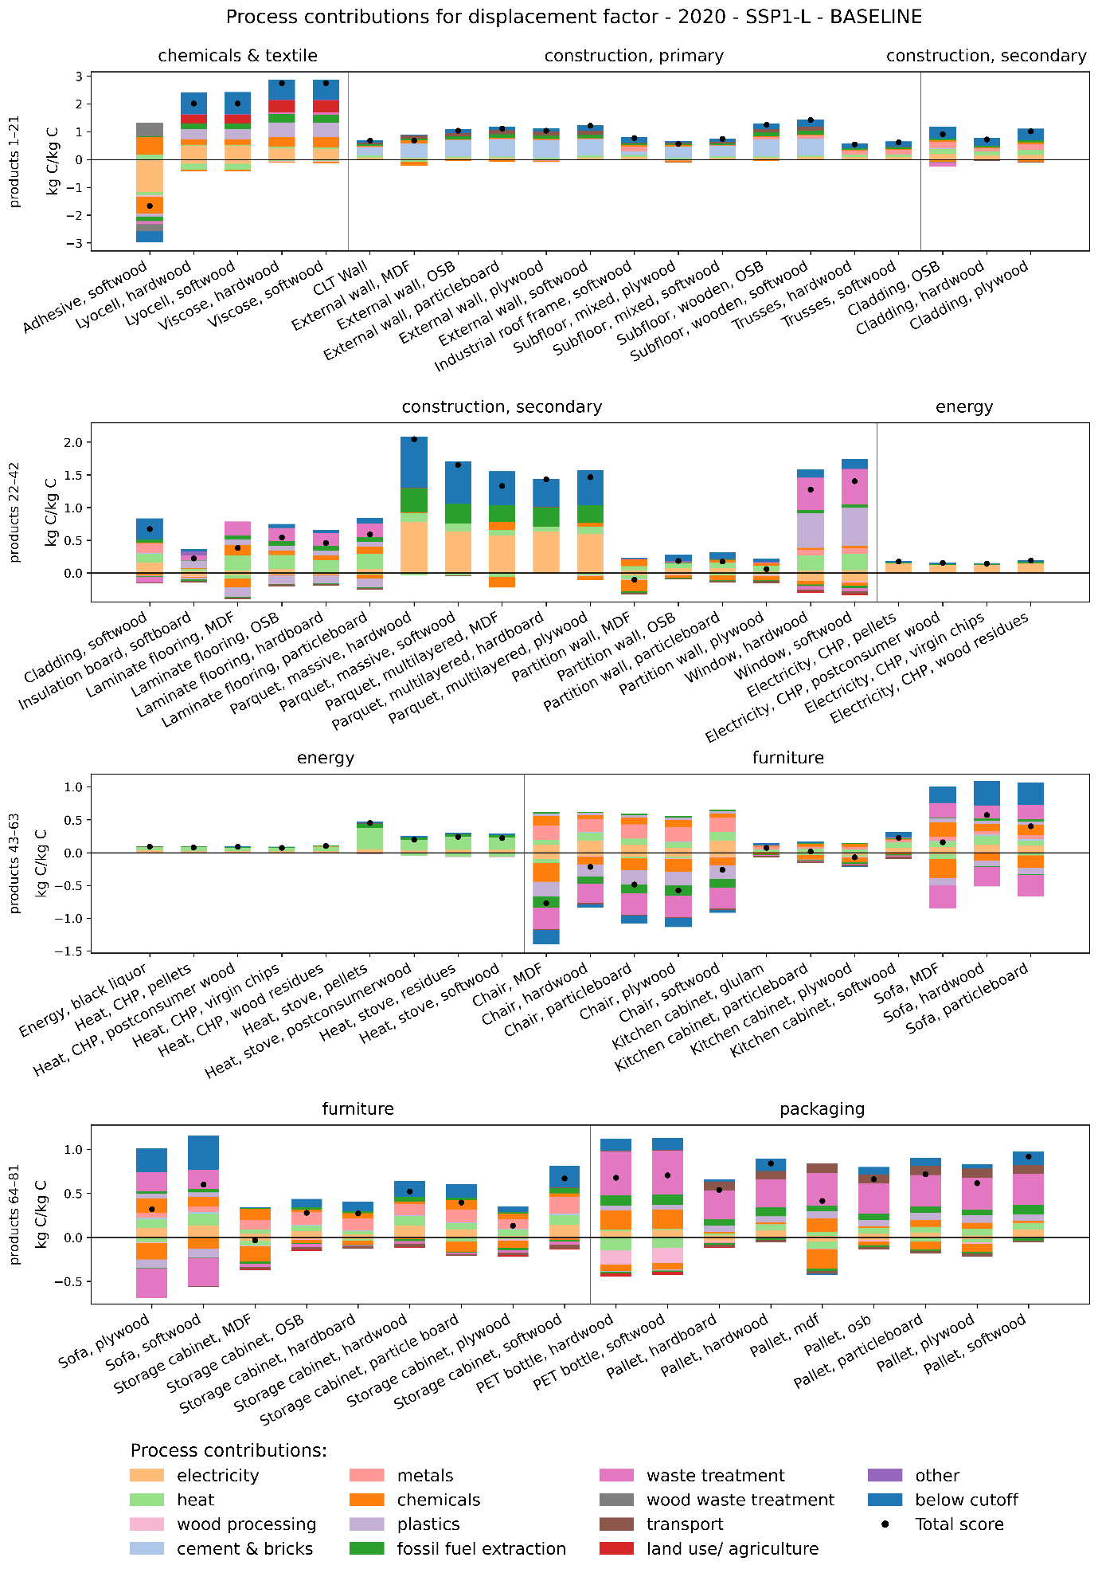
Figure S15: process contributions of DFs for all products in 2020 in background scenario SSP1-L.
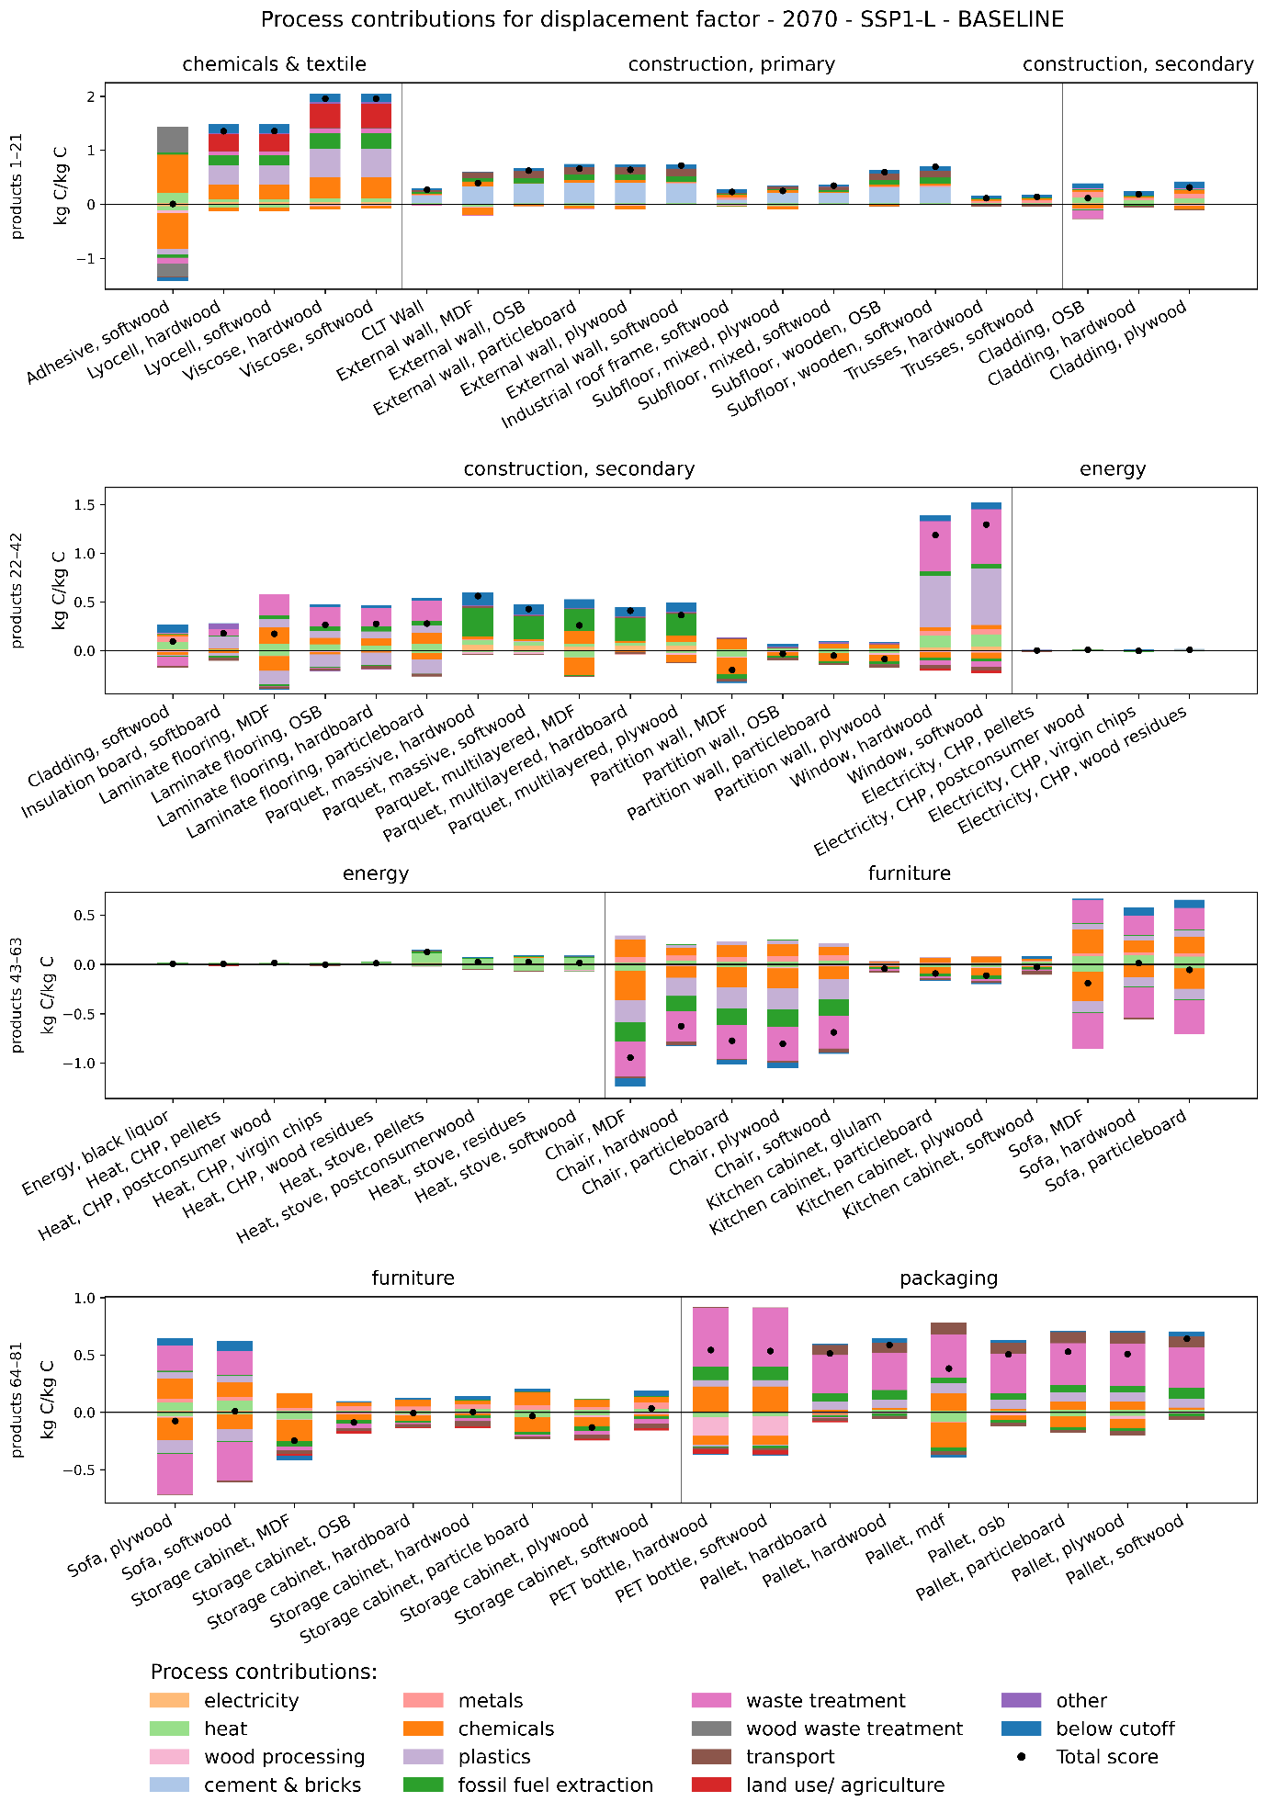
Figure S16: process contributions of DFs for all products in 2070 in background scenario SSP1-L.
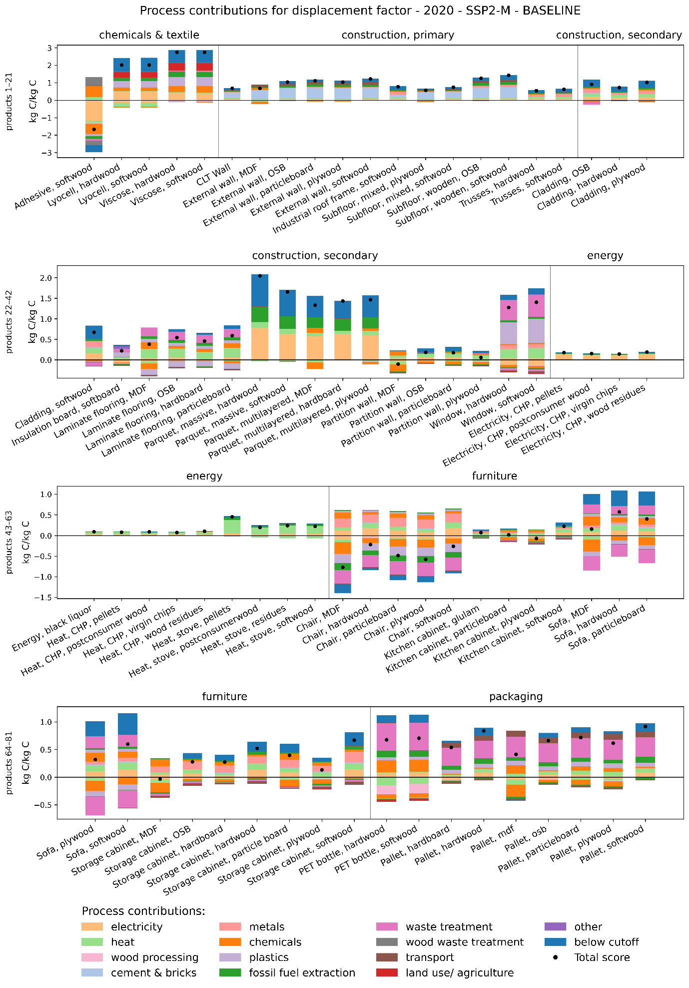
Figure S17: process contributions of DFs for all products in 2020 in background scenario SSP2-M.
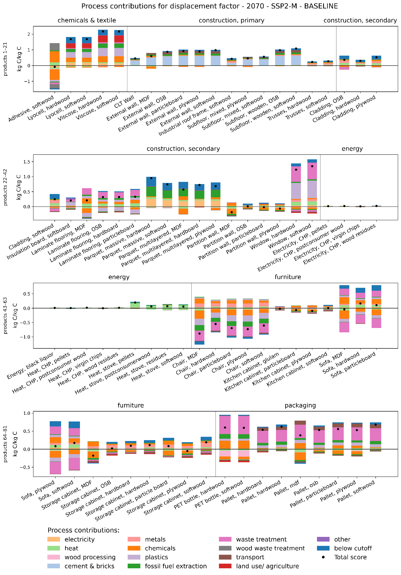
Figure S18: process contributions of DFs for all products in 2070 in background scenario SSP2-M.
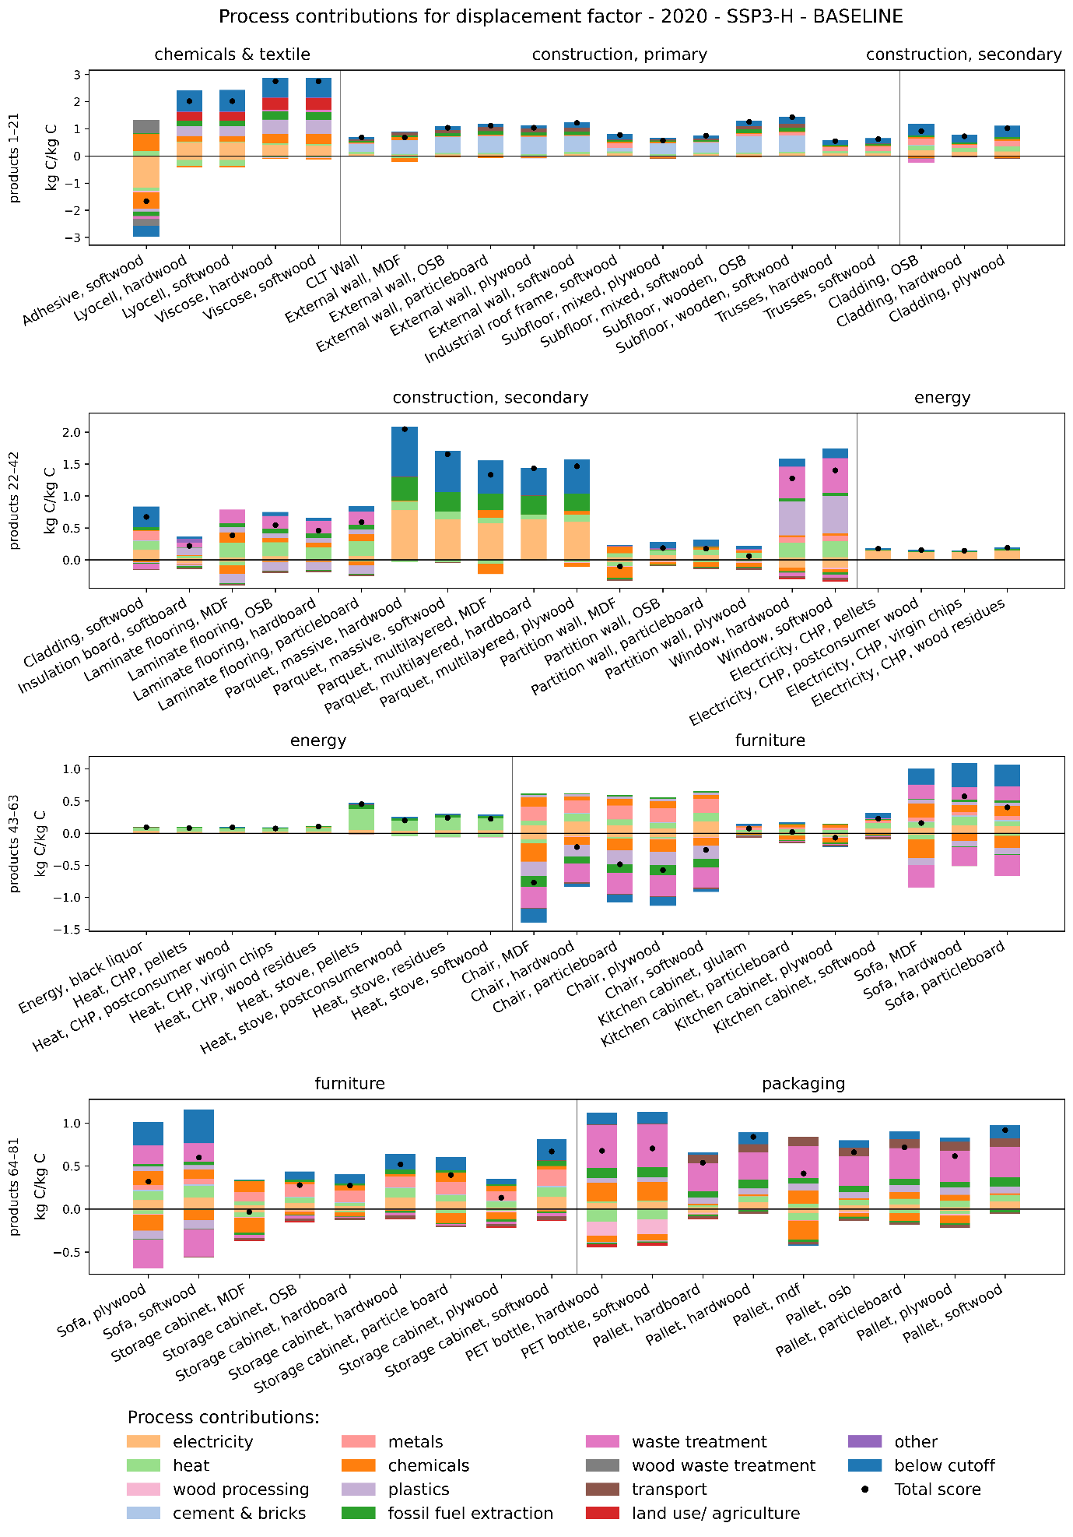
Figure S19: process contributions of DFs for all products in 2020 in background scenario SSP3-H.
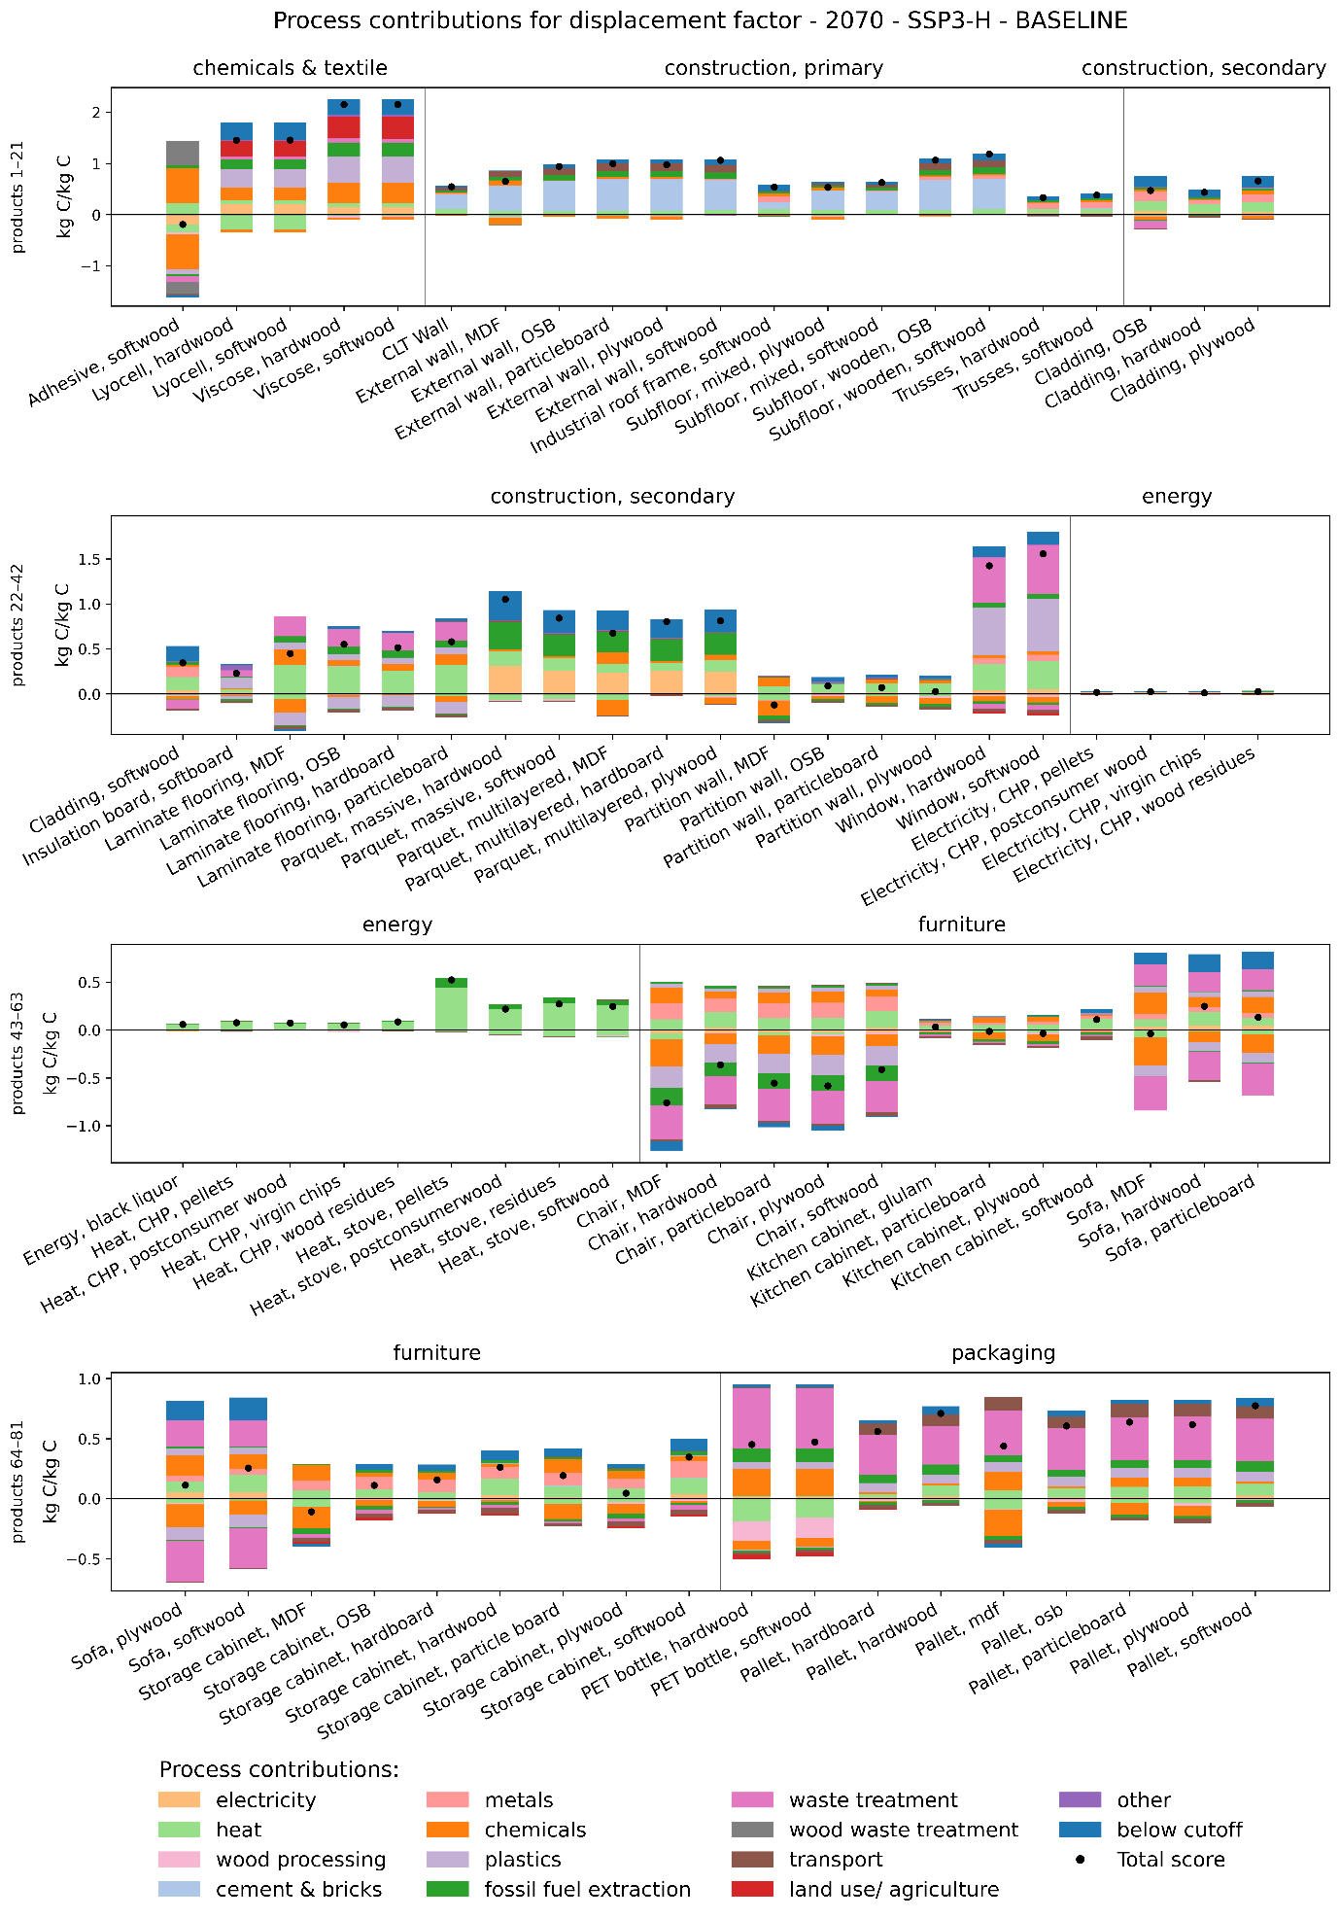
Figure S20: process contributions of DFs for all products in 2070 in background scenario SSP3-H.

Sensitivity analysis
A positive number (underlined in shades of blue) in Figure S21 to XZ means that the DF in the sensitivity analysis is higher than the DF in the baseline.

SA1: Prospective modelling
Replacing the time-explicit LCI model with a prospective model yields up to 0.10 kg C/kg C higher DFs (Figure S21). Differences are only visible in end-use categories with longer lifetimes, and at the start of the assessment period. The differences converge by 2040-2050, as most decarbonization in the prospective databases occurs before this period. It should be noted that a modelling limitation affects results for later years and long-lived products: since the prospective databases extend only to 2100, EoL processes projected beyond this point are modelled using 2100 data, reducing the actual time-difference between prospective and time-explicit LCI modelling in later years.

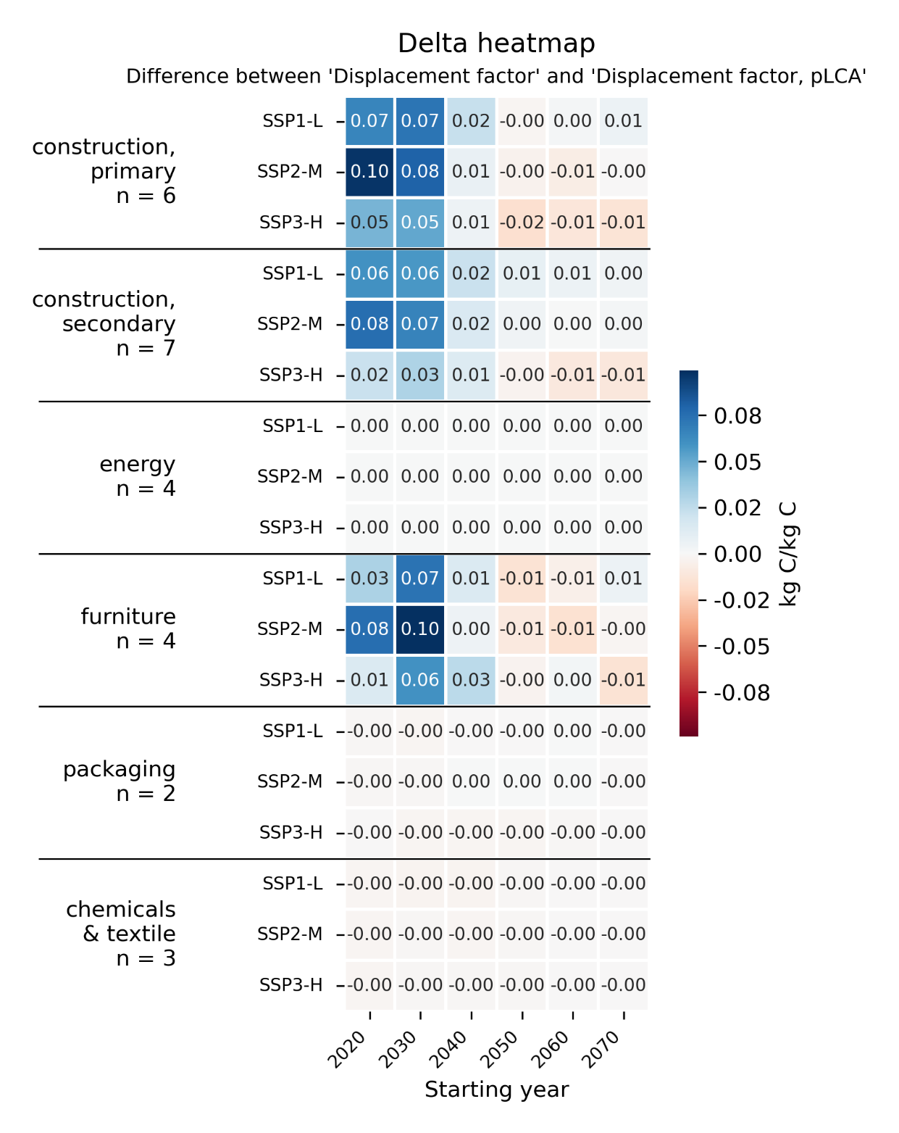
Figure S21: SA1: Heatmap of the differences in DFs between the time-explicit baseline model and a prospective only model.

SA2: Lifetime extension
Extended product lifetimes in the time-explicit model had limited influence on DFs, with differences not exceeding ±0.04 kg C/kg C and confined to products with long lifetimes (Figure S22). The effects reflect two competing mechanisms: later EoL processes may occur in more decarbonized future years, reducing EoL emissions, but energy recovery and material recycling credits also decline. This is particularly visible for furniture, where EoL recycling and energy recovery credits play a substantial role for both alternatives.
The same modelling artefact noted for SA1 applies here, as extended lifetimes push EoL processes further beyond 2100 for some products.

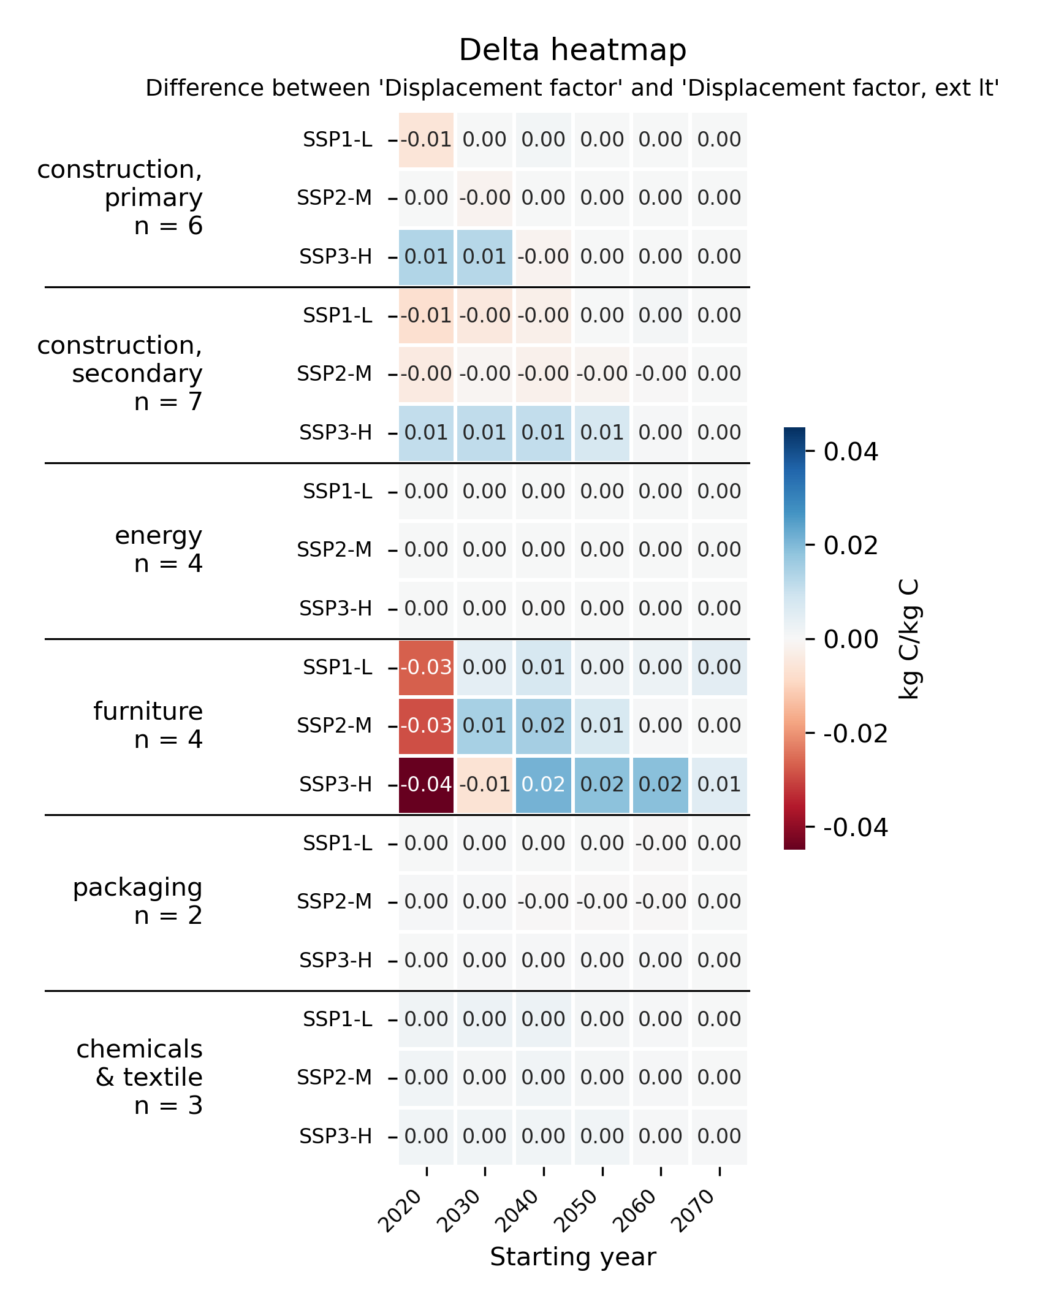
Figure S22: SA2: Heatmap of the differences in DFs between the time-explicit baseline model and a model with extended lifetimes.

SA3: Reduced electricity consumption
Reducing foreground electricity consumption by 25% has a small positive effect on DFs. Chemicals & textiles even show a high effect with +0.19 kg C/kg C in 2020, driven by the high electricity demand of wood-based adhesive. Effects diminish over time as the electricity mix decarbonizes. This diminishing effect is slowest in SSP3-H, where electricity remains more carbon-intensive into later years. It should be noted that this sensitivity analysis only modified electricity in foreground supply chains, while background processes, which is where most electricity consumption is modelled, especially for non-wood alternatives, are not modified.

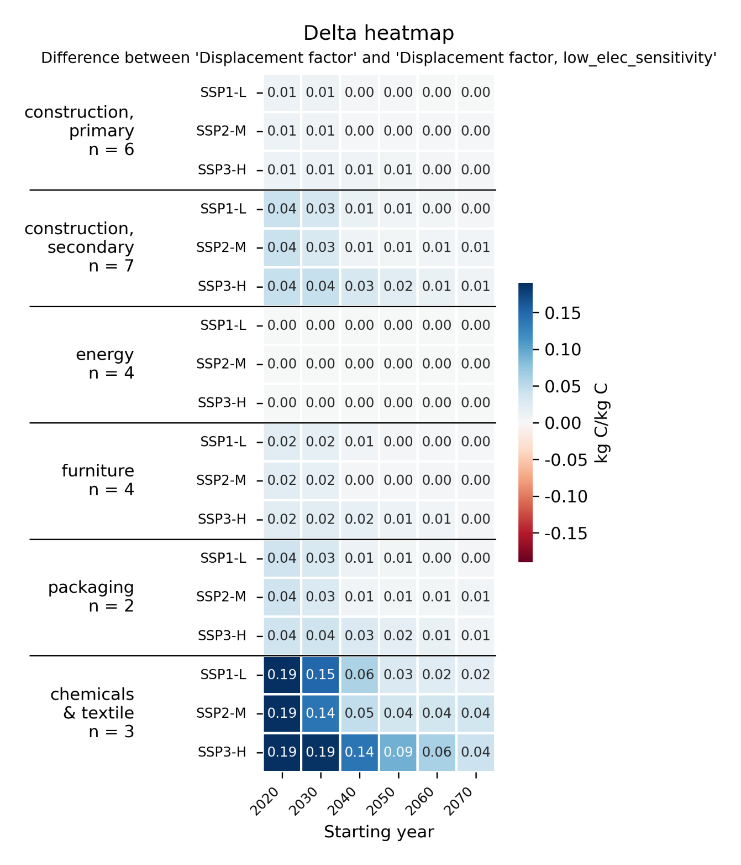
Figure S 23: SA3: Heatmap of the differences in DFs between the time-explicit baseline model and a model with 25% lower electricity consumption.

SA4: Reduced heat consumption
Reducing foreground heat consumption by 25% produces the largest and most varied effects of all sensitivity analyses. DFs increase up to +0.09 kg C/kg C (chemicals & textiles) or decrease up to −0.11 kg C/kg C (furniture). This shows that heat plays a major role in both wood and non-wood supply chains, and that reducing heat consumption does not uniformly favour wood-based products, as some alternative products are also reliant on heat. Unlike electricity, heat-related effects persist into later years, particularly in SSP3-H where the heat markets remain carbon-intensive. Similar to SA3, only heat inputs to the foreground processes are modified and not also heat in the background supply chains.

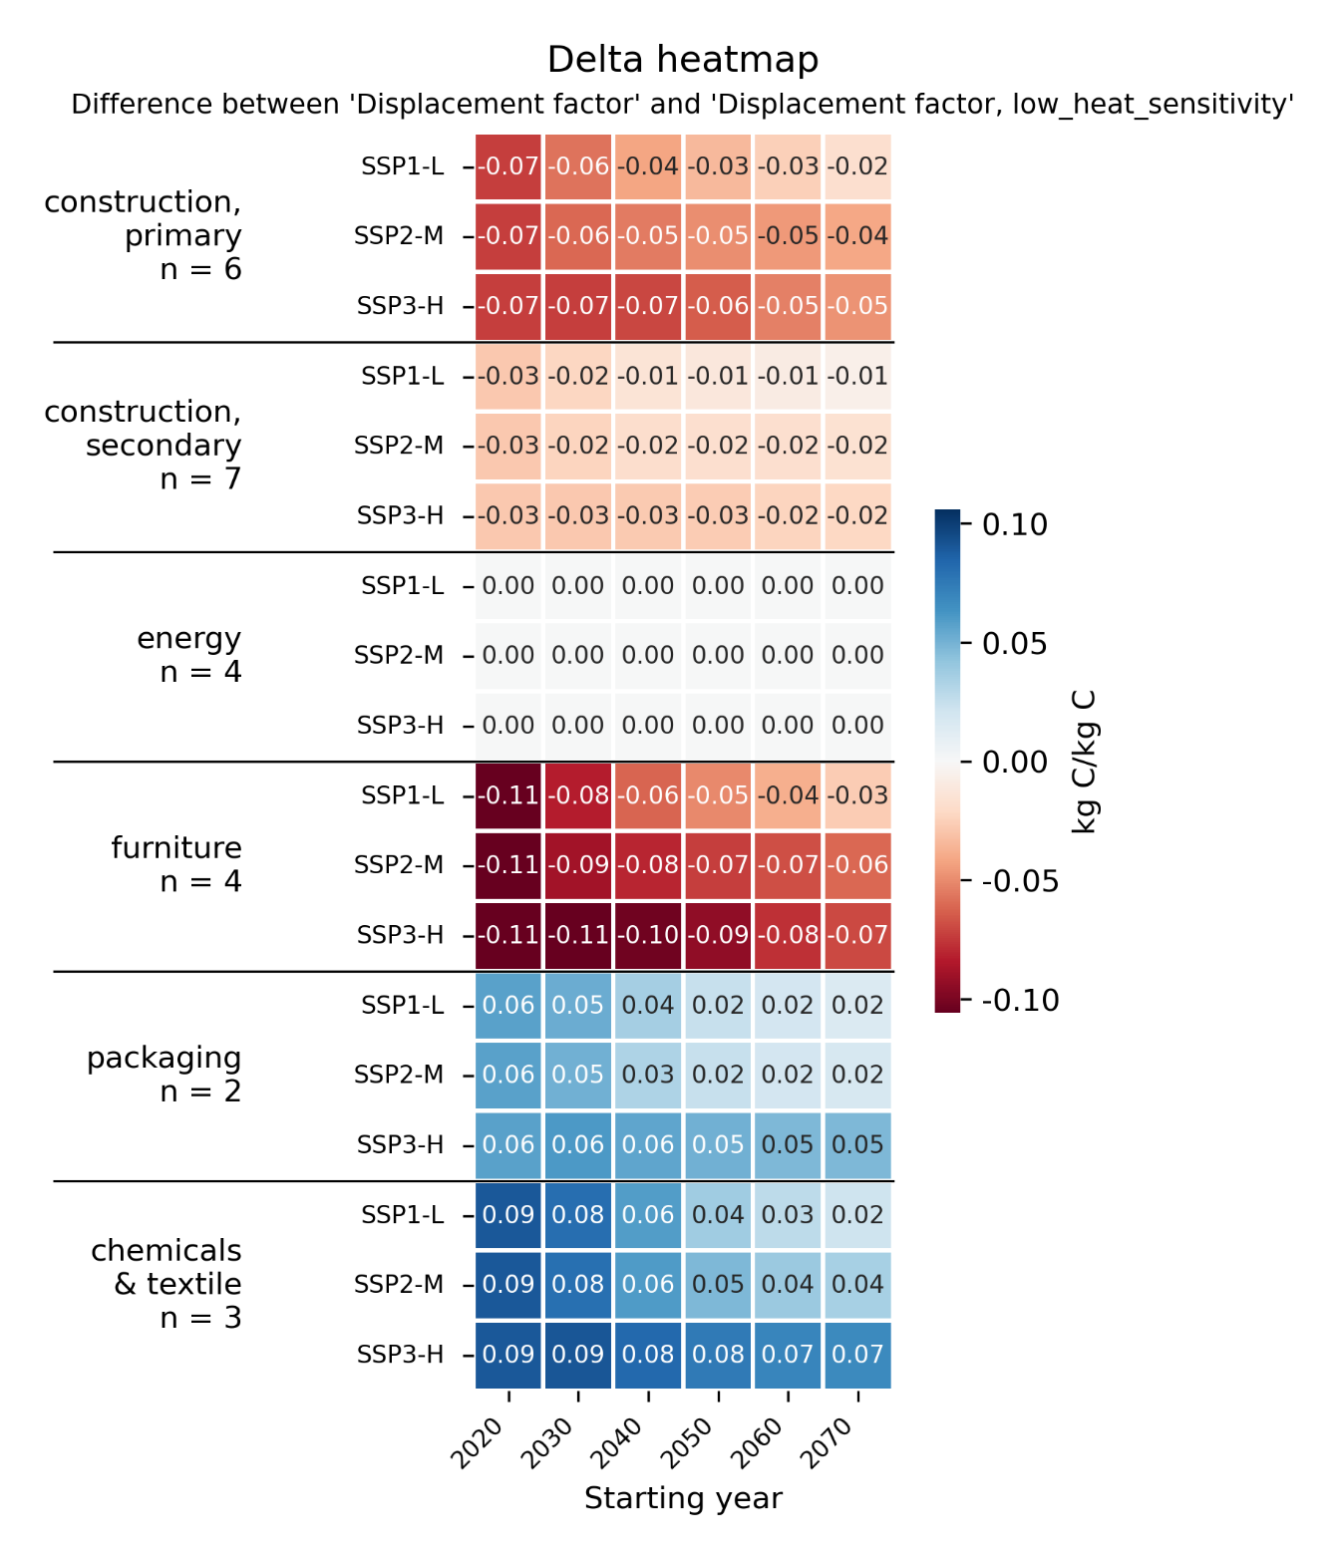
Figure S 24: SA4: Heatmap of the differences in DFs between the time-explicit baseline model and a model with 25% lower heat consumption in the foreground.

SA5: Heat pump integration
Modeling the replaced heat in energy recovery with heat pumps consistently reduces DFs across all product groups and scenarios. The lower DFs are most pronounced and lower over time in SSP3-H, where the baseline heat mix decarbonizes slowly, making substitution of heat from heat pump in energy recovery processes relatively less beneficial compared to the baseline in that scenario.

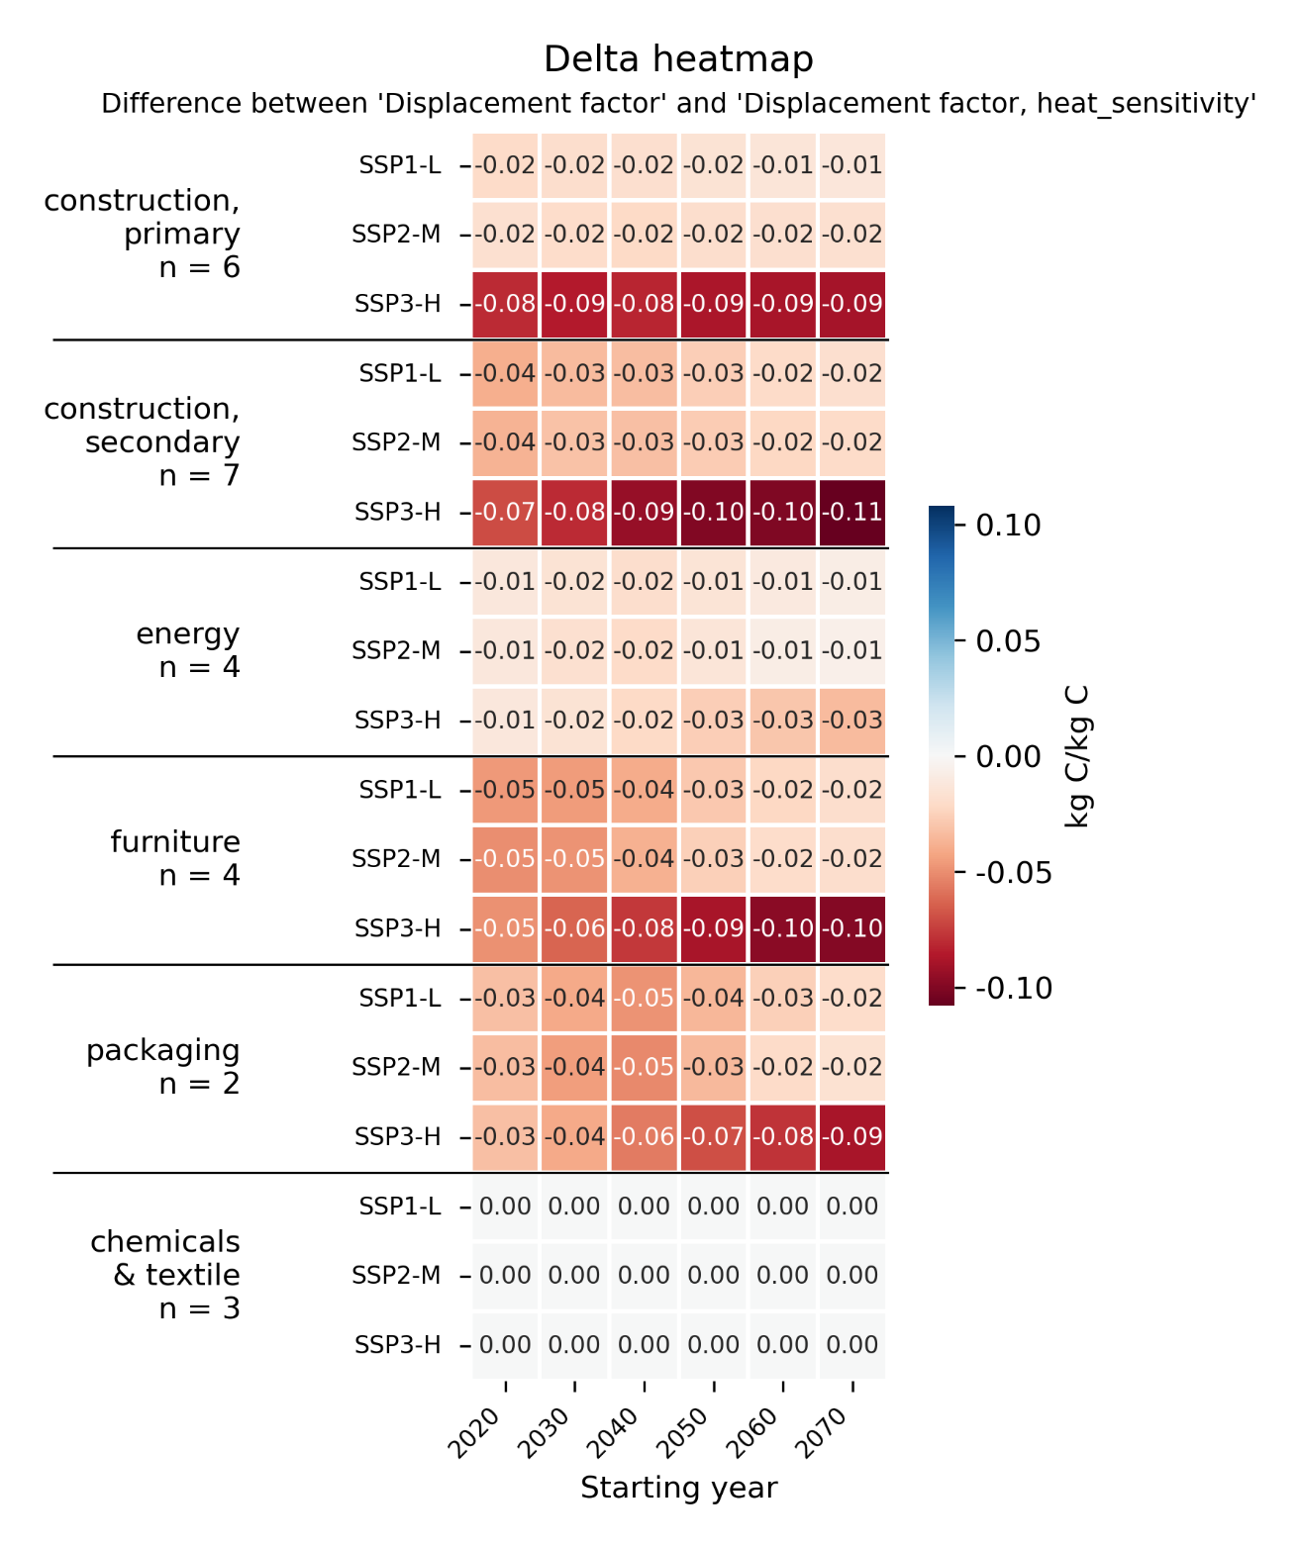
Figure S25: SA5: Heatmap of the differences in DFs between the time-explicit baseline model and a model in which all heat replaced in energy recovery is provided by heat pumps.

SA6: Low production losses
Reducing foreground production material losses has negligible effects on DFs. This reflects multiple mechanisms: first, a 25% reduction in production losses leads to only small absolute changes in material inputs for most products as losses are already small for most products. Second, losses were reduced for both the wood-based and alternative product, with effects partially cancelling out at the DF level. Third, in the baseline, production waste undergoes treatment with partial recycling and energy recovery credits; reducing losses eliminates these credits while simultaneously reducing raw material demand, with the two effects partially compensating each other.
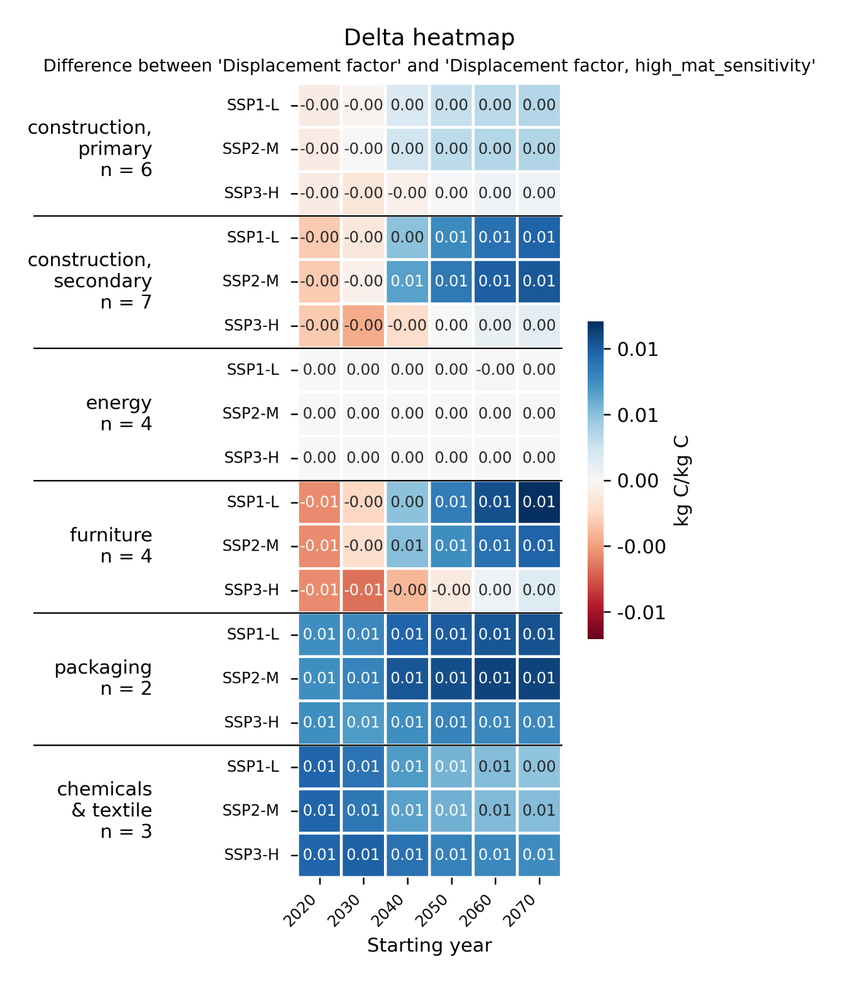
Figure S26: SA6: Heatmap of the differences in DFs between the time-explicit baseline model and a model in which production losses are reduced by 25%.

SA7: Local transport
Reducing transport distances by 80% produces strong and temporally stable, and scenario-independent effects, but the direction differs between product groups. For primary construction products, for which the alternative products are relatively heavier, a reduction in transport distances plays out in favour of the non-wood alternative and reduces the DFs. A similar reduction in DFs is also observed for the packaging item palettes. For the other products, there is either no or a small increase in DFs. The consistency of these effects across scenarios and years reflects that transport does not decarbonize substantially in the prospective scenarios.

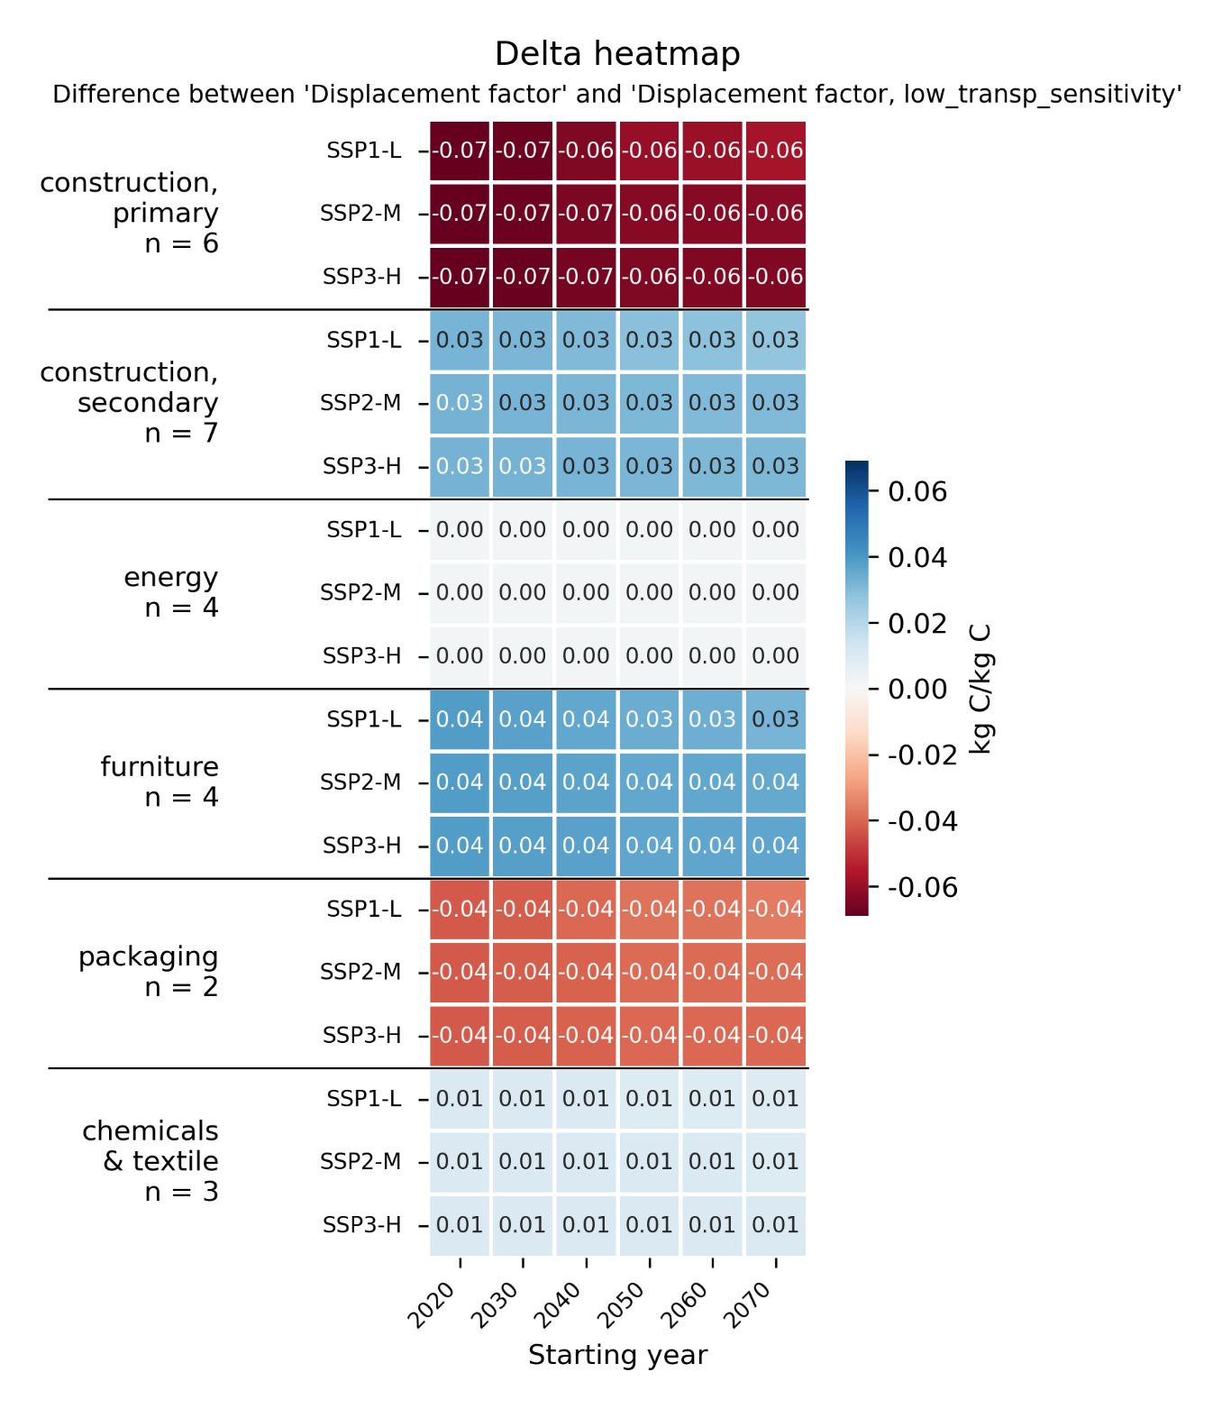
Figure S 27: SA7: Heatmap of the differences in DFs between the time-explicit baseline model and a model in which foreground transportation distances are reduced by 80%.

Publication bibliography
Caserini, S.; Livio, S.; Giugliano, M.; Grosso, M.; Rigamonti, L. (2010): LCA of domestic and centralized biomass combustion: The case of Lombardy (Italy). In Biomass and Bioenergy 34 (4), pp. 474–482. DOI: 10.1016/j.biombioe.2009.12.011.
Padinger, Reinhard; Aigenbauer, Stefan; Schmidl, Christoph (2019): Best practise report on decentralized biomass fired CHP plants and status of biomass fired small- and micro scale CHP technologies. With assistance of Jens Dall Bentzen. IEA Bioenergy: Task 32. Available online at https://www.ieabioenergy.com/wp-content/uploads/2019/05/T32_CHP_Report_01_2019.pdf, checked on 5/6/2026.
Valada, T.; Cardellini, G.; Vial, E.; Levet, A.; Muys, B.; Lamoulie, J. et al. (2016): Deliverable 3.2 LCA and mitigation potential from forest products. FORMIT - FORest management strategies to enhance the MITigation potential of European forests. Project no. 311970.
Wernet, Gregor; Bauer, Christian; Steubing, Bernhard; Reinhard, Jürgen; Moreno-Ruiz, Emilia; Weidema, Bo (2016): The ecoinvent database version 3 (part I): overview and methodology. In Int J Life Cycle Assess 21 (9), pp. 1218–1230. DOI: 10.1007/s11367-016-1087-8.

https://github.com/brightway-lca/brightway2-analyzer
https://github.com/brightway-lca/brightway2-analyzer

