Supporting Information
Hydrological Sensitivity and the Reorganization of Precipitation with Temperature over the Tibetan Plateau
Jesufemi Olowe¹ and Lan Cuo¹
1Institute of Tibetan Plateau Research, Chinese Academy of Sciences, Beijing, China
*Correspondence: jesufemi@itpcas.ac.cn

Contents of this file
Supplementary Tables S1 and S2
Supplementary Figures S1 and S2

Supplementary Table S1. Taylor statistics for surface temperature over the Tibetan Plateau (1970–2014) for the 14 CMIP6 models. Reported metrics include the correlation coefficient (R), observed standard deviation (σ_obs), modeled standard deviation (σ_mod), root mean square error (RMSE; °C), and normalized standard deviation (NSD). Statistics are computed by comparing each model against the observational dataset over 1970–2014, and correspond to the Taylor diagram in Fig. S1.

Model Names | Correlation Coefficient (R) | Standard Deviation of Observed Data  (σ _obs)  (ºC) | Standard Deviation of Modeled Data  (σ _mod)  (ºC) | Root Mean Squared Error (RMSE)  (ºC) | Normalized Standard Deviation (NSD)
BCC-CSM2-MR | 0.97 | 7.68 | 8.99 | 6.02 | 1.19
BCC-ESM1 | 0.96 | 7.68 | 8.87 | 4.14 | 1.17
CNRM-CM6-1-HR | 0.97 | 7.68 | 10.76 | 12.36 | 1.42
CNRM-CM6-1 | 0.97 | 7.68 | 10.47 | 10.35 | 1.38
CNRM-ESM2-1 | 0.97 | 7.68 | 10.55 | 9.41 | 1.39
EC-Earth3-AerChem | 0.96 | 7.68 | 8.45 | 6.22 | 1.12
EC-Earth3-CC | 0.95 | 7.68 | 8.65 | 5.60 | 1.15
EC-Earth3-Veg | 0.96 | 7.68 | 8.57 | 5.66 | 1.14
GISS-E2-1-G | 0.96 | 7.68 | 6.92 | 4.97 | 0.92
IPSL-CM5A2-INCA | 0.96 | 7.68 | 8.70 | 7.93 | 1.16
IPSL-CM6A-LR | 0.96 | 7.68 | 9.25 | 11.14 | 1.23
MIROC-ES2L | 0.96 | 7.68 | 8.82 | 4.70 | 1.16
MPI-ESM1-2-HR | 0.97 | 7.68 | 8.40 | 4.13 | 1.11
MRI-ESM2-0 | 0.97 | 7.68 | 8.96 | 5.80 | 1.19
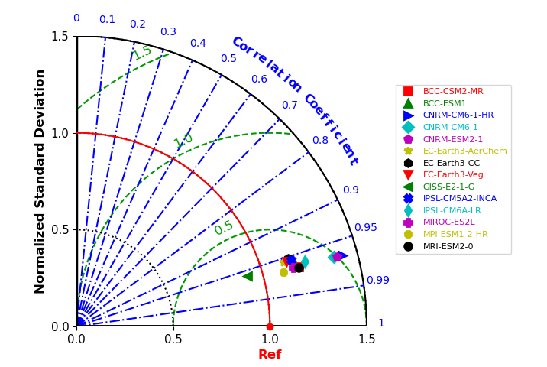
Supplementary Fig. S1. Taylor diagram summarizing CMIP6 model performance for surface temperature over the Tibetan Plateau (1970–2014). The angular coordinate indicates the correlation coefficient(R) between each model and observations, the radial distance indicates the (normalized) standard deviation.

Supplementary Table S2. Taylor statistics for precipitation over the Tibetan Plateau (1970–2014) for the 14 CMIP6 models. Reported metrics include the correlation coefficient (R), observed standard deviation (σ_obs), modeled standard deviation (σ_mod), root mean square error (RMSE; °C), and normalized standard deviation (NSD). Statistics are computed by comparing each model against the observational dataset over 1970–2014, and correspond to the Taylor diagram in Fig. S2
Model Names | Correlation Coefficient (R) | Standard Deviation of Observed Data  (σ _obs)  (mm) | Standard Deviation of Modeled Data  (σ _mod)  (mm) | Root Mean Squared Error (RMSE)  (mm) | Normalized Standard Deviation (NSD)
BCC-CSM2-MR | 0.51 | 31.86 | 50.21 | 63.11 | 2.53
BCC-ESM1 | 0.45 | 31.86 | 61.31 | 79.34 | 3.02
CNRM-CM6-1-HR | 0.59 | 31.86 | 45.48 | 46.30 | 2.06
CNRM-CM6-1 | 0.59 | 31.86 | 56.24 | 59.93 | 2.79
CNRM-ESM2-1 | 0.58 | 31.86 | 58.17 | 62.26 | 2.99
EC-Earth3-AerChem | 0.66 | 31.86 | 45.51 | 42.27 | 2.12
EC-Earth3-CC | 0.66 | 31.86 | 48.96 | 46.01 | 2.29
EC-Earth3-Veg | 0.65 | 31.86 | 48.78 | 46.08 | 2.22
GISS-E2-1-G | 0.49 | 31.86 | 54.26 | 75.76 | 2.59
IPSL-CM5A2-INCA | 0.38 | 31.86 | 44.57 | 57.28 | 2.18
IPSL-CM6A-LR | 0.51 | 31.86 | 43.51 | 55.31 | 2.14
MIROC-ES2L | 0.64 | 31.86 | 65.08 | 75.81 | 3.05
MPI-ESM1-2-HR | 0.58 | 31.86 | 62.34 | 67.87 | 3.09
MRI-ESM2-0 | 0.60 | 31.86 | 60.63 | 66.07 | 2.84

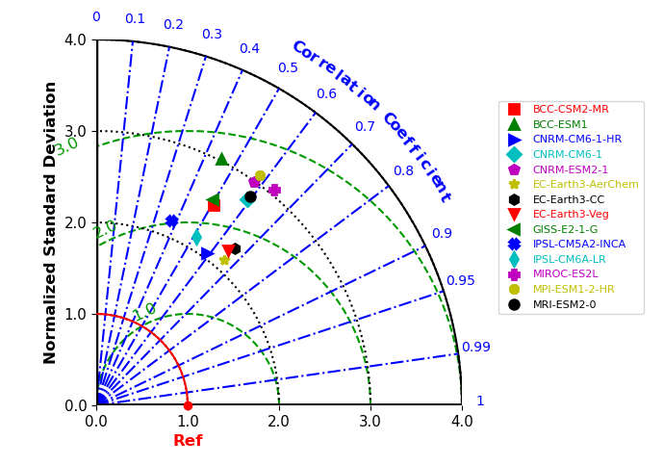
Supplementary Fig. S2. Taylor diagram summarizing CMIP6 model performance for precipitation over the Tibetan Plateau (1970–2014). The angular coordinate indicates the correlation coefficient(R) between each model and observations, the radial distance indicates the (normalized) standard deviation.

