catalogue

Table1 Analysis of the mediation between Number of CMM and disability (Part A) 2
Table2 Analysis of the mediation between Number of CMM and disability (Part B) 2
Table3 Analysis of the mediation between Number of CMM and disability (Part C) 3
Table4 Analysis of the mediation between depression symptoms and disability (Part A) 4
Table5 Analysis of the mediation between depression symptoms and disability (Part B) 5
Table6 Analysis of the mediation between depression symptoms and disability (Part C) 5
Table7 Analysis of the mediation between cognitive function and disability (PartA) 6
Table8 Analysis of the mediation between cognitive function and disability (Part B) 7
Table9 Analysis of the mediation between cognitive function and disability (Part C) 7
Table10 Analysis of the mediation between stroke and disability (Part A) 8
Table11 Analysis of the mediation between stroke and disability (Part B) 8
Table12 Analysis of the mediation between stroke and disability (Part C) 9
Table13 Analysis of the mediation between Fall down and disability (Part A) 10
Table14 Analysis of the mediation between Fall down and disability (Part B) 10
Table15 Analysis of the mediation between Fall down and disability (Part C) 11
Table16 Test for nonlinearity 11
Table17 Comparison with the reference group 11
Table18 Post hoc pairwise comparisons (Tukey-adjusted) 12
Table19 Sensitivity analysis of Comparison with the reference group(PartA) 12
Table20 Sensitivity analysis of Post hoc pairwise comparisons (Tukey-adjusted)(PartB) 12
Table21 Linearity test 12
Table22 Bortua feature selection results 13
Table23 LASSO Regression Results (for Sensitivity Analysis) 14
Table24 Overlapping Variables between Boruta and LASSO 15
Table25 Performance Comparison of Five Machine Learning Models on Training Set 15
Figure1 Restricted cubic spline (RCS) curve (depression symptoms) 16
Figure2 Restricted cubic spline (RCS) curve (Fall down) 16
Figure3 Restricted cubic spline (RCS) curve (Stroke) 17
Figure4 LASSO Coefficent Trajectory(for Sensitivity Analysis) 18
Figure5 Cross-Validation for LASSO Regression(for Sensitivity Analysis) 18
Figure6 SHAP Summary Dot Plot for the Random Forest Model 19
Figure7 SHAP Variable Importance 20
Figure8 SHAP Waterfall Plot for a Single Sample Prediction 21
Figure9 SHAP force plot of the random forest model 22

Table1 Analysis of the mediation between Number of CMM and disability (Part A)
Mediator | a coefficient  （95%CI） | p | b coefficient  (95%CI) | p | c’  coefficient(95%CI) | p
CVAI | -0.01（-0.04-0.02） | 0.53 | 0.09（-0.72 -0.89） | 0.81 | 0.19（-0.21-0.63） | 0.33
TyG | 0.02（-0.01-0.04） | 0.21 | 0.43（-0.37-1.62） | 0.29 | 0.18（-0.21-0.59） | 0.35
TyG-BMI | 0.02（0.01- 0.03） | ＜0.05 | 1.74（-0.56-5.38） | 0.14 | 0.16（-0.22-0.55） | 0.41
HCT | 0.04（-0.02-0.09） | 0.13 | -0.09（-0.60-0.34） | 0.66 | 0.19（-0.22-0.59） | 0.33
HbA1c | 0.06（0.002- 0.12） | ＜0.05 | 0.33（-0.05- 0.74） | 0.09 | 0.19（-0.19-0.60） | 0.33
Social activity | -0.01（-0.09- 0.06） | 0.76 | -0.13（-0.42-0.15） | 0.32 | 0.19（-0.17-0.59） | 0.33
Sleep duration | -0.06（-0.14-0.02） | 0.13 | -0.25（-0.53-0.05） | 0.06 | 0.18（-0.22-0.59） | 0.37
Maximum Right-hand grip strength | -0.05（-0.12-0.02） | 0.14 | -0.52（-0.87- -0.20） | ＜0.05 | 0.16（-0.26-0.55） | 0.42
Maximum Left-hand grip strength | -0.01(-0.08-0.05) | 0.72 | -0.64(-1.00- -0.35) | ＜0.05 | 0.18(-0.20-0.56) | 0.38
Average walking speed | 0.01（-0.07- 0.09） | 0.88 | 0.57（0.25-1.02） | ＜0.05 | 0.19(-0.20-0.57) | 0.35
Fall down | -0.01（-0.09- 0.06） | 0.77 | 0.31（0.02-0.61） | ＜0.05 | 0.21(-0.18-0.61) | 0.30
Abbreviation:CVAI: Chinese Visceral Adiposity Index;TyG:Triglyceride glucose index; TyG-BMI: Triglyceride Glucose-Body Mass Index; HCT: Hematocrit; HbA1c: hemoglobin A1c

Table2 Analysis of the mediation between Number of CMM and disability (Part B)
Mediator | ACME（95%CI） | P | ADE（95%CI） | P
CVAI | -0.0001(-0.0030-0.0015) | 0.76 | 0.0262(-0.0291-0.0784) | 0.31
TyG | 0.0009(-0.0009-0.0051) | 0.38 | 0.0251(-0.0264-0.0771) | 0.39
TyG-BMI | 0.0037(-0.0014-0.0105) | 0.16 | 0.0224(-0.0346-0.0729) | 0.44
HCT | -0.0005(-0.0042-0.0022) | 0.72 | 0.0264(-0.0270-0.0762) | 0.33
HbA1c | 0.0027(-0.0008-0.0084) | 0.16 | 0.0261(-0.0273-0.0775) | 0.40
Social activity | 0.0002(-0.0017- 0.0027) | 0.76 | 0.0261(-0.0299-0.0751) | 0.37
Sleep duration | 0.0021(-0.0007-0.0064) | 0.18 | 0.0241(-0.0279-0.0755) | 0.35
Maximum Right-hand grip strength | 0.0036(-0.0014-0.0097) | 0.17 | 0.0218(-0.0318-0.0713) | 0.41
Maximum Left-hand grip strength | 0.0010(-0.0046- 0.0079) | 0.60 | 0.0237(-0.0284-0.0751) | 0.35
Average walking speed | 0.0005(-0.0057-0.0073) | 0.85 | 0.0251(-0.0280-0.0759) | 0.37
Fall down | -0.0005(-0.0045- 0.0032) | 0.82 | 0.0280(-0.0293-0.0785) | 0.35

Table3 Analysis of the mediation between Number of CMM and disability (Part C)
Mediator | Proportion mediated（95%CI） | P
CVAI | -0.004(-0.34-0.13) | 0.81
TyG | 0.04(-0.60-0.46) | 0.64
TyG-BMI | 0.14(-2.47-1.19) | 0.50
HCT | -0.02(-0.49-0.39) | 0.83
HbA1c | 0.09(-1.16-1.17) | 0.46
Social activity | 0.01(-0.24-0.27) | 0.84
Sleep duration | 0.08(-0.55-0.61) | 0.44
Maximum Right-hand grip strength | 0.14(-1.25-1.44) | 0.45
Maximum Left-hand grip strength | 0.04(-0.88-0.94) | 0.66
Average walking speed | 0.02(-0.98-0.92) | 0.92
Fall down | -0.02(-0.61-0.53) | 0.92

Table4 Analysis of the mediation between depression symptoms and disability (Part A)
Mediator | a coefficient  （95%CI） | p | b coefficient  (95%CI) | p | c’  coefficient(95%CI) | p
CVAI | 0.01  （-0.01-0.04） | 0.55 | 0.09（-0.72 -0.89） | 0.81 | 1.31（1.05-1.72） | ＜0.05
TyG | -0.01（-0.03-0.003） | 0.22 | 0.43（-0.37-1.62） | 0.29 | 1.32（1.04-1.72） | ＜0.05
TyG-BMI | -0.01（-0.01- 0.0001) | ＜0.05 | 1.74（-0.56-5.38） | 0.14 | 1.32（1.04-1.71） | ＜0.05
HCT | -0.04（-0.08-0.01） | 0.12 | -0.09（-0.60-0.34） | 0.66 | 1.31（1.03-1.70） | ＜0.05
HbA1c | -0.03  （-0.07- 0.02） | ＜0.05 | 0.33（-0.05- 0.74） | 0.09 | 1.31（1.04-1.69） | ＜0.05
Social activity | -0.10  （-0.15- -0.05） | 0.82 | -0.13（-0.42-0.15） | 0.32 | 1.31（1.03-1.68） | ＜0.05
Sleep duration | -0.23  （-0.29- -0.17） | 0.13 | -0.25（-0.53-0.05） | 0.06 | 1.25（0.98-1.63） | ＜0.05
Maximum Right-hand grip strength | -0.09  （-0.14- -0.03） | 0.32 | -0.52（-0.87- -0.20） | ＜0.05 | 1.27（0.99-1.68） | ＜0.05
Maximum Left-hand grip strength | -0.11  (-0.16- -0.06) | 0.79 | -0.64(-1.00- -0.35) | ＜0.05 | 1.26(0.97-1.65) | ＜0.05
Average walking speed | 0.03  （-0.02- 0.09） | 0.27 | 0.57（0.25-1.02） | ＜0.05 | 1.31(1.03-1.70) | ＜0.05
Fall down | 0.12  （0.06- 0.19） | 0.75 | 0.31（0.02-0.61） | ＜0.05 | 1.29(1.00-1.66) | ＜0.05

Table5 Analysis of the mediation between depression symptoms and disability (Part B)
Mediator | ACME（95%CI） | P | ADE（95%CI） | P
CVAI | 0.00002(-0.0002-0.0003) | 0.83 | 0.0206(0.0153-0.0259) | 0
TyG | -0.0001(-0.0005-0.0001) | 0.32 | 0.0206(0.0156-0.0259) | 0
TyG-BMI | -0.0002(-0.0007-0.0001) | 0.20 | 0.0208(0.0160-0.0260) | 0
HCT | 0.0001(-0.0002-0.0004) | 0.77 | 0.0205(0.0159-0.0257) | 0
HbA1c | -0.0001(-0.0005-0.0001) | 0.33 | 0.0206(0.0160-0.0257) | 0
Social activity | 0.0002(-0.0002- 0.0006) | 0.31 | 0.0206(0.0155-0.0257) | 0
Sleep duration | 0.0009(-0.0001-0.0019) | 0.07 | 0.0196(0.0143-0.0248) | 0
Maximum Right-hand grip strength | 0.0007(0.0002-0.0014) | 0.01 | 0.0198(0.0145-0.0253) | 0
Maximum Left-hand grip strength | 0.0011(0.0005- 0.0020) | 0.00 | 0.0194(0.0150-0.0244) | 0
Average walking speed | 0.0003(-0.0002-0.0009) | 0.25 | 0.0202(0.0156-0.0250) | 0
Fall down | 0.0006(0.0001- 0.0013) | 0.03 | 0.0201(0.0155-0.0251) | 0

Table6 Analysis of the mediation between depression symptoms and disability (Part C)
Mediator | Prop_Mediated（95%CI） | P
CVAI | 0.0008(-0.01-0.01) | 0.83
TyG | -0.0045(-0.03-0.004) | 0.32
TyG-BMI | -0.077(-0.03-0.003) | 0.20
HCT | 0.0025(-0.01-0.02) | 0.77
HbA1c | -0.0067(-0.02-0.005) | 0.33
Social activity | 0.0097(-0.01-0.03) | 0.31
Sleep duration | 0.0432(-0.003-0.10) | 0.07
Maximum Right-hand grip strength | 0.0339(0.01-0.07) | 0.01
Maximum Left-hand grip strength | 0.0522(0.02-0.10) | 0.00
Average walking speed | 0.0146(-0.01-0.04) | 0.25
Fall down | 0.0291(0.003- 0.07) | 0.03

Table7 Analysis of the mediation between cognitive function and disability (PartA)

Mediator | a_beta（95%CI） | a_p | b_beta(95%CI) | b_p | c_prime_beta(95%CI) | c_prime_p
CVAI | 0.01  （-0.01-0.03） | 0.53 | 0.09（-0.72 -0.89） | 0.81 | -1.04（-1.37- -0.77） | ＜0.05
TyG | -0.003（-0.02-0.02） | 0.76 | 0.43（-0.37-1.62） | 0.29 | -1.03（-1.36- -0.77） | ＜0.05
TyG-BMI | -0.002（-0.01-0.01） | 0.62 | 1.74（-0.56-5.38） | 0.14 | -1.03（-1.38- -0.75） | ＜0.05
HCT | -0.01（-0.05-0.03） | 0.51 | -0.09（-0.60-0.34） | 0.66 | -1.04（-1.41- -0.76） | ＜0.05
HbA1c | -0.03（-0.08-0.005） | 0.09 | 0.33（-0.05- 0.74） | 0.09 | -1.03（-1.38- -0.76） | ＜0.05
Social activity | 0.21  （0.17-0.27） | ＜0.05 | -0.13（-0.42-0.15） | 0.32 | -1.03（-1.40- -0.75） | ＜0.05
Sleep duration | 0.002（-0.06-0.07） | 0.95 | -0.25（-0.53-0.05） | 0.06 | -1.04（-1.39- -0.77） | ＜0.05
Maximum Right-hand grip strength | 0.13  （0.08-0.18） | ＜0.05 | -0.52（-0.87- -0.20） | ＜0.05 | -0.97（-1.35- -0.69） | ＜0.05
Maximum Left-hand grip strength | 0.10  (0.05-0.15) | ＜0.05 | -0.64(-1.00- -0.35) | ＜0.05 | -0.98(-1.32- -0.71) | ＜0.05
Average walking speed | -0.12  （-0.17- -0.06） | ＜0.05 | 0.57（0.25-1.02） | ＜0.05 | -0.98(-1.35- -0.70) | ＜0.05
Fall down | -0.08  （-0.14- -0.02） | ＜0.05 | 0.31（0.02-0.61） | ＜0.05 | -1.01(-1.36- -0.74) | ＜0.05

Table8 Analysis of the mediation between cognitive function and disability (Part B)
Mediator | ACME（95%CI） | P | ADE（95%CI） | P
CVAI | 0.00002(-0.0002-0.0003) | 0.91 | -0.0293(-0.0375- -0.0201) | 0
TyG | -0.00003(-0.0006-0.0003) | 0.72 | -0.0292(-0.0376- -0.0210) | 0
TyG-BMI | -0.0001(-0.0008-0.0003) | 0.58 | -0.0291(-0.0379- -0.0201) | 0
HCT | 0.00003(-0.0002-0.0004) | 0.83 | -0.0292(-0.0377- -0.0204) | 0
HbA1c | -0.0003(-0.0009-0.0001) | 0.19 | -0.0292(-0.0380- -0.0207) | 0
Social activity | -0.0008(-0.0024- 0.0009) | 0.31 | -0.0293(-0.0383- -0.0205) | 0
Sleep duration | -0.00001(-0.0005-0.0005) | 0.97 | -0.0293(-0.0375- -0.0208) | 0
Maximum Right-hand grip strength | -0.0019(-0.0034- -0.0007) | 0.00 | -0.0272(-0.0361- -0.0188) | 0
Maximum Left-hand grip strength | -0.0017(-0.0032- -0.0007) | 0.00 | -0.0272(-0.0363- -0.0188) | 0
Average walking speed | -0.0018(-0.0034- -0.0007) | 0.00 | -0.0274(-0.0358- -0.0184) | 0
Fall down | -0.0007(-0.0017- -0.00003) | 0.04 | -0.0285(-0.0370- -0.0201) | 0

Table9 Analysis of the mediation between cognitive function and disability (Part C)
Mediator | Prop_Mediated（95%CI） | P
CVAI | -0.0006(-0.01-0.01) | 0.91
TyG | 0.0011(-0.01-0.02) | 0.72
TyG-BMI | 0.0026(-0.01-0.03) | 0.58
HCT | -0.0011(-0.01-0.01) | 0.83
HbA1c | 0.0108(-0.004-0.03) | 0.19
Social activity | 0.0262(-0.03-0.08) | 0.31
Sleep duration | 0.0005(-0.02-0.02) | 0.97
Maximum Right-hand grip strength | 0.0650(0.02-0.13) | 0.00
Maximum Left-hand grip strength | 0.0589(0.02-0.11) | 0.00
Average walking speed | 0.0628(0.02-0.13) | 0.00
Fall down | 0.0241(0.0009-0.06) | 0.04

Mediator | a_beta（95%CI） | a_p | b_beta(95%CI) | b_p | c_prime_beta(95%CI) | c_prime_p
CVAI | 0.002  （-0.02-0.02） | 0.85 | 0.09（-0.72 -0.89） | 0.81 | 0.57（0.27-0.94） | ＜0.05
TyG | -0.03  （-0.05- -0.0002） | ＜0.05 | 0.43（-0.37-1.62） | 0.29 | 0.58（0.25-0.94） | ＜0.05
TyG-BMI | -0.01  （-0.02- -0.004） | ＜0.05 | 1.74（-0.56-5.38） | 0.14 | 0.59（0.27-0.95） | ＜0.05
HCT | -0.03  （-0.08-0.01） | 0.11 | -0.09（-0.60-0.34） | 0.66 | 0.56（0.26-0.93） | ＜0.05
HbA1c | -0.02  （-0.06- 0.02） | 0.52 | 0.33（-0.05- 0.74） | 0.09 | 0.57（0.26-0.91） | ＜0.05
Social activity | -0.02  （-0.08- 0.03） | 0.58 | -0.13（-0.42-0.15） | 0.32 | 0.57（0.26-0.94） | ＜0.05
Sleep duration | 0.03  （-0.03-0.10） | 0.29 | -0.25（-0.53-0.05） | 0.06 | 0.58（0.25-0.92） | ＜0.05
Maximum Right-hand grip strength | -0.01  （-0.07-0.05） | 0.36 | -0.52（-0.87- -0.20） | ＜0.05 | 0.57（0.26-0.92） | ＜0.05
Maximum Left-hand grip strength | -0.11  (-0.17- -0.05) | ＜0.05 | -0.64(-1.00- -0.35) | ＜0.05 | 0.50(0.19-0.84) | ＜0.05
Average walking speed | 0.07  （-0.004- 0.14） | 0.64 | 0.57（0.25-1.02） | ＜0.05 | 0.53(0.22-0.90) | ＜0.05
Fall down | 0.01  （-0.05- 0.06） | 0.86 | 0.31（0.02-0.61） | ＜0.05 | 0.56(0.24-0.92) | ＜0.05

Table10 Analysis of the mediation between stroke and disability (Part A)

Table11 Analysis of the mediation between stroke and disability (Part B)
Mediator | ACME（95%CI） | P | ADE（95%CI） | P
CVAI | 0.0001(-0.0018-0.0027) | 0.85 | 0.1551(0.0726-0.2298) | 0.00
TyG | -0.0029(-0.0105-0.0024) | 0.30 | 0.1583(0.0822-0.2261) | 0.00
TyG-BMI | -0.0058(-0.0151-0.0026) | 0.16 | 0.1614(0.0780-0.2290) | 0.00
HCT | 0.0008(-0.0041-0.0064) | 0.75 | 0.1543(0.0759-0.2285) | 0.00
HbA1c | -0.0015(-0.0069-0.0021) | 0.43 | 0.1552(0.0710-0.2266) | 0.00
Social activity | 0.0008(-0.0022- 0.0045) | 0.65 | 0.1553(0.0796-0.2271) | 0.00
Sleep duration | -0.0021(-0.0081-0.0023) | 0.32 | 0.1571(0.0712-0.2267) | 0.00
Maximum Right-hand grip strength | 0.0011(-0.0073-0.0096) | 0.83 | 0.1546(0.0663-0.2303) | 0.00
Maximum Left-hand grip strength | 0.0190(0.0065- 0.0357) | 0.00 | 0.1347(0.0481-0.2100) | 0.00
Average walking speed | 0.0103(0.0011-0.0243) | 0.02 | 0.1432(0.0624-0.2146) | 0.00
Fall down | 0.0008(-0.0048- 0.0073) | 0.78 | 0.1521(0.0738-0.2299) | 0.00

Table12 Analysis of the mediation between stroke and disability (Part C)
Mediator | Prop_Mediated（95%CI） | P
CVAI | 0.0003(-0.01-0.02) | 0.86
TyG | -0.0186(-0.08-0.02) | 0.40
TyG-BMI | -0.0373(-0.13-0.02) | 0.20
HCT | 0.0053(-0.03-0.05) | 0.78
HbA1c | -0.0095(-0.06-0.01) | 0.49
Social activity | 0.0050(-0.02-0.03) | 0.76
Sleep duration | -0.0137(-0.07-0.02) | 0.29
Maximum Right-hand grip strength | 0.0069(-0.06-0.08) | 0.40
Maximum Left-hand grip strength | 0.1234(0.04-0.34) | 0.02
Average walking speed | 0.0669(0.01-0.21) | 0.74
Fall down | 0.0055(-0.04-0.06) | 0.86

Table13 Analysis of the mediation between Fall down and disability (Part A)

Mediator | a_beta（95%CI） | a_p | b_beta(95%CI) | b_p | c_prime_beta(95%CI) | c_prime_p
CVAI | 0.01  （-0.01-0.04） | 0.13 | 0.06（-0.76 -0.89） | 0.87 | 0.31（0.04-0.60） | ＜0.05
TyG | -0.01（-0.02-0.01） | 0.32 | 0.45（-0.35-1.67） | 0.27 | 0.31（0.04-0.61） | ＜0.05
TyG-BMI | -0.004  （-0.01- -0.002） | 0.20 | 1.85（-0.43-5.54） | 0.12 | 0.32（0.08-0.60） | ＜0.05
HCT | -0.003（-0.03-0.03） | 0.85 | -0.08（-0.59-0.35） | 0.68 | 0.31（0.04-0.61） | ＜0.05
HbA1c | -0.02  （-0.06- 0.02） | 0.36 | 0.35（-0.04-0.76） | 0.07 | 0.31（0.04-0.60） | ＜0.05
Social activity | 0.02  （-0.03- 0.07） | 0.40 | -0.14（-0.43-0.14） | 0.28 | 0.31（0.06-0.62） | ＜0.05
Sleep duration | -0.09  （-0.15- -0.04） | ＜0.05 | -0.22（-0.51-0.07） | 0.09 | 0.29（0.03-0.59） | ＜0.05
Maximum Right-hand grip strength | -0.03（-0.08-0.01） | 0.15 | -0.51（-0.86- -0.19） | ＜0.05 | 0.30（0.02-0.62） | ＜0.05
Maximum Left-hand grip strength | -0.04  (-0.08-0.01) | 0.09 | -0.63(-0.99- -0.34) | ＜0.05 | 0.29(0.02-0.56) | ＜0.05
Average walking speed | 0.02  （-0.04- 0.07） | 0.48 | 0.57（0.25-1.02） | ＜0.05 | 0.30(0.04-0.58) | ＜0.05

Table14 Analysis of the mediation between Fall down and disability (Part B)
Mediator | ACME（95%CI） | P | ADE（95%CI） | P
CVAI | 0.0002(-0.0030-0.0037) | 0.87 | 0.0700(0.0150-0.1266) | 0.01
TyG | -0.0009(-0.0050-0.0011) | 0.43 | 0.0709(0.0093-0.1276) | 0.01
TyG-BMI | -0.0016(-0.0067-0.0016) | 0.33 | 0.0719(0.0106-0.1277) | 0.02
HCT | 0.0001(-0.0018-0.0021) | 0.90 | 0.0699(0.0034-0.1289) | 0.04
HbA1c | -0.0013(-0.0062-0.0017) | 0.44 | 0.0701(0.0147-0.1277) | 0.01
Social activity | -0.0007(-0.0035- 0.0012) | 0.59 | 0.0703(0.0067-0.1277) | 0.03
Sleep duration | 0.0046(-0.0011-0.0117) | 0.12 | 0.0662(0.0054-0.1215) | 0.04
Maximum Right-hand grip strength | 0.0037(-0.0012-0.0104) | 0.15 | 0.0673（0.0084-0.1183） | 0.03
Maximum Left-hand grip strength | 0.0052(-0.0010- 0.0129) | 0.08 | 0.0651（0.0045-0.1226) | 0.03
Average walking speed | 0.0023(-0.0042-0.0113) | 0.54 | 0.0674（0.0108-0.1231) | 0.02

Table15 Analysis of the mediation between Fall down and disability (Part C)
Mediator | Prop_Mediated（95%CI） | P
CVAI | 0.003(-0.06-0.07) | 0.87
TyG | -0.01(-0.13-0.02) | 0.44
TyG-BMI | -0.02(-0.22-0.03) | 0.35
HCT | 0.0009(-0.05-0.04) | 0.91
HbA1c | -0.02(-0.15-0.03) | 0.45
Social activity | -0.01(-0.09-0.02) | 0.58
Sleep duration | 0.07(-0.02-0.36) | 0.14
Maximum Right-hand grip strength | 0.05(-0.03-0.24) | 0.16
Maximum Left-hand grip strength | 0.07(-0.03-0.38) | 0.10
Average walking speed | 0.03(-0.11-0.24) | 0.54

Table16 Test for nonlinearity
variable | P
cognitive function | 0.0042
depression symptoms | 0.8367
Fall down | 0.6091
Stroke | 0.3415

Term | OR(95%CI)or Odds | P
Number of CMM=2(Intercept) | 1.19(1.04-1.36)(Odds) | 0.01
Number of CMM=3 | 1.40(1.10-1.78)(OR) | 0.01
Number of CMM=4 | 1.72(1.17-2.58)(OR) | 0.01
Number of CMM=5 | 10.08(1.97-184.12)(OR) | 0.03

Table17 Comparison with the reference group
The OR of Number of CMM=2 = 1

Table18 Post hoc pairwise comparisons (Tukey-adjusted)
Term | LogOR(Difference Value) | p
Number of CMM=2 - Number of CMM=3 | -0.334 | 0.0322
Number of CMM=2 - Number of CMM=4 | -0.543 | 0.0363
Number of CMM=2 - Number of CMM=5 | -2.311 | 0.1185
Number of CMM=3 - Number of CMM=4 | -0.209 | 0.7681
Number of CMM=3 - Number of CMM=5 | -1.977 | 0.2316
Number of CMM=4 - Number of CMM=5 | -1.768 | 0.3387

Term | OR(95%CI)or Odds | P
Number of CMM=2(Intercept) | 1.19(1.04-1.36)(Odds) | 0.01
Number of CMM=3 | 1.40(1.10-1.78)(OR) | 0.01
Number of CMM≥4 | 1.92(1.31-2.85)(OR) | 0.001

Table19 Sensitivity analysis of Comparison with the reference group(PartA)
The OR of Number of CMM=2 = 1

Table20 Sensitivity analysis of Post hoc pairwise comparisons (Tukey-adjusted)(PartB)
Term | LogOR(Difference Value) | p
Number of CMM=2 - Number of CMM=3 | -0.334 | 0.0175
Number of CMM=2 - Number of CMM≥4 | -0.653 | 0.0027
Number of CMM=3 - Number of CMM≥4 | -0.318 | 0.2873

Table21 Linearity test
Method for detection | P
Likelihood ratio test (linear model vs. factor model) | 0.258
Polynomial contrasts
linear | 0.0227
quadratic | 0.1781
cubic | 0.1701
Cochran-Armitage trend test | 3.302e-05

Table22 Bortua feature selection results
Feature | decision
depression symptoms | Confirmed
sleep duration | Confirmed
HbA1c | Confirmed
maximum left-hand grip strength | Confirmed
maximum right-hand grip strength | Confirmed
average walking speed | Confirmed
chest pain symptoms | Confirmed
cognitive function | Confirmed
fall down | Confirmed
stroke | Confirmed
kidney disease | Confirmed
number of CMM | Confirmed
gender | Tentative
life satisfaction | Tentative
social activity | Tentative
TyG | Tentative
CVAI | Tentative
FBG | Tentative
HCT | Tentative
CREA | Tentative
UA | Tentative
WC | Tentative
are you smoking now | Rejected
drinking history | Rejected
are you drinking now | Rejected
TyG-BMI | Rejected
TG | Rejected
TC | Rejected
LDL | Rejected
HDL | Rejected
WBC | Rejected
CRP | Rejected
PLT | Rejected
MCV | Rejected
HGB | Rejected
BUN | Rejected
CYSC | Rejected
mean of the second and third pulse measurements | Rejected
BMI | Rejected
hip fractures | Rejected
hypertension | Rejected
heart disease | Rejected
diabetes | Rejected
dyslipidemia | Rejected

Table23 LASSO Regression Results (for Sensitivity Analysis)
Feature | Status | Coefficient
kidney disease | Selected | 0.227132403
stroke | Selected | 0.187130954
chest pain symptoms | Selected | 0.119190042
average walking speed | Selected | 0.087807181
depression symptoms | Selected | 0.082949525
fall down` | Selected | 0.041405956
maximum left-hand grip strength | Selected | -0.00925773
maximum right-hand grip strength | Selected | -0.01109885
cognitive function` | Selected | -0.029507139
age | Rejected | 0
gender | Rejected | 0
life satisfaction | Rejected | 0
sleep duration | Rejected | 0
social activity | Rejected | 0
smoking history | Rejected | 0
are you smoking now | Rejected | 0
drinking history | Rejected | 0
are you drinking now | Rejected | 0
TyG | Rejected | 0
TyG-BMI | Rejected | 0
CVAI | Rejected | 0
HbA1c | Rejected | 0
FBG | Rejected | 0
TG | Rejected | 0
TC | Rejected | 0
LDL | Rejected | 0
HDL | Rejected | 0
WBC | Rejected | 0
CRP | Rejected | 0
PLT | Rejected | 0
MCV | Rejected | 0
HGB | Rejected | 0
HCT | Rejected | 0
CREA | Rejected | 0
BUN | Rejected | 0
CYSC | Rejected | 0
UA | Rejected | 0
mean of the second and third pulse measurements | Rejected | 0
BMI | Rejected | 0
WC | Rejected | 0
hip fractures | Rejected | 0
hypertension | Rejected | 0
heart disease | Rejected | 0
diabetes | Rejected | 0
dyslipidemia | Rejected | 0
number of CMM | Rejected | 0

Table24 Overlapping Variables between Boruta and LASSO
Feature
kidney disease
stroke
chest pain symptoms
average walking speed
depression symptoms
fall down
maximum left-hand grip strength
maximum right-hand grip strength
cognitive function

Model | AUC | Sensitivity | Recall | Specificity | Precision | Accuracy | F1
LGB | 0.7157 | 0.7095 | 0.7095 | 0.615 | 0.7037 | 0.6682 | 0.7066
XGB | 0.7161 | 0.7012 | 0.7012 | 0.6364 | 0.7131 | 0.6729 | 0.7071
LR | 0.796 | 0.724 | 0.724 | 0.724 | 0.587 | 0.742 | 0.648
RF | 0.737 | 0.643 | 0.643 | 0.643 | 0.534 | 0.699 | 0.583
SVM | 0.755 | 0.735 | 0.735 | 0.735 | 0.533 | 0.702 | 0.618

Table25 Performance Comparison of Five Machine Learning Models on Training Set

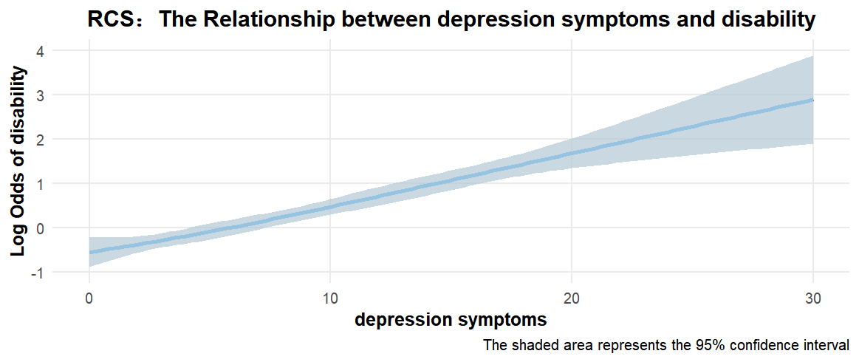

Figure1 Restricted cubic spline (RCS) curve (depression symptoms)
The solid blue curve represents the estimated smooth fitting curve, and the light blue shaded area indicates the 95% confidence interval of the estimate. The horizontal axis displays the range of depression symptoms values, while the vertical axis reflects the log-odds ratio of disability (on a continuous scale).

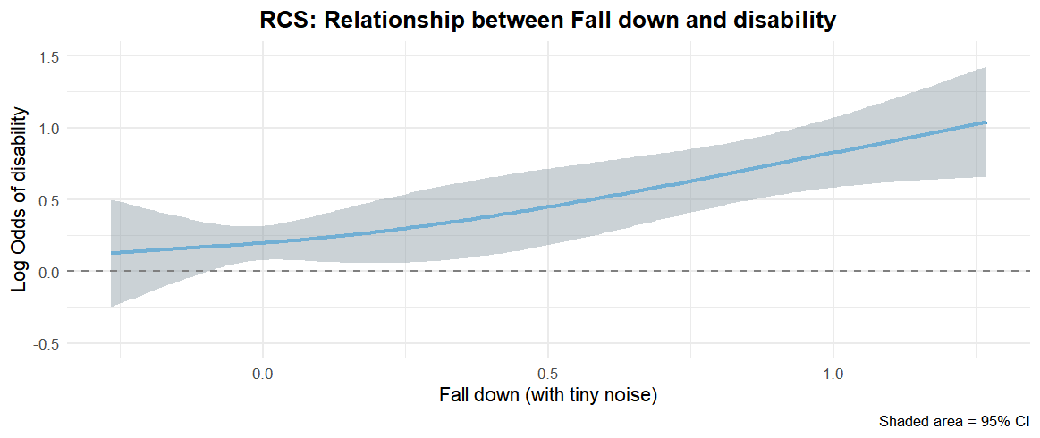

Figure2 Restricted cubic spline (RCS) curve (Fall down)
The solid blue curve represents the estimated smooth fitting curve, and the light blue shaded area indicates the 95% confidence interval of the estimate. The horizontal axis displays the range of Fall down values, while the vertical axis reflects the log-odds ratio of disability (on a continuous scale).

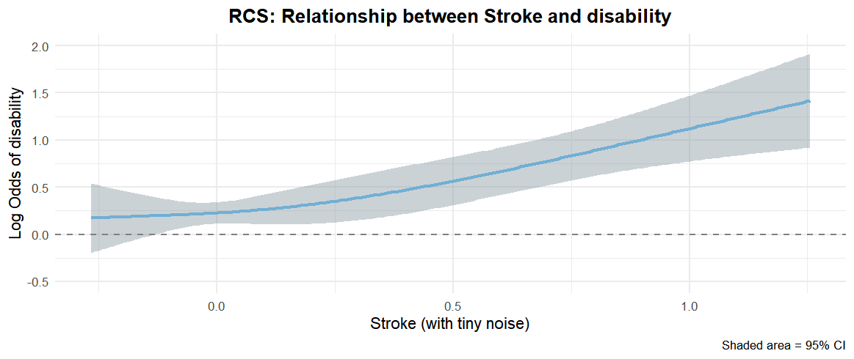

Figure3 Restricted cubic spline (RCS) curve (Stroke)
The solid blue curve represents the estimated smooth fitting curve, and the light blue shaded area indicates the 95% confidence interval of the estimate. The horizontal axis displays the range of Stroke values, while the vertical axis reflects the log-odds ratio of disability (on a continuous scale).

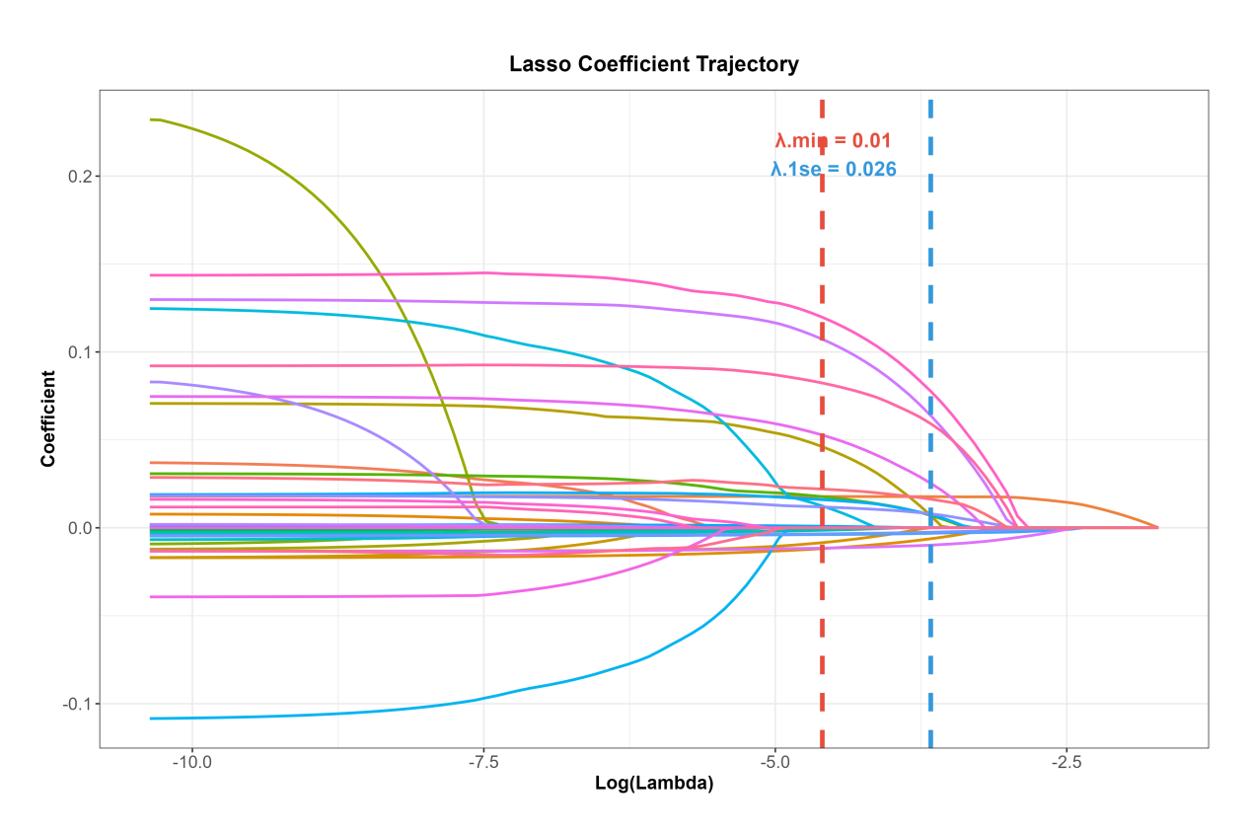

Figure4 LASSO Coefficent Trajectory(for Sensitivity Analysis)
This LASSO Coefficent curve was used to determine the optimal penalty parameter λ for the binary classification model. The red curve represents the trend of mean squared error (MSE) with increasing λ, and error bars indicate the variation range of the model. The MSE first decreased and reached the minimum at λ.min = 0.01, indicating the highest prediction accuracy. The value at λ.1se = 0.026 yielded slightly higher error but a sparser model structure. Considering both stability and generalizability, λ.1se was selected as the optimal parameter to achieve feature sparsification while maintaining predictive performance, supporting the construction of a parsimonious and robust prediction model.
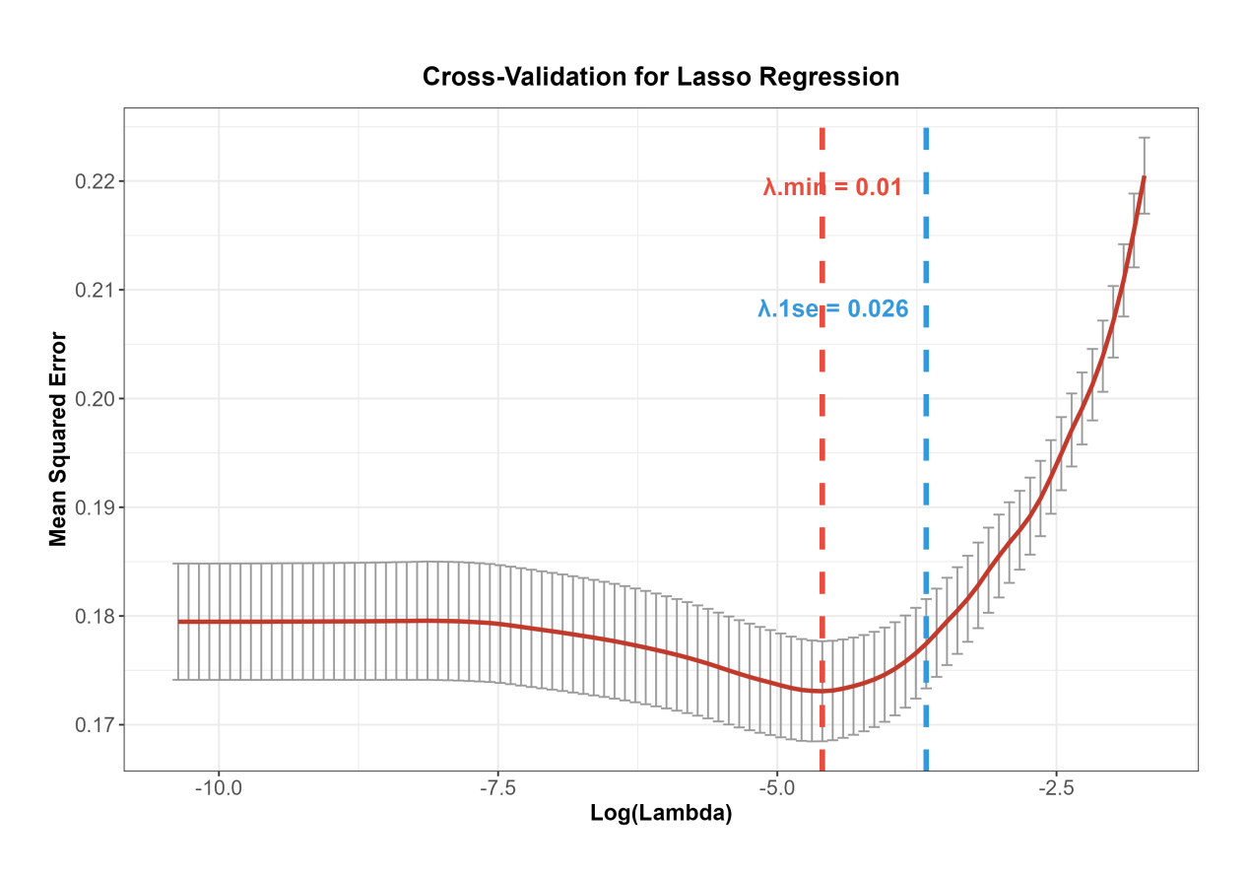

Figure5 Cross-Validation for LASSO Regression(for Sensitivity Analysis)
The LASSO coefficient trajectory plot illustrates the dynamic changes in variable coefficients with increasing penalty strength (λ). As λ increases (stronger regularization), the coefficients of most variables shrink to zero, indicating the elimination of non-informative features, which reflects the core feature-selection property of LASSO. At the optimal λ.1se = 0.026 and λ.min = 0.01 (vertical dashed lines), several variables retained non-zero coefficients and were selected as core predictors. Among them, chest pain symptoms, stroke, kidney disease, depression symptoms, cognitive function, and physical function indicators (e.g., grip strength) showed large absolute coefficient values, indicating their strong effects on disability outcomes and highlighting their potential as key clinical intervention targets.

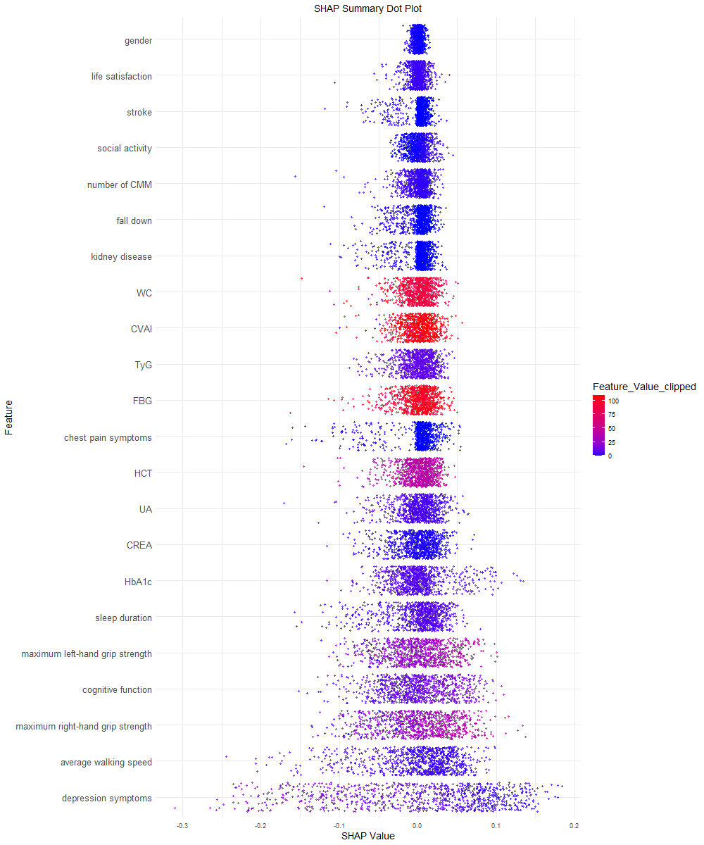

Figure6 SHAP Summary Dot Plot for the Random Forest Model
This figure illustrates the direction, magnitude, and distribution pattern of each feature’s contribution to the prediction of disability in older adults. The y-axis lists the variables, sorted by feature importance from highest to lowest, while the x-axis shows the SHAP values, representing the direction and strength of each variable’s contribution to the prediction outcome. The color gradient from blue to red indicates increasing values of the corresponding feature. Depression symptoms and Chinese Visceral Adiposity Index (CVAI) emerged as the significant positive predictors in the model: higher depression symptom scores and more severe CVAI were consistently associated with positive SHAP values, indicating an increased predicted probability of disability.
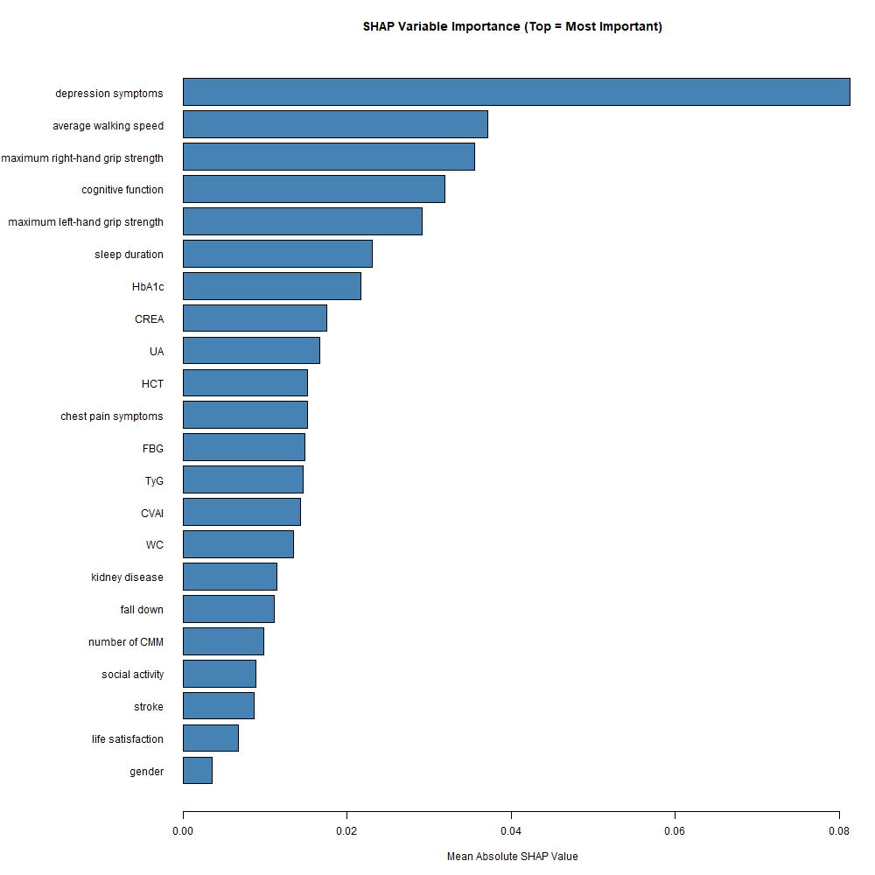

Figure7 SHAP Variable Importance
This picture uses the Mean Absolute SHAP Value as the indicator to visualize the contribution ranking of each feature to the prediction of disability in older adults. The results show that depression symptoms, walking speed, grip strength, and cognitive function were the top four variables with the highest contribution in the model, with significantly higher mean absolute SHAP values than other features, indicating that these variables play a key role in the model's prediction process. In contrast, variables such as gender and life satisfaction showed relatively low contribution. This ranking is generally consistent with clinical knowledge: depression symptoms, physical function indicators, and cognitive status, which are well-established core risk factors for disability in older adults, were also identified as important predictors in this machine learning model, supporting the clinical interpretability of the model.
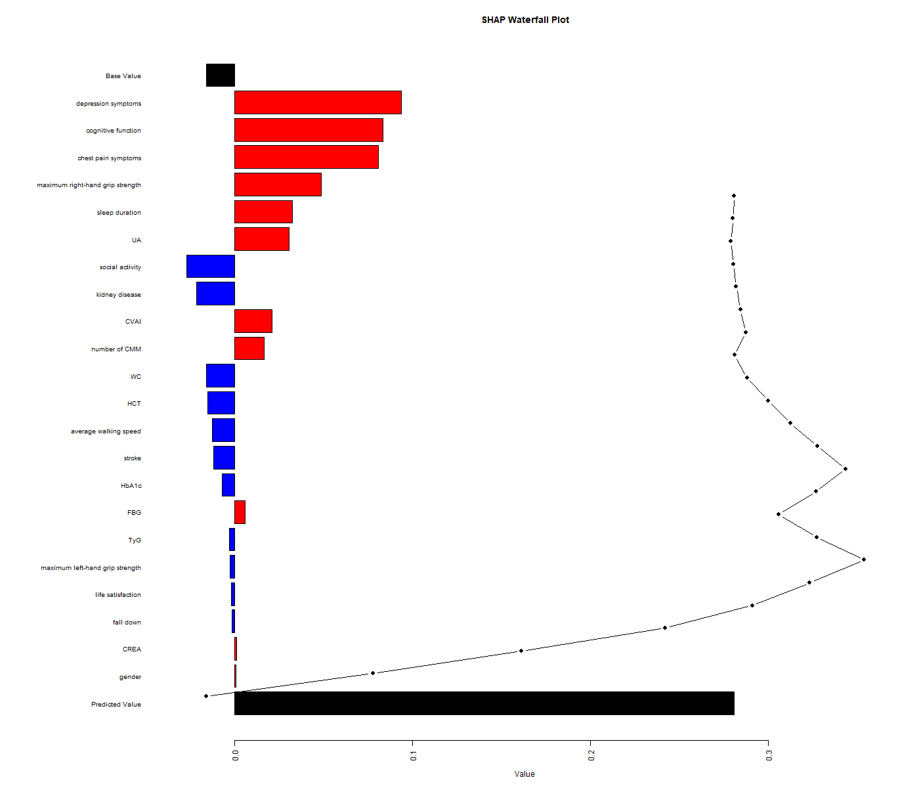

Figure8 SHAP Waterfall Plot for a Single Sample Prediction
This picture illustrates the cumulative contribution of each variable to disability prediction for a single sample: the black bar represents the model’s base prediction value, red bars indicate positive contributions to disability risk, blue bars show negative inhibitory effects, and the line on the right reflects the dynamic change of the predicted value; depression symptoms, cognitive function, chest pain symptoms, maximum right-hand grip strength, and Metabolic indicators(such as UA and CVAI) were the core positive factors driving the increase in the predicted disability value for this sample, while variables like social activity and kidney disease showed protective effects, clearly revealing the individual-level role patterns of key features and the prediction-driven pathway of the model.
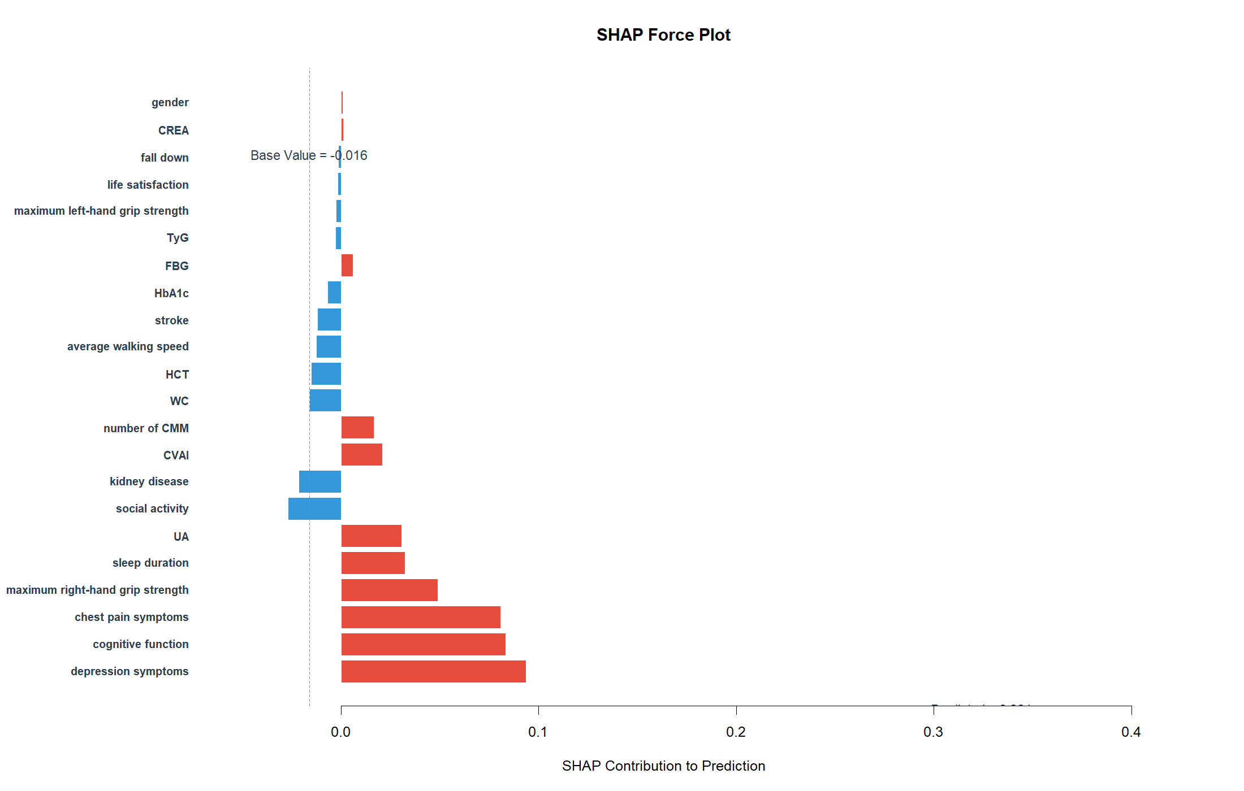

Figure9 SHAP force plot of the random forest model
This picture illustrates the variable-driven pathway for disability prediction in a single sample: the dashed line marks the model’s base value (-0.016), red bars indicate positive contributions to disability risk, and blue bars represent negative inhibitory effects, with bar lengths corresponding to the magnitude of each contribution. Variables including depression symptoms, cognitive function, chest pain symptoms, maximum right-hand grip strength and uric acid (UA) were the core positive factors driving the increase in the predicted disability value for this sample, while factors such as social activity and kidney disease showed protective effects, clearly demonstrating the role patterns of key features at the individual level.

