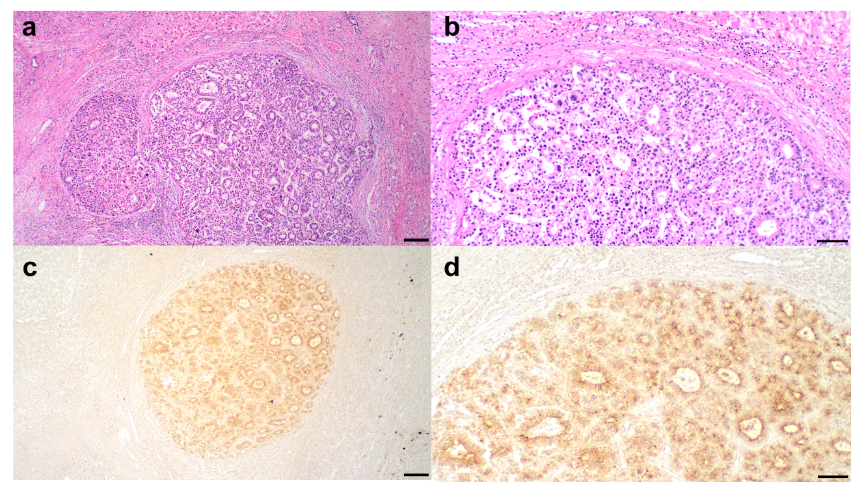

Supplementary Fig. S1 Representative histological and immunohistochemical findings of glypican-3 (GPC3) expression in resected hepatocellular carcinoma (HCC) specimens
The patient was a 66-year-old man with a solitary HCC in segment 5. The tumor was pathologically diagnosed as moderately differentiated HCC. GPC3 expression in the tumor cells was confirmed via immunohistochemical staining. Atezolizumab plus bevacizumab (Atezo/Bev) therapy was initiated 3 years after the surgical resection. The serum full-length GPC3 concentration at the start of treatment was 3.0 pg/mL. The best overall response to Atezo/Bev therapy was a partial response, according to the Response Evaluation Criteria in Solid Tumors version 1.1.
a: Hematoxylin and eosin (H&E) staining showing the overall tumor architecture (×40 magnification). Scale bar: 200 μm.
b: H&E staining demonstrating typical moderately differentiated HCC (×100). Scale bar: 100 μm.
c: Immunohistochemical staining for GPC3 within the same tumor nodule (×40). Scale bar: 200 μm.
d: GPC3 immunohistochemical staining revealing expression predominantly in tumor cells (×100). Scale bar: 100 μm.

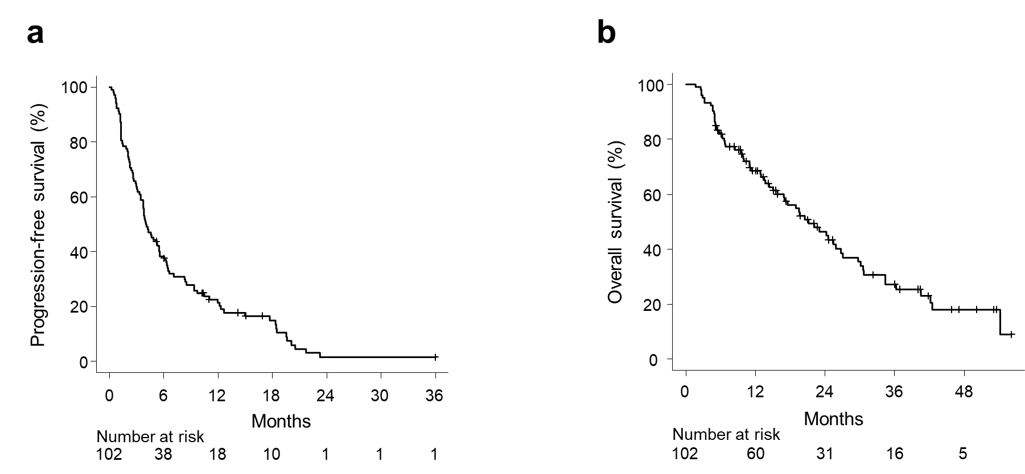
Supplementary Fig. S2 Patient survival
a: Progression-free survival (median: 4.1 months, 95% CI: 3.4–5.5).
b: Overall survival (median: 21.2 months, 95% CI: 15.8–26.7).

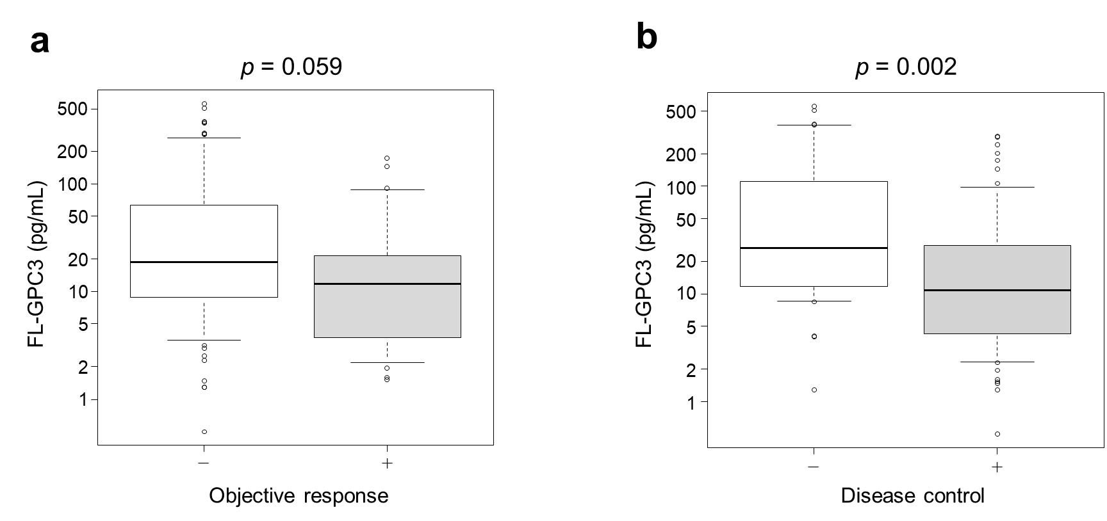

Supplementary Fig. S3 Serum FL-GPC3 concentration stratified according to therapeutic effectiveness
a: Median FL-GPC3 concentration according to objective response: Objective response: no vs. yes = 18.7 vs. 11.8 pg/mL, p = 0.059.
b: Median FL-GPC3 concentration according to disease control: Disease control: no vs. yes = 26.7 vs. 10.8 pg/mL, p = 0.002.
Significance was determined using the Mann–Whitney U-test. A p-value < 0.05 was considered statistically significant. Abbreviations: FL-GPC3, full-length glypican-3.

Supplementary Table S1. Confirmation of FL-GPC3 expression in resected specimens from patients who previously underwent surgical resection.

 | n=10
Interval from liver resection to start of Atezo/Bev therapy, days | 725 (414-809)
Serum FL-GPC3 concentration before the start of Atezo/Bev therapy, pg/mL | 10.2 (3.8-12.1)
GPC3⁺ cells ≥1% | 9 (90.0)

Data are presented as medians (quartiles 1-3) or frequencies (%). FL-GPC3 expression was evaluated using immunohistochemistry. Abbreviations: Atezo/Bev, atezolizumab plus bevacizumab; FL-GPC3, full-length glypican 3; GPC3⁺, glypican 3-positive.

Supplementary Table S2. Tumor response.

Best response | N=102
CR | 1 (1.0)
PR | 26 (25.5)
SD | 40 (39.2)
PD | 35 (34.3)
Objective response | 27 (26.5)
Disease control | 67 (65.7)

The data are presented as frequencies (%). An objective response was defined as a CR or PR, while disease control was defined as a CR, PR, or SD. Abbreviations: CR, complete response; PD, progressive disease; PR, partial response; SD, stable disease.

Supplementary Table S3. Baseline serum concentration of FL-GPC3 and tumor markers according to OR.

Tumor markers | OR⁻ (n=75) | OR⁺ (n=27) | p-value
AFP, ng/mL | 149.7 (9.4-1160.5) | 20.8 (4.6-74.3) | 0.002
AFP-L3, % | 11.7 (3.5-43.3) | 9.6 (0.5-67.5) | 0.737
DCP, mAU/mL | 463.0 (104.5-5583.5) | 99.0 (34.5-1320.5) | 0.010
FL-GPC3, pg/mL | 18.7 (8.9-63.5) | 11.9 (3.8-21.6) | 0.059

Data are shown as medians (quartiles 1-3). Abbreviations: AFP, alpha-fetoprotein; AFP-L3, alpha-fetoprotein bound to Lens culinaris agglutinin; DCP, des-gamma-carboxy prothrombin; FL-GPC3, full-length glypican 3; OR, objective response;.

Supplementary Table S4. Baseline serum concentration of FL-GPC3 and tumor markers according to DC.

Tumor markers | DC⁻ (n=35) | DC⁺ (n=67) | p-value
AFP, ng/mL | 96.0 (8.8-6452.2) | 49.0 (6.5-340.8) | 0.216
AFP-L3, % | 23.9 (5.7-48.2) | 9.6 (0.7-42.3) | 0.172
DCP, mAU/mL | 1173.0 (152.5-7838.5) | 163.0 (44.0-2771.5) | 0.015
FL-GPC3, pg/mL | 26.7 (11.8-110.6) | 10.8 (4.3-28.3) | 0.002

Data are shown as medians (quartiles 1-3). Abbreviations: AFP, alpha-fetoprotein; AFP-L3, alpha-fetoprotein bound to Lens culinaris agglutinin; DC, disease control; DCP, des-gamma-carboxy prothrombin; FL-GPC3, full-length glypican 3.

Supplementary Table S5. Internal validation of the ROC curve-derived cut-off value of serum FL-GPC3 for predicting disease control.

Metric | Value
Observed AUC | 0.688
Optimism-corrected AUC | 0.688
Bootstrap 95% CI | 0.582-0.793
Bootstrap resampling iterations | 1,000

The ROC-derived cutoff was internally validated using bootstrap resampling with 1,000 iterations. The 95% CI of the AUC was estimated from the bootstrap distribution. Abbreviations: AUC, area under the receiver operating characteristic curve; CI, confidence interval; FL-GPC3, full-length glypican 3; ROC, receiver operating characteristic

Supplementary Table S6. Comparison of baseline characteristics between FL-GPC3-low and FL-GPC3-high patients.

Characteristics | Particulars/Units | FL-GPC3-high (n=42) | FL-GPC3-low (n=60) | p-value
Age | Years | 74 (67-80) | 71 (66-79) | 0.469
Sex | Male | 35 (83.3) | 48 (80.0) | 0.798
Etiology | HBV/HCV/AL/Others | 3 (7.1)/18 (42.9)/10 (23.8)/11 (26.2) | 15 (25.0)/16 (26.7)/14 (23.3)/15 (25.0) | 0.086
ECOG PS | 0-1 | 39 (92.9) | 57 (95.0) | 0.323
Child–Pugh grade | A/B | 38 (90.5)/4 (9.5) | 57 (95.0)/3 (5.0) | 0.442
ALBI score |  | -2.35 (-2.71 to -2.15) | -2.64 (-2.87 to -2.31) | 0.015
mALBI grade | 1/2a/2b/3 | 12 (28.6)/15 (35.7)/13 (31.0)/2 (4.8) | 33 (55.0)/15 (25.0)/12 (20.0)/0 (0.0) | 0.023
NLR |  | 3.2 (2.0-5.7) | 3.1 (2.4-4.2) | 0.422
Bilirubin | mg/dL | 1.1 (0.6-1.4) | 0.8 (0.6-1.0) | 0.031
Albumin | g/dL | 3.7 (3.5-4.2) | 4.0 (3.7-4.2) | 0.050
PT | % | 84 (78-93) | 88 (81-94) | 0.157
AST | IU/L | 46 (34-58) | 36 (25-47) | 0.013
ALT | IU/L | 30 (18-42) | 24 (18-34) | 0.122
AFP | ng/mL | 227.2 (9.6- 888.0) | 35.3 (5.6-290.0) | 0.059
AFP-L3 | % | 13.2 (5.2-41.0) | 11.4 (0.5-50.0) | 0.503
DCP | mAU/mL | 709.5 (173.0-8438.3) | 125.0 (54.3-2697.8) | 0.018
FL-GPC3 | pg/mL | 77.7 (32.6-195.5) | 8.8 (3.8-12.5) | <0.001
MTD | mm | 35 (20-74) | 33 (20-50) | 0.388
Number of tumors | At least four | 22 (52.4) | 39 (65.0) | 0.104
BCLC stage | A/B/C | 3/17/22 | 5/24/31 | >0.999
Up-to-seven criteria | Out | 29 (69.0) | 40 (66.7) | 0.833
Previous therapy | RFA/PEI | 13 (31.0) | 19 (31.7) | >0.999
 | Resection | 7 (16.7) | 26 (43.3) | 0.005
 | Radiation | 1 (2.4) | 8 (13.3) | 0.078
 | TACE/HAIC | 32 (76.2) | 44 (73.3) | 0.820
 | Chemotherapy | 10 (23.8) | 11 (18.3) | 0.620
 | None | 10 (23.8) | 11 (18.3) | 0.620
Data are shown as medians (quartiles 1-3) or frequencies (%). Abbreviations: AFP, alpha-fetoprotein; AFP-L3, AFP bound to Lens culinaris agglutinin; AL, alcohol; ALBI, albumin–bilirubin; ALT, alanine aminotransferase; AST, aspartate aminotransferase; BCLC, Barcelona Clinic Liver Cancer; DCP, des-gamma-carboxy prothrombin; ECOG PS, Eastern Cooperative Oncology Group performance status; FL-GPC3, full-length glypican 3; HAIC, hepatic arterial infusion chemotherapy; HBV, hepatitis B virus; HCV, hepatitis C virus; mALBI, modified albumin–bilirubin; MTD, maximum tumor diameter; NLR, neutrophil–lymphocyte ratio; PEI, percutaneous ethanol injection; PT, prothrombin time; RFA, radiofrequency ablation; TACE, transarterial chemoembolization.

