Supplemental Information

Supplementary Methods
Outcome Measures and Variables
Per Barch et al. (2021)¹, the Kiddie Schedule for Affective Disorders and Schizophrenia Computerized Version (KSADS-COMP) version 1.0 utilized at the baseline and 2-year follow-up assessment timepoints resulted in greater than expected rates of past manic episodes. Thus, we re-scored BD-I and BD-II most recent past episode manic diagnoses from those timepoints, such that youth needed to meet criteria for a past manic episode and any current or past depressive disorder. Moreover, to align with algorithmic changes in the KSADS-COMP version 2.0, BD-NOS diagnoses at the baseline and 2-year follow-up assessment timepoints were re-scored to require the presence of a lifetime endorsement of major depressive disorder.
Clustering Procedure
Pertaining to the weighting of mixed-type variables utilized in k-prototypes clustering, Huang (1998)² recommends that the λ parameter be manipulated and/or iteratively tuned to prevent the dominance of one data type and/or adjust the relative importance of theoretically relevant variables. In the current study, we adopted the default λ estimated by the lambdaest function from the clustMixType package³ (i.e., the ratio of the average variance of numeric variables to the average concentration of categorical variables). This decision followed analyses indicating that grid-searched scalar constants every tenth-decimal place between 0.1-100 and vectorized λ values for each individual variable derived from lambdaest produced insignificant improvements in clustering performance over the default method, and that we did not have clear theoretical rationale for prioritizing specific risk variables over others.
Missing Data and Imputation Sensitivity Analysis
To examine whether the primary complete-case clustering solution was sensitive to baseline missing-data handling, we first summarized variable-level missingness across the 17 risk features for clustering and evaluated whether missingness in the numeric features was consistent with missing completely at random (MCAR). This was assessed using Little’s MCAR test from the naniar package⁴. Participants were then screened for imputability using a prespecified threshold requiring at least 50% of the 17 baseline clustering variables to be observed. This threshold was set given prior work which has shown that imputation methods perform well up to 50% missingness, but caution is warranted above 50-70%, wherein imputed data reliability decreases^{5,6}.
Among imputable participant data, missing values were imputed using missForest^{7,8} a nonparametric random-forest-based imputation procedure appropriate for mixed-type data. After imputation, numeric variables were z-scored to preserve the scaling convention used in the primary clustering pipeline. We then refit k-prototypes solutions across k=2:8 using the same lambda-estimation and bootstrap-stability framework as the primary analysis. For each candidate k, we summarized silhouette values, bootstrap Jaccard stability, and agreement with the original complete-case k=2 anchor partition using adjusted Rand index (ARI) via the mclust package ⁹. Because the goal of this analysis was to assess the robustness of the original profile, rather than replace the primary solution, the complete-case clustering pipeline remained the primary clustering solution utilized in downstream analyses.
Feature Importance and Parsimonious Feature-Set Sensitivity Analysis
To characterize which baseline risk variables most strongly drove the selected 2-cluster k-prototypes solution, we quantified feature importance using 3 complementary approaches. First, we computed permutation-based misclassification rates (MCRs) using the FeatureImpCluster¹⁰ package as the primary importance metric, estimating the change in cluster assignment after separately permuting each individual feature while holding the selected k and anchor solution structure fixed. MCR summary statistics were aggregated across 1,000 differently seeded runs for each feature.
Second, we summarized centroid geometry for each feature using standardized between-cluster separation metrics, including absolute centroid differences (|Δz|) and the largest pairwise Cohen’s d. Third, we fit a regularized eXtreme Gradient Boosting (XGBoost) surrogate using the xgboost package^{11,12} to predict the anchor k-prototypes cluster labels from the same baseline feature set. Continuous predictors were entered as the z-scored variables used in the primary clustering pipeline, and binary categorical predictors were encoded as 0/1 indicators for XGBoost. Surrogate fidelity was summarized using stratified 5-fold out-of-fold balanced accuracy and macro-F1, with inverse-frequency class weighting. We then refit the surrogate on the full dataset and computed SHapley Additive exPlanation (SHAP) global importance values via the shapviz package^{13,14} to provide descriptive corroboration of which variables most strongly discriminated the 2 clusters. These 3 approaches were used jointly to characterize the cluster-defining geometry.
We next evaluated whether the full 17-feature anchor partition could be reproduced using a smaller subset of variables. Features were first ordered using a consensus priority procedure in which permutation MCR ranking served as the primary ordering, with priority promotion when centroid separation and SHAP both favored a lower-ranked adjacent feature¹⁵. Using this ranked list, we conducted a greedy forward wrapper search, sequentially adding features one at a time and refitting k-prototypes at each subset size while preserving the anchor k=2 target.
Agreement between each candidate subset solution and the full 17-feature anchor partition was quantified using ARI via the mclust package⁹, and the bootstrap stability of each candidate subset was quantified using mean and minimum cluster wise Jaccard similarity. The minimally viable feature subset (MVFS) was defined a priori as the smallest feature set meeting both ARI ≥0.80 and mean & minimum cluster wise Jaccard ≥0.80, as these cut-offs offer a pragmatic balance of strong agreement and parsimony in this context^{16,17}. As sensitivity analyses, we repeated the search using backward elimination and examined lambda-handling sensitivity where available. Finally, to confirm that the selected MVFS preserved the broader profile of the original clustering solution rather than only its k=2 labels, we recalculated candidate cluster solutions across k=2:8 within the selected subset and summarized silhouette and stability metrics using the clustMixType³ package.
Algorithm Benchmark Sensitivity Analysis
To examine whether the primary clustering solution was specific to the k-prototypes algorithm itself, we benchmarked the selected k-prototypes pipeline against 2 alternative mixed-data clustering approaches: KAMILA¹⁸ and clustMD¹⁹. All algorithms were fit on the same complete-case baseline clustering dataset used in the primary analysis after applying identical variable coercion and z-scoring procedures. Candidate solutions were estimated across k=2:8.
Because algorithm-specific objective functions are not directly comparable across k-prototypes, KAMILA, and clustMD, primary cross-algorithm evaluation was based on a shared internal-validation metric. More specifically, mean silhouette values were calculated on Gower distance using the cluster package²⁰. Within each algorithm, the recommended k was defined as the solution maximizing mean Gower silhouette. As descriptive comparability metrics, we also summarized minimum and maximum cluster size and agreement of each candidate solution with the original k-prototypes k=2 anchor partition using ARI after Hungarian label alignment¹⁵.
For completeness, we also retained algorithm-specific objective information when available, including k-prototypes objective values and clustMD Bayesian information criterion (BIC). In addition, KAMILA’s algorithm-native cluster-number routine based on prediction strength was run descriptively, but was not treated as the primary cross-algorithm selection criterion because it is specific to KAMILA and not directly comparable with k-prototypes or clustMD solutions.
Statistical Analyses
Onset of Bipolar Disorders by Risk Cluster
Regarding additional covariates considered beyond those specified in the primary onset models, a within-person age component was evaluated but not retained, because it was highly collinear with assessment timepoint in this sparse repeated-measures setting and did not alter inferences in sensitivity analyses. Additionally, participant- and family-level random-intercept models were evaluated to account for non-independence of observations within participants over time and accommodate unobserved variability between participants. However, because the implied intraclass correlation coefficient (ICC) was low (ICC = 0.03), conditional models were unstable (i.e., did not converge) across optimizers, and fixed-effect inferences were materially unchanged relative to marginal models, the primary analyses were estimated via pooled logistic regression with participant-clustered CR2 robust standard errors²¹.
Occurrence of Bipolar Disorders Over Time by Risk Cluster
In the current study, we elected to utilize the exchangeable correlation structure in generalized estimating equation (GEE) models. The exchangeable correlation structure assumes equal correlation between any two timepoints within the same participant. While autoregressive working correlation structures may in theory better account for the longitudinal, annual assessment design of the adolescent brain and cognitive development (ABCD) study (i.e., wherein measurements closer in time may be more strongly correlated than those further apart, timepoints are equally spaced, etc.), time between assessment visits is in actuality not equally distributed, and sensitivity analyses of autoregressive working correlation structures across all GEE models yielded similar effect estimates to the exchangeable correlation models. Therefore, results from the exchangeable working correlation structure are reported.
Common Comorbidity Sensitivity Analysis
To evaluate whether cluster differences were specific to BSDs versus broader psychopathology, we derived lifetime diagnostic indicators at each analytic wave from KSADS-COMP data for disorders commonly comorbid with BD reported by parents or youth. These included ADHD, anxiety disorders (i.e., GAD, social anxiety disorder, separation anxiety disorder, panic disorder, and OCD), depressive disorders (i.e., DMDD, MDD, and PDD), PTSD, and ODD/conduct disorder. We first generated a 4-level session-specific diagnostic grouping variable: no diagnosis in the set of interest, BSD only, BSD plus any other diagnosis, and other diagnosis only. Because the BSD-only group remained too sparse for model convergence across follow-up waves, final inferential models used a collapsed 3-level grouping variable of no diagnosis, BSD plus any other diagnosis, and other diagnosis only.
Moreover, due to the sparsity of the BSD-only group across follow-up waves, inferential analyses focused on contrast-specific binary logistic GEE models derived from the collapsed grouping, including common comorbidity(s) only vs no diagnoses; any BSD + concurrent comorbidity(s) vs no diagnoses; and any BSD + concurrent comorbidity vs other diagnosis (i.e., common comorbidity) only. Each model paralleled the primary occurrence analyses and estimated higher-risk vs lower-risk cluster differences over time, using robust standard errors and the same covariate structure as the primary models.
Utility of Alternative Baseline Risk Representations Sensitivity Analysis
This sensitivity analysis evaluated how much downstream BSD-related information was retained when the multidomain baseline risk structure was represented as 1) the full 17-variable baseline risk-variable set, 2) the 7-variable MVFS, or 3) the empirically derived 2-cluster label in 3 different modeling procedures. To ensure fair comparison across these competing baseline representations, both the first-onset and occurrence datasets were restricted to the exact subset of rows complete across the full 17-variable predictor set. Accordingly, differences in downstream model performance reflect the baseline risk representation itself, rather than differences in analytic sample composition.
For BD first-onsets, we fit pooled logistic discrete-time hazard models separately for BD-I, BD-II, BD-NOS, and any BSD using 3 competing baseline-risk parameterizations: 1) cluster membership, 2) the 7 MVFS variables, and 3) the full 17 baseline risk variables. The cluster-label model paralleled the primary onset specification and included cluster, sex-assigned-at-birth, interval indicator, and between-person age. The MVFS and full-risk models retained the same covariate structure, but replaced the cluster membership variable with either the 7 selected baseline variables or the full 17-variable set, respectively. As in the primary onset analyses, repeated person-period observations within participants were accounted for using participant-clustered robust standard errors. CR2 was used for the cluster-label models, whereas HC1 was used for the MVFS and full-risk models when CR2 was not estimable in those higher-parameter specifications. Model comparison was conducted via McFadden pseudo-R² as the primary descriptive fit index and Brier score as a secondary probability-calibration summary. Because the MVFS and full-risk models contain multi-parameter predictor blocks, joint Wald-type block tests based on participant-clustered HC1 robust standard errors were used to evaluate whether those baseline predictor sets retained significant downstream onset information beyond model covariates.
For BD occurrence, we fit GEE models separately for BD-I, BD-II, BD-NOS, and any BSD using the same 3 competing baseline-risk representations. All prevalence models retained the same covariate structure used in the primary occurrence analyses, including wave, sex-assigned-at-birth, baseline BD diagnostic status, and grand-mean centered age. The cluster-label model included cluster as the baseline risk representation, whereas the MVFS and full-risk models substituted the corresponding predictor blocks. Model comparison here was conducted using row-level in-sample area under the curve (AUC) as a descriptive apparent-discrimination summary, and log loss as the primary loss metric, with Brier score retained as an additional calibration index. Because these AUCs were calculated on person-wave rows within the analytic sample, they should be regarded as descriptive within-sample summaries, rather than internally validated, subject-level predictive performance estimates. Joint block tests were again used to assess whether the MVFS and full 17-variable sets retained significant downstream occurrence information beyond model covariates.

Supplementary Results
Missing Data and Imputation Sensitivity Analysis
Missingness across the 17 baseline clustering variables was modest overall, with the greatest proportions observed for ACE exposure (11.63%), Child Opportunity Index (9.22%), family history of mania (4.44%), and family history of depression (4.37%) (Table S3). All remaining clustering variables had missingness below 2%. Little’s MCAR test was significant (χ²=1308.98, df=767, p<.001), indicating that numeric missingness was not consistent with MCAR. Additionally, under the specified imputability threshold requiring at least 50% observed baseline clustering data, 11,865 of 11,868 baseline participants (99.97%) were eligible for missForest imputation.
Refit k-prototypes solutions in the missForest-imputed data again favored k=2 (Figure S1). Specifically, the k=2 solution yielded the highest mean silhouette value (mean silhouette=0.509; Table S4), substantially exceeding k=3 (mean silhouette=0.227; Table S4) and all higher-k solutions (mean silhouette range=0.114-0.173; Table S4). At k=2, the missForest-imputed solution also showed high stability (mean Jaccard=0.938; Table S4) and strong agreement with the original complete-case k=2 anchor partition (ARI=0.871; Table S4). Together, these findings indicate that the primary 2-cluster profile was largely preserved under missForest-based baseline imputation.
Feature Importance and Parsimonious Feature-Set Sensitivity Analysis
Across permutation-based MCR, centroid-separation metrics, and SHAP global importance, as part of which the XGBoost surrogate closely approximated the anchor partition with stratified 5-fold out-of-fold balanced accuracy of 0.980 and macro-F1 of 0.973, the most consistently influential variables were parent-reported CBCL DSM-oriented depression, aggression, attention, and anxiety T-scores, lifetime GBI mania symptoms, sleep disturbance scale scores, and endorsement of family history of depression (Table S5; Figure S2). This suggests that the core geometry of the 2-cluster solution was anchored primarily by symptom-burden and sleep-related features, with smaller albeit non-negligible contributions from adversity, impulsivity, neighborhood context, and neurocognitive measures.
In forward wrapper selection, the 7-feature subset consisting of parent-reported CBCL DSM-oriented depression, DSM-oriented anxiety, aggression, and attention T-scores; lifetime GBI mania symptoms; sleep disturbance sum scores; and family history of depression yielded the first subset meeting both reproduction and stability criteria, and thereby defined a 7-feature MVFS. This subset reproduced the anchor partition with ARI=0.814 and high bootstrap stability (mean Jaccard=0.984; minimum clusterwise Jaccard=0.972; Figure S3). Together, these results indicate that much of the full 17-feature clustering structure could be recovered using a substantially smaller set of 7 clinically interpretable variables.
Recalculation of candidate cluster solutions within the selected 7-feature MVFS again favored k=2. Specifically, the k=2 solution yielded the highest silhouette value (mean silhouette = 0.738), exceeding k=3 (mean silhouette = 0.562) and all higher-k solutions (mean silhouette range=0.352-0.423). Stability metrics within the 7-feature set were also strongest at k=2 (mean Jaccard=0.988), supporting preservation of the original low-dimensional 2-cluster profile under considerable feature reduction.
Algorithm Benchmark Sensitivity Analysis
Across the shared benchmark framework, all 3 mixed-data clustering algorithms favored k=2. Specifically, the highest Gower silhouette values for each algorithm were observed at k=2: clustMD (mean silhouette=0.339), k-prototypes (mean silhouette=0.322), and KAMILA (mean silhouette=0.303) (Table S6; Figure S4). In each case, mean silhouette values declined at higher-k solutions, supporting a low-dimensional 2-cluster structure across algorithmic families.
Agreement with the original k-prototypes k=2 anchor partition was also strongest at k=2 for the alternative algorithms. At k=2, KAMILA showed high agreement with the anchor partition (ARI=0.878), and clustMD also showed substantial agreement (ARI=0.775). Cluster size distributions at k=2 were also broadly comparable across algorithms, with minimum cluster sizes ranging from 1,011 to 1,486 and maximum cluster sizes ranging from 7,707 to 8,182 (Table S6).
In contrast to other results, KAMILA’s algorithm-native prediction-strength routine did not provide a similarly clear low-k confirmation. Specifically, the routine returned best number of clusters=8, with prediction strength=0.461 and average prediction strength=0.426, well below the prespecified threshold of 0.80. Thus, while the common cross-algorithm comparison framework supported k=2 across all 3 algorithms, KAMILA’s native prediction-strength output did not independently reproduce that same low-k recommendation.
Taken together, these findings indicate that the primary 2-cluster profile was not obviously an artifact of the k-prototypes algorithm; while also displaying that not all algorithm-native criteria converge identically across methods.
Common Comorbidity Sensitivity Analysis
Because BSD without a concurrent comorbid diagnosis was comparatively sparse across follow-up waves, final inferential models focused on a collapsed 3-level diagnostic grouping consisting of no diagnosis in the set of interest, BSD plus any other diagnosis, and other diagnosis only. Across follow-up waves, the higher-risk cluster showed significantly greater odds of both other diagnosis only and BSD plus any concurrent other diagnosis relative to the no-diagnosis reference group.
More specifically, relative to the lower-risk cluster, the higher-risk cluster showed greater odds of other diagnosis only at year-2 (OR=3.88, 95% CI [3.37, 4.48], p<.001; Figure S5), year-4 (OR=2.09, 95% CI [1.80, 2.42], p<.001), and year-6 (OR=1.93, 95% CI [1.59, 2.34], p<.001). The corresponding odds of BSD plus any concurrent other diagnosis were larger at each wave: year-2 (OR=15.84, 95% CI [10.64, 23.59], p<.001), year-4 (OR=4.79, 95% CI [3.40, 6.73], p<.001), and year-6 (OR=4.65, 95% CI [3.02, 7.15], p<.001).
Subsequent direct pairwise comparisons indicated that higher-risk cluster membership more strongly differentiated BSD plus any concurrent other diagnosis than other diagnosis only (i.e., without concurrent BSD) at year-2 (OR=2.58, 95% CI [1.75, 3.79], p<.001; Figure S5), but not at year-4 (OR=1.33, 95% CI [0.94, 1.89], p=0.108) or year-6 (OR=1.41, 95% CI [0.92, 2.16], p=0.112). Considered jointly, these findings suggest that the higher-risk cluster indexes broader diagnostic enrichment over follow-ups, with particularly strong early enrichment at year-2 for BSD occurring alongside concurrent comorbidity(s).
Utility of Alternative Baseline Risk Representations Sensitivity Analysis
Across both first-onset and occurrence analyses, all competing baseline representations were compared on identical analytic rows complete for the full 17-variable predictor block (n=9,193), permitting direct comparison of relative information retention and parsimony.
For first-onset BSD modeling, the full 17-variable baseline representation retained the greatest downstream information. More specifically, across all 4 discrete-time hazard models, the full 17-variable model had the highest McFadden pseudo-R², ranging from 0.054 to 0.074, compared with 0.042 to 0.063 for the MVFS models and 0.039 to 0.049 for the cluster-label models (Table S7). On average, the MVFS retained 47.3% of the incremental pseudo-R² gain achieved by the full 17-variable model over the cluster-label model. Joint block tests also indicated that both the MVFS and full 17-variable predictor sets retained significant downstream onset information across all 4 BSDs, although evidence was comparatively more modest for BD-II than for other BSDs (Table S7). These findings suggest that the cluster label retained meaningful low-dimensional onset information, but that some onset-relevant signal was lost when the full multidomain baseline risk structure was reduced to either the MVFS or the 2-cluster representation.
Unsurprisingly, pertaining to BSD occurrence modeling, fuller baseline representations again retained more downstream BSD-related information than the cluster label alone. The full 17-variable representation showed the strongest apparent discrimination for all 4 prevalence models, whereas the MVFS ranked second, and the cluster-label representation third (Table S7). Moreover, for any BSD occurrence, row-level in-sample AUC values were 0.714 for the cluster-label model, 0.732 for the MVFS model, and 0.750 for the full 17-variable model. Corresponding values for BD-NOS were 0.712, 0.740, and 0.757; for BD-I, 0.696, 0.726, and 0.743; and for BD-II, 0.726, 0.725, and 0.757, respectively. Thus, while the rank ordering was generally full 17-variable representation first, MVFS second, and cluster-label representation third, the absolute differences between representations were modest. Additionally, both the MVFS and full 17-variable predictor blocks were jointly significant for all 4 prevalence models (Table S7). Log-loss values also consistently favored the fuller baseline representations, although the absolute differences were similarly low in magnitude.
Notably, the cluster-label effect sizes in the primary BSD onset (Table S8) and prevalence (Table S9) models were substantially larger than the corresponding per-SD or binary-contrast effects for any single baseline predictor in either sensitivity model (Figure S6), supporting the interpretation that the 2-cluster solution captured a concentrated and clinically meaningful summary of a broader multidomain risk profile.
These findings should be interpreted as a comparison of relative information retention and parsimony, rather than as evidence of predictive utility. In other words, although the full 17-variable baseline representation retained the strongest downstream BSD-related information, the cluster label preserved a meaningful portion of that signal under substantial dimension reduction, while the MVFS occupied an intermediate position between the 2-cluster grouping and the full multidomain baseline feature set.

Supplementary Figures
Figure S1. MissForest-imputed clustering mean silhouette, mean Jaccard, and adjusted Rand index vs anchor solution metrics across candidate k solutions.
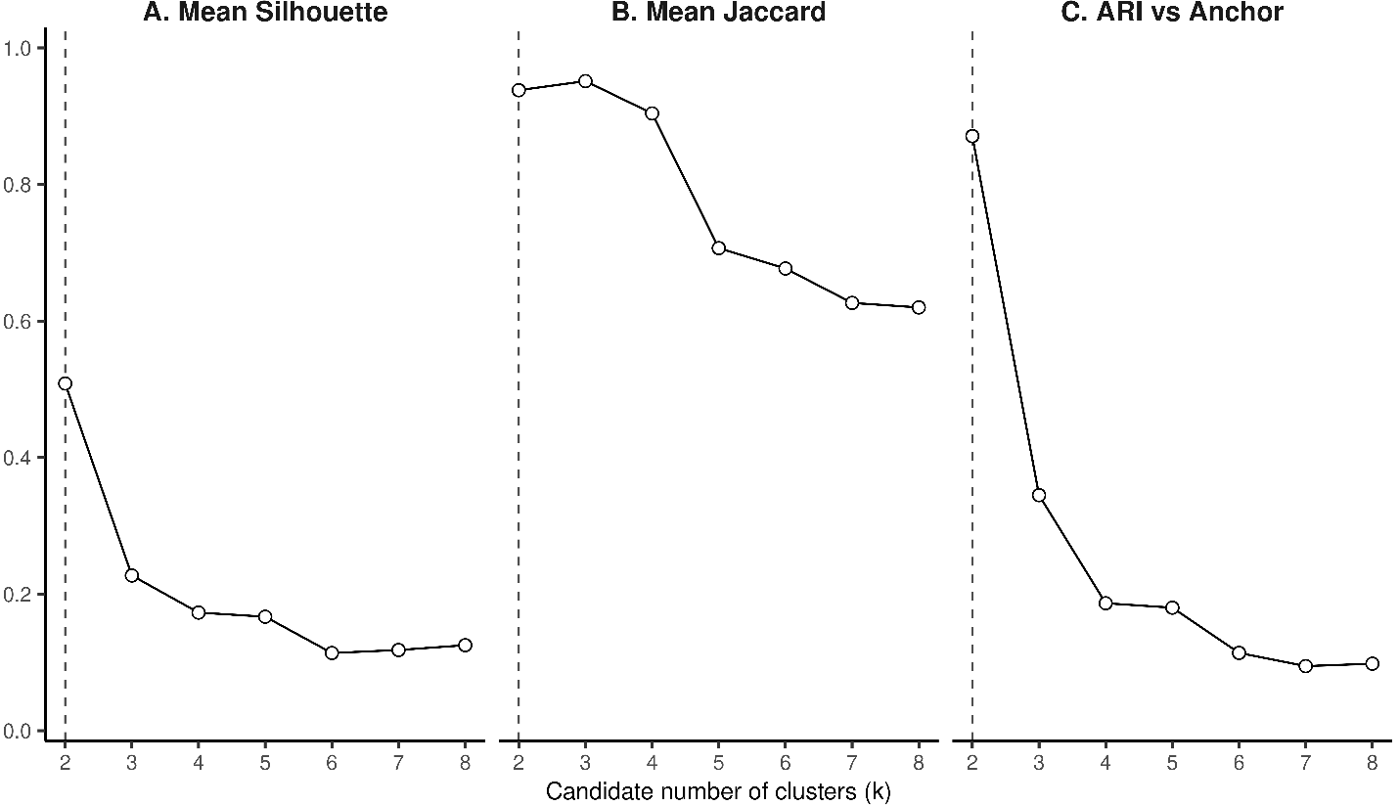
Note: Three internal validity metrics plotted across candidate cluster solutions (k = 2:8) derived from risk data imputed via MissForest. Panel A shows mean silhouette width computed using the Huang dissimilarity measure for mixed-type data. Panel B shows mean Jaccard similarity coefficient across bootstrap replicates. Panel C shows Adjusted Rand Index (ARI) quantifying agreement between each candidate k solution and the anchor two-cluster solution derived from complete-case data. The dashed vertical line denotes the anchor solution (k = 2). All metrics are bounded [0, 1]; higher values indicate greater cluster cohesion (A, B) or greater agreement with the anchor partition (C). Abbreviations: ARI = adjusted Rand index.

Figure S2. MCR, centroid z-score delta, and XGBoost derived SHAP value feature importance distributions for risk variable contributions to the final k=2 clustering solution.
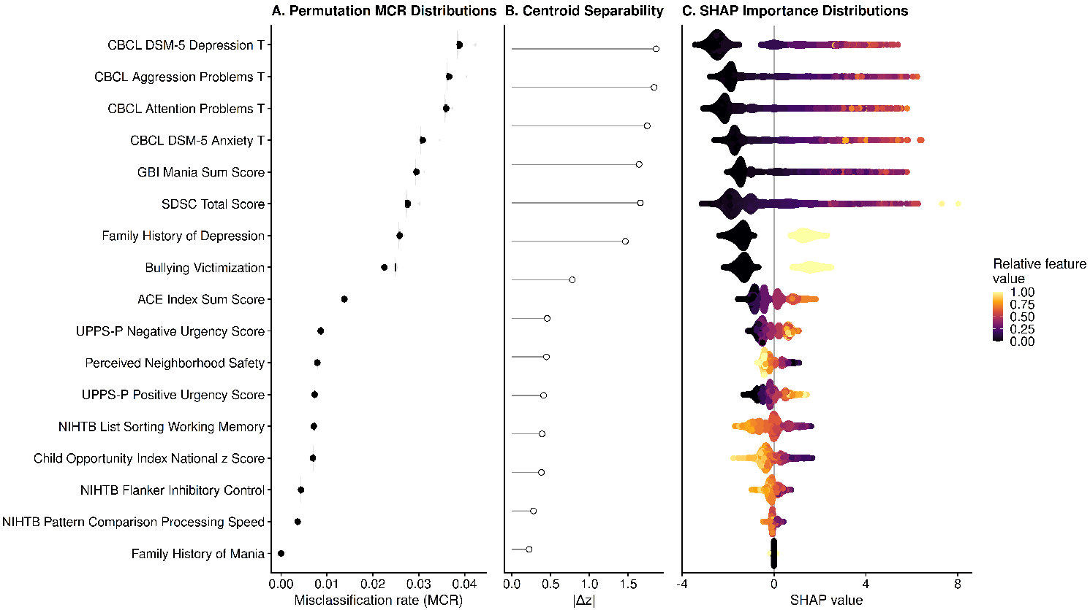
Note: Risk variables are vertically organized according to their relative ranked importance to clustering derived from the consensus priority procedure. Panel A shows distributions of permutation-based MCR across 1,000 differently seeded runs. Panel B shows absolute standardized (i.e., z-scored) centroid separation (|Δz|) between clusters used as the secondary ranking metric. Panel C shows SHAP beeswarm values from the XGBoost surrogate model used for descriptive triangulation; each point represents one participant-feature contribution, horizontal position reflects the direction and magnitude of that feature’s contribution to the surrogate classification (wherein positive directionality contributed to higher-risk cluster classification, and negative directionality to lower-risk cluster classification), and color reflects whether the participant’s observed value for that feature is relatively lower or higher within that feature. For binary features, the gradient corresponds to binary category values (i.e., 0 = No vs 1 = Yes). Abbreviations: ACE=adverse childhood experience; COI=child opportunity index; CBCL=child behavior checklist; GBI=general behavior inventory; MCR = misclassification rate; NIHTB=NIH toolbox; SDSC=sleep disturbance scale for children; SHAP = SHapley Additive exPlanations; UPPS-P=urgency, premeditation, perseverance, sensation seeking, and positive urgency impulsive behavior scale for children; XGBoost = eXtreme Gradient Boosting.

Figure S3. MVFS anchor partition ARI and minimum clusterwise Jaccard similarity across variable subset size.
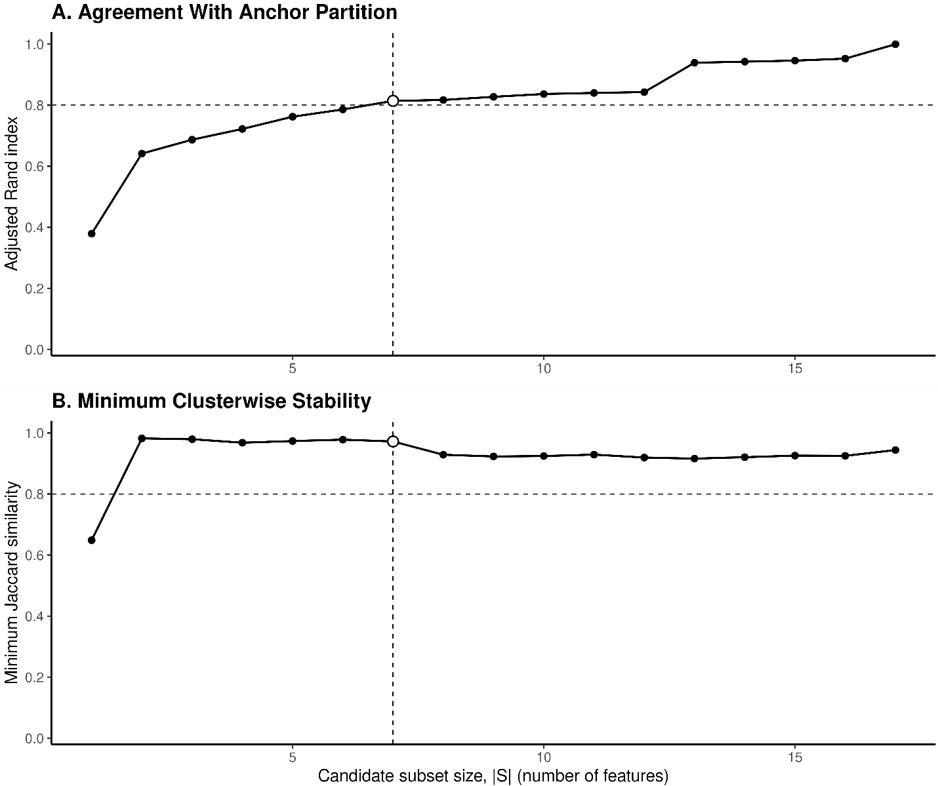
Note: Agreement with the anchor partition and minimum clusterwise stability plotted across candidate MVFS sizes for the selected primary search. Panel A shows ARI between the cluster partition recovered from each candidate feature subset and the anchor complete-feature partition. Panel B shows minimum Jaccard similarity coefficient across clusters, reflecting the worst-case bootstrap stability for a given subset. In both panels, the dashed horizontal line denotes the prespecified adequacy threshold (i.e., ARI ≥ 0.80; minimum Jaccard ≥ 0.80); the dashed vertical line denotes the selected MVFS cardinality (|S| = n), defined as the smallest subset simultaneously satisfying both thresholds. The open circle highlights the selected solution. All metrics are bounded [0, 1]. Abbreviations: ARI = adjusted Rand index; MVFS = minimally viable feature subset.

Figure S4. Cross-algorithm benchmark sensitivity metrics across candidate k solutions
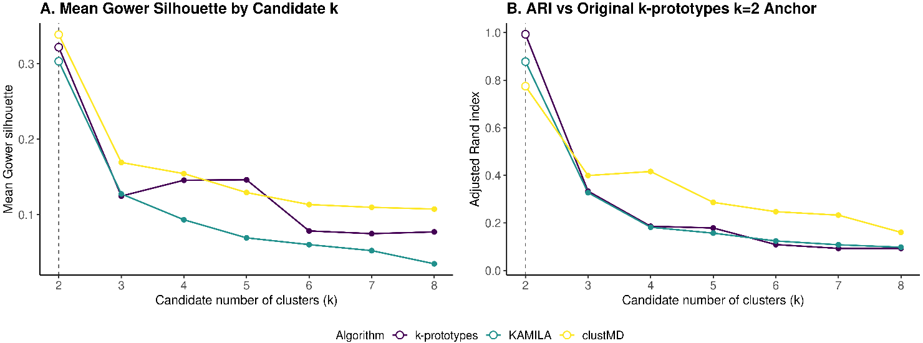
Note: Points indicate candidate clustering solutions across algorithms and k values; the dashed vertical line marks k=2. Panel A shows Gower distance derived mean silhouette scores for each k value across clustering algorithms. Panel B shows ARI values between candidate k clustering solutions and the “anchor” partition (i.e., the original k=2 k-prototypes model assignments). Higher mean Gower silhouette and ARI values indicate better within-solution cohesion/separation and greater agreement with the original k-prototypes k=2 anchor partition, respectively. Abbreviations: ARI = adjusted Rand index; clustMD = model-based clustering for mixed data; KAMILA = k-means for mixed large data.

Figure S5. Commonly comorbid with bipolar disorder diagnosis odds for the higher-risk relative to lower-risk cluster over time.
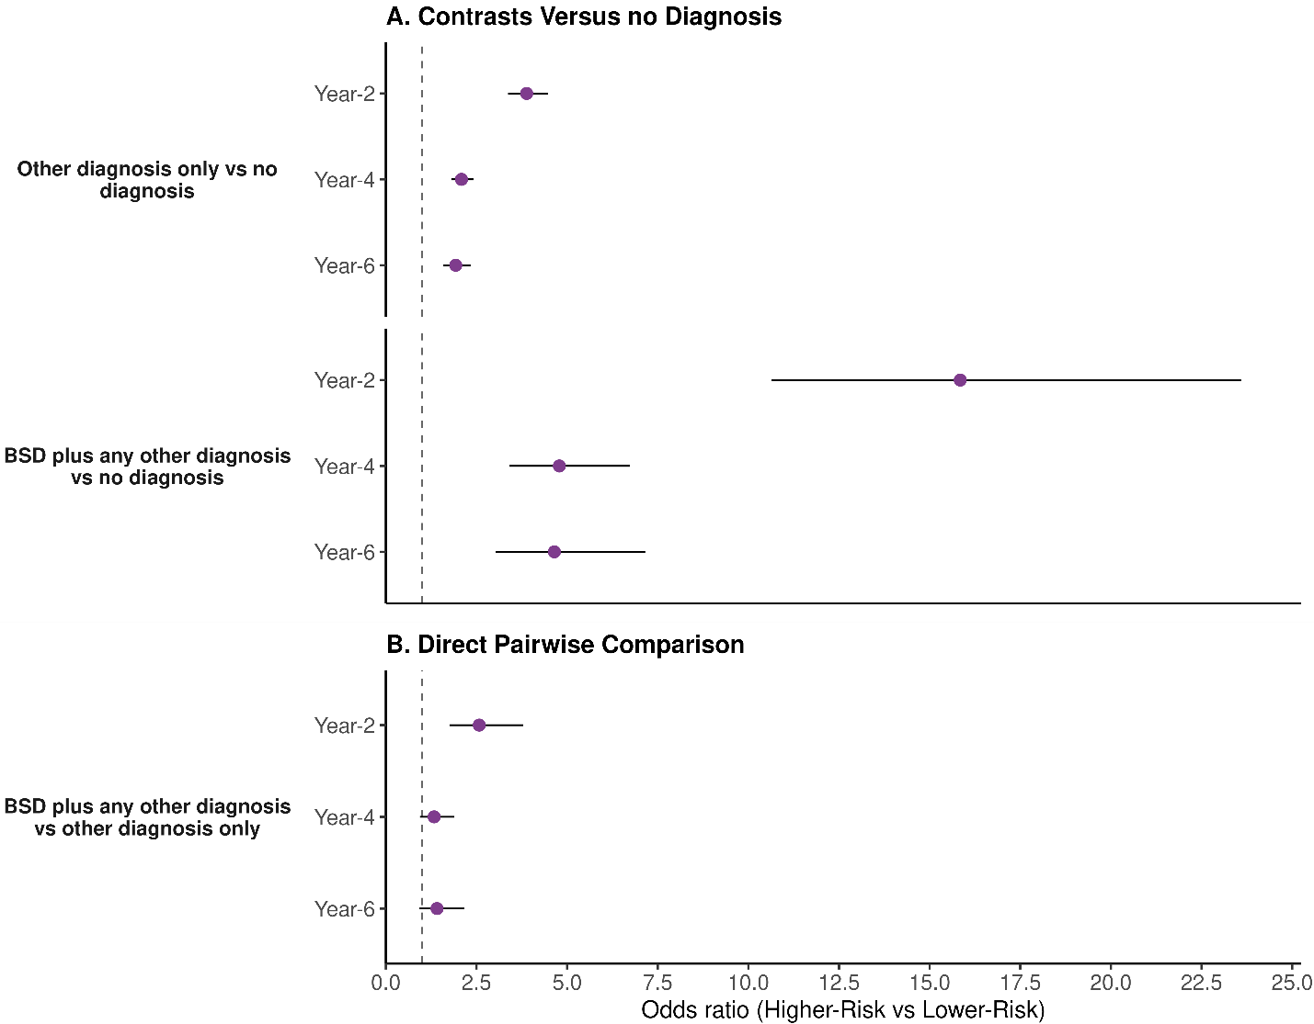
Note: Forest-style panels display per-timepoint odds ratios comparing the Higher-Risk vs Lower-Risk clusters across the common comorbidity diagnostic-group contrasts at year-2, year-4, and year-6 follow-ups. Panel A shows Higher-Risk versus Lower-Risk cluster ORs for other diagnosis only versus no diagnosis, and for any BSD plus any other diagnosis versus no BSD or comorbidity; Panel B shows the corresponding Higher-Risk versus Lower-Risk cluster odds ratios for BSD plus any other diagnosis versus other diagnosis only. Estimates were derived from GEE logistic models with an exchangeable working correlation and a cluster-by-timepoint interaction, adjusted for timepoint, grand-mean centered age, baseline status of the BD of interest, and sex assigned at birth covariates. Per-timepoint Higher-Risk vs Lower-Risk contrasts were obtained via emmeans on the logit scale using robust model-based standard errors, and exponentiated to ORs. Points indicate ORs and horizontal bars 95% confidence intervals; the vertical dashed line marks OR=1. Abbreviations: BSD = bipolar spectrum disorder; CI = confidence interval; GEE = generalized estimating equation; OR = odds ratio; Other diagnosis = lifetime endorsement at the given timepoint of ADHD, anxiety disorders (i.e., generalized anxiety disorder, social anxiety disorder, separation anxiety disorder, panic disorder, or obsessive-compulsive disorder), depressive disorders (i.e., disruptive mood dysregulation disorder, major depressive disorder, or persistent depressive disorder), posttraumatic stress disorder, oppositional defiant disorder, or conduct disorder; vs = versus.

Figure S6. Cluster label odds ratios versus strongest single predictor odds ratios from MVFS and full 17 risk variable comparison models.
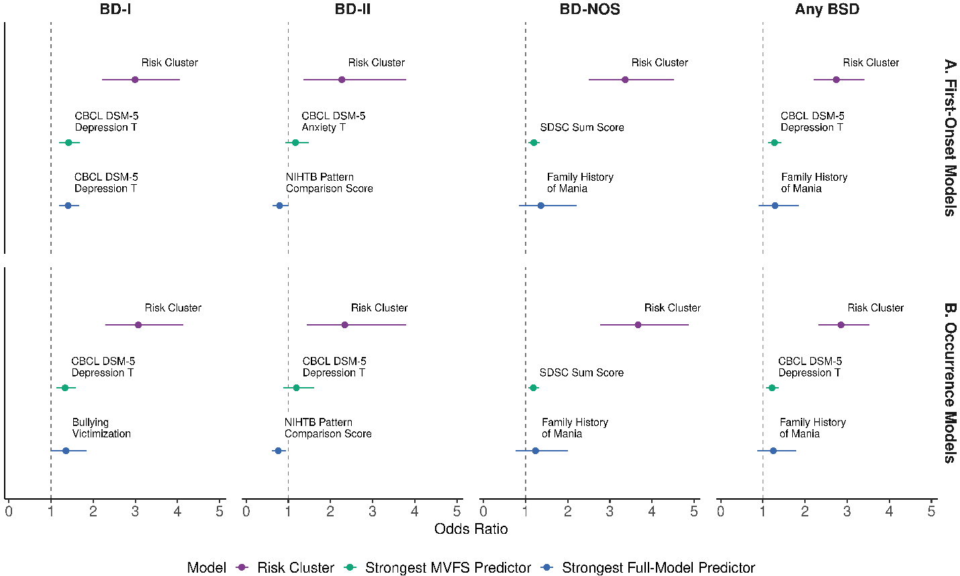
Note: Panel A summarizes first-onset discrete-time hazard models. Panel B summarizes occurrence generalized estimating equation models. Each facet shows 3 adjusted ORs for any BSD across timepoints: the higher- vs lower-risk cluster OR from the cluster-label model, the single baseline predictor with the largest absolute log-odds-ratio magnitude from the MVFS 7-variable model, and the corresponding single strongest baseline predictor from the full 17-variable model. Abbreviations: BSD = bipolar spectrum disorder; MVFS = minimally viable feature subset; OR = odds ratio.

Supplementary References
- Barch, D. M., Albaugh, M. D., Baskin-Sommers, A., Bryant, B. E., Clark, D. B., Dick, A. S., Feczko, E., Foxe, J. J., Gee, D. G., Giedd, J., Glantz, M. D., Hudziak, J. J., Karcher, N. R., LeBlanc, K., Maddox, M., McGlade, E. C., Mulford, C., Nagel, B. J., Neigh, G., Palmer, C. E., Potter, A.S., Sher, K.J., Tapert, S.F., Thompson, W.K., Xie, L. (2021). Demographic and mental health assessments in the adolescent brain and cognitive development study: Updates and age-related trajectories. Developmental Cognitive Neuroscience, 52, 101031.
- Huang, Z. (1998). Extensions to the k-Means Algorithm for Clustering Large Data Sets with Categorical Values. Data Mining and Knowledge Discovery, 2, 283–304.
- Szepannek G (2018). clustMixType: User-Friendly Clustering of Mixed-Type Data in R. The R Journal, https://doi.org/10.32614/RJ-2018-048.
- Tierney N., Cook D. (2023). Expanding Tidy Data Principles to Facilitate Missing Data Exploration, Visualization and Assessment of Imputations. Journal of Statistical Software, 105(7), 1–31.
- Junaid, K. P., Kiran, T., Gupta, M., Kishore, K., Siwatch, S. (2025). How much missing data is too much to impute for longitudinal health indicators? A preliminary guideline for the choice of the extent of missing proportion to impute with multiple imputation by chained equations. Population health metrics, 23(1), 2.
- Hu, Y.H., Wu, R.Y., Lin, Y.C., Lin, T.Y. (2024). A novel MissForest-based missing values imputation approach with recursive feature elimination in medical applications. BMC medical research methodology, 24(1), 269.
- Stekhoven, D.J. (2025). missForest: Nonparametric Missing Value Imputation using Random Forest. R package version 1.6.1.
- Stekhoven D.J., Bühlmann P (2012). MissForest: nonparametric missing value imputation for mixed-type data. Bioinformatics, 28(1), 112–118.
- Scrucca, L., Fraley, C., Murphy, T.B., Raftery, A.E. (2023). Model-Based Clustering, Classification, and Density Estimation Using mclust in R. Chapman and Hall/CRC. ISBN 978-1032234953, https://mclust-org.github.io/book/.
- Pfaffel, O. (2020). FeatureImpCluster: Feature Importance for Partitional Clustering. R package version 0.1.5. https://cran.r-project.org/web/packages/FeatureImpCluster.
- Chen T., He T., Benesty M., Khotilovich V., Tang Y., Cho H., Chen K.., Mitchell R, Cano I., Zhou T.., Li M, Xie J., Lin M., Geng Y., Li Y., Yuan J., Cortes D. (2026). xgboost: Extreme Gradient Boosting. R package version 3.2.0.1, https://github.com/dmlc/xgboost.
- Chen, T., Guestrin, C. (2016). XGBoost: A Scalable Tree Boosting System. In Proceedings of the 22nd ACM SIGKDD International Conference on Knowledge Discovery and Data Mining (KDD '16). ACM.
- Mayer, M. (2025). shapviz: SHAP Visualizations. R package version 0.10.3, https://github.com/modeloriented/shapviz.
- Lundberg, S.M., Lee, S.I. (2017). A unified approach to interpreting model predictions. In Proceedings of the 31st International Conference on Neural Information Processing Systems (NIPS'17). Curran Associates Inc., Red Hook, NY, USA, 4768–4777.
- Kuhn, H. W. (1955). The Hungarian method for the assignment problem. Naval Research Logistics Quarterly, 2, 83–97.
- Warrens, M., Hoef, H. (2022). Understanding the Adjusted Rand Index and Other Partition Comparison Indices Based on Counting Object Pairs. Journal of Classification, 39, 487-509.
- Chac'on, J., Rastrojo, A. (2020). Minimum adjusted Rand index for two clusterings of a given size. Advances in Data Analysis and Classification, 17, 125-133.
- Foss, A.H., Markatou, M. (2018). kamila: Clustering Mixed-Type Data in R and Hadoop. Journal of Statistical Software, 83(13), 1–45.
- McParland, D., Gormley, I.C. (2016). Model based clustering for mixed data: clustMD. Advances in Data Analysis and Classification, 10(2):155-169.
- Maechler M, Rousseeuw P, Struyf A, Hubert M, Hornik K (2026). cluster: Cluster Analysis Basics and Extensions. R package version 2.1.8.2, https://CRAN.R-project.org/package=cluster.
- Pustejovsky, J. E., Tipton, E. (2017). Small-Sample Methods for Cluster-Robust Variance Estimation and Hypothesis Testing in Fixed Effects Models. Journal of Business & Economic Statistics, 36(4), 672–683.

