Additional file 1. Predictive margins of time since diagnosis with 95% CI
Dietary patterns and their association with glycated haemoglobin among adults with type 2 diabetes in urban DR Congo in 2025: a cross-sectional study

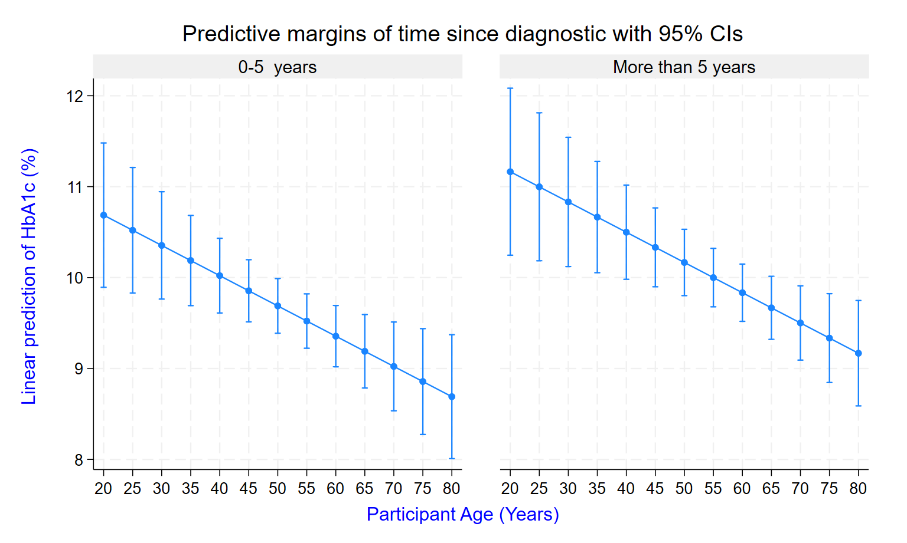
Figure S1. Predictive margins of time since diagnostis with 95% CI

