Additional file 4: Post-estimation plot residuals vs predicted values after gamma regression

Dietary patterns and their association with glycated haemoglobin among adults with type 2 diabetes in urban DR Congo in 2025: a cross-sectional study

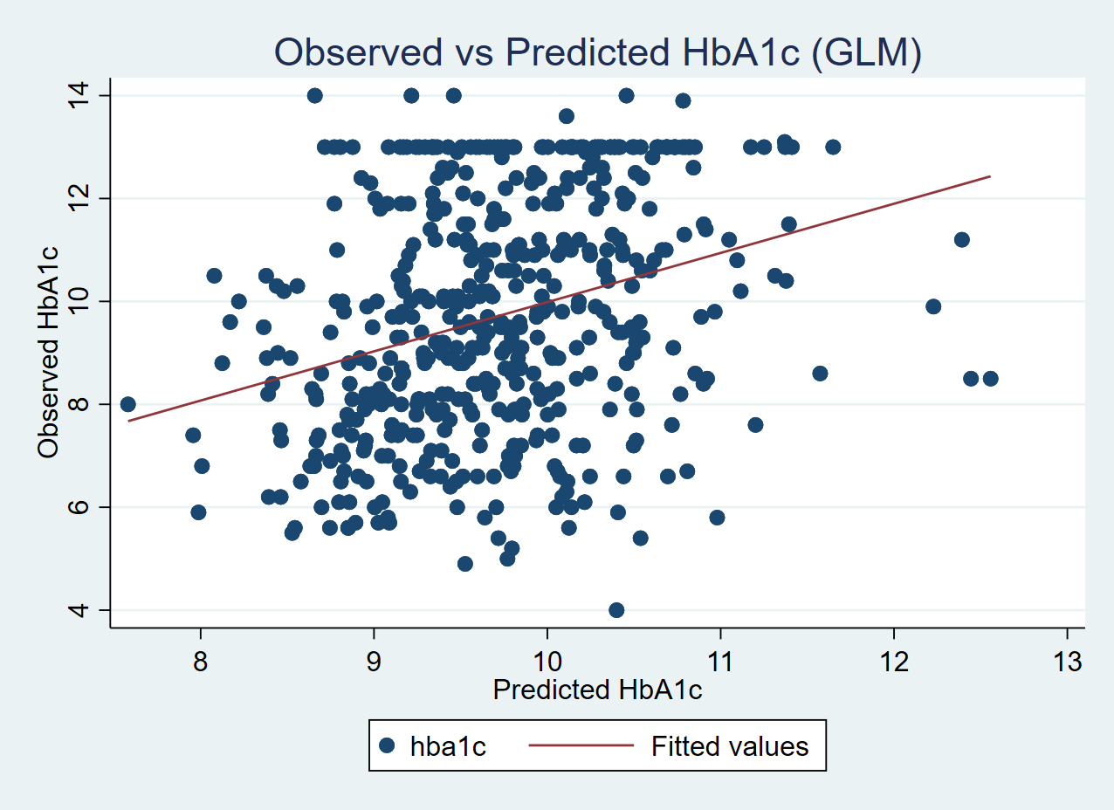Figure S2. Post-estimation plot residuals vs predicted values after gamma regression

