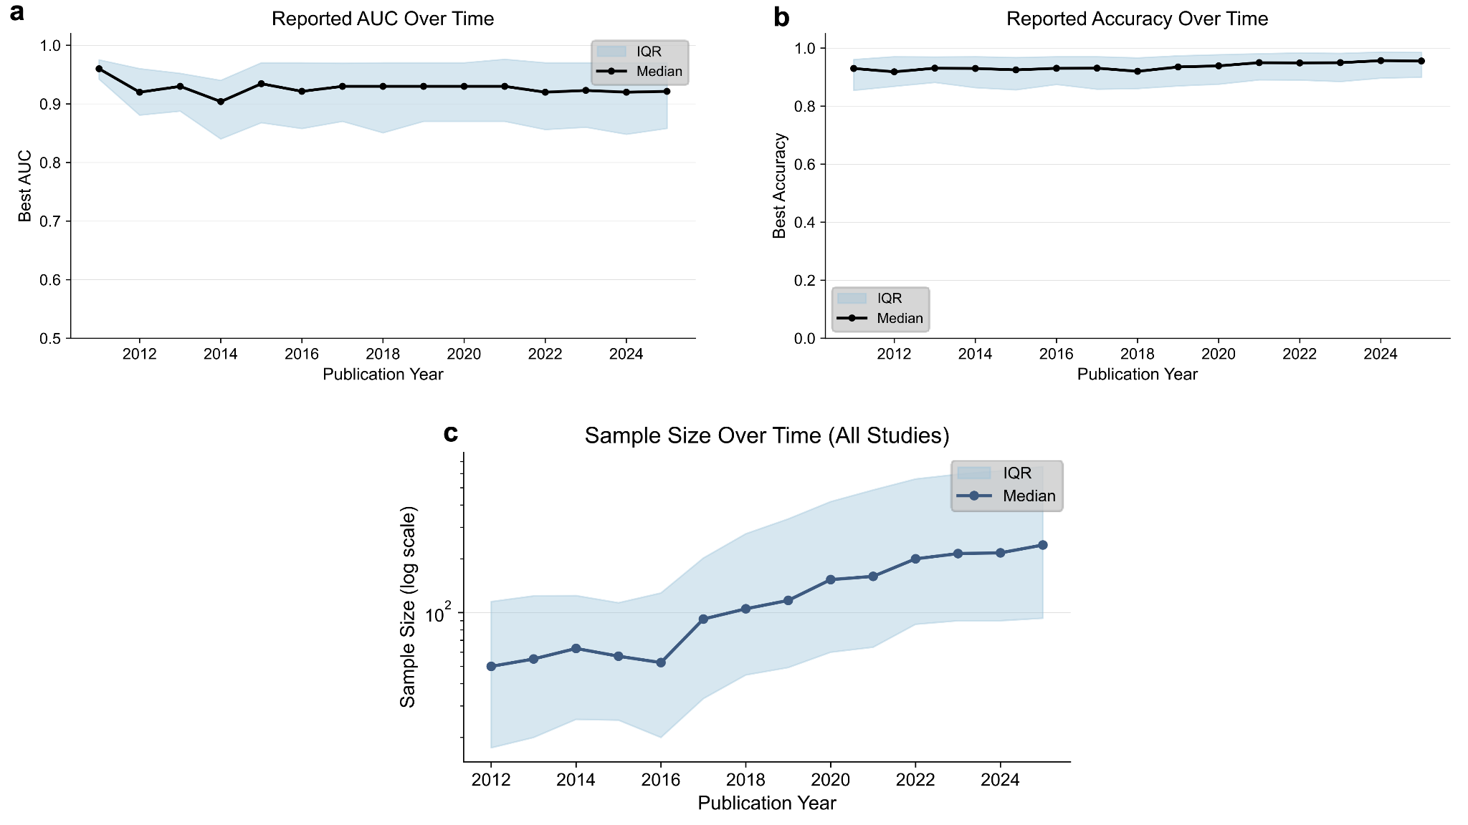
Extended Data Figure 1. Trends in study reported a) AUC, b) accuracy, and c) sample size over time.
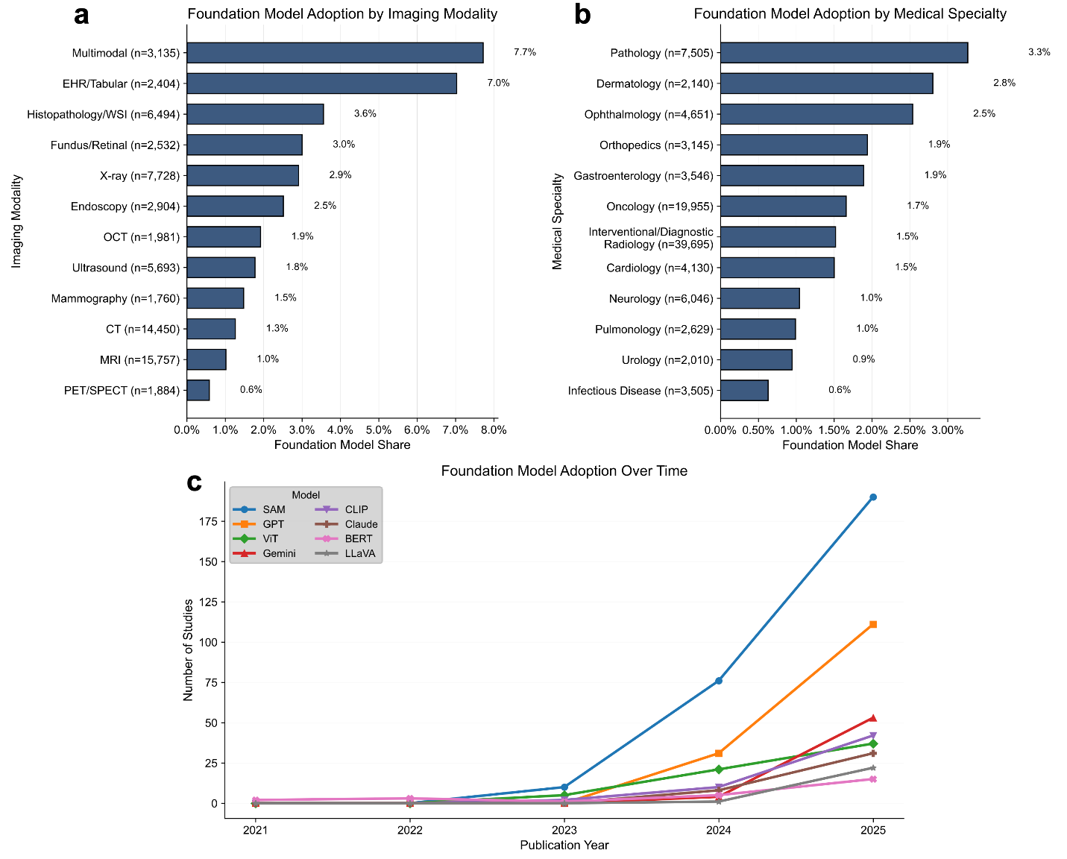
Extended Data Figure 2. Breakdown of foundation model usage among a) imaging modality, b) medical specialty, and c) trends over time.

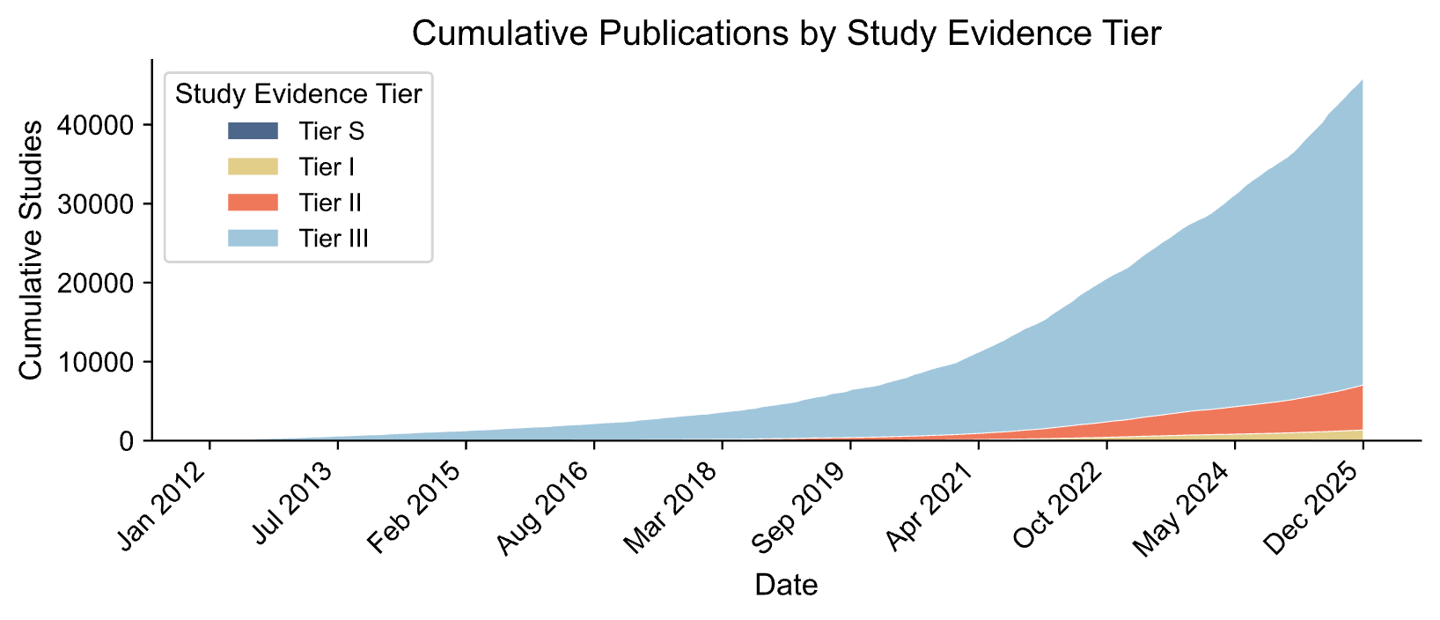
Extended Data Figure 3. Cumulative publications per year by study evidence tier from January 2012 to December 2025.

﻿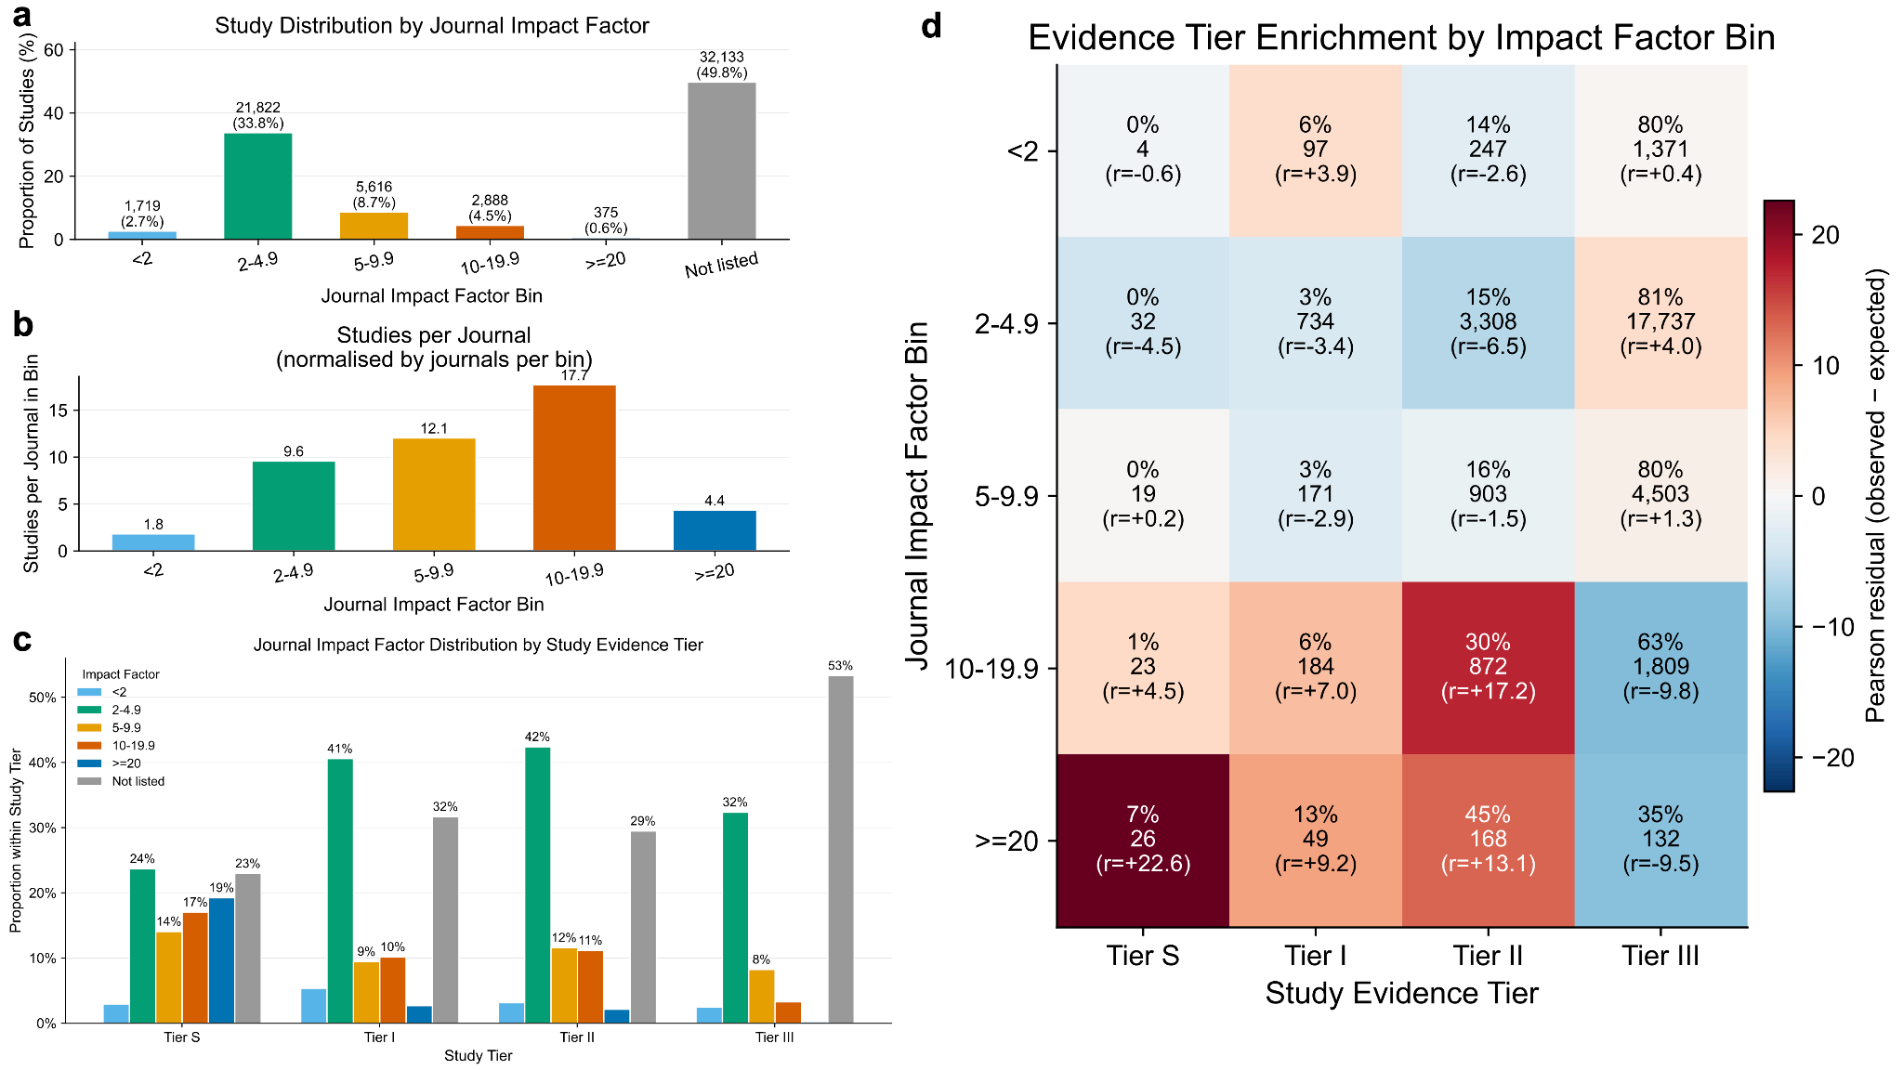

Extended Data Figure 4. a) Breakdown of study evidence tier and journal impact factor bin. b) Proportion of studies among journal impact factor bins and c) number of studies per journal per bin. d) Enrichment of evidence tier by journal impact factor bin.

﻿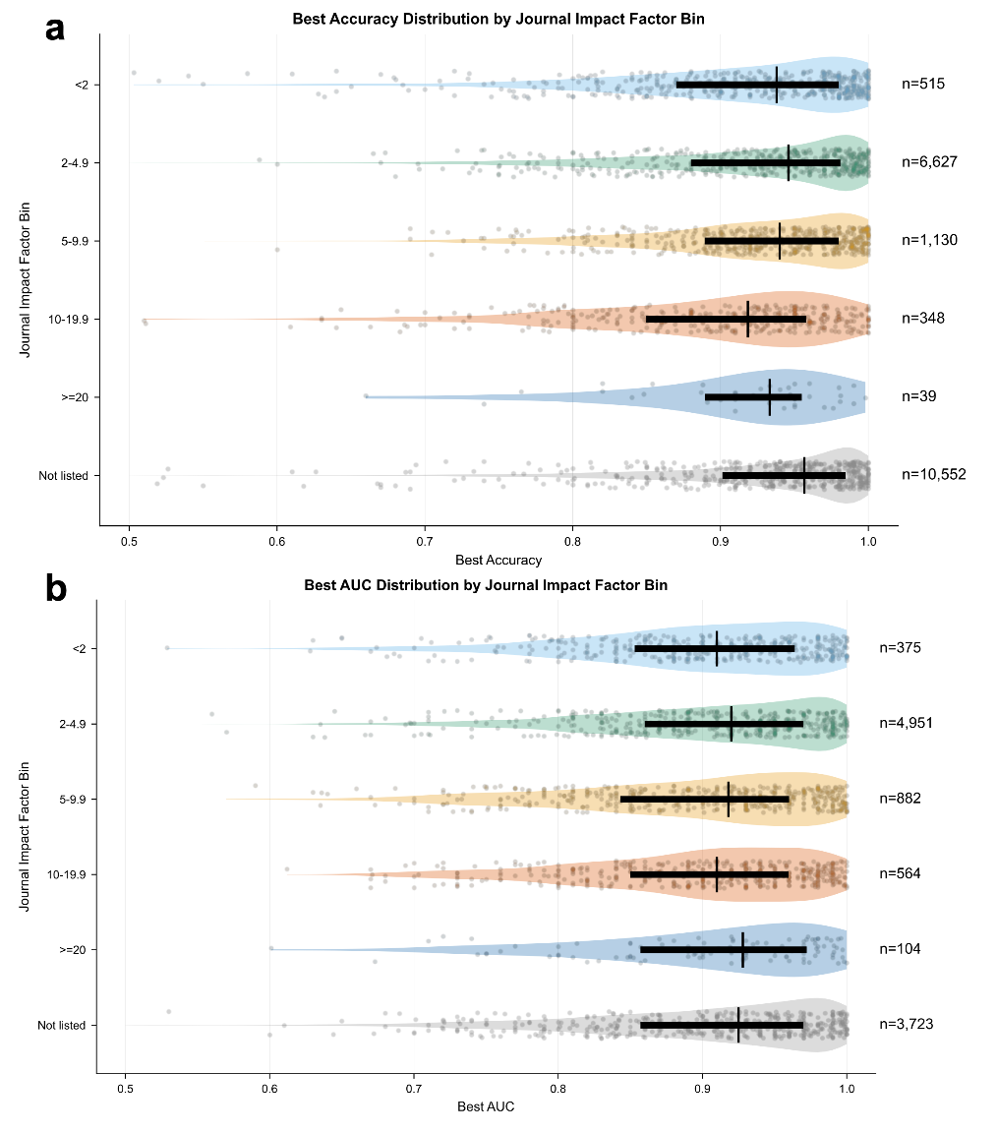
Extended Data Figure 5. Ranges of a) AUC and b) accuracy based on journal impact factor.

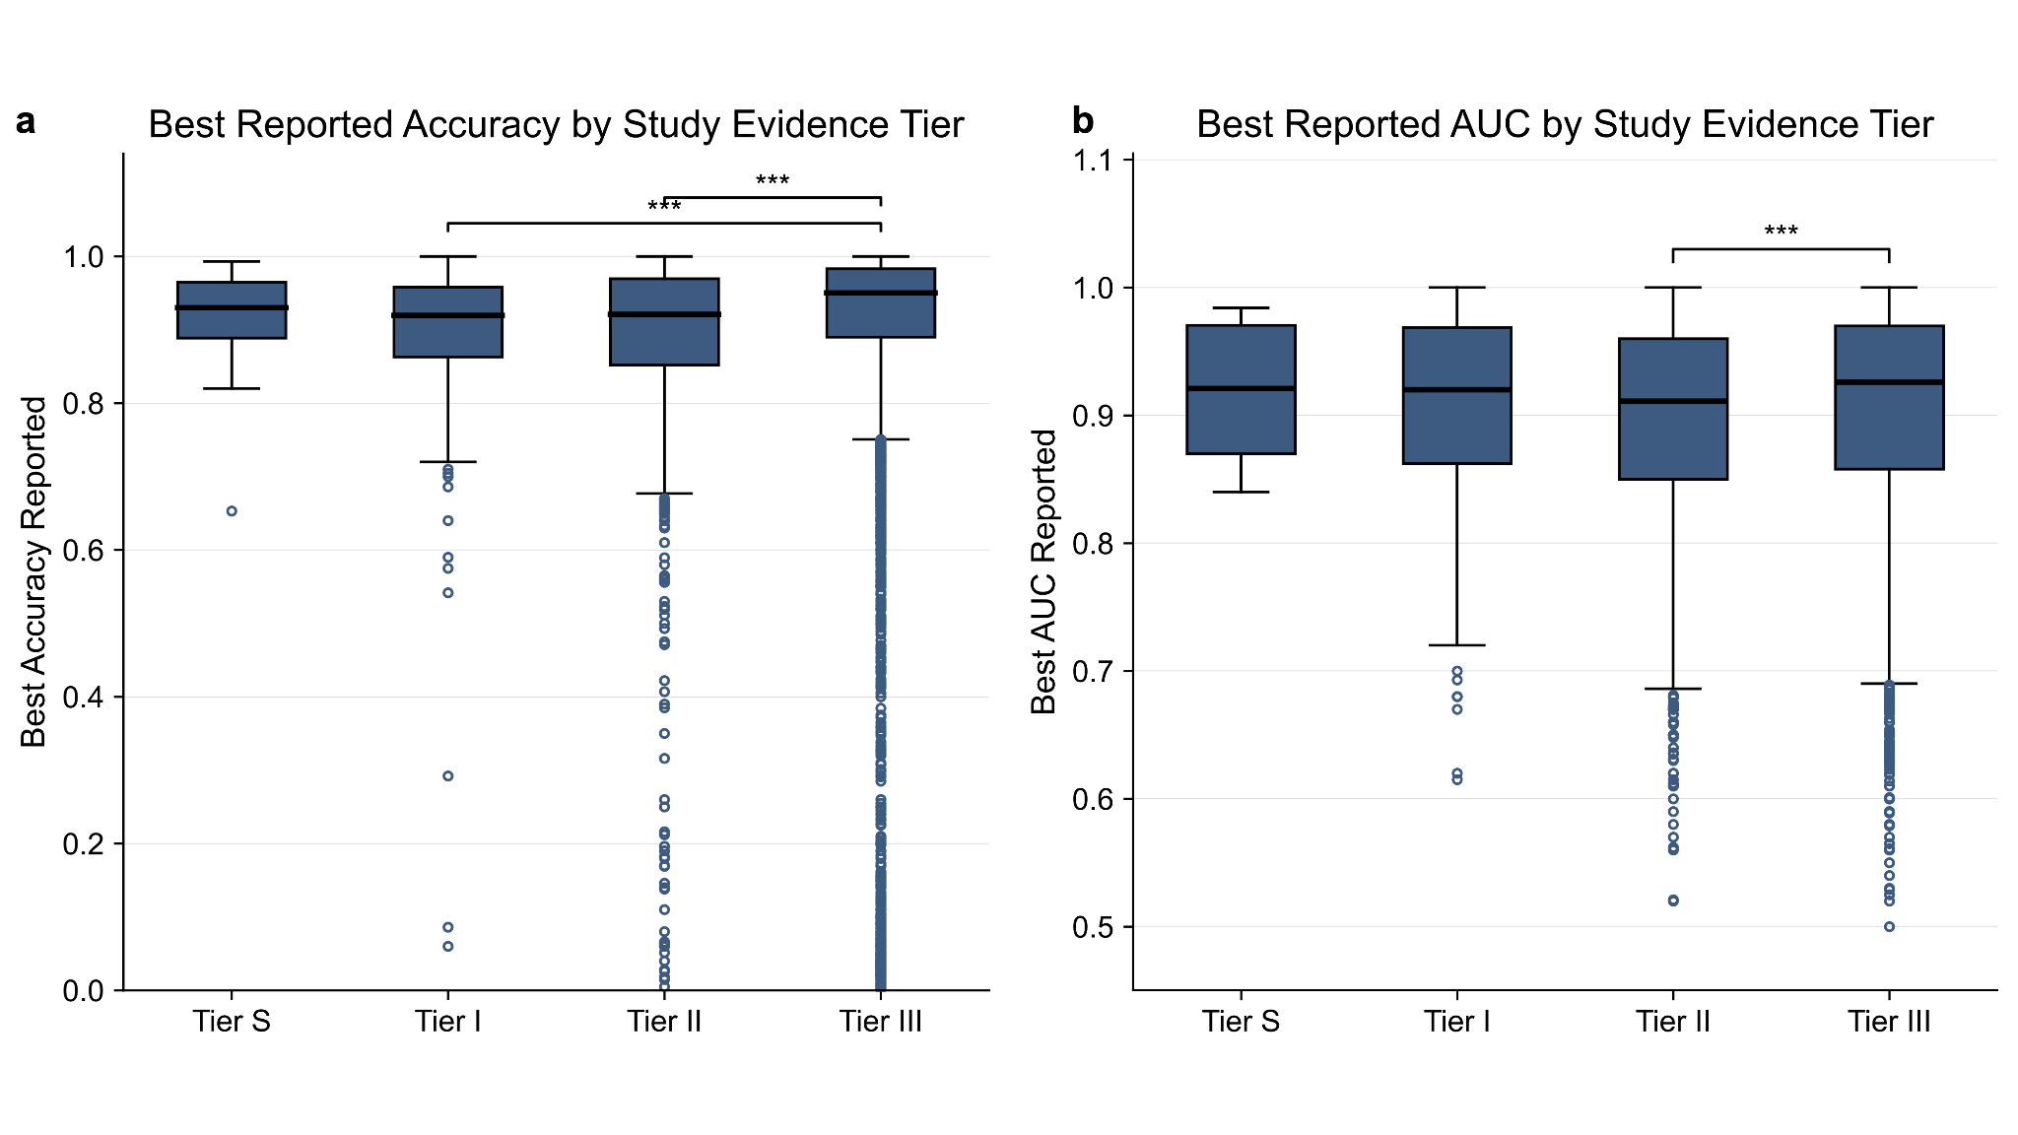
Extended Data Figure 6. a) Best reported accuracy by study evidence tier. Significant differences were observed in accuracy between Tier I and Tier III as well as Tier II and Tier III (p < 0.001). b) Best reported AUC by study evidence tier. Significant differences were observed in AUC between Tier II and Tier III (p < 0.001).

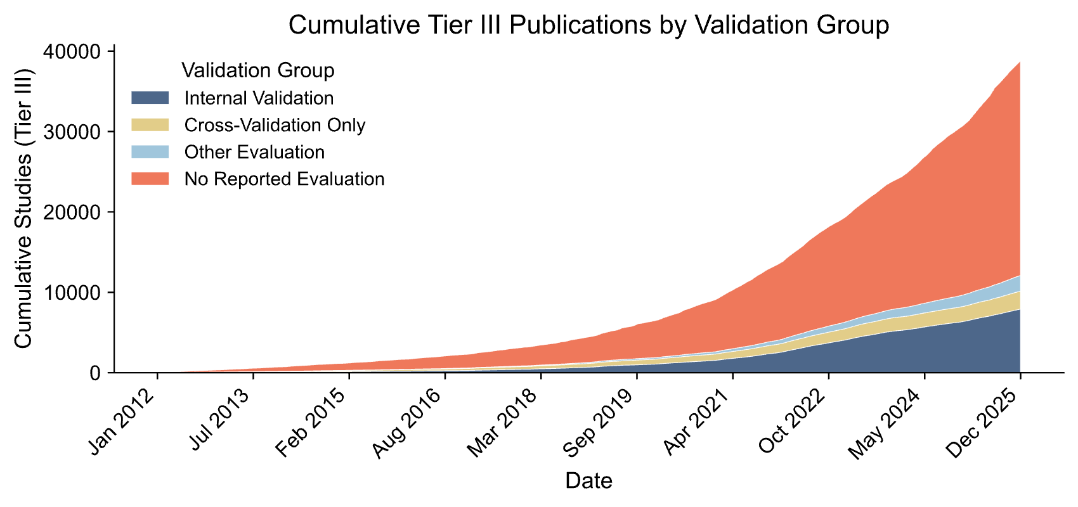
Extended Data Figure 7. Trends in study evidence tier III by validation, including internal validation, cross-validation, other evaluation, and no reported evaluation.

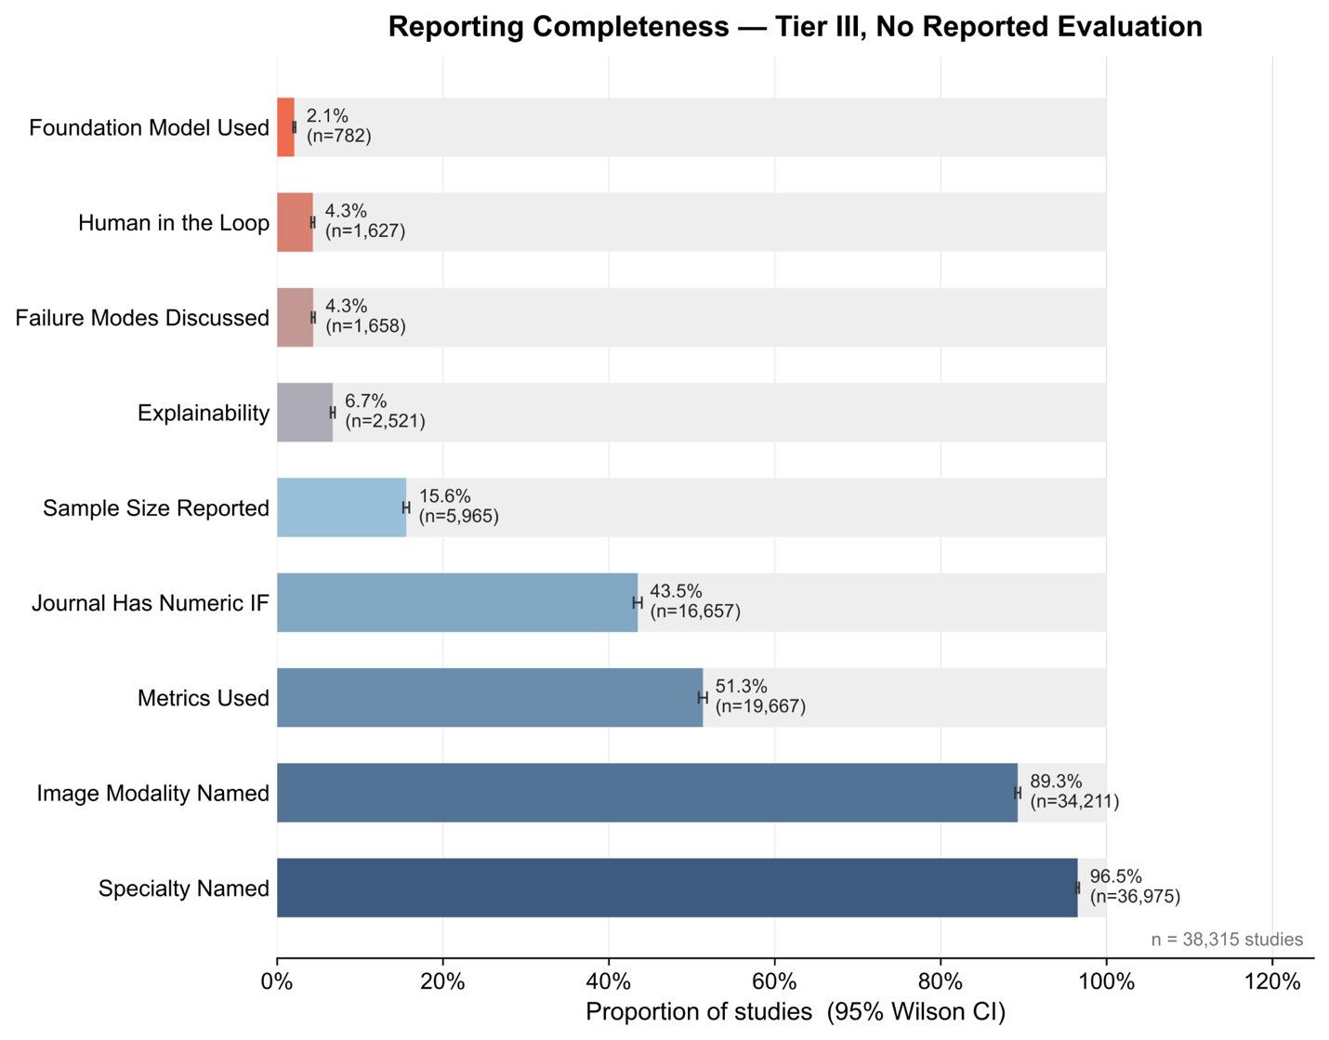
Extended Data Figure 8. Out of the 39,434 studies without validation metrics reported, abstract completeness based on other factors is shown.

