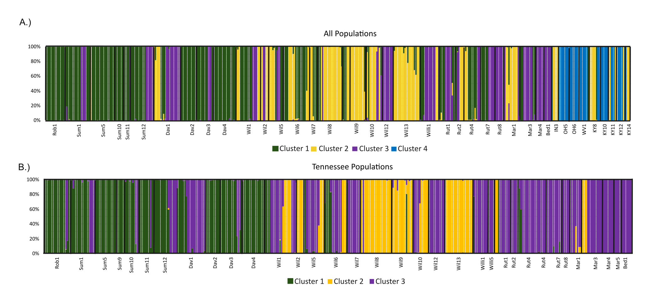
Supplement 1. Individual membership probabilities from Analysis of Principal Components (DAPC) of the A) AP SNP dataset and the B) Tennessee SNP dataset. Membership colors correspond to the clusters in DAPC scatterplot (Fig. 4).

