Supporting Information

Triple-action biomimetic nanoplatform: antigen delivery, lysosomal escape, and innate immune activation against lethal SFTSV

Mengyao Zhang^{1, #}, Ning Shi^{1, #}, Yuancheng Li¹, Xiaohan Xie¹, Chenglin Shi¹, Yutong Xie¹, Luotong Chen¹, Qianruo Wang¹, Pei Huang¹, Haili Zhang¹, Zengguo Cao^{2, *}, HuaLei Wang^{1, *} and Yuanyuan Li^{1, *}
¹State Key Laboratory for Diagnosis and Treatment of Severe Zoonotic Infectious Diseases, Key Laboratory for Zoonosis Research of the Ministry of Education, Institute of Zoonosis, and College of Veterinary Medicine, Jilin University, Changchun, Jilin 130062, China.
²CAS Key Laboratory of Special Pathogens and Biosafety, Wuhan Institute of Virology, Center for Biosafety Mega-Science, Chinese Academy of Sciences, Wuhan 430071, China
#These authors contributed equally: Mengyao Zhang, Ning Shi

Contents:
Supplementary Figures 1 – 23
Supplementary Tables 1 - 7

Supplementary Figure 1

Supplementary Figure 1: Expression pattern of SFTSV Gn protein in ExpiCHO‑S cells.

Supplementary Figure 2

Supplementary Figure 2: The morphology and structure of MPDA was characterized via scanning electron microscopy (SEM).

Supplementary Figure 3

Supplementary Figure 3: Safety evaluation of PDANP. (a)Cell viability under varying concentrations of MPDA was assessed in HEK-293T, Vero E6, and DC2.4 cell lines using the CCK‑8 assay (n=6). The average viability of cells treated with 0 μg/mL MPDA was set as the 100% control. (b)Hemolysis rates of red blood cells under varying concentrations of MPDA were measured (n=3). dd H₂O was used as the positive control, with its average hemolysis rate set at 100%. Data represent mean ± SEM (standard error of the mean) of technical duplicates. Source data are provided as a Source data file.

Supplementary Figure 4

Supplementary Figure 4: Colocalization of internalized Gn@PDANP (green) with lysosomes (red) was observed by CLSM. Left panels: The extent of colocalization between Gn@PDANP and lysosomes was assessed at different time points. Right panel: curve profiles of Gn@PDANP with lysotracker. The intensity of each curve was quantified by ImageJ software and drawn using GraphPad Prism 8.4. Scale bar represents 20 μm. Source data are provided as a Source data file.

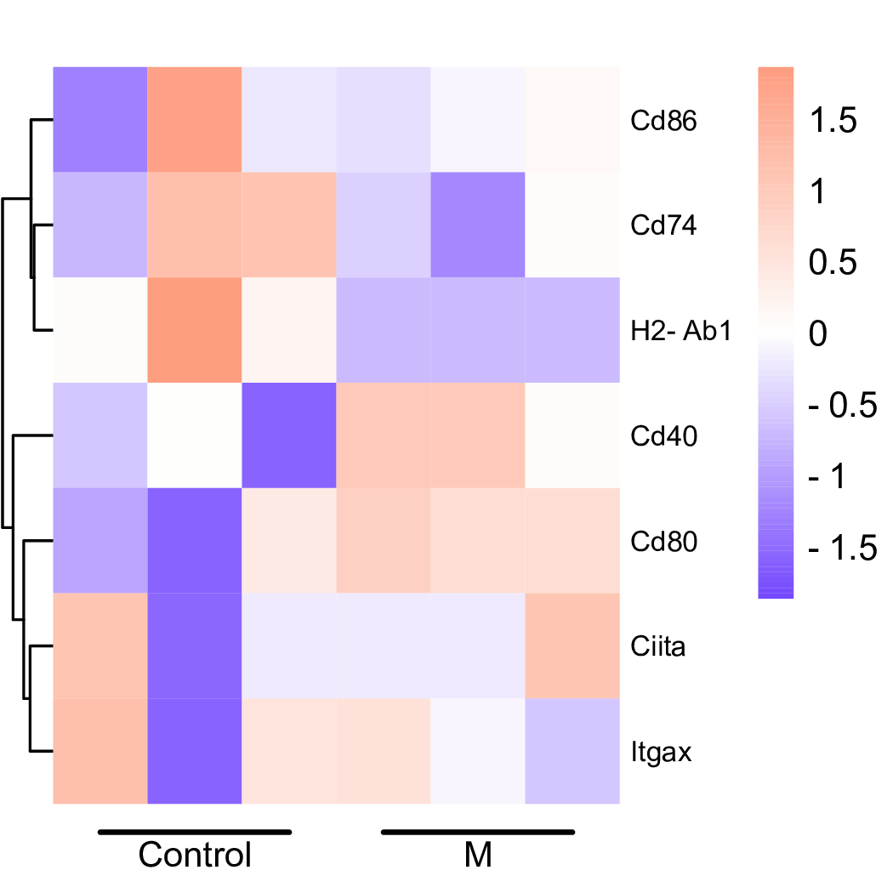
Supplementary Figure 5

Supplementary Figure 5: Clustering heatmap of DC maturation‑related factors revealed by transcriptomic analysis (n=3). Source data are provided as a Source data file.

Supplementary Figure 6
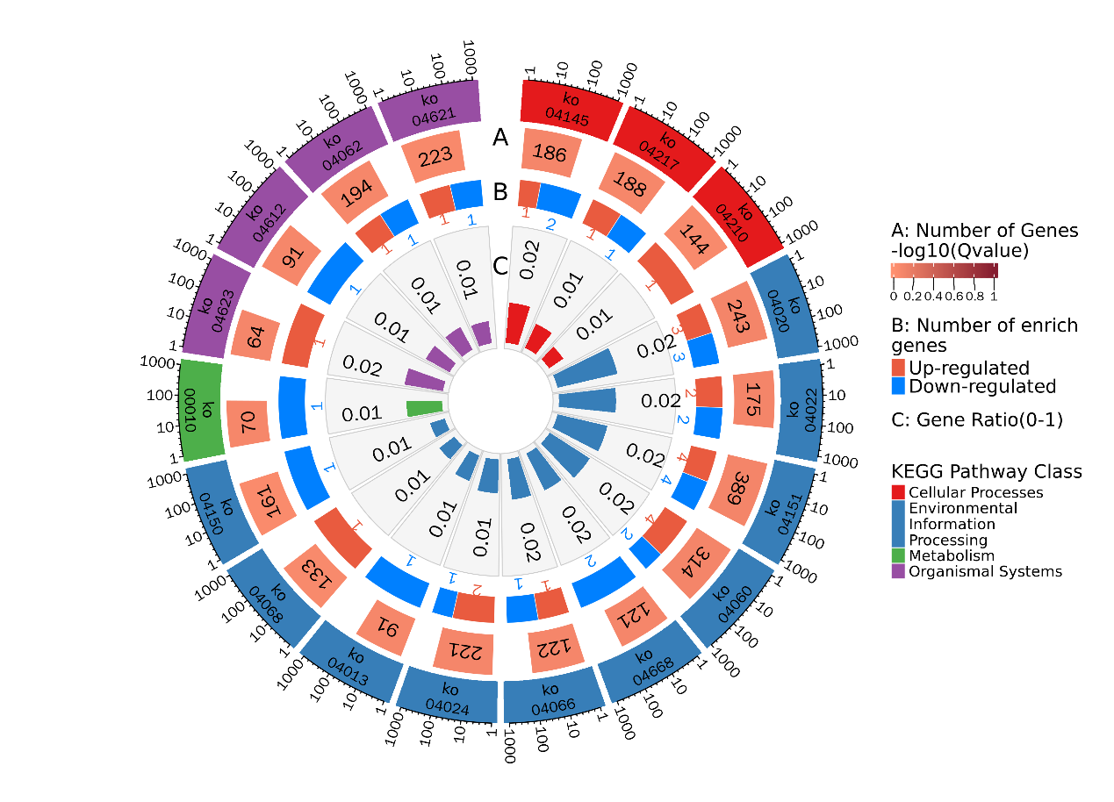

Supplementary Figure 6: Enrichment circle plot corresponding to the bubble plot of KEGG enrichment analysis for differentially expressed genes (n=3).

Supplementary Figure 7

Supplementary Figure 7: Dendritic cell activation in mouse inguinal lymph node cells following 12 hours of Gn@MPDA stimulation. Proportions of CD11c⁺CD80⁺, CD11c⁺CD86⁺, CD11c⁺H‑2Kd⁺, and CD11c⁺I‑A/I‑E⁺ double‑positive cells ( a ), along with the gating strategy ( b ) and representative dot plots ( c ) (n=3). Data were presented as mean ± SEM. Comparisons were performed with two‑tailed unpaired Student’s t‑test. A P value < 0.05 was considered statistically significant (**p < 0.01; ***p < 0.001). Raw data were provided as source data files.

Supplementary Figure 8

Supplementary Figure 8: Gating strategy and representative dot plots for dendritics cell activation in mouse inguinal lymph nodes at 12 h post‑primary immunization analyzed by FlowJo.

Supplementary Figure 9

Supplementary Figure 9: CD11c and CD80 dot plots for dendritic cell activation in mouse inguinal lymph nodes at 12 h post‑primary immunization analyzed by FlowJo.

Supplementary Figure 10

Supplementary Figure 10: CD11c and CD86 dot plots for dendritic cell activation in mouse inguinal lymph nodes at 12 h post‑primary immunization analyzed by FlowJo.

Supplementary Figure 11

Supplementary Figure 11: CD11c and H-2Kd dot plots for dendritic cell activation in mouse inguinal lymph nodes at 12 h post primary immunization analyzed by FlowJo.

Supplementary Figure 12

Supplementary Figure 12: CD11c and I-A/I-E dot plots for dendritic cell activation in mouse inguinal lymph nodes at 12 h post primary immunization analyzed by FlowJo.

Supplementary Figure 13

Supplementary Figure 13: Gating strategy and dot plots for Tfh cells in mouse inguinal lymph nodes at 5 weeks post‑third immunization analyzed by FlowJo.

Supplementary Figure 14

Supplementary Figure 14: Gating strategy and dot plots for germinal center B cells in mouse inguinal lymph nodes at 5 weeks post‑third immunization analyzed by FlowJo.

Supplementary Figure 15

Supplementary Figure 15: Gating strategy and representative dot plots for T‑ and B‑cell differentiation in mouse spleen at 5 weeks post‑third immunization analyzed by FlowJo.

Supplementary Figure 16

Supplementary Figure 16: CD4 and CD69 dot plots for T‑cell differentiation in mouse spleen at 5 weeks post‑third immunization analyzed by FlowJo.

Supplementary Figure 17

Supplementary Figure 17: CD8 and CD69 dot plots for T cell differentiation in mouse spleen at 5 weeks post third immunization analyzed by FlowJo.

Supplementary Figure 18

Supplementary Figure 18: CD19 and CD40 dot plots for sustained B‑cell activation in mouse spleen at 5 weeks post third immunization analyzed by FlowJo.

Supplementary Figure 19

Supplementary Figure 19: CD19 and CD69 Dot plots for early B‑cell activation in mouse spleen at 5 weeks post‑third immunization analyzed by FlowJo.

Supplementary Figure 20

Supplementary Figure 20: Gating strategy and representative dot plots for memory T cells in mouse spleen at 5 weeks post‑third immunization analyzed by FlowJo.

Supplementary Figure 21

Supplementary Figure 21: Dot plots for CD4⁺ memory T cells in mouse spleen at 5 weeks post‑third immunization analyzed by FlowJo.

Supplementary Figure 22

Supplementary Figure 22: Dot plots for CD8⁺ memory T cells in mouse spleen at 5 weeks post‑third immunization analyzed by FlowJo.

Supplementary Figure 23

Supplementary Figure 23: ELISpot images of splenocytes from mice at 5 weeks post‑third immunization analyzed.

Supplementary Table 1
 | Gn@MPDA‑treated group
Parameter | 1 | 2 | 3 | 4 | 5 | 6 | Unit | Reference range
WBC | 9.27 | 6.42 | 3.55 | 2.84 | 7.15 | 3.87 | 10^9/L | 2.61-13.00
Neu# | 6.24 | 4.26 | 2.66 | 1.47 | 5.02 | 2.38 | 10^9/L | 0.10-2.00
Lym# | 2.91 | 2.02 | 0.79 | 1.12 | 1.94 | 1.38 | 10^9/L | 1.27-8.44
Mon# | 0.1 | 0.13 | 0.09 | 0.19 | 0.18 | 0.11 | 10^9/L | 0.00-0.29
Eos# | 0 | 0 | 0 | 0.04 | 0 | 0 | 10^9/L | 0.00-0.17
Bas# | 0.02 | 0.01 | 0.01 | 0.02 | 0.01 | 0 | 10^9/L | 0.00-0.20
Neu% | 67.3 | 66.3 | 74.9 | 51.5 | 70.1 | 61.3 | % | 1.2-30.0
Lym% | 31.3 | 31.4 | 22.2 | 39.3 | 27.1 | 35.7 | % | 70.0-96.0
Mon% | 1.1 | 2.1 | 2.6 | 6.8 | 2.6 | 2.9 | % | 0.0-10.0
Eos% | 0 | 0 | 0 | 1.6 | 0 | 0 | % | 0.0-10.0
Bas% | 0.3 | 0.2 | 0.3 | 0.8 | 0.2 | 0.1 | % | 0.0-5.0
RBC | 9.15 | 7.45 | 8.43 | 8.15 | 8.28 | 8.08 | 10^12/L | 6.00-12.50
HGB | 152 | 122 | 139 | 145 | 136 | 135 | g/L | 100-190
HCT | 41.5 | 34.7 | 37.8 | 36.5 | 36.8 | 36.6 | % | 40.0-48.0
MCV | 45.4 | 46.6 | 44.8 | 44.7 | 44.4 | 45.3 | fL | 41.0-63.0
MCH | 16.6 | 16.4 | 16.5 | 17.7 | 16.5 | 16.7 | pg | 13.0-19.0
MCHC | 367 | 351 | 369 | 397 | 371 | 368 | g/L | 290-351
RDW-CV | 15.3 | 17.1 | 15.5 | 16.1 | 16.4 | 18 | % | 10.0-20.0
RDW-SD | 26.9 | 31.4 | 27 | 28 | 28.4 | 31.7 | fL | 0.1-99.9
PLT | 801 | 853 | 919 | 795 | 1063 | 978 | 10^9/L | 540-1540
MPV | 8.6 | 7.6 | 7.9 | 8.5 | 8 | 8.5 | fL | 3.8-14.1
PDW | 5.2 | 6.8 | 5.2 | 6.3 | 5.8 | 6.8 | fL | 0.1-30.0
PCT | 0.688 | 0.65 | 0.724 | 0.676 | 0.85 | 0.835 | % | 0.100-9.990
Supplementary Table 1: Hematological analysis of Gn@MPDA‑treated mice.

Supplementary Table 2
 | PBS-SFTSV‑treated group
Parameter | 1 | 2 | 3 | 4 | 5 | 6 | Unit | Reference range
WBC | 4.13 | 0.29 | 0.63 | 3.63 | 3.9 | 2.91 | 10^9/L | 2.61-13.00
Neu# | 3.34 | 0.2 | 0.32 | 2.43 | 2.95 | 1.9 | 10^9/L | 0.10-2.00
Lym# | 0.65 | 0.02 | 0.07 | 0.94 | 0.48 | 0.48 | 10^9/L | 1.27-8.44
Mon# | 0.14 | 0.01 | 0.21 | 0.22 | 0.43 | 0.34 | 10^9/L | 0.00-0.29
Eos# | 0 | 0.05 | 0.02 | 0.02 | 0.03 | 0.13 | 10^9/L | 0.00-0.17
Bas# | 0 | 0.01 | 0.01 | 0.02 | 0.01 | 0.06 | 10^9/L | 0.00-0.20
Neu% | 80.8 | 66.5 | 49.7 | 66.8 | 75.4 | 65 | % | 1.2-30.0
Lym% | 15.5 | 9.9 | 11.5 | 25.7 | 12.3 | 16.4 | % | 70.0-96.0
Mon% | 3.4 | 4.1 | 32.6 | 6.2 | 11 | 11.9 | % | 0.0-10.0
Eos% | 0.1 | 14.9 | 3.6 | 0.6 | 0.8 | 4.6 | % | 0.0-10.0
Bas% | 0.2 | 4.6 | 2.6 | 0.7 | 0.5 | 2.1 | % | 0.0-5.0
RBC | 8.69 | 2.93 | 3.17 | 7.94 | 5.21 | 7.03 | 10^12/L | 6.00-12.50
HGB | 151 | 41 | 52 | 131 | 80 | 113 | g/L | 100-190
HCT | 38.7 | 13.7 | 14.7 | 35 | 21.1 | 29.8 | % | 40.0-48.0
MCV | 44.5 | 46.6 | 46.5 | 44.1 | 40.6 | 42.3 | fL | 41.0-63.0
MCH | 17.4 | 14.1 | 16.5 | 16.5 | 15.4 | 16 | pg | 13.0-19.0
MCHC | 391 | 302 | 355 | 375 | 379 | 379 | g/L | 290-351
RDW-CV | 16.1 | 18.2 | 17.2 | 15.9 | 16.8 | 16.7 | % | 10.0-20.0
RDW-SD | 27.7 | 34.8 | 33.1 | 27.6 | 27.3 | 27.9 | fL | 0.1-99.9
PLT | 985 | 348 | 374 | 881 | 642 | 721 | 10^9/L | 540-1540
MPV | 10 | 8.6 | 9.4 | 8.6 | 8.6 | 9.3 | fL | 3.8-14.1
PDW | 8.2 | 6.3 | 20.7 | 5.7 | 7.8 | 9.4 | fL | 0.1-30.0
PCT | 0.988 | 0.301 | 0.35 | 0.761 | 0.55 | 0.67 | % | 0.100-9.990
Supplementary Table 2: Hematological analysis of PBS-SFTSV‑treated mice.

Supplementary Table 3
 | Uninfected‑treated group
Parameter | 1 | 2 | 3 | 4 | 5 | 6 | Unit | Reference range
WBC | 5.4 | 6.43 | 3.77 | 7.39 | 5.4 | 10.65 | 10^9/L | 2.61-13.00
Neu# | 1.3 | 0.97 | 0.62 | 0.78 | 1.3 | 1.37 | 10^9/L | 0.10-2.00
Lym# | 3.81 | 5.21 | 2.86 | 6.54 | 3.81 | 9.09 | 10^9/L | 1.27-8.44
Mon# | 0.24 | 0.13 | 0.09 | 0.03 | 0.24 | 0.12 | 10^9/L | 0.00-0.29
Eos# | 0.01 | 0.02 | 0.11 | 0 | 0.01 | 0 | 10^9/L | 0.00-0.17
Bas# | 0.04 | 0.1 | 0.09 | 0.04 | 0.04 | 0.07 | 10^9/L | 0.00-0.20
Neu% | 23.9 | 15 | 16.2 | 10.5 | 23.9 | 12.8 | % | 1.2-30.0
Lym% | 70.5 | 81 | 75.7 | 88.4 | 70.5 | 85.3 | % | 70.0-96.0
Mon% | 4.6 | 1.9 | 2.6 | 0.5 | 4.6 | 1.2 | % | 0.0-10.0
Eos% | 0.2 | 0.4 | 3 | 0 | 0.2 | 0 | % | 0.0-10.0
Bas% | 0.8 | 1.7 | 2.5 | 0.6 | 0.8 | 0.7 | % | 0.0-5.0
RBC | 6.22 | 6.44 | 6.15 | 9.52 | 6.22 | 7.35 | 10^12/L | 6.00-12.50
HGB | 97 | 106 | 104 | 134 | 97 | 120 | g/L | 100-190
HCT | 30.2 | 32 | 30.4 | 44.5 | 30.2 | 36.6 | % | 40.0-48.0
MCV | 48.6 | 49.8 | 49.4 | 46.7 | 48.6 | 49.8 | fL | 41.0-63.0
MCH | 15.6 | 16.4 | 16.9 | 14.1 | 15.6 | 16.3 | pg | 13.0-19.0
MCHC | 321 | 330 | 342 | 302 | 321 | 328 | g/L | 290-351
RDW-CV | 16.5 | 17.2 | 16.8 | 15.5 | 16.5 | 16.8 | % | 10.0-20.0
RDW-SD | 32.2 | 34 | 32.9 | 28 | 32.2 | 33.1 | fL | 0.1-99.9
PLT | 592 | 772 | 543 | 725 | 592 | 694 | 10^9/L | 540-1540
MPV | 6.8 | 7.3 | 7.6 | 9.5 | 6.8 | 7.2 | fL | 3.8-14.1
PDW | 5.7 | 8.3 | 6.8 | 21.4 | 5.7 | 5.8 | fL | 0.1-30.0
PCT | 0.4 | 0.565 | 0.412 | 0.692 | 0.4 | 0.503 | % | 0.100-9.990
Supplementary Table 3: Hematological analysis of uninfected‑treated mice.

Supplementary Table 4
 | Gn@MPDA‑treated group
Parameter | 1 | 2 | 3 | 4 | 5 | 6 | Unit | Reference range
ALB | 30.8 | 29.5 | 28.9 | 28.5 | 35.1 | 31 | g/L | 25-48
TP | 59.6 | 53.3 | 58.7 | 66.9 | 62.8 | 62 | g/L | 36-72
GLB | 28.8 | 23.9 | 29.8 | 38.4 | 27.6 | 31 | g/L
A/G | 1.07 | 1.24 | 0.97 | 0.74 | 1.27 | 1
TBIL | 2.1 | 0.6 | 1 | 8.6 | 2.3 | 2.6 | μmol/L | 0-15
GGT | <2 | <2 | <2 | <2 | <2 | <2 | U/L
AST | 55 | 59 | 84 | 261 | 69 | 86 | U/L | 59-269
ALT | 56 | 57 | 50 | 129 | 107 | 60 | U/L | 28-132
ALP | 95 | 107 | 82 | 55 | 57 | 70 | U/L | 62-222
TBA | 2.86 | 10.02 | 5.14 | 4.24 | 17.11 | 9.14 | μmol/L
TC | 2.09 | 2.69 | 2.6 | 2.99 | 2.44 | 2.26 | μmol/L | 0.93-4.04
AST/ALT | 0.99 | 1.02 | 1.68 | 2 | 0.64 | 1.44
Supplementary Table 4: Liver function test results in Gn@MPDA‑treated mice.

Supplementary Table 5
 | PBS-SFTSV‑treated group
Parameter | 1 | 2 | 3 | 4 | 5 | 6 | Unit | Reference range
ALB | 27.6 | 29.5 | 27.8 | 28.7 | 26.4 | 27.3 | g/L | 25-48
TP | 66.3 | 58.9 | 68.6 | 70 | 60.9 | 54.6 | g/L | 36-72
GLB | 38.7 | 29.4 | 40.8 | 41.3 | 34.5 | 27.3 | g/L
A/G | 0.71 | 1 | 0.68 | 0.7 | 0.76 | 1
TBIL | 0.6 | <0.1 | 29 | 18.1 | <0.1 | 1.7 | μmol/L | 0-15
GGT | <2 | <2 | <2 | <2 | <2 | <2 | U/L
AST | 543 | 470 | 426 | 434 | 421 | 650 | U/L | 59-269
ALT | 238 | 476 | 237 | 130 | 352 | 216 | U/L | 28-132
ALP | 48 | 54 | 59 | 30 | 60 | 72 | U/L | 62-222
TBA | <1.00 | 22.34 | 4.71 | 2.07 | 1.55 | 4.2 | μmol/L
TC | 2 | 0.96 | 1.83 | 2.53 | 1.29 | 2.35 | μmol/L | 0.93-4.04
AST/ALT | 2.29 | 0.99 | 1.8 | 3.33 | 1.2
Supplementary Table 5: Liver function test results in PBS-SFTSV‑treated mice.

Supplementary Table 6
 | Uninfected‑treated group
Parameter | 1 | 2 | 3 | 4 | 5 | 6 | Unit | Reference range
ALB | 32.9 | 27.4 | 30.3 | 32.6 | 29.4 | 35.4 | g/L | 25-48
TP | 59.7 | 54.8 | 59.4 | 63 | 58.2 | 68.1 | g/L | 36-72
GLB | 26.8 | 27.4 | 29.1 | 30.4 | 28.8 | 32.7 | g/L
A/G | 1.23 | 1 | 1.04 | 1.07 | 1.02 | 1.08
TBIL | 0.1 | 2.5 | 1 | 4.3 | 1.9 | <0.1 | μmol/L | 0-15
GGT | <2 | <2 | <2 | <2 | <2 | <2 | U/L
AST | 79 | 147 | 72 | 171 | 86 | 225 | U/L | 59-269
ALT | 53 | 116 | 54 | 69 | 76 | 117 | U/L | 28-132
ALP | 180 | 121 | 143 | 134 | 110 | 141 | U/L | 62-222
TBA | 15.03 | >120.00 | 7.26 | 18.46 | 20.62 | 7.69 | μmol/L
TC | 2.28 | 1.48 | 2.43 | 2.24 | 2.34 | 2.67 | μmol/L | 0.93-4.04
AST/ALT | 1.49 | 1.27 | 1.34 | 2.47 | 1.12 | 1.93
Supplementary Table 6: Liver function test results in uninfected‑treated mice.

Supplementary Table 7
Primer | Sequence（5'-3'）
SFTSV-N-F | GCCTTCACCAAGACTATCAATGTG
SFTSV-N-R | AACATCATTGGGGAAGAAGACAGA
IL-1β-F | CTCGCAGCAGCACATCAACAAG
IL-1β-R | CCACGGGAAAGACACAGGTAGC
IFN-β-F | CGTTCCTGCTGTGCTTCT
IFN-β-R | GCATCTTCTCCGTCATCT
IL-6-F | TGCCTTCTTGGGACTGAT
IL-6-R | CTGGCTTTGTCTTTCTTGTT
TNF-α-F | CTTCTCATTCCTGCTTGTG
TNF-α-R | ACTTGGTGGTTTGCTACG
IL-12-F | ATGTGGAATGGCGTCTCTGTCTG
IL-12-R | CAGTTCAATGGGCAGGGTCTCC
MIP-1α-F | TCCCAGCCAGGTGTCATTTTCC
MIP-1α-R | AGGCATTCAGTTCCAGGTCAGTG
MCP-1-F | ACTCACCTGCTGCTACTCATTCAC
MCP-1-R | TCTTTGGGACACCTGCTGCTG
iNOS-F | GACGAGACGGATAGGCAGAGATTG
iNOS-R | AACTCTTCAAGCACCTCCAGGAAC
C0X-2-F | TGGTGCCTGGTCTGATGATGTATG
C0X-2-R | GTCTGCTGGTTTGGAATAGTTGCTC
IL-12p40-F | CACTGTTTCTCCAGGGGCAT
IL-12p40-R | TTGCCATCGTTTTGCTGGTG
IL-23p19-F | AAGGAGGTGGATAGGGGGTC
IL-23p19-R | ACTGCTCTGCAATCCAGCAT
Supplementary Table 7: Primer sequences for quantitative real-time PCR.

