Supplementary Information for

Ocean eddy compensation regulates feedbacks amplifying ozone-induced Southern Ocean cooling

Travis R. Prochko, Xue Liu, Qiuying Zhang, Frederic Castruccio, Ping Chang, Gokhan Danabasoglu, Gaopeng Xu, Stephen G. Yeager, Clara Deser, Pedro DiNezio

*Corresponding authors: Travis Prochko and Ping Chang
Email: trp2@tamu.edu and ping@tamu.edu

This PDF file includes:
Figures S1 to S8
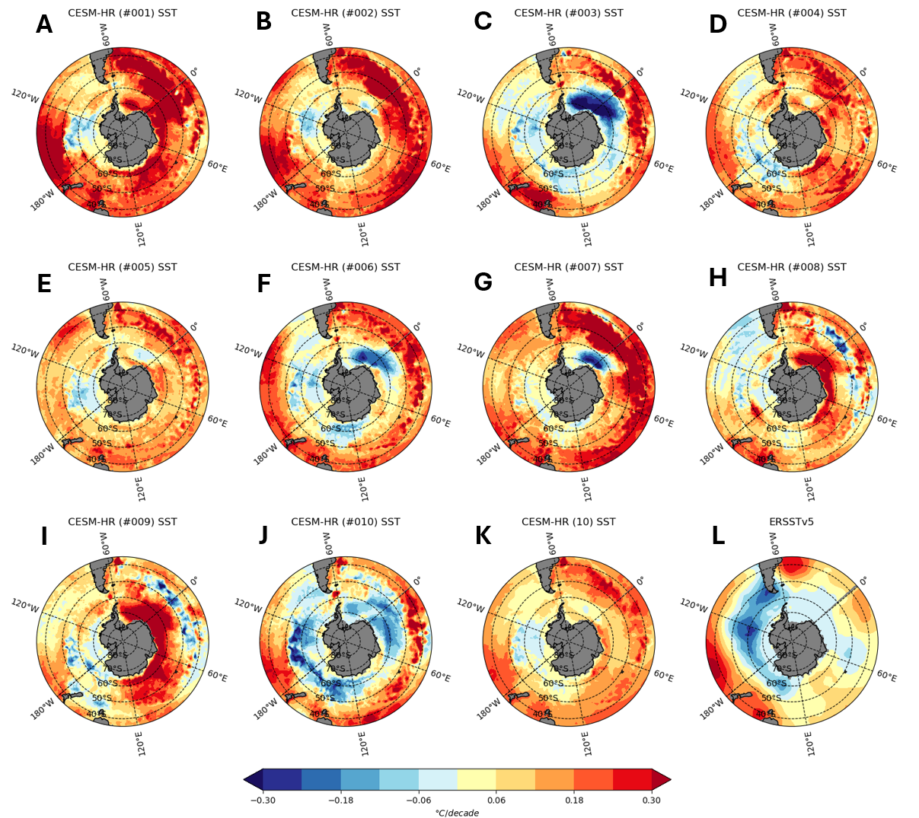
Fig. S1: Linear SST trend in each ensemble member of CESM-HR over 1980-2022, compared to ERSST. (A-J) CESM-HR ensemble members #001-#010. (K) CESM-HR ensemble mean. (L) ERSSTv5.

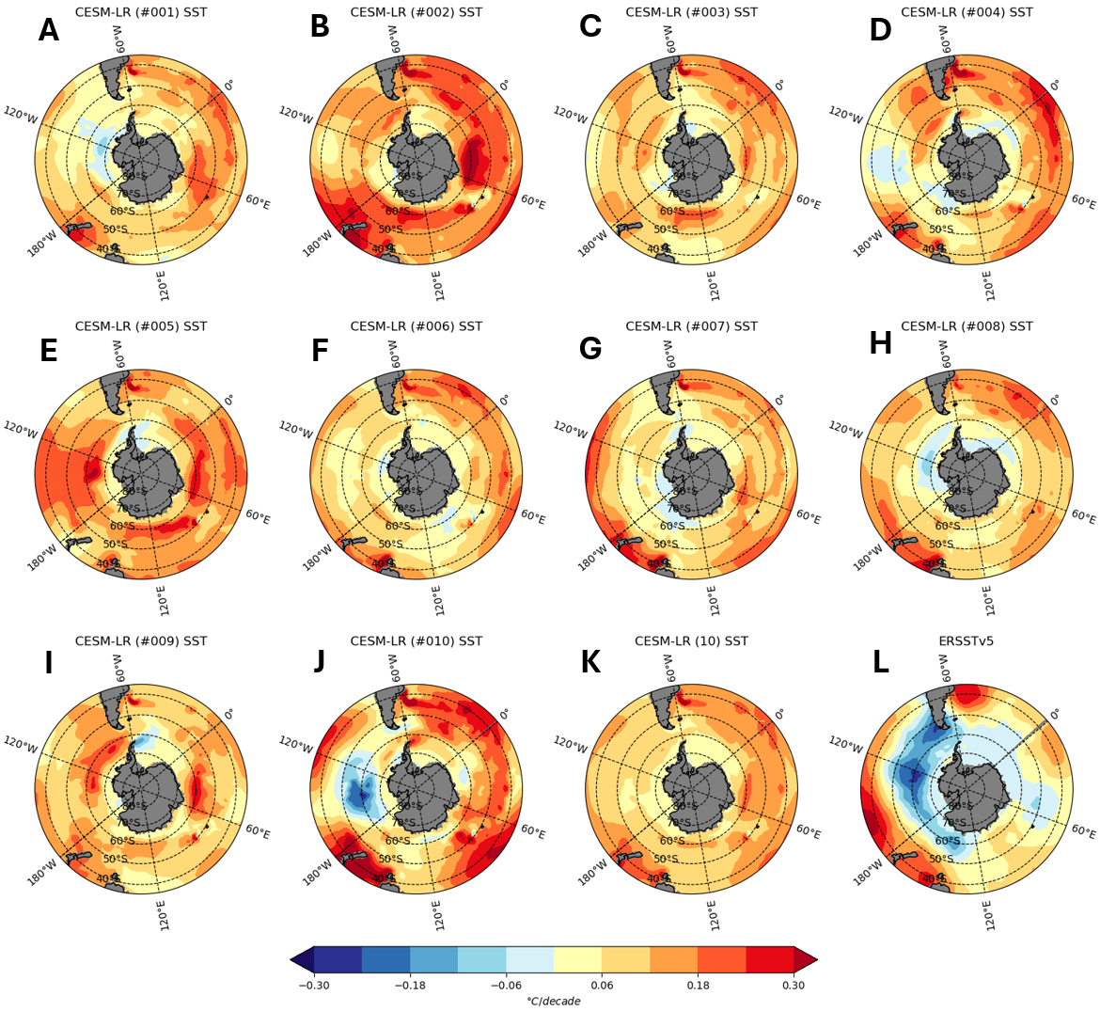
Fig. S2: Linear SST trend in each ensemble member of CESM-LR over 1980-2022, compared to ERSSTv5. (A-J) CESM-LR ensemble members #001-#010. (K) CESM-LR ensemble mean. (L) ERSSTv5.

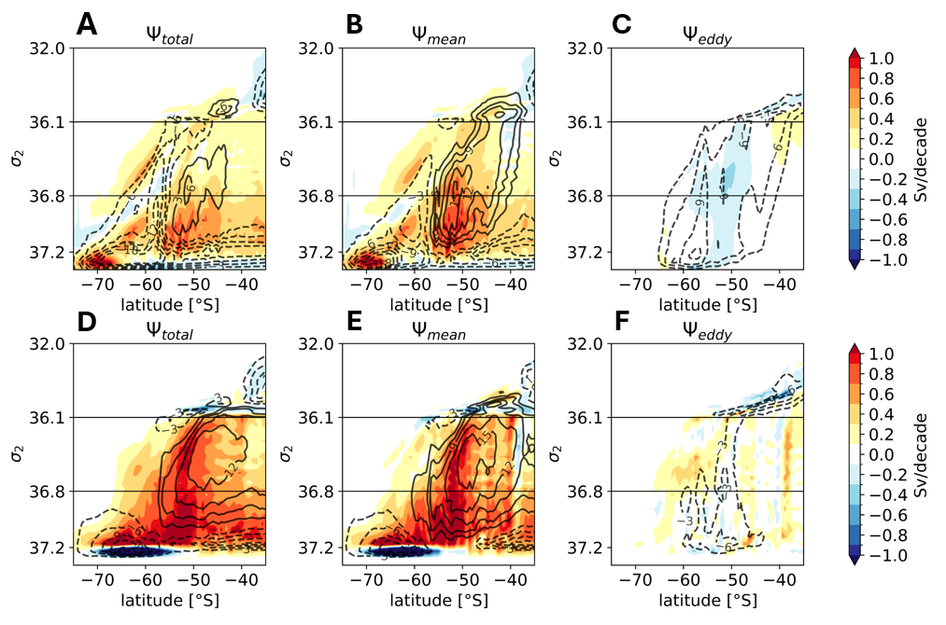
Fig S3: Ocean meridional overturning streamfunction in density space: time-average (black contours, 3 Sv intervals) and linear trend (shading) in the Southern Ocean in FOSI-HR and FOSI-LR over the 1979-2017 period. (A and D) total (residual) streamfunction $Ψ_{total}$, (B and E) time-mean streamfunction $Ψ_{mean}$, and (C and F) transient eddy streamfunction $Ψ_{eddy}$.

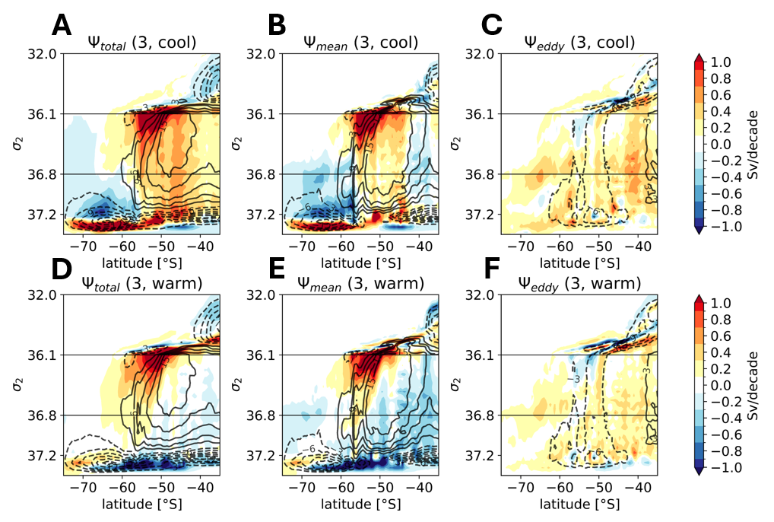
Fig. S4: Ocean meridional overturning streamfunction time-average (black contours, 3 Sv intervals) and linear trend (shading) in the Southern Ocean in CESM-HR over the 1980-2022 period. For the three cool members, (A) residual streamfunction $Ψ_{total}(3, cool)$, (B) time-mean streamfunction $Ψ_{mean}(3, cool)$, and (C) transient eddy streamfunction $Ψ_{eddy}(3,cool)$. For the warm members, (D) residual streamfunction $Ψ_{total}(3,warm)$, (E) time-mean streamfunction $Ψ_{mean}(3,warm)$, and (F) transient eddy streamfunction $Ψ_{eddy}(3,warm)$.

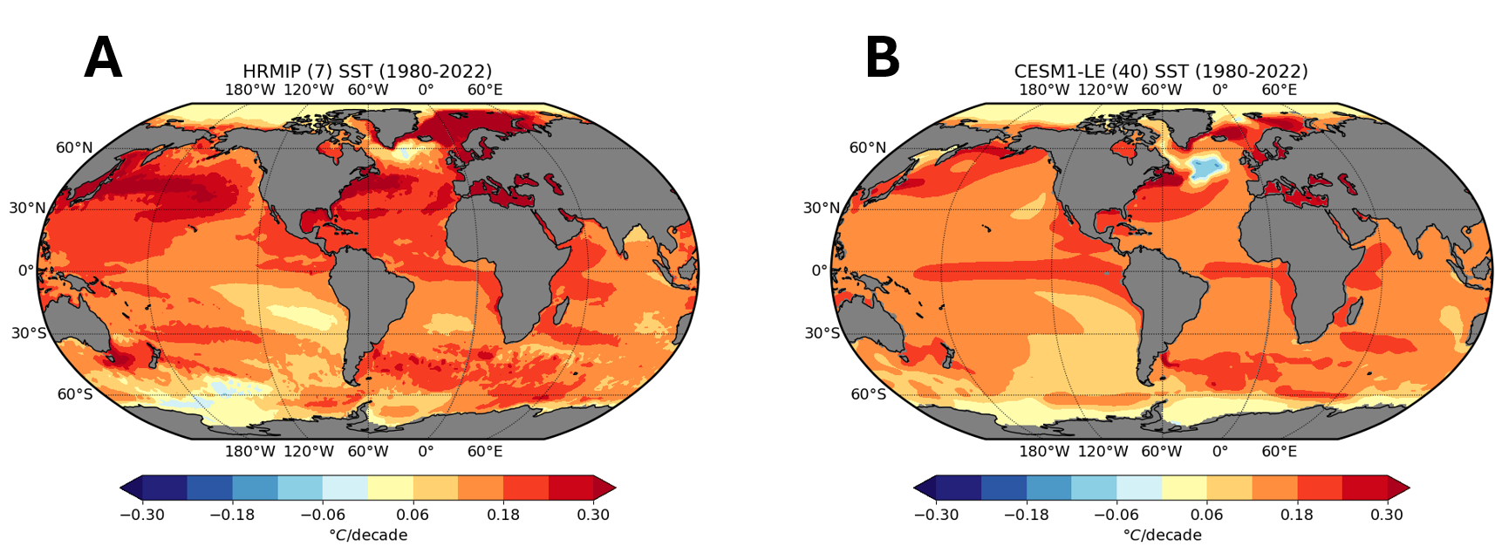
Fig. S5: Linear trends in SST over 1980-2022 for (A) HighResMIP, multi-model-mean and (B) CESM1-LE, 40-member ensemble mean.

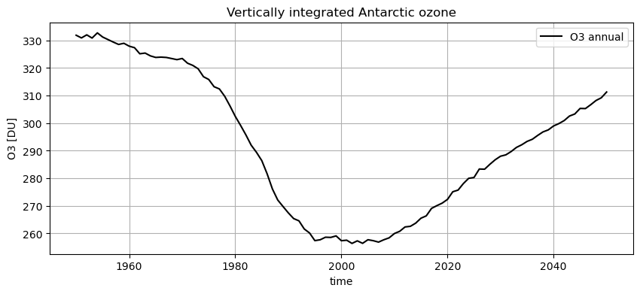Fig. S6: Vertically-integrated annual ozone (O3) averaged over the Antarctic region (63$°$S-90$°$S) for 1950-2050 as prescribed in CESM-HR, CESM-LR, AMIP-HR, and AMIP-LR. The Antarctic region is defined from 90$°$S to the climatological extent of the polar jet, at about 63$°$S.
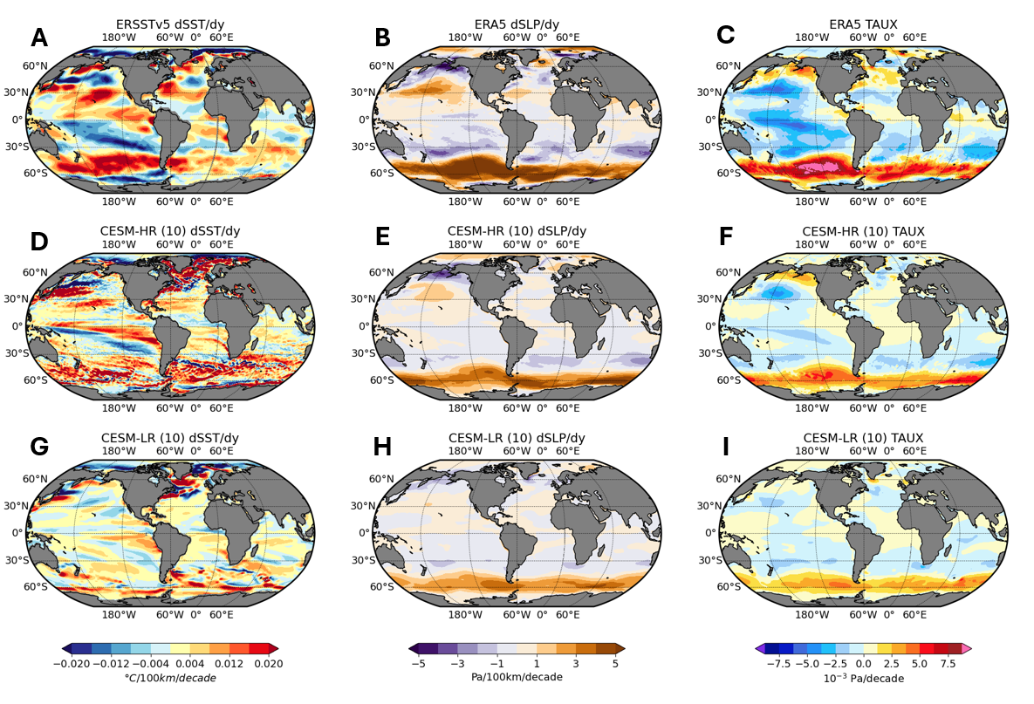
Fig. S7: Observation-based and simulated linear trends of meridional gradients of sea surface temperature (dSST/dy) and sea level pressure (dSLP/dy), along with zonal surface wind stress (TAUX) over the 1980-2022 period. (A) Linear trends of dSST/dy in ERSSTv5. Linear trends in ERA5 of (B) dSLP/dy and (C) $τ^{x}$. Ensemble mean linear trends simulated in CESM-HR of (D) dSST/dy, (E) dSLP/dy, and (F) $τ^{x}$. Ensemble mean linear trends simulated in CESM-LR of (G) dSST/dy, (H) dSLP/dy, and (I) $τ^{x}$ .
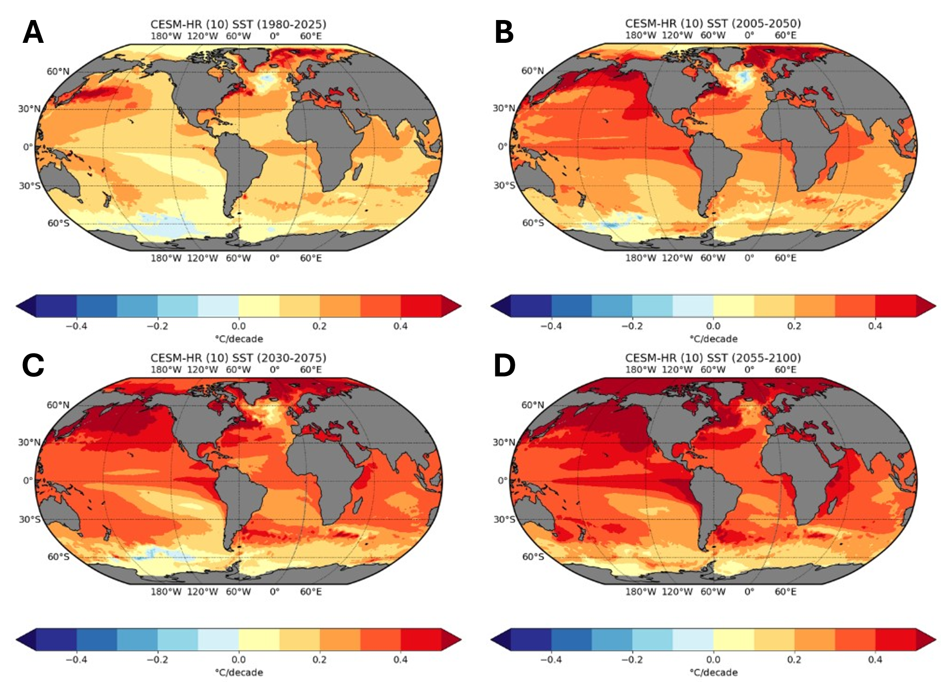
Figure S8. Linear trends of simulated SST over the period of (A) 1980-2025, (B) 2005-2050, (C) 2030-2075, and (D) 2055-2100 in CESM-HR future climate simulations under the RCP8.5 emission scenario, averaged over all 10 ensemble members.

