Supplemental Figures:
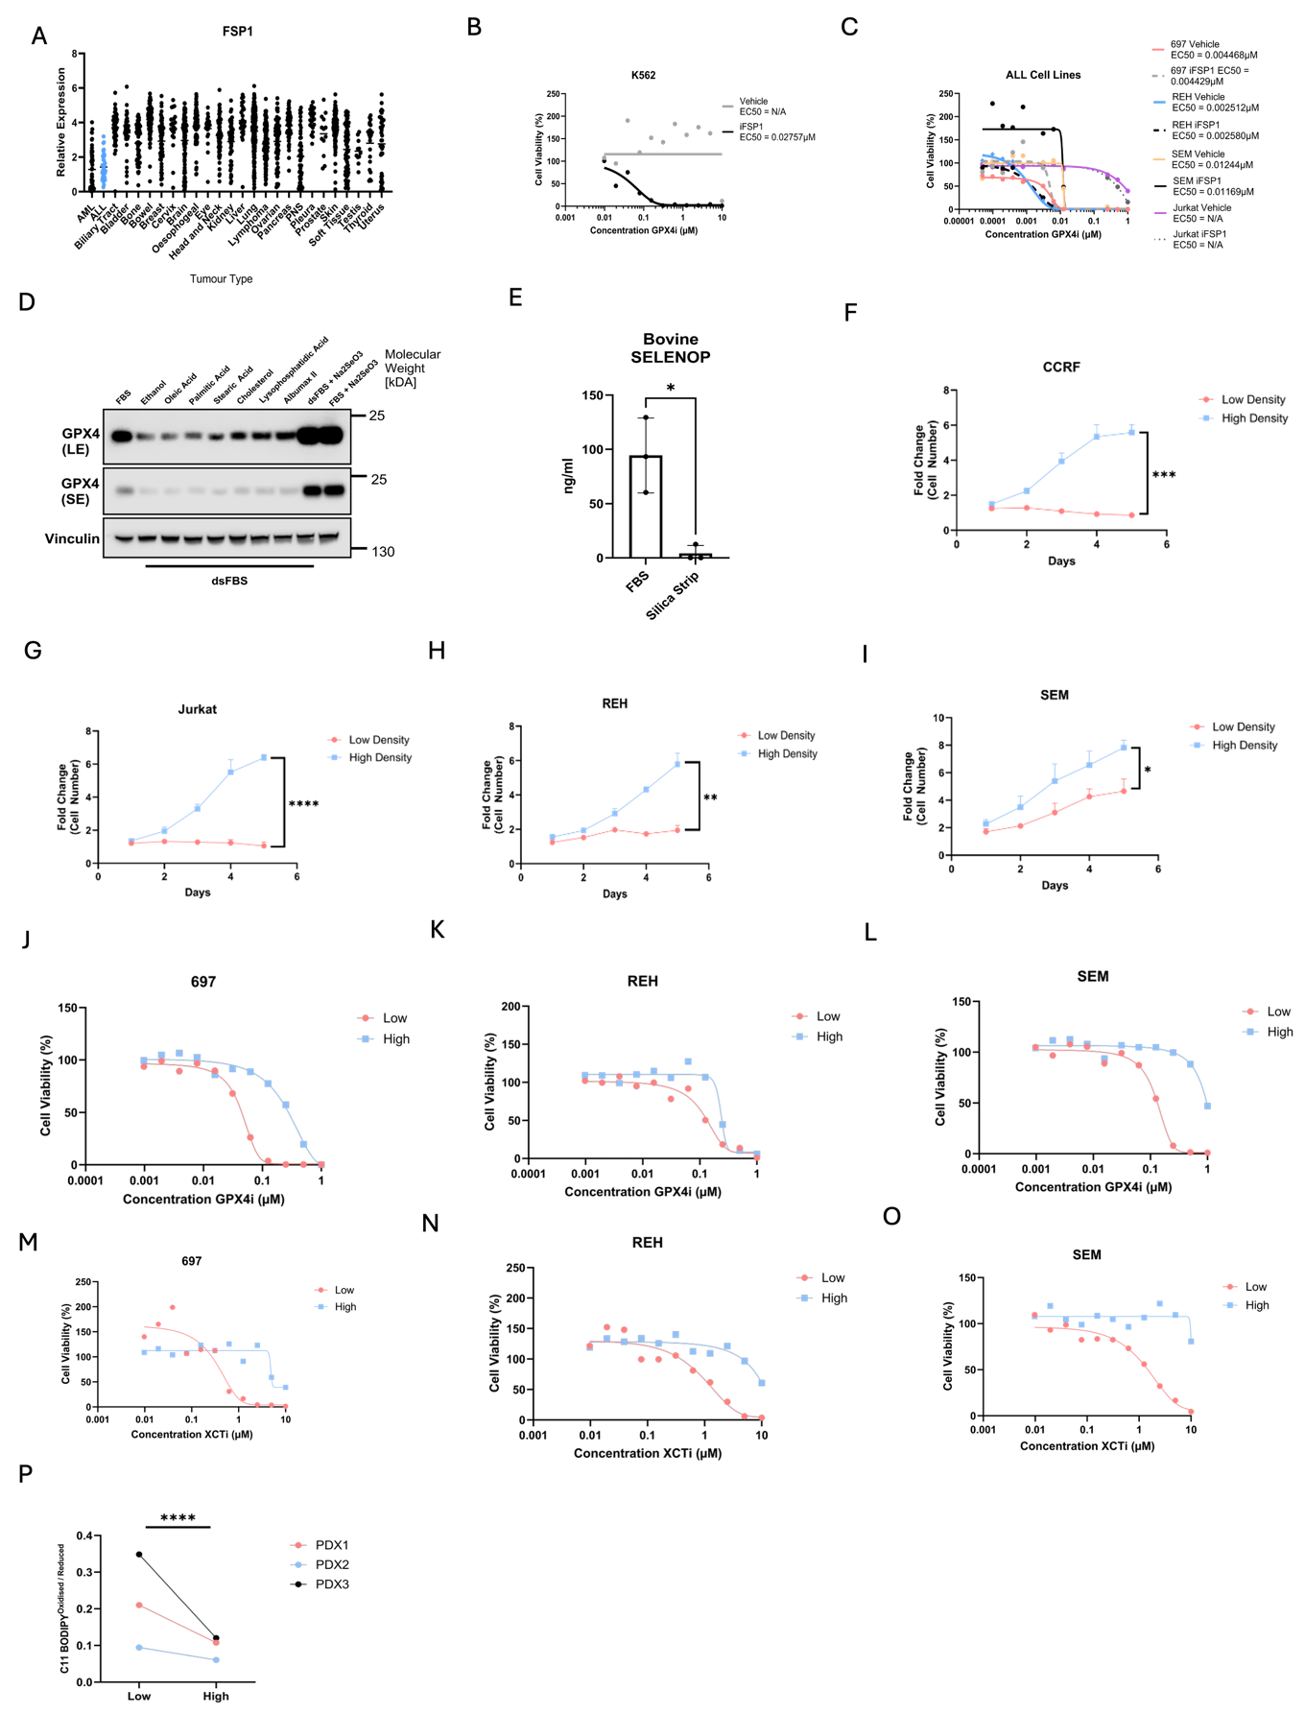

Supplemental Figure 1 - ALL Cells Seeded at Low Cell Density are Primed for Ferroptosis.
(A) FSP1 mRNA expression in ALL cell lines (n = 42) highlighted in blue compared with other tumour types. Data obtained from the DepMap portal. (B) Dose–response to RSL3 in K562 cells, a CML line that expresses FSP1 protein¹², treated with vehicle or 5 µM iFSP1, as positive control for effectiveness of iFSP1. Luminescence for each concentration was normalised to vehicle-treated controls. Data represent 1 of 2 independent experiments. (C) Dose–response to RSL3 (GPX4i) in ALL cell lines treated with vehicle or 5 µM iFSP1. Luminescence for each concentration was normalised to vehicle-treated controls. Points represent the mean of n = 3 independent experiments. (D) Immunoblot images of GPX4 and β-Actin (loading control) in REH cells cultured in 10% FBS / 90% RPMI or 10% dsFBS / 90% RPMI supplemented with 100 µM of individual lipid species, 10 µM cholesterol, 1.6 g/L lipid-rich BSA (Albumax II), or 50 nM Na₂SeO₃, as indicated, 1 representative of n = 2 independent experiments. LE – Long Exposure, SE = Short Exposure (E) Levels of bovine SELENOP in FBS before and after silica stripping. Bar graph represents the mean of n = 3 independent FBS batches. P values were determined by unpaired Student’s t-test. Error bars represent the mean ± SEM. (F–I) Proliferation of CCRF, Jurkat, REH, or SEM cells seeded at low or high density in medium containing 10% dsFBS / 90% RPMI. Data points represent the mean of n = 3 independent experiments. P values were determined by unpaired Student’s t-test comparing fold change on day 4 between low- and high-density cultures. Error bars represent the mean ± SEM. (J-L) Dose–response to RSL3 (GPX4i) in ALL cell lines seeded at low (5000) or high (50,000) cells per well. Luminescence for each concentration was normalised to vehicle-treated controls. Points represent the mean of n = 3 independent experiments. (M-O) Dose–response to Erastin (XCTi) in ALL cell lines treated with vehicle or 5 µM iFSP1. Luminescence for each concentration was normalised to vehicle-treated controls. Points represent the mean of n = 3 independent experiments. (P) Ratio of oxidised/reduced C11-BODIPY 581/591 in three BCP-ALL PDX models seeded at low or high density for 48 hours. Bar graph represent the mean from n = 3 independent PDX lines. P values were determined by two-way ANOVA. Error bars represent mean ± SEM. * P ≤ 0.05 ** P ≤ 0.01 *** P ≤ 0.001 **** P ≤ 0.0001.

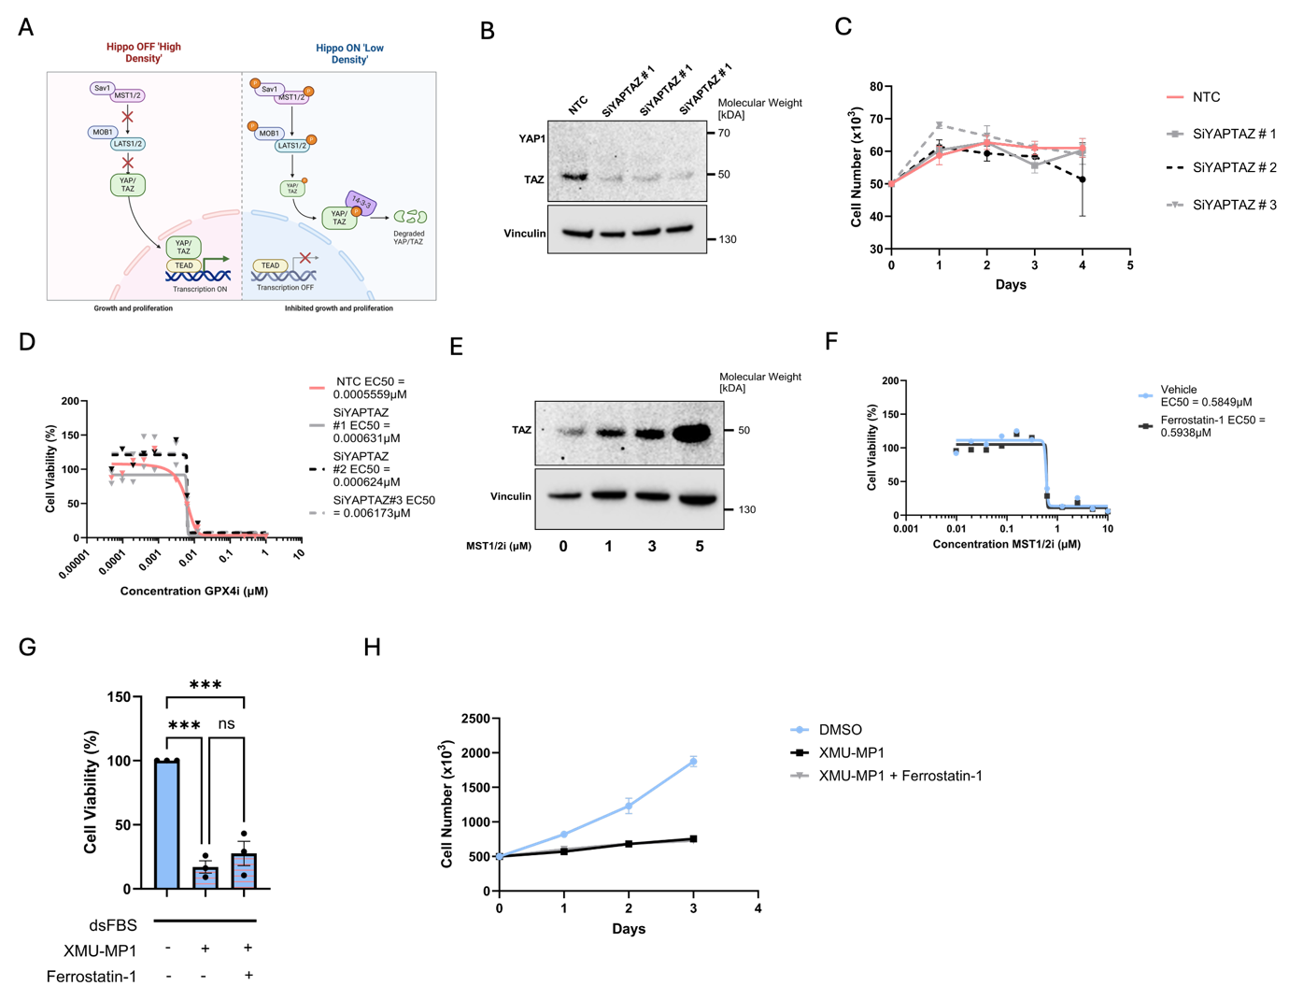
Supplemental Figure 2 - Density Dependant Ferroptosis Occurs Independently from the Hippo Effectors Yap and Taz.
(A) Schematic of the Hippo Kinase Cascade. Created with BioRender.com. (B) Immunoblot images of TAZ and Vinculin (loading control) in REH cells transfected with siNTC or one of three siYAP/TAZ for 48 hours.
(C) Proliferation of REH cells seeded at low density in dsFBS following 48-hour transfection with siYAP/TAZ. Points represent the mean of n = 3 independent experiments. (D) Dose–response to RSL3 in REH cells seeded at 5,000 cells per well in a 96-well plate for 24 hours, following 48-hour transfection with siYAP/TAZ. Luminescence for each concentration was normalised to vehicle-treated controls. Points represent the mean of n = 2 independent experiments. (E) Immunoblot images of TAZ and Vinculin (loading control) in REH cells treated with increasing concentrations of XMU-MP1 for 48 hours. 1 of 2 representative experiments. (F) Dose–response to XMU-MP1 in REH cells with or without 2 µM Ferrostatin-1. Luminescence was normalised to vehicle-treated controls. Points represent the mean of n = 3 independent experiments. (G) ATP-based luminescence readout of REH cells seeded at high density and treated with XMU-MP1 with or without Ferrostatin-1. Luminescence was normalised to untreated controls. Bar graph represent the mean of n = 3 independent experiments. P values were determined by one-way ANOVA with Tukey’s multiple comparisons test. Error bars represent mean ± SEM. (H) Proliferation of REH cells seeded at high density in dsFBS and supplemented with 3 µM XMU-MP1 with or without Ferrostatin-1 for 4 days. n = 2 independent experiments. Error bars represent mean ± SEM. * P ≤ 0.05 ** P ≤ 0.01 *** P ≤ 0.001.

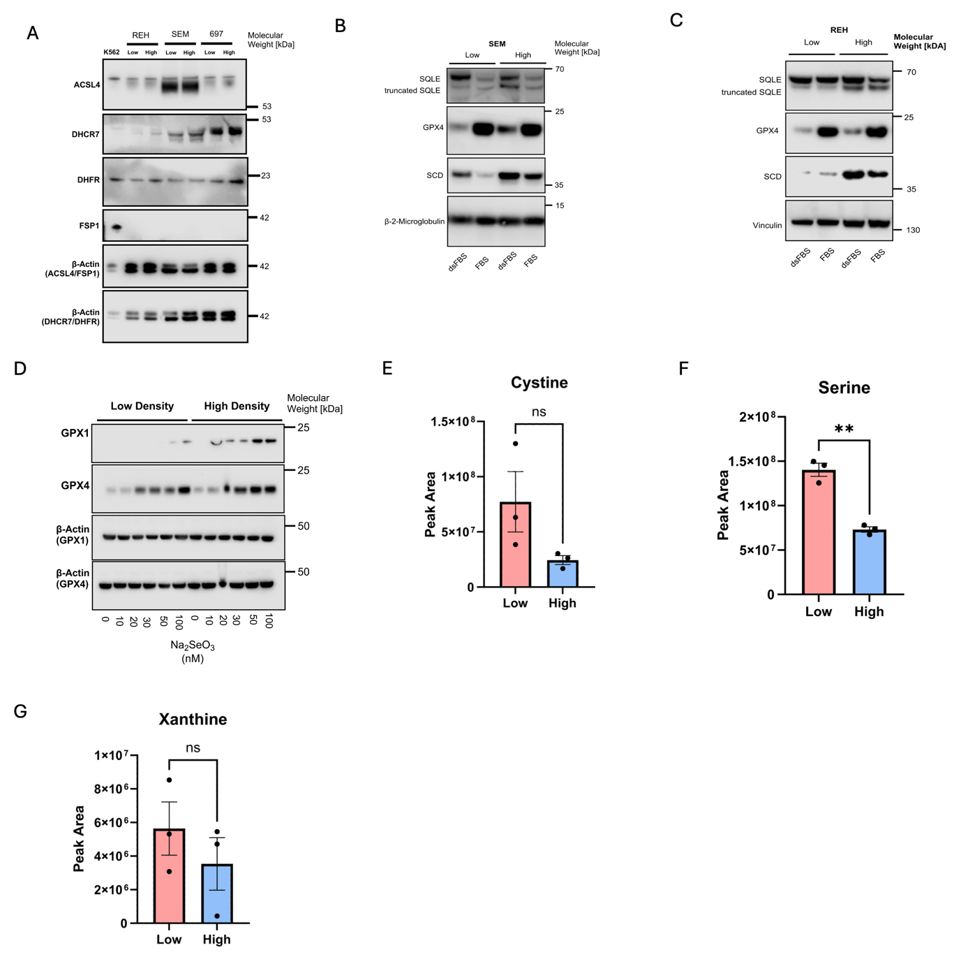
Supplemental Figure 3 - Cell Density Regulates SREBP1 Activity and the Protein Stability of SQLE and GPX4.
(A) Immunoblot images of ACSL4, DHCR7, DHFR, FSP1 and β-Actin (loading control) in 697, REH and SEM cells seeded at low or high density in dsFBS with2 µM Ferrostatin-1. K562 represent a positive control for FSP1. (B) Immunoblot images of GPX4, SCD, SQLE, and β-2microglobulin (loading control) cells in REH seeded at low or high density for 48 hours in FBS or dsFBS with 2 µM Ferrostatin-1 as indicated. 1 representative from n = 2 independent experiments. (C) Immunoblot images of GPX4, SCD, SQLE, and Vinculin (loading control) cells in REH seeded at low or high density for 48 hours in FBS or dsFBS with 2 µM Ferrostatin-1 as indicated. 1 representative from n = 2 independent experiments. (D) Immunoblot images of GPX1, GPX4, and β-actin (loading control) in 697 cells seeded at low or high density in serum-free medium for 48 hours, supplemented with 2 µM Ferrostatin-1 and increasing concentrations of Na₂SeO₃, as indicated. A representative from n = 3 independent experiments. (E-G) Intracellular levels of Cystine, Serine and Xanthine in 697 cells seeded at low or high density 48 hours in dsFBS with 2 µM Ferrostatin-1. Peak area was normalised to cell count and reported as arbitrary units per 10⁶ cells. Bar graph represents the mean of n=3 independent experiments. P values were determined by an unpaired Student’s t test. Error bars represent mean ± SEM.
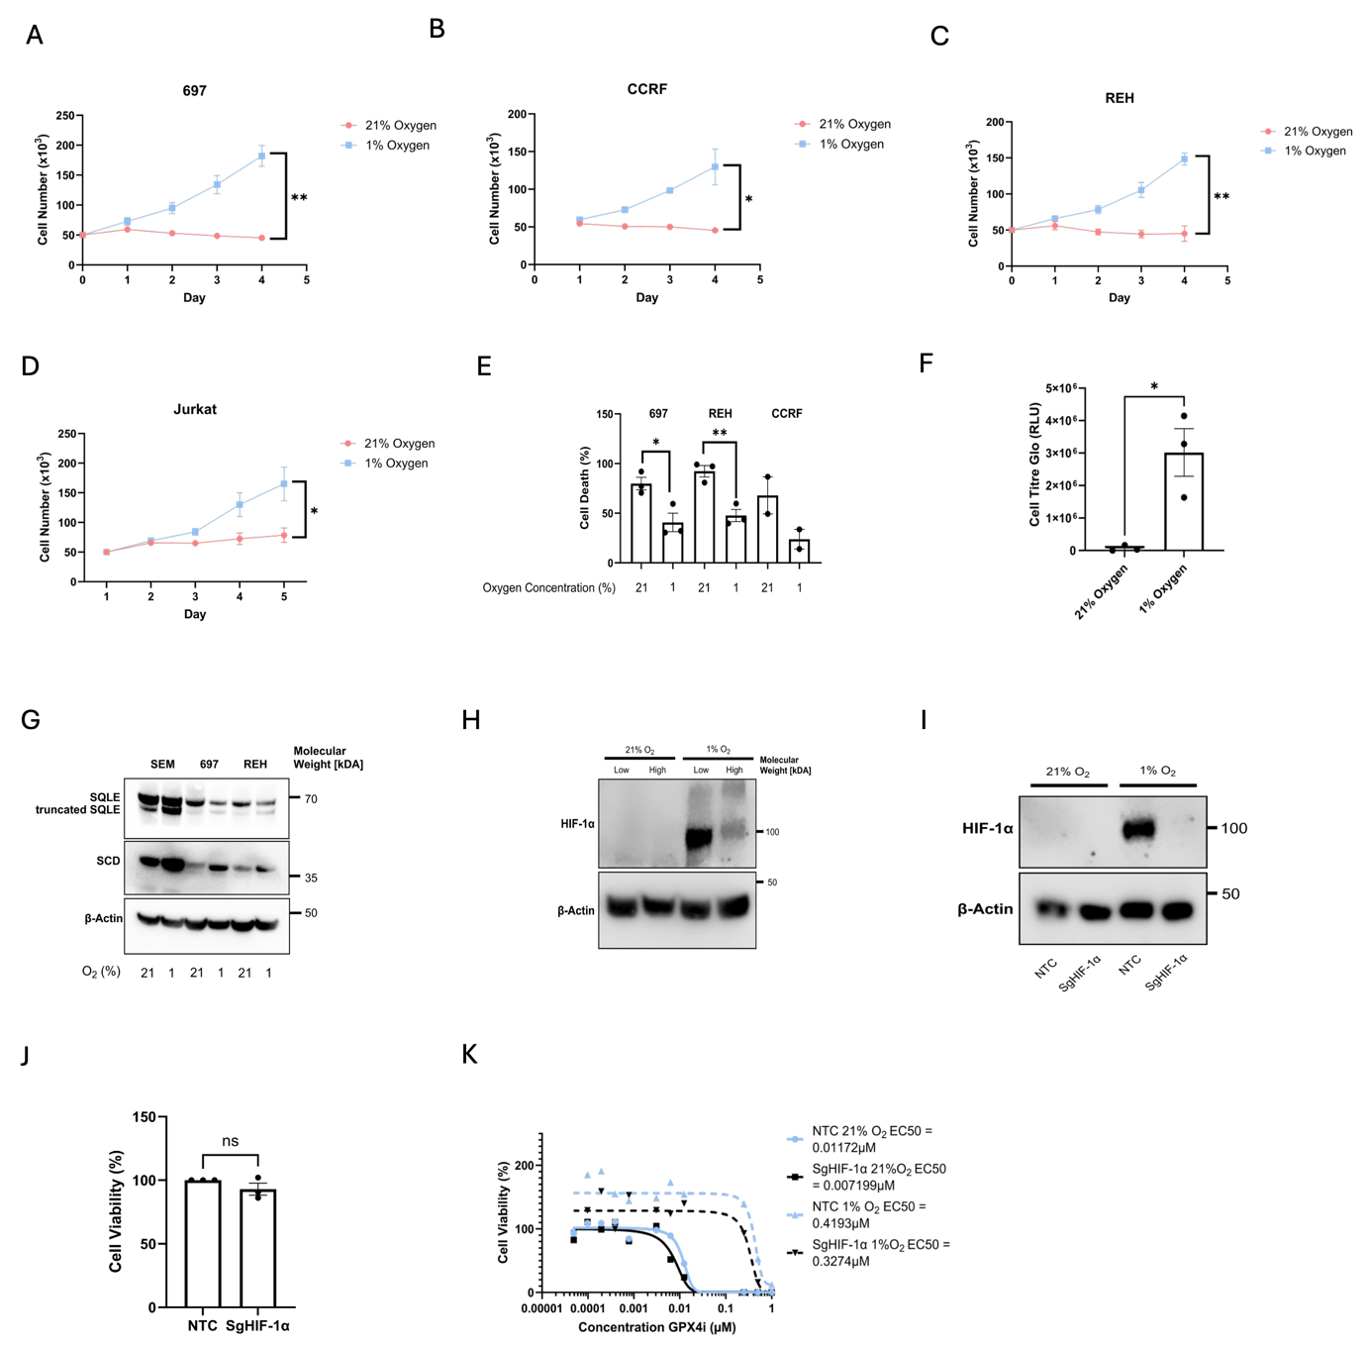

Supplemental Figure 4 - Oxygen availability exacerbates density dependent ferroptosis independently of HIF1-α.
(A–D) Proliferation of 697, Jurkat, CCRF, or REH cells seeded at low density in dsFBS under 21% or 1% O₂ for 4 days. Points represent the mean of n = 3 independent experiments. P values were determined by unpaired Student’s t-test. (E) Relative P.I fluorescence of 697, REH, or CCRF cells cultured in dsFBS at low density for 72 hours in 21% or 1% O₂. Fluorescence was normalised to lethal controls. Bar graph represents the mean of n = 2–3 independent experiments. P values were determined by paired Student’s t-test. Error bars represent mean ± SEM. (F) ATP-based luminescence readout of 697 cells seeded at low density in dsFBS for 72 hours under 21% or 1% O₂. Bar graph represents the mean of n = 3 independent experiments. P values were determined by unpaired Student’s t-test. Error bars represent mean ± SEM. (G) Immunoblot images of SCD, SQLE, and β-actin (loading control) in 697, SEM, or REH cells seeded at low density for 48 hours in dsFBS under 21% or 1% O₂ with 2 µM Ferrostatin-1. 1 representative of n = 3 independent experiments. (H) Immunoblot of HIF-1α and β-actin (loading control) in 697 cells seeded at low or high density for 48 hours in dsFBS under 21% or 1% O₂ with 2 µM Ferrostatin-1. 1 representative from n = 2 independent experiments. (I) Immunoblot images of HIF-1α and β-actin in 697 cells transduced with NTC or sgHIF1α under 21% or 1% O₂. (J) ATP-based luminescence readout of 697 cells transduced with NTC or sgHIF1α and seeded at high density in dsFBS for 72 hours. Luminescence was normalised to NTC controls.Bar graph represents the mean of n = 3 independent experiments. P values were determined by unpaired Student’s t-test. Error bars represent mean ± SEM. (K) Dose–response to RSL3 in 697 cells transduced with NTC or sgHIF1α under 21% or 1% O₂. Luminescence for each concentration was normalised to vehicle-treated controls. n = 3 independent experiments. * P ≤ 0.05 ** P ≤ 0.01

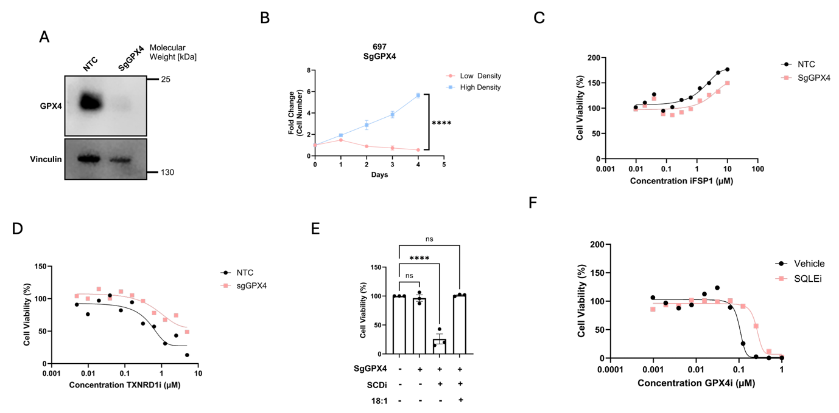
Supplemental Figure 5 - Density Dependent Ferroptosis Resistance Occurs Independently from Canonical NADPH Consuming Ferroptosis Defence Systems.
(A) Immunoblot images of GPX4 and Vinculin (loading control) in 697 cells transduced with NTC or SgGPX4. (B) Proliferation of 697 cells transduced with SgGPX4 seeded at low or high density. Data points represent the mean of n = 3 independent experiments. P-values were determined by an unpaired Student’s t-test comparing fold change on day 4 between low- and high-density cultures. Error bars represent mean ± SEM. (C) Dose–response to iFSP1 in 697 cell lines transduced with NTC or SgGPX4 and seeded at 100,000 cells per well for 48 hours. Luminescence for each concentration was normalised to vehicle-treated controls. Points represent the mean of n = 3 independent experiments. (D) Dose–response to Auranofin (TXNRD1i) in 697 cell lines transduced with NTC or SgGPX4 and seeded at 100,000 cells per well for 48 hours. Luminescence for each concentration was normalised to vehicle-treated controls. Points represent the mean of n = 3 independent experiments. (E) ATP-based luminescence readout of 697 cells transduced with NTC or SgGPX4 seeded at high density for 72 hours and treated with 2.5uM SW203668 (SCDi) with or without 100 µM oleic acid (18:1) as indicated. Bar graph represents the mean of n = 3 independent experiments. Luminescence values were normalised to NTC controls. P values were determined by two-way ANOVA with Tukey’s multiple comparisons test. Error bars represent mean ± SEM. (F) Dose–response to RSL3 (GPX4i) in 697 cell lines pretreated with vehicle or 1µM NB598 seeded at 5000 cells per well for 48 hours. Luminescence for each concentration was normalised to vehicle-treated controls. Points represent the mean of n = 3 independent experiments.

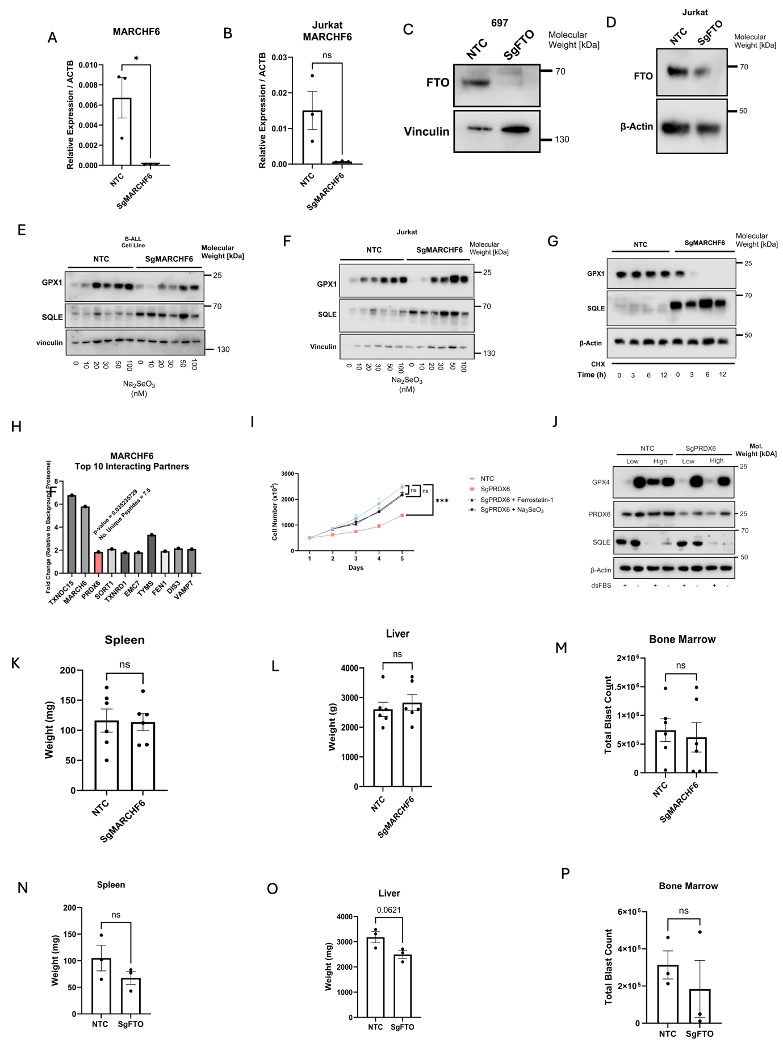
Supplemental Figure 6 - The E3 Ubiquitin Ligase MARCHF6 and m⁶A demethylase FTO are activated by NADPH and Coordinate Cholesterol, Selenocysteine and Fatty Acid Biosynthesis.
(A) qPCR quantification of MARCHF6 mRNA expression in 697 cells transduced with NTC or sgMARCHF6. Expression was normalised to the mean mRNA abundance of ACTB. P values were determined by an unpaired Student’s t-test. Bar graph represents the mean of n = 3 independent replicates. Error bars represent mean ± SEM. (B) qPCR quantification of MARCHF6 mRNA expression in Jurkat cells transduced with NTC or sgMARCHF6. Expression was normalised to the mean mRNA abundance of ACTB. P values were determined by an unpaired Student’s t-test. Bar graph represents the mean of n = 3 independent replicates. Error bars represent mean ± SEM. (C) Immunoblot images of FTO and Vinculin (loading control) in 697 cells transduced with NTC or sgFTO. (D) Immunoblot images of FTO and Vinculin (loading control) in Jurkat cells transduced with NTC or sgFTO. (E) Immunoblot images of GPX1, SQLE, and vinculin (loading control) in 697 cells transduced with NTC or sgMARCHF6, seeded at high density in serum-free medium for 48 hours, supplemented with 2 µM Ferrostatin-1 and increasing concentrations of Na₂SeO₃. A representative of n = 3 independent experiments. (F) Immunoblot images of GPX1, SQLE, and vinculin (loading control) in Jurkat cells transduced with NTC or sgMARCHF6, seeded at high density in serum-free medium for 48 hours, supplemented with 2 µM Ferrostatin-1 and increasing concentrations of Na₂SeO₃. A representative of n = 3 independent experiments. (G) CHX chase experiment in 697 cells transduced with NTC or sgMARCHF6 and seeded at high density in dsFBS. Left: representative immunoblot images of GPX1, SQLE and β-Actin (loading control) from n = 3 independent experiments. (H) Top 10 interaction partners of MARCHF6 obtained from Fenech et al. (I) Proliferation of 697 cells transduced with NTC or SgPRDX6 seeded at low or high density. Data points represent the mean of n = 3 independent experiments. P-values were determined by an unpaired Student’s t-test comparing fold change on day 4 between low- and high-density cultures. Error bars represent mean ± SEM. (J) Immunoblot images of GPX4, PRDX6, SQLE and β-actin cultured at low and high density in FBS or dsFBS supplemented with 2uM Ferrostatin-1 for 48 hours. 1 Representative image from n=3 independent experiments. (K-M) Leukaemic burden assessed in (K) spleen (weight), (L) liver (weight), and (M) bone marrow (blast counts) in NSG mice xenografted with NTC or sgMARCHF6 697 cells. Bar graphs represent n = 6 mice per cohort. P values were determined by unpaired Student’s t-test. Error bars represent the mean ± SEM. (N-O) Leukaemic burden assessed in (N) spleen (weight), (O) liver (weight), and (P) bone marrow (blast counts) in NSG mice xenografted with NTC or sgFTO 697 cells. Bar graphs represent n = 3 mice per cohort. P values were determined by unpaired Student’s t-test. Error bars represent the mean ± SEM.

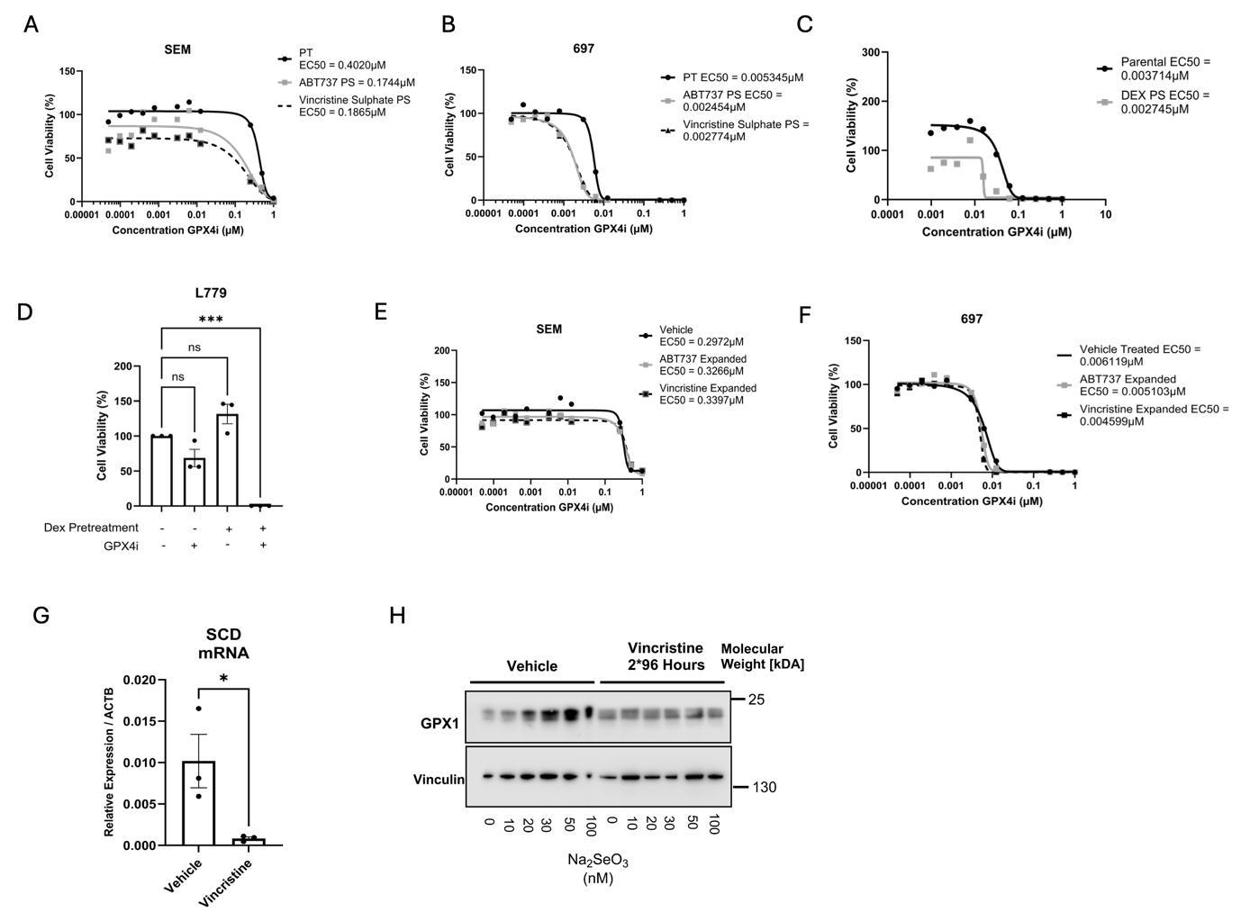
Supplemental Figure 7 – ALL Cells at Minimal Residual Disease Co-opt Density Dependant NADPH Metabolic Rewiring in vitro.
(A–C) Dose–response to RSL3 in 697 or SEM cells pretreated with sublethal concentrations (PS) of ABT737 (300 nM for 697, 200 nM for SEM), vincristine sulphate (2.5 nM for 697, 5 nM for SEM), or dexamethasone (85 nM) for 96 hours, then treated with RSL3 for 24 hours. Luminescence was normalised to vehicle-treated controls (PT). Points represent the mean of n = 3 independent experiments. (D) ATP-based luminescence readout in L779 PDX cells pretreated for 72 hours with vehicle or 1.5 µM dexamethasone, followed by vehicle or 200 nM 1S,3R-RSL3 for 24 hours. Bar graph represent the mean of n = 3 independent experiments. P values were determined by one-way repeated measures ANOVA with Dunnett’s multiple comparisons test. Error bars represent the mean ± SEM. (E–F) Dose–response to RSL3 in 697 or SEM cells pretreated with ABT737 or vincristine sulphate for 96 hours, washed for 96 hours, then treated with RSL3 for 24 hours. Points represent the mean of n = 2 independent experiments. (G) qPCR quantification of SCD mRNA expression in 697 cells seeded at high density and treated with vehicle or 2.5 nM vincristine sulphate for 8 days (2 × 96 hours). Expression was normalised to ACTB. Bar graph represents the mean of n=3 independent replicates. P values were determined by unpaired Student’s t-test. Error bars represent the mean ± SEM. (H) Immunoblot images of GPX1 and Vinculin (loading control) in 697 cells treated with vehicle or 2.5 nM vincristine sulphate for 8 days (2 × 96 hours), then seeded at high density in serum-free medium supplemented with 2 µM Ferrostatin-1 and increasing concentrations of Na₂SeO₃. 1 representative of n = 3 independent experiments. * P ≤ 0.05 ** P ≤ 0.01 *** P ≤ 0.001.
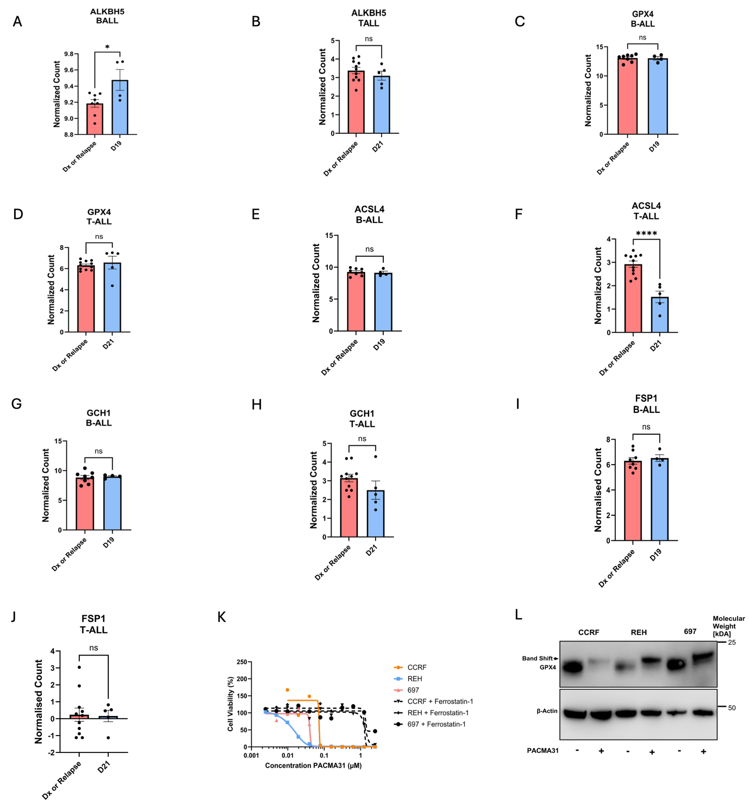
Supplemental Figure 8 - ALL Patients at MRD Exhibit NADPH mediated Transcriptional Rewiring, priming primary ALL cells for GPX4 Inhibition in vivo.
(A, B) ALKBH5 levels in B-ALL (A) and T-ALL (B) cells at diagnosis, relapse, and Day 19 (B-ALL) or Day 21 (T-ALL) of induction therapy. P values were determined by unpaired Student’s t-test. Error bars represent the mean ± SEM. (C–J) Expression of ferroptosis-regulating genes in B-ALL or T-ALL cells at diagnosis, relapse, and Day 19 or 21 of chemotherapy treatment, respectively. P values were determined by unpaired Student’s t-test. Error bars represent the mean ± SEM. (K) Dose–response to PACMA31 in 697, REH, and CCRF cells with or without 2 µM Ferrostatin-1. Luminescence was normalised to vehicle-treated controls. Points indicate the mean of n = 3 independent experiments. (L) Immunoblot images of GPX4 and β-actin (loading control) in CCRF, REH, and 697 cells treated with 250 nM PACMA31 for 24 hours, supplemented with 2 µM Ferrostatin-1. * P ≤ 0.05 **** P ≤ 0.0001.

