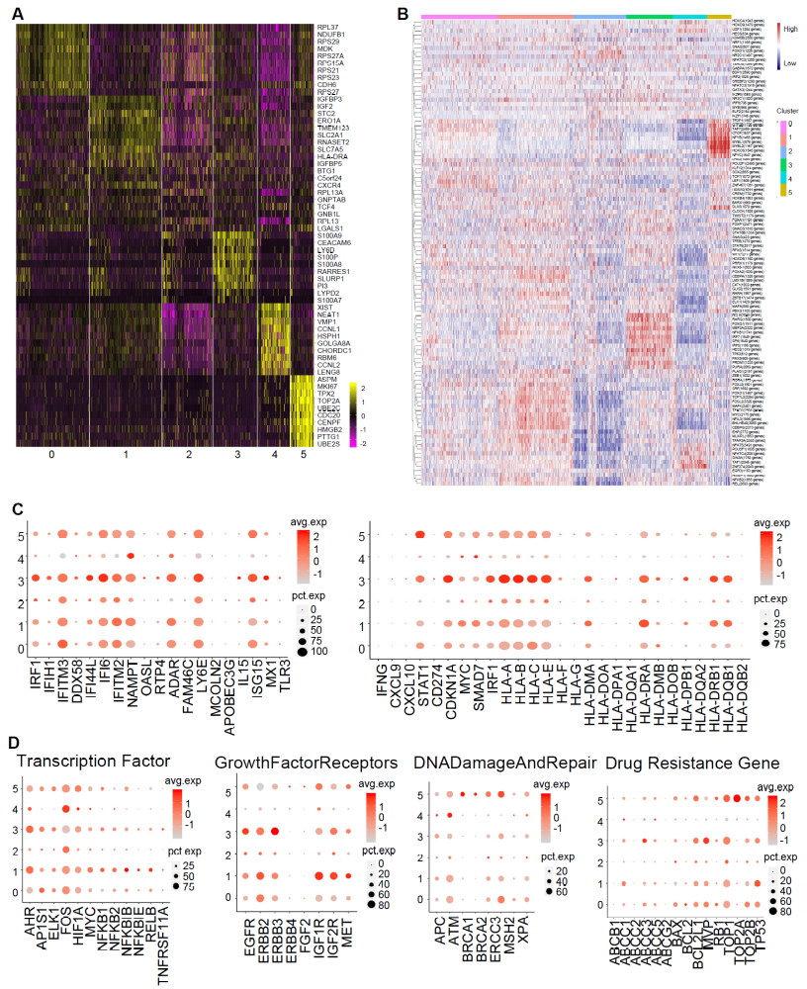
Figure S1. Characterization of epithelial cell subtypes in OCS tumor. (A) Heatmap showing expression levels for marker genes with subpopulation-specific patterns in OCS epithelial cells. (B) Heatmap of the area under the curve score of expression regulation by transcription factors, as estimated using SCENIC. (C) Dot plots showing expression levels of specific IFN response genes in each cell subcluster. (D) Dot plots showing expression levels of specific drug resistance-related genes in each cell subcluster.

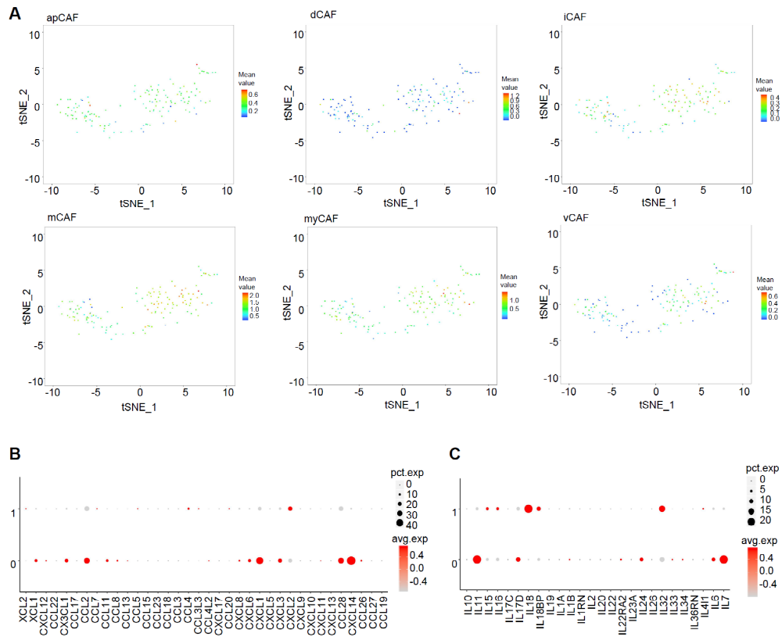
Figure S2. Characterization of fibroblast subtypes in OCS tumor. (A) tSNE plots for distinct CAF subtype scores in each single fibroblast cell. Color key from blue to red indicates relative mean value from low to high. (B) Dot plots showing expression levels of specific chemokine (left) and interleukin (right) genes in each cell subcluster.
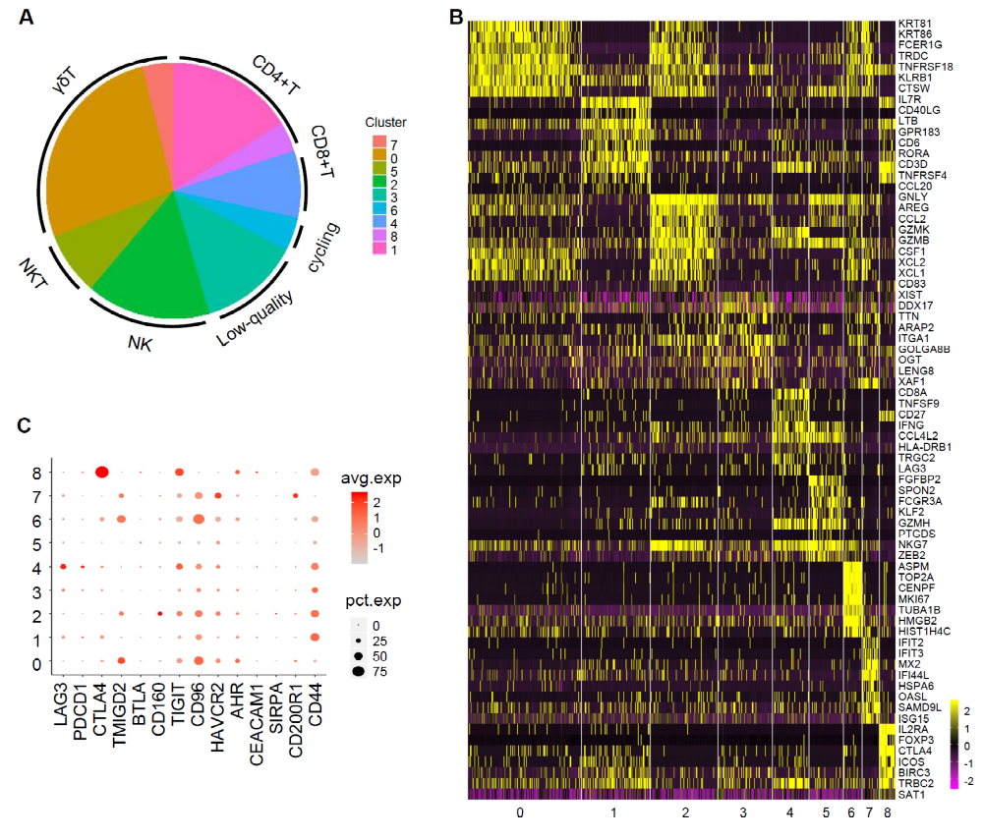
Figure S3. Characterization of T cell and NK cell subtypes in OCS tumor. (A) The abundance of each cell subcluster in OCS tissue. (B) Heatmap showing expression levels for marker genes with subpopulation-specific patterns in OCS T and NK cells. (C) Dot plots showing expression levels of specific immune checkpoint suppressive genes in each cell subcluster.
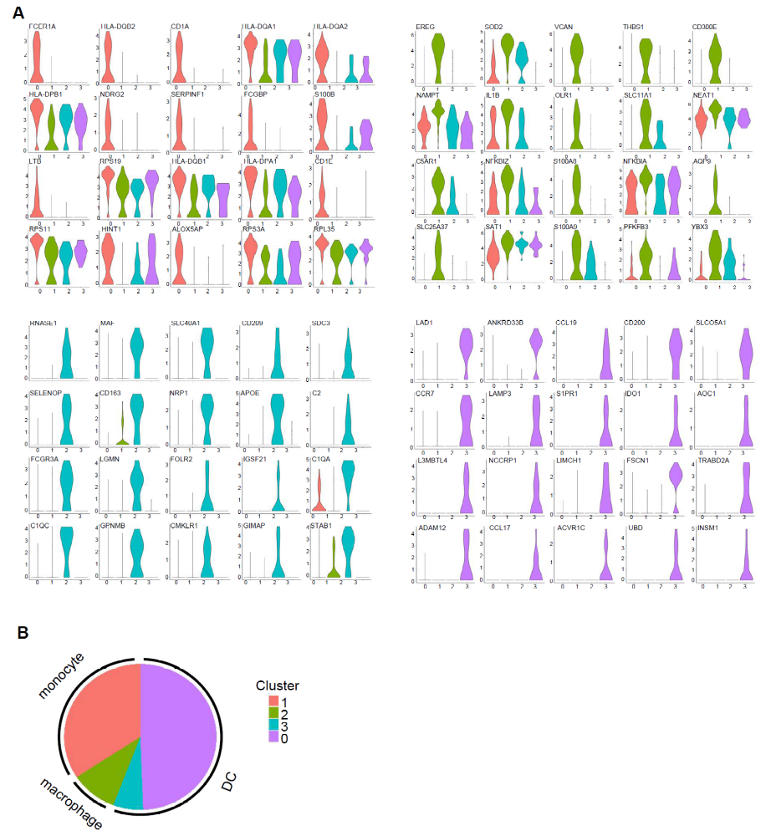
Figure S4. Characterization of myeloid cell subtypes in OCS tumor. (A) Violin plots showing expression levels for marker genes with subpopulation-specific patterns in OCS myeloid cells. (B) The abundance of each myeloid cell subcluster in OCS tissue.
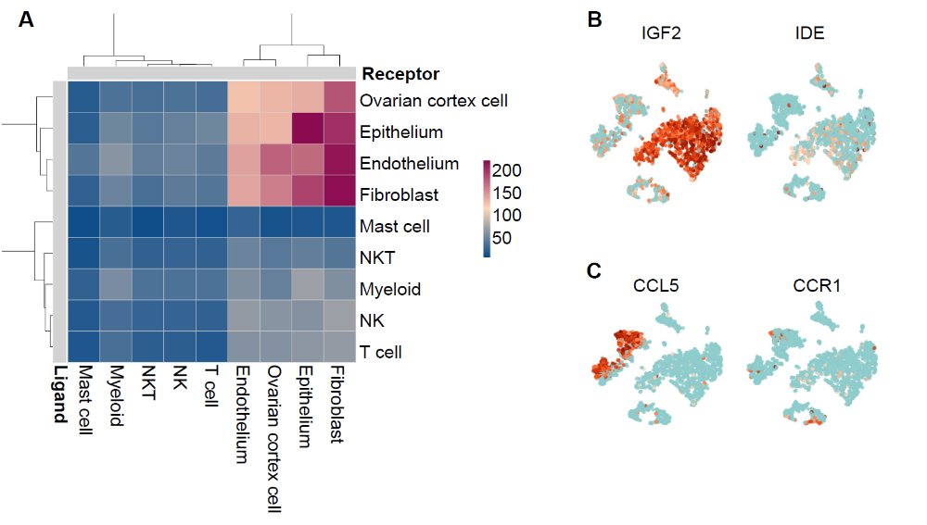
Figure S5. Characterization of cell communications in OCS tumor. (A) Heatmap showing the ligand-receptor interactions among OCS cell types. (B) tSNE plots, color-coded for the expression (green to orange) of IGF2 and IDE in OCS tissue. (C) tSNE plots, color-coded for the expression (green to orange) of CCL5 and CCR1 in OCS tissue.

