Supplementary information: Controllable spatiotemporal mode-locking in solid-state lasers
Hongyu Liu^{1,†}, Kunjian Dai^{2,†}, Lisong Yan^{1,†}, Qian Cao^{3,†}, Heyan Liu¹, Qingzhe Cui¹, Hongshan Chen¹, Shenao Zhang¹, Xin Liu¹, Qing Wang^{4,*}, Qiwen Zhan^{3,*}, and Jinwei Zhang^{1,*}

1, School of Optical and Electronic Information and Wuhan National Laboratory for Optoelectronics, Huazhong University of Science and Technology, Wuhan, China
2, Department of Biomedical Engineering, The Chinese University of Hong Kong, Shatin, New Territories, Hong Kong, China
3, School of Optical-Electrical and Computer Engineering, University of Shanghai for Science and Technology, Shanghai, China.
4, School of Optics and Photonics, Beijing Institute of Technology, Beijing, China

†These authors contributed equally to this work.
*Corresponding author: qingwang@bit.edu.cn; qwzhan@usst.edu.cn; jinweizhang@hust.edu.cn

Contents
1 ABCD matrix theory for realization of transverse mode-locking
2 Theoretical analysis of transverse mode-locking
3 Cylindrical lens mode converter
4 Analysis of the spatiotemporal structure of multi-pulse outputs
5 4-path ray-wave duality results
6 Gain and loss analysis for pumping scheme along Path 4
7 Gain and loss analysis for pumping scheme along other Paths
8 Demonstration of Video 3 about the pulse generation dynamics under SPI-STML mechanism
9 Temporal and spectral results for the SPI-STML events

1 ABCD matrix theory for realization of transverse mode-locking
In a laser resonator, a laser beam starts from one end mirror, propagates along the cavity, gets reflected and transmitted from mirror, and finally after one roundtrip, travels back to the original position with the same state, equal amplitude and phase, which can be considered as the self-realization of a beam mode. With resonance conditions changing, such as the pumping and intracavity mirror adjustment, the resonated laser mode may not be aligned with the cavity axis and cannot realize itself after one roundtrip. When the condition satisfies, the laser mode will realize itself after N roundtrips and the intracavity light trajectory will show a spatial structure. This phenomenon is called ray-wave duality, or in some references, transverse mode-locking, considering its complex transverse mode resonance. ABCD matrix method is commonly utilized to analyze the stability of a laser resonator and an appropriate tool to solve problems involving complicated spatial resonance.
To show the advantage of using a sophisticated femtosecond laser oscillator, we will use ABCD matrix method to calculate the condition for realizing ray-wave duality between a plano-concave cavity and the proposed femtosecond laser cavity. We assume a plano-concave laser cavity with a cavity length of L and its concave mirror with a curvature of radius of R. The intracavity propagating laser beam starts from the plano mirror, travels a distance of L, gets reflected from the concave mirror, travels another L, gets reflected from the plano mirror and finishes one roundtrip. This process can be demonstrated by the following ABCD matrix calculation:
$\left(\begin{matrix}r_{1} \\ θ_{1}\end{matrix}\right)=M_{plano}M_{L}M_{concave}M_{L}\left(\begin{matrix}r \\ θ\end{matrix}\right)=\left(\begin{matrix}1 & 0 \\ 0 & 1\end{matrix}\right)\left(\begin{matrix}1 & L \\ 0 & 1\end{matrix}\right)\left(\begin{matrix}1 & 0 \\ -\frac{2}{R} & 1\end{matrix}\right)\left(\begin{matrix}1 & L \\ 0 & 1\end{matrix}\right)\left(\begin{matrix}r \\ θ\end{matrix}\right)$ (1)
$M=M_{plano}M_{L}M_{concave}M_{L}$ (2)
where $M_{plano}$, $M_{L}$, $M_{concave}$ are the ABCD matrices for plano mirror, propagation distance of L, concave mirror, respectively. $\left(\begin{matrix}r \\ θ\end{matrix}\right)$ represents the initial beam location $r$ and propagation direction $θ$, and $\left(\begin{matrix}r_{1} \\ θ_{1}\end{matrix}\right)$ is the beam status after one roundtrip. $M$ is the ABCD matrix for the cavity.
Now let’s consider the ray-wave duality. If the resonated laser beam reveals itself after N trips, the ABCD matrix theory becomes the following format,
$\left\{\begin{matrix}\left(\begin{matrix}r_{N} \\ θ_{N}\end{matrix}\right)=M^{N}\left(\begin{matrix}r \\ θ\end{matrix}\right) \\ r_{N}=r,θ_{N}=θ \\ M^{N}=I and M^{N^{'}}≠I,N^{'}<N \end{matrix}\right.$ (3)
It turns out if the laser beam propagates along intracavity trajectory and after N roundtrips the ray-wave duality is completed, the N-roundtrip ABCD matrix will equal to an identity matrix, and it must be satisfied that the ray-wave duality cannot be satisfied before the N-roundtrip. By solving Eq. (3), we get table I, showing the relationship between the cavity length $L$ and the radius of curvature $R$ of the concave mirror. Please note that when the roundtrip number becomes large, the multi-roundtrip ABCD matrix gets very complicated. As a result, we don’t get the analytical solution for 7- and 9-roundtrips. Here a special case is 2 roundtrips, in which there are no analytical and numerical solutions. It is easy to realize the 2-roundtrip ray-wave duality using a symmetrical confocal cavity, while with a plano-concave cavity it is impossible. However, for 7- and 9-roundtrips, the numerical solutions can be calculated, and the approximate results are listed in the table. Another interesting point is that, for some cases, there are multiple solutions, such as the 5-, 8-, and 10-roundtrips. This is because we are calculating Eq. (3) under the approximation of ray optics. If we additionally consider the propagation rule of Gaussian beams, the shortest cavity lengths for these cases are the most reasonable.
Table I Realization of ray-wave duality in a plano-concave cavity
Paths of ray-wave duality | 2 | 3 | 4 | 5 | 6 | 7 | 8 | 9 | 10
Cavity Length L | NaN | $$\frac{3R}{4}$$ | $$\frac{R}{2}$$ | $$\frac{5±\sqrt{5}}{8}R$$ | $$\frac{R}{4}$$ | NaN | $$\frac{2±\sqrt{2}}{4}R$$ | NaN | $$\frac{3±\sqrt{5}}{8}R$$
Cavity Length L (R=200 mm) | NaN | 150 | 100 | 69.1 180.9 | 50 | 37.7 122.3 190.1 | 29.3 170.7 | 23.4 82.6 194.0 | 19.1 130.9

Next, we do the same analysis with our sophisticated femtosecond laser oscillator. The GTI mirror, DM, HR mirrors, and OC can be considered as flat mirrors which have a ABCD matrix of $\left(\begin{matrix}1 & 0 \\ 0 & 1\end{matrix}\right)$. The ABCD matrix of the Yb:KGW crystal can be combined into the propagation between R2 and R3. For simplicity, the laser oscillator can be considered as combination of two end flat mirrors and three concave mirrors, consisting of four propagation lengths and three concave reflections. We change the distance between the SESAM and R1, which means $L_{1}$ in Eq. (4) work as unknow parameter. The one roundtrip ABCD matrix is named as $M_{fs}$. Then the one roundtrip matrix can be calculated as follows.
$$\left(\begin{matrix}r_{1} \\ θ_{1}\end{matrix}\right)=M_{plano}M_{L_{1}}M_{R_{1}}M_{L_{2}}M_{R_{2}}M_{L_{3}}M_{R_{3}}M_{L_{4}}M_{plano}M_{L_{4}}M_{R_{3}}M_{L_{3}}M_{R_{2}}M_{L_{2}}M_{R_{1}}M_{L_{1}}\left(\begin{matrix}r \\ θ\end{matrix}\right)=\left(\begin{matrix}1 & 0 \\ 0 & 1\end{matrix}\right)\left(\begin{matrix}1 & L_{1} \\ 0 & 1\end{matrix}\right)\left(\begin{matrix}1 & 0 \\ -\frac{2}{R_{1}} & 1\end{matrix}\right)\left(\begin{matrix}1 & L_{2} \\ 0 & 1\end{matrix}\right)\left(\begin{matrix}1 & 0 \\ -\frac{2}{R_{2}} & 1\end{matrix}\right)\left(\begin{matrix}1 & L_{3} \\ 0 & 1\end{matrix}\right)\left(\begin{matrix}1 & 0 \\ -\frac{2}{R_{3}} & 1\end{matrix}\right)\left(\begin{matrix}1 & L_{4} \\ 0 & 1\end{matrix}\right)\left(\begin{matrix}1 & 0 \\ 0 & 1\end{matrix}\right)∙$$
$\left(\begin{matrix}1 & L_{4} \\ 0 & 1\end{matrix}\right)\left(\begin{matrix}1 & 0 \\ -\frac{2}{R_{3}} & 1\end{matrix}\right)\left(\begin{matrix}1 & L_{3} \\ 0 & 1\end{matrix}\right)\left(\begin{matrix}1 & 0 \\ -\frac{2}{R_{2}} & 1\end{matrix}\right)\left(\begin{matrix}1 & L_{2} \\ 0 & 1\end{matrix}\right)\left(\begin{matrix}1 & 0 \\ -\frac{2}{R_{1}} & 1\end{matrix}\right)\left(\begin{matrix}1 & L_{1} \\ 0 & 1\end{matrix}\right)\left(\begin{matrix}r \\ θ\end{matrix}\right)$ (4)
$M_{fs}=M_{plano}M_{L_{1}}M_{R_{1}}M_{L_{2}}M_{R_{2}}M_{L_{3}}M_{R_{3}}M_{L_{4}}M_{plano}M_{L_{4}}M_{R_{3}}M_{L_{3}}M_{R_{2}}M_{L_{2}}M_{R_{1}}M_{L_{1}}$ (5)
Same with Eq. (3), we can use the following equation to calculate the condition for satisfying transverse mode-locking.
$\left\{\begin{matrix}\left(\begin{matrix}r_{N} \\ θ_{N}\end{matrix}\right)=M_{fs}^{N}\left(\begin{matrix}r \\ θ\end{matrix}\right) \\ r_{N}=r,θ_{N}=θ \\ M_{fs}^{N}=I and M_{fs}^{N^{'}}≠I,N^{'}<N \end{matrix}\right.$ (6)

Considering Eqs. (4-6) are so complex that it is hard to get the analytical solution, we calculate the numerical solutions based on the parameters of the experimental setup. The theoretical results of L1 for realization of different paths of ray-wave duality are listed in Table II.

Table II Realization of ray-wave duality in the proposed open-cavity oscillator
Paths of ray-wave duality | 2 | 3 | 4 | 5 | 6 | 7 | 8 | 9 | 10
L1 (mm) | NaN | 59.6 | 64.6 | 67.7 | 69.6 | 70.9 | 71.7 | 72.3 | 72.7

From the simulated results in Table II, the adjustment of the distance of L1 is within several millimeters, facilitating the transition between different transverse mode-locking schemes very conveniently. As a comparison, for a simple two-mirror plano-concave oscillator with a cavity length of 200 mm, achieving the same transition requires an adjustment of tens of millimeters, which not only greatly changes the laser cavity, but the design is also far away from the requirement for generating ultrashort femtosecond lasers. However, to achieve transverse mode-locking in a femtosecond laser resonator consisting of multiple mirrors demands minimum change to the laser cavity, facilitating the transverse mode-locking with only millimeter adjustment.

2 Theoretical analysis of transverse mode-locking
The ABCD matrix theory and ray transfer matrix analysis presented in Supplementary Note 1 predict the geometric conditions required for the formation of periodic ray trajectories. Crucially, this geometric condition is not merely a ray-optics constraint but constitutes the fundamental prerequisite for mode superposition: frequency degeneracy. In the wave-optics picture, the geometric parameters derived in Note 1 ensure that the Gouy phase shift accumulated per roundtrip leads to a precise alignment of resonance frequencies for different high-order transverse modes (i.e., their frequency differences equal integer multiples of the longitudinal mode spacing). This frequency degeneracy allows a family of distinct high-order modes to oscillate simultaneously within the cavity and establish fixed phase relationships, thereby forming the basis for spatiotemporal mode-locking. Thus, the geometric condition for stable ray orbits is intrinsically consistent with the wave condition for coherent mode superposition.
In our solid-state laser oscillator, the formation of the multi-path beam pattern is the result of the coherent superposition of a family of frequency-degenerate transverse modes, which is referred to as transverse mode-locking. Under the specific cavity configuration where the cavity length and mirror curvatures satisfy the degeneracy condition, multiple higher-order transverse modes share identical resonance frequencies (or phase shifts modulo 2π). In a Cartesian symmetry cavity (such as ours, defined by the Z-shaped folding), the eigenmodes are Hermite-Gaussian (HG_{m,0}) modes. The total intracavity field $E(x,y,z)$can be described as a linear superposition of these degenerate eigenmodes:
$$E(x,y,z)=\sum_{m,0}{ }c_{m,0}HG_{m,0}(x,y,z)e^{iϕ_{m,0}}$$
where $c_{m,0}$ represents the amplitude coefficient which follows a theoretical Poisson distribution and $ϕ_{m,0}$ is the relative phase of each mode. When the cavity is tuned to the degeneracy point, the phase differences between these modes become locked, leading to a stable interference pattern that manifests as the spatially separated multi-spot trajectory observed in experiments.
To theoretically verify that the observed 5-path ray-wave duality corresponds to transverse mode-locking, we performed a numerical simulation by superposing a series of high-order HG modes. As the experimentally observed spots are distributed horizontally, we consider the superposition of HG_{m,0} modes. Figure 1b in the main text illustrates the simulation results. We selected a basis set of HG modes ranging from m=15 to m=55 (specifically including HG_{15,0}, HG_{20,0}, HG_{25,0}, …, HG_{15,0}). As shown in Fig. 1b, individual high-order HG modes (e.g., HG_{15,0} and HG_{55,0}) exhibit wide spatial distributions and specific nodal patterns. However, when these modes are coherently superposed, their interference leads to constructive peaks at specific spatial locations, forming a localized multi-spot beam pattern shown in the Ray-wave duality panel. The simulated intensity distribution and the propagation path closely match the experimentally observed 5-path trajectory. This confirms that the geometric rays are essentially the caustics of the phase-locked superposition of degenerate high-order transverse modes.

To further clarify the physical origin and differentiate STML from incoherent geometric ray bouncing (a hypothesis where rays propagate with random phase fluctuations), we investigated the ray-wave duality of the system. While the output field can be intuitively modeled as the superposition of bouncing rays, valid laser operation strictly requires phase coherence among these rays to satisfy the self-consistency condition of the cavity. We performed rigorous wave-optical simulations reconstructing the optical fields using the geometric ray model under two conditions: (i) Locked Phase (STML), where rays maintain a fixed coherent phase relationship; and (ii) Random Phase, where random phase fluctuations are introduced to simulate incoherent bouncing. Figure S1 presents the comparison of the direct ray output fields between these two scenarios. The simulation shows that the intracavity intensity distributions of the Locked and Random states appear nearly identical (Fig. S1a vs. S1d). This similarity explains why the incoherent ray bouncing model is intuitively appealing—intensity measurements alone mask the underlying phase incoherence. However, the phase maps reveal a fundamental difference. The STML state exhibits a highly ordered phase distribution, characterized by a regular and continuous evolution of the phase wavefronts (represented by regular color changes in Fig. S1b). In contrast, the Random state displays a chaotic phase distribution, where abrupt phase jumps and disordered color changes occur between different spatial regions (Fig. S1e). This discontinuity indicates a lack of global wavefront coherence. To provide definitive proof of the underlying mechanism, we performed a modal decomposition of the optical fields generated by the ray model. By projecting the reconstructed ray fields onto the Hermite-Gaussian basis, we obtained the modal spectra. The STML state perfectly follows a Poisson distribution (Fig. S1c), which is the signature of a macroscopic coherent state (displacement eigenstate). This confirms that the "bouncing ray" is physically equivalent to a coherent superposition of locked eigenmodes. In contrast, the Random Phase model yields a chaotic, jagged spectrum (Fig. S1f) with fluctuating mode weights. Since physical laser systems naturally evolve towards low-loss, ordered eigenstates, the high stability and repeatability of our experimental results confirm that the observed phenomenon is governed by the STML mechanism with strict phase locking.
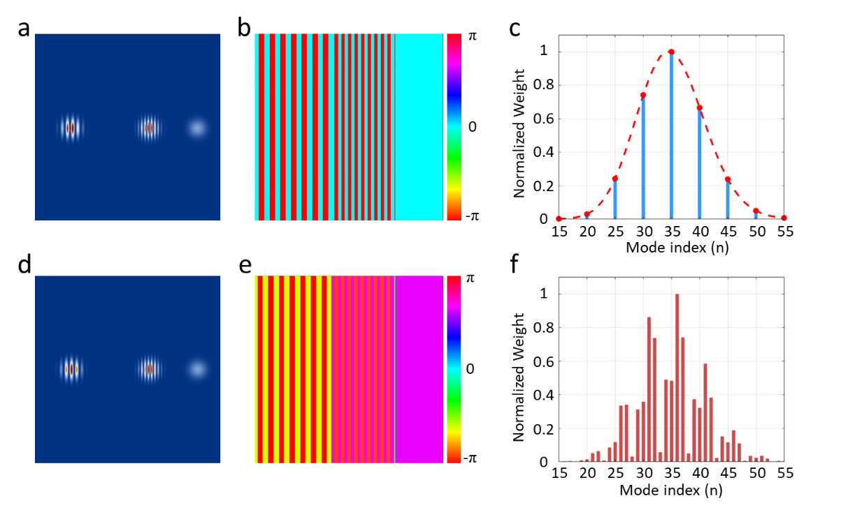
Fig. S1. Comparison of the direct ray output fields and modal spectra under locked and random phase conditions. (a-c) Locked Phase (STML) state: (a) The intensity distribution shows spatially separated spots. (b) The phase map exhibits a regular and ordered distribution, indicated by the continuous and periodic variation of colors. (c) The modal spectrum perfectly fits a theoretical Poisson distribution (red dashed line), identifying the state as a macroscopic coherent state. (d-f) Random Phase state: (d) The intensity profile mimics the locked case. (e) The phase map reveals chaotic discontinuities, characterized by disordered color changes and abrupt phase jumps. (f) The modal decomposition yields a chaotic, jagged spectrum, indicating an incoherent superposition inconsistent with stable laser operation.
3 Cylindrical lens mode converter
The cylindrical lens mode converter was first proposed to illustrate the transformation from Hermite Gaussian (HG) beams to Laguerre Gaussian (LG) beams [1]. The input HG mode can be decomposed into a set of HG modes of the same order:
$u_{nm}^{HG}(\frac{x+y}{\sqrt{2}}, \frac{x+y}{\sqrt{2}}, z)=\sum_{k=0}^{N}{ b\left(n, m, k\right)}u_{N-k,k}^{HG}(x, y, z)$ (7)
where N = n + m, and the coefficient is
$b(n,m,k)={\left(\frac{(N-k)!k!}{2^{N}n!m!}\right)}^{1/2}×\frac{1}{k!}\frac{d^{k}}{dt^{k}}[(1-t)^{n}(1+t)^{m}]_{ t=0}$ (8)
After passing the mode converter, a relative phase difference of π/2 is introduced between the successive components. The LG mode can be composed by combining these different components, which can be described as
$\sum_{k=0}^{N}{ i^{k}b(n, m, k) }u_{N-k,k}^{HG}(x, y, z)=u_{pl}^{LG}(x, y, z)$ (9)
where the index $p$ is the minimum of $n$ and $m$ (min ($n$, $m$)), and the index $l$ is the absolute value of $n$-$m$ (|$n$-$m$|). In this way, an HG mode can be converted into an LG mode by a mode converter.
The situation in this manuscript is like the transformation from HG modes to LG modes. The output pulse train at the OC plane shows five distinct spots that are arranged in a linear line, and they are located in time and space with a zigzag structure. After the mode converter, these pulses will be mapped into a circle. This process is simulated and shown in Fig. S2(a) and (b). Fundamentally, the formation of high-visibility, stable interference fringes serves as the most rigorous signature of phase coherence. For an incoherent multi-mode field, the rapid, random relative phase fluctuations between independently oscillating components induce severe temporal dephasing, completely washing out the interference visibility into a featureless intensity background. Conversely, as demonstrated in Fig. S2(c), the recorded interferogram and its reconstructed phase map exhibit a highly visible, stable multiple spiral phase structure at the beam center. The exceptional stability and clarity of these spiral phase features conclusively verify that the frequency-degenerate modes inside the resonator are rigidly phase-locked.
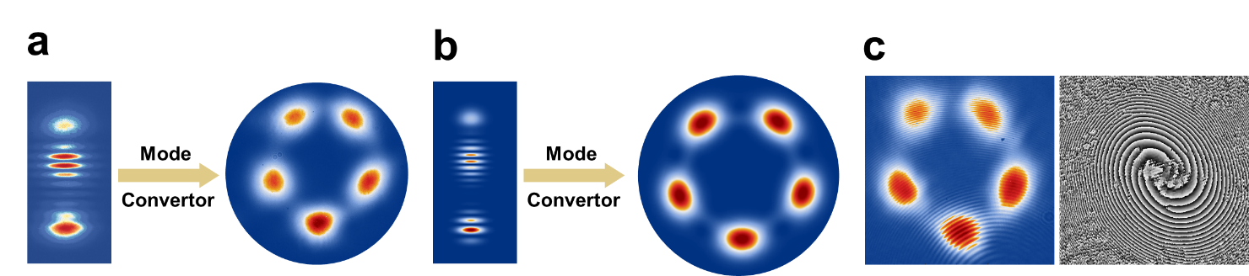

Fig. S2. Measured and simulated transverse mode patterns demonstrating the mode conversion process and spatial phase distribution. (a) Experimental results showing the intensity distribution of the generated multi-path beam (left) and its transformation into a circular pattern (right) after passing through the cylindrical lens mode converter. (b) Corresponding numerical simulation obtained by superposing multiple frequency-degenerate HG modes, which reproduces the spatial characteristics observed in the experiment. (c) Spatial interferometry of the mode-converted STML pulses. The left panel displays the recorded interferogram and the right panel shows the reconstructed spatial phase distribution, revealing a distinct multiple spiral phase structure at the beam center. This topological feature provides direct evidence for the rigidly phase-locked coherent superposition of the transverse modes.

4 Analysis of the spatiotemporal structure of multi-pulse outputs
In the experiment, we collected and characterized the output pulse trains of the intracavity multi-pulse states under different STML events. The Supplementary Video 1 shows the conversion process from a line structure to a circular structure, using the cylindrical lens mode converter. Since the output pulse trains illustrate the intensities of five spots, and they cannot be characterized based on a regular CCD camera due to its low response, the five spots are filtered using a controllable aperture and detected using an oscilloscope. With the gradually opening of the aperture, one to five spots are incident at the scope sequentially. Thus, in Supplementary Videos 2, 4 to 7, Spot 1, Spots 1 2, Spots 1 2 3, Spots 1 2 3 5, Spots 1 2 3 5 4, are the five events temporally spaced in the videos. The simulated results corresponding to each video are depicted in Fig. S3. Specifically, since Spot 5 is analyzed after Spot 4 in the collection, the pulse trains show a feature of jumping in the results. The experimental results in Videos 2, 4 to 7 correspond well with the simulated results, demonstrating a good correspondence between the theoretical analysis and our experiment.

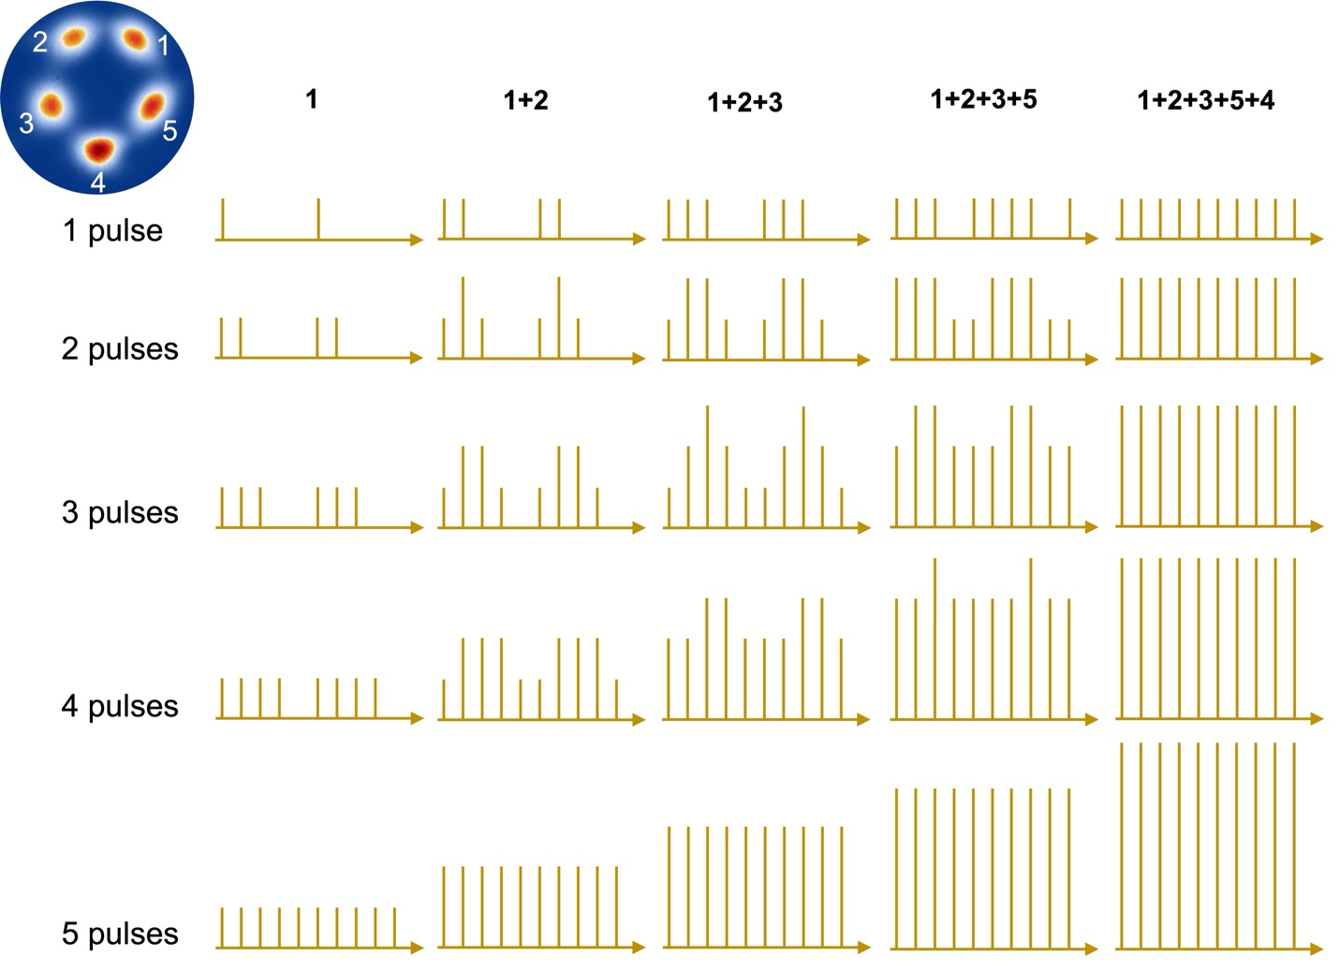
Fig. S3. Simulated pulse trains of different incident spots at the different STML events, for comparison with the experimental results.

5 4-path ray-wave duality results
As analyzed in the first section, when the distance between SESAM and R1 is adjusted from 67.7 mm to 64.6 mm, the 5-path ray-wave duality transfers to 4-path ray-wave duality. In the experiment, by finely tuning the distance, we achieved the STML with relative structured pulse generation. As shown in Fig. S4, the intensity distribution has 4 spots arranged in a circle. The temporal information of one spot is measured, and the pulse trains show a typical feature of the realization of the STML and the SPI-STML.
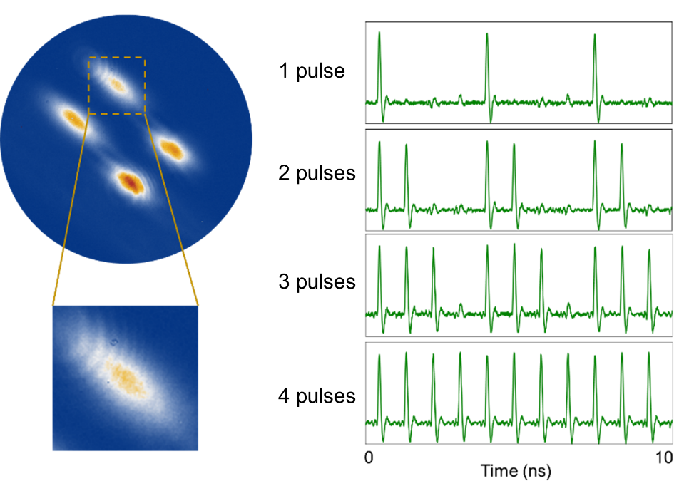
Fig. S4. Experimental results for structured pulse characterization for 4-path ray-wave duality with a time scale of 10 ns.

6 Gain and loss analysis for pumping scheme along Path 4
In this manuscript, the numerical and experimental results are given based on the condition that the pumping configuration is conducted along Path 4. Under this condition, the SPI-STML happens and the trigger and generated pulses interact at the corresponding SESAM position. Specifically, when the trigger pulse propagates along Path 5, the bleaching effect occurs on the SESAM position in Paths 4 and 5, and subsequently the induced pulse is generated and then propagates along Path 4. However, the ray-wave duality causes that the intracavity light goes across multiple SESAM positions and the SPI-STML may be initiated at these positions. A theoretical analysis needs to be done to support our point.
The numerical study on the gain and loss analysis is carried out based on the theoretical model and experimental configuration. Assuming the pumping scheme is set in Path 4 direction, as labelled in Fig. S5, the first mode-locking pulse travels back and forth within the cavity with the order from path 1 to path 5. The first row on the right part shows the paths the first pulse travels along temporally, with different colors demonstrating corresponding paths. The numbers above the pulses denote the paths where the output pulse locates. The following rows are the scenarios when the SPI-STML occurs at different SESAM positions. Specifically, the second row is the case illustrated in the manuscript, where the trigger pulse propagates in Path 5, initiates the bleaching effect, and then the second pulse is generated along the Path 4 direction. The value labelled after the pulses denotes the normalized minimum intracavity CW power density that is required to initiate the new pulse. As explained above, the third row demonstrates the situation that the trigger pulse propagates along Path 1 and alters the property of relative SESAM position, and the new pulse is generated along Path 3. With this scenario, a time delay between pulses of time-of-flight of two paths is achieved, which is different from the experimental observation. The following rows are other scenarios for different SPI-STML processes. Comparing all these assumptions and the minimum CW power density for initiating the SPI-STML, we can conclude that the results shown in the manuscript have the best gain and loss balance and under the condition of using Path 4 as the pumping scheme, the SPI-STML occurs at the SESAM position in Paths 4 and 5. As a result, the time delay between pulses is the time-of-flight of one single path.
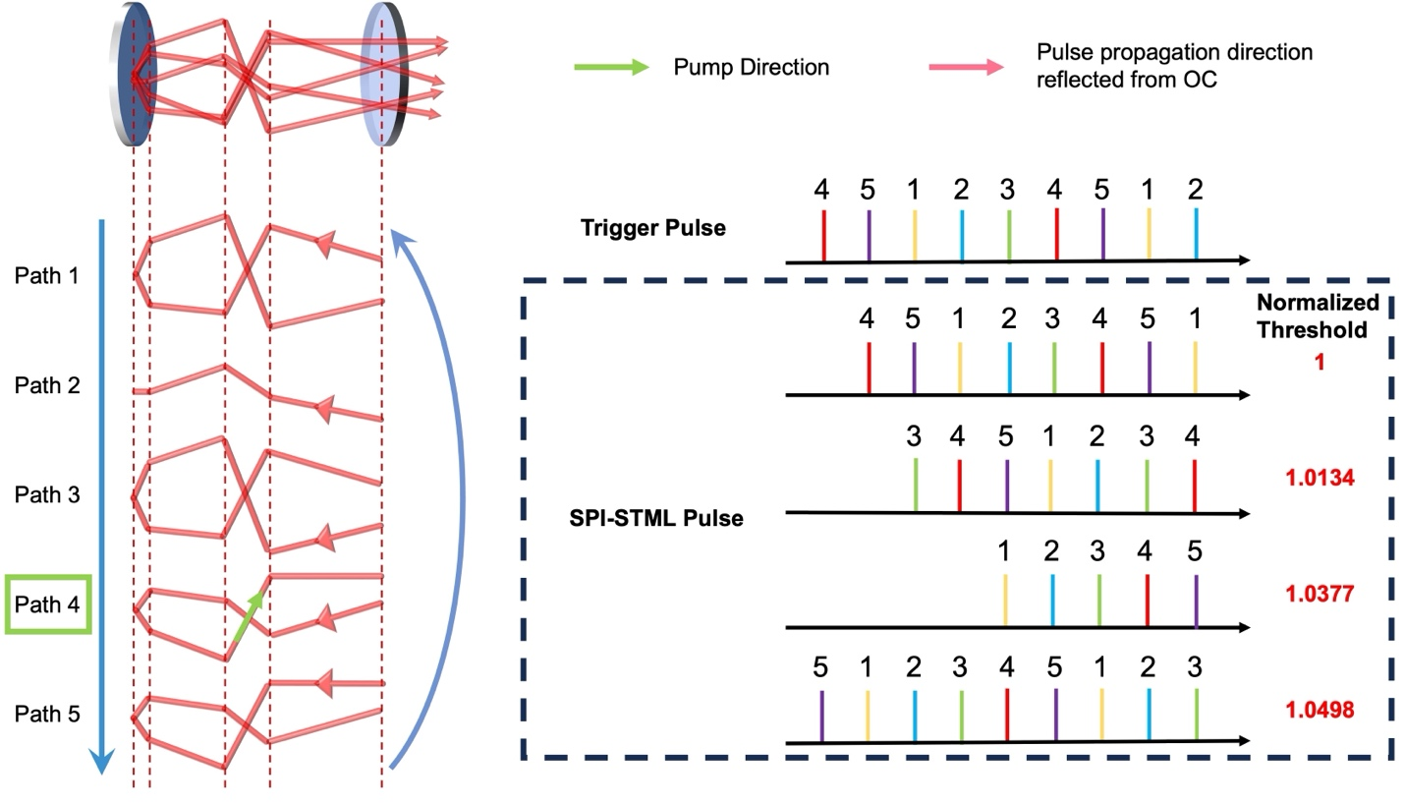
Fig. S5. Numerical analysis of gain and loss of different SPI-STML scenarios at different SESAM positions using Path 4 as the pumping direction.

7 Gain and loss analysis for pumping scheme along other Paths
Due to the employment of ray-wave duality in the sophisticated femtosecond laser oscillator, more than one pumping configuration can be utilized, which may initiate different phenomena. In this section, different pumping schemes along other paths will be analyzed. Like the scenario discussed above, there will be different spatiotemporal mode-locking cases for initiating multi-pulse states. The numerical results using Paths 1, 2, 3, and 5 are shown from Figs. S6 to S9. The first row on the right part of each figure describing the pulse still demonstrates the status of the first pulse, with the same setting that different colors represent the output position at the OC plane. The SPI-STML can occur at different SESAM positions, thus for each scenario, the gain and loss are analyzed. For the pumping along Paths 1 and 2 results, the second row describes that when the first pulse propagates in Path 3, the triggered pulse will be generated in Path 1, with a time delay of time-of-flight of two paths. Similarly, from the third row to the fifth row, the first trigger pulse propagates in different paths, and the generated pulse will be delayed by time-of-flight of -1, 1, and -2 paths. The minus sign here denotes that the triggered pulse will be ahead of the first pulse. However, the best gain and loss case will be the second row. For the pumping schemes along Paths 3 and 5 results, the second row describes that the trigger pulse propagates in Path1, while the SPI-pulse is generated in Path 3, with a time delay of -2 paths. The following rows exhibit similar situation as analyzed above. Note that, for each case, the SPI-STML pulses are arranged in the order of increasing threshold. Then it turns out that using pumping schemes along Paths 1 and 2 will have the same output structured pulse train. Using pumping scheme Paths 3 and 5 will show same results. The difference for these results only requires different pumping power to initiate the STML. We can conclude that different pumping schemes will be an important factor for designing the ultrashort structured pulse trains.
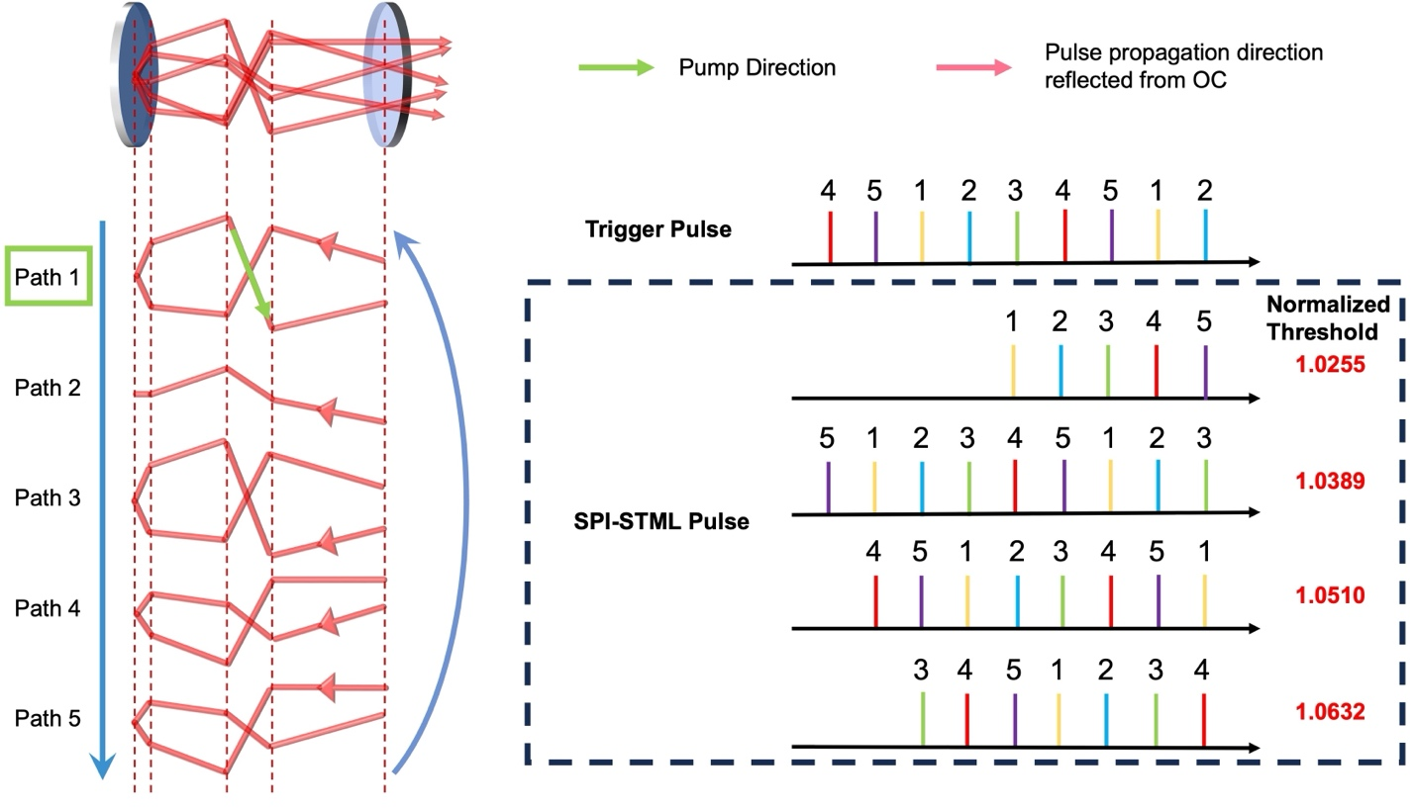
Fig. S6. Numerical analysis of gain and loss of different SPI-STML scenarios at different SESAM positions using Path 1 as the pumping direction.

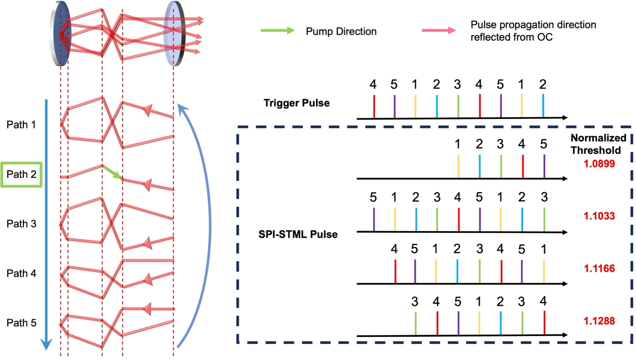
Fig. S7. Numerical analysis of gain and loss of different SPI-STML scenarios at different SESAM positions using Path 2 as the pumping direction.

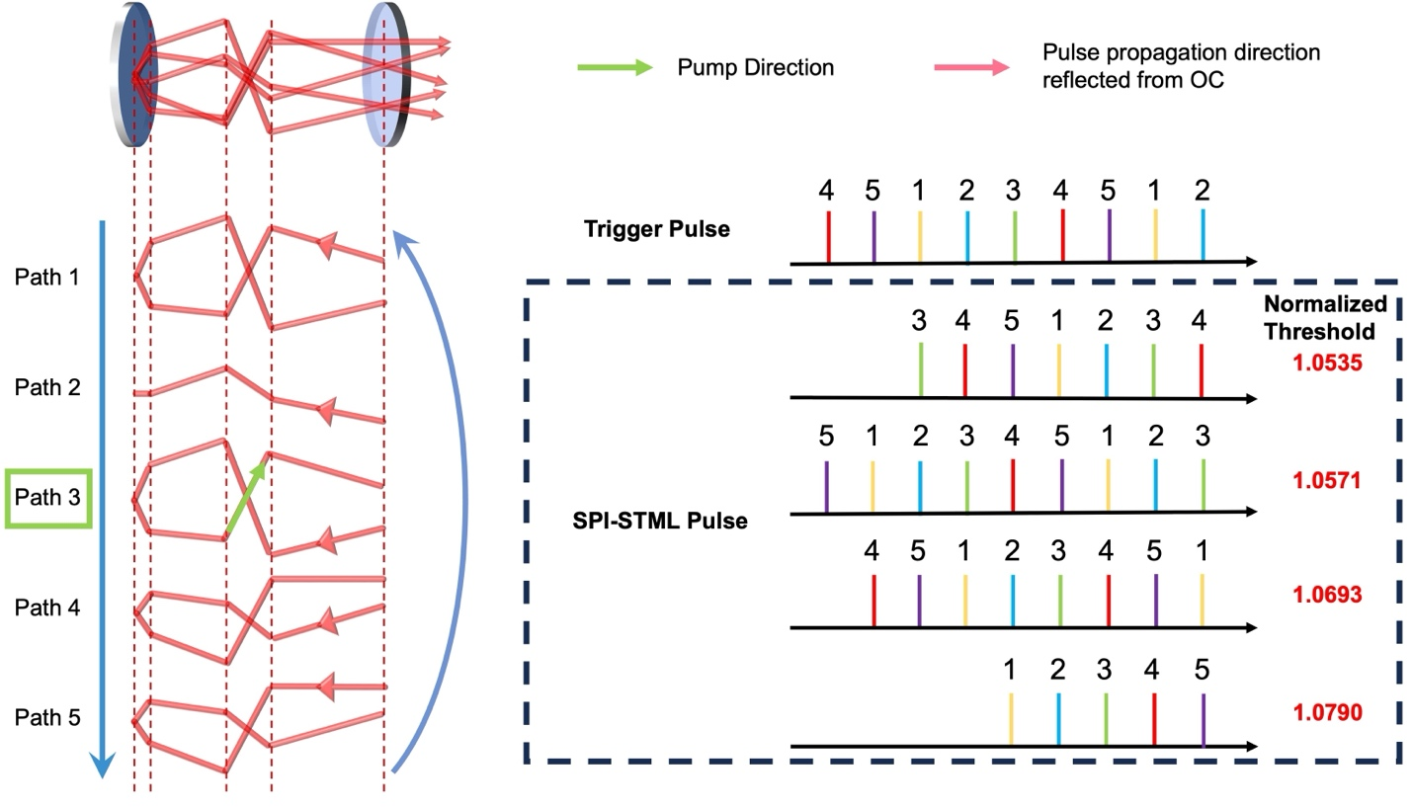
Fig. S8. Numerical analysis of gain and loss of different SPI-STML scenarios at different SESAM positions using Path 3 as the pumping direction.

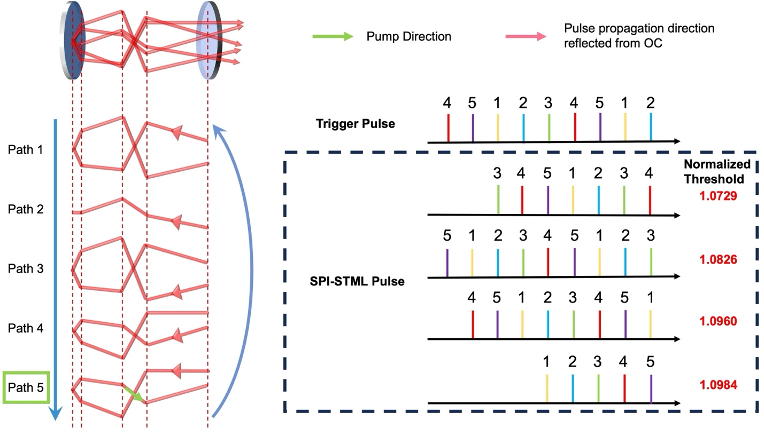
Fig. S9. Numerical analysis of gain and loss of different SPI-STML scenarios at different SESAM positions using Path 5 as the pumping direction.

For comparing the difference between different pumping schemes, we analyzed the pulse sequence emitted from one spot. The results are shown in Fig. S10. With increased pump power, relative STML events emerge, and specific spatiotemporal feature can be measured from the pulse train analysis. The labelled colors for each pulse represent the order of the STML events. Specifically, for using pumping scheme along Paths 1 and 2, the first STML pulse and the corresponding generated SPI-pulse have a delay of time-of-flight of two paths. Based on this, for the five STML events, the measured pulse train will show a feature as shown in the following figure. For the pumping scheme along Path 4, since the delay between pulses has a time-of-flight of one path, the emitting order of the pulses will follow the generated sequence. A different case is for using pumping scheme along Paths 3 and 5, the first SPI-pulse will be ahead of the trigger pulse by a time-of-flight of two paths. However, the structured pulse train for the first and third results will be nonseparable since the time interval between pulses are the same and we do not have methods to distinguish the trigger pulses and the SPI-pulses.

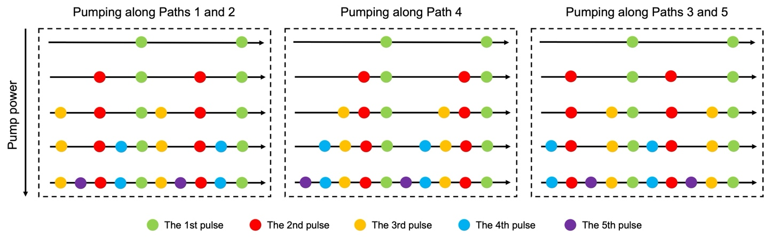
Fig. S10. Comparison results on the pulse sequence from one spot by using different pumping schemes. The labelled colors for each pulse correspond to different STML events.

8 Demonstration of Video 3 about the pulse generation dynamics under SPI-STML mechanism
The Video 3 in the Supplement shows the detailed pulse generation processes within different SPI-STML events. Specifically, the first section of the video shows the first STML events and there is one pulse propagating within the cavity. And on the right side, the output pulse train shows the staggered emission pattern. The second section shows the existence of the first STML and the first SPI-STML, with the first pulse (Green) interacting with the SESAM and triggering the second pulse (Red). Also, the output pulse feature can be seen on the right side. Then more pulses are triggered by the previous SPI-pulse and finally there are five pulses existing within the cavity and the output structured pulse train strongly correlates with the STML events. These simulated results vividly demonstrate how the SPI-STML mechanism operates and how the output structured pulses are generated.

9 Temporal and spectral results for the SPI-STML events
The measurement of temporal characteristics of a single spot under the operation of the initial STML and four SPI-STML events is shown in Fig. S11 below. Under this condition, a total number of five intracavity pulses is realized, resulting in the output pulse train at Spot 1 has a time interval of time-of-flight of one path. The measured repetition rate equals to the fundamental repetition rate of the cavity, with no additional peaks between higher-order harmonics.

To further characterize the SPI-STML dynamics, Fig. S12 presents the measured spectral and temporal properties associated with the distinct SPI-STML events. The top row shows the optical spectra for operations ranging from single- to five-pulse states, while the bottom row displays the corresponding experimental autocorrelation traces together with sech² fits and extracted pulse durations. These measurements represent the detailed experimental data corresponding to the summary shown in Fig. 5a of the main manuscript.

In addition, the stability of the SPI-STML operation is evaluated in Fig. S13 through measurements of the relative intensity noise and long-term power stability. The radio-frequency spectrum confirms low-noise operation over the measured frequency range, while the long-term power monitoring demonstrates stable output over an extended duration, indicating robust SPI-STML performance under multi-pulse operation.
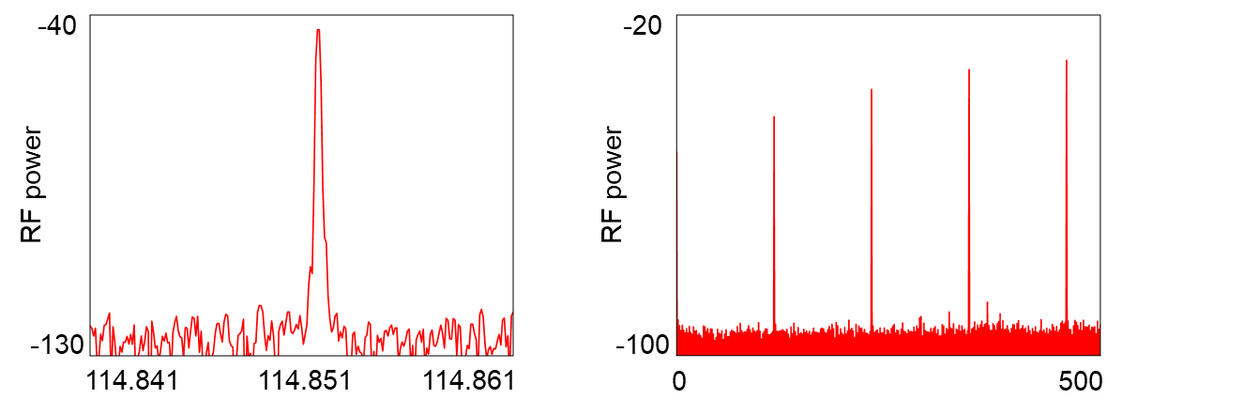
Fig. S11. The temporal characteristics of Spot 1 with the 5 STML events, which correspond to the result of 5 pulses in Fig. 5b.

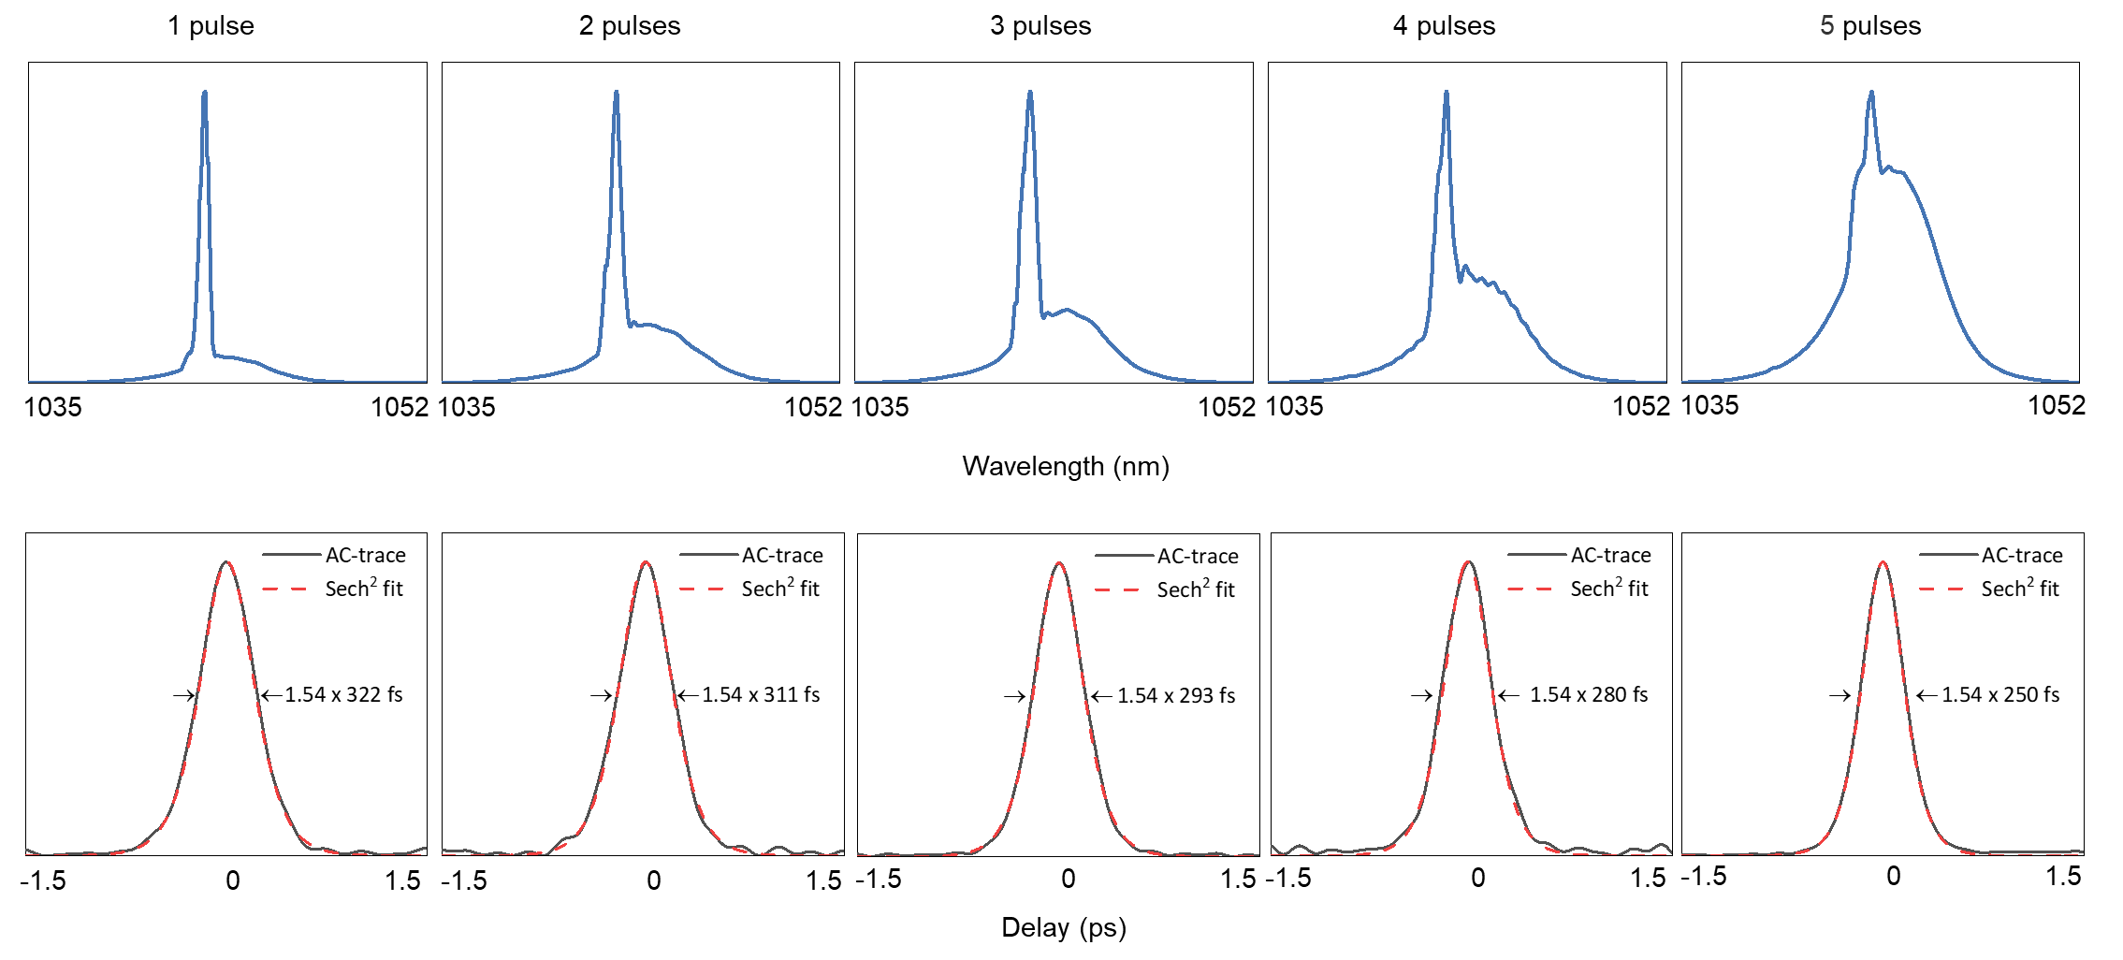
Fig. S12. Measured spectral and temporal characteristics corresponding to the distinct SPI-STML events. The top row displays the optical spectra measured for 1 to 5 pulse operations, while the bottom row shows the corresponding experimental autocorrelation traces (solid gray lines) with sech² fits (red dashed lines) and marked pulse durations. These panels provide the detailed 2D representations of the data visualized in Fig. 5a of the main manuscript.

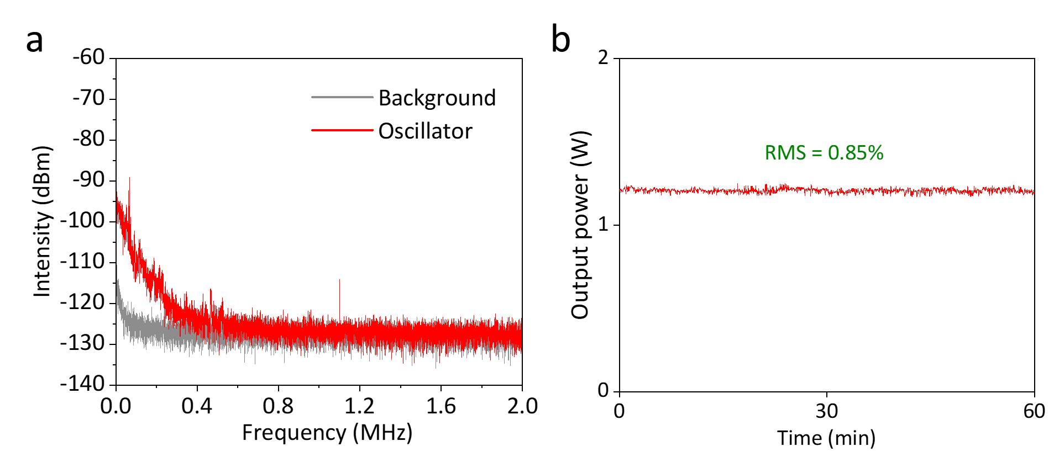
Fig. S13. Measured relative intensity noise and power stability. (a) Radio frequency spectrum characterizing the relative intensity noise (RIN) of the laser oscillator (red) relative to the detector background (gray) in the low-frequency range (0–2 MHz). (b) Long-term power stability recorded over 60 minutes for the 5-pulse STML state, exhibiting an RMS fluctuation of 0.85% at an average output power of ~1.2 W.

Reference
[1] Beijersbergen, M. W. et al. Astigmatic laser mode converters and transfer of orbital angular momentum. Optics Communications 96, 123-132 (1993).

