Supplemental Methods and Results file

Strong population genetic structure and cryptic diversity in the Florida bonneted bat (Eumops floridanus)

James D. Austin, Jeffery A. Gore, John S. Hargrove, Elizabeth C. Braun de Torrez, Celine M. Carneiro, Frank Ridgley, Samantha M. Wisely

Supplemental Methods 3
Supplemental Results 13
Table S1 Primer information, Genbank Accession numbers, and PCR annealing temperatures electrophoresis combinations for microsatellite loci used in this study. 15
Table S2 Parameters for VarEff function in VarEff to estimate past demographics in bonneted bats. 17
Table S3 Model specification and prior distributions for demographic parameters and locus-specific mutation model parameters for DIYABC simulations 18
Table S4 Genbank accessions for cyt b haplotypes, voucher or isolate IDs and locations of Eumops included to assess the evolutionary relationships of Florida bonneted bats. 19
Table S5 Locus-specific results from F_{ST,} F_{IT} and D_{Jost} with 95% confidence intervals. Measures not significantly greater than zero (negative lower 95% CI) are bold, measures significantly less than zero (negative upper 95% CI) are in italics. 20
Table S6 Nuclear microsatellite genetic diversity of Florida bonneted bats by region. 21
Table S7 AMOVA results by locus and overall. F-statistics are reported to indicate the strength of differentiation among regional groups. P-values are not reported due to a lack of independence from the clustering results. 22
Table S8 Estimates of contemporary migration rate (m) among regional bonneted bat populations estimated using BayesAss. 23
Table S9 Demographic parameter estimates for best supported models tested using DIYABC. 24
Table S10 Protein translation of the 705 bp cyt b alignment. Shown are variable codons in order of appearance along the 234 codon alignment. 25
Fig. S1 Graphical results illustrating the estimates of posterior probability of the data (top) for a given K (Mean LnP(K)) and the ∆K method (bottom), which evaluates the second order rate of change between successive K values. 27
Fig. S2 (Top) Results from DAPC cross-validation using the xvalDapc function in adegenet. 28
Fig. S3 Plots of F_{ST} and D_{Jost} versus locus polymorphism (number of alleles per locus). Best fit line and 95% CI are illustrated 29
Fig. S5 DIYABC output for microsatellite data models comparing alternative scenarios for the four Eumops floridanus populations. 31
Fig. S6 DIYABC output for cyt b data models comparing two alternative scenarios three Eumops populations. 33
References 35

Supplemental Methods
Sampling
To date, there has been no attempt to capture Florida bonneted bats systematically across their range in south Florida, in large part because they are challenging to find, fly high off the ground, and are difficult to capture away from roosts (Braun de Torrez et al. 2017).We obtained bat samples from four regions in southern Florida where bonneted bats have been captured or specimens collected and which we assume reflect the main distribution of bonneted bats based on consistent acoustic detections and known roosting sites. These four regions (Fig. 1) were: 1) the vicinity of Avon Park Air Force Range, Polk County (PC), 2) Fred C. Babcock/Cecil M. Webb Wildlife Management Area, Charlotte County (BW), 3) Florida Panther National Wildlife Refuge and neighboring Fakahatchee Strand Preserve State Park, Big Cypress National Preserve and Picayune Strand State Forest in Collier County (CC), and 4) areas in Miami-Dade County (MD). The first three regions are located in central and southwestern Florida (considered “western” sites; Fig. 1) and represent rural locations consisting of largely natural habitat types including pine flatwoods, freshwater prairies, cypress swamp and hardwood hammock. Bats from these western sites were captured in mist nets set near roosts or acoustic lures (for capture procedures see Braun de Torrez et al. 2017). Captures at BW occurred as part of a long-term study (Braun de Torrez et al. 2020), whereas collections from PC and CC were opportunistic and part of efforts to locate natural roost sites for the species. In contrast to the western regions, sampling in the MD region occurred in the developed environment of the Miami metropolitan area where bonneted bats have long been known to be present (Webb et al. 2021). Samples from bats in MD were collected primarily from bats in buildings, from individuals in rehabilitation facilities, or from bats opportunistically found injured or dead at various locations. Although Florida bonneted bats have occasionally been detected by acoustic surveys in other areas of the species’ range (Bailey et al. 2017), none have been captured nor roosts located outside the four regions we sampled.
DNA was obtained from live bats from oral swabs (Catch-All™ Sample Collection Swab, Epicentre cat. QEC89100), wing punches (4 mm biopsy punch of wing membrane, Worthington Wilmer and Barratt 1996), or both. Swabs were stored in Longmire’s tissue lysis buffer solution (modified to 1% SDS; Longmire et al. 1997) and tissues were placed in ~500 ul 95% ethanol and both stored at 4ºC. DNA was extracted using the Qiagen DNeasyBlood and Tissue protocol (Qiagen, Valencia, California, USA). Extractions from oral swabs were conducted using a modified QIAamp protocol (available upon request).
Microsatellite loci development
We initially screened microsatellite loci developed for free-tailed bats (Russell et al. 2005) to assess their suitability on bonneted bats. Of the nine loci tested, four failed to amplify, and four amplified but were monomorphic. One locus (TabrD15) was polymorphic and was retained for use in our dataset. We included one published locus (TabrD15; Russell et al. 2005) and developed microsatellite loci de novo from PacBio sequence reads. Briefly, genomic DNA was extracted from one bonneted bat wing punch (see below). Whole genome amplification was performed using the Qiagen REPLI-g Mini protocol (50ul reaction volumes) using approximately ~200ng of DNA. Samples were submitted for single molecule real time (SMRT) sequencing on the PacBio platform at the University of Florida Interdisciplinary Center for Biotechnology Research (ICBR; http://www.biotech.ufl.edu). The pooled sample was sheared into 1-2 kb insert libraries and sequenced on a single SMRT cell using P6/C4 chemistry. Data were processed with the SMRT Analysis toolkit (v 2.3.0) via the SMRT Portal web interface (www.pacb.com).
Di- and tetra-nucleotide repeats (≥ 6 repeat units) were identified using Msatcommander vers. 0.8.2; (Faircloth 2008). All primers were designed using the Primer3 (v 0.4.0) website (Koressaar and Remm 2007; Untergasser et al. 2012; http://bioinfo.ut.ee/primer3-0.4.0/). We selected 17 di- and 13 tetra-nucleotide repeat microsatellite loci with optimal primer annealing temperature 60°C, a 3’ GC clamp, and a lack of potentially complicating sequence structure between the outside primers and the repeat area itself (e.g., other repeats, compound or complex microsatellites). These markers were tested initially on three bonneted bat samples from different bat BW colonies (plus a negative control) to determine 1) amplification success (i.e., alleles present in correct size range), and 2) allele morphology that is conducive to ease of scoring (e.g., minimal stutter, clear primary peak). Subsequent trials on suitable loci were done on 11 additional samples to determine variability.
PCR of wing tissue DNA was performed in 15 μl reaction volumes and consisted of the following: 1 μl DNA (normalized to 20 ng/μl), 7.5 ul Mastermix (Type-it Microsatellite PCR kit, Qiagen cat. 206246), 5.66 μl sterile H₂O, 0.02 μM forward primer, 0.18 μM reverse primer, and 0.18 μM of fluorophore. For swab DNA, the amount of template per reaction was increased to 2 ul (14 ng of DNA on average), and the volume of sterile water was reduced to 4.66 μl. Forward primers and fluorphores [6-carboxyfluorescein (FAM), hexachlorofluorescein (HEX), or 5-Carboxytetramethylrhodamine (TAMRA)] were tagged with a 5’ CAC-sequence (5’-CACGACGTTGTAAAACGAC-3’). Thermal cycling parameters were as follows: 95°C for 5 mins, 33 cycles of 95°C for 30 sec, 54°C-58°C (depending on locus) for 90 sec, and 72°C for 1 min, followed by a final extension at 60°C for 30 mins. Genotyping PCRs incorporated positive controls to ensure binning consistency, and a negative control. Fragments were electrophoresed on an ABI 3130xl using the GS500 ROX size standard (Applied Biosystems, Carlsbad, California, USA) and genotype scores were assessed by one observer using GeneMarker vers. 2.6.2 (Hulce et al. 2011).
Marker assessment
Prior to population genetic analysis, we characterized microsatellite markers to ensure the absence of errors stemming from null alleles, the presence of Hardy-Weinberg equilibrium, and sufficient power to detect heterogeneity. First, null alleles were estimated within each regional sample and globally using the method of Brookfield (1996) implemented in the R (vers. 3.6.1, R Core Team 2019) program PopGenReport vers. 3.0.4 (Adamack and Gruber 2014). Null alleles were assumed to be insignificant or absent when the 95% bootstrap estimates overlapped zero. Pairwise tests for Genotypic linkage disequilibrium (LD) between locus pairs were estimated using Fisher’s exact test implemented in Genepop. Departures from the null hypothesis of no LD was evaluated using sequential Bonferroni correction at α = 0.05.
The power of these 22 loci to detect genetic heterogeneity among regional samples was tested using POWSIM vers. 4.0 (Ryman and Palm 2006). POWSIM simulates drift measured as F_{ST} to evaluate the null hypothesis of genetic homogeneity. We simulated empirical sample sizes of our four regional populations each across different effective population sizes (500, 1000, 3000, 5000) with F_{ST} calculated at generation 0, 20, 35, 50, 75 and 100. Tests for homogeneity were assessed using Fisher’s exact tests with tests at generation 0 expected to give false significance (α) at approximately 0.05. The proportion of significant tests over 1,000 replicates at each value of F_{ST} was used to indicate power of the markers to detect differentiation due to drift. Departures from Hardy Weinberg Equilibrium (HWE) were assessed within regional samples and globally using the hw.test function in the R program pegas vers. 0.13 (Pradis 2010). Significance was assessed using exact tests (Guo and Thompson 1992) with 1000 permutations.
Assessing genetic structure and population genetic diversity
We used model-based and model-free approaches to detect latent genetic clusters. To visualize the level of genetic clustering among sample regions we used the model-based clustering algorithm implemented in STRUCTURE vers 2.3.4 (Pritchard et al. 2000). We applied the linkage model (Falush et al. 2003) to allow for admixture when estimating the number of potential source populations (K) contributing to ancestry. Population information was excluded as a prior to test for unknown population structure. We evaluated the likelihood of K ranging from 1 to 10 with 20 replicate runs per K, 100,000 burnin iterations and 200,000 sampling iterations per run. We conducted model (K) selection by comparing the results based on the following criteria implemented in StructureSelector (Li and Liu 2018): 1) The maximal estimate of the posterior probability of the data for a given K, Pr(X | K), hereafter L(K); 2) The adhoc ∆K method (Evanno et al. 2005), which evaluates the second order rate of change between successive K values to identify the break in the slope of L(K) at the ‘true’ K; 3) The four supervised measures (MedMedK, MedMeanK, MaxMedK, and MaxMeanK) proposed by Puechmaille (2016) which are expected to be less sensitive to unbalanced sample numbers and less likely to identify the highest heirachical level of genetic structure (i.e., relative to ∆K). For the latter, we evaluated varying thresholds (0.5, 0.6, and 0.7) for membership coefficients, where higher coefficients increase the stringency for a subpopulation being included in a cluster (Puechmaille 2016). Finally, based on the results from L(K), ∆K, and the supervised measures, we inspected the results from a range of K values (Novembre 2016) to evaluate their potential implications for the interpretation of latent genetic structure.
We also explored microsatellite variation using a principal component analysis (PCA) which reduces the dimensionality of microsatellite genotypes to identify the most important components of variation in the data. PCA was conducted using the function dudi.pca in the R package ade4 (Dray and Dufour 2007) applying weighted vectors and mean centering. PCA is free from population genetic model assumptions (e.g., HWE, LD) and does not assume any underlying existing structure, and thus can more easily evaluate the presence of clinal patterns (e.g., isolation by distance) in the genetic data (Jombart et al. 2009). We transformed absolute variance of principal component axes to percentage of total variance represented in the genotype data.
Finally, we performed a discriminant analysis of principal components (DAPC), which represents a multivariate approach to identify genetic clusters with fewer assumptions than required by STRUCTURE. In contrast to PCA, which describes the largest axes of variation, DAPC reduces intra-group principal component variation in order to maximally explain between group variation (Jombart et al. 2010). DAPC was performed using the R package adegenet (Jombart 2008; Jombart and Ahmed 2011). We first performed cross-validation for discriminant analysis using the xvalDapc function in adegenet. This step assesses what number of PCs have the highest cluster assignment success and lowest mean squared error for a constant number of discriminant functions. We tested up to a maximum of 200 PCA components, retaining three axes for each DA (one less than the number of regional groups). The number of clusters was assessed using the function find.clusters, which runs successive K-means clustering with increasing number of clusters (k). We examined up to 30 clusters, using the number of PCs and DAs recommended by the xvalDapc function to identify the number of clusters having the lowest BIC scores. DA clusters were plotted in adegenet with an overlayed minimal spanning network, implemented in the R package ade4, and we examined posterior assignment values for individual bats to assess structure.
Non-spatial estimates of structure (i.e., STRUCTURE and AMOVA) assume an island model (Wright 1943) which includes equal migration regardless of the spatial proximity of populations. Substantial deviations from an island model can distort results from estimates of gene flow and other parameters of interest (Meirmans 2012). Isolation by distance (IBD) arises from the simple relationship of decreased gene flow with increasing geographic distance among populations in organisms with restricted dispersal. We tested for IBD among regional populations by regression of genetic differentiation to geographic distance (centroid of sampling location within each region) using 1000 bootstrap permutations to estimate the 95% CI of the regression slope in Genepop R v. 1.13 (Rousset 2008). The null hypothesis that the regression slope = 0, reflecting a lack of IBD (i.e., panmixia) could be rejected when the 95% CI of the slope does not overlap zero. Prior to regression analyses, F_{ST} (Weir and Cockerham 1984) was linearized [F_{ST}/(1-F_{ST})] and geographic distance was log transformed following recommendations for IBD on 2-dimensional geographic patterns (Rousset 1997). We calculated a standard Mantel test which tests the correlation of genetic (Euclidian) and geographic distance matrices, and we ran a stratified Mantel test permuting individuals within BW+CC+PC to allow for the potential influence of hierarchical structure as inferred from PCA, DAPC and DIYABC results. Both Mantel tests utilized 9,999 permutations and were conducted in GENODIVE.
Estimates of migration and gene flow
Estimates of genetic differentiation may be biased when subpopulations have high levels of unique allelic variation (i.e., display negative dependence; Jost 2008). When negative dependence is present, demographic signals (e.g., the influence of gene flow) can be difficult to accurately quantify because of an elevated mutation rate (Keenan et al. 2013). One method to look for negative dependence is to examine the relationship between estimators of genetic differentiation and the number of alleles per locus. We used the corPlot functon in diveRsity to plot F_{ST} (Θ)/D_{Jost} calculated for individual loci against the number of alleles per locus. Contrasting slopes between estimators (e.g., negative F_{ST} and positive D_{Jost}) was taken as evidence of bias stemming from elevated mutation rates.
After determining the most probable number of genetic clusters, we used the GENSBACK option in STRUCTURE to evaluate the probability of recent migration or recent mixed ancestry. In contrast with earlier population clustering efforts with STRUCTURE, this analysis used population data (sampling location) as priors (USEPOPINFO = 1) to identify which individuals were unlikely to be residents of their sampled population or were a descendant of a recent migrant. STRUCTURE was run using the previously inferred structure cluster memberships (K=4) based on outputs from previous STRUCTURE and multivariate analyses (see results). We set GENBACK=2 to assign migrants (0) and recent migrant ancestry (parental=1, grandparent=2). We evaluated different migration rate priors (MIGPRIOR) to assess sensitivity to this variable as an initial condition (Pritchard and Wen 2004), using a range of values (0.01, 0.05, and 0.1) and ran 200,000 and 500,000 Iterations for burnin and run length, respectively.
We assessed contemporary migration rates among regional populations using a Bayesian MCMC approach implemented in BayesAss ver. 3.0 (Wilson and Rannala 2003). BayesAss estimates the posterior mean migration rates based on posterior individual ancestry. We used a total of 1.0 $×$ 10⁷ iterations, discarding the first 1.0 $×$ 10⁶ as burnin and a sampling frequency of 100 to avoid autocorrelation between samples. During preliminary runs we adjusted the mixing parameters for inbreeding (dF), migration rates (dM) and allele frequencies (dA) to ensure each parameter was mixing effectively (between 0.2 and 0.6) and to assess the consistency of run results (see BayesAss manual). Final parameters were dF = 0.3, dM = 0.1, dA = 0.3. Convergence was assess by plotting the trace file in TRACER 1.6 (Rambaut et al. 2018) and migration rate estimates were considered non-zero where the 95% credibility set (mean ± 1.96 $×$ stdev) did not overlap zero.
While the previous approaches can identify contemporary (0-2 generations) migration, we also calculated the directional relative migration among populations and the symmetry of gene flow using the divMigrate function in DiveRsity (Alcala et al. 2014; (Sundqvist et al. 2016). We calculated effective number of migrants (Nm) to quantify gene flow and assessed the asymmetry of gene flow among pairs of populations by looking for overlap of 95% CI around estimates of migration generated using 1,000 bootstrap values (Sundqvist et al. 2016). Overlapping confidence intervals were interpreted as evidence for symmetrical gene flow.
Demographic analyses
One of the most critical evolutionary parameters from a management and conservation perspective is effective population size (N_{e}) (Husemann et al. 2016). To inform conservation and planning efforts we conducted multiple Ne analyses, namely: 1) we estimated contemporary (i.e., previous 1-2 generations) N_{e} based on patterns of linkage disequilibrium (LD); and 2) we tested for evidence of historical (i.e., over the past 500 generations) changes in N_{e} based on microsatellite repeat motif frequencies and differences between alleles.
Contemporary effective population size estimates were estimated using the LD method (Waples and Do 2008) implemented in NeEstimator vers. 2 (Do et al. 2014). LD is estimated as r² (Weir 1979) which is dependent upon the true N_{e} and the sample size (S). We evaluated parametric bootstrap estimates of 95% confidence intervals as well as jackknifing on samples, the later can reduce potential bias associated with standard chi-squared confidence intervals (Do et al. 2014). We calculated N_{e} under both a random mating and monogamy models as mating system can have a large impact of inferences of N_{e} (Weir and Hill 1980). We also evaluated omitting alleles with minimal frequencies of $<$0.05, 0.02, and 0.01.
We tested for changes in N_{e} through time among regional populations using the method implemented in VarEff vers. 1.0 (Nikolic and Chevalet 2014). The VarEff method uses microsatellite repeat motif frequencies and differences in motif repeats between alleles to estimate variation in N_{e} over time using approximate likelihood Markov chain Monte Carlo (MCMC). Trial runs were performed to evaluate the impact of prior parameter settings. For the final analyses we applied a generic mutation rate prior of 0.001 for all loci, using a two-phase mutation model allowing 0.15 of mutations to be more than one step. The number of allowed changes in past demography (JMAX) was set at JMAX = 5. Priors for N_{e} (NBAR) was selected to represent intermediate theta values estimated from the theta function in VarEff (Supplemental File, Table S2). The Number of generations prior (GBAR) was set to 500 generations since population origin to encompass the period of major anthropogenic change in south Florida (~500 years). Variance for NBAR and GBAR were set to 3 and the coefficient of correlation between successive time intervals was set to 0.5 following recommendation by Nikolic and Chevalet (2014). Following 10,000 burnin iterations we ran 10,000 steps with 10 steps per batch and 100 steps between sampled steps to avoid autocorrelation for a total of 10,000,000 MCMC iterations.
To assess the relative support for four competing demographic models of population history we used approximate Bayesian computation implemented in DIYABC (Cornuet et al. 2014). We developed four models based on outputs from genetic clustering and tests of genetic differentiation, with competing models differing in patterns and times since divergence from a common ancestral population (Fig. 2). The four models were: (M1) Simultaneous radiation of four populations from an ancestral population at time t_{A} in the past; (M2) Ancestral divergence leading to MD and an ancestral population N_{W}, with the latter subsequently radiated into three populations (BW, PC, CC); (M3) an ancestral population diverged into eastern (MD) and southern (CC) populations with subsequent colonization of the BW population from CC at t₂, followed by the colonization of PC from BW at t₁; (M4) an ancestral population diverged into an eastern (MD) and southern (CC) population from an ancestor, followed by the serial colonization of BW at t₂ and PC at t₁. For each scenario, priors were drawn from a uniform distribution with priors established following preliminary evaluations of posterior demographic distributions We used uniform priors and default parameters for microsatellite mutation rates. Demographic priors were selected following preliminary runs bounded as follows: N₁ through N₄, 10 < 50,000; N_{W} 10 < 20,000; N_{a} 10 < 200,000; t₁ (10-10,000) < t₂ (20,000) < t_{A} (50,000) (see Table S3). Summary statistics for model comparison included the mean number of alleles, mean genic diversity, and mean size variance for the ‘1-sample’ statistics and F_{ST} for ‘2-sample’ statistics. . We simulated 1 million datasets per model assuming both a 1:1 sex ratio and a 1:3 (M:F) ratio to evaluate the potential effect of skewed reproductive success in males on demographic parameter estimates. Our exploration of different sex ratios was based on the assumed polygynous mating system in this species (Ober et al. 2017; Braun de Torrez et al. 2020).
Our primary objective for DIYABC was to assess the support for alternative demographic models, rather than to infer ancestral N_{e} and t (both inferred at the time of population splitting). The posterior probability for each model was estimated from the weighted logistic regression (Beaumont 2008) the 1% of simulated datasets closest to the observed data, which provides a point estimate and the 95% confidence intervals. The most probable demographic model was assumed to be successfully identified if the maximum posterior probability of the model was excluded from the 95% confidence intervals estimated for all other candidate models (Cornuet et al. 2008).
Confidence in model choice was examined two ways. First, we estimated the posterior-based error rate — the proportion of scenarios, other than the most probable, that were selected over 1000 test datasets. Second, we estimated the classification error (type I error) and the misclassification error (type II error) between the most supported and second-most supported models using the prior-based error option. For type I, 1,000 pseudo-observed data sets were simulated from the initial prior distributions under the favored model (‘scenario specific’) and compared against the original 4x10⁶ simulated data sets for each of the alternative models to calculate the posterior parameter distributions. The type I error was estimated as the proportion of pseudo-observed data among which the favored model was incorrectly excluded. The type II error was estimated as the proportion of pseudo-observed data among which an incorrect model was recovered.
Mitochondrial sequencing and analysis
In addition to analysis of microsatellites, we generated sequence data for the cytochrome b (cyt b) gene using a subset of 49 samples to examine whether hierarchical structuring observed with microsatellites extended to the mitochondrial genome. We included 13 MD, 11 BW, 17 CC, and 8 PC bonneted bats. The cyt b gene was amplified using primers L14724, 5'- GTG ACT TGA AAA ACC ACC GTT G -3' (Schmidt and Gold 1993) and H15918, 5'- CTC CAT CTC CGG TTT ACA AGA C-3' (Song et al. 1998). PCR amplification was performed in 25 μL reactions containing 2 μL genomic DNA, 1 uL of each primer at 10 μM, 0.2 μL GoTaq Flexi DNA polymerase (5 U/μL, Promega), 5 μL 5X GoTaq Flexi Buffer, 0.5 μL dNTPs (10 mM), 1.6 μL MgCl (25 mM), and the remaining volume in sterile water. PCR conditions consisted of 1 cycle at 95°C for 2 minutes, 39 cycles at 95°C, 51°C, and 72°C for 1 minute each, and a final cycle at 72°C for 3 minutes. Sanger sequencing was conducted using the PCR primers at a final DNA concentration of 4 ng/μL in a 10uL volume and a final primer concentration of 25 pmol. PCR amplicons were Sanger sequenced at GENEWIZ (https://www.genewiz.com).
Sequences were aligned using Clustal Omega (https://www.ebi.ac.uk/Tools/msa/clustalo/) then imported into Mesquite vers. 3.7 (Maddison and Maddison 2021) for manual error correction and trimming. Due to the extent of haplotype divergence detected, to improve our phylogeographic inference we added published cyt b sequences representing three previously sequenced Florida bonneted bats from Florida (EU350024 and EU350025 from near Fort Myers, Lee County FL, and EU350026 from Miami Dade County), fourteen E. ferox sampled from Guantanamo, Cuba (EU350007–EU350020), three from Jamaica (EU350021–EU350023), four from Yucatan, Mexico (EU350038-EU350040 and JQ731820) and 2 E. glaucinus from South America (Paraguay JQ731817 and Venezuela JQ731819).
We again used DIYABC to assess the relative support for two competing demographic models of matrilineal population history. Our demographic scenarios were designed to test support for two competing models that contrast the matrilineal history of MD bats relative to the western populations of E. floridanus and that of the Caribbean bats. The first model (Mt1) assumed that the diversity of haplotypes and differentiation between MD and the other Florida populations reflected the retention of ancestral polymorphism from a Pleistocene bonneted bat population in Florida. The second model (Mt2) assumed that western E. floridanus had an independent population history from MD, and that the later derived separately and more recently from a Caribbean ancestor (Fig. 2).
We used uniform priors and a maximum mutation rate of 1.0x10⁻⁶ and Kimura 2 parameter substitution model for simulations. Priors for final simulations are provided in the Table S3). Summary statistics used were the number of haplotypes (1 and 2 sample summary), number of segregating sites (1 and 2 sample), mean of pairwise sequence differences, private segregating sites, and F_{ST} (2 sample). We simulated 1 million datasets per model and confidence in model choice was conducted as per the microsatellite dataset.

Supplemental Results

Loci development
SMRT sequencing resulted in a total of 16,601 reads with an average raw read length of 1,413 bp. We identified 6,247 SSR motifs, of which 17 di- and 13 tetra-nucleotide were selected for primer development. After our initial screen, nine loci either failed to amplify consistently or were difficult to score due to electropherogram peak morphology. Remaining loci amplified well and were polymorphic in the initial 20 bats screened using paired wing and swab extractions. Genotyping error was low with two instances (< 1%) of incorrect allele call at different loci due to weak amplification, one from a swab origin and the other from a wing tissue sample. Other issues were limited to occasional failed amplifications that were readily amplified in subsequent experiments. From this we conclude that oral swabs should serve as an adequate source of DNA for basic PCR-based applications. The average DNA yields from swabs was 5.48 ng/μL (n = 38, range 1.3– 15.5) and 16.5 ng/μL (n = 64, range 2.7– 47.5) ng/μL from wing punches.

POWSIM
The results from simulations indicate that under a model of genetic drift, the microsatellite markers used have high power to detect differentiation due to genetic drift even over short periods of time (i.e. < 20 generations). The power to detect significant differentiation is low only if the true if N_{e} is large (N_{e} > 3000). Given that current estimates put the true population size of bonneted bats at less than 1000, N_{e} is expected to be small (Frankham 2008). F_{ST} approaching observed level (F_{ST} = 0.166) would require very small population sizes, drifting apart for a long period (> 100 generations).
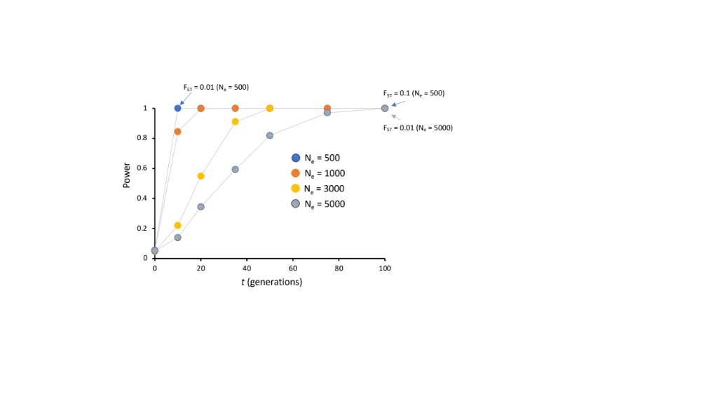
Left: Plotted power estimates from empirical allele frequencies and sample sizes for four bonneted bat populations drifting apart (without gene flow) for four effective populations sizes. Estimates of F_{ST} for select simulations are indicated for comparative purposes.

Table S1 Primer information, Genbank Accession numbers, and PCR annealing temperatures electrophoresis combinations for microsatellite loci used in this study.
Locus | Species Isolated From | Reference | Genbank Accession Number | Primer Sequence 5’-3’ | Motif | Anneal Temp. C° | Electrophoresis combo (dye)
Eufl5989 | Florida bonneted bat (Eumops floridanus) | This study | MK061321 | F: GTCCTTCCTGTTGCGGCTTC  R: AAAGGTTGCGGGTTCCATCC | AG₂₂ | 58 | 1 (Fam)
Eufl7656 | Florida bonneted bat (Eumops floridanus) | This study | MK061322 | F: CCCAGGCATGTAACCCATC  R: TGATGTTGAAGAGCCCAGTTGC | AG₁₈ | 54 | 1 (Hex)
Eufl55690 | Florida bonneted bat (Eumops floridanus) | This study | MK061323 | F: TTCAAATAATCCTTGTGCCTCAGTC  R: TGGGTTAAAGAGCTGAACAGAGAGAAC | AGAT₇ | 54 | 3 (Tam)
Eufl38728 | Florida bonneted bat (Eumops floridanus) | This study | MK061324 | F: CCATCACAGCAGGGTCACTAAAG  R: TCCAAAGGACAGTTAGGTCTCAGC | AGAT₁₃ | 54 | 3 (Tam)
Eufl11764 | Florida bonneted bat (Eumops floridanus) | This study | MK061325 | F: CCGGTCCCAAACAAGTAGCC  R: GCCAGCAGGTATGCAGAAATG | AC₁₉ | 52 | 3 (Fam)
TabrD15 | Brazilian free-tailed bat (Tadarida brasiliensis) | Russel et al. 2005 | AY954903 | F: AGTCCTGGCTCCTATTCTCATTG  R: CTATCCGTCTACCTGTCCGTCTAT | GATA | 52 | 1 (Hex)
Eufl115881 | Florida bonneted bat (Eumops floridanus) | This study | MK061326 | F: TGACCAAGGCCACACAGCTC  R: GGTGCAACGCCATGAGTGAG | GT₁₆ | 58 | 1 (Tam)
Eufl40155 | Florida bonneted bat (Eumops floridanus) | This study | MK061327 | F: GAGGCTTTCAGGCAGGTGTG  R: CTTGGGCTTTCGGACTCTGG | ATCC₁₀ | 54 | 1 (Fam)
Eufl8400 | Florida bonneted bat (Eumops floridanus) | This study | MK061328 | F: ACACAATGGACGGTGAGCTT  R: CCTTGCATGGCTGTCCTACT | AT₁₄ | 52 | 2 (Fam)
Eufl117077 | Florida bonneted bat (Eumops floridanus) | This study | MK061329 | F: TCCGAAGGGCAGGTATTGTTAG  R: CCCACGAACTCTCACTGTCTTGG | GT₁₉ | 54 | 2 (Fam)
Eufl109865 | Florida bonneted bat (Eumops floridanus) | This study | MK061330 | F: GTGCAGTTAGGGCAATGGAT  R: GGCTGCAGAATGTTTGTTGA | CT₂₅ | 52 | 2 (Hex)
Eufl39543 | Florida bonneted bat (Eumops floridanus) | This study | MK061331 | F: CGCTTCCTGCTCTTCACTCC  R: CCTGCCTTAGTTTCCAGCCTTTAG | ATCT₁₁ | 54 | 2 (Hex)
Eufl91027 | Florida bonneted bat (Eumops floridanus) | This study | MK061332 | F: CACCTTCCCTTCCTCACAGG  R: TGACACATTGGGCTGAGTGG | ACAT₁₀ | 54 | 2 (Tam)
Eufl28830 | Florida bonneted bat (Eumops floridanus) | This study | MK061333 | F: CGAAGGCAGACAAACACAAGC  R: TGGTAGGGAAGAAGAAATGTCAAGC | CATT₆ | 54 | 4 (Fam)
Eufl30125 | Florida bonneted bat (Eumops floridanus) | This study | MK061334 | F: TTGCAGCCGTGAGGGAGAAG  R: TGTGAAGAATGGGATTGGCTTC | AAAT₁₀ | 51 | 4 (Fam)
Eufl30712 | Florida bonneted bat (Eumops floridanus) | This study | MK061335 | F: GATGCTCAAGGCAGGGTTGC  R: TCAAACTCGACTACAGACCTTATTCAG | CA₁₆ | 53 | 4 (Hex)
Eufl15378 | Florida bonneted bat (Eumops floridanus) | This study | MK061336 | F: CCTGGTTTACGGCTCCATTTATTC  R: GCTAGGCTTGTTTACCTGAAATACCC | CA₁₆ | 54 | 4 (Hex)
Eufl25822 | Florida bonneted bat (Eumops floridanus) | This study | MK061337 | F: TGTGTGAACAGCGCCTCCTG  R: GGACTTGTGATTGTTTATGGCAAAGG | GT₁₃ | 53 | 5 (Fam)
Eufl157269 | Florida bonneted bat (Eumops floridanus) | This study | MK061338 | F: CACTACATGGCAAATGGATGGTG  R: TCCTAAAGCTCAGGCTCATCACC | CA₉ | 54 | 5 (Fam)
Eufl33150 | Florida bonneted bat (Eumops floridanus) | This study | MK061339 | F: TCCTTCTCTCACGGGCAATG  R: TGGCAACCAGTCGATGTGTC | ATTT₈ | 54 | 5 (Hex)
Eufl18018 | Florida bonneted bat (Eumops floridanus) | This study | MK061340 | F: GGGAATGTGTGCTCTGTGGAG  R: GGAATCAGCCAATGTTCTCTTGG | CCTT₁₁ | 54 | 5 (Hex)
Eufl32421 | Florida bonneted bat (Eumops floridanus) | This study | MK061341 | F: ATGTGGGCAGTAGCGTGGGTAG  R: GCCTTCTACGAGCCTGGATATTG | AC₂₂ | 54 | 5 (Tam)

Table S2 Parameters for VarEff function in VarEff to estimate past demographics in bonneted bats. JMAX refers to the number of discrete time periods for which N_{e} is assumed to be constant; DMAX is the maximal distance (repeats) between alleles used for the estimation algorithm; Prior N_{e} (NBAR) is selected as an intermediate value from the min. and max. estimates estimated with the theta function in VarEff (in parentheses) from Theta function; VAR N_{e} variance of the of the prior log-distribution of N_{e}; COR is the coefficient of correlation between N_{e} in successive time intervals; GBAR is the number of generations in the past considered since the start of the population; D is a smoothing parameter recommended to be 0.5.

 | JMAX | DMAX | Prior N_{e} (theta estimate) | VAR N_{e} | COR | GBAR | VAR_{GBAR} | D
BW | 5 | 8 | 500 (376-635) | 3 | 0 | 500 | 3 | 0.5
PC | 5 | 6 | 500 (339-593) | 3 | 0 | 500 | 3 | 0.5
MD | 5 | 14 | 1000 (477-5454) | 3 | 0 | 500 | 3 | 0.5
CC | 5 | 7 | 500 (408-781) | 3 | 0 | 500 | 3 | 0.5

Table S3 Model specification and prior distributions for demographic parameters and locus-specific mutation model parameters for DIYABC simulations.

Demographic parameter | Type (model) | prior
Microsatellite loci
Mutation rate | default
N_{A} | Unsampled ancestral effective population size (M1 – M4) | 10 – 200,000
N_{W} | Unsampled ancestral western effective population size (M2) | 10 – 30,000
N₁ | BW ancestral effective population size | 10 – 50,000
N₂ | PC ancestral effective population size | 10 – 50,000
N₃ | MD ancestral effective population size | 10 – 50,000
N₄ | CC ancestral effective population size | 10 – 50,000
t_{A} | Time of ancestral divergence | 10 – 50,000
t₂ |  | 10 – 10,000
t₁ |  | 10 – 20,000
Mitochondrial DNA
N_{A} | Unsampled ancestral effective population size (M1 – M3) | 100-100000
N_{W} | Unsampled ancestral Florida effective population size (M2) | 100-100000
N₁ | BW+PC+CC ancestral effective population size | 100-100000
N₂ | MD ancestral effective population size | 100-100000
N₃ | Caribbean ancestral effective population size | 100-1000000
t_{A} | Time of ancestral divergence | 10000-500000
t_{d} | Time of most recent divergence | 100-100000

Table S4 Genbank accessions for cyt b haplotypes, voucher or isolate IDs and locations of Eumops included to assess the evolutionary relationships of Florida bonneted bats. Haplotype numbers correspond to those in Fig. 5
Genbank | Voucher/isolate | Location | Haplotype
EU350008 | TK32002 | Guantanamo, Cuba | 6
EU350007 | TK32001 | Guantanamo, Cuba | 8
EU350009 | TK32003 | Guantanamo, Cuba | 8
EU350010 | TK32018 | Guantanamo, Cuba | 8
EU350012 | TK32032 | Guantanamo, Cuba | 8
EU350015 | TK32052 | Guantanamo, Cuba | 8
EU350018 | TK32111 | Guantanamo, Cuba | 8
EU350013 | TK32033 | Guantanamo, Cuba | 9
EU350014 | TK32034 | Guantanamo, Cuba | 10
EU350016 | TK32053 | Guantanamo, Cuba | 11
EU350017 | TK32054 | Guantanamo, Cuba | 12
EU350019 | TK32112 | Guantanamo, Cuba | 13
EU350020 | TK32113 | Guantanamo, Cuba | 14
EU350011 | TK32019 | Guantanamo, Cuba | 22
EU350021 | TK9380 | Jamaica | 8
EU350023 | TK9382 | Jamaica | 8
EU350022 | TK9378 | Jamaica | 15
EU350024 | RMT4610 | Lee Co., Florida | 3
EU350025 | RMT4611 | Lee Co., Florida | 4
EU350026 | RMT4618 | Miami-Dade Co., Florida | 5
EU350032 | TK13581 | Yucatan, Mexico | 18
EU350036 | TK13585 | Yucatan, Mexico | 18
EU350028 | TK13564 | Yucatan, Mexico | 19
EU350030 | TK13566 | Yucatan, Mexico | 19
EU350031 | TK13567 | Yucatan, Mexico | 19
EU350035 | TK13584 | Yucatan, Mexico | 19
EU350037 | TK13586 | Yucatan, Mexico | 19
EU350038 | TK13587 | Yucatan, Mexico | 19
EU350041 | TK13590 | Yucatan, Mexico | 19
EU350039 | TK13588 | Yucatan, Mexico | 20
EU350040 | TK13589 | Yucatan, Mexico | 21
EU350027 | TK13563 | Yucatan, Mexico | 26
EU350034 | TK13583 | Yucatan, Mexico | 27
JQ73817 | TK64163 | Paraguay | 16
EU350004 | TK64926 | Paraguay | 28
EU350002 | TK63051 | Paraguay | 29
EU350003 | TK63052 | Paraguay | 31
EU350006 | TK15248 | Venezuela | 17
MT262814 | Esparanza118 | Argentina | 30

Table S5 Locus-specific results from F_{ST,} F_{IT} and D_{Jost} with 95% confidence intervals. Measures not significantly greater than zero (negative lower 95% CI) are bold, measures significantly less than zero (negative upper 95% CI) are in italics.
Locus | F_{ST} | Lower  95% CI | Upper  95% CI |  | F_{IT} | Lower  95% CI | Upper  95% CI |  | D_{Jost} | Lower  95% CI | Upper  95% CI
L5989 | 0.213 | 0.161 | 0.275 |  | 0.213 | 0.120 | 0.313 |  | 0.554 | 0.458 | 0.646
L7656 | 0.183 | 0.149 | 0.223 |  | 0.097 | 0.018 | 0.180 |  | 0.642 | 0.554 | 0.730
L55690 | 0.202 | 0.147 | 0.268 |  | 0.225 | 0.126 | 0.335 |  | 0.517 | 0.408 | 0.629
L38728 | 0.081 | 0.040 | 0.134 |  | 0.099 | -0.005 | 0.209 |  | 0.220 | 0.132 | 0.326
L11764 | 0.071 | 0.034 | 0.112 |  | 0.118 | 0.020 | 0.227 |  | 0.231 | 0.147 | 0.325
TabrD15 | 0.162 | 0.126 | 0.206 |  | 0.252 | 0.155 | 0.345 |  | 0.588 | 0.508 | 0.667
L115881 | 0.185 | 0.120 | 0.264 |  | 0.220 | 0.073 | 0.370 |  | 0.178 | 0.101 | 0.268
L40155 | 0.184 | 0.134 | 0.239 |  | 0.265 | 0.153 | 0.376 |  | 0.488 | 0.376 | 0.599
L8400 | 0.282 | 0.213 | 0.363 |  | 0.238 | 0.130 | 0.348 |  | 0.620 | 0.538 | 0.696
L117077 | 0.185 | 0.110 | 0.272 |  | 0.153 | 0.026 | 0.279 |  | 0.225 | 0.136 | 0.313
L109865 | 0.144 | 0.110 | 0.182 |  | 0.142 | 0.063 | 0.228 |  | 0.565 | 0.476 | 0.652
L39543 | 0.196 | 0.142 | 0.252 |  | 0.101 | -0.013 | 0.216 |  | 0.395 | 0.299 | 0.491
L91027 | 0.121 | 0.075 | 0.184 |  | 0.116 | -0.022 | 0.26 |  | 0.242 | 0.153 | 0.356
L28830 | 0.077 | 0.016 | 0.165 |  | 0.100 | -0.068 | 0.262 |  | 0.073 | 0.025 | 0.146
L30125 | 0.262 | 0.207 | 0.320 |  | 0.299 | 0.189 | 0.407 |  | 0.501 | 0.425 | 0.594
L30712 | 0.032 | 0.002 | 0.080 |  | 0.159 | -0.026 | 0.491 |  | 0.005 | 9e-04 | 0.015
L15378 | 0.140 | 0.086 | 0.219 |  | 0.071 | -0.073 | 0.233 |  | 0.109 | 0.050 | 0.197
L25822 | 0.031 | 0.002 | 0.068 |  | -0.020 | -0.034 | -0.009 |  | 0.003 | 6e-04 | 0.006
L157269 | 0.170 | 0.081 | 0.271 |  | 0.167 | -0.026 | 0.349 |  | 0.195 | 0.108 | 0.287
L33150 | 0.044 | -0.005 | 0.144 |  | 0.160 | -0.016 | 0.353 |  | 0.030 | 0.005 | 0.097
L18018 | 0.387 | 0.317 | 0.456 |  | 0.373 | 0.267 | 0.480 |  | 0.441 | 0.363 | 0.513
L32421 | 0.197 | 0.144 | 0.253 |  | 0.180 | 0.074 | 0.288 |  | 0.376 | 0.281 | 0.465
global | 0.178 | 0.166 | 0.192 |  | 0.182 | 0.155 | 0.208 |  | 0.270 | 0.253 | 0.288

Table S6 Nuclear microsatellite genetic diversity of Florida bonneted bats by region.
 | Fred C. Babcock/Cecil M. Webb Wildlife Management Area, Charlotte Co. (BW) |  |  |  |  |  |  |  | Avon Park Air Force Range, Polk Co. (PC) |  |  |  |  |  |  |  | Florida Panther National Wildlife Refuge and neighboring Fakahatchee Strand Preserve State Park and Picayune Strand State Forest, Collier Co. (CC) |  |  |  |  |  |  |  | Miami-Dade Co. (MD)
Locus | S | A | A₁₅ | A_{p} | H_{O} | H_{E} | F_{IS} |  | S | A | A₁₅ | A_{p} | H_{O} | H_{E} | F_{IS} |  | S | A | A₁₅ | A_{p} | H_{O} | H_{E} | F_{IS} |  | S | A | A₁₅ | A_{p} | H_{O} | H_{E} | F_{IS}
L5989 | 60 | 6 | 5.6 | 1 | 0.78 | 0.78 | 0.001 |  | 15 | 3 | 3 | 0 | 0.50 | 0.50 | -0.003 |  | 31 | 5 | 4.6 | 0 | 0.54 | 0.51 | -0.060 |  | 19 | 4 | 3.7 | 0 | 0.58 | 0.61 | 0.048
L7656 | 60 | 6 | 5.2 | 1 | 0.72 | 0.69 | -0.040 |  | 15 | 4 | 4 | 0 | 0.89 | 0.64 | -0.395 |  | 31 | 6 | 5.6 | 1 | 0.77 | 0.75 | -0.029 |  | 19 | 5 | 5.0 | 2 | 0.89 | 0.73 | -0.233
L55690 | 60 | 5 | 4.9 | 0 | 0.77 | 0.77 | -0.002 |  | 15 | 3 | 3 | 0 | 0.56 | 0.61 | 0.089 |  | 31 | 6 | 5.0 | 1 | 0.65 | 0.64 | -0.016 |  | 19 | 3 | 3.0 | 0 | 0.37 | 0.44 | 0.156
L38728 | 60 | 7 | 5.8 | 2 | 0.73 | 0.76 | 0.029 |  | 15 | 6 | 6 | 1 | 0.78 | 0.72 | -0.086 |  | 29 | 4 | 5.0 | 0 | 0.67 | 0.68 | 0.017 |  | 18 | 3 | 3.0 | 0 | 0.44 | 0.51 | 0.133
L11764 | 60 | 7 | 4.9 | 3 | 0.65 | 0.72 | 0.101 |  | 15 | 4 | 4 | 0 | 0.78 | 0.64 | -0.209 |  | 31 | 4 | 4.0 | 0 | 0.73 | 0.74 | 0.007 |  | 19 | 4 | 4.0 | 0 | 0.63 | 0.66 | 0.044
TabrD15 | 60 | 5 | 4.9 | 0 | 0.58 | 0.68 | 0.139 |  | 15 | 5 | 5 | 0 | 0.50 | 0.63 | 0.210 |  | 31 | 6 | 5.1 | 1 | 0.54 | 0.69 | 0.224 |  | 18 | 6 | 5.8 | 2 | 0.83 | 0.74 | -0.127
L115881 | 60 | 3 | 2.2 | 0 | 0.32 | 0.31 | -0.012 |  | 15 | 2 | 2 | 0 | 0.61 | 0.50 | -0.226 |  | 31 | 3 | 2.9 | 0 | 0.38 | 0.49 | 0.222 |  | 19 | 3 | 3.0 | 1 | 0.68 | 0.63 | -0.081
L40155 | 60 | 4 | 3.6 | 0 | 0.57 | 0.62 | 0.089 |  | 15 | 3 | 3 | 0 | 0.56 | 0.54 | -0.026 |  | 31 | 4 | 3.5 | 0 | 0.50 | 0.60 | 0.162 |  | 18 | 3 | 3.0 | 1 | 0.50 | 0.66 | 0.238
L8400 | 60 | 4 | 3.4 | 0 | 0.55 | 0.56 | 0.025 |  | 15 | 5 | 5 | 1 | 0.78 | 0.67 | -0.167 |  | 31 | 6 | 5.6 | 2 | 0.65 | 0.62 | -0.055 |  | 19 | 4 | 3.8 | 1 | 0.58 | 0.61 | 0.048
L117077 | 60 | 4 | 3.6 | 0 | 0.38 | 0.39 | 0.012 |  | 15 | 2 | 2 | 0 | 0.44 | 0.40 | -0.108 |  | 31 | 4 | 3.6 | 0 | 0.58 | 0.50 | -0.161 |  | 19 | 3 | 3.0 | 0 | 0.89 | 0.73 | -0.233
L109865 | 60 | 6 | 5.6 | 1 | 0.78 | 0.75 | -0.041 |  | 15 | 5 | 5 | 1 | 0.89 | 0.75 | -0.180 |  | 31 | 7 | 6.4 | 0 | 0.65 | 0.80 | 0.187 |  | 19 | 4 | 4.0 | 0 | 0.37 | 0.44 | 0.156
L39543 | 60 | 4 | 3.3 | 1 | 0.62 | 0.54 | -0.138 |  | 15 | 3 | 3 | 0 | 0.72 | 0.56 | -0.282 |  | 31 | 5 | 4.5 | 0 | 0.73 | 0.75 | 0.029 |  | 18 | 4 | 4.0 | 0 | 0.44 | 0.51 | 0.133
L91027 | 60 | 3 | 3.0 | 0 | 0.53 | 0.55 | 0.026 |  | 15 | 3 | 3 | 0 | 0.56 | 0.61 | 0.089 |  | 31 | 3 | 2.5 | 0 | 0.58 | 0.48 | -0.209 |  | 19 | 3 | 3.0 | 1 | 0.63 | 0.66 | 0.044
L28830 | 60 | 2 | 2.0 | 0 | 0.28 | 0.31 | 0.086 |  | 15 | 2 | 2 | 0 | 0.56 | 0.48 | -0.169 |  | 31 | 3 | 3.0 | 1 | 0.42 | 0.49 | 0.135 |  | 18 | 2 | 2.0 | 0 | 0.83 | 0.74 | -0.127
L30125 | 60 | 5 | 3.8 | 1 | 0.48 | 0.52 | 0.067 |  | 15 | 4 | 4 | 0 | 0.61 | 0.71 | 0.135 |  | 31 | 4 | 3.6 | 0 | 0.31 | 0.33 | 0.078 |  | 19 | 4 | 4.0 | 1 | 0.68 | 0.63 | -0.081
L30712 | 60 | 3 | 2.3 | 1 | 0.10 | 0.13 | 0.207 |  | 15 | 1 | 1 | 0 | 0.00 | 0.00 | − |  | 31 | 1 | 1.0 | 0 | 0.00 | 0.00 | − |  | 18 | 2 | 2.0 | 0 | 0.50 | 0.66 | 0.238
L15378 | 60 | 3 | 2.4 | 0 | 0.45 | 0.39 | -0.150 |  | 15 | 1 | 1 | 0 | 0.00 | 0.00 | − |  | 31 | 2 | 2.0 | 0 | 0.42 | 0.33 | -0.268 |  | 19 | 2 | 2.0 | 0 | 0.58 | 0.61 | 0.048
L25822 | 60 | 2 | 1.9 | 1 | 0.13 | 0.12 | -0.071 |  | 15 | 1 | 1 | 0 | 0.00 | 0.00 | − |  | 31 | 2 | 1.5 | 1 | 0.04 | 0.04 | -0.020 |  | 19 | 2 | 1.0 | 0 | 0.89 | 0.73 | -0.233
L157269 | 60 | 2 | 2.0 | 0 | 0.43 | 0.48 | 0.097 |  | 15 | 2 | 2 | 0 | 0.56 | 0.48 | -0.169 |  | 31 | 2 | 2.0 | 0 | 0.35 | 0.33 | -0.038 |  | 19 | 2 | 2.0 | 0 | 0.37 | 0.44 | 0.156
L33150 | 60 | 3 | 2.6 | 0 | 0.17 | 0.18 | 0.096 |  | 15 | 2 | 2 | 0 | 0.17 | 0.31 | 0.468 |  | 31 | 4 | 3.4 | 1 | 0.19 | 0.21 | 0.094 |  | 18 | 3 | 2.8 | 0 | 0.44 | 0.51 | 0.133
L18018 | 60 | 2 | 2.0 | 0 | 0.20 | 0.23 | 0.135 |  | 15 | 1 | 1 | 0 | 0.00 | 0.00 | -0.029 |  | 31 | 4 | 3.6 | 1 | 0.54 | 0.51 | -0.055 |  | 19 | 4 | 4.0 | 1 | 0.63 | 0.66 | 0.044
L32421 | 60 | 5 | 4.4 | 0 | 0.48 | 0.44 | -0.097 |  | 15 | 3 | 3 | 0 | 0.33 | 0.51 | − |  | 31 | 7 | 5.7 | 0 | 0.73 | 0.66 | -0.105 |  | 18 | 6 | 5.8 | 0 | 0.83 | 0.74 | -0.127
Mean overall | 60 | 4.1 | 3.6 | 0.5 | 0.49 | 0.50 | 0.025 |  | 15 | 3.0 | 3.0 | 0.1 | 0.49 | 0.47 | -0.038 |  | 30.9 | 4.2 | 3.8 | 0.4 | 0.50 | 0.51 | 0.007 |  | 18.6 | 3.5 | 3.4 | 0.5 | 0.68 | 0.63 | -0.081
S: Number of genotypes for locus; A number of alleles; A₁₅: allelic richness rarefaction to 15 genotypes; A_{p}: number of private alleles; H_{O}: observed heterozygosity; H_{E}: expected heterozygosity; F_{IS}: fixation index (all 95% CI overlap 0).

Table S7 AMOVA results by locus and overall. F-statistics are reported to indicate the strength of differentiation among regional groups. P-values are not reported due to a lack of independence from the clustering results.
Locus | Source of Variation | Nested in | SSD | d.f. | MS | %Var | F-stat | F-value
L5989 | Within Individual | -- | 41.5 | 125 | 0.33 | 0.79 | F_it | 0.21
 | Among Individual | Region | 41.2 | 121 | 0.34 | 0.01 | F_is | 0.01
 | Among Regions | -- | 15.1 | 3 | 5.05 | 0.20 | F_st | 0.20
L7656 | Within Individual | -- | 48.5 | 125 | 0.39 | 0.91 | F_it | 0.09
 | Among Individual | Region | 39.1 | 121 | 0.32 | -0.08 | F_is | -0.09
 | Among Region | -- | 13.2 | 3 | 4.40 | 0.17 | F_st | 0.17
L55690 | Within Individual | -- | 41.0 | 125 | 0.33 | 0.78 | F_it | 0.22
 | Among Individual | Region | 43.3 | 121 | 0.36 | 0.04 | F_is | 0.04
 | Among Region | -- | 14.2 | 3 | 4.75 | 0.19 | F_st | 0.19
L38728 | Within Individual | -- | 42.0 | 122 | 0.34 | 0.90 | F_it | 0.10
 | Among Individual | Region | 43.5 | 118 | 0.37 | 0.03 | F_is | 0.03
 | Among Region | -- | 5.2 | 3 | 1.75 | 0.07 | F_st | 0.07
L11764 | Within Individual | -- | 42.0 | 125 | 0.34 | 0.89 | F_it | 0.11
 | Among Individual | Region | 46.2 | 121 | 0.38 | 0.06 | F_is | 0.06
 | Among Region | -- | 4.6 | 3 | 1.53 | 0.05 | F_st | 0.05
TabrD15 | Within Individual | -- | 38.0 | 124 | 0.31 | 0.75 | F_it | 0.25
 | Among Individual | Region | 47.0 | 120 | 0.39 | 0.10 | F_is | 0.12
 | Among Region | -- | 10.9 | 3 | 3.62 | 0.14 | F_st | 0.14
L115881 | Within Individual | -- | 25.5 | 125 | 0.20 | 0.78 | F_it | 0.22
 | Among Individual | Region | 27.8 | 121 | 0.23 | 0.05 | F_is | 0.06
 | Among Region | -- | 8.1 | 3 | 2.69 | 0.17 | F_st | 0.17
L40155 | Within Individual | -- | 34.5 | 124 | 0.28 | 0.73 | F_it | 0.27
 | Among Individual | Region | 42.3 | 120 | 0.35 | 0.10 | F_is | 0.12
 | Among Region | -- | 11.5 | 3 | 3.85 | 0.17 | F_st | 0.17
L8400 | Within Individual | -- | 39.0 | 124 | 0.32 | 0.76 | F_it | 0.24
 | Among Individual | Region | 34.5 | 120 | 0.29 | -0.03 | F_is | -0.04
 | Among Region | -- | 19.3 | 3 | 6.43 | 0.27 | F_st | 0.27
L117077 | Within Individual | -- | 29.5 | 125 | 0.24 | 0.85 | F_it | 0.15
 | Among Individual | Region | 27.2 | 121 | 0.23 | -0.02 | F_is | -0.03
 | Among Region | -- | 8.5 | 3 | 2.85 | 0.17 | F_st | 0.17
L109865 | Within Individual | -- | 47.0 | 125 | 0.38 | 0.86 | F_it | 0.15
 | Among Individual | Region | 47.2 | 121 | 0.39 | 0.02 | F_is | 0.02
 | Among Region | -- | 10.7 | 3 | 3.57 | 0.13 | F_st | 0.13
L39543 | Within Individual | -- | 41.5 | 124 | 0.34 | 0.90 | F_it | 0.10
 | Among Individual | Region | 32.6 | 120 | 0.27 | -0.09 | F_is | -0.10
 | Among Region | -- | 12.1 | 3 | 4.02 | 0.18 | F_st | 0.18
L91027 | Within Individual | -- | 34.0 | 125 | 0.27 | 0.88 | F_it | 0.12
 | Among Individual | Region | 33.9 | 121 | 0.28 | 0.01 | F_is | 0.01
 | Among Region | -- | 6.2 | 3 | 2.06 | 0.10 | F_st | 0.10
L28830 | Within Individual | -- | 24.5 | 125 | 0.20 | 0.90 | F_it | 0.10
 | Among Individual | Region | 25.7 | 121 | 0.21 | 0.04 | F_is | 0.04
 | Among Region | -- | 2.8 | 3 | 0.95 | 0.06 | F_st | 0.06
L30125 | Within Individual | -- | 29.5 | 124 | 0.24 | 0.70 | F_it | 0.30
 | Among Individual | Region | 32.9 | 120 | 0.27 | 0.05 | F_is | 0.07
 | Among Region | -- | 14.7 | 3 | 4.89 | 0.25 | F_st | 0.25
L30712 | Within Individual | -- | 4.5 | 125 | 0.04 | 0.84 | F_it | 0.16
 | Among Individual | Region | 5.8 | 121 | 0.05 | 0.14 | F_is | 0.15
 | Among Region | -- | 0.3 | 3 | 0.10 | 0.02 | F_st | 0.02
L15378 | Within Individual | -- | 22.5 | 125 | 0.18 | 0.93 | F_it | 0.07
 | Among Individual | Region | 19.1 | 121 | 0.16 | -0.06 | F_is | -0.07
 | Among Region | -- | 4.7 | 3 | 1.56 | 0.13 | F_st | 0.13
L25822 | Within Individual | -- | 4.5 | 125 | 0.04 | 1.02 | F_it | -0.02
 | Among Individual | Region | 4.0 | 121 | 0.03 | -0.05 | F_is | -0.05
 | Among Region | -- | 0.3 | 3 | 0.09 | 0.03 | F_st | 0.03
L157269 | Within Individual | -- | 27.0 | 124 | 0.22 | 0.84 | F_it | 0.16
 | Among Individual | Region | 26.5 | 120 | 0.22 | 0.01 | F_is | 0.01
 | Among Region | -- | 7.4 | 3 | 2.48 | 0.16 | F_st | 0.16
L33150 | Within Individual | -- | 13.0 | 125 | 0.10 | 0.84 | F_it | 0.16
 | Among Individual | Region | 16.7 | 121 | 0.14 | 0.14 | F_is | 0.14
 | Among Region | -- | 0.9 | 3 | 0.29 | 0.02 | F_st | 0.02
L18018 | Within Individual | -- | 22.0 | 124 | 0.18 | 0.63 | F_it | 0.37
 | Among Individual | Region | 21.0 | 120 | 0.18 | 0.00 | F_is | -0.01
 | Among Region | -- | 18.3 | 3 | 6.08 | 0.38 | F_st | 0.38
L32421 | Within Individual | -- | 35.0 | 125 | 0.28 | 0.82 | F_it | 0.18
 | Among Individual | Region | 33.9 | 121 | 0.28 | 0.00 | F_is | 0.00
 | Among Region | -- | 11.2 | 3 | 3.74 | 0.18 | F_st | 0.18
Overall | Within Individual | -- | 686.5 | -- | -- | 0.82 | F_it | 0.18
 | Among Individual | Region | 691.3 | -- | -- | 0.02 | F_is | 0.02
 | Among Region | -- | 200.3 | -- | -- | 0.16 | F_st | 0.16

Table S8 Estimates of contemporary migration rate (m) among regional bonneted bat populations estimated using BayesAss. Values on the diagonal represent the proportion of alleles inferred to have originated in the sampled population (mean ± 95% CI). Remaining values in columns reflect estimates of m into the population (column) from the origin (rows). Negative 95% CI indicated a lack of significance.
 | BW | PC | MD | CC
BW | 0.98 (0.97–1.0) | 0.005 (-0.005–0.016) | 0.005 (-0.005–0.016) | 0.006 (-0.006–0.018)
PC | 0.015 (-0.014–0.045) | 0.954 (0.91–1.0) | 0.015 (-0.013–0.043) | 0.015 (-0.013–0.044)
MD | 0.015 (-0.013–0.042) | 0.015 (-0.013–0.042) | 0.96 (0.91–1.0) | 0.015 (-0.013–0.042)
CC | 0.015 (-0.011–0.035) | 0.014 (-0.012–0.039) | 0.011 (-0.011–0.033) | 0.96 (0.92–1.0)

Table S9 Demographic parameter estimates for best supported models tested using DIYABC.
 | Parameter | mean | median | 95% CI
Microsatellites (M2)
 | BW (N_{e}) | 6,170 | 6,320 | 2,100-9,580
 | PC (N_{e}) | 4,180 | 2,240 | 446-23,900
 | MD (N_{e}) | 5,320 | 3,880 | 844-22,000
 | CC (N_{e}) | 18,500 | 16,200 | 4,180-44,100
 | N_{A} | 66,100 | 51,000 | 1,570-188,000
 | N_{W} | 5,460 | 4,230 | 276-20,500
 | t_{A} | 5,520 | 3,320 | 410-25,800
 | t₁ | 2,800 | 2,320 | 300-8,120
mtDNA (Mt2)
 | Western FL (BW+CC+PC) (N_{e}) | 58,000 | 57,900 | 19,000-96,000
 | MD (N_{e}) | 27,400 | 21,700 | 3,260-82,400
 | Caribbean (N_{e}) | 570,000 | 571,000 | 125,000-982,000
 | N_{W} | 11,100 | 11,500 | 1,070-19,600
 | N_{A} | 42,000 | 38,100 | 1,630-96,100
 | t_{A} | 117,000 | 96,700 | 18,400-354,000
 | t_{d} | 12,800 | 13,100 | 3,830-19,600

Table S10 Protein translation of the 705 bp cyt b alignment. Shown are variable codons in order of appearance along the 234 codon alignment.
 |  | Alignment position
Accession #/  isolate | Location | 3 | 6 | 8 | 9 | 10 | 92 | 94 | 104 | 128 | 150 | 156 | 157 | 160 | 170 | 194 | 208 | 225 | 230 | 232
E131407 | BW | G | G | C | T | M | M | T | G | L | H | I | V | M | E | I | L | T | L | T
E132446 | BW | G | G | C | T | M | M | T | G | L | H | I | V | M | E | I | L | T | L | T
E132786 | BW | G | G | C | T | M | M | T | G | L | H | I | V | M | E | I | L | T | L | T
E35122 | BW | G | G | C | T | M | M | T | G | L | H | I | V | M | E | I | L | T | L | T
E444782 | BW | G | G | C | T | M | M | T | G | L | H | I | V | M | E | I | L | T | L | T
E607234 | BW | G | G | C | T | M | M | T | G | L | H | I | V | M | E | I | L | T | L | T
E607529 | BW | G | G | C | T | M | M | T | G | L | H | I | V | M | E | I | L | T | L | T
E607535 | BW | G | G | C | T | M | M | T | G | L | H | I | V | M | E | I | L | T | L | T
E614733 | BW | G | G | C | T | M | M | T | G | L | H | I | V | M | E | I | L | T | L | T
E614836 | BW | G | G | C | T | M | M | T | G | L | H | I | V | M | E | I | L | T | L | T
E651384 | BW | G | G | C | T | M | M | T | G | L | H | I | V | M | E | I | L | T | L | T
EU350024 | Lee Co. | G | G | C | T | M | T | A | G | L | H | I | V | M | E | I | L | T | L | T
EU350025 | Lee Co. | G | G | C | T | M | M | T | G | L | H | I | V | M | E | I | L | T | L | T
Polk01 | PC | G | G | C | T | M | M | T | G | L | H | I | V | M | E | I | L | T | L | T
Polk06 | PC | G | G | C | T | M | M | T | G | L | H | I | V | M | E | I | L | T | L | T
Polk07 | PC | G | G | C | T | M | M | T | G | L | H | I | V | M | E | I | L | T | L | T
Polk10 | PC | G | G | C | T | M | M | T | G | L | H | I | V | M | E | I | L | T | L | T
Polk12 | PC | G | G | C | T | M | M | T | G | L | H | I | V | M | E | I | L | T | L | T
Polk18 | PC | G | G | C | T | M | M | T | G | L | H | I | V | M | E | I | L | T | L | T
R0301 | PC | G | G | C | T | M | M | T | G | L | H | I | V | M | E | I | L | T | L | T
R0304 | PC | G | G | C | T | M | M | T | G | L | H | I | V | M | E | I | L | T | L | T
Ef1_120521 | CC | G | G | C | T | M | M | T | G | L | H | I | V | M | E | I | L | T | L | T
Ef1_200421 | CC | G | G | C | T | M | M | T | G | L | H | I | V | M | E | I | L | T | L | T
Ef1_230621 | CC | G | G | C | T | M | M | T | G | L | H | I | V | M | E | I | L | T | L | T
Ef13_13072 | CC | G | G | C | T | M | M | T | G | L | H | I | V | M | E | I | L | T | L | T
Ef14_13072 | CC | G | G | C | T | M | M | T | G | L | H | I | V | M | E | I | L | T | L | T
Ef16_13072 | CC | G | G | C | T | M | M | T | G | L | H | I | V | M | E | I | L | T | L | T
Ef2_110521 | CC | G | G | C | T | M | M | T | G | L | H | I | V | M | E | I | L | T | L | T
Ef2_120521 | CC | G | G | C | T | M | M | T | G | L | H | I | V | M | E | I | L | T | L | T
Ef2_200421 | CC | G | G | C | T | M | M | T | G | L | H | I | V | M | E | I | L | T | L | T
Ef2_300621 | CC | G | G | C | T | M | M | T | G | L | H | I | V | M | E | I | L | T | L | T
Ef3_110521 | CC | G | G | C | T | M | M | T | G | L | H | I | V | M | E | I | L | T | L | T
Ef4_210421 | CC | G | G | C | T | M | M | T | G | L | H | I | V | M | E | I | L | T | L | T
Ef5_210421 | CC | G | G | C | T | M | M | T | G | L | H | I | V | M | E | I | L | T | L | T
Ef5_290621 | CC | G | G | W | T | M | M | T | G | L | H | I | V | M | E | I | L | T | L | T
Ef6_120521 | CC | G | G | C | T | M | M | T | G | L | H | I | V | M | E | I | L | T | L | T
Ef7_120521 | CC | G | G | C | T | M | M | T | G | L | H | I | V | M | E | I | L | T | L | T
Ef8_200421 | CC | G | G | C | T | M | M | T | G | L | H | I | V | M | E | I | L | T | L | T
Dade09 | MD | G | G | C | A | V | M | T | G | L | H | I | V | M | E | I | L | T | L | T
Dade10 | MD | G | G | C | A | V | M | T | G | L | H | I | V | M | E | I | L | T | L | T
Dade11 | MD | G | G | C | A | V | M | T | G | L | H | I | V | M | E | I | L | T | L | T
DADE12 | MD | G | G | C | A | V | M | T | G | L | H | I | V | M | E | I | L | T | L | T
Dade12b | MD | G | G | C | A | V | M | T | G | L | H | I | V | M | E | I | L | T | L | T
Dade16 | MD | G | G | C | A | V | M | T | G | L | H | I | V | M | E | I | L | T | L | T
EU350026 | MD | G | E | C | A | V | M | T | G | L | H | I | V | M | E | I | L | T | L | T
EUFLHA | MD | G | G | C | A | V | M | T | G | L | H | I | V | M | E | I | L | T | L | T
HARBF2 | MD | G | G | C | A | V | M | T | G | L | H | I | V | M | E | I | L | T | L | T
M2A | MD | G | G | C | A | V | M | T | G | L | H | I | V | M | E | I | L | T | L | T
M2B | MD | G | G | C | A | V | M | T | G | L | H | I | V | M | E | I | L | T | L | T
MIA1 | MD | G | G | C | A | V | M | T | G | L | H | I | V | M | E | I | L | T | L | T
MIA2 | MD | G | G | C | A | V | M | T | G | L | H | I | V | M | E | I | L | T | L | T
MIA3 | MD | G | G | C | A | V | M | T | G | L | H | I | V | M | E | I | L | T | L | T
EU350007 | Cuba | G | G | C | A | V | M | T | G | L | H | I | V | M | E | I | L | T | L | T
EU350008 | Cuba | G | G | C | A | V | M | T | G | L | H | I | V | M | E | I | L | T | L | T
EU350009 | Cuba | G | G | C | A | V | M | T | G | L | H | I | V | M | E | I | L | T | L | T
EU350010 | Cuba | G | G | C | A | V | M | T | G | L | H | I | V | M | E | I | L | T | L | T
EU350011 | Cuba | G | G | C | A | V | M | T | G | L | H | I | V | M | E | I | L | T | L | T
EU350012 | Cuba | G | G | C | A | V | M | T | G | L | H | I | V | M | E | I | L | T | L | T
EU350013 | Cuba | G | G | C | A | V | M | T | G | L | H | I | V | M | E | I | L | T | L | T
EU350014 | Cuba | G | G | C | A | V | M | T | G | L | H | I | V | M | K | I | L | P | L | T
EU350015 | Cuba | G | G | C | A | V | M | T | G | L | H | I | V | M | E | I | L | T | L | T
EU350016 | Cuba | G | G | C | A | V | M | T | G | L | Y | I | V | M | E | I | L | T | L | T
EU350017 | Cuba | G | G | C | A | V | M | T | G | P | H | I | V | M | E | I | L | T | L | T
EU350018 | Cuba | G | G | C | A | V | M | T | G | L | H | I | V | M | E | I | L | T | L | T
EU350019 | Cuba | G | G | C | A | V | M | T | A | L | H | I | V | M | E | I | L | T | L | T
EU350020 | Cuba | G | G | C | A | V | M | T | G | L | H | I | V | M | E | I | L | T | L | T
EU350021 | Jamaica | G | G | C | A | V | M | T | G | L | H | I | V | M | E | I | L | T | L | T
EU350022 | Jamaica | G | G | C | A | V | M | T | G | L | H | I | V | M | E | I | L | T | L | A
EU350023 | Jamaica | G | G | C | A | V | M | T | G | L | H | I | V | M | E | I | L | T | L | T
EU350027 | Mexico | G | G | C | A | V | M | T | G | L | H | I | I | M | E | T | L | T | L | T
EU350028 | Mexico | G | G | C | A | V | M | T | G | L | H | I | I | M | E | I | L | T | L | T
EU350030 | Mexico | G | G | C | A | V | M | T | G | L | H | I | I | M | E | I | L | T | L | T
EU350031 | Mexico | G | G | C | A | V | M | T | G | L | H | I | I | M | E | I | L | T | L | T
EU350032 | Mexico | G | G | C | A | V | M | T | G | L | H | I | I | M | E | I | L | T | L | T
EU350033 | Mexico | G | G | C | A | V | M | T | G | L | H | I | I | M | E | I | L | T | L | T
EU350034 | Mexico | G | G | C | A | V | M | T | G | L | H | I | I | L | E | I | L | T | L | T
EU350035 | Mexico | G | G | C | A | V | M | T | G | L | H | I | I | M | E | I | L | T | H | T
EU350036 | Mexico | G | G | C | A | V | M | T | G | L | H | I | I | M | E | I | L | T | L | T
EU350037 | Mexico | G | G | C | A | V | M | T | G | L | H | I | I | M | E | I | L | T | L | T
EU350038 | Mexico | G | G | C | A | V | M | T | G | L | H | I | I | M | E | I | L | T | L | T
EU350039 | Mexico | G | G | C | A | V | M | T | G | L | H | I | I | M | E | I | L | T | L | T
EU350040 | Mexico | D | G | C | A | V | M | T | G | L | H | I | L | M | E | I | L | T | L | T
EU350041 | Mexico | G | G | C | A | V | M | T | G | L | H | I | I | M | E | I | L | T | L | T
EU350002 | Paraguay | G | G | C | A | V | M | T | G | L | H | I | I | M | E | I | L | T | L | T
EU350003 | Paraguay | G | G | C | A | V | M | T | G | L | H | I | I | M | E | I | L | T | L | T
EU350004 | Paraguay | G | G | C | A | V | M | T | G | L | H | I | I | M | E | I | L | T | L | T
JQ731817 | Paraguay | G | G | C | A | V | M | T | G | L | H | I | I | M | E | I | H | T | N | N
EU350006 | Venesuala | G | G | C | A | V | M | T | G | L | H | I | I | M | E | I | L | T | L | T
M262814 | Argenina | G | G | C | A | V | M | T | G | L | H | V | I | M | E | I | L | T | L | T

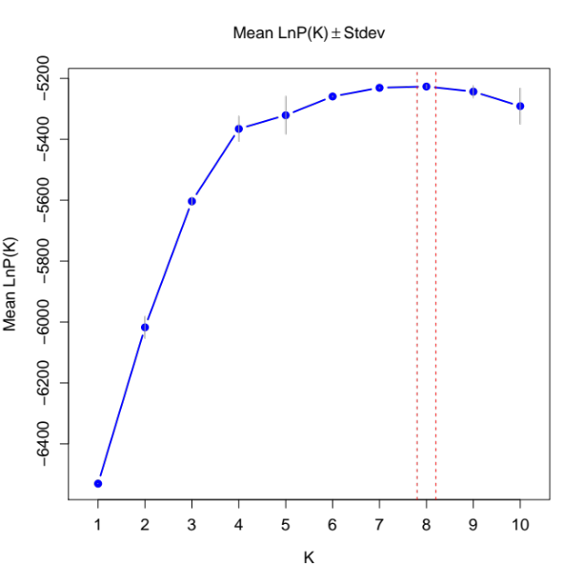

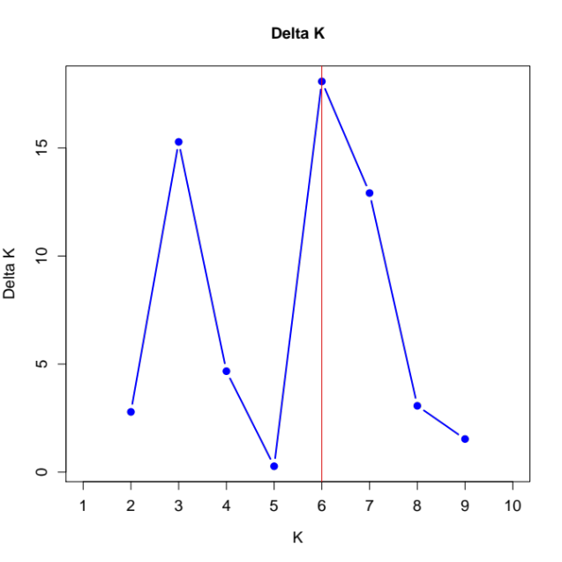

Fig. S1 Graphical results illustrating the estimates of posterior probability of the data (top) for a given K (Mean LnP(K)) and the ∆K method (bottom), which evaluates the second order rate of change between successive K values. Mean LnP(K) begins to asymptote at K = 4, with a peak at K = 8. The adhoc ∆K values are highest at K = 6; however, the scores are low across all K examined suggesting that this adhoc value is not strongly supporting one model over the rest.

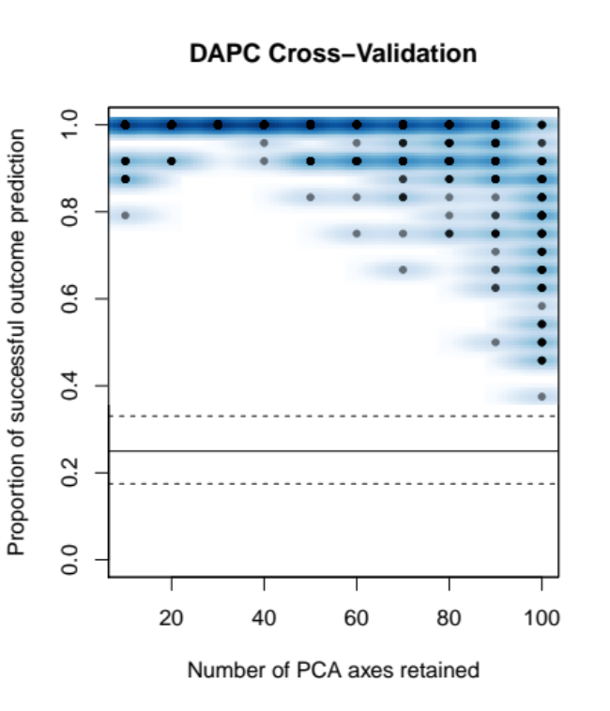

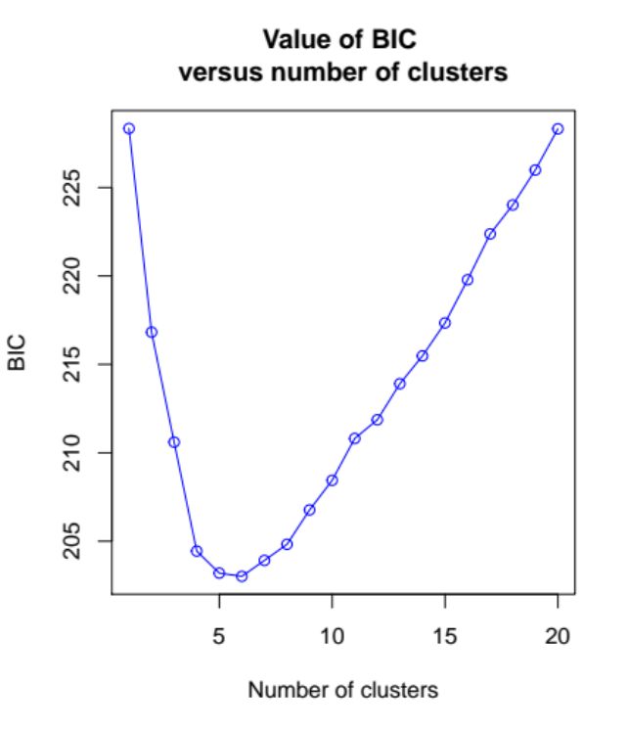

Fig. S2 (Top) Results from DAPC cross-validation using the xvalDapc function in adegenet. Thirty PCs had the highest mean success (100%) and lowest mean squared error (0) when 3 DA were retained. (Bottom) BIC plot for inferred numbers of clusters based on 30 PCs and 3 DAs. The BIC scores for K = 4 to K = 7 were: 204.44, 203.20, 203.02, 203.92 respectively. Group membership was consistent for CC, MD, and PC regardless of the number of retain K (4–7), with additional groups being identified among BW bats, mirroring results from the STRUCTURE analysis.

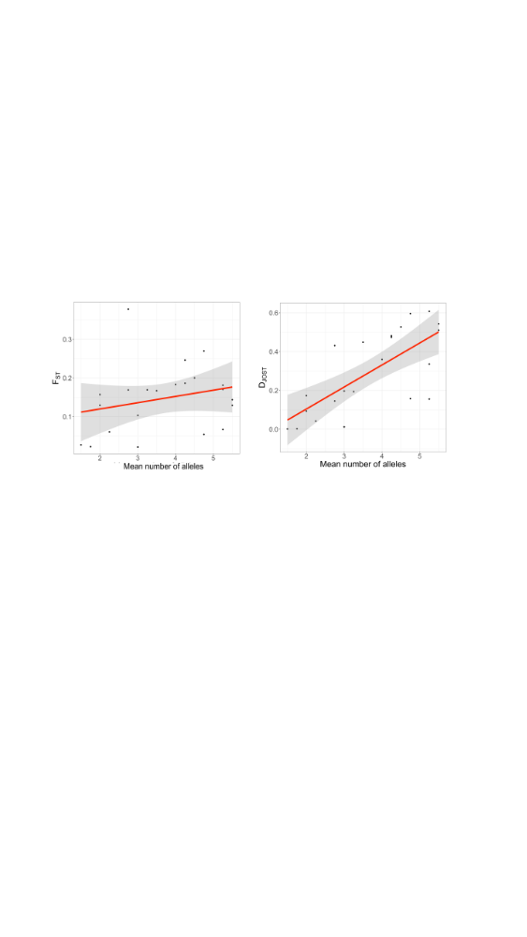

Fig. S3 Plots of F_{ST} and D_{Jost} versus locus polymorphism (number of alleles per locus). Best fit line and 95% CI are illustrated. Both F_{ST} and D_{Jost} are positively correlated with the number of alleles per locus. This similarity is indicative of a case where mutation rate is not likely to obscure past demographic processes, in particular gene flow (Keenan et al. 2013). In other words, the variation measured at the range-wide scale is likely suitable for inferring patterns of historical connectivity among regional groups using these microsatellites. A negative association between F_{ST} and polymorphism juxtaposed with the expected positive relationship between D_{Jost} and polymorphism would suggest that mutation rate, and likely drift are going to explain most of the patterns of variation at this scale.

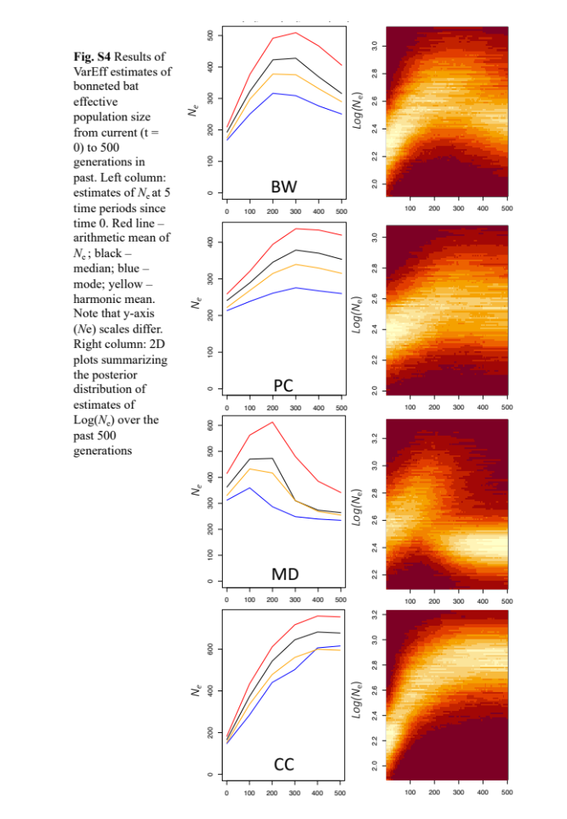
Fig. S5 DIYABC output for microsatellite data models comparing alternative scenarios for the four Eumops floridanus populations. A) PCA of prior and parameter fit to the observed dataset. Each small dot represents a simulated dataset, and the large yellow dot is the observed data set (scenario 1 = M1, scenario 2 = M2, etc). The PCA is based on the summary statistics estimated for each dataset. B) PCA of posterior fit of the best scenario (M2). Small open circles are the prior values for M2, closed circles are the posterior estimates, and yellow is the observed data set. C) Logistic estimate of support for each of the four models. D) Four demographic models being compared. M1, instantaneous divergence model. M2, hierarchical divergence where western populations diverged from a shared most recent common ancestor. M3, an ancestral population diverged into MD and CC populations with subsequent colonization of the BW population from CC at t₂, followed by the colonization of PC from BW at t₁; (M4) an ancestral population diverged forming MD and CC followed by the serial colonization of BW at t₂ and PC at t₁. Prior selection, summary statistics and assessment of confidence in model choice are provided in the Supplemental File.
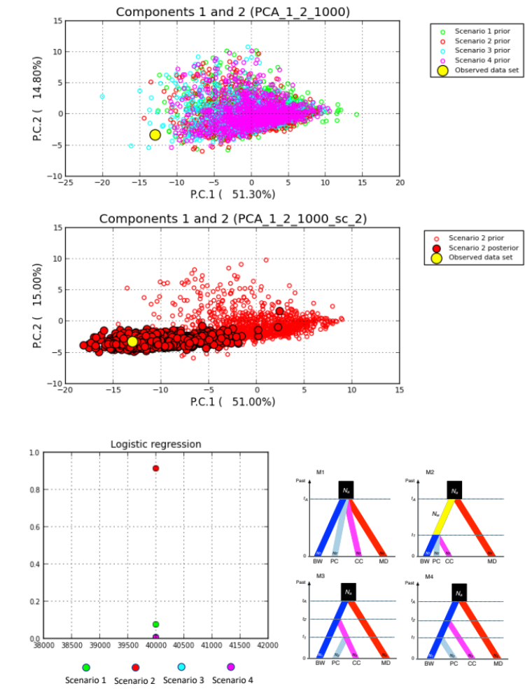
Posterior probability\)
C))
D))
B))
A)

Fig. S6 DIYABC output for cyt b data models comparing two alternative scenarios three Eumops populations. A) PCA of prior and parameter fit to the observed dataset. Each small dot represents a simulated dataset (scenario 1 = Mt1, scenario 2 = Mt2), and the large yellow dot is the observed data set. The PCA is based on the summary statistics estimated for each dataset. B) PCA of posterior fit of the best scenario (Mt2). Small open circles are the prior values for Mt2, closed circles are the posterior estimates, and yellow is the observed data set. C) Logistic estimate of support for each of the four models. D) Two demographic models being compared: Mt1 represents the incomplete lineage sorting hypothesis which supposes that the haplotypes found in MD and the western (PC, BW, CC) populations share a most recent common ancestor, likely being a Pleistocene origin in Florida. Mt2 represents a secondary colonization hypothesis, which supposes that the MD haplotypes have a more recent origin in Florida and shares a most recent common ancestor with Caribbean haplotypes.

C)
B)
D)
A)
C)
B)

References

Adamack AT, Gruber B (2014) PopGenReport: Simplifying basic population genetic analyses in R. Methods Ecol Evol 5:384–387
Alcala N, Goudet J, Vuilleumier S (2014) On the transition of genetic differentiation from isolation to panmixia: What we can learn from G_{ST} and D. Theor Pop Biol 93:75–84
Bailey AM, Ober HK, Sovie AR, McCleery RA (2017) Impact of land use and climate on the distribution of the endangered Florida bonneted bat. J Mammal 98:1586–1593
Beaumont MA (2008) Joint determination of topology, divergence time, and immigration in population trees. In: Matsumura S, Forster P, Renfrew C (eds) Simulation, genetics and human prehistory, McDonald Institute for Archaeological Research, University of Cambridge, Cambridge
Braun de Torrez EC, Samoray ST, Silas A, Wallrichs MA, Gumbert MW, Ober HK, McCleery RA (2017) Acoustic lure allows for capture of a high-flying, endangered bat. Wildl Soc Bull 41:322–328
Braun de Torrez EC, Gore JA, Ober HK (2020) Evidence of resource-defense polygyny in an endangered subtropical bat, Eumops floridanus. Glob Ecol Conserv 24:e01289
Brookfield JFY (1996) A simple new method for estimating null allele frequency from heterozygote deficiency. Mol Ecol 5:453–455
Cornuet J-M, Santos F, Beaumont MA, Robert CP, Marin J-M, Balding DJ, Guillemaud T, Estoup A (2008) Inferring population history with DIY ABC: a user-friendly approach to approximate Bayesian computation. Bioinformatics 24:2713–2719
Cornuet J-M, Pudlo P, Veyssier J, Dehne-Garcia A, Gautier M, Leblois R, Marin J-M, Estoup A (2014) DIYABC v2.0: a software to make approximate Bayesian computation inferences about population history using single nucleotide polymorphism, DNA sequence and microsatellite data. Bioinformatics 30:1187–1189
Do C, Waples R, Peel D, Macbeth G, Tillet B, Ovenden J (2014) NeEstimator v2: re-implementation of software for the estimation of contemporary effective population size (N_{e}) from genetic data. Mol Ecol Resour 14:209–214
Dray S, Dufour A-B. 2007. The ade4 package: implementing the duality diagram for ecologists. J Stat Softw 22:1–20
Evanno G, Regnaut S, Goudet J (2005) Detecting the number of clusters of individuals using the software structure: a simulation study. Mol Ecol 14:2611–2620
Faircloth BC (2008) Msatcommander: detection of microsatellite repeat arrays and automated, locus-specific primer design. Mol Ecol Res 8:92–94
Falush D, Stephens M, Pritchard JK (2003) Inference of population structure using multilocus genotype data: linked loci and correlated allele frequencies. Genetics 164:1567–1587.
Guo S, Thompson E (1992) Performing the exact test of Hardy–Weinberg proportion for multiple alleles. Biometrics 48:361–372.
Hulce D, Li X, Snyder-Leiby T, Johnathan Lui C (2011) GeneMarker Genotyping Software: tools to increase the statistical power of DNA fragment analysis. J Biomol Tech 22:S35–S36.
Husemann M, Zachos FE, Paxton RJ, Habel JC (2016) Effective population size in ecology and evolution. Heredity 117:191–192
Jombart T (2008) adegenet: a R package for the multivariate analysis of genetic markers. Bioinformatics 24:1403–1405
Jombart T, Ahmed I (2011) adegenet 1.3-1: new tools for the analysis of genome-wide SNP data. Bioinformatics 27:3070–3071
Jombart T, Devillard S, Balloux F (2010) Discriminant analysis of principal components: a new method for the analysis of genetically structured populations. BMC Genet 11:94
Jost L (2008) G_{ST} and its relatives do not measure differentiation. Mol Ecol 17:4015–402
Keenan K, McGinnity P, Cross TF, Crozier WW, Prodöhl PA (2013) diveRsity: An R package for the estimation and exploration of population genetics parameters and their associated errors. Methods Ecol Evol 4:782–788
Koressaar T, Remm M (2007) Enhancements and modifications of primer design program Primer3. Bioinformatics 23:1289–1291.
Li YL, Liu JX (2018) StructureSelector: A web-based software to select and visualize the optimal number of clusters using multiple methods. Mol Ecol Res 18:176–177. https://doi.org/10.1111/1755-0998.12719
Longmire JL, Maltbie M, Baker RJ (1997) Use of lysis buffer in DNA isolation and its implications for museum collections. Mus Texas Tach Univ 163:1–3
Maddison WP, Maddison DR (2021) Mesquite: a modular system for evolutionary analysis. Version 3.70 http://www.mesquiteproject.org
Meirmans PG (2012) The trouble with isolation by distance. Mol Ecol 21:2839–2846
Nikolic N, Chevalet C (2014) Detecting past changes of effective population size. Evol Appl 7:663–681
Novembre J (2016) Pritchard, Stephens, and Donnelly on population structure. Genetics 204:391–393
Ober HK, Braun De Torrez EC, Gore JA, Bailey AM, Myers JK, Smith KN, McCleery RA (2017) Social organization of an endangered subtropical species, Eumops floridanus, the Florida bonneted bat. Mammalia 81:375–383
Pradis E (2010) pegas: an R package for population genetics with an integrated–modular approach. Bioinformatics, 26:419–420
Pritchard JK, Stephens M, Donnelly P (2000) Inference of population structure using multilocus genotype data. Genetics 155:945–959
Pritchard JK, Wen W (2004) Documentation for the STRUCTURE software Version 2. Chicago. http://www.pritch.bsd.uchicago.edu/software/structure2_1.html
Puechmaille SJ (2016) The program structure does not reliably recover the correct population structure when sampling is uneven: Subsampling and new estimators alleviate the problem. Mol Ecol Res 16:608–627
R Core Team (2019) R: A language and environment for statistical computing. R Foundation for Statistical Computing, Vienna, Austria. URL https://www.R-project.org/
Rousset F (1997) Genetic differentiation and estimation of gene flow from F-statistics under isolation by distance. Genetics 145:1219–1228
Rousset F (2008) Genepop'007: a complete reimplementation of the Genepop software for Windows and Linux. Mol. Ecol. Res 8:103–106
Russell AL, Turmelle AS, Brown VA, McCracken GF (2005) Extremely variable di- and tetranucleotide microsatellite loci in Brazilian free-tailed bats (Tadarida brasiliensis) Mol Ecol Notes 5:669–671
Ryman N, Palm S (2006) POWSIM: a computer program for assessing statistical power when testing for genetic differentiation. Mol Ecol Notes 6:600–602
Schmidt TR, Gold JR (1993) Complete sequence of the mitochondrial cytochrome b gene in the cherryfin shiner, Lythrurus roseipinnis (Teleostei: Cyprinidae). Copeia 1993:880–883
Sundqvist L, Keenan K, Zackrisson M, Prodöhl P, Kleinhans D (2016) Directional genetic differentiation and relative migration. Ecol Evol 6:3461–3475.
Untergasser A, Cutcutache I, Koressaar T, Ye J, Faircloth B, Remm M, Rozen S (2012) Primer 3 - new capabilities and interfaces. Nucl Acids Res 40:e115
Waples RS, Do CHI (2008) LDNe: a program for estimating effective population size from data on linkage disequilibrium. Mol Ecol Res 8:753–756
Webb EN, Ober HK, Braun de Torrez EC, Gore JA, Zambrano R (2021) Urban roosts: use of buildings by Florida bonneted bats. Urban Nat 42:1–11
Weir B, Hill W (1980) Effect of mating structure on variation in linkage disequilibrium. Genetics 95:477–488
Weir BS, Cockerham CC (1984) Estimating F-statistics for the analysis of population structure. Evolution 38:1358–1370
Wilson GA, Rannala B (2003) Bayesian inference of recent migration rates using multilocus genotypes. Genetics 163:1177–1191
Wright S (1943) Isolation by distance. Genetics 28:114–138

