Supplementary Information

Remediation of Cd contaminated soil by sewage sludge biochar particle modified with phosphorus: Speciation transformation and risk evaluation

Table S1 Basic properties of the sewage sludge.
Table S2 Basic properties of soils, SSBP and P-SSBP.
Table S3 The arrangement of soil experiment.
Table S4 The Cd leaching toxicity of SS, SSBP, P-SSBP, and comparison of thresholds for Cd in International Biochar Initiative (IBI) and European Biochar Foundation (EBF) standards (mg/kg).
Table S5 Phosphorus release behavior from SSBP and P-SSBP in deionized water.
Table S6 Total amount of heavy metals in different experimental groups.
Table S7 TP content of different experimental groups.
Table S8 Organic matter content in different experimental groups (g/kg).

Fig. S1 The map of soil experimental
Fig. S2 The SEM of the 5,000 x (a, b) and 20,000 x (c, d) of the SSBP and P-SSBP
Fig. S3 The XRD diffraction patterns (a), the nitrogen adsorption-desorption isotherms and BJH pore size distribution curve (b), the FTIR spectra (c) of SSBP and P-SSBP
Fig. S4 The XPS full spectrum, C spectrograms and P spectrograms of SSBP and P-SSBP

Tables:
Table S1 Basic properties of the sewage sludge.
water content/% | Ash content/% | Volatiles/% | fixed carbon/% | pH
82 | 76.02 | 10.99 | 12.99 | 7.05

Table S2 Basic properties of soils, SSBP and P-SSBP.
 | pH | Cd (mg/kg) | TP (mg/kg)
Soil | 6.80 | 66.75 | 33.50
SSBP | 6.95 | 1.01 | 12.85×10³
P-SSBP | 7.09 | 0.93 | 27.55×10³

Table S3 The arrangement of soil experiment.
BP | Potting test | Indoor culture test
0% | PZ-0%C | SN-0%C
1% | PZ-1%YC | SN-1%YC
1% | PZ-1%PC | SN-1%PC
2% | PZ-2%YC | SN-2%YC
2% | PZ-2%PC | SN-2%PC
5% | PZ-5%YC | SN-5%YC
5% | PZ-5%PC | SN-5%PC

Table S4 The Cd leaching toxicity of SS, SSBP, P-SSBP, and comparison of thresholds for Cd in International Biochar Initiative (IBI) and European Biochar Foundation (EBF) standards (mg/kg).
Category | SS | SSBP | P-SSBP | IBI | EBF
Cd | 1.22 | 1.01 | 0.93 | 1.4-39 | ＜1.5

Table S5 Phosphorus release behavior from SSBP and P-SSBP in deionized water.
Biochar | Time/h
Biochar | 24 | 72 | 96 | 12 | 168
SSBP | 0.31 | 1.04 | 1.39 | 1.89 | 2.69
P-SSBP | 1.40 | 3.94 | 3.80 | 3.82 | 8.11

Table S6 Cd amount in different experimental groups.
Type | Time (d)
Type | 0 | 5 | 15 | 35 | 55
SN-0%C | 66.75 | 65.40 | 65.40 | 65.50 | 64.99
SN-1%YC | 66.75 | 56.67 | 50.93 | 46.37 | 38.68
SN-2%YC | 66.75 | 49.61 | 49.52 | 48.26 | 37.05
SN-5%YC | 66.75 | 52.99 | 48.77 | 46.06 | 40.03
SN-1%PC | 66.75 | 52.99 | 48.77 | 46.06 | 40.03
SN-2%PC | 66.75 | 46.29 | 42.68 | 38.45 | 35.37
SN-5%PC | 66.75 | 63.33 | 51.47 | 48.08 | 38.79
PZ-0%C | 66.75 | 66.13 | 59.31 | 49.03 | 46.14
PZ-1%YC | 66.75 | 51.60 | 49.65 | 47.09 | 38.69
PZ-2%YC | 66.75 | 53.52 | 51.26 | 47.75 | 37.70
PZ-5%YC | 66.75 | 52.43 | 43.02 | 42.60 | 39.52
PZ-1%PC | 66.75 | 51.48 | 41.18 | 38.79 | 34.37
PZ-2%PC | 66.75 | 52.60 | 47.39 | 39.95 | 32.78
PZ-5%PC | 66.75 | 57.77 | 41.94 | 40.07 | 34.78

Table S7 TP content in different experimental groups.
Type | Time (d)
Type | 0 | 5 | 15 | 35 | 55
SN-0%C | 33.50 | 29.12 | 29.19 | 27.46 | 27.06
SN-1%YC | 33.50 | 44.47 | 81.38 | 164.37 | 463.56
SN-2%YC | 33.50 | 39.90 | 122.42 | 155.12 | 484.27
SN-5%YC | 33.50 | 46.29 | 117.10 | 165.09 | 600.59
SN-1%PC | 33.50 | 40.98 | 110.72 | 174.70 | 545.55
SN-2%PC | 33.50 | 37.71 | 108.60 | 238.55 | 577.77
SN-5%PC | 33.50 | 48.11 | 213.82 | 232.58 | 673.36
PZ-0%C | 33.50 | 27.79 | 34.66 | 36.00 | 39.43
PZ-1%YC | 33.50 | 25.42 | 77.48 | 174.15 | 506.77
PZ-2%YC | 33.50 | 23.82 | 110.50 | 175.24 | 520.97
PZ-5%YC | 33.50 | 23.27 | 130.82 | 165.35 | 558.31
PZ-1%PC | 33.50 | 23.83 | 199.60 | 179.46 | 546.45
PZ-2%PC | 33.50 | 40.87 | 240.24 | 200.40 | 602.47
PZ-5%PC | 33.50 | 20.70 | 198.80 | 207.92 | 600.00

Table S8 Organic matter content in different experimental groups (g/kg).
Type | Time (d)
Type | 0 | 5 | 15 | 35 | 55
SN-0%C | 18.88 | 18.10 | 17.55 | 17.03 | 15.15
SN-1%YC | 18.88 | 18.72 | 17.95 | 15.88 | 15.15
SN-2%YC | 18.88 | 17.98 | 17.39 | 17.11 | 15.48
SN-5%YC | 18.88 | 18.28 | 17.47 | 17.97 | 15.80
SN-1%PC | 18.88 | 18.66 | 17.56 | 17.26 | 15.52
SN-2%PC | 18.88 | 18.43 | 17.46 | 16.45 | 16.11
SN-5%PC | 18.88 | 18.72 | 18.60 | 17.67 | 16.25
PZ-0%C | 18.88 | 18.10 | 16.29 | 15.06 | 14.56
PZ-1%YC | 18.88 | 18.69 | 15.61 | 15.35 | 15.02
PZ-2%YC | 18.88 | 17.98 | 17.67 | 16.49 | 15.55
PZ-5%YC | 18.88 | 18.81 | 18.21 | 15.25 | 15.01
PZ-1%PC | 18.88 | 18.09 | 17.93 | 16.25 | 16.23
PZ-2%PC | 18.88 | 18.24 | 18.12 | 17.68 | 16.41
PZ-5%PC | 18.88 | 18.26 | 17.48 | 17.11 | 14.89

Figures:
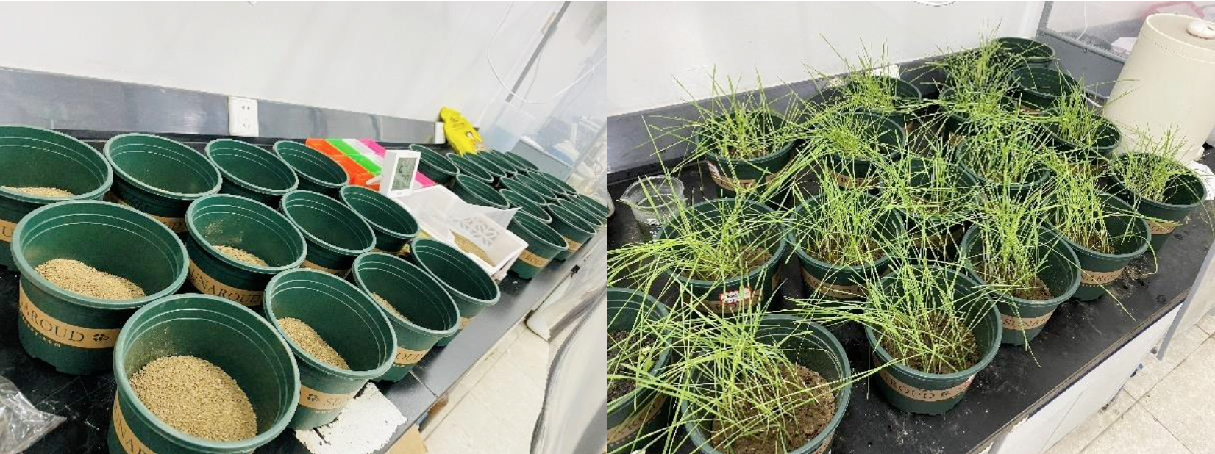
Fig. S1 The map of soil experimental.

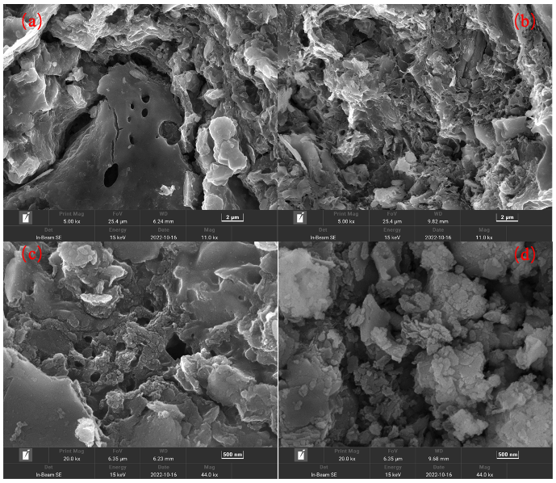
Fig. S2 The SEM of the 5,000 x (a, b) and 20,000 x (c, d) of the SSBP and P-SSBP.
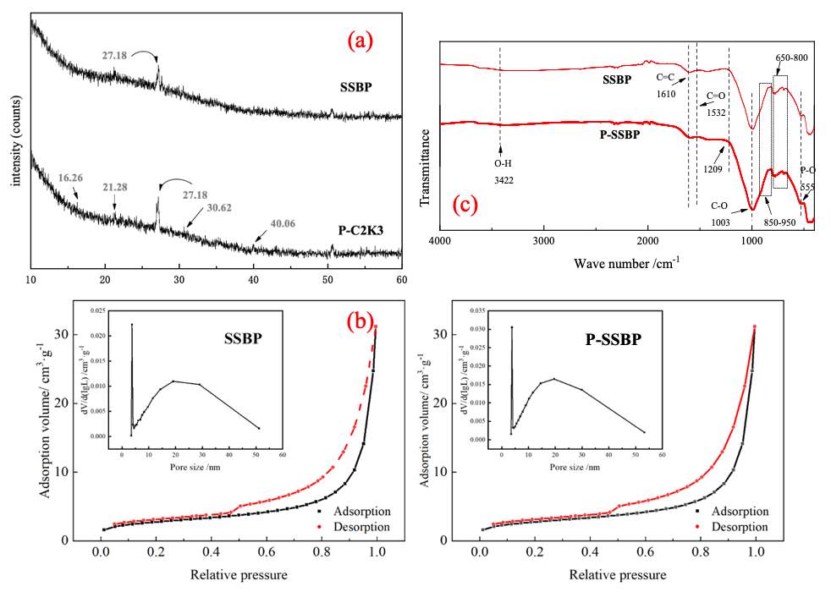
Fig. S3 The XRD diffraction patterns (a), the nitrogen adsorption-desorption isotherms and BJH pore size distribution curve (b), the FTIR spectra (c) of SSBP and P-SSBP.
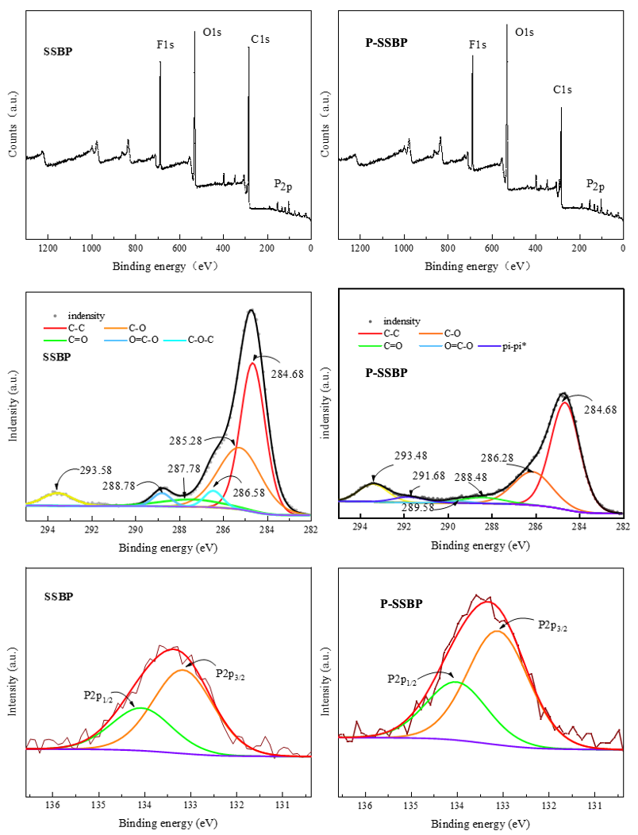
Fig. S4 The XPS full spectrum, C spectrograms and P spectrograms of SSBP and P-SSBP.

