Histological sections of Middle Histological sections of Posterior
Silk gland of V Instar at different light Silk gland of V Instar at different light
Intensity intensity
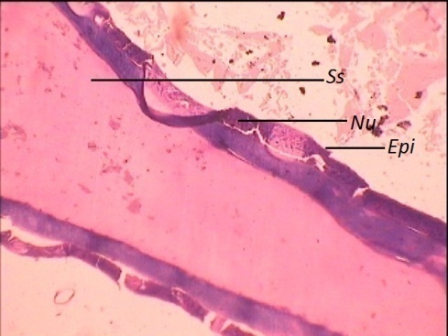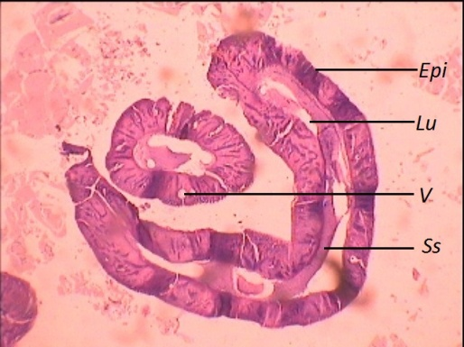
Plate 1. Middle silk gland of V Instar in sunlight Plate 2. Posterior silk gland of V Instar in
sunlight
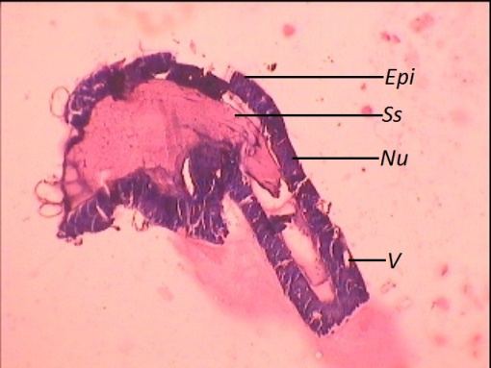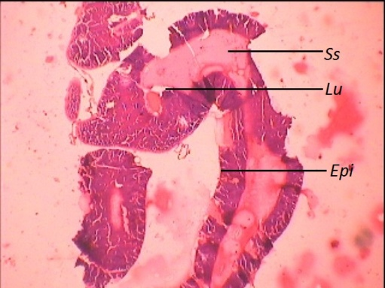
Plate 3. Middle silk gland of V Instar in Plate 4. Posterior silk gland of V Instar in
Artificial light Artificial light

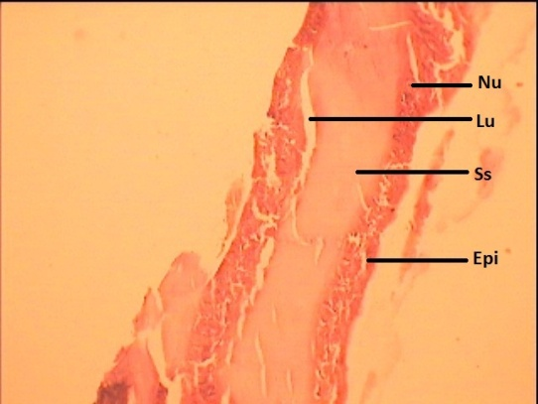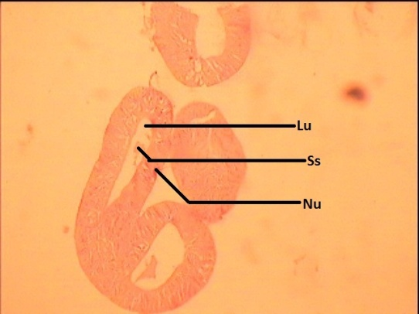
Plate 5. Middle silk gland of V Instar in dark Plate 6. Posterior silk gland of V Instar in dark dark

