Supplementary Material
Surface plasmon resonance biosensor for sensitive detection of HER2-positive exosomes based on reformative tyramine signal amplification activated by molecular aptamer beacon conversion
Wenqin Chen ^{a, b, 1}, Zhiyang Li ^{b, 1}, Wenqian Cheng ª, Tao Wu ^{c}, Jia Li ª, Xinyu Li ª, Lin Liu ^{c}, Huijie Bai ª, Shijia Ding ª, Xinmin Li ^{a,} *, Xiaolin Yu^{c,} *
ª Key Laboratory of Clinical Laboratory Diagnostics (Ministry of Education), College of Laboratory Medicine, Chongqing Medical University, Chongqing 400016, China
^{b} Department of Clinical Laboratory, the Affiliated Drum Tower Hospital of Nanjing
University Medical School, Nanjing 210008, China
^{c} Department of Laboratory Medicine, Zigong Fourth People’s Hospital, Sichuan 643000, China

* Corresponding author
E-mail: E-mail: yuxiaolincq@hotmail.com (X. Yu); xinmnli@163.com (X. Li).
Author Contributions
¹ W. Chen and Z. Li contributed equally to this work.
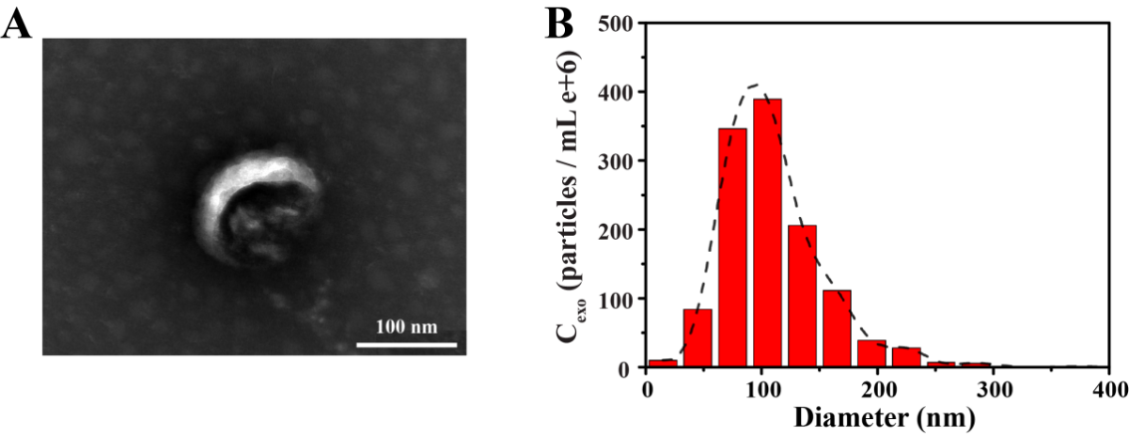
Fig. S1 Characterization of the exosomes. (A) TEM image and (B) NTA of the collected exosomes derived from SK-BR3 cells.
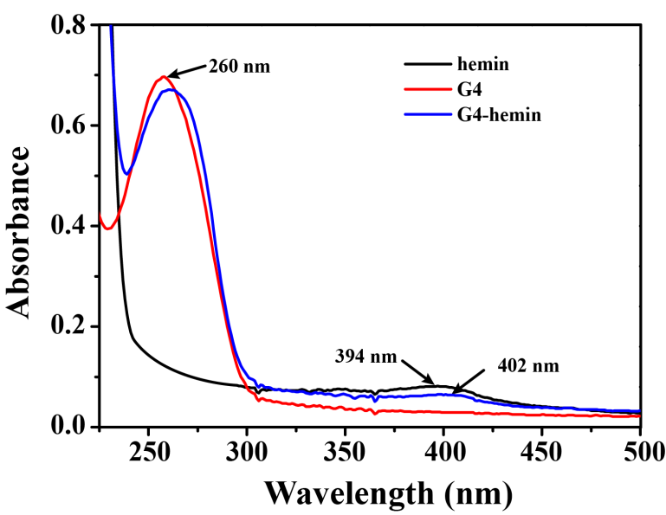
Fig. S2 Characterization of G4-hemin. UV–vis absorption spectra of free hemin (black line), G4 (red line), and G4-hemin (blue line).
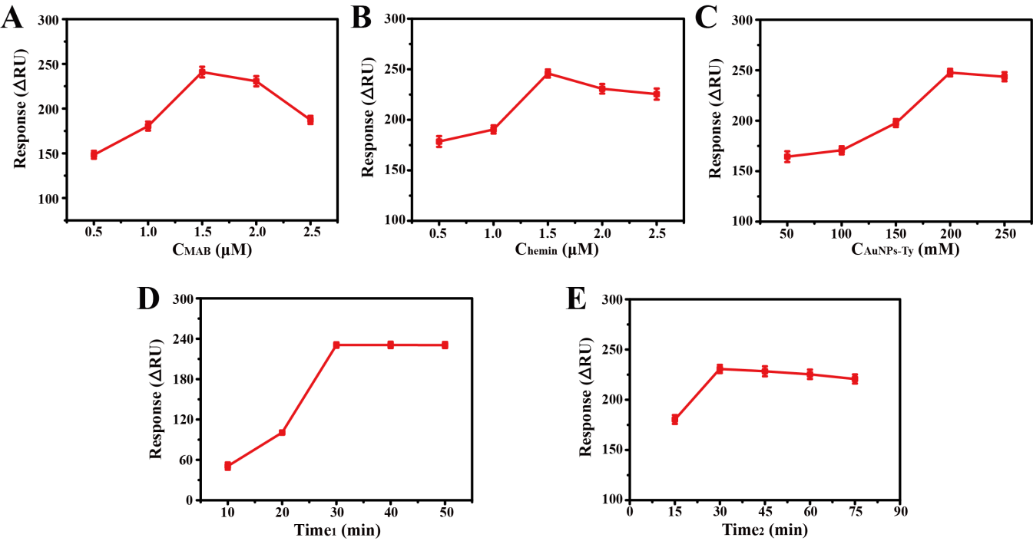
Fig. S3 Optimizations of the concentrations of (A) the MAB, (B) hemin, (C) AuNPs-Ty, the reaction time of (D) MAB and exosomes, and (E) the incubation time of the developed TSA.
Table S1. Sequences of oligonucleotides employed in this work.
Oligonucleotides | Sequences (5’-3’)
Hairpin probe | GTACTCGGGTGGGTGGGTGGGTCCACGCAGGGCCGTCGAACACGAGCATGGTGCGTGGACCTAGGATGACCTGAGTACTGTCCT₁₅- C₆HS-SH
Table S2. Comparison of biosensing strategies for the detection of exosomes.
Detection platform | Amplification strategy | Linear range (particle/mL) | LOD (particle/mL) | Ref.
Colorimetry | Enzyme-induced etching of Au NBP@MnO₂ NSs | 8.50 × 10⁵- 8.50 × 10⁷ | 1.35 × 10⁵ | [1]
Fluorescence | Branched RCA | 1.00 × 10⁵- 1.00 ×10⁹ | 4.27 × 10⁴ | [2]
Electrochemistry | NTH-coupled enzymatic signal amplification | 2.16 × 10⁴- 7.50 × 10⁷ | 1.66 × 10⁴ | [3]
Fluorescence | Fe₃O₄@SiO₂@  TiO₂ particles | 5.00 × 10⁵- 1.00 × 10⁷ | 5.00 × 10⁵ | [4]
Colorimetry | DNAzyme | 8.30 × 10⁵- 5.30 × 10⁷ | 3.94 × 10⁵ | [5]
SPR | MAB and the reformative TSA | 1.00 × 10⁴ -1.00 × 10⁷ | 1.00 × 10⁴ | This  work

Au NBP@MnO₂ NSs: gold nanobipyramid@MnO₂ nanosheet nanostructures; RCA: rolling circle amplification; NTH: DNA nanotetrahedron; SPR: surface plasmon resonance; MAB: molecular aptamer beacon; TSA: tyramine signal amplification.
References
[1] R. Huang, L. He, S. Li, H. Liu, L. Jin, Z. Chen, Y. Zhao, Z. Li, Y. Deng, N. He, A simple fluorescence aptasensor for gastric cancer exosome detection based on branched rolling circle amplification, Nanoscale. 12 (2020) 2445-2451.
[2] J. Jiang, Y. Yu, H. Zhang, C. Cai, Electrochemical aptasensor for exosomal proteins profiling based on DNA nanotetrahedron coupled with enzymatic signal amplification, Anal. Chim. Acta. 1130 (2020) 1-9.
[3] Q. Li, Y. Wang, L. Ling, L. Qiao, H. Chen, C. Ding, S. Yu, Rapid and specific detection nanoplatform of serum exosomes for prostate cancer diagnosis, Microchim. Acta. 188 (2021) 283.
[4] Y. Zhang, J. Jiao, Y. Wei, D. Wang, C. Yang, Z. Xu, Plasmonic Colorimetric Biosensor for Sensitive Exosome Detection via Enzyme-Induced Etching of Gold Nanobipyramid@MnO₂ Nanosheet Nanostructures, Anal. Chem. 92 (2020) 15244-15252.
[5] Y. Zhou, H. Xu, H. Wang, B.C. Ye, Detection of breast cancer-derived exosomes using the horseradish peroxidase-mimicking DNAzyme as an aptasensor, Analyst 145 (2019) 107-114.

