Supplementary Information
Coupled Ionic–Electronic Transport Governs Energy Conversion in Hydrogel Salinity-Gradient Batteries
Chun-Hao Huang, ^{1‡} Chia-Fu Chang, ^{1‡} Bing-Xuan Zhong, ^{1‡} Phok-Jin Yang,² Ying-Huang Lai,³ Yi-Qi Yeh,² Chia-Hsin Wang,² Lo-Yueh Chang,² Ying-Rui Lu,² U-Ser Jeng,² Chien-Lung Wang,¹* Wei-Tsung Chuang, ²*
¹ Department of Chemistry, National Taiwan University, No. 1, Sec. 4, Roosevelt Road, Taipei 10617, Taiwan
² National Synchrotron Radiation Research Center, 101 Hsin-Ann Road, Hsinchu 300092, Taiwan
³ Department of Chemistry, Tunghai University, No. 1727, Sec. 4, Taiwan Boulevard, Taichung 40704, Taiwan
‡These authors contributed equally.

Correspondence.
Chien-Lung Wang (kclwang@ntu.edu.tw),
Wei-Tsung Chuang (weitsung@nsrrc.org.tw)

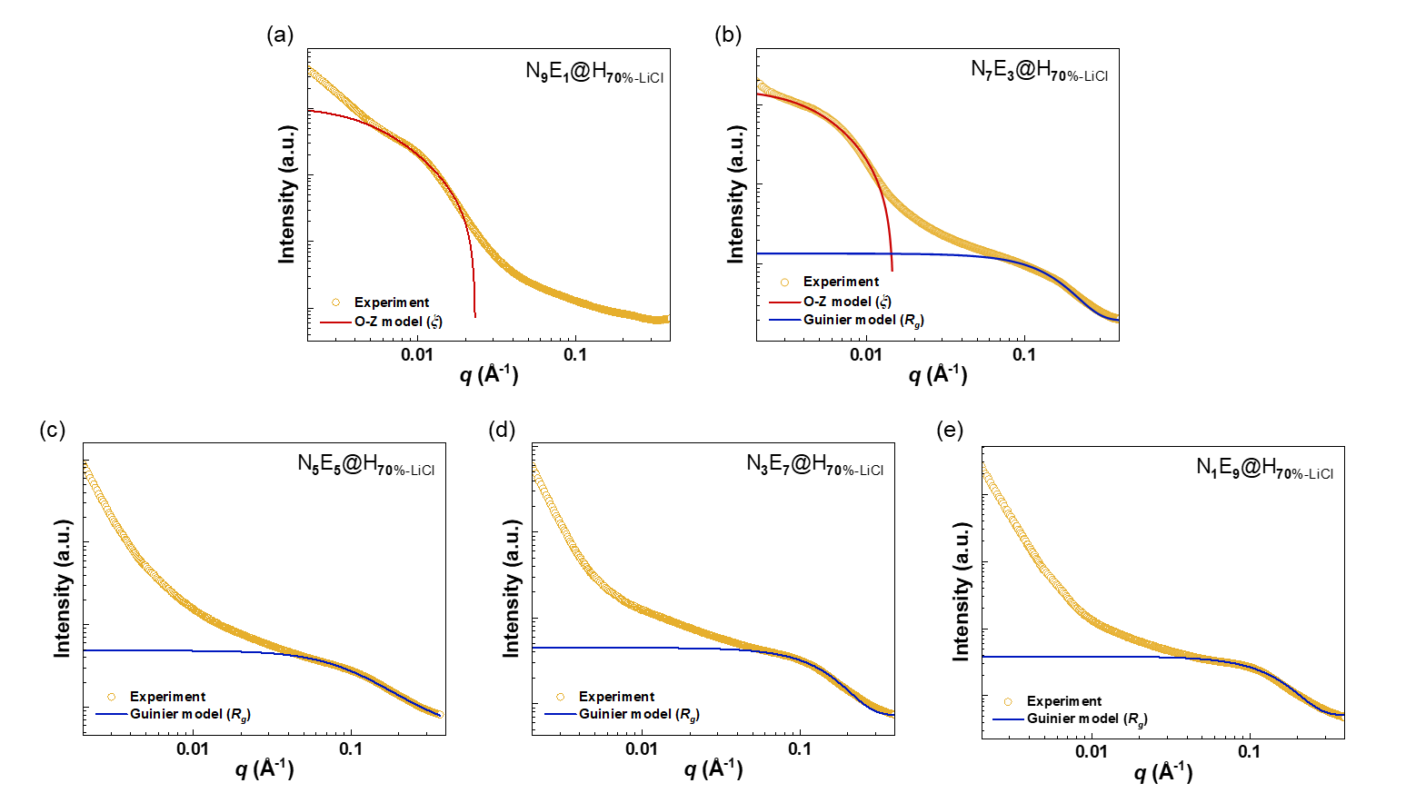
Supplementary Figure 1. SAXS profiles of N_{x}E_{y}@H_{70%-LiCl} hydrogels fitted using the Ornstein–Zernike (O–Z) and Guinier models for different monomer ratios (x : y): (a) 9 : 1, (b) 7 : 3, (c) 5 : 5, (d) 3 : 7, (e) 1 : 9.

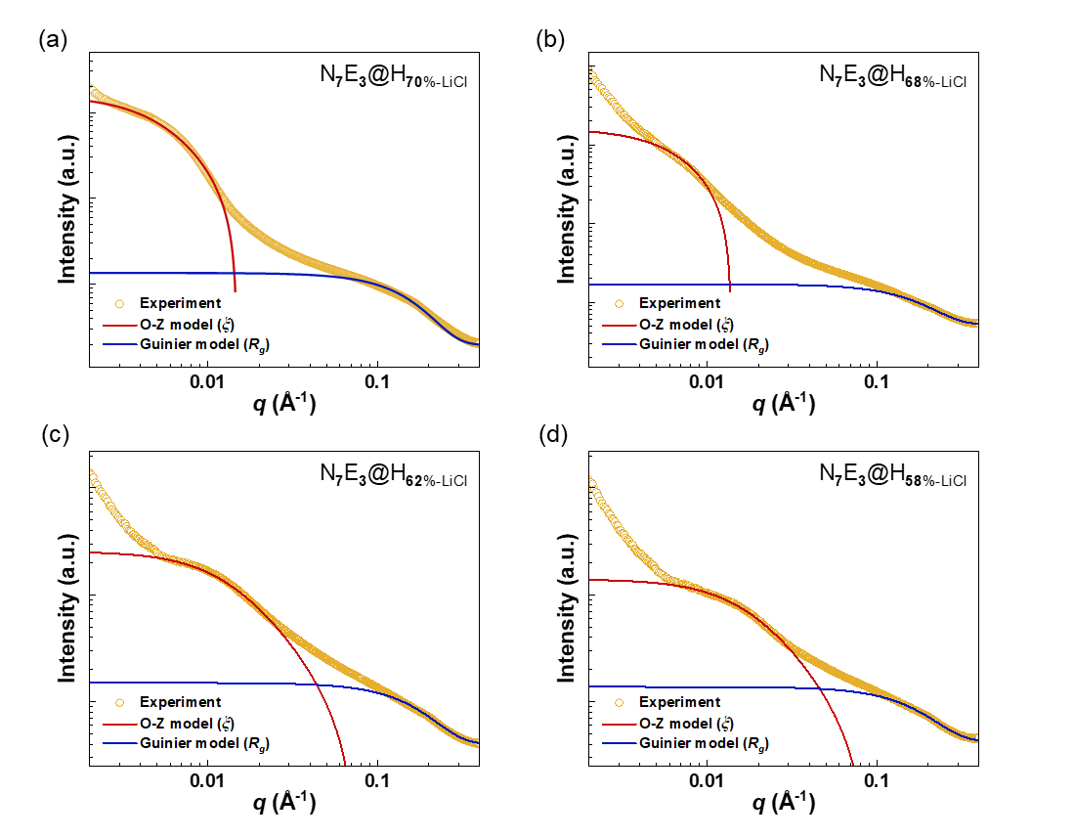
Supplementary Figure 2. SAXS profiles of N₇E₃@H_{w%-LiCl} hydrogels fitted using the Ornstein–Zernike (O–Z) and Guinier models for different water contents (w %): (a) 70 %, (b) 68 %, (c) 62 %, (d) 58 %.

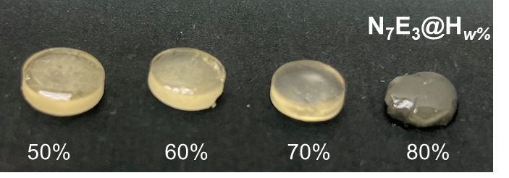
Supplementary Figure 3. Photographs of N₇E₃@H_{w%} hydrogels with different water contents. At w = 80 %, the sample exhibits a soft, sol-like state.

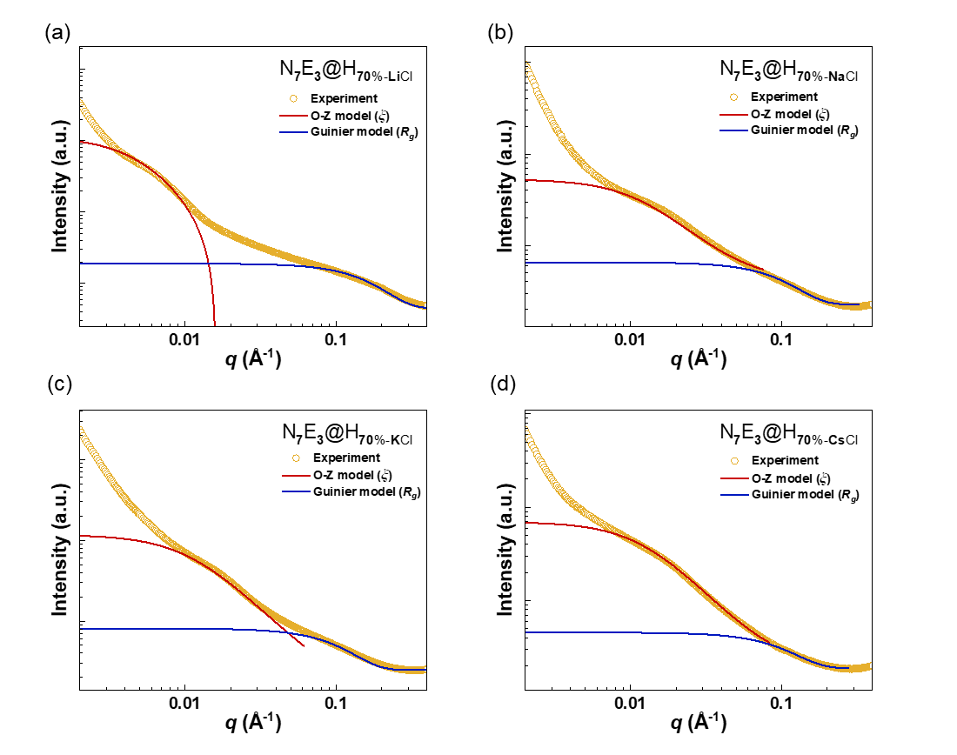
Supplementary Figure 4. SAXS profiles of N₇E₃@H_{w%-LiCl} hydrogels fitted using the Ornstein–Zernike (O–Z) and Guinier models for different alkali metal cations (ACl) (a) LiCl (b) NaCl (c) KCl (d) CsCl.

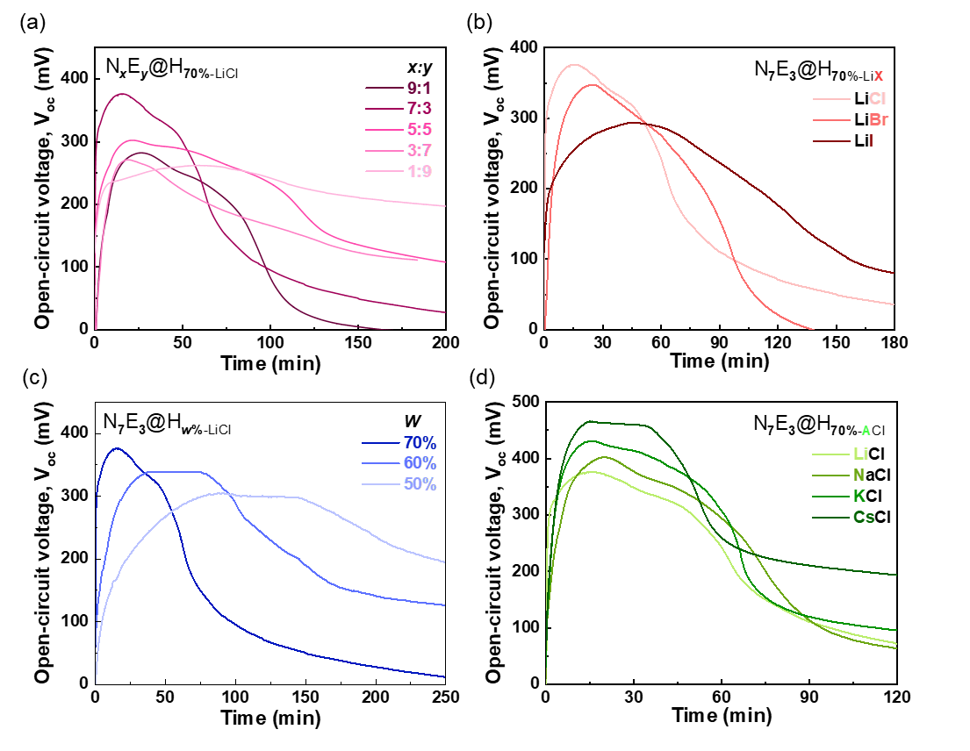
Supplementary Figure 5. Representative voltage–time profiles of HSGB devices under different structural and ionic conditions: (a) N_{x}E_{y}@H_{70%-LiCl} hydrogels with different monomer ratios (x : y); (b) N₇E₃@H_{w%-LiCl} hydrogels with different water contents (w %); (c) N₇E₃@H_{70%-LiX} hydrogels showing the effect of halide anions (X⁻= Cl⁻, Br⁻, I⁻); (d) N₇E₃@H_{70%-ACl} hydrogels illustrating the influence of alkali-metal cations (A⁺= Li⁺, Na⁺, K⁺, Cs⁺).

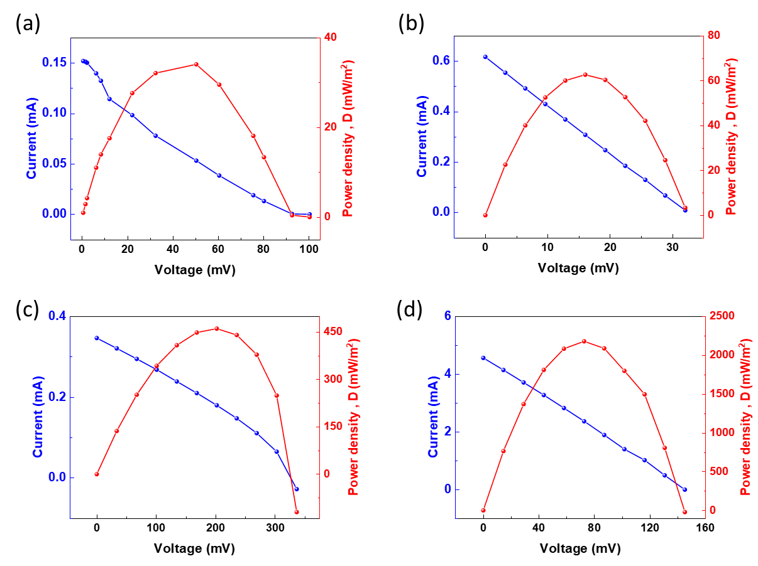

Supplementary Figure 6. Representative current–voltage (I–V) curves and power density plots for paper-based N₇E₃@H_{70%} HSGB devices with different electrodes: (a) carbon paper (CP), (b) K4[Fe(CN)₆]/K₃[Fe(CN)₆]/CP, (c) PEDOT:PSS/CP, (d) K4[Fe(CN)₆]/K₃[Fe(CN)₆]/PEDOT:PSS/CP.

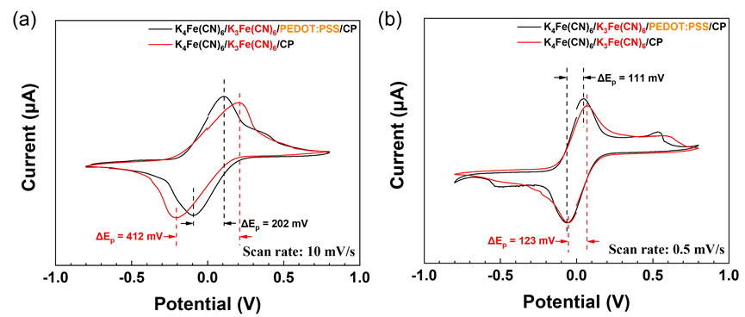
Supplementary Figure 7. Cyclic voltammograms recorded at different scan rates of (a) 10 mV/s and (b) 0.5 mV/s, with the peak-to-peak separation (ΔE_{p}) indicated in the figures.

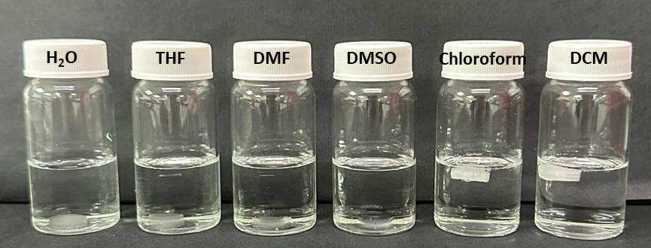
Supplementary Figure 8. Solubility assessment of N₇E₃@H_{70%} hydrogels in water, tetrahydrofuran (THF), N,N-dimethylformamide (DMF), dimethyl sulfoxide (DMSO), chloroform, and dichloromethane (DCM).

Supplementary Figure 9. Raman spectra of PEGMA monomer, NIPAM monomer, and N₇E₃@H_{70%} hydrogel, confirming the successful synthesis of the PNIPAM–PEGMA-based bottlebrush polymer hydrogels.

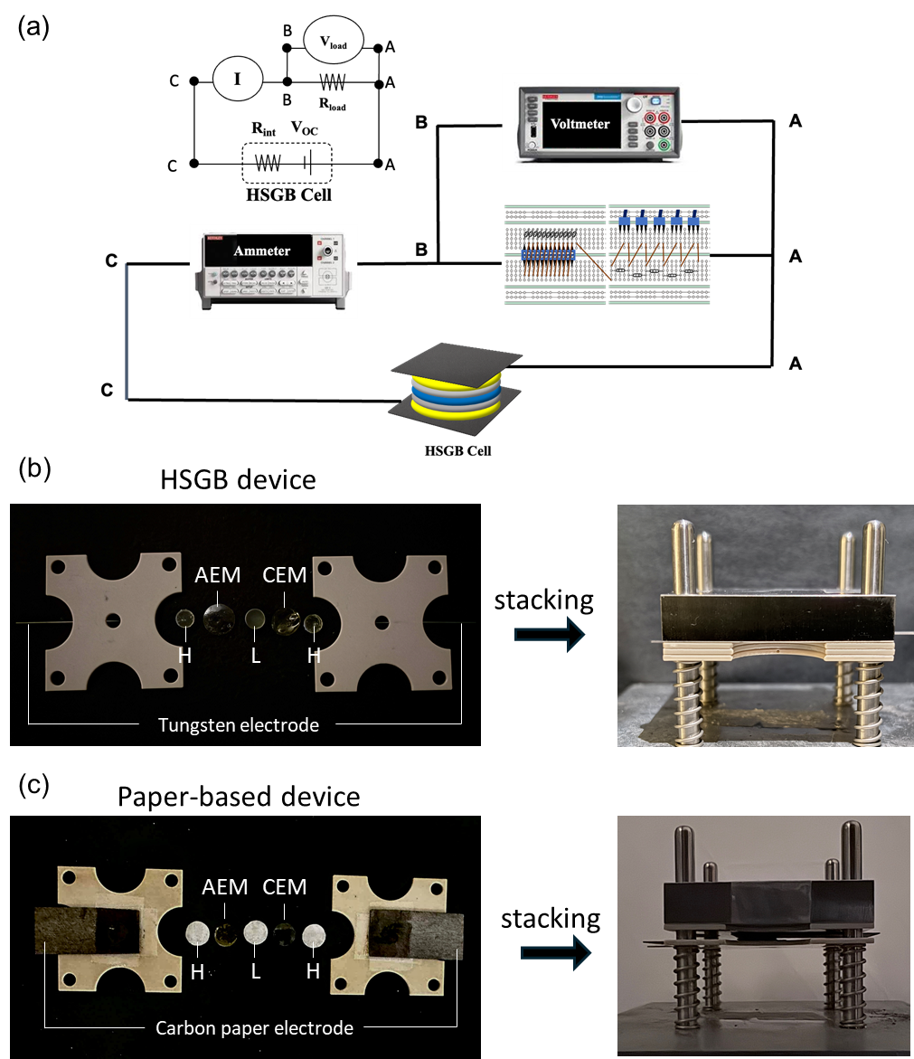
Supplementary Figure 10. (a) Equivalent circuit of the HSGB device; (b) photographs of the assembled HSGB components and the complete device; and (c) photographs of the assembled components and complete paper-based HSGB device.

Supplementary Table 1. Calculation of free-water fraction by DSC
- Monomer ratio (x : y)
Sample | $$∆H_{m}(mJ/mg)$$ | $${W_{t}(mg)}^{a}$$ | $${W_{f}(mg)}^{b}$$ | $${W_{nf}(mg)}^{ac}$$ | Free-water content (%)^{b} | Bound-water content (%)^{d}
Pure water | 311.02 | 4.90 | 4.90 | 0 | 100 | 0
N₉E₁@H_{70%} | 259.28 | 1.79 | 1.49 | 0.30 | 83 | 17
N₇E₃@H_{70%} | 130.14 | 2.16 | 0.90 | 1.26 | 42 | 58
N₅E₅@H_{70%} | 95.22 | 4.01 | 1.22 | 2.78 | 31 | 69
N₃E₇@H_{70%} | 89.49 | 2.45 | 0.70 | 1.75 | 28 | 72
N₁E₉@H_{70%} | 91.73 | 2.89 | 0.85 | 2.04 | 29 | 71

- Water content (w%)
Sample | $$∆H_{m}(mJ/mg)$$ | $${W_{t}(mg)}^{a}$$ | $${W_{f}(mg)}^{b}$$ | $${W_{nf}(mg)}^{ac}$$ | Free-water content (%)^{b} | Bound-water content (%)^{d}
Pure water | 311.02 | 4.90 | 4.90 | 0 | 100 | 0
N₇E₃@H_{80%} | 189.72 | 1.90 | 0.61 | 1.29 | 61 | 39
N₇E₃@H_{70%} | 130.14 | 2.16 | 0.90 | 1.26 | 42 | 58
N₇E₃@H_{60%} | 49.85 | 1.76 | 0.28 | 1.48 | 16 | 84
N₇E₃@H_{50%} | 0 | 0.85 | 0 | 0.85 | 0 | 100

(c) Anionic effect (LiX)
Sample | $$∆H_{m}(mJ/mg)$$ | $${W_{t}(mg)}^{a}$$ | $${W_{f}(mg)}^{b}$$ | $${W_{nf}(mg)}^{ac}$$ | Free-water content (%)^{b} | Bound-water content (%)^{d}
Pure water | 311.02 | 4.90 | 4.90 | 0 | 100 | 0
N₇E₃@H_{70%-LiCl} | 130.14 | 2.16 | 0.90 | 1.26 | 42 | 58
N₇E₃@H_{70%-LiBr} | 112.32 | 2.98 | 1.08 | 1.90 | 36 | 64
N₇E₃@H_{70%-LiI} | 73.49 | 3.55 | 0.84 | 2.71 | 24 | 76

(d) Cationic effect (ACl)
Sample | $$∆H_{m}(mJ/mg)$$ | $${W_{t}(mg)}^{a}$$ | $${W_{f}(mg)}^{b}$$ | $${W_{nf}(mg)}^{ac}$$ | Free-water content (%)^{b} | Bound-water content (%)^{d}
Pure water | 311.02 | 4.90 | 4.90 | 0 | 100 | 0
N₇E₃@H_{70%-CsCl} | 197.34 | 2.79 | 1.77 | 1.02 | 64 | 36
N₇E₃@H_{70%-KCl} | 186.78 | 2.21 | 1.33 | 0.88 | 60 | 40
N₇E₃@H_{70%-NaCl} | 179.62 | 2.93 | 1.58 | 1.35 | 53 | 47
N₇E₃@H_{70%-LiCl} | 130.14 | 2.16 | 0.90 | 1.26 | 42 | 58
ª$W_{t}=W_{gel}×w\%$
^{b}Free water content (%)= ${W_{f}}/{W_{t}}=∆H_{m,gel}/∆H_{m,water}$
^{c}$W_{b}=W_{t}-W_{f}$
^{d}Bound water content (%)= ${W_{b}}/{W_{t}}$
$W_{gel}$= gel weight
$W_{t}$= total water weight
$W_{f}$ = free-water weight
$W_{nf}$ = nonfree-water weight
$W_{b}$= bound-water weight
$∆H_{m,gel}$= melting enthalpy of gels
$∆H_{m,water}$= melting enthalpy of water

Supplementary Table 2. Hydration enthalpies of representative ions, as reported in reference 38.

Cations | $$∆H_{hyd} (kJ/mol)$$ | Anions | $$∆H_{hyd} (kJ/mol)$$
Li⁺ | －531.4 | Cl－ | －351.5
Na⁺ | －422.6 | Br－ | －318.0
K⁺ | －338.9 | I－ | －280.3
Cs⁺ | －280.3

Supplementary Table 3. Summary of electrochemical performance parameters for the paper-based HSGB devices with different electrodes (carbon paper (CP), K₄[Fe(CN)₆]/K₃[Fe(CN)₆]/CP, PEDOT:PSS/CP, K₄[Fe(CN)₆]/K₃[Fe(CN)₆]/PEDOT:PSS/CP).

Electrode | V_{OC} (mV) | I_{SC} (mA) | P_{max}ª (x10⁻³ mW) | D_{max}ª (mW/m²) | D_{max}^{b} (mW/m²)
Carbon Paper (CP) | 106 ± 4.5 | 0.143 ± 0.007 | 2.69 ± 0.04 | 34.2 ± 0.5 | 48.0 ± 2.1
K₄[Fe(CN)₆]/K₃[Fe(CN)₆]/CP | 37 ± 5.6 | 0.58 ± 0.04 | 5.4 ± 0.5 | 69±6 | 68 ± 5.6
PEDOT:PSS/CP | 289 ± 44 | 0.38 ± 0.03 | 35.9 ± 2.1 | 457±27 | 347 ± 35
K₄[Fe(CN)₆]/K₃[Fe(CN)₆]/PEDOT:PSS/CP | 149 ± 3.9 | 4.51 ± 0.45 | 161 ± 12 | 2050 ± 150 | 2129 ± 178

ᵃ The experimental maximum power (P_{max}​) and maximum power density (D_{max}) were determined from the peak of the power–voltage (P–V) curve, as shown in Figure S6, where P = I × V. The power density was calculated by dividing P_{max} by the device’s active area.
ᵇ The theoretical maximum power density was calculated using a simplified linear resistor model (assuming constant internal resistance) according to the equation: D_{max}​=(V_{oc}×I_{sc}​)/(4×A).

